Draft Minutes - 58th Informal Group on Child Restraint System, OICA, Paris, on 19th of April, 2016

At the request of the Chair, Irina Dausse drafted the minutes. Please refer the comments to the Yoann Brunetiere.

- Welcome and Roll call (participants list joint + webex: Britta Schnottale, Marianne Hynd, Yoann Brunetiere)
- Adoption of the agenda (CRS-58-01e), with modifications in blue
- Validation of the minutes of the last meeting (CRS-56-09e): revised minutes approved.
- Validation of a Geneva document for Phase II based on document “ECE/TRANS/WP.29/GRSP2016/04-Rev2” as modified during the 57th informal meeting and document “Rev2 23-3-2016 + TEG combined” including TSG proposals. These documents have been circulated to all by Irina
Proposal for the 02 series of amendments to Phase 2 of Regulation No. 129
- TRL presentation : EC study
- VTI presentation TSG point: discussed during rev 3
- IFFSTAR presentation EEVC WG12
- Humanetics presentation Q3
- Carrycot: not discussed
- Phase-out of regulation R44 ISOFIX: not discussed
- Work on phase III: not discussed
- Next meetings
  - June 9th, OICA office – Paris 9:30 AM to 5:00 PM (To be modified)
on 22nd of June instead of 9th of June, Stuttgart airport; 9am-5pm (hours tbc)
  - On 13th September, BAST – Bergisch-Gladbach; 9am-16:30pm
- A.O.B.

Point 4 of the agenda:
Revision of doc GRSP-2016-04e-rev2-23-3-2016(002) into rev3
- Definition of isize boosters with isofix mandatory ?
CLEPA: insists it should be optional. No safety gain.
Chair: In an isize seating position : isofix anchorages , stowable because in some cases it doesn’t work.
NL: We might find 3 types of boosters:
- Rigid isofix connectors …
- Soft tethers which may later be called isofix…
- Without connectors
We have to clarify what we want on the market.
Marianne Hynd: for non-integral CRS, if isofix, they must be stowable. But this is optional. Isofix system will make a booster heavier, and load more the child if the isofix are not connected in a seating position. Thinks they must remain optional.
Dorel : in R44 there is no definition of connectors on boosters. How do we define a seat which respects everything (not universal? ).
Chair: if any fixation, then it must be isofix only. We don’t use flexible straps…
NL: we still have to change R44
Dorel: define the scope of ph3 & ph4… ph3 need to define universal without isofix, only belted. It could help for booster “universal” but not isize.
Chair: ph 3 =belted integral only => universal with child attached by harness only.
§ 2.11 : def isofix anchorage system => Have to specify that the isofix connectors must be as defined in R129 (rigid, etc…). , then Ok for optional isofix connectors.
Here ph2 = non-integral CRS
Principle Decision: optional isofix for isize boosters, which must be stowable, if existent. We have to use only isofix anchorage systems according to R129 . 2 tests with connected and without isofix connectors.
- Reg to clarify that if any CRS connectors, they must be compli ant to isofix definition and those CRSs are to be tested in both ways (with & without isofix connected).

- Labels:
Britax – CLEPA: requests to postpone draft label until June – July : provisions for labels marking for non-integral ECRS
Chair: that means postponing ph1
NL+ Chair: § 4.7.3 comes from NL: impact shield which can be disassembled has to have a warning, and may be considered as a module.
Sweden: a system needs a shield. But without a shield, the system does not work anymore.
Britax: please allow some time to review the label proposal.
NL: already made a presentation in January. Would have appreciated remarks from CLEPA until now, to clarify the position for May GRSP. Requests to maintain the §4.7.3 in [ ] in the draft text.
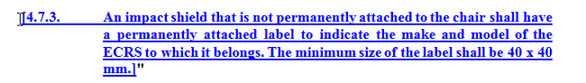

- Moving § “uninterrupted size range” in § 6.1 , but wording ok.
Hans: configuration (height, type, HR upper than the gabarit, adjusting to the child) might be a lot of things.
Ph Beillas: range cannot be interrupted => resumes all
Marianne: why get out “converted”?
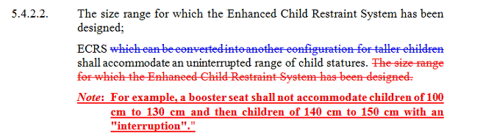

- §6.1.1. :
- CLEPA to reword that FF isize integral CRS with TT may be used in IUF isofix positions; for May GRSP
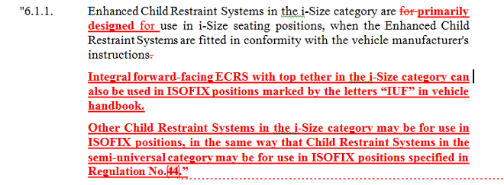
Make clear it is the CRS manufacturer’s handbook: 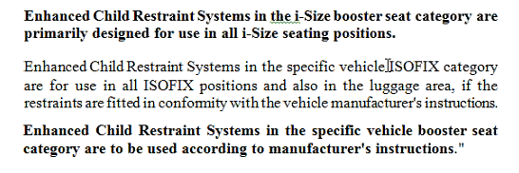

- Size range declaration:
Chair: has to declare the size range. Here, not to declare a booster <100cm.
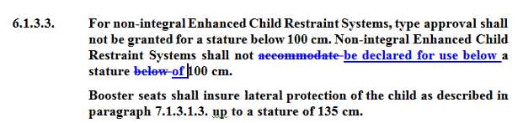

Hans: CRS < 100cm = integral; with harness; then harness away + approval from non-integral. In one type approval. Comes back to the shield label (only from that stature).
Marianne: instead of accommodate => be declared.
Hans: also on the consumer’s handbook & CRS (see presentation from January 2016).

- § 6.3.2.1 + § 6.1.1
- CLEPA to reword
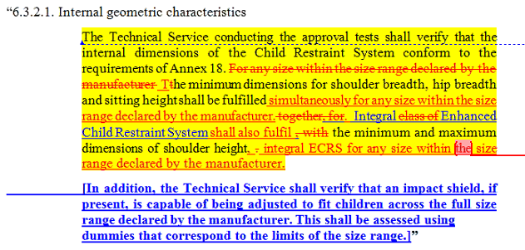

- § 6.6.3.1. agreed:
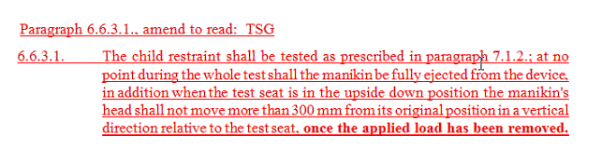
- § 6.6.4.3.1: head & chest acceleration thresholds included (then later in the minutes, the complete table)

Point 8 of the agenda:
Paul Lemman - Humanetics presentation: Q3

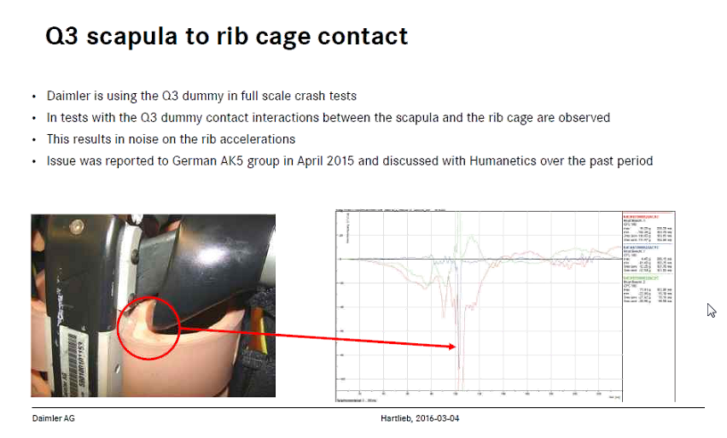

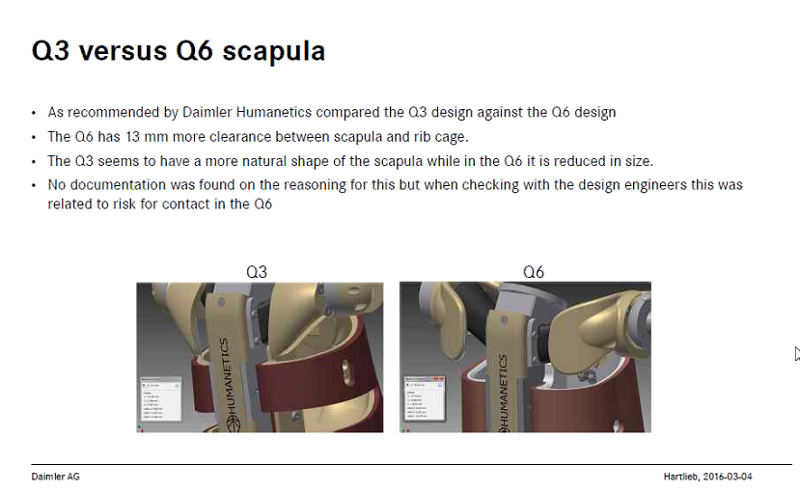

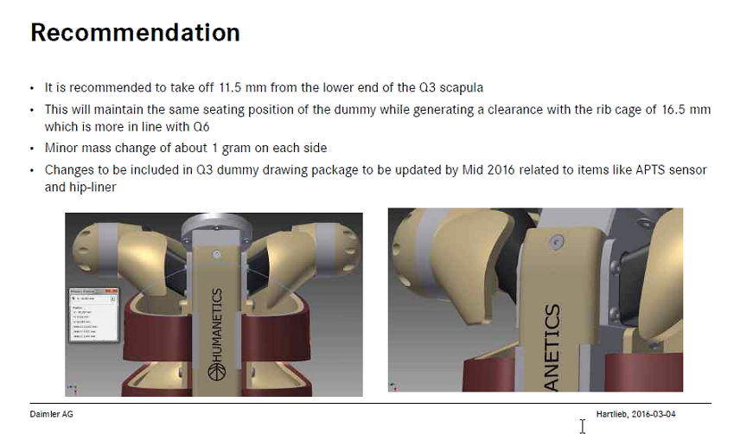
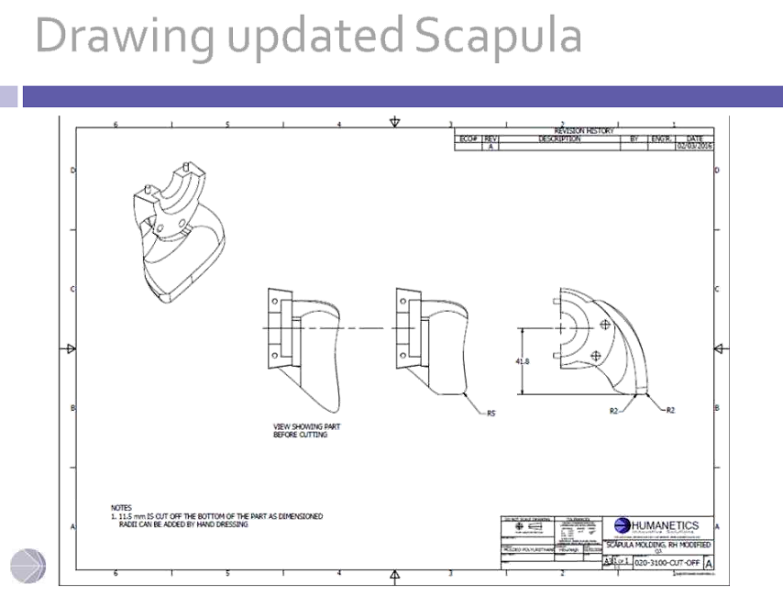

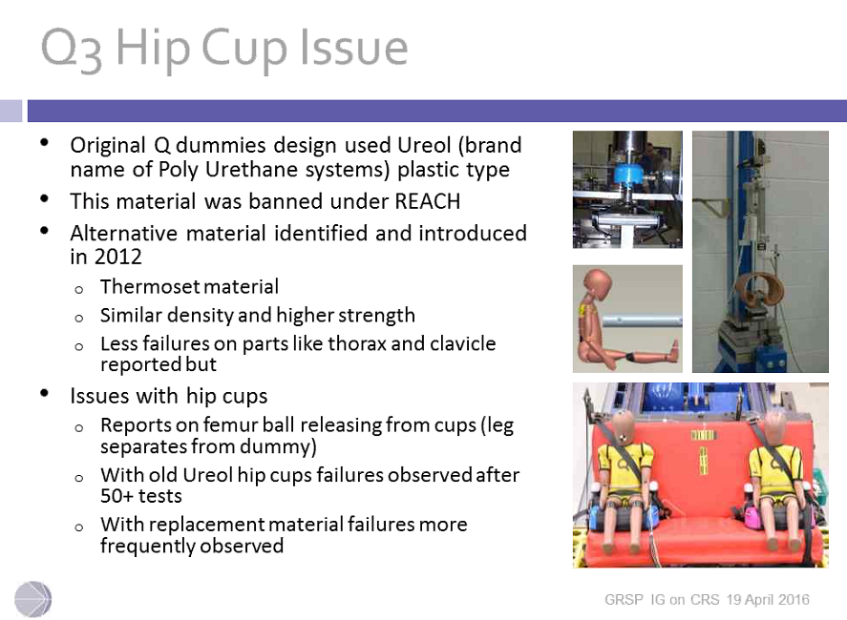

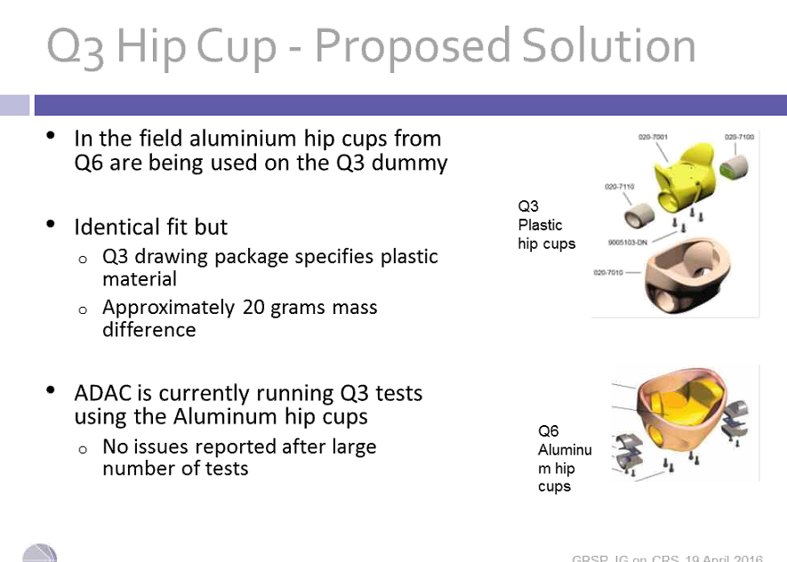

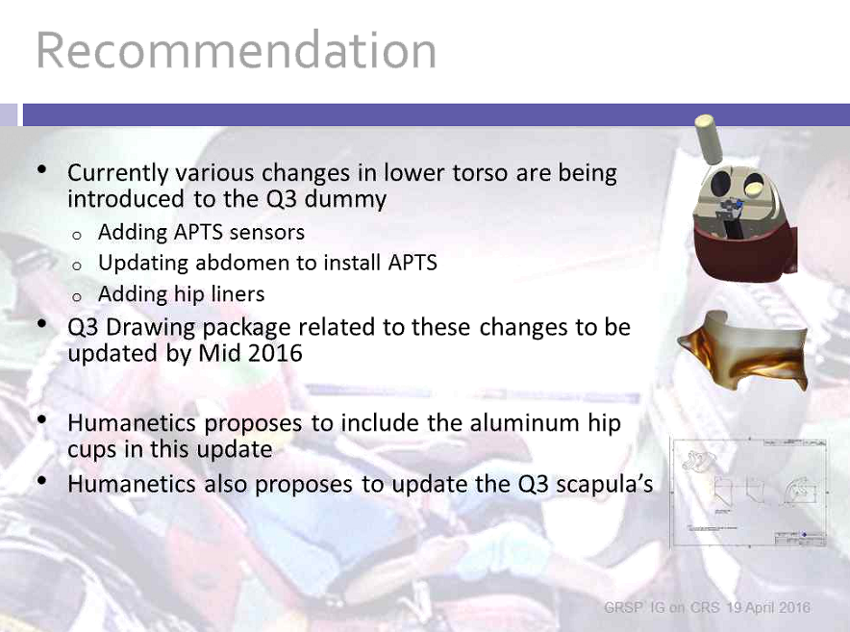
- The IG decides to use Humanetics reccomendations.

Point 7 of the agenda:
Ph Beillas – EEVC draft results on Q dummies presentation
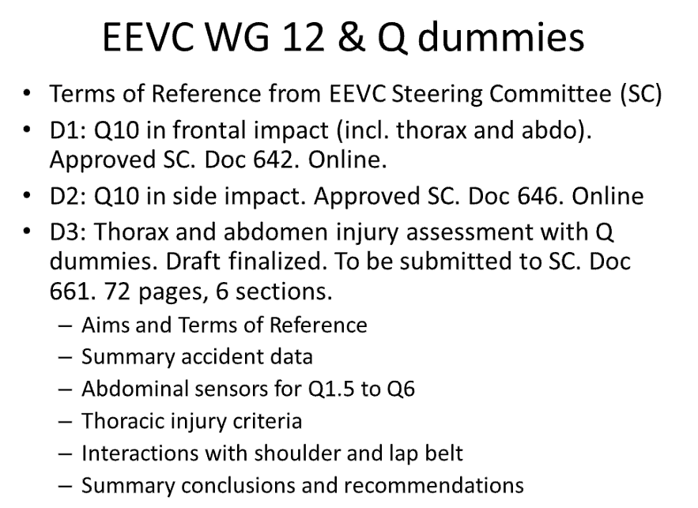

Draft reccomendations:
+ 200g for Q10; 100g Q6?
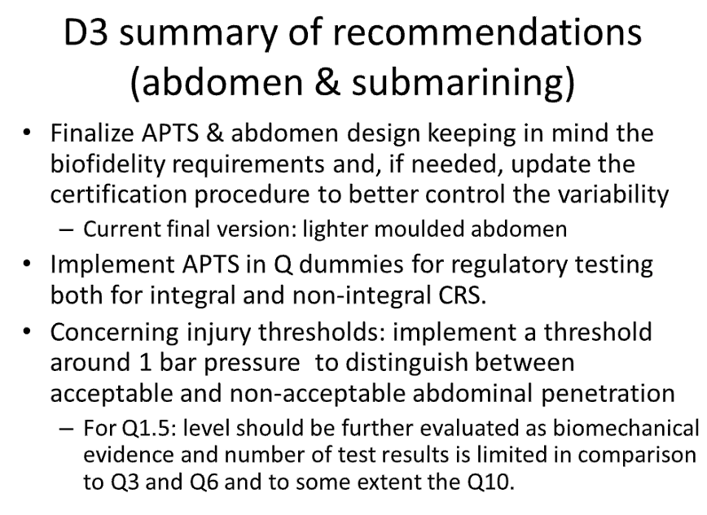

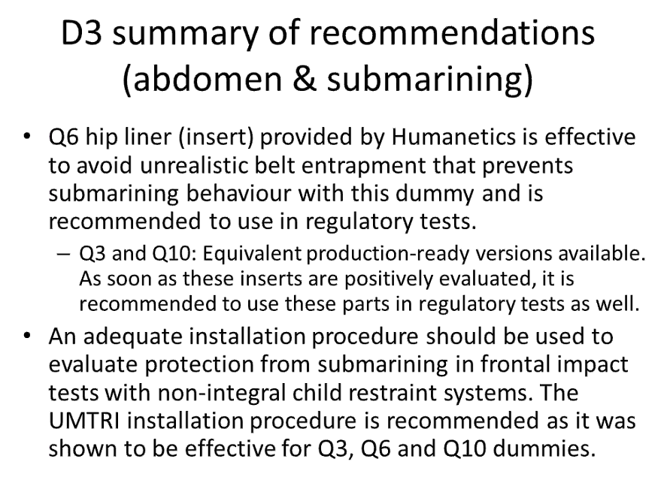

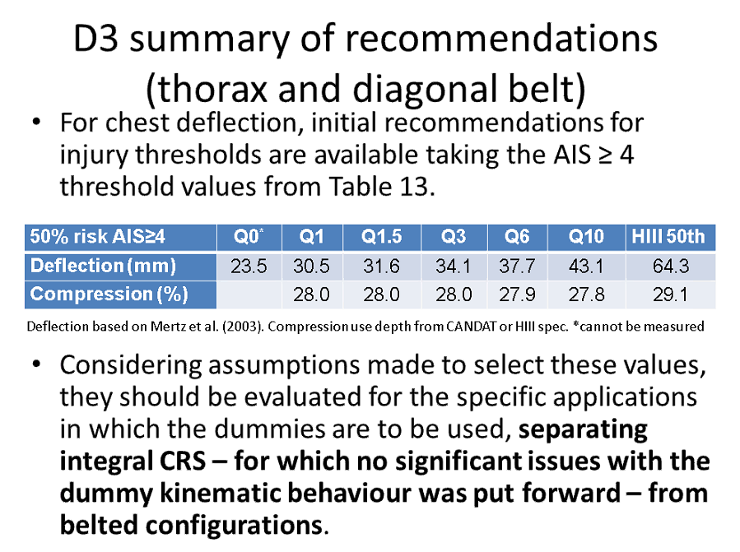

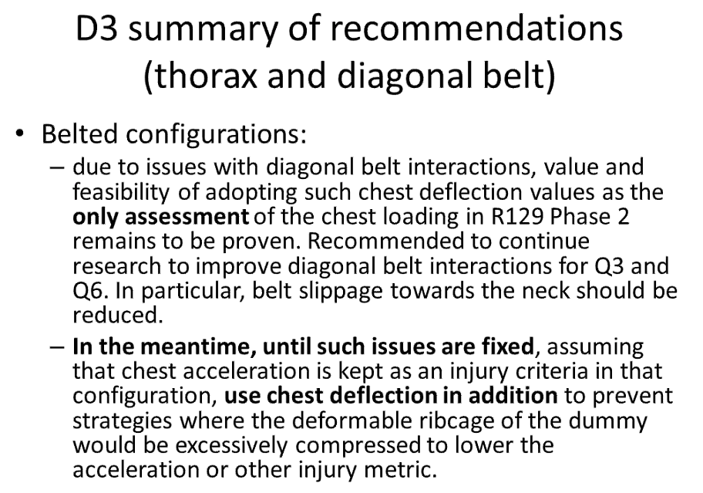
Discussion:
- AIS4 was considered more representative of submarining and chosen type of injuries. As an initial configurations. The group has to provide IRC, not thresholds.
- AIS3: not enough numbers.

Diagonal belt not appropriate (high level…).
- Reccommendation is to review the numbers used.
- Hans: the monitoring data should be available on demand in Europe; other CP .
- Conclusion: We had the presentation of draft EEVC . We have to analyse then review the table and ask GRSP how to manage the monitoring of these data.

Point 5 of the agenda:
Mark Pitcher - TRL presentation – E.C. study

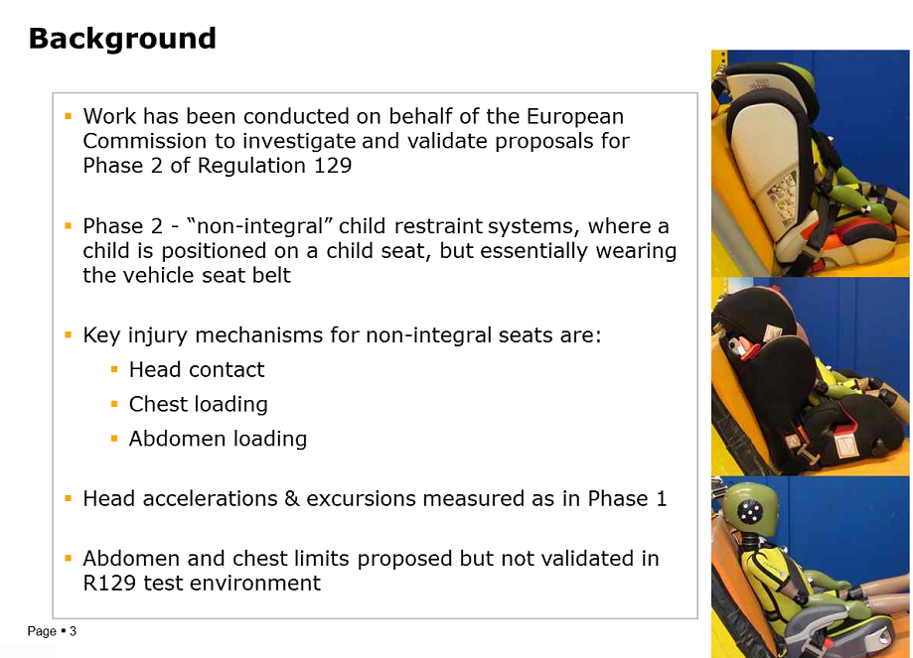

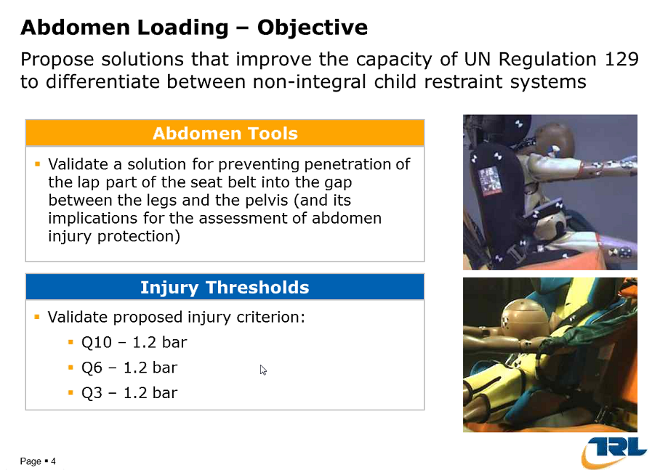

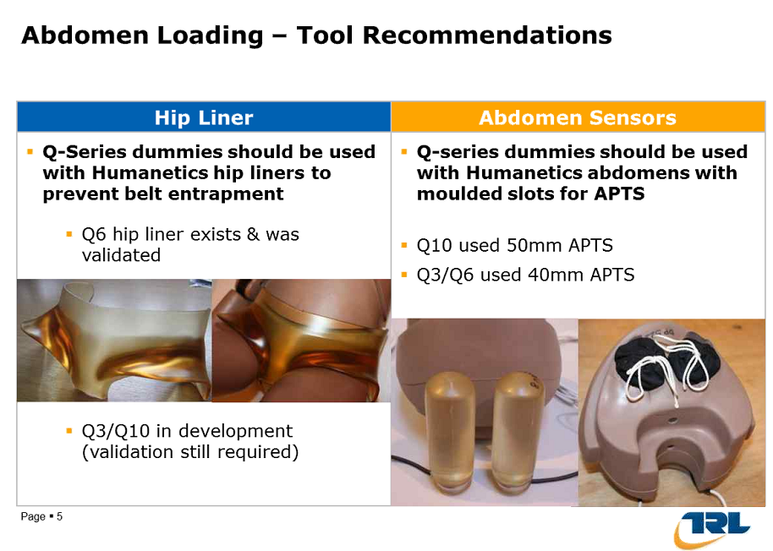
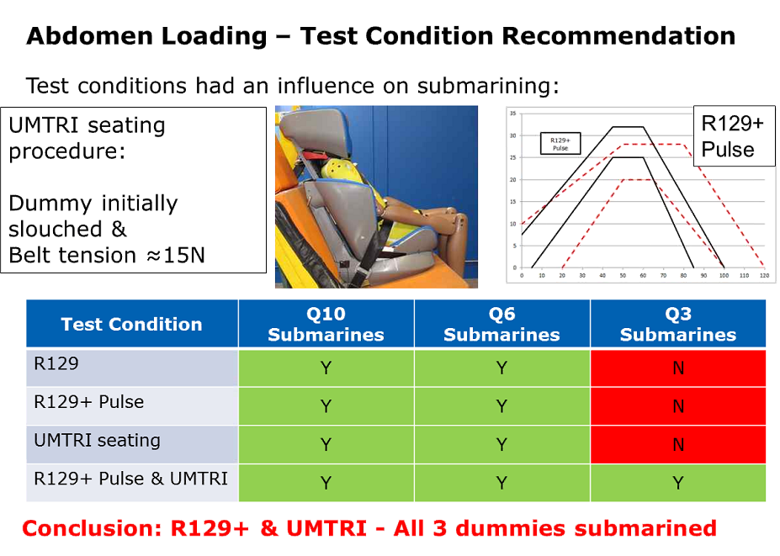

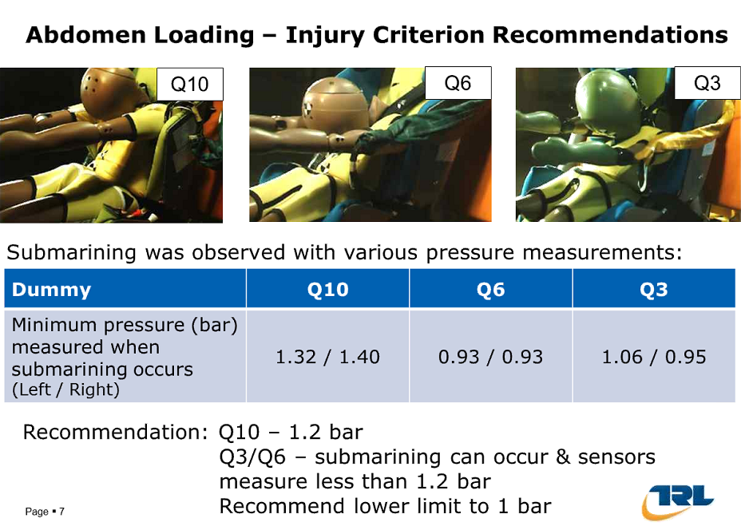

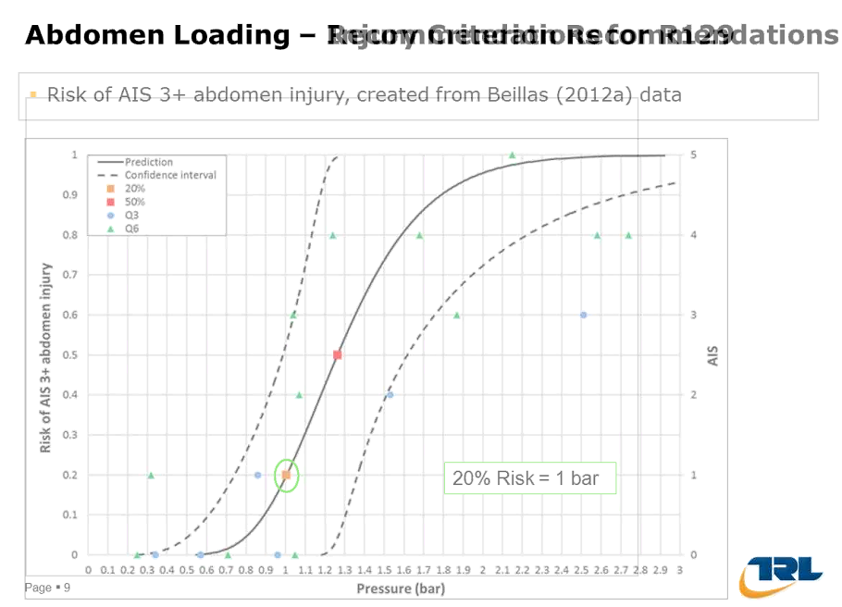

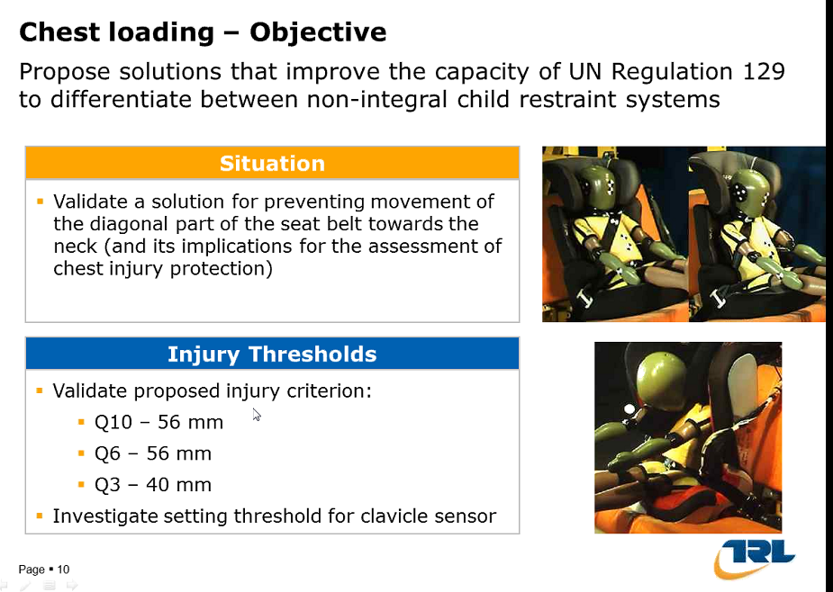

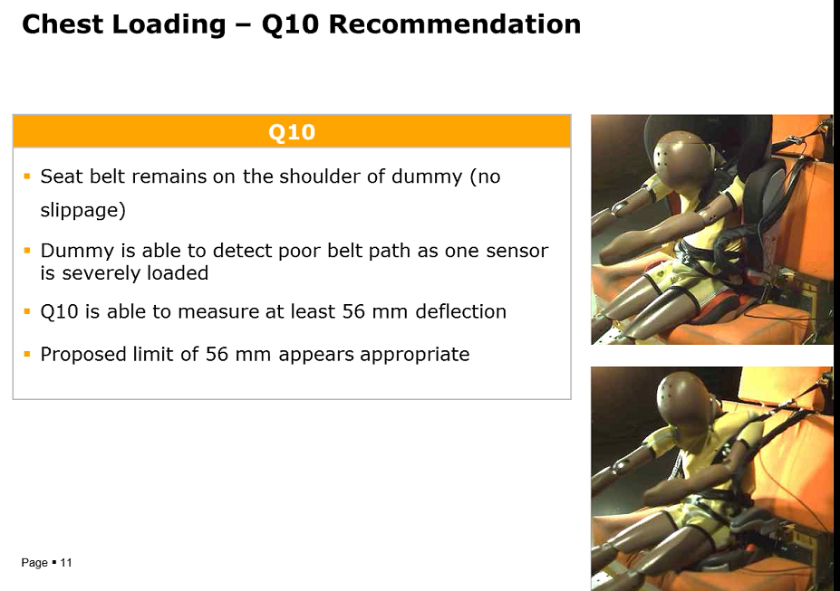

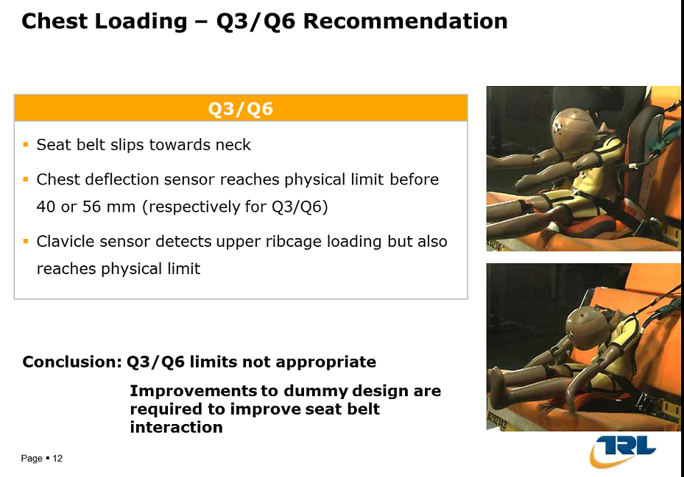

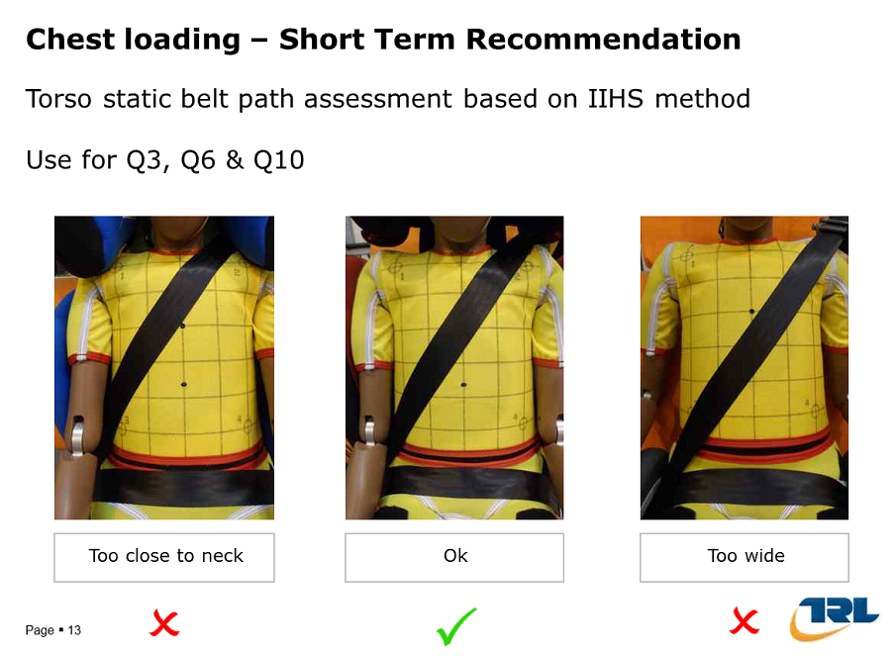

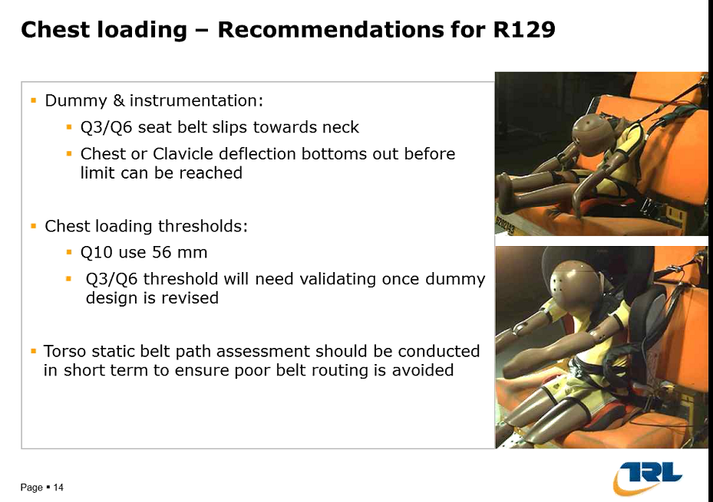
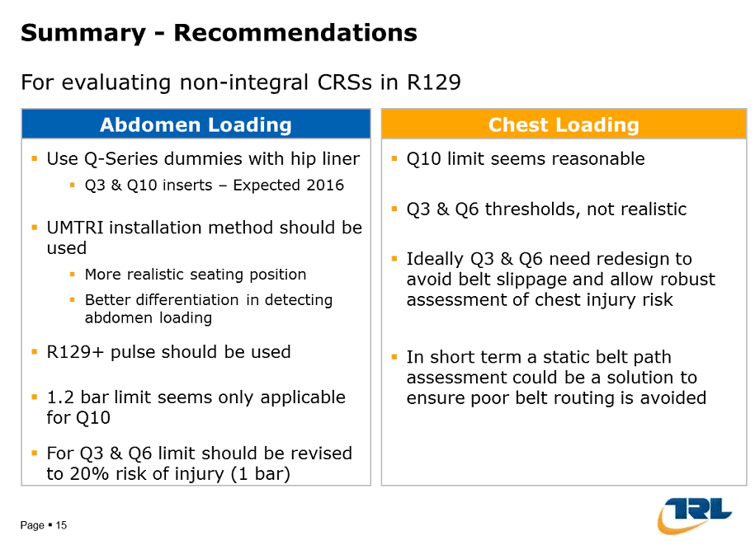
- Humanetics:
  - UMTRI seating position is also used by ENCAP, so it is an existing procedure
  - Hip liners – not been tested yet by TRL

- Page 7: why 20% IRC : because also for head was 20%
  - 56mm limit : do we reach 56 or is it physical limit of the dummy? (Seb)
- No belt slip for Q10
Note: If it works well in pure frontal impact; it doesn’t mean that we could use the same limits for different test configurations.
- Kinematics of the dummy makes that the Q3 did not slip under the belt until the most severe pulse was used.
- Q3 is less prone to submarining, which should not be the case for real children. The bigger pulse is a way to make the submarining happen for this dummy.
- CLEPA needs some time to analyse the presentation
- Pulse + : one advantage is to see the submarining.
- Can we see if smth is discriminant ?
- We use for size range between 100 & 105cm : Q3
- The Q6 will allways be used for this booster seat
- Bench parameters will also affect dummy behaviour
- Limits for Q3 & Q6 ; uncertainty of the method;
- Dinos: this is a poor CRS; so before using the findings of this CRS ; rises the child, the angle of the belt…is it generalisable?
Chair: how to improve ? UMTRI seat pos is a good way to test.
Dinos: is this UMTRI set pos reproducible?
Ph Beillas: is it used in ENCAP or USNCAP ? discuss with them
Conclusion: today we have a text which is not perfect but we can use it until we modify it. We know that we miss smth. For bad products, it autorises submarining in Q6 & Q10. Improve the belt positioning, it’s possible. If we want to modify the pulse, we have to review all the criteria thresholds…
TRL: Humanetics also tries to improve the “slouch” of the Q10. 20mm block, which is not much.
NL: do we have a reproducible method ?
Chair: How to integrate this proposal in the text?
We have an official doc inUNO. How can we improve it “short term”? Until now, no experience with ph2 R129, because not official?
EC: not ok to vote the Q3 usage if the submarining is nok. Include the Q10, Q6 but not Q3. Pulses might be even higher in the future…
Chair: Accidentology shows that it’s not the pulse which makes the highest risk, but the misuse. Consumer test & minimum reg limits should be different. A higher pulse means heavier, bigger, more expensive CRSs. If we don’t release now the ph2, we don’t have the lateral protection, etc…Of course, more improvements will arrive.
Concerning the submarining, these non-integral CRS will also be tested with Q6 & be thrown out if nok.

Following discussions:
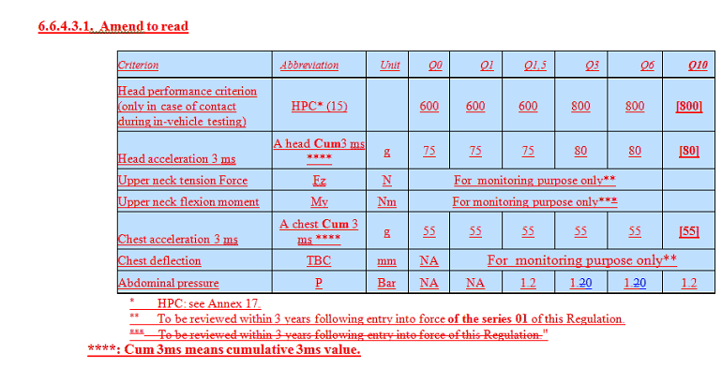
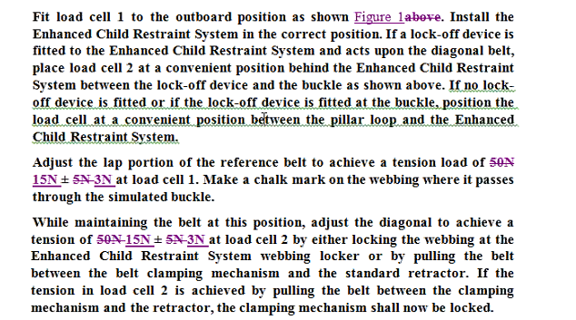
- Clarify that a booster should be tested with a Q3 but also with Q6 to take into account the possible submarining behaviour:
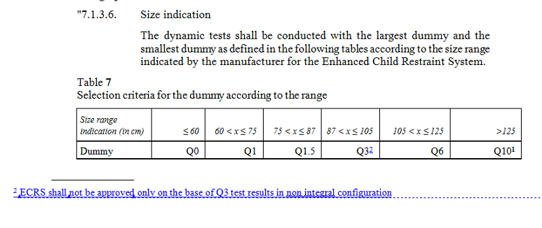
- Adoption of TSG modifications:
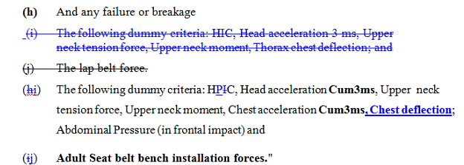

- Insert a requirement for geometry check of diagonal belt path on the chest (Humanetics grid) (in § installation of the dummy for dynamic test) and send to an annex with TRL proposal:
CLEPA requests to check the proposal before inserting it => for September
  - Chair: If we miss 15th of September, then we miss the December 2016.


