 | United Nations | ECE/TRANS/WP.29/GRSP/2016/4-Rev3
 | Economic and Social Council |  | Distr.: General  19 April 2016  Original: English
Economic Commission for Europe
Inland Transport Committee
World Forum for Harmonization of Vehicle Regulations
Working Party on Passive Safety
Fifty-ninth session
Geneva, 9-13 May 2016
Item 19 of the provisional agenda
Regulation No. 129 (Enhanced Child Restraint Systems)
Proposal for the 02 series of amendments to Phase 2 of Regulation No. 129 (Enhanced Child Restraint Systems)
Submitted by the expert from France*
The text reproduced below was prepared by the expert from France. It introduces the 02 series of amendments to UN Regulation No. 129 (Enhanced Child Restraint System (ECRS)) that were agreed upon by the experts of the Informal Working Group on Child Restraint Systems (IWG CRS). It is based on an informal document GRSP-58-08 distributed at the fifty-eighth session of the Working Party on Passive Safety (GRSP). The modifications to the existing text of the UN Regulation, including the draft 01 series of amendments (ECE/TRANS/WP.29/GRSP/2015/24), are marked in bold for new or strikethrough for deleted characters. This revised version includes all modifications done during the 3 last meetings of the Informal Working Group on Child Restraint Systems (IWG CRS)
I. Proposal
Table Content, insert a new Annexe 23:
"23. Standard safety-belt "
Paragraph 1., amend to read:
"1. Scope
This Regulation applies (in its Phases 1 and 2to the following child restraint system for child occupants of power driven vehicles:
a - Integral Universal ISOFIX Enhanced Child Restraint Systems (i-Size
b - Integral Specific vehicle ISOFIX Enhanced Child Restraint Systems
c - non-integral Universal Enhanced Child Restraint Systems (i-Size booster seat):
d - non integral specific vehicle enhanced child restraint systems (specific vehicle booster seat),."
Insert new paragraph 2.3., to read:
"2.3. "Integral Universal" and "Non-Integral Universal"
Paragraph 2.3.(former), renumber as paragraph 2.3.1.
Insert new paragraph 2.3.2., to read:
"2.3.2. " i-Size booster seat" (Non-Integral Universal Enhanced Child Restraint System) is a category of Enhanced Child Restraint Systems with integrated backrest and stowable ISOFIX connectors if any, primarily designed for use in all i-Size seating positions of a vehicle."
Insert new paragraph 2.7.2., to read:
"2.7.2. "Specific vehicle booster seat" is a category of Non-Integral Enhanced Child Restraint System, with integrated backrest, for use in specific vehicle types, with vehicle anchorages approved according to Regulation No. 14. This category includes "Built-in booster seats."
Insert new paragraph 2.17.2., to read:

"2.17.2. " i-Size booster seat fixture" means a fixture, of the dimensions given in figure 1 of Annex 17, Appendix 5 of Regulation No. 16 and used by an Enhanced Child Restraint System manufacturer to determine the appropriate dimensions of a i-Size booster seat and its compatibility with most vehicle seating positions and, in particular, those which have been assessed without ISOFIX attachments, according to Regulation No. 16 as being compatible with such a category of an Enhanced Child Restraint System."
Paragraph 2.51., amend to read:
"2.51. "ECRS position"
"2.51.1. "ISOFIX position" means a location as defined in paragraph 2.17. of Regulation No. 14.
"2.51.2. " i-Size seating position" means a seating position, declared by the vehicle manufacturer, which is designed to accommodate any i-Size Enhanced Child Restraint System, as defined in this Regulation."
Insert new paragraphs 2.56. to 2.56.2., to read:
"2.56. "Lock-off device" locks and prevents movement of one section of the webbing of an adult safety-belt relative to another section of the webbing of the same belt. Such devices may act upon either the diagonal or the lap sections or secure together both lap and diagonal sections of the adult belt. The term covers the following classes:
2.56.1. "Class A device" prevents the child from pulling the webbing of the retractor through to the lap part of the belt, when the adult belt is used to restrain the child directly.
2.56.2. "Class B device" (to be used in phase III) allows the retention of an applied tension in the lap part of an adult safety-belt, when the adult belt is used to restrain the Enhanced Child Restraint System. The device intends to prevent the webbing from slipping from the retractor through the device, which would release the tension and place the restraint in a non-optimal position."
Paragraph 2.56.(former), renumber as paragraph 2.57.
Paragraph 3.2.2., amend to read:
"3.2.2. The applicant shall indicate the kind of application:
(a) Application for an i-Size Enhanced Child Restraint Systems; or
(b) Application for a specific vehicle ISOFIX; or
(c) Application for a i-Size booster seat Enhanced Child Restraint System; or
(d) Application for a specific vehicle booster seat Enhanced Child Restraint System;
(e) Or any combination of (a), (b), (c) and (d) as long as they fulfil paragraphs 5.4.2.2. and 6.1.3.3."
Paragraph 4.3., amend to read:
"4.3. The following information shall be clearly indicated on the product:
- The orientation of the Enhanced Child Restraint System relative to the vehicle.
- The size range(s) of the Enhanced Child Restraint System in centimetres
c) The maximum occupant mass allowed for the Integral Enhanced Child Restraint System in kilograms

If the Enhanced Child Restraint System is to be used in combination with an adult safety-belt, the correct webbing path shall be clearly indicated by means of a drawing permanently attached to the Enhanced Child Restraint System. If the restraint is held in place by the adult safety-belt, the webbing paths shall be clearly marked on the product by colour coding. The colours used for the path of the safety-belt when the device is installed in the forward-facing position shall be red and when installed in the rearward-facing shall be blue. The same colours shall also be used on the labels on the device that illustrate the methods of use.
There shall be a clear differentiation between the intended paths for the lap section and the diagonal section of the safety belt. Indication such as colour coding, words, shapes, etc. shall distinguish between sections of the safety belt.
The marking defined in this paragraph shall be visible with the Enhanced Child Restraint System in the vehicle, with the child in the Enhanced Child Restraint System."
Insert new paragraphs 4.7. to 4.7.3., to read:
"4.7. Marking for non-integral ECRS
4.7.1. i-Size booster seat Enhanced Child Restraint Systems shall have a permanently attached label with the following information visible to the person installing the Enhanced Child Restraint System in the car:
i-Size booster seat 
4.7.2. Specific vehicle booster seat Enhanced Child Restraint System (except built-in) shall have a permanently attached label with the following information visible to the person installing the Enhanced Child Restraint System in the car:
Specific vehicle booster seat
[4.7.3. An impact shield that is not permanently attached to the chair shall have a permanently attached label to indicate the make and model of the ECRS to which it belongs. The minimum size of the label shall be 40 x 40 mm.]"
Paragraphs 4.7.(former), renumber as paragraph 4.8.
Paragraphs 5.4.2. to 5.4.2.2., amend to read:
"5.4.2. The following additional symbols:
5.4.2.1. The words "i-Size universal ISOFIX", or "i-Size booster seat", or "specific vehicle ISOFIX" or "specific vehicle booster seat" depending on the category of Enhanced Child Restraint System;
5.4.2.2. The size range for which the Enhanced Child Restraint System has been designed;

5.4.2.3 In case the ECRS is equipped with a module, the size range is not on the pproval mark but on the module mark.
Paragraph (former) 5.4.2.3 renumber as paragraph 5.4.2.4

Paragraph 6.1.1., amend to read:
"6.1.1. Enhanced Child Restraint Systems in the i-Size category are primarily designed for use in i-Size seating positions, when the Enhanced Child Restraint Systems are fitted in conformity with the vehicle manufacturer's instructions
Integral forward-facing ECRS with top tether in the i-Size category can also be used in ISOFIX positions marked by the letters “IUF” in vehicle handbook.
Other Child Restraint Systems in the i-Size category may be for use in ISOFIX positions, in the same way that Child Restraint Systems in the semi-universal category may be for use in ISOFIX positions specified in Regulation No.44.”

Enhanced Child Restraint Systems in the i-Size booster seat category are primarily designed for use in all i-Size seating positions.
Enhanced Child Restraint Systems in the specific vehicle ISOFIX category are for use in all ISOFIX positions and also in the luggage area, if the restraints are fitted in conformity with the vehicle manufacturer's instructions.
Enhanced Child Restraint Systems in the specific vehicle booster seat category are to be used according to manufacturer's instructions."

Insert new paragraphs 6.1.3. to 6.1.3.5., to read:
"6.1.3. According to the category as defined by Table 2, the Non-Integral Enhanced Child Restraint System and the child shall be secured in a vehicle seating position:
6.1.3.1. For the i-Size booster seat category, by means of the adult safety seat belt and possibly with optional ISOFIX attachments, if these are stowable (see Regulation No 16, Annex 17, Appendix 5, Figure 1, Detail B).
6.1.3.2. For the specific vehicle booster seat category, by means of the adult safety seat belt and possibly with attachments designed by the manufacturer of the Enhanced Child Restraint System, secured to anchorages as designed by the vehicle manufacturer. Only ISOFIX attachments shall be used in conjunction with ISOFIX anchorage system.
Table 2
Possible configurations of Non-Integral Enhanced Child Restraint Systems for type approval
 | Orientation | Category
Non-Integral |  | i-Size  booster seat | Specific vehicle booster seat (Built-in included)
Non-Integral | Forward Facing | A | A
Non-Integral | Rearward Facing | NA | NA
A: Applicable
NA: Non-Applicable
6.1.3.3. For non-integral Enhanced Child Restraint Systems, type approval shall not be granted for a stature below 100 cm. Non-integral Enhanced Child Restraint Systems shall not be declared for use below a stature of 100 cm.
Booster seats shall insure lateral protection of the child as described in paragraph 7.1.3.1.3. up to a stature of 135 cm.
ECRS shall accommodate an uninterrupted range of child statures.
Note: For example, a booster seat shall not accommodate children of 100 cm to 130 cm and then children of 140 cm to 150 cm with an "interruption"."
6.1.3.4. Enhanced Child Restraint Systems of the i-Size booster seat category shall have a main load-bearing contact point, between the Enhanced Child Restraint System and the adult safety belt. This point shall not be less than 150 mm from the Cr axis when measured with the Enhanced Child Restraint System on the dynamic test bench installed in accordance with paragraph 7.1.3.5.2.2. of this Regulation, without a dummy. This shall apply to all adjustment configurations and variable belt paths.
6.1.3.5. The adult seat belt required to secure a i-Size booster seat on the dynamic test bench is defined in Annex 23 to this Regulation. The Enhanced Child Restraint System shall be secured onto the test bench using the appropriate standard seat belt described in Annex 23 using a preload tension of 50N +/- 5N. The dummy shall not be installed unless the design of the restraint is such that the installation of a dummy would increase the amount of belt used. With the Enhanced Child Restraint System in the installed position, there shall be no additional tension in the belt, apart from that exerted by the standard retractor (4 ± 3 N), where fitted. Where the retractor belt is used, this condition shall be met with at least 150 mm of belt remaining on the spool.
A clamping mechanism used according to paragraph 7.1.3.5.2.2. shall not have any influence on the belt path."
Insert new paragraph 6.2.1.6., to read:
"6.2.1.6. For i-Size or specific vehicle booster seats, the lap portion of the adult seat belt shall be positively guided to ensure that the loads transmitted by the adult lap belt are transmitted through the pelvis. The shoulder portion of the adult safety belt shall be positively guided to ensure that the child torso and neck do not escape."
Paragraphs 6.2.1.6.(former) to 6.2.1.9.(former), ), renumber as paragraphs 6.2.1.7. to 6.2.1.10.
[Insert new paragraph 6.2.7., to read:
“6.2.7. If a convertible Enhanced Child Restraint System is equipped with a harness for use only in its rearward facing configuration, there shall be a mechanism to prevent the harness from being used in the forward facing configuration.”]

Paragraph 6.3.2.1.., amend to read:
“6.3.2.1. Internal geometric characteristics
The Technical Service conducting the approval tests shall verify that the internal dimensions of the Child Restraint System conform to the requirements of Annex 18. The minimum dimensions for shoulder breadth, hip breadth and sitting height shall be fulfilled simultaneously for any stature within the size range declared by the manufacturer.. Integral Enhanced Child Restraint System shall also fulfil the minimum and maximum dimensions of shoulder height, for any stature within the size range declared by the manufacturer.
[In addition, the Technical Service shall verify that an impact shield, if present, is capable of being adjusted to fit children across the full size range declared by the manufacturer. This shall be assessed using dummies that correspond to the limits of the size range.]”
Paragraph 6.3.2.2., amend to read:
"6.3.2.2. External dimensions
The Technical Service conducting the approval tests shall verify that the external dimensions of the Enhanced Child Restraint System conform to the requirements of paragraphs 6.3.2.2.1 and 6.3..2.2.2., as applicable.
6.3.2.2.1. Integral Class Enhanced Child Restraint Systems
The maximum external dimensions for the width, height and depth of the Enhanced Child Restraint System and the locations of the ISOFIX anchorages system, with which its attachments shall engage, shall be defined by the ISOFIX vehicle seat fixture as defined in paragraph 2.17.1. of this Regulation.
(a) i-Size Forward facing Enhanced Child Restraint Systems shall fit within the ISO/F2x size envelope for a reduced-height forward-facing toddler.CRS.
(b) i-Size Rearward facing Enhanced Child Restraint Systems shall fit within the ISO/R2 size envelope for a reduced-size rearward-facing toddler CRS;
(c) Specific vehicle ISOFIX Enhanced Child Restraint Systems shall fit:
• in vehicle(s) specified in a list or
• at least in one of the ISO (R1, R2, R3, F2, F2X, F3, L1, L2) size envelopes as described in Annex 17, Appendix 2 of Regulation No. 16.
When conducting this assessment, the Integral Enhanced Child Restraint System shall be adjusted to the largest size of its declared stature range (height, depth and width dimensions as defined in Annex 18). If the Enhanced Child Restraint System is capable of being adjusted to different positions of seat surface inclination, the fitting assessment shall be done in at least one position. If other positions of inclination are outside the limits of the applicable size envelope, the user manual shall indicate that the child restraint may not fit in all approved vehicles when used in one of these positions.
. i-Size booster seats shall be adjusted to accommodate children of 135 cm stature (height, depth and width dimensions as defined in Annex 18) or to the largest size of its declared stature range in case the upper limit is below 135 cm. In this case, it must fit within each of its declared Vehicle Seat Fixtures in at least one adjustable position. The Enhanced Child Restraint System may be adjusted to other inclined positions (less or more reclined) that are outside the Vehicle Seat Fixture’s height; in this case, the child restraint manufacturer’s user manual shall clearly indicate that when used in one of these configurations, the Enhanced Child Restraint System may not fit in all vehicles approved for a Universal fixture."

"6.3.2.2.2. Non-Integral Class Enhanced Child Restraint Systems
The maximum external dimensions for the width, height and depth of the Enhanced Child Restraint System and the locations of the ISOFIX anchorages system if any, with which its attachments shall engage, shall be defined by the i-Size booster seat fixture as defined in paragraph 2.17.2. of this Regulation.
(a) i-Size booster seat Enhanced Child Restraint Systems shall fit within the ISO/B2 size envelope;
(b) Specific vehicle booster seat Enhanced Child Restraint Systems shall fit:
- in vehicle(s) specified in a list or
- at least in one of ISO/B2 –ISO/B3 size envelope as described in Annex 17, Appendix 2 of regulation N°. 16.
When conducting this assessment, the Non-integral Enhanced Child Restraint System shall be adjusted to accommodate children of 135 cm stature (height, depth and width dimensions as defined in Annex 18) or to the largest size of its declared stature range if the upper limit is below 135 cm. If the Non-integral Enhanced Child Restraint System is capable of being adjusted to different positions of seat surface inclination, the fitting assessment shall be done in at least one position. If other positions of inclination are outside the limits of the applicable size envelope, the user manual shall indicate that the child restraint may not fit in all approved vehicles when used in one of these positions. If the Non-integral Enhanced Child Restraint System has a declared stature range above 135 cm, and if it is necessary to adjust the child restraint outside the limits of the applicable size envelope for such adjustments (height, depth and width dimensions), the user manual shall indicate that the child restraint may not fit in all approved vehicles when used in one of these positions."

Paragraph 6.6.3.1., amend to read:
6.6.3.1. The child restraint shall be tested as prescribed in paragraph 7.1.2.; at no point during the whole test shall the manikin be fully ejected from the device, in addition when the test seat is in the upside down position the manikin's head shall not move more than 300 mm from its original position in a vertical direction relative to the test seat, once the applied load has been removed.

Paragraph 6.6.4.1.3., amend to read:
"6.6.4.1.3. The dynamic test shall be performed on Child Restraint Systems which have not previously been under load. The Enhanced Child Restraint System of the i-Size booster seat category shall be tested on the test bench described in Annex 6, and in conformity with paragraph 7.1.3.1. below."
Insert new paragraph 6.6.4.1.7., to read:

“6.6.4.1.7. In the case of Non Integral Child Restraint System making use of ISOFIX attachments, the dynamic test shall be carried out as follows:
6.6.4.1.7.1. With the ISOFIX attachments in use, and
6.6.4.1.7.2. Without the ISOFIX attachments in use.”

6.6.4.3.1. Amend to read
Criterion | Abbreviation | Unit | Q0 | Q1 | Q1,5 | Q3 | Q6 | Q10
Head performance criterion (only in case of contact during in-vehicle testing) | HPC* (15) |  | 600 | 600 | 600 | 800 | 800 | [800]
Head acceleration 3 ms | A head Cum3 ms **** | g | 75 | 75 | 75 | 80 | 80 | [80]
Upper neck tension Force | Fz | N | For monitoring purpose only**
Upper neck flexion moment | My | Nm | For monitoring purpose only***
Chest acceleration 3 ms | A chest Cum 3 ms **** | g | 55 | 55 | 55 | 55 | 55 | [55]
Chest deflection | TBC | mm | NA | For monitoring purpose only**
Abdominal pressure | P | Bar | NA | NA | 1.2 | 1.0 | 1.0 | 1.2
- * HPC: see Annex 17.
      - ** To be reviewed within 3 years following entry into force of the series 01 of this Regulation.
- *** To be reviewed within 3 years following entry into force of this Regulation."
****: Cum 3ms means cumulative 3ms value.
amend 6.6.4.5.2. Injury assessment criteria for lateral impact to read,
Criterion | Abbreviation | Unit | Q0 | Q1 | Q1,5 | Q3 | Q6 | Q10
Head performance criterion | HPC (15) |  | 600 | 600 | 600 | 800 | 800 | For monitoring purpose only
Head acceleration  3 ms | A head Cum 3 ms** | g | 75 | 75 | 75 | 80 | 80 | For monitoring purpose only
Upper neck tension force | Fz | N | For monitoring purpose only*
Upper neck flexion moment | Mx | Nm | For monitoring purpose only*
* To be reviewed within 3 years following entry into force of this Regulation. "
** Cum 3ms means cumulative 3ms value

Paragraph 6.6.4.4.1.1., amend to read:
"6.6.4.4.1.1. Forward facing Enhanced Child Restraint Systems
Head excursion: No part of the head of the dummy shall pass beyond the planes BA, DA and DE as defined in Figure 1 below. This shall be judged up to 300 ms or the moment that the dummy has come to a definitive standstill whatever occurs first. Except for booster seats when testing using Q10 dummy where:
(a) the value in relation to the DA plane is 840 mm; and
(b) the value in relation to the BA plane is 550 mm; and
(c) the rebound phase is not considered for the assessment of the plane DA & DE."
Paragraph 6.6.4.5.1., amend to read:
"6.6.4.5.1. Main injury assessment criterion — Head containment
…
(b) Head shall not exceed … Appendix 3, Figure 1. This criteria is for monitoring purpose only for tests with a Q10 dummy."
[Paragraph 6.7., amend to read:
“6.7. Provisions applicable to individual components of the restraint
This paragraph is applicable to any such components that are found on the Enhanced Child Restraint System regardless of its category.” ]

[Paragraph 6.7.1.8.2., amend to read:
“6.7.1.8.2. Depending on the mass limit declared by the manufacturer a buckle shall withstand:”]
Paragraph 7.1.2.3, amend to read:
7.1.2.3 At this static inverted position a mass equivalent to 4 times that of the dummy, with a tolerance of -0/+5% with reference to dummies nominal masses as in Annex 8, shall be applied vertically downwards in a plane perpendicular to the axis of rotation in addition to the dummy utilizing the load application device described in Annex 21. The load shall be applied in a gradual controlled manner at a rate not exceeding gravitational acceleration or 400 mm/min. Maintain the prescribed maximum load for a duration of 30 -0/+5 seconds.

Paragraph 7.1.3.1.1.5.1 amend to read:

7.1.3.1.1.5.1. Deceleration test device:
The deceleration of the trolley shall be achieved by using the apparatus prescribed in Annex 6 to this Regulation or any other device giving equivalent results. This apparatus shall be capable of the performance specified in paragraph 7.1.3.4. and hereafter specified:
Calibration procedure:
The deceleration curve of the trolley, in the case of child restraint tests performed in accordance with paragraph 7.1.3.1. above, ballasted with inert masses up to 55 kg in order to reproduce one occupied Child Restraint System, and in the case of Child Restraint System tests in a vehicle body shell performed in accordance with paragraph 7.1.3.2 below, where the trolley is ballasted with the vehicle structure and inert masses up to (x times) 55 kg reproducing the number of (x) occupied child restraint systems, shall remain, in the case of frontal impact, within the hatched area of the graph in Annex 7, Appendix 1 to this Regulation, and, in the case of rear impact, within the hatched area of the graph in Annex 7, Appendix 2 to this Regulation.
During calibration of the stopping device, the stopping distance shall be 650 ± 30 mm for frontal impact, and 275 ± 20 mm for rear impact.
Dynamic testing conditions during testing:
For frontal and rear impact the deceleration shall be achieved with the apparatus calibrated as stated above, however:
(a) The deceleration curve shall not have a more than 3 ms time duration exceedance of the lower borders of the performance requirements;
(b) If the tests above were performed at a higher speed and/or the deceleration curve has exceeded the upper level of the hatched area and the Child Restraint System meets the requirements, the test shall be considered satisfactory.

For frontal impact, the trolley shall be so propelled that, at the beginning of the test, its velocity is 50 + 0 – 2 km/h and its acceleration curve is within the hatched area of the graph in Annex 7, Appendix 1.
For rear impact, the trolley shall be so propelled that, at the beginning of the test, its velocity is 30 +2 -0 km/h and its acceleration curve is within the hatched area of the graph in Annex 7, Appendix 2.
In addition to fulfilling the above requirements, the Technical Service shall use a mass of trolley (equipped with its seat), as specified in paragraph 1. of Annex 6, greater than 380 kg.
However, if the tests above were performed at a higher speed and/or the acceleration curve has exceeded the upper level of the hatched area and the child restraint meets the requirements, the test shall be considered satisfactory.
It is however permitted the deceleration curve exceeds the lower boundaries of the performance requirements but for a cumulative period less than 3 ms time;

Paragraph 7.1.3., amend to read:
"7.1.3. Dynamic testing for frontal, rear and lateral impact:
(a) Frontal impact test shall be performed on i-Size (Integral Universal ISOFIX Enhanced Child Restraint Systems), Specific vehicle ISOFIX Enhanced Child Restraint Systems and to non-integral Enhanced Child Restraint Systems i-Size booster seats and specific vehicle booster seats;
(b) Rear impact test shall be performed on i-Size and Specific Vehicle ISOFIX Rearward and Lateral facing Enhanced Child Restraint Systems;
(c) Lateral impact test are performed only on the test bench for i-Size Integral Universal ISOFIX Enhanced Child Restraint Systems, Specific vehicle ISOFIX and for non-integral Enhanced Child Restraint Systems i-Size booster seats and specific vehicle booster seats;
…"
Paragraphs 7.1.3.5.2. and 7.1.3.5.2.1., amend to read:
"7.1.3.5.2. Installation for frontal, rear and lateral impacts.
7.1.3.5.2.1. Installation of Integral Universal ISOFIX Enhanced Child Restraint Systems (i-Size), or Integral Specific vehicle ISOFIX Enhanced Child Restraint Systems on the test bench.
The unoccupied ISOFIX Enhanced Child Restraint System shall be attached to the ISOFIX anchorage system.
Securing the ISOFIX attachments to the ISOFIX lower anchorages shall be permitted to draw the unoccupied Enhanced Child Restraint System towards those anchorages.
An additional force of 135 +/- 15N shall be applied in a plane parallel to the surface of the test seat cushion. The force shall be applied along the centre line of the Enhanced Child Restraint System and at a height no more than 100 mm above the cushion.
If present, the top tether shall be adjusted to achieve a tension load of
50 +/- 5N. Alternatively, and if present, the support-leg shall be adjusted according to the Enhanced Child Restraint System manufacturer's instructions.
The Enhanced Child Restraint System centre line shall be aligned with the centre line of the test bench.
The dummy shall be placed in the Enhanced Child Restraint System separate from the seat-back of the chair by a flexible spacer. The spacer shall be 2.5 cm thick and 6 cm wide. It shall have length equal to the shoulder height less the thigh height, both in the sitting position and relevant to the dummy size being tested. The resulting height of the spacer is listed in the table below for the different dummy sizes. The board should follow as closely as possible the curvature of the chair and its lower end should be at the height of the dummy's hip joint.
 | Q0 | Q1 | Q1.5 | Q3 | Q6 | Q10  (design targets)
 | Dimensions in mm
Height of spacer device for positioning of dummy | 173 ± 2 | 229 ± 2 | 237 ± 2 | 250 ± 2 | 270 ± 2 | 359 ± 2
Adjust the ECRS belt in accordance with the manufacturer's instructions, but to a tension of 250 ± 25 N above the adjuster force, with a deflection angle of the strap at the adjuster of 45 ± 5°, or alternatively, the angle prescribed by the manufacturer.
The spacer shall then be removed and the dummy pushed towards to the seat back. Distribute the slack evenly throughout the harness.
The longitudinal plane passing through the centre line of the dummy shall be set midway between the two lower ECRS belt anchorages, however note shall also be taken of paragraph 7.1.3.2.1.3. above.

7.1.3.5.2.2. Installation of a non-integral Enhanced Child Restraint Systems i-Size booster seat or specific to vehicle booster seat on the test bench.
The unoccupied booster seat shall be placed on the test bench.
If present and tested, securing the ISOFIX attachments to the ISOFIX lower anchorages shall be permitted to draw the unoccupied Enhanced Child Restraint System towards these anchorages. An additional force of 135 +/-15N shall be applied in a plane parallel to the surface of the test bench seat cushion. The force shall be applied along the centre line of the Enhanced Child Restraint System and at a height of no more than 100 mm above the test bench seat cushion.
The dummy shall be placed in the Enhanced Child Restraint System.
A 125 × 95 × 20mm piece of closed cell foam should be taped to the back of the dummy’s pelvis. The longest edge of the pad should be aligned with the top of the pelvis flesh and the pad aligned with the centreline of the dummy.
The dummy should be aligned centrally in the booster seat, with the pelvis pad in contact with the seatback of the booster seat.
Route the seat belt in accordance with the manufacturers’ instructions.
Once the seat belt has been routed, but before the seat belt has any tension introduced, fit seat belt load cells in the following two positions (Figure 1):
Lap - Installed on the lap portion of the belt, typically between the CRS and the terminal anchorage point
Diagonal - Installed on the diagonal portion of the belt either:
- Between the B-pillar and the CRS, if no lock-off
or
- Between the lock-off and the buckle, if the CRS has a lock-off

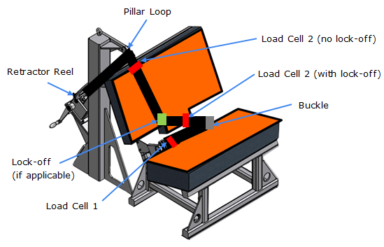
Figure 1: Load cell positions

Fit load cell 1 to the outboard position as shown Figure 1. Install the Enhanced Child Restraint System in the correct position. If a lock-off device is fitted to the Enhanced Child Restraint System and acts upon the diagonal belt, place load cell 2 at a convenient position behind the Enhanced Child Restraint System between the lock-off device and the buckle as shown above. If no lock-off device is fitted or if the lock-off device is fitted at the buckle, position the load cell at a convenient position between the pillar loop and the Enhanced Child Restraint System.

Adjust the lap portion of the reference belt to achieve a tension load of 15N ± 3N at load cell 1. Make a chalk mark on the webbing where it passes through the simulated buckle.
While maintaining the belt at this position, adjust the diagonal to achieve a tension of 15N ± 3N at load cell 2 by either locking the webbing at the Enhanced Child Restraint System webbing locker or by pulling the belt between the belt clamping mechanism and the standard retractor. If the tension in load cell 2 is achieved by pulling the belt between the clamping mechanism and the retractor, the clamping mechanism shall now be locked.
Extract all webbing from the retractor spool and rewind the excess webbing keeping a tension of 4 ± 3 N in the belt between the retractor and the pillar loop. The spool shall be locked before the dynamic test. Conduct the dynamic crash test.

7.1.3.5.2.3. After installation
After installation, the dummy position shall be adjusted so that:
The dummy centre line and the Enhanced Child Restraint System centre line shall be aligned exactly with the centre line of the test bench.
The arms of the dummy shall be positioned symmetrically. Elbows shall be positioned in such a way that the upper arms are closely aligned with the sternum.
Hands shall be positioned on the thighs.
Legs shall be positioned parallel to one another or at least symmetrically.
For lateral impact, positive measures shall be taken to ensure the stability of the dummy is maintained until t0 and this shall be confirmed using video analysis. Any means used to stabilise the dummy before t0 shall not influence the dummy kinematics after t0.
Because the foam of the test bench seat cushion will compress after installation of the Enhanced Child Restraint System, the dynamic test shall be conducted no more than 10 minutes after installation.
To allow the test bench seat cushion to recover, the minimum period between two tests using the same test bench seat cushion shall be 20 minutes.
Example for arm alignment:
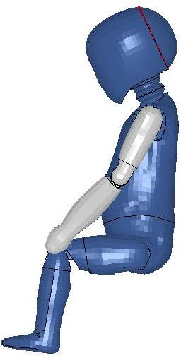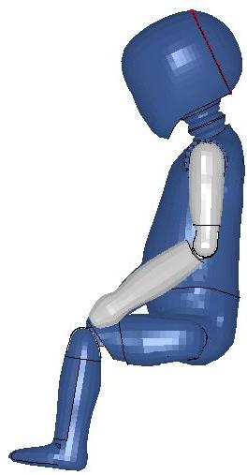
Arms are aligned with sternum | Arms are not aligned with sternum | "

Paragraph 7.1.3.6., amend to read:
"7.1.3.6. Size indication
The dynamic tests shall be conducted with the largest dummy and the smallest dummy as defined in the following tables according to the size range indicated by the manufacturer for the Enhanced Child Restraint System.
Table 7
Selection criteria for the dummy according to the range
Size range indication (in cm) | ≤ 60 | 60 < x ≤ 75 | 75 < x ≤ 87 | 87 < x ≤ 105 | 105 < x ≤ 125 | >125
Dummy | Q0 | Q1 | Q1.5 | Q3 | Q6 | Q10¹
¹ No lateral impact test using the Q10 dummy is required for i-Size booster seats with a size range upper limit between 125 cm and 135 cm. .
Where the Enhanced Child Restraint System requires … defined above."

Paragraph 7.3, 7.3.1, 7.3.2, 7.3.3 amend to read:
7.3 Certification of test bench cushion
7.3.1. The test seat cushion shall be certified when new to establish initial values for impact penetration and peak deceleration, and then after every 50 dynamic tests or at least every month, whichever is the sooner, or before each test if the test rig is used frequently.
7.3.2. The certification and measuring procedures shall correspond to those specified in the latest version of ISO 6487; the measuring equipment shall correspond to the specification of a data channel with a channel filter class (CFC) 60.
Using the test device defined in Annex 14 to this Regulation, conduct three tests on the seat base prepared as described in Annex 6, foam covered with textile, 150 ± 5 mm from the front edge of the cushion on the centre line and at 150 ± 5 mm in each direction from the centre line.
Place the seat cushion device vertically on a flat rigid surface. Lower the impact mass until it contacts the surface and set the penetration marker to the zero position. Place the device vertically above the test point, raise the mass at a height of 500 ± 5 mm and allow it to fall freely to make impact on the seat surface. Record the penetration and the deceleration curve.
7.3.3. The initial peak recorded values for impact deceleration shall be 24 ± 4 g and subsequent The peak values recorded shall not deviate by more than 15 percent from the initial values.

Paragraph 8.1., amend to read:
8.1. The test report shall record the results of all tests and measurements including the following test data:
(a) The type of device used for the test (acceleration or deceleration device),
(b) The total velocity change,
(c) The trolley speed immediately before impact only for deceleration sleds,
(d) The acceleration or deceleration curve during all the velocity change of the trolley and at least 300 ms,
(e) The time (in ms) when the head of the manikin reaches its maximum displacement during the performance of the dynamic test,
(f) The place occupied by the buckle during the tests, if it can be varied, and
(g) The name and address of the laboratory where tests have been performed
(h) And any failure or breakage

(j) The lap belt force.
(i) The following dummy criteria: HPC, Head acceleration Cum3ms, Upper neck tension force, Upper neck moment, Chest acceleration Cum3ms, Chest deflection; Abdominal Pressure (in frontal impact) and
(j) Adult Seat belt bench installation forces."

Insert new paragraph 14.2.2., to read:
"14.2.2. For i-Size booster seat category Enhanced Child Restraint Systems the following label shall be clearly visible on the exterior of the packing:
Notice
This is a i-Size booster seat Enhanced Child Restraint System. It is approved according to Regulation No. 129, for use in " i-Size seating positions" as indicated by vehicle manufacturers in the vehicle user’s manual.
If in doubt, consult either the Enhanced Child Restraint System manufacturer or the retailer. | "

Paragraphs 14.2.2. to 14.2.8. (former), renumber as 14.2.3. to 14.2.9.
Insert new paragraphs 16.5. and 16.6., to read:
"16.5. As from the official date of entry into force of the 02 series of amendments to this Regulation, no Contracting Party applying this Regulation shall refuse to grant or refuse to accept type approvals to this Regulation as amended by the 02 series of amendments.
16.6. Until 1 September [20XX], type approvals to the preceding series of amendments to the Regulation which are not affected by the 02 series of amendments to the Regulation shall remain valid and Contracting Parties applying this Regulation shall continue to accept them.
16.7. Until 1 September [20XX], Contracting Parties applying this Regulation shall not refuse to grant extensions of approval to the 01 series of amendments to this Regulation."
Paragraphs 14.2.2. to 14.2.8.(former), renumber as paragraphs 14.2.3. to 14.2.9.
Annex 2, amend to read:
"Annex 2
Arrangements of the approval mark

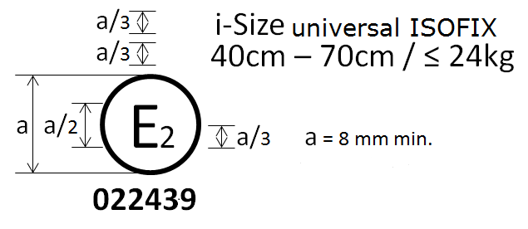
The Enhanced Child Restraint System bearing the above approval mark is a device capable of being fitted in any i-size seating position of the vehicle and of being used for the 40 cm - 70 cm size range and mass limit of 24 kg; it is approved in France (E 2) under the number 022439. The approval number indicates that the approval was granted in accordance with the requirements of the Regulation concerning the approval of Enhanced Child Restraint Systems used onboard of motor vehicles as amended by the 02 series of amendments. In addition the name of the regulation has to be identified on the approval mark followed by the series of amendment according to which the approval has been granted.

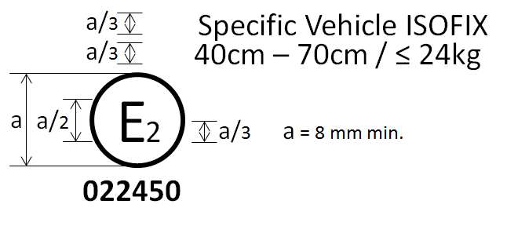
The Enhanced Child Restraint System bearing the above approval mark is a device not capable of being fitted in every vehicle and capable of being used for the 40 cm - 70 cm size range and mass limit of 24 kg; it is approved in France (E 2) under the number 022450. The approval number indicates that the approval was granted in accordance with the requirements of the Regulation concerning the approval of Specific vehicle ISOFIX Enhanced Child Restraint Systems used onboard of motor vehicles as amended by the 02 series of amendments. In addition the name of the regulation has to be identified on the approval mark followed by the series of amendment according to which the approval has been granted.

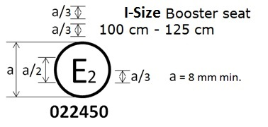

The Enhanced Child Restraint System bearing the above approval mark can be fitted in any i-Size booster seating position and used for the 100 cm - 125 cm size range; it is approved in France (E 2) under the number 022450. The approval number indicates that the approval was granted in accordance with the requirements of the Regulation concerning the approval of Enhanced Child Restraint Systems used on-board of motor vehicles as amended by the 02 series of amendments. In addition, the name of the regulation is to be identified on the approval mark followed by the series of amendment according to which the approval has been granted.

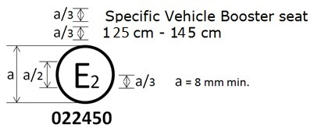

The Enhanced Child Restraint System bearing the above approval mark is a device not capable of being fitted in every vehicle but capable of being used for the 125 cm - 145 cm size range; it is approved in France (E 2) under the number 022450. The approval number indicates that the approval was granted in accordance with the requirements of the Regulation concerning the approval of specific vehicle booster seat Enhanced Child Restraint Systems used onboard of motor vehicles as amended by the 02 series of amendments. In addition the name of the regulation has to be identified on the approval mark followed by the series of amendment according to which the approval has been granted.
In case the ECRS is equipped with a module, the size range is not on the approval mark but on the module mark.

Arrangements of the approval mark in combination with a module mark

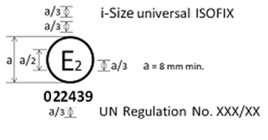
The Enhanced Child Restraint System bearing the above approval mark is a device, including module(s), capable of being fitted in any i-size compatible vehicle seating position. It is approved in France (E 2) under the number 022439. The approval number indicates that the approval was granted in accordance with the requirements of the Regulation concerning the approval of Enhanced Child Restraint Systems used onboard of motor vehicles as amended by the 02 series of amendments. In addition the name of the regulation has to be identified on the approval mark followed by the series of amendment according to which the approval has been granted.

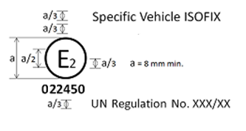
The Enhanced Child Restraint System bearing the above approval mark is a device, including module(s), not capable of being fitted in every vehicle. It is approved in France (E 2) under the number 022450. The approval number indicates that the approval was granted in accordance with the requirements of the Regulation concerning the approval of Specific vehicle ISOFIX Enhanced Child Restraint Systems used on board of motor vehicles as amended by the 02 series of amendments. In addition the name of the regulation has to be identified on the approval mark followed by the series of amendment according to which the approval has been granted.

Arrangements of the module mark in combination with an approval mark
R129 - 022439
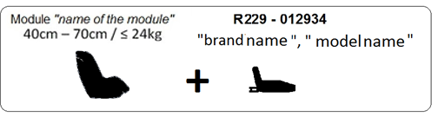
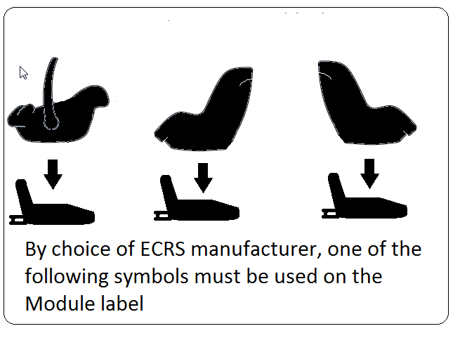

The Enhanced Child Restraint System module bearing the above module mark capable of being used for the 40 cm - 70 cm size range and mass limit of 24 kg; it is approved under the number 022439 to be used in combination with device approved according to Regulation No. 129 under the same number 022439. The approval number indicates that the approval was granted in accordance with the requirements of the Regulation concerning the approval of Enhanced Child Restraint Systems used onboard of motor vehicles as amended by the 02 series of amendments."
- Annex 6, Appendix 2, amend to read:
"Annex 6 - Appendix 2
Arrangement and use of anchorages on the test trolley
1. The anchorages shall be positioned as shown in the figure below.
2. Enhanced Child Restraint Systems in the i-Size universal, specific and restricted categories shall use the following anchorage points: H₁ and H₂.
3. For testing of Enhanced Child Restraint Systems with top tether, the anchorage G₁ or G₂ shall be used.
4. In the case of Enhanced Child Restraint Systems utilising a support-leg, the Technical Service shall select the anchorages to be used according to paragraph 3. above and with the support-leg adjusted as specified in paragraph 7.1.3.6.3. of this Regulation.
5. The structure carrying the anchorages shall be rigid. The upper anchorages shall not be displaced by more than 0.2 mm in the longitudinal direction when a load of 980 N is applied to them in that direction. The trolley shall be so constructed that no permanent deformation shall occur in the parts bearing the anchorages during the test.
Figure 1
Top View – Bench with ISOFIX anchorages (Tolerance general: ±2 mm)
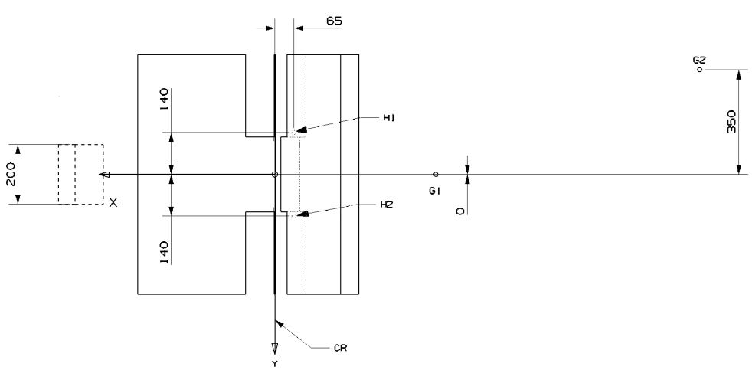
Figure 2
Side View – Bench with anchorages (Tolerance general: ±2 mm)
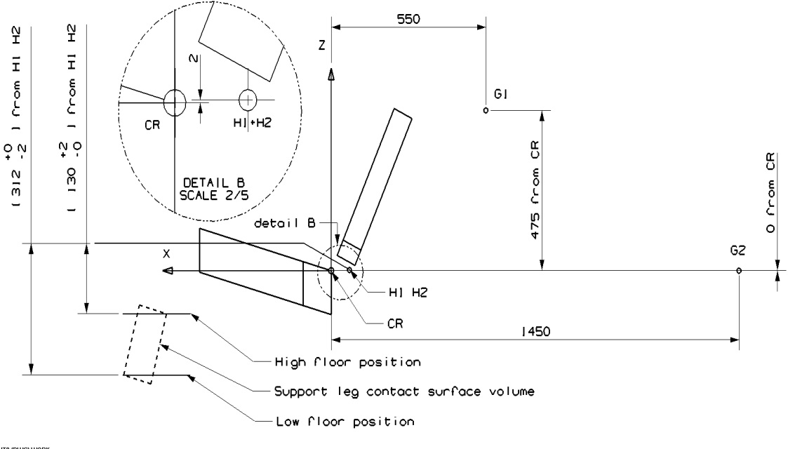
- Definition of belt anchorages
- The following table gives the belt anchorages points.
Table 1
 | Upper Anchorage (P) |  |  | Buckle (A2) |  |  | Lower outer (A1)
Direction | X | Y | Z | X | Y | Z | X | Y | Z
Distance  (mm) | -240 | -220 | -630 | -29 | 200 | 59 | 10 | -200 | 14.5

Figure 3
Top View – Bench with belt anchorages (Tolerance general: ±2 mm)
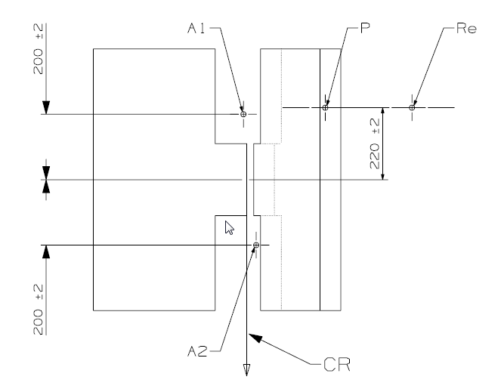
"Re" is located on the centre line of the retractor spool
Figure 4
Side View – Bench with belt anchorages (Tolerance general: ±2 mm)
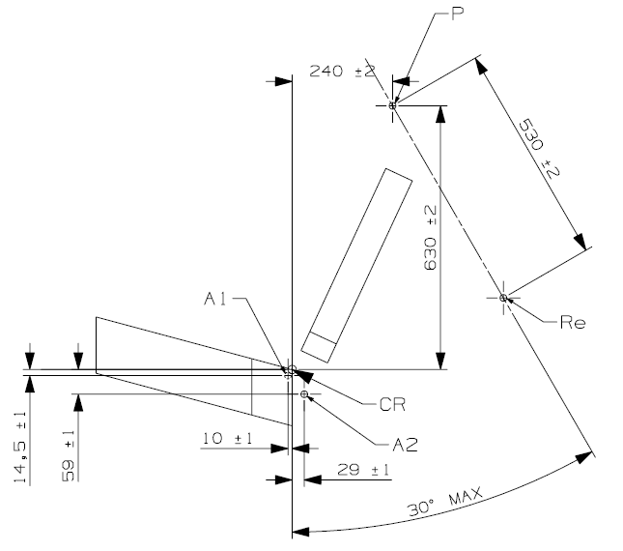
"Re" is located on the centre line of the retractor spool"
Annex 18, amend to read:
"Annex 18
Geometrical dimensions of Enhanced Child Restraint Systems

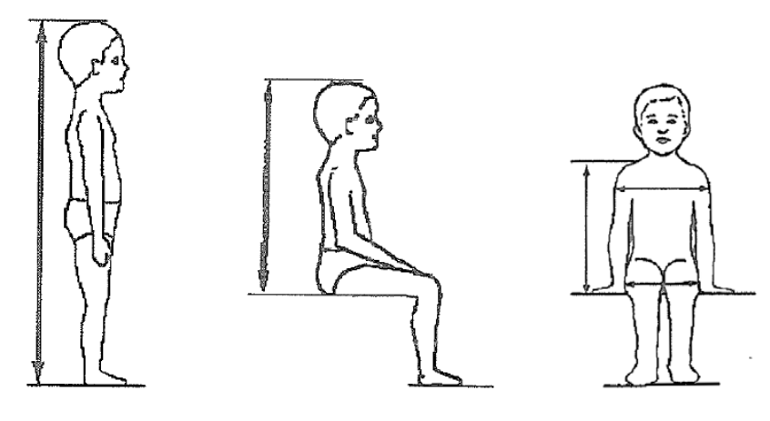
Figure 1

A
B
C
E
D

Stature cm | Minimum  Sitting height cm | Minimum  Shoulder breadth cm | Minimum  Hip breadth cm | Minimum  Shoulder height cm | Maximum  Shoulder height cm
A | B | C | D | E1 | E2
 | 95%ile | 95%ile | 95%ile | 5%ile | 95%ile
≤40 |  |  |  | ≤27.4
45 | 39.0 | 12.1 | 14.2 | 27.4 | 29.0
50 | 40.5 | 14.1 | 14.8 | 27.6 | 29.2
55 | 42.0 | 16.1 | 15.4 | 27.8 | 29.4
60 | 43.5 | 18.1 | 16.0 | 28.0 | 29.6
65 | 45.0 | 20.1 | 17.2 | 28.2 | 29.8
70 | 47.1 | 22.1 | 18.4 | 28.3 | 30.0
75 | 49.2 | 24.1 | 19.6 | 28.4 | 31.3
80 | 51.3 | 26.1 | 20.8 | 29.2 | 32.6
85 | 53.4 | 26.9 | 22.0 | 30.0 | 33.9
90 | 55.5 | 27.7 | 22.5 | 30.8 | 35.2
95 | 57.6 | 28.5 | 23.0 | 31.6 | 36.5
100 | 59.7 | 29.3 | 23.5 | 32.4 | 37.8
105 | 61.8 | 30.1 | 24.9 | 33.2 | 39.1
110 | 63.9 | 30.9 | 26.3 | 34.0 | 40.4
115 | 66.0 | 32.1 | 27.7 | 35.5 | 41.7
120 | 68.1 | 33.3 | 29.1 | 37.0 | 43.0
125 | 70.2 | 34.5 33.3 | 30.5 29.1 | 38.5 | 44.3
130 | 72.3 | 35.7 33.3 | 31.9 29.1 | 40.0 | 46.1
135 | 74.4 | 36.9 33.3 | 33.3 29.1 | 41.5 | 47.9
140 | 76.5 | 38.1 34.2 | 34.7 29.6 | 43.0 | 49.7
145 | 78.6 | 39.3 35.3 | 36.3 30.8 | 44.5 | 51.5
150 | 81.1 | 41.5 36.4 | 37.9 32.0 | 46.3 | 53.3

…"
Annex 20, amend to read:
"Minimum list of documents required for approval
 | i-Size or i-Size booster seat ECRS | Specific vehicle, ISOFIX or booster seat ECRS | paragraph:
General documents | Application letter/request | Application letter/request | 3.1.
…"
Annex 21, modify figure of Load Application device II, by adding the text “measured in flat condition of the harness”

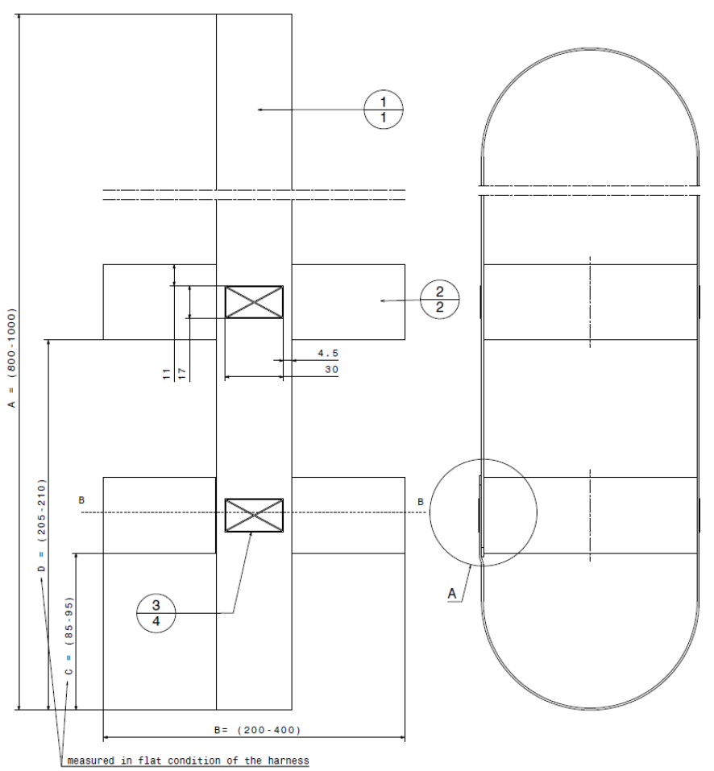

Insert new Annex 23, to read:
"Annex 23
Standard safety-belt
1. The safety-belt for the dynamic test and for the maximum length requirements shall be made according to the configuration shown in Figure 1. These are a three-point retracting belt system.
2. The three-point retracting belt has the following rigid parts: a retractor (R), a pillar loop (P), two anchorage points (A1 and A2) (see Figure 1), and a central part (N, in detail in Figure 3). The retractor shall comply with the requirements of Regulation No. 16 (paragraph 6.2.5.2.2.) for retraction force. The retractor spool diameter is 33 ± 0.5 mm [(example is given in Mutual Resolution No. 1 (M.R.1))].
3. The retracting belt shall be fitted to the anchorages on the test bench, described in Annex 6, Appendix 2 as follows:
(a) Belt anchorage A1 shall be fitted to trolley anchorages B0 (outboard);
(b) Belt anchorage A2 shall be fitted to trolley anchorage A (inboard);
(c) Belt pillar loop P shall be fitted to trolley anchorage C;
(d) Belt retractor R shall be fitted to trolley anchorage such that the spool centre line is positioned on Re.
The value of X in Figure 1 below is 200 ± 5 mm. The effective strap length between A1 and the centre line of the retractor spool Re (when the webbing is fully extracted including the minimum length of 150 mm for testing of Enhanced Child Restraint System shall be [2820] ± 5 mm when measured in a straight line without load and on a horizontal surface. This length may be increased for the testing of restricted categories; for all categories with the Enhanced Child Restraint System installed, there shall be a minimum of 150 mm of strap length on the retractor spool.
4. The strap requirements for the belt as follows:
(a) Material: polyester spinnblack;
(b) Width: 48 +/- 2 mm at 10,000 N;
(c) Thickness: 1.0 +/- 0.2 mm;
(d) Elongation: 8 +/- 2 per cent at 10,000 N.
Figure 1
Standard seat belt configurations
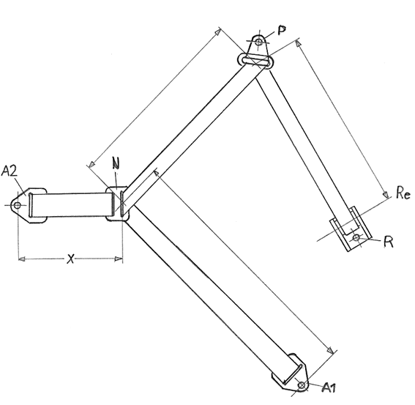

Figure 2
Typical standard anchorage plate

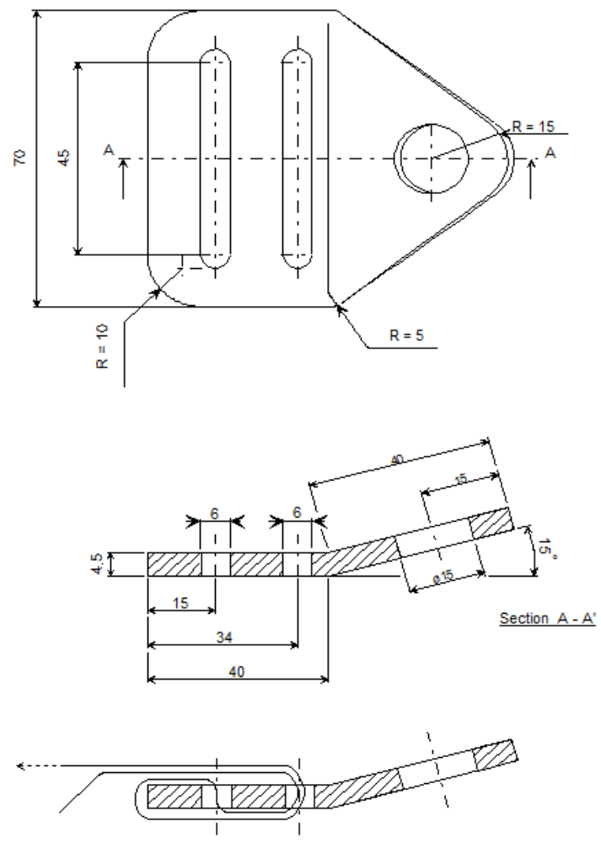
Figure 3
Central part of the standard belt configuration
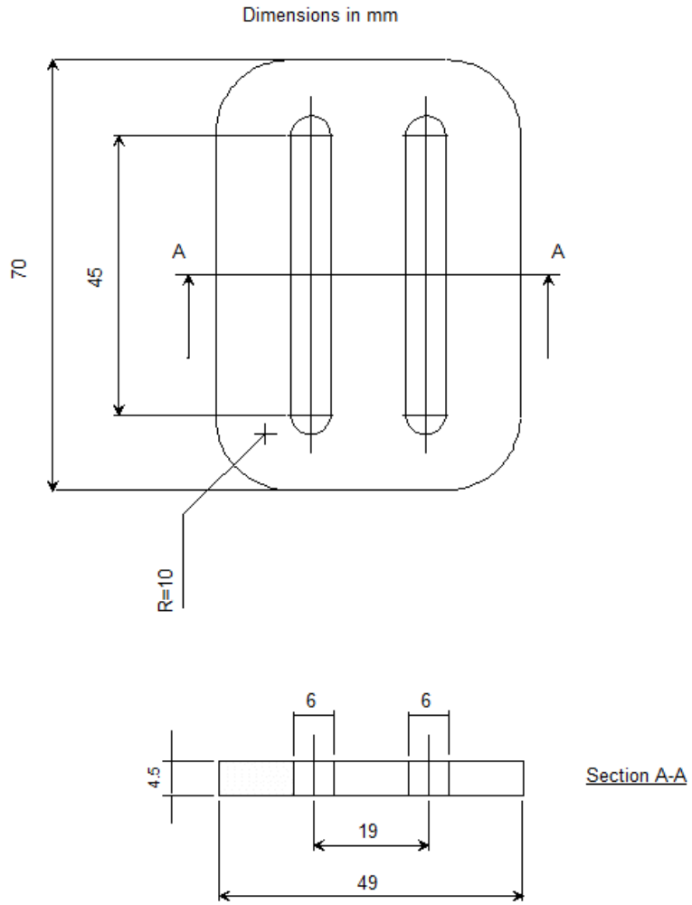
Figure 4
Pillar loop
Finish: Chromium plated
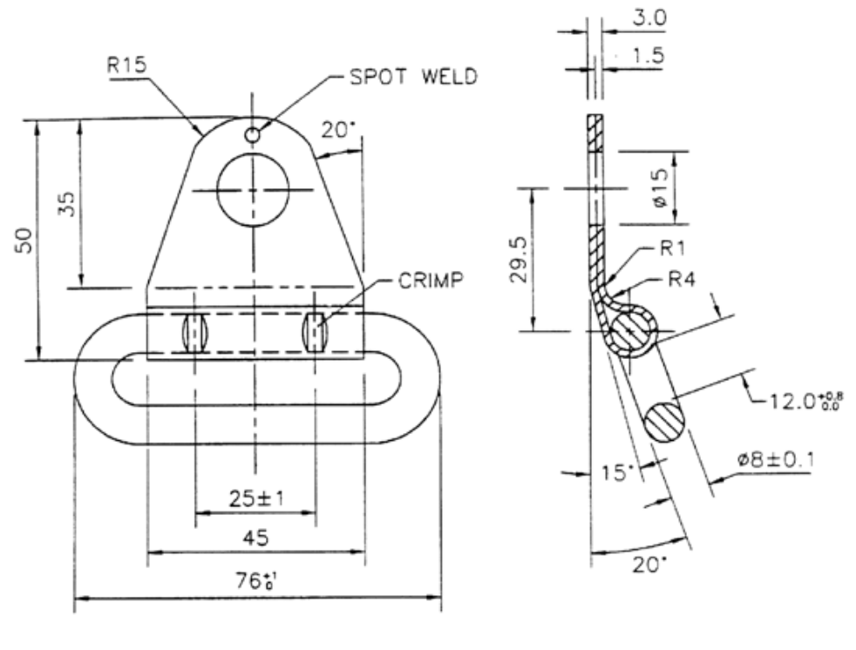"
II. Justification
1. The proposed amendment includes Enhanced Child Restraint Systems from the booster seat category (booster seat with backrest) into the scope of UN Regulation No. 129. This represents Phase 2 of the UN Regulation.
2. The text includes all modifications proposed by GRSP up to and including its fifty-seventh session (Geneva, 18–22 May 2015) as well as those of the IWG CRS up to and including its fifty-third session (London, 2 September 2015).
3. The reference document is the original UN Regulation No. 129, Corrigendum 1, Supplements 1, 2, 3 and 4 as well as the draft 01 series of amendments to the UN Regulation (ECE/TRANS/WP.29/GRSP/2015/24) Phase 1.

* * In accordance with the programme of work of the Inland Transport Committee for 2014–2018 (ECE/TRANS/240, para. 105 and ECE/TRANS/2014/26, programme activity 02.4), the World Forum will develop, harmonize and update Regulations in order to enhance the performance of vehicles. The present document is submitted in conformity with that mandate.
? Detail B describes the standard dimensions without ISOFIX attachments. Figure 1 gives the dimensions for optional ]stowable ISOFIX attachments.
ECRS shall not be approved only on the base of Q3 test results in non integral configuration

