SLR-74-04
(Revision of SLR-72-12)

Draft proposal (NL) concerning simplification of “apparent surface”.
Prepared for the SLR-74 meeting (10 to 12 September 2025).
Taking the comments / discussions during SLR-72 and -73 into account.

List of documents: see end of this document.
Essential elements and considerations
- Removal of the concepts “light-emitting surface” and “illuminating surface”. Only use the concept “apparent surface” instead. If necessary, the concept “apparent surface” should be given another name.

- Simplify the definition (and therefore also the determination) of “apparent surface”:
  - For signalling lamps:
- Luminance method or
- Improved old method:
    - Active textured lens or
    - Aperture of reflectors of non-textured lens (or if there is a lens behind the outer non-textured lens then start with b) for that lens as well).
    - Sum of active textured lenses (i.) plus apertures of non-textured lens (ii.)
  - For lighting devices:
The full apertures of the reflectors and projection lenses etc. In principle no change.
  - For retro-reflecting devices:
No changes.

- In case of determination of only the edges (upper, lower, inner and outer), horizontal and vertical tangents of the apparent surface shall be used.

- Improved definition of textured lenses. If necessary “lenses” can be replaced by “optical component” or “optical element”. One of the alternative definitions of “active textured lens” have been given. The word “outer” is removed.
- Consideration of deleting of examples of Annex 3 as a consequence of the proposed simplified wording of the body text.

Draft amendment to Regulation No. 48 (based on baseline document R.48 SLR-73-07 Rev. 1)

Paragraph 2.8.3. amend to read:
2.8.3. "Textured lens" or "Textured lens area" means
a light diffusing lens or a light diffusing lens area,
or
a lens or lens area having optical structures
designed to modify or influence the propagation of light from the light source(s), such that the light rays are significantly diverted from their original direction.

Add a new paragraph:
2.8.3.1. “Active textured lens” or “Active textured lens area” is that portion of the textured lens that is illuminating light when viewed by an observer from a defined direction.

Delete existing par. 2.10.2, 2.10.3 and 2.10.4 and insert:
2.10.2. The "apparent surface" for a defined direction of observation means the orthogonal projection, as declared by the applicant during the component approval procedure, of:
2.10.2.1. In case of a light-signalling device: that portion of the lamp that is determined by either a) or b) below.
- That portion of the lamp that is having a luminance in candela per square meter (cd/m²) exceeding the applicable threshold value. This method is described in Annex [xx]
- That portion of the lamp that is
    - constituting the active textured lens of the exterior surface
or
    - including the apertures of the reflectors behind the outer lens that are creating the function, or active textured lenses behind the outer lens, in case the outer lens, relevant for the applicable light-signalling device, is not textured
or
    - constituting partly of i. and partly of ii. above, in case the lens, relevant for the applicable light-signalling device, is partly textured and partly not textured.
2.10.2.2. In case of a lighting device: that portion of the lamp, relevant for the applicable lighting device, which includes the full apertures of the reflectors and lenses.
If only part of the reflector or projection lens is creating the function then that part only is taken into account.
If the reflector and lens are adjustable relative to one another, the mean adjustment should be used.
2.10.2.3. In case of a retro-reflector: that portion of the device delimited by planes contiguous to the declared outermost parts of the retro-reflectors' optical system. For the purposes of determining the lower, upper and lateral edges of the device, only horizontal and vertical planes shall be considered.
2.10.2.4. In the case that a lamp, relevant for the applicable light-signalling or lighting device, is composed by two or more simultaneously operating units, the individual apparent surfaces taken together constitute the apparent surface.
2.10.2.5. To determine the lower, upper and lateral limits (edges) of a lighting or light-signalling device the following applies:
2.10.2.5.1. For verifying the distance to the extreme edges of the vehicle and the height above the ground the [relevant] horizontal and vertical tangent of the apparent surface shall be used.
2.10.2.5.2. For other applications, e.g. distance between two lamps or functions, the tangents used shall remain parallel, but other orientations are allowed to be used.
Renumber 2.10.5 to 2.10.18 to: 2.10.3 to 2.10.16.

New ANNEX xx
At this moment the measurement method is under review in the GTB WG Photometry. Next meeting end of September
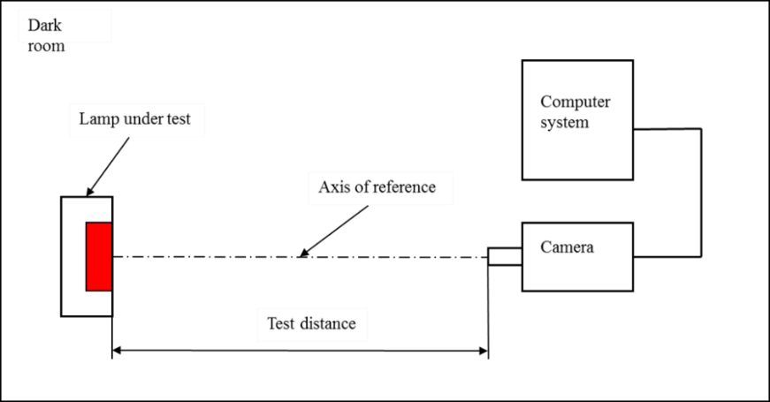
Measurement system

The test distance between DUT and luminance camera shall be at least ten times (10x) the size of the evaluated area. In case of larger devices, it is possible to segment the measurement of the apparent surface by taking multiple images.
The spectral adaptation f’1 of the luminance camera, as defined in ISO/CIE 19476.2014, shall be less than 3%. The luminance camera shall be a type II ILMD. i.e. in addition to the photometric calibration it carries a geometry calibration as well (cf. CIE S027:2024).
The field-of-view of the camera lens shall be such that the apparent surface of the light-signalling device can be captured, either full or in segments, for subsequent analysis of the luminance distribution.
The image resolution shall be such that at least one pixel of the camera-sensor-chip corresponds with one square millimetre of the apparent surface of the device. Subsequently, the image resolution shall be downsized to [1mm²]/px before the apparent surface is evaluated.

The apparent surface measured in the direction (θ, φ) consists of the surface that exceeds the corresponding threshold T(θ, φ).
T(θ, φ) = K ∙ I(θ, φ) where

θ represents the vertical (or elevation) angle (in °) with respect to the reference axis
φ represents the horizontal (or longitudinal) angle (in °) with respect to the reference axis
K is equal to a factor of 5 and having a dimension of 1/m²

I(θ, φ) is equal to the measured luminous intensity (in cd) in the direction of observation (θ, φ) with respect to the reference axis of the light-signalling device under test.

Remark:
On the reference axis both θ and φ are zero resulting in T = K ∙ I
Examples:
- I = 85 cd for a stop lamp on the reference axis. Then the threshold is 85 ∙ 5 cd/m² = 425 cd/m²
- I = 12 cd for a rear position lamp on the reference axis. Then the threshold is 12 ∙ 5 cd/m² = 60 cd/m²

Justification and Remarks
- To reduce confusions and to simplify the three concepts (Light emitting surface, Illuminating surface and Apparent surface) into one concept “apparent surface” only.

- The determination of the apparent surface is simplified with either the luminance measurement method or the determination on the bases of active textured lens areas and, if not textured, apertures of reflectors and lenses.

- The 98% intensity method is removed and in case of determination of only the edges (upper, lower, inner and outer), horizontal and vertical tangents of the apparent surface shall be used.

- A text shall be added to UN Regulation No. 148-01 paragraph 3.1.2.1. (c ) where the applicant confirms which alternative (a or b) of the revised par. 2.10.2.1. has been applied for the individual light-signalling devices.

- The Luminance Threshold shall be dependent on the actual luminous intensity:
For typical stop lamp the typical values: I_{HV} = 100 cd and an area of about 100 cm².
This would correspond with an average luminance (L_{avg}) of 100 cd / 100 cm² = 1 cd/cm² = 10.000 cd/m². Then 5% is corresponding with 500 cd/m², which has been used numerous times to determine the effective projected luminous lens area according to the American Federal Motor Vehicle Safety Standard No. 108 (FMVSS108).

- Regulations 48, 148, 149 and 150 shall be reviewed for using the wording “illuminating surface” or “light-emitting surface”. In principle the wording has to be replaced by apparent surface.

- The examples (images) of Annex 3 were intended for a better understanding of the concepts. However in the view of the various discussions and many different interpretations, the question now arises whether the examples of Annex 3 are still serving the intended purposed. Especially with the proposed simplified wording. The proposal does not refer to Annex 3 anymore, implying that all examples related to apparent surface would be superfluous and could be removed. Therefore deletion of (a number of) examples in Annex 3 is considered.

List of documents (in blue the Dutch contributions)
# | Document number | Content
1 | SLR-54-08 | NL - Measurement of Luminous Area of Automotive Lamp Function
2 | SLR-54-14 | SAE - FMVSS - EPLLA Presentation for SLR-54
3 | SLR-57-03 | NL - Apparent surface, key questions and considerations
4 | SLR-58-05 | CLEPA - Appearance of signal lamps - AL study from 2011
5 | SLR-61-03 | NL - Discussion document on apparent surface
6 | SLR-61-05 | AL Marelli - Apparent surface measurement approach
7 | SLR-61-08 | GTB - Comments to the Dutch discussion document SLR-61-03
8 | SLR-61-09 | GTB - Investigation on apparent surface based on luminance criteria
9 | SLR-62-14 | GTB - Apparent surface and angles of geometric visibility in UNECE R48
10 | SLR-63-02 | Officers SLR - Apparent Surface - Overview of ideas for simplification (withdrawn)
11 | SLR-64-08 Rev. 1 | SAE - New technology and EPLLA
12 | SLR-64-09 | GTB - Ideas for new approach to apparent surface
13 | SLR-65-06 | NL - Draft proposal Apparent Surface
14 | SLR-66-03 | NL - Revised proposal Apparent Surface
15 | SLR-67-10 | OICA - Luminance threshold for apparent surface
16 | SLR-68-07 | NL - Revised proposal Apparent Surface
17 | SLR-68-08 | NL - Addressing OICA comments on luminance threshold (doc. SLR-67-10)
18 | SLR-68-09 | Dieter Kooss - Apparent surface measurement - Explanation method
19 | SLR-68-16 | SAE - University of Michigan Report - UMTRI-98-19
20 | SLR-69-01 | NL - Revised proposal Apparent Surface
21 | SLR-69-02 | NL - Rev. Addressing OICA comments on luminance threshold (doc. SLR-67-10)
22 | SLR-69-12 | OICA – Apparent Surface by luminance measurement
23 | SLR-70-01 | NL - Revised proposal Apparent Surface
24 | SLR-70-02 | NL - Comments and Explanation of OICA document SLR-69-12
25 | SLR-70-04 | SAE – EPLLA Presentation at SAE Scottsdale 2008
26 | SLR-70-06 | … – Apparent Surface SLR special session
27 | SLR-70-07 | … - Proposal on apparent surface
28 | SLR-70-08 | OICA - Apparent Surface by luminance measurement OICA concerns
29 | SLR-70-16 | UK - Apparent Surface - Multiple modes animation, V2X and warnings
30 | SLR-71-05 | PL - Proposal to simplify the definition of 'surface'
31 | SLR-71-11 | … - Additional information on the EPLLA measurement methods in USA
32 | SLR-72-02 | PL - Rev. proposal to simplify the definition of 'surface' (Rev. of SLR-71-05)
33 | SLR-72-12 | NL – Revised proposal Apparent Surface
34 | SLR-72-15 | GTB - Info GTB input to SLR on Apparent Surface
35 | SLR-72-19 | PL - Examples of luminance surface measurements
36 | SLR-73-03 | PL - Surface test by luminance camera
37 | SLR-73-06 | GTB Input on Apparent surface for SLR 73

