Input from GTB TF Apparent Surface to SLR 74 discussion on apparent surface
SLR-74-05/Rev.1

I Task
Develop a simple method to determine the apparent surface at an early design stage (offer phase) by means of CAD, which remains valid until the approval of installation of the lamps on the vehicle.
The result should be predictable and repeatable and represent what you see on the vehicle. Any new method should lead to more clarity and not add complexity.
The GTB Taskforce concentrates on the development of a CAD based method. In parallel GTB Working Group Photometry explore the luminance method.

II. Approach
- Identification of the relevant areas/elements contributing to the light function = light emitting surfaces
- Optical components (light guides, reflectors, filters, textured lens areas, etc.) and light sources
- Definition of the apparent surface
- Explanatory pictures replacing current pictures in Annex 3 to show the intention will be helpful.

This approach significantly simplifies the apparent surface by concentrating on one method (light emitting surface) that can be used in an early design stage and is close to visual impression.

III. Identified opportunity for clarification
Some lamps (maneuvering lamps, exterior courtesy lamps) can be either assessed visually on the vehicle or on a drawing. During the task force discussions, it became clear that the “apparent surface” (=projection on a plane) may not be the correct reference to assess illuminating areas for visual inspection or from different visibility angles. What you actually see on the vehicle is the light emitting surface.
To resolve this, two alternatives have been discussed:

Alternative A (refine current approach):
Apparent surface = projection in the “direction of observation” (one defined direction) as present in current R48 + replace instances relating to visual inspection with “light emitting surface” (= 3- dimensional) where appropriate. Proposed text SLR73:
2.10.3 The “apparent surface” means the orthogonal projection of the unobstructed light emitting surface(s) contributing to a specific function on a plane perpendicular to the axis of reference [and in contact to the most exterior point of the lens]

Alternative B:
More general definition of apparent surface to fit for drawings (= projection) as well as for visual inspection. Proposed text SLR73:
2.10.3 The apparent surface from a defined direction of observation means the sum of all visible light emitting surface(s) contributing to a function.

 | PRO | CON
Alternative A  (apparent surface = projection visual aspect = reference to light emitting surface) | -Keeps current, well-known concept  -Relates to existing type-approval documentation  - Retains two specific definitions for 2D and 3D assessment | -does not suit visual inspection on the vehicle (can be solved by improving the specifications, e.g. using “light emitting surface” where appropriate)
Alternative B  more generic approach to apparent surface fitting to projection (= drawings) as well as to visual inspection | - Fits for drawings, as well as for visual inspection  - clarifies requirement for visibility of a function | - projection is needed to assess all relevant requirements, e.g. size, single lamp, etc.  -may confuse difference between “apparent surface” (2D) and “light emitting surface” (3D)

Conclusion: The GTB experts came to the conclusion that Alternative A is more advantageous as it does not change current understanding of the concept and retains specific definition for 2D and 3D assessment.

III. Draft Text Proposal (based on alternative A)
2.10.2 “Light emitting surface” of a function means any area that emits light or is designed to modify or influence the propagation of light towards the standard light distribution grid.
To evaluate the geometric visibility of a function any area contributing to the respective visibility zone inboards and outboards is also taken into account.
2.10.3 The “apparent surface” means all [visible /unobstructed] light emitting surface(s) contributing to a specific function orthogonally projected on a plane perpendicular to the direction of observation [and intersecting the lens transmitting the function].
2.10.3 The “apparent surface” means the orthogonal projection of the visible and unobstructed light emitting surface(s) contributing to a specific function on a plane perpendicular to the direction of observation [and intersecting the lens transmitting the function]
It is declared on the drawing in the request for approval by the applicant or his duly accredited representative.

Remark: in a first step the group agreed to concentrate on a definition for Light-signaling devices. Then it will be decided, if this fits also for road illumination devices and retroreflectors – if necessary with some adaptions – or if it is better to add separate definitions for RID and RRD.
- Discussion in SLR, whether “apparent surface” term should be used also for RRD (currently “illuminating surface” is used in R150)

IV. changes to R48/148/149 (not complete)
- Delete/replace current 2.10.2+3+4 relating to light emitting/illuminating surface + apparent surface
- delete R48 3.2.5 declaration of the method chosen for type-approval
- rework R48 annex 3 (new examples)
- R148 review instances of “light emitting surface” e.g. 4.8.1.9 or sequential DI activation

Next steps:
- Check if the new definition is well understodd
- thorough check if the new definition fits to the requirements in regulation and to real life
- Check if definition fits also for road illumination devices

V common understanding
- Areas that are not visible from the projection direction are not taken into account
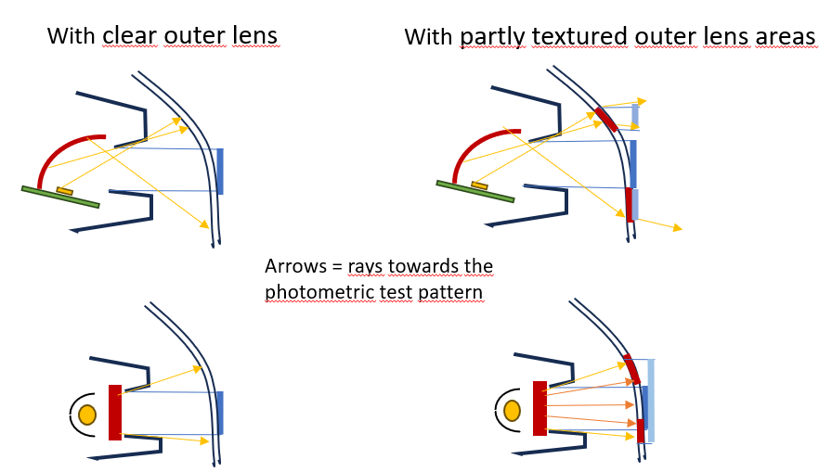
1) Every element, that illuminates for a specific function and contributes to the photometric grid is taken into account
Light source (yellow) and
Light emitting surface (red) (e.g. reflectors, light guides, textured lens areas) = CAD, lamp parts
2) Obstructing elements (e.g. bezel) are taken into account
3a) Alternative A: Apparent surface (blue) identified elements in the direction of observation (here: HV) = drawing
3b) Alternative B: Apparent surface = visibility of light emitting surface

- Textured lens areas are only taken into account if they contribute to the relevant direction (standard light distribution or visibility)
Direction of observation: 80°
Direction of observation: HV
Direction of observation: HV
Partly textured outer lens in the direction of observation
Partly textured outer lens directing light in the irrelevant direction (here: visibility 80° )
Partly textured outer lens directing reflected or direct light towards the standard light distribution grid

Apparent surface:
Alternative B: red area
Apparent surface:
Alternative A: blue area
Apparent surface:
Alternative A: blue area
Alternative B: red areas
Apparent surface:
Alternative A: blue area
Alternative B: red areas

