SLR-74-06

Draft OICA Input to SLR - Horizontal adjustment of passing-beam/driving-beam and for AFS/ADB

Action from SLR-72

Mr. Pernkopf offered to draft, with assistance of OICA experts, a text for SLR-74 to introduce a requirement for correct horizontal adjustment of passing-beam/driving-beam and for AFS/ADB.

OICA Response

OICA is not opposed ‘in principle’ to introducing a regulatory requirement for horizontal adjustment of headlamps. However, we respectfully request that this topic be withdrawn from the current SLR agenda for the following reasons:

- The proposal does not contribute to the simplification of the lighting regulations. There is no identified safety concern or ambiguity in the current regulatory text that would justify this new requirement.

- The topic originated as a question within the SLR group and lacks a formal proposal from a Contracting Party, NGO, or other stakeholder. Without a clear proponent, it is difficult to justify working on this issue.

- The SLR group is already managing several longstanding issues that have yet to be resolved. Introducing a new topic risks further delaying progress on these existing matters.

- Need for PTI Harmonization - To meaningfully address horizontal adjustment requirements, a comprehensive understanding of Periodic Technical Inspection (PTI) specifications across all Contracting Parties is essential. Only then can harmonized requirements be considered.

Illustrative Example:
We are aware of differing national specifications, such as Germany’s PTI requirement of ±0.5 degrees and the UK’s MOT specification, which prohibits any light directed toward oncoming traffic. These discrepancies highlight the complexity of defining a uniform approach.

Furthermore, the UK is currently conducting a glare study and has expressed significant concern regarding headlamp glare affecting oncoming drivers.

Conclusion:
Until PTI specifications from all Contracting Parties are available and reviewed, it is premature to discuss harmonized requirements. We request that this topic is withdrawn from the current SLR agenda.

German PTI Requirements

UK PTI (MOT) Requirements

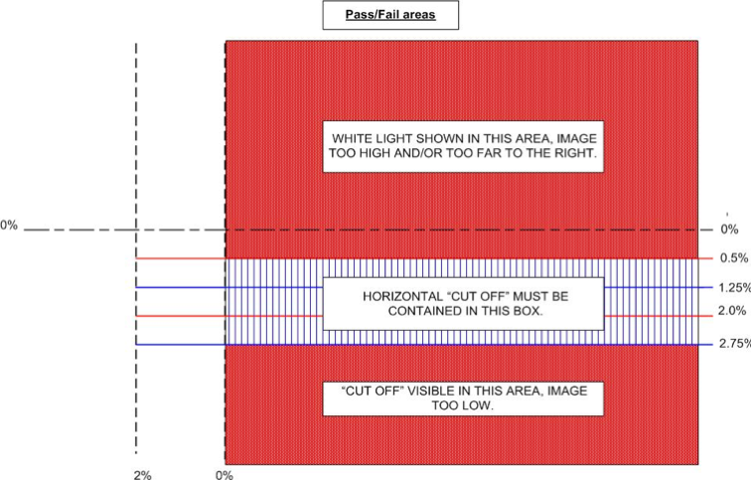

https://www.gov.uk/guidance/mot-inspection-manual-for-private-passenger-and-light-commercial-vehicles/4-lamps-reflectors-and-electrical-equipment#section-4-1-2

