 | United Nations | ECE/TRANS/WP.29/GRSP/2025/XX
 | Economic and Social Council |  | Distr.: General  7. September 2025  Original: English
Economic Commission for Europe
Inland Transport Committee
World Forum for Harmonization of Vehicle Regulations
Working Party on Passive Safety
Seventy-eighth session
Geneva, 1–4 December 2025
Item Y of the provisional agenda
UN Regulation No. 12 (Steering mechanism)

Proposal for supplement 1 to the 05 Series of Amendments to UN Regulation No. 12 (Steering mechanism) *

Submitted by Germany on behalf of the GRSP Task Force AVRS (Automated Vehicle Regulation Screening)

The text reproduced below was prepared by the expert from Germany on behalf of the TF GRSP AVRS, to enable the application of the regulation to vehicles equipped with an ADS. The modifications to the existing text of the UN Regulation are marked in “bold“ for new or strikethrough for deleted characters.

- Proposal
Insert a new paragraph 0, to read:
"0. Introduction
0.1. For supplement 1 to the 05 series of amendments:
0.1.1. The Regulation is amended to account for vehicles of category X¹. Vehicles of category Y¹ are not in the scope of this Regulation.
0.1.2. The Regulation was originally drafted for vehicles with driver and manual driving controls. It is the intention of this new amendment to keep the spirit of the regulation and to extend its application to vehicles without driver and without manual driving controls inside the vehicle. In the absence of driver/manual driving controls in the vehicle, provisions related to them shall not be taken into account if not already covered by this amendment.

0.1.3. In case of vehicles equipped with an Automated Driving System (ADS)¹ other than vehicles of categories X and Y, in the manual driving mode no special provisions or exemptions apply. In a mode where an ADS feature is active the relevant ADS requirements apply."

0.1.4. To improve the structure of the Regulation the scope is separated into vehicles with regard to the protection of occupants against the steering mechanism and/or against electrical shock in a frontal collision and to steering controls with regard to the protection of occupants in the event of an impact, pursuant to the relevant part of Regulation No. 12.

0.1.5. Amendments in paragraphs 3.1.2. and 3.2.2 are not related to the task to make UN Regulations applicable for vehicles with an ADS. The request to send documents in triplicate is outdated.”

Paragraph 1.1., amend to read:
“1.1. This Regulation applies to the behaviour of the steering mechanism and to the electric power train operating on high voltage as well as the high voltage components and systems which are galvanically connected to the high voltage bus of the electric power train, of motor vehicles of category M₁, motor vehicles of category M₁¹ and to vehicles of category N₁¹ with a maximum permissible mass less than 1,500 kg, with regard to the protection of the occupants in a frontal collision. both categories equipped with:
- a steering mechanism with regard to the protection of occupants against the steering mechanism in a frontal collision, and/or
- an electric power train operating on high voltage as well as the high voltage components and systems which are galvanically connected to the high voltage bus of the electric power train with regard to the protection of the occupants in a frontal collision.”

Paragraph 1.1, insert new footnote 1, to read:
^{"1} As defined in the Consolidated Resolution on the Construction of Vehicles (R.E.3.), document ECE/TRANS/WP.29/78/Rev.8, para. 2 -
https://unece.org/transport/vehicle-regulations/wp29/resolutions"
Insert new paragraphs 1.3. and 1.4., to read:
“1.3. This Regulation applies to a steering control type with regard to the protection of occupants against the steering mechanism in the event of an frontal collision, pursuant to the relevant part of Regulation No. 12.
1.4. This Regulation does not apply to vehicles of category Y.”

Paragraph 2.1, amend to read:
“2.1. “Approval of a vehicle" means the approval of a vehicle type with regard to the protection of the driver an occupant against the steering mechanism (if fitted) and, if fitted with an electric power train operating on high voltage, against electrical shock in the event of impact;”

Paragraphs 2.2.1. and 2.2.1.1., amend to read:
“2.2.1. Vehicle powered by an internal combustion engine:
2.2.1.1. The structure, dimensions, lines and constituent materials of that part of the vehicle forward of the steering control (if fitted);”

Paragraphs 2.2.2. and 2.2.2.1., amend to read:
“2.2.2. Vehicle powered by an electric engine
2.2.2.1. The structure, dimensions, lines and constituent materials of that part of the vehicle forward of the passenger compartment and/or if fitted with a steering mechanism, forward of the steering control;”

Paragraph 2.3., amend to read:
"2.3. "Approval of a steering control" means the approval of a steering control type with regard to the protection of the driver an occupant against the steering mechanism in the event of impact;”

Paragraph 2.5., amend to read:
"2.5. "Steering control" means the steering device, usually the steering wheel, which may be actuated by the a driver;

Paragraph 2.7.1., amend to read:
“2.7.1. Designed to protect the vehicle driver an occupant in an impact against the steering control;”

Paragraph 2.8., amend to read:
“2.8. "Steering control rim" means the quasi-toroidal outer ring in the case of the a steering wheel usually griped by the driver's hands during manual driving;

Paragraph 3.1.1., amend to read:
“3.1.1. The application for approval of a vehicle type with regard to the protection of the driver an occupant against the steering mechanism and the application for approval of a vehicle type against electrical shock in the event of impact shall be submitted by the vehicle manufacturer or by his duly accredited representative.”

Paragraph 3.1.2., amend to read:
“3.1.2. It shall be accompanied by the undermentioned documents in triplicate and the following particulars:”

Paragraphs 3.1.2.5 to 3.1.2.8., amend to read:
“3.1.2.5. Evidence that the steering control has been approved in accordance with paragraph 5.2 of the Regulation, if applicable.
3.1.2.6. Evidence that the steering mechanism complies with the specifications of paragraph 5.2.2. of UN Regulation No. 94 or with the specifications of paragraph 5.2.2.1. of UN Regulation No. 137 if the application for approval is submitted by the applicant pursuant paragraph 5.1.2. below, if applicable.
3.1.2.7. Evidence that the steering control complies with the specifications of paragraphs 5.2.1.4. and 5.2.1.5. of UN Regulation No. 94 or with the specifications of paragraphs 5.2.1.1.3. and 5.2.1.1.4. of UN Regulation No. 137 if the application for approval is submitted by the applicant pursuant paragraph 5.2.1. below, if applicable.
3.1.2.8. A general description of the electrical power source type, location and the electric power train (e.g. hybrid, electric), if fitted.”

Paragraph 3.2.1., amend to read:
“3.2.1. The application for approval of a steering control type with regard to the protection of the driver an occupant against the steering mechanism in the event of impact shall be submitted by the vehicle manufacturer or by his duly accredited representative.”

Paragraph 3.2.2., amend to read:
“3.2.2. It shall be accompanied by the undermentioned documents in triplicate and the following particulars:”

Paragraph 3.2.2.3, amend to read:
“3.2.2.3. Evidence that the steering control complies with the specifications of paragraphs 5.2.1.4. and 5.2.1.5. of Regulation No. 94, if the application for approval is submitted by the applicant pursuant paragraph 5.2.1. below, if applicable.”

Paragraph 5.1., amend to read:
“5.1. When the unladen vehicle, equipped with a steering mechanism, in running order, without a manikin, is collision-tested against a barrier at a speed of 48.3 km/h (30 mph), it shall meet paragraphs 5.2. to 5.5.5.5.4.5. and the top of the steering column and its shaft shall not move backwards, horizontally and parallel to the longitudinal axis of the vehicle, by more than 12.7 cm and also not more than 12.7 cm vertically upwards, both dimensions considered in relation to a point of the vehicle not affected by the impact².
²See Annex 3, paragraph 3.1.”

Paragraph 5.1.1. renumber as 5.2., and amend to read:
“5.2.5.1.1. Additionally vehicles Vehicles equipped with electric power train shall meet paragraph 5.5.5.6. In case of vehicles equipped with a steering mechanism This this could be demonstrated in a separate frontal impact test at the request of the manufacturer after validation by the Technical Service, given that the electric components do not influence the driver's occupant protection performance of the vehicle type as defined in this Regulation.”

Former paragraph 5.1.2. renumber as 5.1.1.

Insert new paragraph 5.2.1., amend to read:
“5.2.1. Specifications of paragraph 5.2. above are deemed to be met if the vehicle equipped with such a steering system complies with the specifications of paragraph 5.2.2. of UN Regulation No. 94 or with the specifications of paragraph 5.2.2.1. of UN Regulation No. 137.”

Former paragraph 5.2. renumber as 5.3.

Former paragraph 5.2.1. renumber as 5.3.1., and amend to read:
“5.3.1.5.2.1. If the steering control is fitted with a steering wheel airbag, specifications of paragraph 5.2.5.3 above are deemed to be met if the vehicle equipped with such a steering system complies with the specifications of paragraphs 5.2.1.4. and 5.2.1.5. of UN Regulation No. 94 or with the specifications of paragraphs 5.2.1.1.3. and 5.2.1.1.4. of UN Regulation No. 137.”

Former paragraph 5.3. renumber as 5.4.

Former paragraph 5.4. renumber as 5.5., and amend to read:
“5.5.5.4. TheA steering control shall be designed, constructed and fitted in such a way that:”

Former paragraph 5.4.1. renumber as 5.5.1., and amend to read:
“5.5.1.5.4.1. Before the impact test prescribed in paragraphs 5.2. and 5.35.3. and 5.4. above no part of the steering control surface, directed towards the driver an occupant, which can be contacted by a sphere of 165 mm in diameter shall present any roughness or sharp edges with a radius of curvature of less than 2.5 mm.
In the case of a steering control equipped with an airbag, this requirements shall be deemed satisfactory if no part, which can be contacted by a sphere of 165 mm in diameter, contains any dangerous sharp edges, as defined in paragraph 2.18. of Regulation No. 21, likely to increase the risk of serious injury to the occupants.”

Former paragraph 5.4.1.1. renumber as 5.5.1.1., and amend to read:
“5.5.1.1. 5.4.1.1. After any impact test prescribed in paragraphs 5.2. and 5.35.3. and 5.4. the part of the steering control surface directed towards the driver an occupant shall not present any sharp or rough edges likely to increase the danger or severity of injuries to the driver. Small surface cracks and fissures shall be disregarded.”

Former paragraph 5.4.1.1.1. renumber as 5.5.1.1.1., and amend to read:
“5.5.1.1.1.5.4.1.1.1. In the case of a projection consisting of a component made of non-rigid material of less than 50 Shore A hardness mounted on rigid support, the requirement of paragraph 5.4.1.15.5.1.1. shall only apply to the rigid support.”

Former paragraph 5.4.2. renumber as 5.5.2., and amend to read:
“5.5.2.5.4.2. The steering control shall be so designed, constructed and fitted as not to embody components or accessories, including the horn control and assembly accessories, capable of catching in the driver's clothing of an occupant or jewellery in normal driving movements.”

Renumber former paragraphs 5.4.3 to 5.5.. accordingly, as 5.5.3. to 5.6.

Former paragraph 5.5.1. renumber as 5.6.1., and amend to read:
“5.6.1.5.5.1. Protection against electrical shock”
After the impact, the high voltage buses shall meet at least one of the four criteria specified in paragraph 5.6.1.1. 5.5.1.1. through paragraph 5.6.1.4.2.5.5.1.4.2. below.
If the vehicle has an automatic disconnect function, or device(s) that conductively divide the electric power train circuit during driving condition, at least one of the following criteria shall apply to the disconnected circuit or to each divided circuit individually after the disconnect function is activated.
However, criteria defined in 5.6.1.4. 5.5.1.4. below shall not apply if more than a single potential of a part of the high voltage bus is not protected under the conditions of protection degree IPXXB.
In the case that the crash test is performed under the condition that part(s) of the high voltage system are not energized and with the exception of any coupling system for charging the REESS which is not energized during driving conditions, the protection against electrical shock shall be proved by either paragraph 5.6.1.3. 5.5.1.3. or paragraph 5.6.1.4. 5.5.1.4. below for the relevant part(s).”

Renumber former paragraphs 5.5.1. to 5.5.1.3. accordingly, as 5.6.1.1. to 5.6.1.3.

Former paragraph 5.5.1.4. renumber as 5.6.1.4., and amend to read:
“5.6.1.4.5.5.1.4. Isolation resistance
The criteria specified in the paragraphs 5.6.1.4.1. 5.5.1.4.1. and 5.6.1.4.2. 5.5.1.4.2. below shall be met.
The measurement shall be conducted in accordance with paragraph 5. of Annex 7.”

Renumber former paragraph 5.5.1.4.1. as 5.6.1.4.1.

Former paragraph 5.5.1.4.2. renumber as 5.6.1.4.2., and amend to read:
“5.6.1.4.2. 5.5.1.4.2. Electric power train consisting of combined DC- and AC-buses
If the AC high voltage buses and the DC high voltage buses are conductively connected, they shall meet one of the following requirements:
(a) Isolation resistance between the high voltage bus and the electrical chassis shall have a minimum value of 500 Ω/V of the working voltage;
(b) Isolation resistance between the high voltage bus and the electrical chassis shall have a minimum value of 100 Ω/V of the working voltage and the AC bus meets the physical protection as described in paragraph 5.6.1.3.5.5.1.3.;
(c) Isolation resistance between the high voltage bus and the electrical chassis shall have a minimum value of 100 Ω/V of the working voltage and the AC bus meets the absence of high voltage as described in paragraph 5.6.1.1. 5.5.1.1.”

Renumber former paragraphs 5.5.2. to 5.5.4. accordingly, as 5.6.2. to 5.6.4.
“5.7.5.6. Specifications of paragraphs 5.6.5.5. to 5.6.4.5.5.4. above are deemed to be met if the vehicle equipped with an electrical power train operating on high voltage complies with the specifications of paragraphs 5.2.8. to 5.2.8.4. of UN Regulation No. 94, 04 series of amendments or with the specifications of paragraphs 5.2.8. to 5.2.8.4. of UN Regulation No. 137, 02 series of amendments.”

Paragraph 6.1., amend to read:
“26.1. Compliance with the requirements of paragraphs 5.1. to 5.5.5.4. above shall be checked in accordance with the methods set out in Annexes 3, 4 and 5 to this Regulation. Compliance with the requirements of paragraph 5.5. above shall be checked in accordance with the methods set out in Annex 3 to this Regulation. All measurements should be done on the basis of ISO 6487 1987.”

Annex 1 A, amend to read:
“
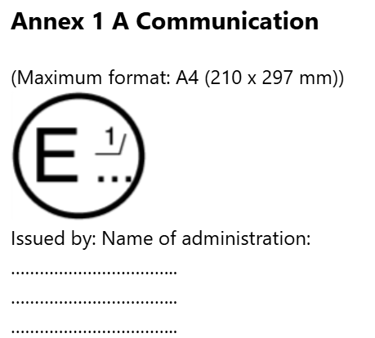
concerning²:
Approval granted
Approval extended
Approval refused
Approval withdrawn
Production definitively discontinued
of a vehicle type with regard to the protection of the driver an occupant against the steering mechanism in the event of impact, pursuant to Regulation No. 12.
of a vehicle type with regard to the protection against electrical shock in the event of impact, pursuant to Regulation No. 12.
Approval No.:......... Extension No.:.........
¹Distinguishing number of the country which has Granted/extended/refused/withdrawn approval (see approval provisions in the Regulation).
²Strike out what does not apply.”

Annex 1 A, paragraph 5., amend to read:
“5. Brief description of the steering mechanism and the components of the vehicle contributing to the protection of the driver an occupant against the steering mechanism in the event of impact”
…………………….”

Annex 1 B; amend to read:
“
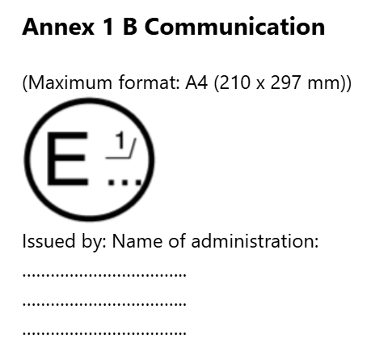
concerning²:
Approval granted
Approval extended
Approval refused
Approval withdrawn
Production definitively discontinued
of a steering control type with regard to the protection of the driver an occupant against the steering mechanism in the event of impact, pursuant to the relevant part of Regulation No. 12.
Approval No.:......... Extension No.:.........
¹ Distinguishing number of the country which has granted/extended/refused/withdrawn approval (see approval provisions in the Regulation).
² Strike out what does not apply.”

Annex 1 B, paragraph 5., amend to read:
“5. Brief description of the steering control and of the components contributing the protection of the driver an occupant against the steering mechanism in the event of impact
………………………………….”

Annex 2, amend to read:
“Model A
(See paragraph 4.2.4. of this Regulation)
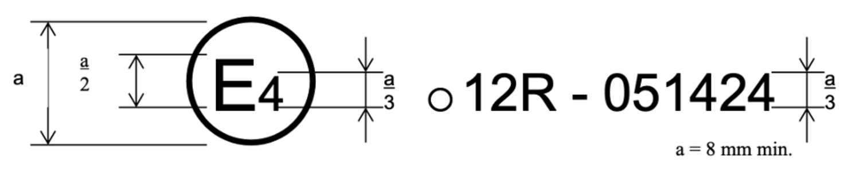
The above approval mark affixed to a vehicle shows that the vehicle type concerned has, with regard to the protection of the driver an occupant against the steering mechanism (if fitted) and/or against electrical shock (if the vehicle is equipped with an electric power train operating on high voltage) in the event of impact, been approved in the Netherlands (E4) pursuant to Regulation No. 12. The approval number indicates that the approval was granted according to the requirements of Regulation No. 12 as amended by the 05 series of amendments.
Model B
(See paragraph 4.2.5. of this Regulation)
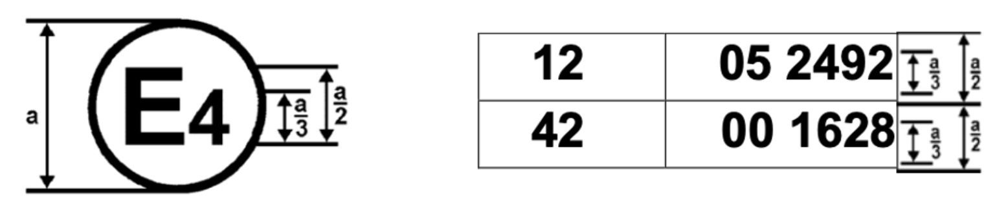
a = 8 mm min.
The above approval mark affixed to a vehicle shows that the vehicle type concerned has been approved in the Netherlands (E4) pursuant to Regulations Nos. 12 and 42¹. The approval numbers indicate that, at the dates when the respective approvals were given, Regulation No. 12 included the 05 series of amendments and Regulation No. 42 the 00 series of amendments.
Model C
(See paragraph 4.3.4. of this Regulation)
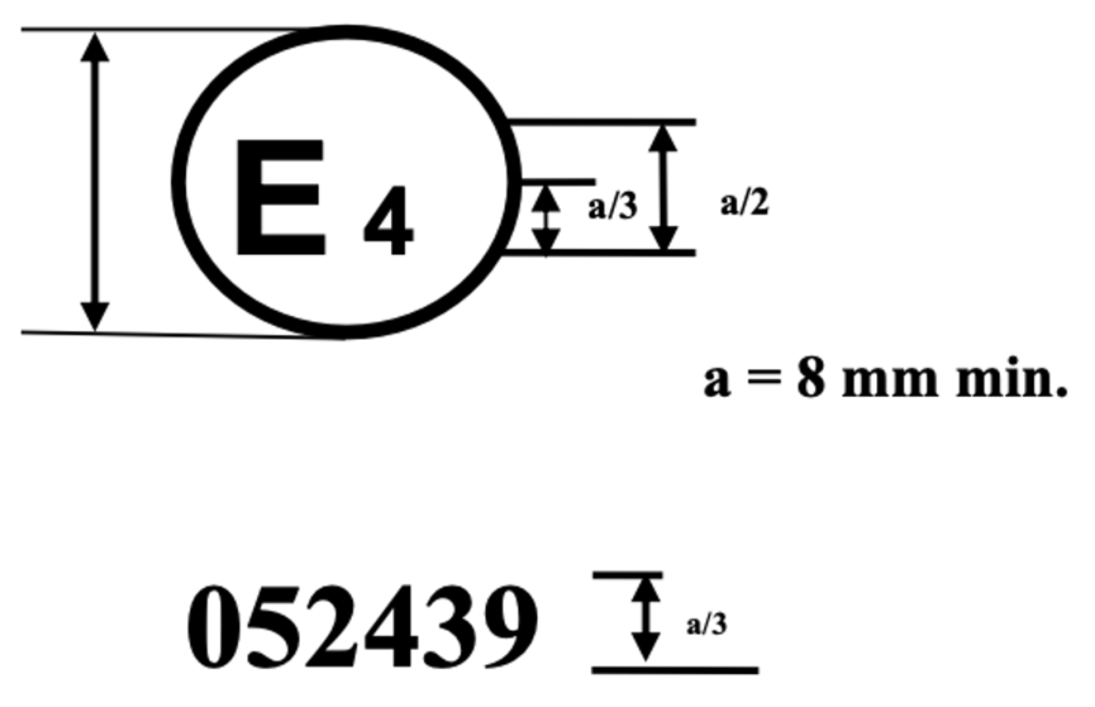
The above approval mark affixed to a steering control shows that the steering control type concerned has, with regard to the protection of the driver an occupant against the steering mechanism in the event of impact, been approved in the Netherlands (E4) pursuant to the relevant part of Regulation No. 12 as amended by the 05 series of amendments.
Model D
(See paragraph 4.3.4.3. of this Regulation)
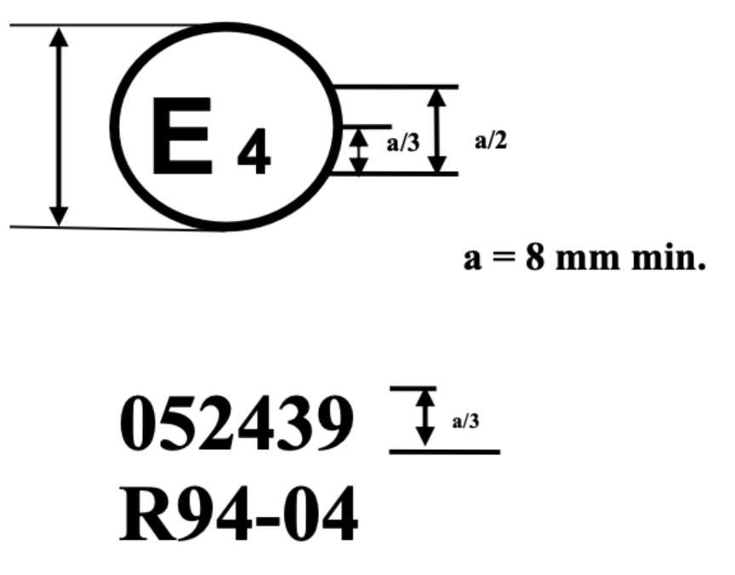
The above approval mark affixed to a steering control shows that the steering control type concerned has been approved in the Netherlands (E4) with regard to the protection of the driver an occupant against the steering mechanism in the event of impact, pursuant to provisions of paragraphs 5.1.2. and/or 5.2.1. of UN Regulation No. 12 as amended by the 05 series of amendments.
¹The second number is given merely as an example.”

Annex 4, paragraph 1., amend to read:
“1. Purpose
The purpose of this test is to verify whether the vehicle meets the requirements set out in paragraph 5.3.5.2. of this Regulation.”

Annex 4, paragraph 2.7.1., amend to read:
“2.7.1. The instrumentation used to record the parameters referred to in paragraph 5.3.5.2. of this Regulation shall enable the measurements to be made with the following accuracy:”

Annex 5, paragraph 1., amend to read:
“1. Purpose
The purpose of this text is to verify whether the steering control meets the requirements set out in paragraph 5.4.5.3. of this Regulation.”

Annex 7, paragraph 1., amend to read:
“Annex 7 Test procedures for vehicles equipped with electric power trains
This annex describes test procedures to demonstrate compliance to the electrical safety requirements of paragraph 5.6.5.5. of this Regulation.”
_________

II. Justification
See paragraph 0.

* In accordance with the programme of work of the Inland Transport Committee for 2023 as outlined in proposed programme budget for 2023 (A/77/6 (Sect. 20), table 20.6), the World Forum will develop, harmonize and update UN Regulations in order to enhance the performance of vehicles. The present document is submitted in conformity with that mandate.

