TFGP-04-03
GRE-TF Glare Prevention, Homework-Group PTI
Outcome of the answers to the first draft about the issues leading to glare. There are more points now, the wording is revised, and the issues are structured to four topic areas.
Below the table, there are some examples of unfavourable light distributions.
issue  (descriptions mostly based on /ECE/TRANS/505/Rev.3/Add.148/Amend.6) | order of  significance | general or detail | task for …
1 aiming
The aiming of a road illumination device shall be found ONLY using instruments (amend R149 Annex 5, intersection of H- and V-line).  This implies that the cut-off line shall be clearly visible in optical HLT or recognizable in electronic HLT. | 1 | g | HWG-PTI, (HWG-R48)
There shall be a clearer and distinct definition of the cut-off line which includes a definition of the elbow point. | 1 | g | HWG-PTI, (HWG-R48)
The finding of the cut-off and the elbow-point shall ONLY be found using instruments (amend R149 Annex 5, 2.x). | 1 | g | HWG-PTI, (HWG-R48)
There shall be a clear requirement with only minor thresholds for the position of the elbow point -> R149 Annex 5 | 1 | g | HWG-PTI, (HWG-R48)
The undefined left (sometimes rising) part of the cut-off line leads to unnecessary glare (->pictures below).  It should be mandated that the cut-off-line may not rise left of the defined area 5° left (R149 Annex5 No. 1.2) above the cut-off line in +- 5° area). | 1 | g | HWG-R48
To avoid indirect glare (wet roads), it may make sense to define a low-light area in front of the vehicle ("reflex zone"). | 3 | d | HWG-R48
2 changes to requirements on construction
The allowed mounting of headlamps (M1, N1) is unnecessarily high.  It should be restricted to a technical necessary height. | 3 | d | HWG-R48
Instead of a wide range of downward inclination values, the basis for type approval should be the max. reach of the light (R48 6.2.6) - equally for every vehicle.  Based on this, the found downward inclination should be noted down in the TA documents.  This value shall be added to the list of information in "provisions for PTI". | 2 | d | HWG-R48
The requirements for cleaning hardware for headlamps are insufficient to remove soiling (e.g. too small water reservoirs). | 2 | d | HWG-R48
It should be mandatory for all M1/N1 to have cleaning hardware. | 2 | g | HWG-R48, IWG on SLR
There should be mandatory dynamic auto-levelling for the complete angle range depending on allowed axle load. It may also be useful to define max. levelling times. | 2 | d | IWG on SLR
3 provisions for PTI
There should be a new chapter "provisions for PTI", instead of a paragraph (R48 6.22.9.2.3, amended in Se7 Am6 to 6.22.9.3.3). | 1 | g | HWG-PTI
It should include at least:  - downward inclination values without passengers and without driver, at with 100%, 75%, 50% and 25% filled tank.  - any documents related to the "unique identifier"  - content of R48 6.22.9.2.3  - procedure how to set the neutral state for AFS (=basis for PTI) | 1 | g | HWG-PTI
The "unique identifier" is impossible to handle in PTI. Especially it must be (again) marked on the lamp, for which kind(s) of light it was approved. | 2 | g | HWG PTI, on advice of GRE and IWG on PTI
4 Measurements
It is not practical for PTI and garages to measure headlamp aiming with "75 kg on driver´s seat".  The filling of the tank does have a significant influence on the measured downward inclination.  -> the TA documents and the "provisions for PTI" should (in addition to the currently necessary values) include downward inclination values without a driver for inspection purposes, with 100%, 75%, 50% and 25% filled tank. | 1 | d | HWG-PTI  HWG-R48
The accuracy of inclination shall be measured/adjusted end-of-line (=installed in the vehicle); an indirect proof via production- and mounting tolerances should not be allowed. | 2 | g | HWG PTI
The accuracy of inclination shall be measured/adjusted at the point of vehicle handover.  (Wording proposal: The OEM shall be responsible for the correct inclination up to and including the point of hand-over. The OEM may use sellers as vicarious agents to fulfil this duty.) | 1 | g | HWG PTI
The wording of R149 Annex 5 should be clearer that the passing beam class C (neutral state) shall be possible to be switched on without a diagnostic device, by the driver and in any conditions (R48 6.22.7.5.).  (Wording proposal: It shall always be possible, without a diagnostic device, for the driver to set the AFS to the neutral state and to return it to its automatic operation.) | 1 | g | HWG-PTI, HWG-R48
There should be requirements for headlamp aiming devices.  This may lead to an amendment of M.R.1, or R.E.6.  Note: M.R.1 might be more general, and in possibly suitable for use in garages. | 2 | g | HWG-PTI (first proposal by CITA?),  IWG on PTI

Examples for a cut-off line, which is rising on the left-hand side (=necessarily glaring the oncoming vehicles).
Note: The pictures are taken from the light box and mirrored so that it resembles the view of the driver.
LED Projection Xenon Projection Halogen Projection LED Reflection
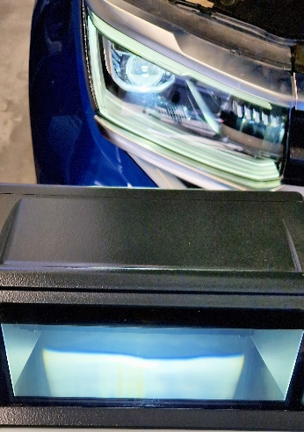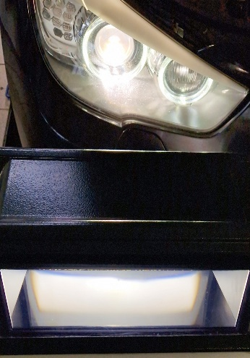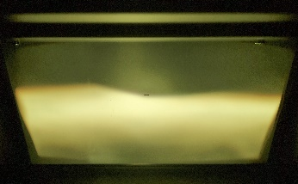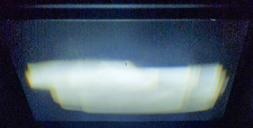
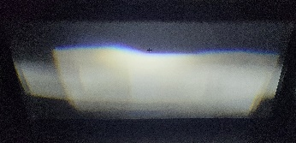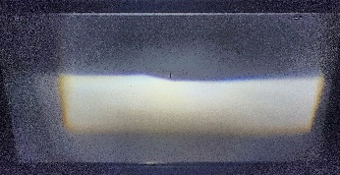
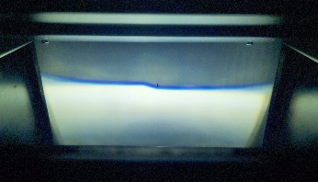

Example very unclear light distribution (is it LHD-asymetric, RHD-asymetric or sealed beam?) 