Contents
1 Open issues 4
1.1 Scope 4
1.2 Definition of fast charging 4
1.3 Family criteria (new) 4
1.4 SoC (high priority) 4
1.5 KPIs (high priority) 6
1.6 Recharged energy (high priority) 7
1.7 Preconditioning 8
1.8 Applicability 9
1.9 Test vehicle 9
1.10 Measurement tolerances and accuracies 10
2 Draft test procedure 10
1 Purpose 12
2 Scope 12
3 Normative references 13
4 Terms and definitions 13
4.1 Definition of fast charging 13
4.2 Definition of family criteria 15
4.2.1 Test family criteria from Netherlands 15
4.2.2 Test family criteria from OICA 15
4.2.3 Test family criteria from JRC 15
4.2.4 Test family criteria from China 15
4.2.5 Parent family criteria from Netherlands 15
4.2.6 Parent family criteria from OICA 15
4.2.7 Other possible approaches on parent family 16
5 Test cases 16
5.1 Overview of test cases from the Netherlands 16
5.2 Overview of test cases from OICA 16
5.3 China position on recharge curve 16
5.4 Overview of test cases JRC 17
6 General requirements 17
6.1 Vehicle manufacturer specifications 17
6.1.1 OICA 17
6.1.2 Netherlands 17
6.1.3 China 18
6.2 Specifications and tests – test system requirements 18
6.2.1 Netherlands 18
6.2.2 OICA 19
6.2.3 JRC comments 19
6.3 Preconditioning 20
6.3.1 California ARB 20
7 Determination of parameters 21
7.1 Parameters proposed by Netherlands 21
7.2 Parameters proposed by OICA 21
7.3 China 21
7.3.1 General comment on onboard parameters 21
7.3.2 SoC 22
7.3.3 Determination of UBE – Use of dyno? 22
Figure 4: Use of dyno necessary? 22
7.4 Netherlands 22
7.5 OICA 22

PART A – Open issues and options for decisions

Open issues

Scope
Do we only cover DC charging or also AC?
For reference - The ToR of the F&SC cluster specifies under Task A : Development of a new WP.29 resolution on DC Fastest Recharge Power Curve (FRPC) of electric vehicles, hence the drafting team assumes that AC charging is excluded.
Since wireless charging is AC, this is also excluded from the scope.
BEV and PHEV however should be included according to the ToR.

Can the F&SC confirm these assumptions?

Definition of fast charging
See chapter 6.1 of part A of this document.

OICA prefers to set a minimum power for DC fast charging to make clear what is understood as fast charging and what is not. This clarifies which vehicles are included or excluded from the scope.

In ISO/SAE 12906 there is following statement to Fast Charge test:
“The Fast Charge test case is only applicable to EVs that support a maximum charging power > 22 kW.”

The available sources (refer to paragraph 4.1) indicate a minimum power of 50 kW to label a charging cycle as fast charging.

Can the F&SC agree to set a minimum power for DC fast charging at 50 kW?

Family criteria (new)
Proposal is to apply the worst-case principle, which means that the worst-case test vehicle is chosen to represent the family. The family itself is restricted by certain family criteria (yet to be determined, but including e.g. battery chemistry, capacity and pre-heating system). At the option of the manufacturer the family may be split into smaller subgroups.

Can the F&SC agree to the worst-case principle? The family criteria need further discussion within the drafting team, we will provide a proposal later.

SoC (high priority)
Definition of the SOC start condition (SOC level and/or remaining range until the battery is empty)
Clear position of the drafting team is to take the SoC indicated to the driver, not the ‘technical’ SoC The technical SoC may also include battery capacity normally not available to end-user. Plus, the technical SoC will not be visible to end user and any KPIs based on the technical SoC will be inconsistent with what end-users are experiencing.
Does the F&SC accept the SoC signal as presented to the driver by the manufacturer as the to value to be measured and as the basis of KPI’s?

The key issue is that the SoC is not an objective and measurable parameter but a calculated one which is controlled by the manufacturer. It may be recalibrated while the vehicle is stationary or by degradation of the battery. This may lead to less than 70% of the usable battery energy (UBE) being recharged from an SoC of 10 to 80%. It also needs to be acknowledged that introducing an intentional offset in the SoC determination may bias the measured FRPC towards a better performance (overall, a charge from 8 to 78% may be faster than a charge from 12 to 82%).

Does the F&SC require the SoC signal as presented to the driver by the manufacturer as to have been verified, or does F&SC allow manufacturers to use the displayed SoC for the FRPC without verification?

How could SoC be verified/calibrated?
The drafting team has identified different options for this and analysed the arguments in favour or against it. Note that this issue is interlinked with issue 1.5, as for some of these options it would be required to measure the recharged energy, which is not straightforward.
The options for verification/calibration of the SoC are:
- Fast charge the vehicle from 10 to 80% SoC and continue to 100% to check if 20% SoC has been added
- Depleting battery to 0% and charging to 80%, and measure from 10 to 80% SoC
- Fully charge the battery to 100%, deplete it to 10%, and then start fast charging from 10%
- Apply a normal charge at low power and compare recharged energy with SoC
- Apply a WLTP charge-depleting test while monitoring SoC against remaining UBE and use this information to calibrate the SoC during charging
Option | Pros | Cons
Check if [≤20%] of UBE energy was added between [80 and 100%] SoC | This prevents a SoC offset to an interval [<10% to <80%] and ensures adding [70%] UBE between [10 and 80%] SoC | Need to determine recharged energy from [10 to 80%] and from [80 to 100%], see issue 1.5.  Due to slower charging above [80%] the charging to 100% may lead to adding > 20% UBE.
Deplete battery to 0%, then charge to [80%] | The 0% SoC point is calibrated | No guarantee that [70%] of UBE was charged from [10-80%] SoC and/or if an SoC offset was applied (unless recharged energy is measured, see issue 1.5).  Charging from 0% is a very uncommon use case.
Fully charge battery to 100%, deplete to 10% | This ensures that the test starts at 10% SoC (no offset) | Additional test burden, the discharge may take a long time  Need to determine discharged energy, see issue 1.5
Apply a normal charge at low power, record SoC and recharged energy | The SoC vs. recharged energy curve prevents a SoC offset and ensures that [70%] UBE is recharged from [10-80%] | Additional test burden to record the SoC vs. recharged energy.  Need to determine discharged energy, see issue 1.5. Charging at low power may lead to higher UBE than for fast-charging.
Determine the relation between SoC and remaining UBE during the WLTP charge-depleting test | Harmonisation with ISO 12906.  No need to measure recharged energy.  No additional test burden if SoC is monitored during WLTP charge-depleting test. | Additional test burden to establish SoC versus UBE.  No guarantee that SoC indication during fast charging is the same as during driving (hysteresis between charging and depleting).

OICA:
See ISO 12906, chapter 6.2.4:
The indicated SOC shall be obtained from the on-board measurement data of the EV or from the on-board indication.
NOTES:
- The indicated SOC at any other interface available can be used for plausibility checks but can be subject to certain latencies.ISO does not check the SoC, yet a verification is added to observe if the SoC trajectory from 10% to 80% resulted in a recharged energy level of at least 69% (par. 6.3.2.5). There is a need to evaluate if there is a SoC hysteresis between charging and depleting.It needs to be discussed later if the 69% can be agreed, due to various tolerances.

There seems to be a consensus in the drafting team that Option 5 is the best way forward. Does the F&SC support this approach?

KPIs (high priority)
These are the KPI’s which are currently accepted by all members of the drafting team and which already exist in ISO 12906:
- Charging time from 10-80% SoC
- Max charging power

Other options for KPIs that were mentioned during discussions:
- Recharged electric range (via recharged energy) in km after 10 min (included in ISO)
- Charging speed in average recharged distance per hour for the interval of [10-80%] SoC (not included in ISO, but preferred from ARB side)
- Charging efficiency (covered by ISO)
- Recharged SoC in [10 minutes]

What does the F&SC see as information that is needed from a customer perspective? Should the information be limited to avoid information overflow, or complete to answer the needs of well-informed customers? Note that a decision on the KPI’s is urgently needed as this might bring consequences to the test procedure, measured parameters, sample frequencies etc.

KPI | Pros | Cons
Charging time from [10-80%] SoC | KPI already exists in ISO.  Easy to measure.
Maximum charging power from [10-80%] SoC | KPI already exists in ISO. | The maximum power may only be seen during a limited time window
Average charging power from [10-80%] SoC | Promotes improvement of high charging power throughout the whole [10-80%] SoC trajectory. | KPI not included in ISO
Recharged electric range in 10 minutes from [15-60] km remaining range | KPI already exists in ISO  This KPI is better comparable as it includes the vehicle’s energy consumption.  10 min is seen as a representative time for a break.  This KPI promotes both improvements in battery charging and total vehicle efficiency. | Need to determine recharged energy (except for option 4 and 5 in 1.4).  Requires energy consumption (EC) from WLTP charge-depleting test.  Based on WLTP energy consumption (not the actual EC which may be higher for highway driving).
Average charging speed in recharged distance per [hour or minute] over [10-80%] SoC interval | This KPI is better comparable as it includes the vehicle’s energy consumption.  This KPI promotes both improvements in battery charging and total vehicle efficiency. | Need to determine recharged energy (except for option 4 and 5 in 1.4).  Requires energy consumption (EC) from WLTP charge-depleting test.  Based on WLTP energy consumption (not the actual EC which may be higher for highway driving).  KPI not included in ISO
Charging efficiency in 10 minutes  from [15-60] km remaining range | 10 min is seen as a representative time for a break. | Need to determine recharged energy (except for option 4 and 5 in 1.4).  KPI not included in ISO
Charging efficiency (average) over [10-80%] SoC interval | KPI already exists in ISO  Provides an overall efficiency rather than just the first 10 minutes | Need to determine recharged energy (except for option 4 and 5 in 1.4).
Recharged SoC in 10 minutes from [15-60] km remaining range | Easy to measure.  No need to determine discharged energy. | KPI not included in ISO.  This might need vehicle categorisation based on battery size.

Recharged energy (high priority)
Determination of recharged energy: measured power into the battery or DBE curve from the WLTP (See ISO)

OICA-comment: Is the determination of recharged energy necessary? > that depends on the decision regarding the KPI’s and on the verification if the recharged energy on the SoC trajectory of [10-80%] is at least [69%] of the UBE (See ISO par. 6.3.2.5)

Note: The UBE value is not declared in WLTP and not defined for PHEVs (this is likely to be amended in October 2025 in UNR 154).

Possibility is to deplete the battery via the bidirectional charging instead by driving on the dyno but this introduces an error and should therefore not be allowed. Discharging the battery should only be allowed by driving on the dyno while recording the energy versus SoC.

Does the F&SC see a need to measure recharged energy? This decision is interlinked with the issues of SoC determination (see issue 1.4) and KPI’s (see issue 1.5)

NOTE: If option 4 or 5 of issue 1.4 on SoC calibration is accepted, there is no need to measure energy into the battery for the FRPC.

NOTE from drafting coordinator: It needs to be defined what is seen as ‘recharged energy’ and at which location the energy into the battery is determined (see also Figure 1 in ISO 12906)

Preconditioning
A typical use case for a vehicle on its way to the fast-charging facility looks as follows: Driving on the highway at high speed, with battery preconditioning on.
At the same time, the test procedure for the FRPC should be reproducible and repeatable, meaning that the condition for the vehicle at the start of the test should always be identical. The objective is therefore to develop a preconditioning procedure which stays close to this use case, while ensuring the reproducibility and repeatability of the test.

According to the ISO procedure, the vehicle is preconditioned by a soak period of 12 hours at 23 degrees, followed by an optional phase of either 30 minutes driving between 25 and 30 km/h with battery preconditioning on (if installed) or a continued soak of 30 minutes between 0 and 30 degrees. According to the GreenNCAP procedure, the vehicle is soaked for 12 hours at 23 degrees, followed by a mandatory drive on the dyno on the WLTC middle and high phase or on the road for 15 minutes. In ISO/SAE 12906 optimizing features of an EV are allowed and shall be indicated if the declared EV charging performance values are only achievable with enable optimizing feature.
The optional drive with low speed before the charging session has been chosen to make the result comparable with drive or without drive (driving should not have any impact, only the optimizing features). Driving is allowed for EVs whose optimizing features require driving and cannot be activated when stationary. (see clause 7 which states: “If optimizing features that are directly or indirectly activated by the vehicle operator are applied, the vehicle manufacturer shall indicate this for each test result.”).
So for the FRPC the question is: Should the preconditioning phase consist of only soaking or soaking and driving? For maximum comparability the best option is to soak the vehicle prior to the test. Next, to honor the real-world use case of fast charging, we could also allow the vehicle to drive prior to the test and let the battery conditioning function allow the battery to be brought in a good state.

Does the F&SC support a preconditioning consisting of a soak of [12 hours] vehicle and then a mandatory drive the vehicle for [30 minutes]?
NOTE: this has not been discussed in detail by the drafting team.

Note: it also needs discussion what this driving phase should look like. If we allow public chargers for this test procedure (see issue 1.8), the use of a chassis dyno with a prescribed speed profile is not possible and the preconditioning speed should be low so it can be performed in the vicinity of the public charger (this is probably why the speed of 25-30 km/h was chosen for the ISO procedure). If we only test in the laboratory with a dyno, a speed profile could be applied or a higher constant speed.

This leads essentially to three options for the driving part of the preconditioning:
- Driving at higher speeds (constant or dynamic driving profile) on a chassis dynamometer. This option stays close to the use case, but rules out the possibility of using a public fast charging facility.
- Driving at a speed of 25-30 km/h. This is the same as in ISO and allows the use of a public fast charging facility, but is rather different from the use case.
- Driving at variable speeds (e.g. between [80 and 120] km/h for at least 20 minutes followed by lower speed driving for a maximum of [10] minutes). This would allow both testing in the laboratory or at a public fast-charging facility, yet the reproducibility and repeatability are compromised.
Does the F&SC support have a preference for the driving part of the preconditioning?

NOTE: this issue has not been discussed in detail by the drafting team.

For discussion: The test burden of soaking could optionally be left out if the manufacturer is convinced that the battery preconditioning will bring the battery at the optimum temperature for fast charging. This could be described in the test protocol as follows: “At the option of the manufacturer the soaking period may be omitted if the battery has a pre-warming system engaged during the preconditioning phase and the vehicle is not stored in a room above [23 degrees] in the [12 hours] prior to the preconditioning phase.” Possibly also a lower temperature boundary needs to be added for this option).

Applicability
Is the test executed in the laboratory or is it allowed to test outside (e.g. at a fast charger location)? In the latter case, a wider temperature range should be allowed (in ISO: 0 to 30 degrees) and a chassis dynamometer cannot be used for the execution of the test procedure.

Note: due to the high thermal inertia of the battery the wider temperature window will presumably not cause any significant change of battery temperature in the 30 minutes following the soak period.

There are three options for the charging equipment:
- Public fast charger, and/or
- Fast charger in a lab environment, and/or
- Emulator in a lab

Does the F&SC allow public chargers to perform the test procedure or should this be done in a laboratory environment?

What lab equipment should be allowed for the FRPC test procedure?
Does the F&SC allow the use of an emulator or only a fast charger?
NOTE: this has not been discussed in detail by the drafting team, so it needs some further discussions and argumentation. Once these decisions have been made, the drafting team will consider the requirements on that particular charging facility, including in relation to the vehicle battery architecture (400V/800V).

Test vehicle
The run-in according to ISO 12906 is to apply the run-in requirement of the applicable driving test (usually the WLTP procedure) or at least 300 km or the distance covered by one full charge. There is no maximum distance specified. The aim is that a relatively new vehicle is tested, not an in-use vehicle.

Should a maximum vehicle distance or battery cycle age be added? This should not be too strict as it then becomes difficult to obtain vehicles for testing. The maximum age could be based on the State of Certified Energy (SOCE) (UBE indicator) which refers to the drop-off with respect to the UBE at the beginning of life (according to the UNR transposition of GTR 22, due to be adopted in October 2025). An eligible vehicle is proposed to show a value of at least [98] %.

Does the F&SC support adding an eligibility requirement for the test vehicle, for example a SOCE indication which shows that at least 98% of the original capacity is available?

Measurement tolerances and accuracies
Sampling rate
Accuracy
Resolution
- See Table 2 ISO 12906

This is dependent on the KPI’s (what to measure) and on the parameters that need to be measured. Without energy measurement we can have a lower sampling frequency (1 Hz) and with energy measurement it should be higher (10 Hz).

So first a decision is needed on the KPI’s, then the drafting team will prepare a proposal for the measured parameters including the sampling frequency, resolution and accuracy.

Draft test procedure
This picture below is prepared by the JRC and meant to be used for discussion purposes, it is not the final test procedure.

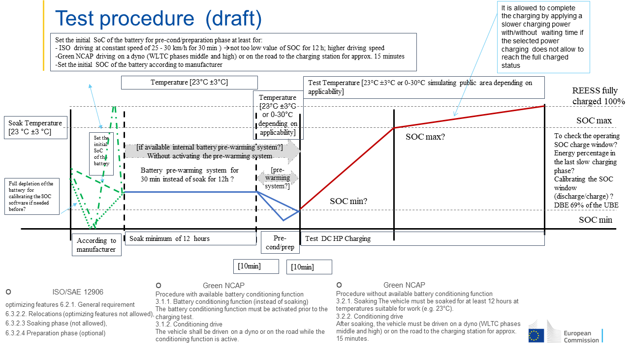

PART B – Background information, normative references and stakeholder positions

JRC: Discussion points (proposal to start from – framework of discussion)
F&SC-04-03e document: Uniform provisions concerning the optimal charging power curve of light-duty electrified chargeable vehicles using direct current – Fastest Recharge Power Curve (FRPC)

Purpose
From the 1st drafting meeting:
The Fast and Smart Charging (F&SC) cluster aims at developing a provision concerning the charging power curve of light-duty vehicle electrified chargeable vehicles using direct current. The procedure to determine the power charging curve shall be both reproducible and repeatable, and representing real-world charging. This will provide consumers with reliable information on the FRPC and related KPIs.
OICA:
This Resolution provides a worldwide harmonized method to set and verify minimum performance requirements on DC fast charging of Pure Electric Vehicles (PEVs) and Off-vehicle Charging Hybrid Electric Vehicles (OVC-HEVs).

JRC:
As a framework for the discussions, the proposal is to start from document F&SC-04-03e:
Uniform provisions concerning the optimal charging power curve of light-duty electrified chargeable vehicles using direct current – Fastest Recharge Power Curve (FRPC)

Scope
OICA: This resolution applies to vehicles of categories 1-2 and 2, that have a technically permissible maximum laden mass not exceeding 3,855 kg, and to vehicles of category 1-1, that are PEV and OVC-HEV vehicles.
At the option of the Contracting Party, the scope may be limited to 3,500 kg for the relevant categories.

Normative references
The following normative references may be used as a basis or referenced to by the FRPC test procedure:
- GTR 15 (WLTP)/ UNR 154 series 2 and 3 (WLTP)
- GTR 22 (Battery durability LDV)
- ISO 12906 (FRPC specific and complimentary source of requirements)
- HDV Battery durability GRPE proposal, if applicable

Terms and definitions

Definition of fast charging
Focus on DC-charging
Minimum power “fast charging” from a charging station point (s. Fig. 1 and 2):
P ≥ 50kW, no upper limit “Fast charging” from vehicle view – tbd:
  - Fastest possible DC charging according to optimized charging conditions of the vehicle
  - Fastest possible DC charging according to selected charging conditions of the vehicle (e.g. precond on/off, battery-efficient charging, …)

Focus on what is possible in the vehicle:
"Fully charged, 100% state of charge (SOC), corresponds to the highest SOC which is achievable with normal operation of the vehicle", however, fast charging is typically terminated at 80% tbd SoC due to battery durability aspects.
Norming factor: UBE on the vehicle (defined by WLTP and GTR22)

https://www.charin.global/media/pages/technology/knowledge-base/63d38591d7-1639130326/charin_dc_ccs_power_classes.pdf
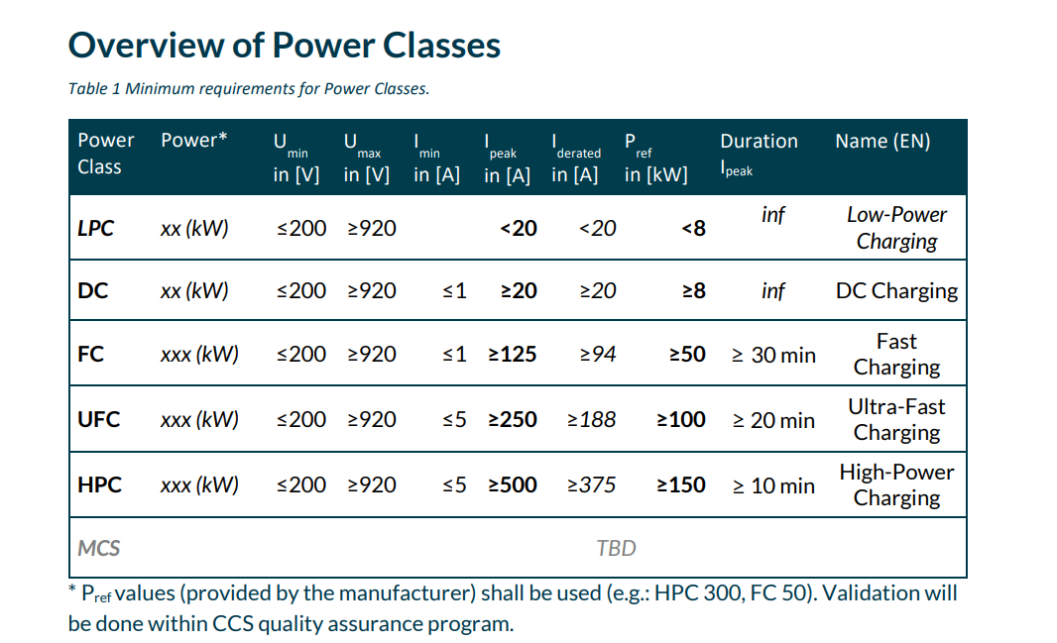
Figure 1: From CharIn

Recharging systems | European Alternative Fuels Observatory / Alternative Fuel Infrastructure Regulation (AFIR)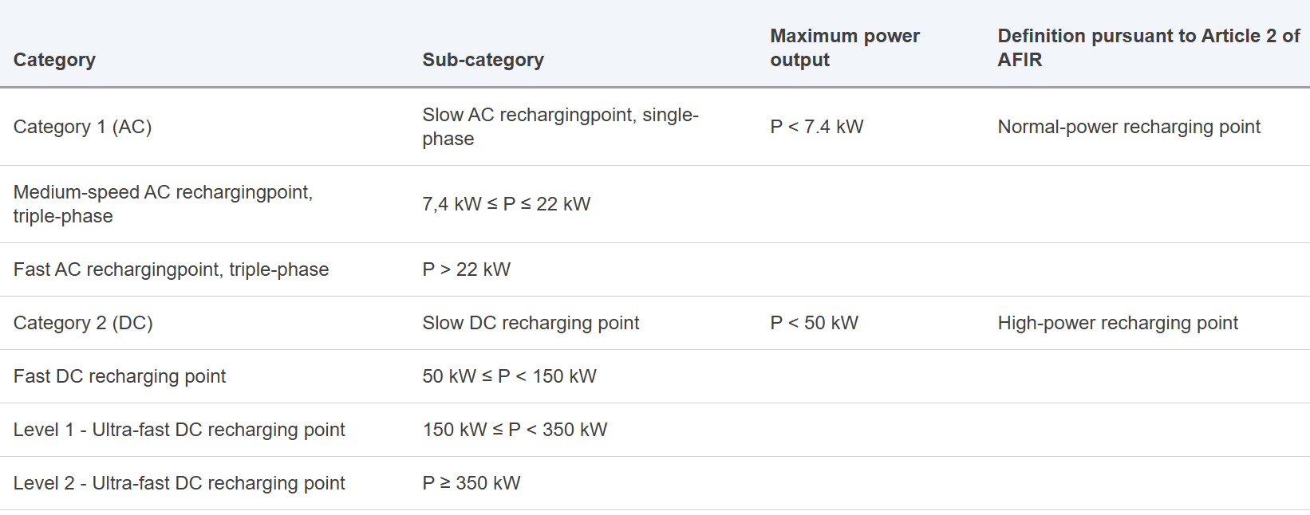

Figure 2: From EU-Com

Definition of family criteria

Test family criteria from Netherlands
Definition of vehicle family GTR 22, part B family as a basis

Test family criteria from OICA
GTR22 Part B criteria for battery durability were used and adjusted for fast charging:
- Battery and charging system design including thermal management and any other characteristics having a non-negligible influence on fast charging
- (Declared maximum charging power (Value from OEM)
- Type of battery (e.g., type of cell, including format, capacity (Ampere-hour), nominal voltage, nominal power tbd by the drafting group) with focus on fast charging
- Battery management system (BMS) with regards to fast charging monitoring and estimations
- Operation strategy of all components influencing the fast charging

Test family criteria from JRC
GTR No. 22 Part B family adjusted to consider the parameters related to the DC fast charging,
-any other characteristics having a non-negligible influence on fast charging
-BMS related to DC fast charging,
-thermal management of the battery, battery conditioning function? Vehicle with/without battery conditioning function in the same family?
In ISO/SAE 12906 optimizing features are in 6.2.1. General requirement, 6.3.2.2. Relocations (optimizing features not allowed), 6.3.2.3 Soaking phase (not allowed), 6.3.2.4 Preparation phase (optional)
(b) Type of battery (dimensions, type of cell, including format and chemistry, capacity (Ampere-hour), nominal voltage, nominal power.

Test family criteria from China
For the different-platform models
For the same-platform models

Parent family criteria from Netherlands
Worst-case principle: test family member with expected worst performance

Parent family criteria from OICA
In general worst-case principle
Definition of worst case may be related to second order characteristics like thermal management, HV-system (length of HV cables)

Remark: Could be very difficult to prove what is “worst case”

Other possible approaches on parent family
GTR22: maximum energy consumption (witness testing, part of WLTP measurement cycle)

Test cases

Overview of test cases from the Netherlands
Charge power curve to cover the entire UBE spectrum from zero charge (0% SoC) to full charge (100% SoC)- FRPC to cover the full charging window from close to 0% to close to 100%
Consumer metric might focus on given charging window, eg. 10% to 80% or else

Overview of test cases from OICA
Discuss charge power curve (handling, parameter, measurement, tolerances …) separately with more time - not part of the resolution, focus on 10-80% SoC relevant for fast charging
Start Point and End Point for the fast charging procedure have to be defined

China position on recharge curve
Is the full recharge curve measured (0-100%) or a limited one (e.g.20-80%)?
It is recommended to measure a 10-80% charging curve.
1.The ISO 12906 standard also measures a 10-80% charging curve.
2.Intercepting the charging curve of 10-80% from the charging curve of 0-100% is not an optimal curve.
3.Most users hardly discharge the vehicle to 0%. This situation does not occur frequently.
Figure 3: 10-80% vs. 0-100% SoC charging curves

Overview of test cases JRC
To agree on the test case requirements and customer metric post-processing and KPI.
Not all the DC HP charging stations will allow to reach automatically the full charged status of the battery due to battery protection systems, and unplugging and plugging again the vehicle is needed to complete the charge at lower power with the same station.
In the draft HDV GTR a provision has been added to take into account this and give instruction on how to charge at full.
To consider in case to prescribe the reporting on how the full charge was reached (i.e. with/without interruption, ...).

General requirements

Vehicle manufacturer specifications

OICA
Required charging values (current, voltage, power and their duration) to be provided by OEM’s see also ISO/SAE 6.2.1 Vehicle manufacturer specifications
Measurement set up, tolerances and accuracies see ISO/SAE 6.2.3 Measurement tolerances and accuracies

Netherlands
Condition for charging
- Break-off criterion: same as UBE from GTR 15 / ISO
- When reached, the battery is nearly empty (close to 0% SoC)
- End-of-charge criterion: same as for UBE from GTR 15 / ISO
- When reached, the battery is nearly full (close to 100% SoC)
Pre-conditioning, soaking, preparation
- Align with GTR 15 / GTR22 as much as possible
- Where GTR15 / GTR22 are not comprehensive enough, follow ISO 12906
- Allow for active/passive battery preconditioning (flag to be recorded)

- Need for vehicle dyno for preparation phase?
  - Is it possible to do without a dyno if UN GTR 15 / GTR22/ISO is used as a basis?
  - Validation test to confirm if vehicle dyno is required
  - Implication of dyno usage:
    - Higher resources needed
    - Restrict potential application of FRPC resolution to OEMs / certification bodies /technical services

China
Measurement temperature
What would be the appropriate temperature?
(Remark: Focus should be on battery temperature rather than outside temp)

operating condition | China | Asia-Pacific | Europe | Middle East and Africa
Constant-temperature DC charging | 25±2 | 25±2 | 25±2 | 35±2
High-temperature DC charging | 38±2 | 38±2 | 38±2 | 45/50±2

Specifications and tests – test system requirements
1st Drafting meeting E-laad also posed the question whether a real market available charging station should be used during the testing or a more sophisticated but more controlled EVSE emulator should be used.
To specify this in the test system requirements can be an option

Netherlands

EVSE specifications and requirements:
- Voltage: as recommended by vehicle manufacturer
- Current: [10%] more than max current from OEMs specs

Test system requirements:
- GTR15 where relevant (Annex 6, para 2.2.)
- Test location requirement from ISO 12906, para 6.3.2.5.
Sampling rate:
- [1]Hz / [20]Hz for energy (as ISO12906)

OICA
Refer in general to ISO/SAE 6.3.2 Test procedure for test case Fast Charge
Start/stop conditions in ISO12906 chapter 6.3.2.5 for 10-80% SoC evaluation
Pre-cond/soaking/prep, focus on ISO12906 only
Conditioning on a dyno for charging possible, could be set as optional
EVSE requirements:
- Remove +10% current not feasible for high charging current demand
Test system requirements:
- Add ISO 6.3.2.3 soaking phase requirements
For test location requirements refer to ISO12906
Sampling rate:
- 1Hz

JRC comments
- Pre-conditioning, soaking, preparation:
- ISO preparation phase: optional
25-30km/h for a maximum 30 minutes or alternatively EV may be soaked for maximum 30 min at temp 0 -30 C
- Green NCAP: conditioning drive on dyno or on road for approx. 15 minutes
- UN GTR No 15: pre-cond WLTC

- Allow for active/passive battery preconditioning (flag to be recorded)
- In ISO/SAE 12906
optimizing features 6.2.1. General requirement,
6.3.2.2. Relocations (optimizing features not allowed),
6.3.2.3 Soaking phase (not allowed),
6.3.2.4 Preparation phase (optional)
- To consider to prescribe the reporting on active/passive battery preconditioning and flag

- Need for vehicle dyno for preparation phase?
- Preparation phase prescribes different drive cycle in ISO/SAE, Green NCAP, GTR 15/22 etc…Dyno can also not be needed for preparation.
But:
- ISO/SAE 12906
It requires dyno for determining the DBE (discharged battery energy) versus SOC curve
This curve DBE vs SOC is needed to determine:
- the recharged usable battery energy within a reference time t_ref
- and the recharged electric range
For the recharged electric range calculation the EC_DC,WLTC is also needed as parameter. This is derived from the WLTP.
To discuss in the group based on KPI

Bidirectional power supply system may be used to deplete the battery during the preparation and to derive the curve DBE vs SOC. But the influence on the battery and systems during preparation is different. Moreover, for the curve DBE vs SOC an error is introduced.
- EVSE specifications and requirements:
- to consider to add provision on modular charging station, for charging efficiency related aspects
-Test system requirements:
- GTR 15 0.1 Hz Pressure, humidity, 0.033Hz temperature
- ISO 1 Hz SOC, Power, Energy depleting 20 Hz,
- Green NCAP , 1 Hz
- GTR 22, GTR 21
- Voltage, Current, 20 Hz during depleting, 0.033Hz during charging
- Room temperature 0.033Hz
- Time, ± 10 ms
- CAN bus data from vehicle?
- SOC monitor vehicle?
- Voltage, current, SOC, from charging station if possible?
- Voltage, current, SOC, man-in-the-middle or EVSE emulator?
- Moving average power window for the calculation of the maximum power?
- ISO the maximum charging power is the highest averaged power within a 30 s interval during the charging duration
- Ambient temperature,
- ISO 23C +/- 3 C on a 5 minutes running arithmetic average during soak with no systematic deviation from the set point,
- ISO 0-30C, 23C+/- 3 C recommended; during charging phase, to resemble real-world conditions

Preconditioning

California ARB
- Should we come up with a driving procedure? The type of driving would affect the battery temperature (and probably other characteristics) and therefore the charge curve/speed.
- How do you establish consistency between all OEMs given that there’s different battery preconditioning strategies among OEMs? (what kind of precondition and how long?)
- Consider that soaking (especially a 12 hour one according to ISO 12906) prior to fast charging may not represent real world behavior, as most people do not do a soak prior to charging.

Determination of parameters

Parameters proposed by Netherlands
- Power at the station (MP2 point of ISO 12906)
- Energy: Station and vehicle/battery
- SoC calculated: from energy at the battery and UBE
- SoC declared: value on dashboard/ from on-board system
(SoC calculated from energy recharged and on-board SoC also collected)
- Charging efficiency derived from total energy at the station vs. UBE (like ISO)
- [Battery/cell] temperature
- Activation flag for Battery pre-conditioning (heating/cooling active)
- Others ?

Parameters proposed by OICA
- Time
- Indicated SoC (declared SoC)
- Electrical power

China

General comment on onboard parameters
We believe that these on-board parameters can accepted as reliable parameters and do not need to be re-measured. Note (response from ARB): If this FRPC procedure will be used for any official certification requirement, then keep in mind that the use of onboard parameters in lieu of physical data may require approval from regulatory authority - at least here in the US.
I would rather use SOC from CAN bus (e.g., SOC parameter in SAE 1979-3) than in-vehicle display. Probably more accurate/resolution and easier to record. (One example is I‘ve seen cases where the displayed SOC is higher than the CAN SOC. Like 5% higher in one instance.)

Otherwise, come up with a standardized method to calculate SOC.

SoC
Currently, the SOC is determined by the vehicle’s instrument display. Before testing, preprocessing is required, involving fully discharging and fully charging the vehicle to calibrate the accuracy of the SOC display.

Determination of UBE – Use of dyno?
Is the UBE from the WLTP test procedure applied (UN R154) or is this established as part of the FRPC?
Is the use of a chassis dynamometer required?
The use of the UBE from the WLTP test procedure (UN R154) is not recommended
There is no need to use a dynamometer.

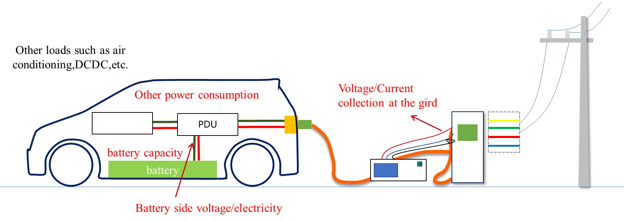

Figure 4: Use of dyno necessary?

Netherlands
Consumer metric might focus on given charging window, eg. 10% to 80% or else
Consumer info metrics to be proposed later
Energy recharged to be compared to declared UBE as part of GTR 15/ISO

OICA
@ temperature = 23±3°C (tolerance from ISO12906)
Charging time from 10-80% SoC
Maximum charging power
Discuss charge power curve (handling, parameter, measurement, tolerances …) separately with more time - not part of the resolution, focus on 10-80% SoC relevant for fast charging

