ORG | Paragraph # | Type of comment¹ | Original text (Consolidated version prepared by OICA) | Proposed change | Comments / Justification
 | 2.6. | ge | "Container" (for hydrogen storage) means the component within the hydrogen storage system that stores the primary volume of hydrogen fuel. | "Container" (for hydrogen storage) means the component within the hydrogen storage system, consisting of an inner container and a vacuum jacket that stores the primary volume of hydrogen fuel. | In Figure 1, the term “Vacuum Jacket” appears.  However, no definition of Vacuum Jacket is provided in the Definitions section.  It is necessary to add a definition of Vacuum Jacket, either under the Liquefied Hydrogen Storage System (LHSS) or the Container.  Accordingly, the definition of Container has been revised to cover both the inner container and the Vacuum Jacket.
 | 2.15. | ge | "Liquefied Hydrogen Storage System (LHSS) " means liquefied hydrogen storage container(s), [PRDs (including boil-off valve), shut-off device] and the interconnection piping (if any) and fittings between the above components. | "Liquefied Hydrogen Storage System (LHSS) " means liquefied hydrogen storagea container(s), [PRDs (including boil-off valve), shut-off device] and the interconnection piping (if any) and fittings between the above components. | The term Container is already defined in paragraph 2.6., therefore the phrase “liquefied hydrogen storage container” is unnecessary.  In addition, the term “storage container” is used in the following provisions and should be unified as “container”:  - 2.24.  - 5.2.1.  - Annex 3, 1.1.2.
 | 2.20. | te | "Pressure Relief Device (PRD)" means a device that, when activated under specified performance conditions, is used to release hydrogen from a pressurized system and thereby prevent failure of the system. It can include first and second pressure relief devices as a reclosing or non-reclosing type (e.g., safety relief valve and burst disc)[ as well as boil off valve]. | "Pressure Relief Device (PRD)" means a device that, when activated under specified performance conditions, is used to release hydrogen from a pressurized system and thereby prevent failure of the system. It can include first and second pressure relief devices as a reclosing or non-reclosing type (e.g., safety relief valve and burst disc)[ as well as boil off valve and vacuum jacket pressure relief devices]. | It is necessary to provide a PRD for the vacuum jacket.  - GTR13 Part I, para. 155 states: “In case of malfunction of the boil-off system, vacuum failure, or external fire, the hydrogen storage container(s) are protected against overpressure by two independent Pressure Relief Devices (PRDs) and the vacuum jacket(s) is protected by a vacuum jacket pressure relief device.”  - This provision assumes, as a worst-case scenario, that the burst of the inner container leads to internal overpressure in the vacuum jacket.  - Therefore, a specific test procedure should be established to demonstrate that the PRD protects the vacuum jacket from burst due to internal overpressure.  In addition, the liquid hydrogen fill line is generally constructed with vacuum insulation. When the vacuum space for the container and that for the piping are separated, a PRD shall be installed for each vacuum space.
 |  |  |  | See Comments on 5.1.1. to 5.1.2
 | 5. | te |  | It is necessary to specify a test for the strength of the vacuum insulated liquid hydrogen fill line. | The liquid hydrogen fill line is generally constructed with vacuum insulation.
 | 5 Figure 1 | ge | 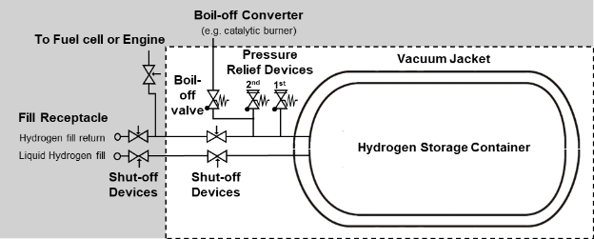 | 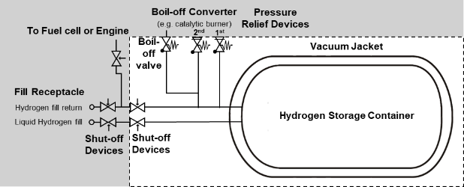 | According to the definition in para. 2.15, the LHSS includes the interconnection piping (if any) and fittings between the above components.  Here, “the above components” refers to the container, PRDs, and the shut-off device.  In this case, piping located outside these components is not included in the LHSS.  Therefore, the scope of the LHSS shown in Figure 1 should exclude such external piping.
 | 5.1.1. to 5.1.2. | te | 5.1.1. Proof pressure  The inner container and the pipe work situated between the inner container and the outer jacket is pressurized to a pressure ptest ≥ 130 per cent (MAWP + 0.1 MPa) in accordance with the test procedure in Annex 3, paragraph 1.1. without visible deformation, degradation of container pressure, or detectable leakage.  5.1.2. Baseline initial burst pressure  The burst test is performed in accordance with the test procedure in Annex 3, paragraph 1.2. on one sample of the inner container that is not integrated in its outer jacket and not insulated.  The burst pressure shall be at least equal to the burst pressure used for the mechanical calculations. For steel containers that is either:  (a) Maximum Allowable Working Pressure (MAWP) (in MPa) plus 0.1 MPa multiplied by 3.25;  or  (b) Maximum Allowable Working Pressure (MAWP) (in MPa) plus 0.1 MPa multiplied by 1.5 and multiplied by Rm/Rp, where Rm is the minimum ultimate tensile strength of the container material and Rp is the minimum yield strength where Rp1.0 shall be used for austenitic steels and Rp0.2 for other steels. | It is necessary to specify a test for the strength of the vacuum jacket. | It is necessary to specify a test for the strength of the vacuum jacket.  - GTR13 Part I, para. 155 states: “In case of malfunction of the boil-off system, vacuum failure, or external fire, the hydrogen storage container(s) are protected against overpressure by two independent Pressure Relief Devices (PRDs) and the vacuum jacket(s) is protected by a vacuum jacket pressure relief device.”  - This provision assumes, as a worst-case scenario, that the burst of the inner container leads to internal overpressure in the vacuum jacket.  - Therefore, it is necessary to specify a test to verify that the vacuum jacket shall be capable of withstanding the internal pressure occurring in case of vacuum loss until the vacuum jacket PRD is activated.
 | 5.1.1. to 5.1.3. | te | 5.1.1. Proof pressure  The inner container and the pipe work situated between the inner container and the outer jacket is pressurized to a pressure ptest ≥ 130 per cent (MAWP + 0.1 MPa) in accordance with the test procedure in Annex 3, paragraph 1.1. without visible deformation, degradation of container pressure, or detectable leakage.  5.1.2. Baseline initial burst pressure  The burst test is performed in accordance with the test procedure in Annex 3, paragraph 1.2. on one sample of the inner container that is not integrated in its outer jacket and not insulated.  ...  5.1.3. Baseline pressure cycle life  When using metallic containers and metallic vacuum jackets, the manufacturer shall either provide a calculation in order to demonstrate that the container is designed according to current regional legislation or accepted standards (e.g. the ASME Boiler and Pressure Vessel Code, EN 1251-1:2000 and EN 1251-2:2000 or other applicable regulations for the design of metallic pressure containers), or define and perform suitable tests (including Annex 3, paragraph 1.3.) that prove the same level of safety compared to a design supported by calculation according to accepted standards.  ... | 5.1.1. Proof pressure  The inner container and the pipe workas well as interconnection piping (if any) and fittings situated between the inner container and the outer jacket is pressurized to a pressure ptest ≥ 130 per cent (MAWP + 0.1 MPa) in accordance with the test procedure in Annex 3, paragraph 1.1. without visible deformation, degradation of container pressure, or detectable leakage.  5.1.2. Baseline initial burst pressure  The burst test is performed in accordance with the test procedure in Annex 3, paragraph 1.2. on one sample of the inner container as well as interconnection piping (if any) and fittings that is not integrated in its outer jacket and not insulated.  ...  5.1.3. Baseline pressure cycle life  When using metallic containers and metallic vacuum jackets as well as interconnection piping (if any) and fittings, the manufacturer shall either provide a calculation in order to demonstrate that the container is designed according to current regional legislation or accepted standards (e.g. the ASME Boiler and Pressure Vessel Code, EN 1251-1:2000 and EN 1251-2:2000 or other applicable regulations for the design of metallic pressure containers), or define and perform suitable tests (including Annex 3, paragraph 1.3.) that prove the same level of safety compared to a design supported by calculation according to accepted standards.  ... | In the definition of LHSS (para. 2.15), the interconnection piping (if any) and fittings between the above components are included. However, no test is specified for the strength of these piping and fittings.  As with the container, these piping and fittings are pressure-bearing parts and include structural discontinuities such as weld joints.  Therefore, it is necessary to specify a test to verify their strength as well as inner container, as shown below.  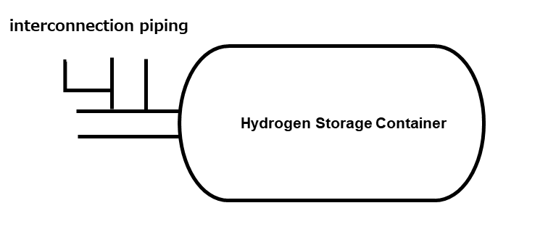
 | 5.1.2. | te | Baseline initial burst pressure  The burst test is performed in accordance with the test procedure in Annex 3, paragraph 1.2. on one sample of the inner container that is not integrated in its outer jacket and not insulated.  The burst pressure shall be at least equal to the burst pressure used for the mechanical calculations. For steel containers that is either:  (a) Maximum Allowable Working Pressure (MAWP) (in MPa) plus 0.1 MPa multiplied by 3.25;  or  (b) Maximum Allowable Working Pressure (MAWP) (in MPa) plus 0.1 MPa multiplied by 1.5 and multiplied by Rm/Rp, where Rm is the minimum ultimate tensile strength of the container material and Rp is the minimum yield strength where Rp1.0 shall be used for austenitic steels and Rp0.2 for other steels. | Baseline initial burst pressure  The burst test is performed in accordance with the test procedure in Annex 3, paragraph 1.2. on one sample of the inner container as well as interconnection piping (if any) and fittings that is not integrated in its outer jacket and not insulated.  The burst pressure shall be at least equal to the burst pressure used for the mechanical calculations. For steel containers that is either:  (a) Maximum Allowable Working Pressure (MAWP) (in MPa) plus 0.1 MPa multiplied by 3.25;  or  (b) Maximum Allowable Working Pressure (MAWP) (in MPa) plus 0.1 MPa multiplied by 1.5 and multiplied by Rm/Rp, where Rm is the minimum ultimate tensile strength of the container material and Rp is the minimum yield strength where Rp1.0 shall be used for austenitic steels and Rp0.2 for other metallic materials. | Regarding formula (b) for the baseline initial burst pressure, the following concerns are noted:  1. The provision requires Rp1.0 for austenitic steels. However, in Japan Rp0.2 has consistently been used as the reference value, and the application of Rp1.0, which may correspond to the strain-hardening region, is not common.  2. For EN10088-2 1.4404 (cold rolled strip), the specified mechanical properties are Rm: 530–680 MPa, Rp0.2: 240 MPa, and Rp1.0: 270 MPa. Substituting these values gives:  - Rp0.2: (MAWP + 0.1 MPa) × 3.31  - Rp1.0: (MAWP + 0.1 MPa) × 2.94  In this case, the result using Rp1.0 falls below the value of formula (a) (3.25)  3. The criteria for the burst pressure of the inner container should be defined with a uniform safety factor. Therefore, instead of using formula (b), which varies depending on the material properties, formula (a) should be applied consistently.  In addition, the wording “Rp0.2 for other steels” is understood to cover not only steels but also aluminium alloys and other metallic materials.
 | 5.2.1. | ed | Boil-off  The boil-off test is performed on a liquefied hydrogen storage system equipped with all components as described in paragraph 5. (Figure 1). The test is performed on a system filled with liquid hydrogen in accordance with the test procedure in Annex 3, paragraph 2.1. and shall demonstrate that the boil-off valve limits the pressure in the inner storage container to below the maximum allowable working pressure. | Boil-off  The boil-off test is performed on a liquefied hydrogen storage system equipped with all components as described in paragraph 5. (Figure 1). The test is performed on a system filled with liquid hydrogen in accordance with the test procedure in Annex 3, paragraph 2.1. and shall demonstrate that the boil-off valve limits the pressure in the inner storage container to below the maximum allowable working pressureMAWP. | The term MAWP is already defined in para. 2.18.
 | 9.4. | te | Every inner container and the pipe work situated between the inner container and the outer jacket shall be pressure tested according to Annex 3 paragraph 1.1. | Every inner container and the pipe work situated between the inner container and the outer jacket as well as interconnection piping (if any) and fittings shall be pressure tested according to Annex 3 paragraph 1.1. | As with the container, these piping and fittings are pressure-bearing parts and include structural discontinuities such as weld joints. Therefore, it is necessary to conduct a test on the finished product, as shown below.  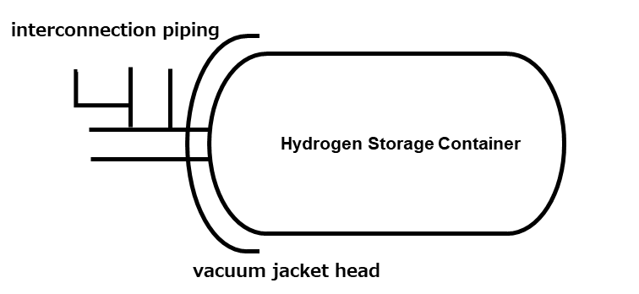
 | Annex 3  1.1. to 1.3. | te | 1. Verification tests for Baseline metrics  1.1. Proof pressure test  The inner container and the pipe work situated between the inner container and the outer jacket shall withstand an inner pressure test at room temperature according to the following requirements.  …  1.2. Baseline initial burst pressure  The test is conducted according to the following procedure:  (a) The test is conducted on the inner container at ambient temperature;  …  1.3. Baseline pressure cycle life  Containers and/or vacuum jackets are pressure cycled with a number of cycles at least three times the number of possible full pressure cycles (from the lowest to highest operating pressure) for an expected on-road performance.  … | 1. Verification tests for Baseline metrics  1.1. Proof pressure test  The inner container and the pipe work situated between the inner container and the outer jacketas well as interconnection piping (if any) and fittings shall withstand an inner pressure test at room temperature according to the following requirements.  ...  1.2. Baseline initial burst pressure  The test is conducted according to the following procedure:  (a) The test is conducted on the inner container as well as interconnection piping (if any) and fittings at ambient temperature;  …  1.3. Baseline pressure cycle life  Containers and/or vacuum jacketsas well as interconnection piping (if any) and fittings are pressure cycled with a number of cycles at least three times the number of possible full pressure cycles (from the lowest to highest operating pressure) for an expected on-road performance.  … | See comments on paras. 5.1.1 to 5.1.3.
 | Annex 3  1.2. | te | 1.2. Baseline initial burst pressure  The test is conducted according to the following procedure:  (a) The test is conducted on the inner container at ambient temperature;  (b) The test is conducted hydraulically with water or a water/glycol mixture;  (c) The pressure is increased at a constant rate, not exceeding 0.5 MPa/min until burst or leakage of the container occurs;  (d) When MAWP is reached there is a wait period of at least ten minutes at constant pressure, during which time the deformation of the container can be checked;  (e) The pressure is recorded or written during the entire test.  For steel inner containers, the test is passed successfully if the passing criteria described in paragraph 5.1.2. of this Regulation is fulfilled. For inner containers made out of an aluminium alloy or other [metallic] material, a passing criterion shall be defined which guarantees at least the same level of safety compared to steel inner containers. | 1.2. Baseline initial burst pressure  The test is conducted according to the following procedure:  (a) The test is conducted on the inner container at ambient temperature;  (b) The test is conducted hydraulically with water or a water/glycol mixture;  (c) The pressure is increased at a constant rate, not exceeding 0.5 MPa/min until burst or leakage of the container occurs;  (d) When MAWP is reached there is a wait period of at least ten minutes at constant pressure, during which time the deformation of the container can be checked;  (e) The pressure is recorded or written during the entire test.  For steel inner containers, the test is passed successfully if the passing criteria described in paragraph 5.1.2. of this Regulation is fulfilled. For inner containers made out of an aluminium alloy or other [metallic] material, a passing criterion shall be defined which guarantees at least the same level of safety compared to steel inner containers. | The provision “For inner containers made out of an aluminium alloy or other [metallic] material, a passing criterion shall be defined which guarantees at least the same level of safety compared to steel inner containers” was originally intended for non-metallic materials and should therefore be deleted.  For aluminium alloys and other metallic materials, the same acceptance criteria as those for steel inner containers in para. 5.1.2 should apply.
 | Annex 3  2.1.2. | ge | 2.1.2. The pressure of the inner container shall be recorded during the entire test. The test is passed when the following requirements are fulfilled:  (a) The pressure shall stabilize and stay below MAWP during the whole test;  (b) The pressure relief devices are not allowed to open during the whole test. | 2.1.2. The pressure of the inner container shall be recorded during the entire test. The test is passed when the following requirements are fulfilled:  (a) The pressure shall stabilize and stay below MAWP during the whole test;  (b) The pressure relief devices except the boil-off valve are not allowed to open during the whole test. | Since the boil-off valve may actuate during the boil-off test, if the boil-off valve will be included in the definition of PRDs, it is necessary to exclude the acutuation of boil-off valve in this requirement.

