Economic Commission for Europe
Inland Transport Committee
World Forum for Harmonization of Vehicle Regulations
Working Party on Brakes and Running Gear
Eightieth session
Geneva, 20 – 23 September 2016
Item 4 of the provisional agenda
Regulation No. 55 (Mechanical couplings)
Proposal for amendments to Regulation No. 55 (Mechanical couplings)
Submitted by the Chair of the informal group on Regulation No. 55*
The text reproduced below was prepared by the experts of the informal group on UN Regulation No. 55 and introduces amendments on:
- An amendment that concerns a procedure to identify allowable combinations of performance values D_{C} and V for drawbar coupling equipment.
The modifications to the existing text of the Regulation are marked in bold for new or strikethrough for deleted characters.

I. Proposal
Add new paragraph 5.3.5.2.
5.3.5.2 Under the conditions given in Annex 8 §4.1.1. calculated performance requirements falling outside the conditions of the above paragraph 5.3.5.1 can be handled.
Annex 8
Insert new paragraph 4., to read:
”4. Special Operation
In paragraph 5.3.5.1. the general requirement on the characteristic performance values are stated.
The designations D_{cert}, D_{C-cert}, V_{cert} and S_{cert} used below in this paragraph designate certified performance capacity of a coupling component under consideration. The designation D_{C-req}, V_{req} and S_{req} designate vehicle combination performance requirements as calculated in accordance with the rules in this annex. They are to be evaluated against certified performance capacities.
”

Insert new paragraph 4.1. and 4.1.1., to read:
“4.1 Clevis coupling systems including drawbeams and drawbar eyes
For each combination of certified performance capacity values a diagram as shown in the Figure 28 may be drawn and included in the user’s manual. Performance requirements D_{C-req} and V_{req} that would fall in the hatched area of the diagram are allowed to be operated in road traffic.
S_{req} shall always be below or equal to 1000 kg.

4.1.1 If diagrams such as described in paragraph 4.1 of this annex is part of the information material at type approval the component manufacturer owning the type approval certificate for that product is entitled for that product to issue a manufactures certificate certifying the safe application for a combination with D_{C-req} and V_{req} laying in the hatched area. Such manufacturers certificate shall at all times be carried with the vehicle combination concerned. “

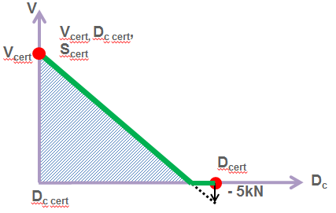
Figure 28 “

II. Justification
- Presently it is not possible to apply coupling equipment in an application where the calculated required performance values D_{C-req}, V_{req} and S_{req} lay in the hatched area of figure 28. I.e. any application with a D_{Creq} higher that D_{Ccert} and a V_{req} above zero is not allowed.
- It is possible to recertify those products for application points in the hatched area. This is also done every now and then. However this procedure result in a number of alternative performance values some of which you may have on the type plate. According to the current proposal recertification would only be called for if you aim for an application above the hatched area in Figure 28.
- This practice has been used on exemption basis with good results. The proposal has also been analysed from a theoretical standpoint applying fatigue analysis involving Haig-formalism. This has shown that the static load shall be kept at the certified value S_{cert}. Any change in S_{req} cannot be traded towards change in V-value limit. I.e. new combinations of S_{cert} shall be handled through recertification.
- Some graphical explanation is given below:
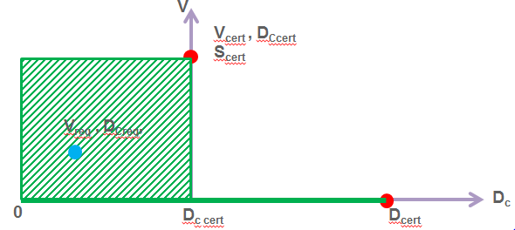
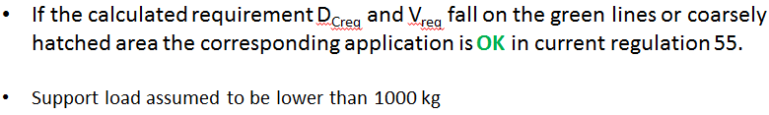
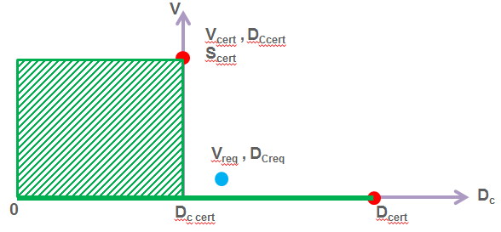
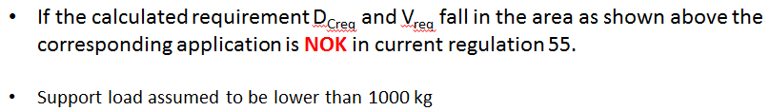

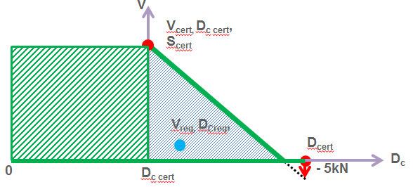
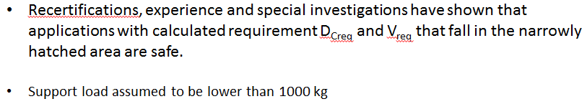
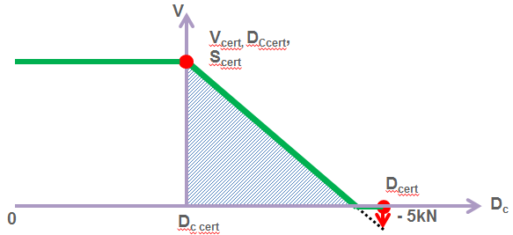
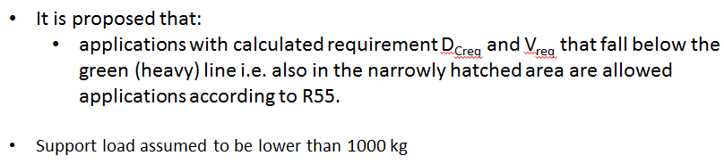

* In accordance with the programme of work of the Inland Transport Committee for 2012–2016 (ECE/TRANS/224, para. 94 and ECE/TRANS/2012/12, programme activity 02.4), the World Forum will develop, harmonize and update Regulations in order to enhance the performance of vehicles. The present document is submitted in conformity with that mandate.

