 | United Nations | ECE/TRANS/WP.29/GRPE/2025/17
 | Economic and Social Council |  | Distr.: General  For 6 November 2025 IWG  Original: English
Economic Commission for Europe
Inland Transport Committee
World Forum for Harmonization of Vehicle Regulations
Working Party on Pollution and Energy
Ninety-third session
Geneva, 14-17 October 2025
Item 14 of the provisional agenda
Automotive Life Cycle Assessment (A-LCA)
Proposal for a new Mutual Resolution No. 5 (M.R.5) concerning Automotive Life Cycle Assessment (A-LCA)
Submitted by the Informal Working Group on Automotive Life Cycle Assessment *
The text reproduced below was prepared by the Informal Working Group on Automotive - Life Cycle Assessment (A-LCA). It is a proposal for a new Mutual Resolution No. 5 (M.R.5) concerning Automotive Life Cycle Assessment (A-LCA). It is submitted to the Working Party on Pollution and Energy consideration at its 93rd session.

Mutual Resolution No. 5 (M.R.5) concerning Automotive Life Cycle Assessment (A-LCA)
Contents
Page *
I. Preamble
II. Statement of technical rationale and justification
1. Introduction
2. Methodology background
3. Existing regulations and standards
4. Technical rationale and justification
III. Text of the Mutual Resolution
1. Purpose and principles
2. Scope and application
3. Definitions
4. Abbreviations
5. [Future review]
6. [Language]
7. General methodology
8. Methodology per life cycle stages
9. Reporting
10. Verification process
Annex
Service life (in km and years) values for European countries

* Page number will be added at a later stage prior to WP.29 submission

I. Preamble
The Administrative Committee of the 1958 Agreement (AC.1) and the Executive Committee of the 1998 Agreement (AC.3),
DESIRING to harmonise technical requirements while ensuring high levels of safety, environmental protection, energy efficiency and anti-theft performance of wheeled vehicles, equipment and parts which can be fitted and/or be used on wheeled vehicles,
BEARING IN MIND that the 1958 Agreement established on 20 March 1958 provides for the adoption of uniform technical prescriptions for wheeled vehicles, equipment and parts which can be fitted and/or be used on wheeled vehicles and the conditions for reciprocal recognition by Contracting Parties of approvals granted on the basis of these prescriptions,
BEARING IN MIND that the 1998 Agreement provides for the establishment of global technical regulations for wheeled vehicles, equipment and parts which can be fitted and/or be used on wheeled vehicles was opened for signature in Geneva on 25 June 1998,
BEARING IN MIND that both Agreements facilitate the trade of wheeled vehicles, equipment and parts with harmonised performance requirements among the respective Contracting Parties,
BEARING IN MIND that this Resolution does not hold regulatory status within Contracting Parties and does not constitute a global technical regulation.
RECOMMENDS that Contracting Parties and manufacturers refer to this Mutual Resolution when establishing studies used for the assessment of life cycle CO₂ equivalent emissions in the framework of the 1958 or 1998 Agreements respectively.
II. Statement of technical rationale and justification
1. Introduction
The 2030 Agenda for Sustainable Development, adopted by all United Nations Member States in 2015, provides a shared blueprint for peace and prosperity for people and the planet, now and into the future. At its heart are the 17 Sustainable Development Goals (SDGs), which are an urgent call for action by all developed and developing countries in a global partnership.
UN SDG 12 on "responsible consumption and production" and 13 on "climate action" encourage efficient use of natural resources and to limit climate warming through long-term societal goals. Sound and reasoned resource use and climate change mitigation are key preoccupation of citizens, corporations, investors, legislator and society as a whole.
The Paris Agreement has set ambitious targets to limit global warming to well below 2 degrees, preferably to 1.5 degrees Celsius, compared to pre-industrial levels. To achieve this long-term temperature goal, stakeholders aim to reach a global peak of greenhouse gas (GHG) emissions as soon as possible and transition towards achieving a climate neutral world by mid-century.
In 2010 the transport sector was a major contributor to global GHG emissions (23% of global GHG emissions) and road transport had the majority of the overall transport sector emissions (72.06%¹).
In the event that a contracting party seeks to have comprehensive, comparable and consistent values for the carbon footprint over the whole life of new automotive products across the globe, from material extraction and processing, to manufacturing, use and dismantling / recycling at the end-of-life (EoL), it is desirable to define and develop an internationally unified guideline for GHG Life Cycle Assessment (LCA).
The ISO 14040 series has been in effect since 2006 as an international standard on LCA for environmental management, and automotive manufacturers have been publishing results of LCA in accordance with these ISO standards for several types of vehicles.
However, the ISO standards state that the scope of the investigation and the preconditions for conducting LCAs should be determined by the investigator, such as the automotive manufacturer, and since each investigator conducts LCAs according to their own method, an internationally harmonised LCA methodology designed for the automotive industry with global business activity is needed. While LCA is intended to be a multi-impact tool accounting for impact trade-offs, the ISO standards allow for single impact assessments provided such a choice is acknowledged at the outset and the resulting limitations are noted. This LCA effort focuses entirely on GHG emissions and makes no claims regarding other potential impacts that may arise throughout the life cycles of the assessed technologies.
2. Methodology background
During the 85th GRPE session in January 2022, Japan and Korea proposed to work on clarifying methodologies for assessing life cycle GHG emissions of automotive products in the context of GRPE (GRPE-85-29r1e). GRPE agreed to organise a dedicated workshop during the 86th GRPE session in June 2022. Following the successful workshop, GRPE agreed to put the automotive LCA (A-LCA) methodology on its priority list and agreed to create a new Informal Working Group (IWG) on A-LCA under GRPE (ECE/TRANS/WP.29/GRPE/86/Rev.1). Accordingly, the first session of the IWG on A-LCA was held in October 2022 in Okinawa, Japan.
The IWG on A-LCA is an open structure that will enable the exchange of information and experiences on relevant regulations, policy measures, and standardisation efforts. It is intended that the discussions will encompass all types of road automotive products with different technologies for energy pathways.
The 1958 Agreement and the 1998 Agreement do not define methods of measuring GHG emissions from automotive life cycles. The objective of the IWG on A-LCA is to develop an internationally harmonised procedure [methodology] to determine the carbon footprint (CFP) for all stages of the life cycle of a light-duty vehicle, also considering energy use for energy pathways and automotive types from production to use and disposal as a Resolution under the framework of WP.29. The ISO 140xxx series of LCA standards and definitions serves as the foundation of the A-LCA methodology. The definition of CFP used within this methodology is based upon the 100-year global warming potentials (GWP100) – as defined by the United Nations Intergovernmental Panel on Climate Change (IPCC).
This Mutual Resolution can inform policy and can help encourage automotive industries to reduce CFP via improved efficiencies at all stages of the life cycle. The methodology shall be has been developed respecting the principles of transparency and consistency. It also strikes a balance between accuracy and workload, considering the automotive industry's complex supply chain.
3. Existing regulations and standards
Several countries and organisations throughout the world have already introduced guidelines and standards related to the Life Cycle Assessment of vehicles. However, these guidelines and standards differ in terms of methodology, scope of application, objectives and targeted audiences.
Examples of existing standards:
(a) ISO 14040:2006 & 14044:2006: describing the principles and framework for general LCA.
(b) ISO 14067:2018 Greenhouse gases — Carbon footprint of products — Requirements and guidelines for quantification.
Examples of existing guidelines from the automotive industry:
(a) EPD PCR passenger cars: providing rules for the assessment of the environmental performance of passenger cars including internal combustion engine vehicles ICEVs, battery electric vehicles BEVs, fuel cell electric vehicles FCHVs, hybrid electric vehicles HEVs …
(b) PFA LCA guidelines: where the French automotive platform provided methodological guidelines on vehicle and component LCA for 7 environmental indicators.
(c) VDA LCA guidelines: where the German Association of the Automotive Industry provided methodological guideline on vehicle and component LCA for 5 environmental indicators.
(d) JAMA LCA guidelines: the Japanese Automobile Manufacturers Association provided a certified methodology for passenger car, truck, bus and motorcycle, focusing on GHG emissions only.
4. Technical rationale and justification
The purpose of this Resolution is to support the global automotive sector's efforts to reduce GHG emissions throughout the supply chain. In other words, it is intended to provide a process [methodology] for automotive manufacturers, component suppliers and government authorities to assess CFPs.
III. Text of the Mutual Resolution
1. Purpose and principles
1.1. This Mutual Resolution provides an internationally harmonised methodology to determine the CFP for light-duty vehicles, also considering energy use for energy pathways and automotive types from production to use and disposal, as a Mutual Resolution under the framework of WP.29. Note that the methodology is specifically limited in scope to light-duty vehicles.
1.2. This Mutual Resolution inform policy and can help encourage automotive industries to reduce CFP via improved efficiencies at all stages of the life cycle. The methodology shall be developed respecting the principles of transparency and consistency and shall be consistent with the ISO 140xxx series of LCA international standards. It shall also strike a balance between the accuracy and the workload considering the complex supply chain of the automotive industry.
1.3. To produce reliable, reproducible, verifiable and comparable A-LCA studies, a core suite of analytical principles shall be adhered to. They shall be considered with respect to each phase, from defining the goal and the scope, through data collection, impact assessment, reporting and verification of study outcomes.
1.4. Practitioners of this methodology shall observe the following principles in conducting a CFP study:
(a) Relevance
The selection of data and methods shall be appropriate to the assessment of the GHG emissions and removals arising from the system under study.
(b) Completeness
Quantification of the CFP shall include all GHG emissions and removals that provide a significant contribution to the CFP of the product system under study. The level of significance is determined by the cut-off criteria.
(c) Consistency
Assumptions, methods and data shall be applied in the same way throughout the A-LCA study to arrive at conclusions in accordance with the goal and scope definition.
(d) Accuracy
Quantification of the CFP shall be accurate, verifiable, relevant and not misleading, and bias and uncertainties shall be reduced as far as is practical.
(e) Transparency
All relevant issues shall be addressed and documented in an open, comprehensive and understandable presentation of information. Any relevant assumptions shall be disclosed, and methodologies and data sources used shall be appropriately referenced. Any estimates shall be clearly explained, and bias shall be avoided so that the A-LCA study report represents what it purports to represent.
2. Scope and application
This Mutual Resolution applies to light-duty vehicles.
3. Definitions
3.1. "Allocation" means: partitioning the input or output flows of a process or a product system between the product system under study and one or more other product systems.
3.2. "Attributable process" means those processes that consist of all service, material and energy flows that become, make and carry a product throughout its life cycle.
3.3. "Attributional" means process-based modelling intended to provide a static representation of average conditions, excluding market-mediated effects.
3.4. "Background System" means in contrast (to the foreground system) … processes that are operated as part of the system but are not under direct control or decisive influence of the producer of the good (or operator of the service, or user of the good).
3.5. Batteries
3.5.1. "SLI battery" means [a battery for starting-lighting-ignition and auxiliary applications only - does not apply to primary battery packs used for electric-drive powertrains (traction batteries)]
3.5.2. [A battery that is specifically designed to supply electric power for starting, lighting, or ignition and that can also be used for auxiliary or backup purposes in vehicles, other means of transport or machinery]
3.5.3. ["Traction battery" means a battery system that stores energy with the main purpose of propelling the vehicle.]
3.6. "Bill of Material(s)" means a list of raw materials, sub-assemblies, intermediate assemblies, sub-components, parts and the quantities of each needed to manufacture the product in the scope. In some sectors it is equivalent to the bill of components.
3.7. "Biogenic carbon" means Carbon derived from biomass.
3.8. "Biomass" means material of biological origin, excluding material embedded in geological formations and material transformed to fossilised material. Biomass includes organic material (both living and dead), e.g. trees, crops, grasses, tree litter, algae, animals, manure and waste of biological origin. Biomass excludes peat. ¹¹
3.9. "Product Carbon Footprint (PCF)" means the sum of GHG emissions and GHG removals in a product system, expressed as CO₂ equivalents and based on a life cycle assessment using the single impact category of climate change. ¹¹
3.10. [Reserved]
3.11. "Characterisation factor" means a factor derived from a characterisation model, which is applied to convert an assigned life cycle inventory analysis (3.4.26) result to the common unit of the category indicator (3.10.8).
3.12. "Circular Footprint Formula (CFF)" means a framework for evaluating the environmental impacts of a product throughout its entire life cycle, particularly based on the principles of a circular economy. This method calculates the environmental burdens and benefits obtained from recycling a product and aims to improve resource use efficiency.
3.13. "Climate Change" means the environmental footprint impact category considering all inputs and outputs that result in greenhouse gas (GHG) emissions. The consequences include increased average global temperatures and sudden regional climatic changes. ⁸
3.14. [Reserved]
3.15. "Carbon dioxide equivalent (CO₂eq) " means the unit for comparing the radiative forcing of a greenhouse gas to that of carbon dioxide . ¹³
3.16. "Co-product" means any of two or more products coming from the same unit process or product system. ¹¹
3.17. [Reserved]
3.18. "Cradle-to-gate" means a system boundary that is applied for a partial PCF assessment that includes a part of the product’s life cycle. Cradle-to-gate represents the GHG emissions and removals arising from all life cycle stages, up to the point where the product leaves the production site (the ”gate”). This explicitly excludes the life cycle stages use and end-of-life.
3.19. "Cut-off criteria" means the specification of the amount of material or energy flow or the level of significance of GHG emissions associated with unit process or the product system, to be excluded from a PCF study. ¹¹
3.20. Data
3.20.1. "Primary data" means a quantified value of a process, or an activity obtained from a direct measurement, or a calculation based on direct measurements. Primary data can include greenhouse gas emission factors and/or greenhouse gas activity data. Average data from industry associations or global averages do not qualify as primary data. ¹²
3.20.2. "Secondary data" means any data which do not fulfil the requirements for primary data. ¹²
Note 1: Secondary data can include data from databases and published literature, default emission factors from national inventories, calculated data, estimates or other representative data, validated by competent authorities.
Note 2: Secondary data can include data obtained from proxy processes or estimates.
3.21. "Declared unit" means the quantity of a product for use as a reference unit in the quantification of a partial PCF. ¹¹
3.22. "Direct emissions" means the GHG emissions from the processes that are owned or controlled by the reporting company. ⁷
3.23. "Downstream emissions" means the indirect GHG emissions that occur in the value chain following the processes owned or controlled by the reporting company. ⁷
3.24. "Elementary flow" means the material or energy entering the system being studied that has been drawn from the environment without previous human transformation, or material or energy leaving the system being studied that is released into the environment without subsequent human transformation. ¹¹
3.25. [Reserved]
3.26. "End-of-life" means the point in time during the life cycle at which a product or resource is taken out of use and is disposed.
3.27. [Reserved]
3.28. "Exergy" means the proportion of the total energy of a system or material flow that can perform work when brought into thermodynamic equilibrium with its environment.
3.29. "Foreground system" means processes of the system that are regarding their selection or mode of operation directly affected by the decisions analysed in the study. The foreground processes are hence those that are under direct control of the producer of the good or operator of the service or user of the good or where they have decisive influence. ⁹
3.30. "Functional unit" means the quantified performance of a product system for use as a reference unit. ^{11 ,}
3.31. "Global warming potential (GWP)" means an index, based on radiative properties of GHGs, measuring the radiative forcing following a pulse emission of a unit mass of a given GHG in the present-day atmosphere integrated over a chosen time horizon, relative to that of carbon dioxide (CO₂). ¹¹
3.32. "Greenhouse gases" (GHGs) means the gaseous constituent of the atmosphere, both natural and anthropogenic, that absorbs and emits radiation at specific wavelengths within the spectrum of infrared radiation emitted by the Earth’s surface, the atmosphere, and clouds. ¹¹
3.33. "Hotspot" refers to an input, a process or a life cycle stage that has the highest contribution to the impact category of the product system under consideration or a group of these inputs or processes or life cycle stages.
Note: Definitions for hotspots exist in other references such as the 2017 UNEP report, the EU Environmental Footprint method (PEF, 2021)

3.34. [Reserved]
3.35. [Reserved]
3.36. [Reserved]

3.37. "Input" means the product, material, or energy flow that enters a unit process. ⁶
3.38. "Land use" means the human use or management of land within the relevant boundary. ¹¹
3.39. "Life cycle" means the consecutive and interlinked stages related to a product, from raw material acquisition or generation from natural resources to end-of-life treatment. ¹¹
3.40. "Life cycle assessment (LCA)" means the compilation and evaluation of the inputs, outputs and the potential environmental impacts of a product system throughout its life cycle. ¹¹
3.41. "Life cycle emissions" means the sum of GHG emissions resulting from all stages of the life cycle of a product and within the specified boundaries of the product. ⁷
3.42. "Life Cycle impact Assessment" (LCIA) means the phase of life cycle assessment aimed at understanding and evaluating the magnitude and significance of the potential environmental impacts for a product system throughout the life cycle of the product. ⁶
3.43. "Life cycle inventory" (LCI) means the phase of life cycle assessment involving the compilation and quantification of inputs and outputs for a product throughout its life cycle (such as a product’s GHG emissions and sources). ¹¹
3.44. [Reserved]
3.45. ["Market-mediated effects" means the indirect impacts that arise from the market dynamics associated with a product or service throughout its life cycle. These effects can occur due to changes in supply and demand, price fluctuations, and shifts in consumer behaviour that are influenced by the introduction or modification of a product.]
3.46. Materials
3.46.1. "Material" means physical goods that are further processed (and not consumed) in manufacturing processes.
3.46.2. "Modular Burdens and Benefits Method" (MBBM) means a concept defined in the UNECE A-LCA Circular Footprint Formula (CFF). It refers to mathematical terms that are used to calculate the emission shares related to burdens and benefits associated with secondary materials input and output in the material recycling or with energy recovery. The MBBM concept is also applied to the traction battery repurposing and to the incineration with energy recovery. The MBBM concept is based on the avoided burden in the expanded system boundary.
3.46.3. "Primary material" means material extracted from nature also referred to as virgin material.
3.46.4. "Secondary material" means any material taken from a recycling flow.
3.46.5. "Raw material" means any primary or secondary material that is used to produce a semi-finished good, product or service.
3.47. [Reserved]
3.48. "Negative emissions" means the removal of greenhouse gases (GHGs) from the atmosphere by deliberate human activities, i.e., in addition to the removal that would occur via natural carbon cycle processes.
3.49. [Reserved]
3.50. [Reserved]
3.51. "Output" means any product, material, or energy that leaves a unit process. ⁶
3.52. "Packaging" means any product to be used for the containment, protection, handling, delivery, storage, transport and presentation of goods, from raw materials to processed goods, from the producer to the user or consumer, including processor, assembler or other intermediary.
3.53. "Partial PCF" means the sum of GHG emissions and GHG removals of one or more selected process(es) in a product system, expressed as carbon dioxide equivalents and based on the selected stages or processes within the life cycle. ¹¹
3.54. "Process" means the set of interrelated or interacting activities that transforms inputs into outputs. ¹¹
3.55. "Product" means any good or service. ⁶
Note 1: The product can be categorised as follows:
(a) services (e.g. transport);
(b) software (e.g. computer program, dictionary);
(c) hardware (e.g. engine mechanical part);
(d) processed materials (e.g. lubricant).
Note 2: Services have tangible and intangible elements. Provision of a service can involve, for example, the following:
(a) an activity performed on a customer-supplied tangible product (e.g. automobile to be repaired);
(b) an activity performed on a customer-supplied intangible product (e.g. the income statement needed to prepare a tax return);
(c) the delivery of an intangible product (e.g. the delivery of information in the context of knowledge transmission);
(d) the creation of ambience for the customer (e.g. in hotels and restaurants).
Software consists of information and is generally intangible and can be in the form of approaches, transactions or procedures.
Hardware is generally tangible, and its amount is a countable characteristic. Processed materials are generally tangible and their amount is a continuous characteristic.
3.56. "Product category" means a group of products that can fulfil equivalent functions. ¹¹
3.57. "Product category rules (PCR)" means a set of specific rules, requirements and guidelines for developing Type III environmental declarations. ⁶
3.58. "Product system" means the collection of unit processes with elementary and product flows, performing one or more defined functions, and which models the life cycle of a product.
3.59. "Recycled Content Method (RCM)" means a technique used to assess the contribution of recycled materials to the environmental impact of new products. This method quantifies the extent to which the use of recycled materials reduces the environmental impact of new products (as long as the secondary material has less environmental impact than the virgin material). Specifically, it considers the environmental benefits gained by substituting a share of the virgin (primary) raw materials with recycled (secondary) materials. The RCM does not consider any benefit for the provision of recyclable materials at the end-of-life of a product and allocates the full impact of the recycling process (production of the secondary material) to the recycled content (secondary material used in the vehicle production).
3.60. "Reference flow" means a measure of the inputs to or outputs from processes in a given product system required to fulfil the function expressed by the functional unit. ¹¹
3.61. "Renewable Energy" or "Energy from renewable sources" means energy from renewable non-fossil sources, namely wind, solar (solar thermal and solar photovoltaic) and geothermal energy, ambient energy, tide, wave and other ocean energy, hydropower, biomass, landfill gas, sewage treatment plant gas, and biogas.
3.62. "Sectoral guideline" means PCF reporting rules issued by industry associations or initiatives as guidance for their members, ¹¹
3.63. "Sensitivity analysis" means systematic procedures for estimating the effects of the choices made regarding methods and data on the outcome of a CFP study. ¹¹
3.64. "Supply chain" means a network of organisation involved, through upstream and downstream linkages, in process and activities relating to the provision of products to the user. ¹¹
3.65. "Sustainability" means a dynamic process that guarantees the persistence of natural and human systems in an equitable manner. ²⁵
3.66. "System boundary" means a boundary based on a set of criteria representing which unit processes are a part of the system under study. ⁶
3.67. [Reserved]
3.68. ["Type III environmental declarations" means declarations which present quantified environmental information on the life cycle of a product to enable comparisons between products fulfilling the same function. Such declarations
(a) are provided by one or more organisations,
(b) are based on independently verified life cycle assessment (LCA) data, life cycle inventory (LCI) analysis data or information modules in accordance with the ISO 14040 series of standards and, where relevant, additional environmental information,
(c) are developed using predetermined parameters, and
(d) are subject to the administration of a programme operator, such as a company or a group of companies, industrial sector or trade association, public authorities or agencies, or an independent scientific body or other organisation. ]
3.69. "Unit process" means the smallest element considered in the life cycle inventory analysis for which input, and output data are quantified. ¹¹
3.70. "Upstream emissions" means the indirect GHG emissions that occur in the value chain prior to the processes owned or controlled by the reporting company. All upstream transportation emissions are also included as part of upstream emissions. ⁷
3.71. "Use stage" means that part of the life cycle of a product that occurs between the transfer of the product to the consumer and the end-of-life of the product. ²³
3.72. "Value chain" means all upstream and downstream activities associated with the product system.
3.73. "Waste" means materials, co-products, products, or emissions that the holder intends or is required to dispose of. ^{11, 7}
4. Abbreviations
A-LCA - Automotive Life Cycle Emissions
AC - Air Conditioning
ASR - Automobile shredder residue
[BEV/PEV - Battery Electric Vehicle / Pure Electric Vehicle]
BoM - Bill of Materials
CD - charge-depleting electric
CFF - Circular Footprint Formula
CFP - Carbon Footprint
CNG - Compressed Natural Gas
CO₂ - Carbon Dioxide
CO₂eq - Carbon Dioxide equivalent
CP - Contracting Party (to an agreement of WP.29)
CS - charge-sustaining
DLUC - Direct Land Use Change
EA - European Aluminium
EAC - Energy Attribute Certificate
EAER - Equivalent All Electric Range
EEF - EoL Emission factor
EF - Emissions Factor / Environmental Footprint
EGU - Electricity Generation Units
ELV - End-of-Life Vehicle
[EMEP - European Monitoring and Evaluation Programme]
EoL - End-of-Life
EPD - Environmental Product Declaration
EPDM - Ethylene Propylene Diene Monomer
EU27 - The 27 Member States of the European Union
FC - Fuel Cell
FCEV - Fuel Cell Electric Vehicle
FCHV - Fuel Cell Hybrid Vehicle
FCV - Fuel Cell vehicle
FTP - Federal Test Procedure
FU - Functional Unit
GCD - Great Circle Distance
GHG - Greenhouse Gas
GO - Guarantee of Origin
GREET - The Greenhouse Gases, Regulated Emissions, and Energy Use in Transportation
GRPE - (UNECE) Groupe de Rapporteurs Pollution et Energie
GWP - Global Warming Potential
HC - Hydrocarbon
HCFC - Hydrochlorofluorocarbons
HDV - Heavy-Duty Vehicle
HEV - Hybrid Electric Vehicle
HFC - Hydrofluorocarbons
HWFET - Highway Fuel Economy Test
ICE(V) - Internal Combustion Engine (Vehicle)
IEA - International Energy Agency
ILCD Format - International Life Cycle Data Format
ILUC - Indirect Land Use Change
IPCC - (United Nations) Intergovernmental Panel on Climate Change
ISO - International Organisation for Standardisation
IT - Information Technology
IWG - Informal Working Group
JAMA - Japanese Automobile Manufacturers Association
KPI - Key Performance Indicator
LCI - Life Cycle Inventory
LDV - Light-Duty vehicle
MAC - Mobile Air Conditioning
MBBM - Modular Burdens and Benefits Method
(I)MDS - (International) Material Data Sheet
NOVC-HEV - Not Off-Vehicle Charging Hybrid Electric Vehicle
OBFCM - On-Board Fuel Consumption Monitoring
OEM - Original Equipment Manufacturer
OVC-HEV - Off-Vehicle Charging Hybrid Electric Vehicle
PCF - Product Carbon Footprint
PDS - Primary Data Share
PEF - Product Environmental Footprint
PHEV - Plug-in Hybrid Electric Vehicle
PPA - Power Purchase Agreements
RCM - Recycled Content Method
REC - Renewable Energy Certificate
RFS - Renewable Fuels Standards
REEV - Range-Extended Electric Vehicle
RV - Representative Vehicle
SDG - Sustainable Development Goals
SFD - Shortest Feasible Distance
SLI - Starting-Lighting-Ignition (Battery)
SOCE - State of Certified Energy
SoH - State of Health
t-km - tonne-kilometres
TtW - Tank to Wheel
UEF - Upstream Emission Factor
UN GTR - United Nations Global Technical Regulation
UNECE - United Nations Economic Commission for Europe
VDA - German Association of the Automotive Industry
WEO - World Energy Outlook
WLTP - Worldwide Light-duty Test Procedure
WP.29 - (UN-ECE) Working Party 29
WtT - Well to Tank
5. [Future review
The methodology under this Mutual Resolution is a first for WP.29. It is organised as much as possible under the current circumstances while understanding the issues that need to be considered. It is to be anticipated that there will be matters that need to be more appropriately considered, new market demands, and challenges that may arise in situations where this methodology will be utilised. In light of such circumstances, revising the methodology as necessary will be desirable.]
6. [Language
English is the original language of this document. Only translations in French and Russian have legal character.]
7. General methodology
7.1. Level Concept
The Level Concept was developed in UNECE IWG A-LCA to reflect the different motivations and goals of determination of CFP for light-duty vehicles and indicates four classes or levels which correspond to intended use cases of an automotive LCA. The importance of LCA has grown considerably in recent years and the number and type of use cases for LCA expanded as a result. The Level Concept also considers the increasing demand for primary data to inform LCA results. By addressing variations in availability and quality of data inputs, the Level Concept helps to ensure a consistent analysis across all product systems and goals. By transparently addressing these new forms of vehicle LCAs and their input data variation, the Level Concept helps to ensure a consistent application of the vehicle LCA method and the appropriate selection of a product system model for an intended application and scope.
Figure 1
Life cycle assessment framework based on ISO 14040:2006
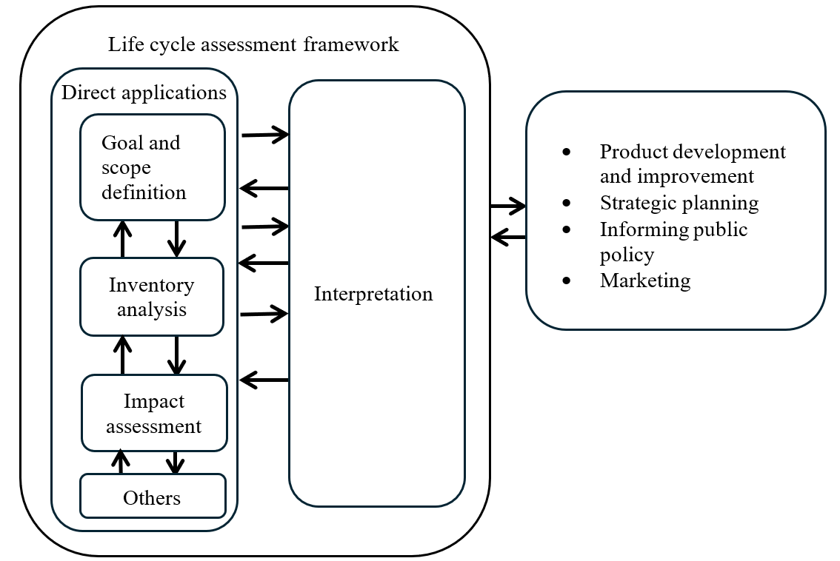
Based on the ISO 14040:2006 standard, a life cycle assessment (LCA) consists of four steps (Figure 1). Goal and scope definition is the first step of these four. In this step the study is defined in detail and central choices are made regarding its conduct.
“The goal definition shall firstly state the intended application(s) of the LCA results in a precise and unambiguous way. The decision-context is one key criterion for determining the most appropriate methods for the LCI model.”
For the practitioner it is crucial to define appropriate requirements for modelling the product system according to the intended purpose and application of an LCA.
At the same time, vehicle LCAs are used by a growing number of stakeholders for an increasing range of different purposes and applications. Traditionally, vehicle LCAs were mainly used in R&D for technology comparisons and support of strategic decision making (e.g. which powertrain / material / production technology / … is environmentally superior?) or by OEM’s (Original Equipment Manufacturer) to show that their successor models were more environmentally friendly than the previous ones (continuous improvement). This is also reflected in the list of direct applications in ISO 14040:2006 (compare Figure 1, box on the right). Currently, an extension of applications towards implementation and reporting of reduction measures – especially in the context of GHG reduction and circular economy (CE) – can be observed by various stakeholders with different expectations from automotive LCAs.
Potential stakeholders are listed below, but are not limited to:
(a) Society/ Policy makers
(b) Green finance & ESG rating
(c) Customer
(d) OEM
(e) Suppliers
Potential motivations are listed below, but are not limited to:
(a) Decision support of policy making
(b) Comparison / rating
(c) Communication /marketing
(d) Fair competition
(e) Incentivisation
(f) Internal steering of decarbonisation
(g) Proof of decarbonisation
(h) Identification of reduction potentials
As a consequence, this Mutual Resolution on A-LCA addresses different types of use cases by using the Level Concept, and highlights where these require different scope definitions and requirements concerning methodology and data granularity.
7.2. Use cases and application of Level Concept
The Level Concept distinguishes four different levels based on the underlying questions of the assessment. This could range from “what is the right mobility concept for a city?” to “what is the carbon footprint of a certain vehicle model?”. This leads to different requirements for the product system model especially with regard to the upstream life cycle phases in the foreground system (supply chain and vehicle production).
According to questions of the assessment granularity, product specificity and the scope of the foreground and background is chosen. To put it the other way round: whereas Level 1 study is representative of a broad range of products, e.g. all vehicles, Level 4 is more focused on the fine variations of individual vehicle models and the supply chain of their specific components (parts).
The choice of representativity and specificity also concerns downstream life cycle stages (Well To Wheel (WtW) / use stage, End-of-Life (EoL)) or background system processes (e.g. energy production). Also, for the use stage or EoL the data for a specific vehicle could be used. This implies however that the LCA is done retrospectively. For many use cases the analysis (declaration) point in time is the moment the product is put on the market. Consequently, the following life cycle stages can only be analysed prospectively. For predictive data, average data (e.g. for lifetime milage) can be used. For predictive data there is no way to provide primary data.
In general, every LCA practitioner who has the necessary data (granularity) available for the respective level, may conduct an LCA study for this level. However, in practice mainly OEMs have access to the bills of material (BoM) and the material data [system] (MDS) which are required as basis of the vehicle models for Levels 2 to 4. Level 1 can be used by government officials for public policy making or by researchers for general research purpose, since it doesn’t require proprietary information by OEM, such as BoM.
It is crucial to understand that emission magnitudes are only comparable between studies that use the same combination of methodologies applied to each life stage. Vehicle LCAs that differ in their combination of methodologies shall not be compared on a quantitative basis. Since Level 1 and Level 2 studies can have multiple combinations of approaches depending on the practitioners or the study purposes, comparability across the studies is not typically recommended.
However, Level 3 and Level 4 studies allow improved comparability between studies depending on the choices made by practitioners.
This does not imply any rating on the quality of studies. Level 1 LCA is not necessarily of lower quality than Level 4 study. Both serve different purposes / use cases (strategy focused or reporting focused) and therefore have different underlying “models of reality”. The following provides intended use cases and general approaches for each level.
Description of Level 1
(a) Intended use case:
(i) General uses, including research and public policy making based on generic data sources
(ii) Industry strategic planning: future projection, fleet modelling, etc.
(b) Approach:
(i) Multiple approaches possible by combining methodologies from different life cycle stages in this Resolution, depending on the purpose of the study, availability of data, etc.
(ii) For comparability and transparency, practitioners shall specify and maintain the discrete combination of methodologies used for their applications.
Description of Level 2
(a) Intended use case:
(i) Research and public policy development based on specific data sources relevant to the use case (e.g. bill of material, material data system)
(ii) OEM’s internal assessment and strategic planning
(iii) Product development and improvement
(iv) Marketing, e.g. of technology choices
(b) Approach:
(i) Multiple approaches possible by combining methodologies from different life cycle stages in this Resolution, other than vehicle modelling, depending on the purpose of the assessment
(ii) For comparability and transparency, practitioners shall specify and maintain the discrete combination of methodologies used for their applications.
Description of Level 3
(a) Intended use case:
(i) OEM’s official reporting for public information, marketing, etc.
(ii) Hotspot part supplier’s official reporting for public information, marketing, etc.
(iii) OEM’s official reporting for government programs
(b) Approach:
(i) Each lifecycle stage provides one fixed methodology for one harmonised A-LCA approach.
Description of Level 4
(a) Intended use case:
(i) OEM’s and supplier’s official reporting for public information, marketing, etc.
(ii) OEM’s and supplier’s official reporting for government programs
(b) Approach:
(i) Each lifecycle stage provides one fixed methodology for one harmonised A-LCA approach.
Table 1 summarises the general structure of the Level Concept, while the practitioner can refer to Chapter ‎8 for the detailed application of the level concept to different life cycle stages.

[Table 1
General structure of the Level Concept
 | Items | Level 1* | Level 2* | Level 3** | Level 4**
 | Purpose | Strategy |  | Reporting
Life cycle stage | Possible audiences | Policy makers, researchers | Company strategy/product developers, customers | Government programs, customers
Material production stage (See 8.1) | Activity data (Material weight [kg]) | Secondary data | Primary data
Material production stage (See 8.1) | Carbon intensity of material acquisition  [kg-CO₂eq/kg] | Secondary data |  | Primary and secondary data | Primary data
Parts production and vehicle assembly stage (See 8.2) | Vehicle model | Average for a vehicle fleet | Average for vehicles of a specific segment or a vehicle chosen as representative for a specific segment | Average for specific vehicle models with different equipment variants | Specific vehicle mode
Parts production and vehicle assembly stage (See 8.2) | Supply chain model | Generic |  | Partly specific for hotspot part supply chain | Mainly specific for whole supply chain
Parts production and vehicle assembly stage (See 8.2) | Waste | Implicit in surcharge factor |  | Implicit in surcharge factor except explicit for hotspot part | Fully explicit
Parts production and vehicle assembly stage (See 8.2) | Gross vs. net material input (yield) | Implicit in surcharge factor |  | Implicit in surcharge factor except explicit for hotspot part | Fully explicit
Parts production and vehicle assembly stage (See 8.2) | Transport of parts | Implicit in surcharge factor |  | Implicit in surcharge factor except explicit for hotspot part | Fully explicit
Parts production and vehicle assembly stage (See 8.2) | Transport of vehicles | Generic |  | Explicitly reported from OEM gate to customer
Parts production and vehicle assembly stage (See 8.2) | Primary/secondary material use | Implicit in material production carbon intensity |  | Implicit in material production carbon intensity except explicit for hotspot part | Fully explicit
Parts production and vehicle assembly stage (See 8.2) | Temporal validity | Most recent data |  | Most recent data except annual update for hotspot part | Annual update
Parts production and vehicle assembly stage (See 8.2) | Geographical representativeness | Determined based on the research question |  | As specific as possible while plant level for hotspot part | Plant level
Use stage (See 8.3) | Service life | Officially available data by CPs; if not available, the values in some peer-reviewed reports or methodology or adopt values from this guideline
Use stage (See 8.3) | Use phase consumption | Regional typical consumption values or other local representative realistic data |  | Official certification values; if not available, OEM-specific data
Use stage (See 8.3) | [Discrepancy factor | OEM/CPs/ Suppliers-specific data ; if not available official monitoring info, inventories like EMEP/EEA, etc. or assume 1.0 |  | Default values provided by CPs | Officially available data by CPs; if not available, verifiable OEM-specific average data matched to the region of operation, for informational purposes.
Use stage (See 8.3) | Deterioration factor for fuel cell | Efficiency loss of 10% over the lifetime (6000 hours for LDVs), assuming a starting efficiency of 55% and running at an average of 25% of the peak power rating |  | OEM/supplier-specific data on fuel cell life (to 10% loss in power) and average operational power level (as % of the peak power of the fuel cell, according to regulatory testing cycles) | OEM/supplier-specific approach or data, validated by independent third party expert
Use stage (See 8.3) | Deterioration factor for battery SoH in PHEV | SoH loss of 20% over the operational life cycle of 2000 charge/discharge cycles hours for LDVs |  |  | OEM/supplier-specific approach or data, validated by independent third party expert]
Use stage (See 8.3) | Future changes in energy mix | Energy mix change considered for the use stage based on the latest available dynamic scenario in order of preference: 1. Official government-published LCI based on currently implemented policy for a country or geographical region of interest, 2. [Stated Policies Scenario (STEPS)] from the most recent IEA [WEO report with the inclusion of the Sustainable Development Scenario (SDS) as a sensitivity], [3. Dispatch modelling or the peer-reviewed published data based upon dispatch modelling if it reflects implemented policy]
Use stage (See 8.3) | Maintenance | Optional: maintenance frequency factors based on practitioner’s technical assessment |  | List of maintenance parts/consumable and associated frequency provided by OEM
Use stage (See 8.3) | Determination of traction battery and fuel cell system replacement | Excluded by default, unless a simple assumption on replacement is provided |  | Excluded by default, unless methodology from this guideline to be followed upon justification | Excluded by default, unless OEM /supplier-specific approach to define the need for a replacement over the operational life is provided
End-of-life stage (See 8.4) | Activity data of EoL processes (e.g., weight of vehicle, parts, materials, etc.) | Global secondary data | Primary data based on BoM and MDS
End-of-life stage (See 8.4) | Carbon intensity data of EoL processes (e.g., dismantling and shredding/sorting, ASR thermal recovery, materials recycling, etc.) | Global, regional, or country specific, primary or secondary data, depending on the study |  | Data requirement specified by CPs
End-of-life stage (See 8.4) | Recovered parts disposal and recycling process  (e.g., tyre, lead battery, driving battery, etc.) | Global, regional, or country specific, primary or secondary data, depending on the study |  | Data requirement specified by CPs
End-of-life stage (See 8.4) | Material recycling modelling | RCM or CFF
(*) There are multiple approaches possible for Level 1 and Level 2. The descriptions for each item in the rows of Level 1 and Level 2 are the minimum requirements for calculation. In other words, the practitioners can adopt any methodologies for each item from the designated or higher levels. For example, for material weight, Level 1 practitioner can use either secondary data or primary data, and Level 2 practitioner shall use primary data.
(**) Level 3 and Level 4 shall be carried on the single fixed approach throughout the life cycle stages, and the practitioners shall follow the descriptions for each item in the designated row.
7.3. Product Category
This Mutual Resolution applies to light-duty vehicles.
7.4. Functional Unit and reference flow
[The primary function of a light-duty vehicle is to transport passengers and/or goods from one location to another. The functional unit (FU) for light-duty vehicles is defined as the passengers and/or goods transported over vehicle lifetime in kilometres. For vehicles carrying passengers, the default functional unit for vehicles is defined as “passenger-km” (p-km). A default functional unit for vehicles carrying goods is defined as “tonne-km” (t-km), based on assumed carriage of goods.
In all regional certification conditions, a single occupancy and appropriate loading conditions are already considered for light-duty vehicles, meaning these variables are already factored in in the certification values for the carbon footprint calculation. In any case, the loading condition shall follow to official-national regulation and/or legislation according to each jurisdiction.
However, for vehicles carrying goods, which are designed primarily for goods transport but often serve mixed functions such as carrying tools, equipment, or passengers, the choice of an appropriate functional unit is challenging.
Given these considerations, a more conservative approach should be considered and single passenger per vehicle should be assumed, with the presumption that vehicle technologies and energy sources will not change the light-duty vehicle occupancy rate. This will also ensure comparability between different vehicles.
Considering the above assumption, the functional unit (FU) for a light-duty vehicle is defined as the transportation of 1 passenger per km of distance travelled over the vehicle lifetime. However, since lifetime distance is different in each region, each regional authority, upon providing a thorough explanation and documentation, is entitled to adopt a distinct functional unit (e.g. per vehicle service life) . This unit shall be based on well-founded assumptions that are reflective of the respective jurisdiction under consideration]
The reference flow for a vehicle is defined as the measurable quantity of inputs and outputs necessary to meet the defined functional unit of the product over its lifecycle. The reference flow in automotive LCAs translates this functional unit into specific, quantifiable measures of resources consumed and emissions produced, covering aspects such as:
(a) Vehicle components and materials (e.g., steel, aluminium, plastics required to manufacture the car),
(b) Fuel and/or energy consumption over the vehicle’s lifetime,
(c) Maintenance and replacement parts (such as tyres, fluids, SLI batteries, etc.),
(d) End-of-life treatment for disposal or recycling.
The standardised reference flow enables consistent and comparable assessments across different automotive products, focusing on the impacts associated with achieving the defined service.
Given the current scope of these guidelines, certain definitions, methodological approaches, and calculation rules—including those pertaining to the functional unit, vehicle service life, certification protocols, discrepancy and deterioration factors, leakages, and maintenance parts and activities—are presently limited to the passenger car framework. The processes listed above serve as illustrative examples and are not intended to be exhaustive.]
7.5. System boundaries
7.5.1. Life cycle stages
The following life cycle stages are covered (Figure 2):
(a) Material production stage
(b) Parts production and vehicle assembly stage
(c) Use stage
(d) End-of-life stage
All life cycle stages include fuel and energy cycle
More details regarding system boundaries per life cycle stages are given in dedicated life cycle stage chapters.

Figure 2
Life cycle stages covered by this Resolution
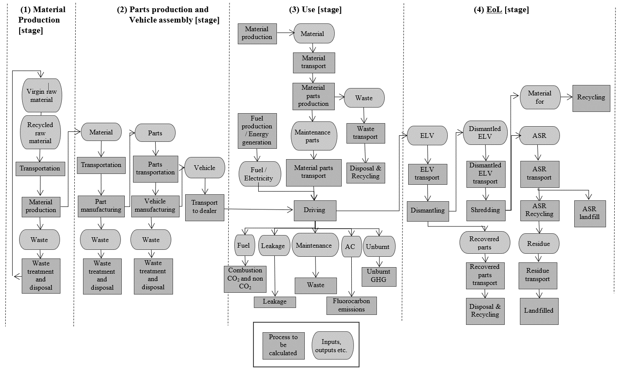

7.6. Infrastructure and capital goods
This section provides rules for infrastructure and capital goods, such as the building in which the product or upstream materials or components are produced, machinery used in the manufacturing of the product or its materials or components, vehicles used for transportation in the product system, the equipment used in the production and supply of energy (e.g. electricity generation equipment), the construction and maintenance of roads and production of charging infrastructure (list without claiming completeness). The applicable infrastructure and capital goods are limited to those that are not consumed and retain their function for a certain period.
In general, the production and end-of-life processes of infrastructure and capital goods used in the product system shall be excluded from the system boundaries. The exception are those infrastructure and capital goods for the production of fuels and for generation of electricity, which should be included by default within the system boundary for the vehicle use stage, unless otherwise required to ensure consistency with the selected regional energy modelling approach (e.g. RED)￼ (as is also the best practice adopted by UNECE publications on LCA of electricity generation, the GREET model, and other models and publications available in different global regions). The general cut-off criteria apply.
Deviations from the above requirements may be possible in the following case:
Infrastructure/capital goods (i.e. also others in addition to those for/resulting from production of fuels and generation of electricity) may be included for any lifecycle phase if a dataset used for A-LCA already includes infrastructure/capital goods, and it is not possible, within reasonable effort, to subtract the data on infrastructure/capital goods from this dataset.

7.7. Land Use Change
[The Indirect Land Use Change (ILUC) can be described as a change in the use or management of land, which is an induced consequence of a direct land use change, but which occurs outside the product system being assessed. The evaluation of the emissions related to the ILUC requires to assess the potential economic impacts induced by increased biofuel demand on commodity prices, and the related shifts in demand and supply across economic sectors, including primarily food and feed production. ILUC cannot be directly measured and is projected with economic models instead. This requires adding consequential element in an LCA methodology, resulting in increasing uncertainties and the potential for arbitrariness. The ILUC emissions, and the spatial dimension of the ILUC effects, are dependent on factors such as local/regional conditions and agronomical practices, regional food import demand and related projections, alternative economic uses of the same feedstock, etc. Given the variability of assumptions underlying the evaluation of indirect effects, quantitative assessment of GHG effects of ILUC is subject to uncertainty and the risk of arbitrary conclusions.
A risk-based approach can be used to take ILUC effects into account. However, the risk-based approach requires to be considered within the framework of sustainability themes.
Conversely, when needed, Direct Land Use Change (DLUC) can be calculated. The DLUC definition can be based on the RED methodology. The DLUC emissions encompass the annualised emissions and sequestration resulting from carbon stock changes in biomass, dead organic matter and soil organic matters, etc.]
Both DLUC and ILUC are already taken into account within LCI provided by some national and regional governments for biofuels. For example, biofuels LCI from the RFS Program in the United States serves as the official source of LCI for biofuels use by light-duty vehicles and engines used in heavy-duty on-road applications. Official, government-provided LCI for biofuels, including treatment of DLUC and ILUC, should be used within national and regional jurisdictions when available.
7.8. [Declaration of Vehicle CFP (for reporting)]
[
Accurately estimating the CFP of vehicles is essential for understanding their environmental impact and guiding efforts to reduce emissions, ultimately contributing to the decarbonisation of the automotive industry.
Vehicles are highly complex products composed of numerous parts manufactured through complex supply chains. Each vehicle’s unique configuration and customisable options make providing and managing LCAs for individual vehicles administratively burdensome for OEMs and but also for authorities. To address this, the methodology introduces the concept of a modular approach.
Comparability is a central challenge. For Level 1 and Level 2 LCA studies, different options (vehicles, technologies, powertrains, materials) are compared within one LCA study. In contrast, for Level 3 and Level 4 it is the aim to allow comparability between the individual vehicle LCA studies.
Level 1 and Level 2 LCAs are mainly conducted to support strategic decisions. It is recommended to model a vehicle which is representative of the considered entity of vehicles / vehicle fleet. Regarding all parameters relevant for the intended research question, it should have generic & average value depending on the availability of the data (e.g. public studies or literature data). For comparison of vehicle LCAs this requires special attention.
For level 3 & level 4, the objective is to rationalise the high administrative burden of LCA reporting, while a modular approach (7.8.1) ensures that the declared vehicle accurately reflects the characteristics and impacts of the entire group of vehicles, which is clearly defined.
This is in line with the terms of reference outlined by UNECE IWG A-LCA, Article 2.3, “The methodology shall be developed respecting the transparency and consistency. It also shall have balance between the accuracy and the workload considering the complex supply chain of automotive industry”.
This paragraph provides a solid foundation on how to declare carbon footprint of vehicle, by considering the entire lifecycle of vehicles.
7.8.1. Modular Approach
Given the complexity of vehicle production and use, a ‘modular approach’ is considered for carbon footprint calculation in this Mutual resolution. This involves separately calculating each stage of the vehicle lifecycle, according to the methodology described in paragraph 7, and then combining the results for the given vehicle.
(a) Production stage GHG Emissions: These emissions are associated with production, including material production, part production and vehicle assembly, they depend on the production region.
(b) Use stage GHG Emissions: These emissions, which occur during the use phase, are well-documented in certified fuel and energy efficiency data. They vary based on the vehicle’s sales region. Consumables and parts used for the scheduled maintenance, according to the manufacturer specifications, are considered.
(c) EoL stage GHG Emissions: These emissions, which occur during the recycling processes, depend on region of sell/use or recycling
7.8.2. Production Stage GHG Emission
Due to the large number of equipment variants for vehicles it is impractical to quantify production emissions for each vehicle individually. Alternatively, a ‘LCA group – Production’ (LGP) approach is followed. From this LGP a representative vehicle (RV) is chosen, for which the GHG-emissions are quantified following the guidelines defined in paragraph 8.1 and 8.2.
To report on a specific vehicle variant that is member of the LGP (declared vehicle) the GHG-emissions for production of that vehicle are calculated by a mass-based extrapolation described in paragraph 7.8.2.3.
The procedure to identify the RV from the LGP is described in paragraph 7.8.2.2.
The criteria that define the LGP are detailed in paragraph 7.8.2.1.
7.8.2.1. [Definition of LCA Group – Production stage
[RESERVED]
The main factors that greatly impact the production carbon footprint of a vehicle are the body structure, powertrain, energy storage system (only in case this is present in the drivetrain system), refer to Ricardo & CATARC study and production region.
Based on these factors, vehicles can be grouped into clusters (LCA group – production):
(a) Vehicle Structure Family: Means a cluster of vehicles of an automobile manufacturer’s vehicle fleet shall consist of vehicles that have the following features in common:
i. Mass variation (excluding the traction battery mass) among vehicles within the group should not be greater than [X %]
ii. Vehicle with similar material composition of ‘body in white’ (i.e., vehicle frame)
iii. Additional parameters will be declared by the OEMs (with justifications) if required to specify the definition of the LCA group (e.g. characteristics like vehicle type, model name, brand, marketing division, or roof line, number of doors, seats, windows or level of décor etc)
(b) Powertrain (drive System) type: to reflect the impact of the energy storage system/traction system e.g. ICE, OVC-HEV, NOVC-HEV, PEV, FCEV and FCHV.
(c) Region of final vehicle assembly: The region shall be defined by the location of the production plant, refers to a single market area, such as European Union, Japan, Korea, or the United States. The modelling of the supply chain should follow the level concept, since vehicle assembly is the final step in the supply chain, this regional definition shall link the RV to the production plant region. RV’s supply chain shall represent the supply chain of its LCA group, for example, vehicles assembled in Europe will typically reflect European consumption mixes and production processes. If vehicles are assembled in multiple regions, separate upstream LCA groups must be defined accordingly.]
7.8.2.2. Production stage representative vehicle Selection
A Representative vehicle characterizes all vehicles within a defined LGP, as specified in section 7.8.2.1.
To ensure that the pars-pro-toto-approach of a RV does not deliver skewed results on GHG emissions of production within that LGP, vehicles with the following characteristics are not fit to be selected as representative for the larger group of vehicles in the LGP, but are not limited to:

- High-performance variants with a focus on driving dynamics (e.g., sport or racing homologation models),
- Off-road-specific configurations with dedicated equipment,
- Special-purpose vehicles (e.g., police, municipal, or emergency vehicles),
- Editions or customized modifications with significantly altered functions or equipment
These vehicles deviate from the standard series profile and would distort the technical and environmental representativeness of LGP. Exclusion shall be justified using objective criteria such as equipment codes, technical data sheets, or project documentation, and ideally supported by sales data.
From the remaining pool of vehicles within the LGP, the RV is selected based on the highest technical mass, considering all series-available options and configurations. This mass-based approach ensures a consistent and conservative representation, independent of fluctuating customer preferences or market trends. If multiple vehicles exhibit the same maximum technical mass ±5%, any of these may be selected as the RV.
Additionally, equipping the vehicle with options until the maximum vehicle weight is reached secures the usage of a technically clear and conservative vehicle setup.
This approach ensures that the RV:
- Reflects the most representative configuration in terms of environmental impact,
- Covers all relevant powertrain [types] within the LGP,
- Supports consistency and comparability across vehicle LCA studies,
- Aligns with the principles of transparency, technical clarity, and conservative estimation as outlined in the UNECE A-LCA methodology.
[For a newly formed LGP of multiple vehicles at Start of Production (SoP), the first vehicle to go into production defines the representative vehicle of the newly formed LGP. Depending on the powertrain portfolio of the LGP further vehicles shall be considered to cover all powertrain types relevant to the respective LGP. As the rollout of the newly formed LGP progresses, the selection of the Representative Vehicle may be updated accordingly.]
Documentation for the choice and configuration of the representative vehicle shall be provided during the third-party certification (see verification paragraph ‎10).
Important Considerations:
(a) If the LGP includes vehicles with a traction battery, the battery shall be excluded from the calculation of the production emission factor. This is due to the fact that the capacity of a traction battery and its weight do not have a proportional relationship, which would distort the correlation via vehicle mass.
(b) The carbon footprint of the traction battery, if applicable, must be calculated separately.
(c) For the calculation of the total vehicle carbon emissions, the carbon footprint of the traction battery shall be subsequently added to the carbon emission of the vehicle production (CFP).
(d) A similar approach (a – c) should also be adopted for vehicles which have a high-pressure hydrogen storage vessel.

7.8.2.3. Production stage: Estimated value for the declared vehicles
The production emissions factors within an LGP [broadly] correlate to the mass of the vehicle for a given LGP, due to similar production characteristics. The RV serves as the baseline for estimating the carbon footprint for the values of the other vehicles from the LGP, for which declaration is required.
The Production Emission Factors (EF_{Prod}) (i.e. carbon emission per kilogram of vehicle weight) is calculated by the ratio between the production stage carbon emissions of the RV and its weight (excluding the weight of the traction battery or hydrogen storage vessels).
Figure 3
Explanation of the estimated value for the declared vehicles – production carbon emissions

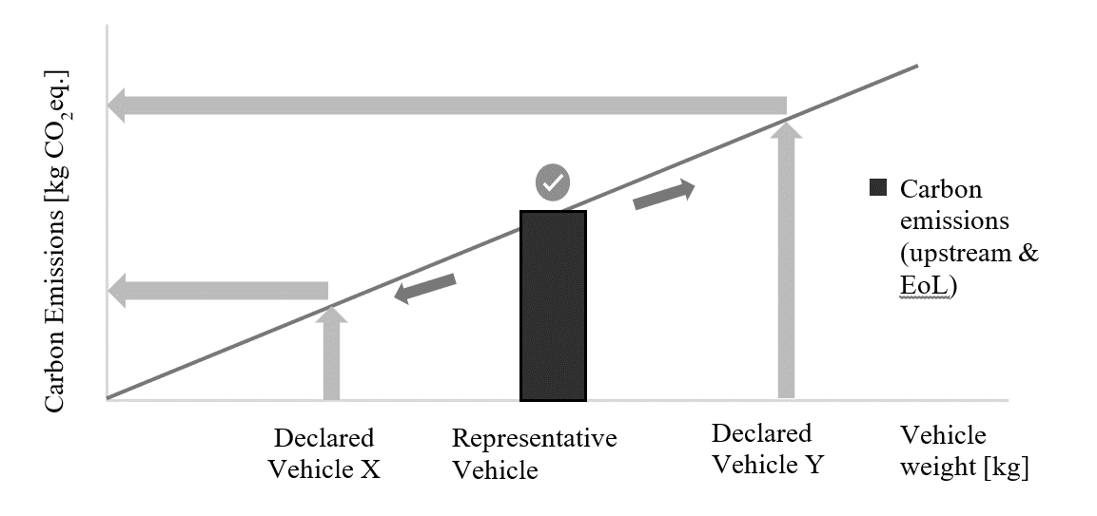
The correlation of CFP value according to the ‘RVs’, should be allowed both below and beyond the mass of the RV,
The production stage GHG emission for the declared vehicles within the same LGP is estimated using the following formula:
$C_{P, i}={EF}_{Prod} × m_{i}$ (5)
Where;
$C_{P, i}$ means the production stage carbon emission of the declared vehicle, [kgCO₂eq];
${EF}_{Prod}$ means the production emission factor, [kgCO₂eq/kg];
EF_{Prod} is describing the correlation between vehicle mass and the production CFP value of the RV, as defined below in 7.8.2.4.
$m_{i}$ means the actual mass of the declared vehicle (with the accessories & options).
For vehicles with traction batteries or hydrogen storage vessels:
$C_{P, i}={EF}_{Prod} × {(m}_{i}-m_{Bat/Ves})+ C_{P, Bat/Ves}$ (6)
Where;
$C_{P,Bat/Ves}$ means the carbon emission of the traction battery or hydrogen storage vessels, [kgCO₂eq];
$m_{Bat/Ves}$ means the weight of the traction battery or hydrogen storage vessels, [kg];
7.8.2.4. Determination of Production Emission factor
In case that CFP values for the vehicles other than the RV need to be declared, the following subchapter will introduce the methodology to estimate the CFP for these vehicles.
The production emission factor (EF_{Prod}), shall be calculated as follows:
${EF}_{Prod}=\frac{C_{P, RV}}{m_{RV}}$ (1)
Where;
${EF}_{Prod}$ means the production emission factor, [kgCO₂eq/kg]
$C_{P, RV}$ means the production carbon emission of the RV, [kgCO₂eq];
$m_{RV}$ means the actual mass of the RV (with the accessories & options), [kg];
In case of powertrain using traction battery or hydrogen storage vessels of the RV the emission factor shall be calculated as follows:
${EF}_{Prod}=\frac{C_{P,RV}-C_{P, Bat/Ves}}{m_{RV}-m_{Bat/Ves }}$ (2)
Where;
$C_{P, RV}$ means the production carbon emission of the RV, [kgCO₂eq];
$C_{P,Bat/Ves}$ means the production carbon emission of the traction battery or hydrogen storage vessels of the RV, [kgCO₂eq];
$m_{RV}$ means the actual mass of the RV (with the accessories & options), [kg];
$m_{Bat/Ves}$ means the weight of the traction battery or hydrogen storage vessels of the RV, [kg];
Both $C_{P, RV}$ and $m_{RV}$ shall be measured on the same RV.
The EF_{Prod} shall be included in all relevant test reports.
The EF_{Prod} shall be rounded to 2 points of decimal, the unit is kgCO₂eq/kg.

7.8.3. Use stage GHG Emission
Carbon emissions related to use stage emissions of the declared vehicle should be calculated according to the method described in paragraph ‎8.3. These emissions are typically derived from certified fuel consumption and energy consumption data, which are included in official homologation documents and regulatory certifications.
7.8.3.1. Use stage Powertrain group
As each region or country have their own definition of the powertrain group (e.g. interpolation family approach in EU) it is recommended to use the same powertrain family criteria defined in the ‘fuel and energy consumption regulation’ (see paragraph ‎8.3). In case of WLTP it is defined in UN GTR 15 / UN Regulation No. 154.
7.8.3.2. Use stage GHG emission: Energy consumption
Each individual vehicle has an ‘energy consumption’ value provided in official documentation (e.g., Certificate of Conformity). Two common approaches to determine downstream emissions are:
(a) Interpolation
(b) Inertia Class
For representative mass, inertia class defined in the regional fuel consumption regulation must be considered.
Figure 4
Explanation of interpolation and inertia approach
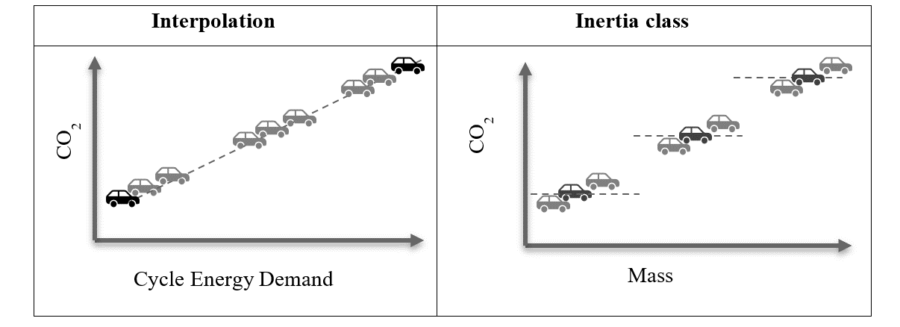
The carbon footprint of a particular type of powertrain and vehicle configuration (mass, aerodynamic, tyre etc.) should be reflected in the selected representative or declared vehicle:
- In case of ‘interpolation approach’: The vehicle configuration of the declared vehicle should be used as described in the Certificate Of Conformity document for that vehicle.
- In case of ‘inertia class approach’: The inertia class configuration of the declared vehicle should be used as described in the Certificate Of Conformity document for that vehicle
7.8.3.3. Use stage GHG emission: Maintenance and leakage
The carbon footprint during the maintenance and leakage does not vary in each powertrain family and hence it is recommended to determine this value for the selected RV of the powertrain family.
7.8.4. EoL stage GHG Emission
Due to the large number of equipment variants for vehicles it is impractical to quantify EoL emissions for each vehicle individually. Alternatively, a ‘LCA group - EoL’ (LGE) approach is followed. From this LGE a representative vehicle (RV) is chosen, for which the GHG-emissions are quantified following the guidelines defined in paragraph 8.4.
To report on a specific vehicle variant that is member of the LGE (declared vehicle) the GHG-emissions for EoL of that vehicle are calculated by a mass-based extrapolation described in paragraph 7.8.4.3.
The procedure to identify the RV from the LPE is described in paragraph 7.8.4.2.
The criteria that define the LGE are detailed in paragraph 7.8.4.1.
7.8.4.1. [Definition of LCA group EoL stage
[RESERVED]
The main factors that greatly impact the end-of-life carbon footprint of a vehicle is same as that of the production stage except the region of recycling. Based on these factors, vehicles can be grouped into clusters (LCA group – EoL) according to their common traits such as:
(a) All criteria defined for production stage emission except the region of production (see paragraph ‎7.8.2.1)
(b) Expected region of vehicle end-of-life: the region refers to a single market area, such as European Union, Japan, Korea, or the united states, if the vehicle is produced in the same region as the expected region of EoL, then both “LCA group – Production” and “LCA group – EoL” are the same.]
7.8.4.2. EoL stage representative vehicle selection
Refer to 7.8.2.2 for EoL stage representative vehicle selection.

7.8.4.3. EoL stage: Estimated value for the declared vehicles
The EoL emissions factors within an LGE [broadly] correlate to the mass of the vehicle for a given LGE, due to similar EoL characteristics. The RV serves as the baseline for estimating the carbon footprint for the values of the other vehicles from the LGE, for which declaration is required.
The EoL Emission Factors (EF_{Prod}) (i.e. carbon emission per kilogram of vehicle weight) is calculated by the ratio between the EoL stage carbon emissions of the RV and its weight (excluding the weight of the traction battery or hydrogen storage vessels).
Figure 5:
Explanation of the estimated value for the declared vehicles – EoL carbon emissions

The correlation of CFP value according to the ‘RVs’, should be allowed both below and beyond the mass of the RV,

The EoL stage GHG emission for the declared vehicles within the same LGE is estimated using the following formula:
$C_{EoL,i}={EF}_{EoL} × m_{i}$ (7)
Where;
$C_{EoL, i}$ means the EoL carbon emission of the declared vehicle, [kgCO₂eq];
${EF}_{EoL}$ means the EoL emission factor, [kgCO₂eq/kg];
EF_{EoL} is describing the correlation between vehicle mass and the EoL CFP value of the RV, as defined below in 7.8.4.4.
$m_{i}$ means the actual mass of the declared vehicle (with the accessories & options).
For vehicles with traction batteries or hydrogen storage vessels:
$C_{EoL, i}={EF}_{EoL} × {(m}_{i}-m_{Bat/Ves})+ C_{EoL, Bat/Ves}$ (8)
Where;
$C_{EoL,Bat/Ves}$ means the EoL carbon emission of the traction battery or hydrogen storage vessels, CO₂eq, [kg];
$m_{Bat/Ves}$ means the weight of the traction battery or hydrogen storage vessels, [kg];
7.8.4.4. Determination of EoL stage Emission factor
The EoL emission factor, EF_{EoL}, shall be calculated as follows:
${EF}_{EoL}=\frac{C_{EoL, RV}}{m_{RV}}$ (3)
Where;
${EF}_{EoL}$ means the EoL emission factor, [kgCO₂eq/kg];
$C_{EoL, RV}$ means the EoL carbon emission of the RV, [kgCO₂eq];
$m_{RV}$ means the actual mass of the RV (with the accessories & options), [kg].
In case of powertrain using traction battery or hydrogen storage vessels of the RV the emission factor shall be calculated as follows:
${EF}_{EoL}=\frac{C_{EoL,RV}-C_{EoL, Bat/Ves}}{m_{RV}-m_{Bat/Ves}}$ (4)
Where;
$C_{EoL, RV}$ means the EoL carbon emission of the RV, [kgCO₂eq];
$C_{EoL,Bat/Ves}$ means the EoL carbon emission of the traction battery or hydrogen storage vessels of the RV, [kgCO₂eq];
$m_{RV}$ means the actual mass of the RV (with the accessories & options), [kg];
$m_{Bat/Ves}$ means the weight of the traction battery or hydrogen storage vessels of the RV, [kg];
Both $C_{EoL, RV}$ and $m_{RV}$ shall be measured on the same RV.
The EF_{EoL} shall be included in all relevant test reports.
The EF_{EoL} shall be rounded to 2 points of decimal, the unit is kgCO₂eq/kg.

7.8.5. Total carbon footprint of declared vehicle
The total carbon footprint of a vehicle is the sum of:
(a) Production stage Emissions (see paragraph ‎7.8.2.)
(b) Production stage Emissions: Traction Battery or hydrogen storage vessels Emissions (if applicable)
(c) Use stage Emissions: energy consumption and maintenance (see paragraph 7.8.3.)
(d) End-of-Life Emissions (see paragraph ‎7.8.4.)
(e) End-of-Life Emissions: Traction Battery Emissions or hydrogen storage vessels (if applicable)
7.8.5.1. Steps to determine carbon footprint value of the ‘declared vehicle’
Step 1 : Production carbon footprint (depend on mass)
(a) Step 1.1: Define the ‘LCA Group – Production (LGP)’ (paragraph 7.8.2.1.)
(b) Step 1.2: Define an RV out of the LGP (paragraph ‎7.8.2.2.)
(c) Step 1.3: Calculate the production carbon footprint of the RV (excl. traction battery or hydrogen storage vessels)
(d) Step 1.4: Calculate the Production Emission Factor (EF_{Prod}) of the LGP (paragraph ‎7.8.2.4.)
(e) Step 1.5: Calculate the production carbon footprint of declared vehicle (paragraph ‎7.8.2.3.)
(f) Step 1.6: Add production carbon footprint of traction battery or hydrogen storage vessels if available
Step 2: Use stage carbon footprint (depend on the regional approach)
(a) Step 2.1: Calculate the use stage carbon emissions of selected vehicle (RV or the declared vehicle) (see paragraph 7.8.3.).
These emissions are typically derived from certified fuel consumption and energy consumption data, which are included in official homologation documents and regulatory certifications.
Step 3: EoL carbon footprint (depend on mass)
(a) Step 3.1: Define the ‘EoL LCA group (LGE)’ (paragraph ‎7.8.4.1.)
(b) Step 3.2: Define an RV out of the LGE (paragraph 7.8.4.2.)
(c) Step 3.3: Calculate the EoL carbon footprint of the RV (excl. traction battery or hydrogen storage vessels)
(d) Step 3.4: Calculate the EoL Emission Factor (EF_{EoL}) of the LGE (paragraph 7.8.4.4.)
(e) Step 3.5: Calculate the EoL carbon footprint of declared vehicle (paragraph ‎7.8.4.3.)
(f) Step 1.6: Add EoL carbon footprint of traction battery or hydrogen storage vessels if available

Step 4: total carbon footprint
Total carbon footprint = Production stage carbon footprint + Use stage carbon footprint + EoL stage carbon footprint

UEF=CU, RVmRV

UEF
CU, RV
mRV

UEF=CU,RV-CU, BatmRV-mBat

CU, RV
CU,Bat
mRV
mBat
CU, RVmRV

EEF=CEoL, RVmRV

EEF
CEoL, RV
mRV

EEF=CEoL,RV-CEoL, BatmRV-mBat

CEoL, RV
CEoL,Bat
mRV
mBat
CFPEoL, RVmRV

CU, i=UEF × mi

CU, i
UEF
mi

CU, i=UEF × (mi-mBat)+ CU, Bat

CU,Bat
mBat

CEoL,i=EEF × mi

CEoL, i
EEF
mi

CEoL, i=EEF × (mi-mBat)+ CFPEoL, Bat

CEoL,Bat
mBat

7.9. Environmental impact category and indicator
The calculation of the CFP shall include non-CO₂ GHGs.
The GHGs to be included shall be considered with reference to the latest IPCC Assessment Report. The potential climate change impact of each GHG emitted and removed by the product system shall be calculated by multiplying the mass of GHG released or removed by the 100-year GWP given by the IPCC in units of kgCO₂eq per kg emission.
Where GWP values are amended by the IPCC, the latest values shall be used in the calculations. For example, once IPCC releases a new Assessment Report, the GWP100 values shall supersede those of the previous Assessment Report. In any case, there should be a clear statement by the LCA practitioner regarding which AR is used. All life cycle stages include fuel and energy cycle. For reference, the AR6 characterisation factors for the substances that are not listed in case of AR6 in Table 7.15 of the IPCC AR6 shall be extracted from Table 7 SM6 in Section 7 Supplementary Materials of the AR6 Climate Change 2021.
7.10. Inclusion of specific GHG emissions and removals
Biogenic GHG emissions and removals shall be calculated in an A-LCA study and be expressed separately.
All relevant unit processes of the life cycle of biomass-derived products shall be included in the system under study, including, but not limited to, cultivation, production and harvesting of biomass.
A product’s biogenic carbon content shall be calculated and documented separately in the CFP study report. In addition, the biogenic carbon content and total carbon content of products shall be reported separately. If mass balanced materials are used in the supply, the attributed biogenic carbon content shall additionally be reported to accurately account for emissions from combustion of these materials.
Specific emission values shall be reported as follows (see Figure 6):
1. Net fossil GHG emissions and removals (d_{e}-d_{r})
2. Net biogenic GHG emissions and removals other than biogenic CO₂ (if applicable, (b_{e}-b_{r}))
3. Net biogenic GHG emissions and removals including biogenic CO₂ (if applicable, (c_{e}-c_{r}))
4. GHG emissions resulting from aircraft transportation (if applicable, a)
5. Biogenic carbon content (if applicable, f)
6. Total carbon content (g)
If separate emission values do not occur, these emission values may be reported as zero.
Removals in the CFP shall not include any measures not related to the product system, usually referred to as carbon offsets.
Figure 6
Illustration of the reporting for specific GHG emissions
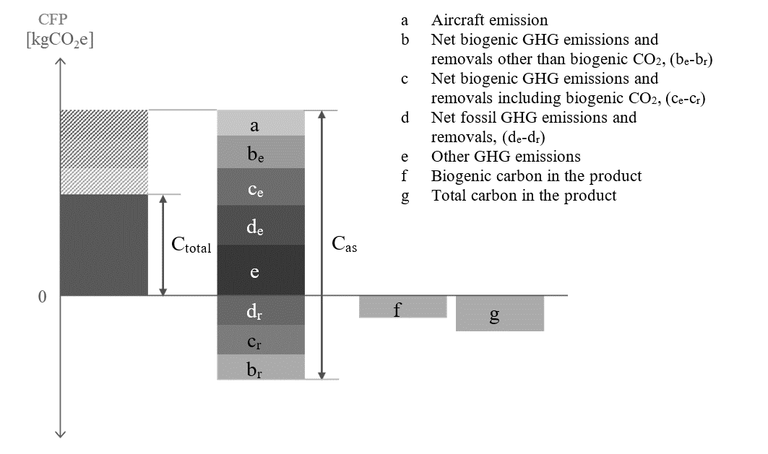

7.11. Data collection requirements and data types
Primary data is a quantified value of a process, or an activity obtained from a direct measurement, or a calculation based on direct measurements. Primary data can include greenhouse gas emission factors and/or greenhouse gas activity data.
Average data from industry associations or global averages do not qualify as primary data.
Primary data may be obtained through meter readings, purchase records, utility bills, engineering models, direct monitoring, material or product balances, stoichiometry or other methods for obtaining data from specific processes in the value chain of a company.
Primary data include primary activity data, i.e., a technical flow, and primary GHG emission factor, i.e., the carbon footprint of the corresponding activity expressed in kgCO₂eq per unit (see Table 2).
Secondary data do not fulfil the requirements for primary data. Secondary data can include data from databases and published literature, prospective emission factors from national inventories, calculated data, estimates or other representative data, validated by competent authorities. Secondary data can include data obtained from proxy processes or estimates.
Table 2
Types of primary data
Approach | Direct emission measurement
Primary data | Source of emission is within company boundaries and is measured
Approach | Activity data source |  | x | Emission factor source
Approach | Energy | Material/Product | x | Energy | Material/Product
Primary data | Consumption measured or invoiced  (primary) |  |  | On-site energy production emission factor  Or energy supplier-specific emission factor | Emission factor quantified and shared by supplier

Requirements regarding data collection and data types (primary or secondary) are given for each life cycle stages in dedicated paragraphs (see paragraph ‎[8.1. - ‎0.]).
7.11.1. Data quality
Data selection should follow data quality requirements outlined in ISO 14044:2006 (see sec. 4.2.3.6 of ISO 14044:2006) including:
7.11.1.1. Temporal representativity:
The data collection period must correspond to the activity data that is most relevant to the process.
For retrospective data emissions shall by default be reported averaged over the period of one year (reporting or calendar year) to avoid seasonal fluctuations and e.g. reflect typical production and operation conditions. Shorter periods may be considered if data on a full year are not yet available. Longer averaging periods may be considered but shall not exceed three years. Any averaging period deviating from the default shall be flagged and justified.
7.11.1.2. Geographical representativity:
The geographical location of data collection must correspond to the activity data that is geographically representative to the process.
For material, parts and vehicle production emissions shall be reported as geographically specific as possible by default (e.g. on the plant level). Averaging over a region or country may be considered but shall be flagged as such.
7.11.1.3. Technological representativity:
The data shall be collected/selected for the processes used in the activity to ensure technological representativeness.
If the practitioner cannot access such information and instead refers to data of a technically similar process from a secondary dataset or other sources, the reason shall be documented and justified.
7.11.1.4. Completeness:
The Life cycle assessment shall include all processes and flows that are attributable to the analysed system. Processes and flows being able to exclude are determined according to the cut-off threshold (see paragraph ‎7.12).
7.11.1.5. Consistency:
The data selection shall ensure uniform application of the methodology to the various components of the analysis.
7.11.1.6. Traceability:
The source of data used in a study shall be documented.
Primary data are to be prioritised if available, otherwise secondary data shall be used.
Specific details on data quality requirements are provided for individual life cycle stages in paragraphs ‎8.1.
7.11.2. Primary data share
To create visibility on the share of primary data in CFP calculations for vehicle product, a primary data share (PDS) indicator can be defined. The PDS is the proportion (percentage) of a (partial) CFP that is derived from primary data.
A CFP calculation might include both primary, secondary data and a mix of both expressed by the primary data share. For example, calculating emissions from the consumption of electricity could involve primary activity data, such as data on consumption in kWh, multiplied by a secondary emission factor in CO₂eq per kWh.[ When calculating the primary data share, a contribution to the primary data share shall only be attributed, if both the activity data (e.g., amount in kWh) and the GHG emission factor (expressed in kgCO2eq per unit) information is derived from primary data.] or [The combination of a measured consumptions (primary) and a secondary GHG emission factor or vice versa is reflected in the primary data share calculation by an attribution factor of 50%.] or [a contribution to the primary data share shall be calculated separately for the activity data (e.g., amount in kWh) and for the GHG emission factor (expressed in kgCO2eq per unit) to track both the share of primary activity data and the share of primary emission factors.]
Reporting of a PDS is relevant in case of detailed supply chain and vehicle modelling. Therefore, the PDS shall be determined and communicated for material production stage (paragraph 4.1), and parts production and vehicle assembly stage (paragraph 4.2) and may optionally be determined and communicated for use (paragraph 4.3) and end-of-life phases (paragraph 4.4). [For the calculation of CFP according to Level 3 and Level 4, reporting of a primary data share may be requested by the contracting party (for application on Level 3 refer to paragraphs 4.2.1.3 and 4.2.4).]
The PDS of each product on the output side is reported for the total CFP (C_{total}) which is algebraic sum of the positive and negative CFP contributions on the input side and the companies own operations (C_{i}). To ensure that a consistent PDS can be reported no matter if reporting is done stepwise or collectively for multiple process steps C_{as}, the absolute sum of C_{i} is also to be calculated. Figure 7 illustrates the definition of C_{total} and C_{as}.

${C_{total}=\sum_{i}{C_{i}}; C}_{as}=\sum_{i}{\left|C_{i}\right|}$ (9)

Figure 7
Definition of C_{as}
e
d
c
b
a
Result
Contribution
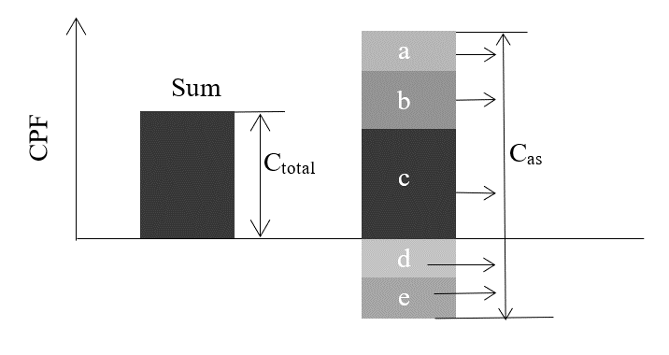

In case there are no negative CFP contributions C_{total} is equal C_{as}. Having introduced C_{as} the primary data share of each process/company on the output side is defined by:
$PDS=\frac{\sum_{i}{\left|Part of CFP based on primary data \right|}}{C_{as} }$ (10)
The aggregated primary data share on the output side for multiple CFP contributions reported with individual PDS (i.e. PDS_{i}) from the input side or own operations.
$PDS={PDS}_{aggregated}=\frac{\sum_{i}{\left(\left|C_{as,i}\right|⋅{PDS}_{i}\right)}}{\sum_{i}{C_{as,i}}}$ (11)
As an example, three suppliers, Company A, Company B and Company C, provide parts to Company D. Each part has a different primary data share and contribution to the total CFP value of the product of Company D (Figure 8). According to formula above, the primary data share of Company D’s part is calculated from the primary data share and contributions to the absolute value total CFP (Table 3).

Figure 8
Cascading PDS
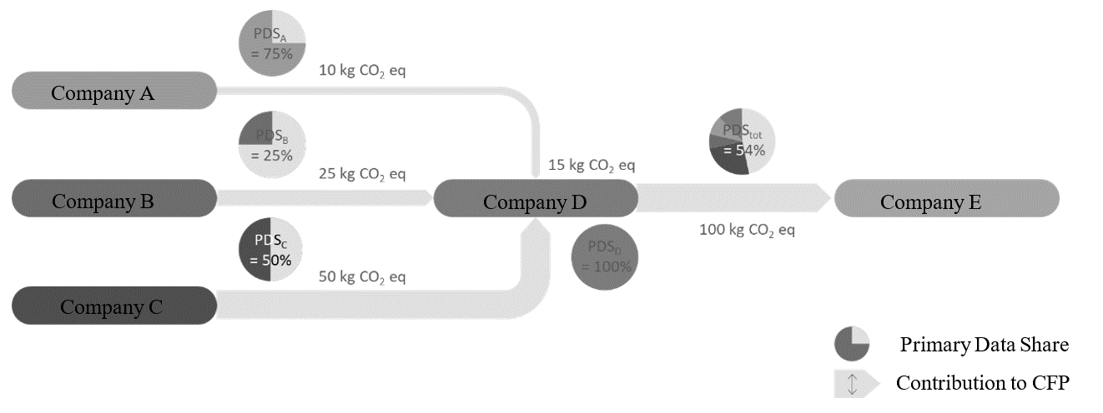

Table 3
Primary data share of the example as in Figure 8
 | PDS_{i} | C_{total},_{i} | PDS Contribution
Company A | 75% | 10 $kg CO_{2} eq$ | 75% * 10 $kg CO_{2} eq$ = 7.5 $kg CO_{2} eq$
Company B | 25% | 25 $kg CO_{2} eq$ | 25% * 25 $kg CO_{2} eq$ = 6.3 $kg CO_{2} eq$
Company C | 50% | 50 $kg CO_{2} eq$ | 50% * 50 $kg CO_{2} eq$ = 25 $kg CO_{2} eq$
Company D | 100% | 15 $kg CO_{2} eq$ | 100% * 15 $kg CO_{2} eq$ = 15 $kg CO_{2} eq$
Total | 54% | 100 $kg CO_{2} eq$ | 54 $kg CO_{2} e$, (7.5 + 6.3 + 25 + 15)$kg CO_{2} eq$

The primary data share is not directly linked to the accuracy of the total CFP. In addition, while LCA analysis by obtaining primary data is beneficial, it should be known that obtaining primary data itself does not necessarily lead to carbon neutrality, and neither does a high Primary Data Share. However, a contracting party may review this indicator, for example, to assess data sources.
Note: When a product with a high PDS in the supply chain (e.g., the product of Company A in Figure 8) is decarbonised through carbon reduction measures, the PDS of the final product (e.g., the product of Company D in Figure 8) may rather decrease as a result of the lowered total CFP. Therefore, while the PDS can be an indicator of the primary data usage, it shall be considered only in conjunction with the total CFP value.
7.12. Cut-off rule
In general, all processes and flows that are attributable to the analysed system shall be included. The analysed system can be the complete product to which the functional unit is associated, (e.g. a passenger car,) but also a subsystem (component, part) to the product or an individual life cycle stage that contributes additive to the life cycle GHG emissions of the final product. For practical reasons (see ISO 14067, PEF method), process modules, inputs and outputs may only be excluded if their sum represents less than 3% of the GHG emissions of the analysed system. It is not permitted to cut-off an entire life cycle stage, even if that falls below the threshold value. GHG emission reported from upstream entities shall be regarded as correct and complete and may not be subject to any further cut-off. A documentation shall be provided to give evidence that the cut-off criterion is met, and which cut-offs were applied. The documentation can be given in the form of a screening analysis.
Compliance with the cut-off threshold value can be proven on a product category or sectoral level and does not have to be executed on a product level. Product category rules or sectoral guidelines can lay down simplified rules for the evidence to be provided.
7.13. Screening Analysis
A screening analysis ensures that cut-offs in total do not exceed a threshold value of the GWP impact.
The screening shall allow further refinement of the LCI and the associated emission factors of the system in scope in an iterative manner. Within screening, no exemption of flows is allowed, and readily available primary or secondary data may be used. If data, such as emission factors, activity data, or measurements are unavailable or challenging to identify, it is essential to find the most appropriate data or proxy emission factors, in case of doubt a conservative choice shall be taken. Emission factors or activity data received from upstream reporting entities shall be regarded as correct and complete. The scope of the final screening iteration shall be documented to inform on the cut-offs and prove compliance with the cut-off threshold value.
7.14. Energy modelling
7.14.1. Fuel modelling
The definition of emission factors for fuels follows the methodology outlined in the EU Renewable Energy Directive 2018/2001 and other systems such as the U.S. EPA Renewable Fuel Standard and shall include:
(a) Upstream processes referring to the extraction or cultivation of raw materials.
(b) Processes related to the fuel’s processing.
(c) Transport and distribution processes at each life cycle stage.
(d) Emissions from the fuel in-use.
Additionally, concerning fuels originated from bio-materials, the following conditions shall be considered;
(a) Additional emissions related to changes from soil carbon stock caused by land use change.(e.g. wetlands conversion, some specific forest areas, etc.).
(b) Emission savings from soil carbon accumulation via improved agricultural management (e.g. shifting to reduced or zero-tillage, using cover crops, etc.), CO₂ capture and geological sequestration, and CO₂ capture and replacement.
In the case of one or more other products (co-products, e.g. sugar beet pulps, Distillers Dried Grains with Solubles), allocation shall be determined in proportion to the energy content of the products, determined by lower heating value in the case of co-products other than electricity and heat, or other allocation methods using the allocation method hierarchy in ISO 14040:2006; or developed for national programs, for example the U.S. Renewable Fuels Standards (RFS). The co-product method used in a study should be transparently presented in the study report, and sensitivity analysis should be conducted with alternative allocation methods for impacts of allocation method choices.
7.14.2. Electricity modelling
Two main approaches exist for modelling electricity consumption by a product system: the location-based approach and the market-based approach.
(a) The location-based approach is a method of allocating electricity impacts among end-users based on geographical representativeness (economic area, country, bidding zone , etc.); this approach is currently the most commonly used by LCA practitioners, with main LCA databases offering detailed models at a relatively fine geographic scale. The same average profile per kWh is applied to all electricity consumers within a single grid. The GHG Protocol defines it as follows: “A location-based method reflects the average emissions intensity of grids on which energy consumption occurs (using mostly grid-average emission factor data).”
(b) The market-based approach allocates electricity impacts among end-users based on a principle of individual contractual instruments, which can be claimed by different consumers. This approach seeks a more precise accounting of the environmental impacts of energy choices made by companies and consumers. The GHG Protocol defines it as follows: “A market-based method reflects emissions from electricity that companies have purposefully chosen (or their lack of choice). It derives emission factors from contractual instruments, which include any type of contract between two parties for the sale and purchase of energy bundled with attributes about the energy generation, or for unbundled attribute claims.”
Development of electricity emission factors shall be based on ISO 14067:2018 and shall include upstream processes and production of electricity generation infrastructure for the electricity supply system (e.g. mining of fuels, transport of fuels to power plants, growing and processing of biomass fuel feedstock, and production of equipment generating renewable energy, such as photovoltaic installations).
[The inclusion of such upstream elements should be prioritised for those components that have been shown to contribute significantly to the emissions of the specific technology (e.g., it is established that the embodied emissions of photovoltaic solar panels may significantly contribute to the gCO₂eq/kWh of that pathway’s electricity). ]
Details about infrastructure/capital goods for production of fuel or electricity, must be referred to paragraph 7.6
(a) Processes related to electricity generation, including losses during transmission and distribution
(b) Downstream emissions (e.g. treatment of waste arising from the operation of nuclear electricity generators or treatment of ashes from coal-fired electricity plants)
Where possible, the generator specific emission factor for the consumed energy shall be applied. Otherwise, if information on supplier-specific electricity is not available, GHG emissions associated with the respective electricity grid by which the electricity is provided shall be used. The respective grid shall reflect the electricity consumption of the related region, ,
In addition to data based on the average electricity mix of a country or region, specific electricity generation mix data can be used if all of the conditions described in paragraphs ‎7.14.2.1 to ‎7.14.2.4 are met.
7.14.2.1. Electricity from the grid via a contractual instrument
Electricity data from electricity certificates for a specific generator site or supplier documented by energy certificates may be used in the calculation of emission factors for electricity supplied from the grid if it can be ensured that all the following conditions are met.
(a) Information on the unit of electricity is provided, together with the characteristics of the electricity generator.
(b) It is guaranteed to be a unique claim.
(c) Tracking, redemption, depreciation, cancellation, etc., of the certificate is carried out by the reporting company. For the same year that electricity was produced within the country, or within the market boundaries where consumption occurs and to which the grid is interconnected
In ISO 14067:2018, there are examples of certificates that can be used by contractual instruments, such as European Guarantee of Origin (GOs) and US Renewable Energy Certificates (RECs) which meet the above conditions. Electricity certificates that do not guarantee compliance with the above conditions shall not be used. Contractual instruments may include utility tariffs, power purchase agreements (PPAs) or energy attribute certificates (EACs) themselves.
Notes on handling power certificates
In order to use electricity certificates in this guideline, their reliability and traceability must be ensured, and it must also be guaranteed that double counting does not occur in LCA calculations. Therefore, in addition to ensuring that electricity certificates meet the above requirements, the following must be ensured in LCA calculations that use electricity certificates:
(a) The environmental value of electricity certificates must not be biased;
(b) There is no double counting with grid electricity (the LCI data for grid electricity uses the residual mix, excluding the value of the electricity certificate. If no residual mix is available, the fossil generation mix for the respective grid shall be used);
(c) [Mixing location-based and market-based modelling shall be avoided within one life cycle stage of an LCA];
(d) Information about the electricity certificate is clearly stated in the LCA report.
The electricity certificate should be accompanied by the following information:
(a) Name and location of the generating facility;
(b) Method of generation;
(c) Amount of electricity generated and amount of electricity certificates issued;
(d) If available, tracking number assigned by the electricity certificate system.
When a practitioner chooses a market-based approach with any kinds of Certifications of electricity, the conditions below should be met…
Conditions for Market-based approaches
The market-based approach for electricity may be used only when the supplier is able to guarantee through a contractual arrangement that the electricity product:
(a) conveys the information associated with the unit of electricity delivered;
(b) is assured with a unique claim, to avoid double counting of GHG emissions and GHG removals within the boundary of the subject;
(c) is tracked and redeemed, retired or cancelled by, or on behalf of, the reporting entity;
(d) is produced as close as possible to the period to which the contractual instrument is applied and comprises a corresponding timespan;
(e) is produced within the country, or within the market boundaries where consumption occurs if the grid is interconnected.
If processes within the subject are located in Small Island Developing States (SIDS)[3)], the carbon footprint may additionally be quantified using contractual instruments for such processes, irrespective of grid interconnectivity.
[The entity shall document in the carbon neutrality management plan its plans to improve the efficiency of electricity use of the subject and report actions that have been taken to implement such activities.
The entity should consistently apply the selected approach in subsequent carbon neutrality reports. If the entity changes its selected approach in subsequent reporting periods, it shall reflect this change in the carbon neutrality management plan, including a recalculation of the baseline, and make it transparent in the carbon neutrality report.]
To promote the development of additional renewable energy capacity, entities should apply the following sourcing hierarchy:
(a) self-generation or physical power purchase agreements with direct line connections;
(b) financial power purchase agreements from renewable sources;
(c) contractual instruments from a generation facility no older than 15 years.
Note 1 Contractual instruments are any type of contract between two parties for the sale and purchase of energy bundled with attributes about the energy generation, or for unbundled attribute claims. This can include energy attribute certificates (EACs), renewable energy certificates (RECs), guarantees of origin (GOs), power purchase agreements (PPAs), green energy certificates or supplier-specific emission rates.
Note 2 The market-based approach is a method to quantify the indirect emissions from energy of a reporting organisation based on GHG emissions emitted by the generators from which the reporting organisation contractually purchases electricity bundled with contractual instruments, or contractual instruments on their own.
Note 3 The location-based approach is a method to quantify indirect emissions from energy based on physical delivery of energy, using average energy generation emission factors for defined geographic locations at a national or sub-national level.
Note 4 Using biofuels or other bio-based materials based on contractual instruments can result in GHG emissions reductions. These market-based approaches involve a separate certification process, which includes use of contractual arrangements that:
(a) convey the information associated with the unit of fuel or materials delivered;
(b) are assured with a unique claim, to avoid double counting of GHG emissions and GHG removals within the boundary of the subject;
(c) are tracked and redeemed, retired or cancelled by, or on behalf of, the reporting entity.
Detailed conditions shall be based on ISO 14068 -1:2023.
7.14.2.2. Electricity from a directly connected supplier
Site-specific electricity data may be used in the calculation of emission factors for electricity supplied directly from electricity generators via dedicated transmission lines to facilities manufacturing the respective products and consumed in the manufacture of such products, if no contractual instruments have been sold to a third party.
7.14.2.3. On-site generated electricity
Site-specific electricity data may be used in the calculation of emissions factors for on-site electricity generated and consumed on the premises where the respective product is produced, if no contractual instruments have been sold to a third party.
7.14.2.4. Grid Mix and On-Site Electricity Production:
On-site electricity production can only be accounted for under the following conditions:
(a) The production asset is owned by the same entity as the factory, or the asset has a direct connection to the factory and is not connected to the grid.
(b) Only the fraction of electricity that is used on-site and not sourced from the grid shall be accounted for.
(c) No credits can be claimed for electricity produced in excess and sent to the grid.
Any deviation, along with detailed explanations of the calculation methods or models used to revise emission factors, must be reported in the LCA report
7.14.3. Future Changes in Energy Mix
Practitioners shall also account for any potential changes in the fuel or electricity production pathways during the lifetime of the vehicle. (Detailed methodology is provided in paragraph 4.3.5.)
For any prospective LCA, secondary data will be needed. Secondary LCI data should be sourced from data sets provided directly by government authorities. If such data is not available, region-specific secondary data from IEA should be used.
(a) Including LCI from regulatory authorities will thus include relevant statutes and regulations under implementation that impact the sector within a specific country or region and within a specified timeframe.
(b) When using IEA data, specific sensitivities from the IEA should also be used
The scenario shall also be explained in the final report. Details must be referred to in the “Reporting” section.
7.15. Allocations
In case a process has more than one output, the question how to allocate the CO₂eq-burden to the outputs arises. Outputs of a process can be viewed as products, co-products or waste. Products or co-products share the CO₂eq-burden of the production/generation process, whereas waste eventually increases the CO₂eq-burden for the product. In a first step the question: ‘Is this a waste or a product?’ must be answered (see Figure 9).
Figure 9
Product, Co-Product or Waste
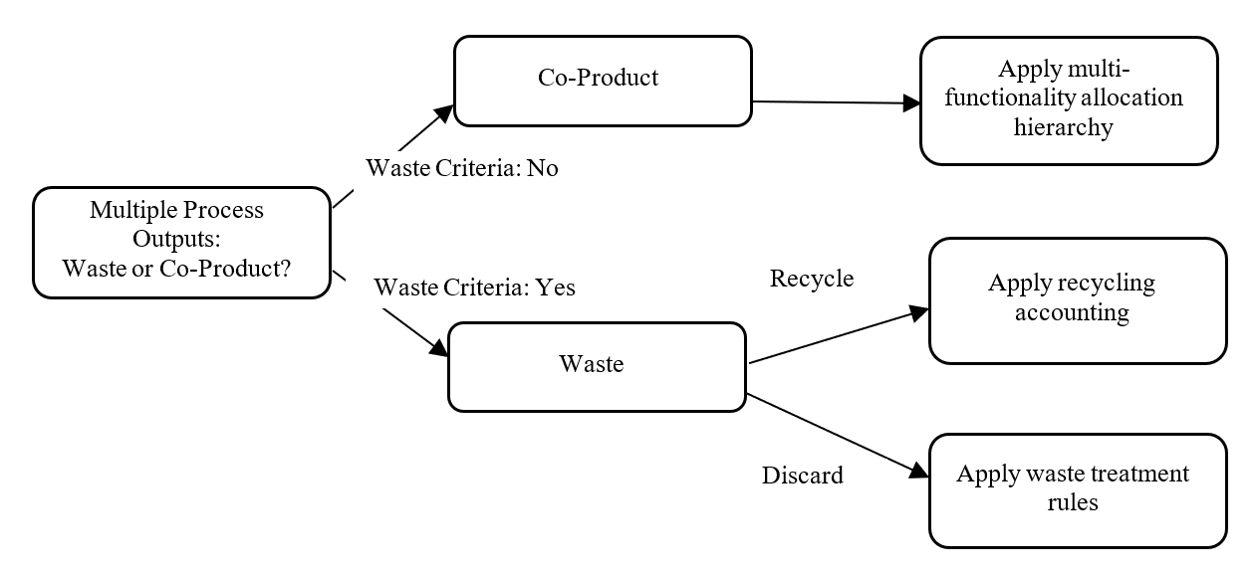
7.15.1. Waste vs Co-product
Waste is any material or process output which is not deliberately produced as an integral part of a multi-output production process. No further use of the material or process output is certain. Additionally, the holder discards or intends to discard or is legally required to discard the residue based on national waste legislation.
Waste materials with certain further use but requiring further treatment other than normal industrial practice before use (i.e., waste recovered by recycling) shall follow the requirements on material recycling.
“Normal industrial practice” can include all steps which a producer would take for a product, such as the material being filtered, washed, or dried; or adding materials necessary for further use; or carrying out quality control. However, treatments usually considered as a recovery operation cannot, in principle, be considered as normal industrial practice in this sense. Some of such processing tasks considered as normal industrial practice can be carried out on the production site of the manufacturer, some on the site of the next user, and some by intermediaries, as long as they also meet the criterion of being ‘produced as an integral part of a production process’ (adopted from the EU’s Guidance on the interpretation of key provisions of Directive 2008/98/EC on waste).
A co-product in contrast is produced as an integral part of a multi-output process where its further use is certain. Typically, co-products directly replace a raw material or fuel without requiring further processing other than normal industry practice. For co-product allocation, multi-output allocation applies (please refer to paragraph ‎7.15.2.).
The following hierarchy shall be applied (please refer to ‘Guidance on the interpretation of key provisions of Directive 2008/98/EC on waste’ ³⁹ for definitions of the respective criteria):
Figure 10
Waste vs. co-product classification hierarchy
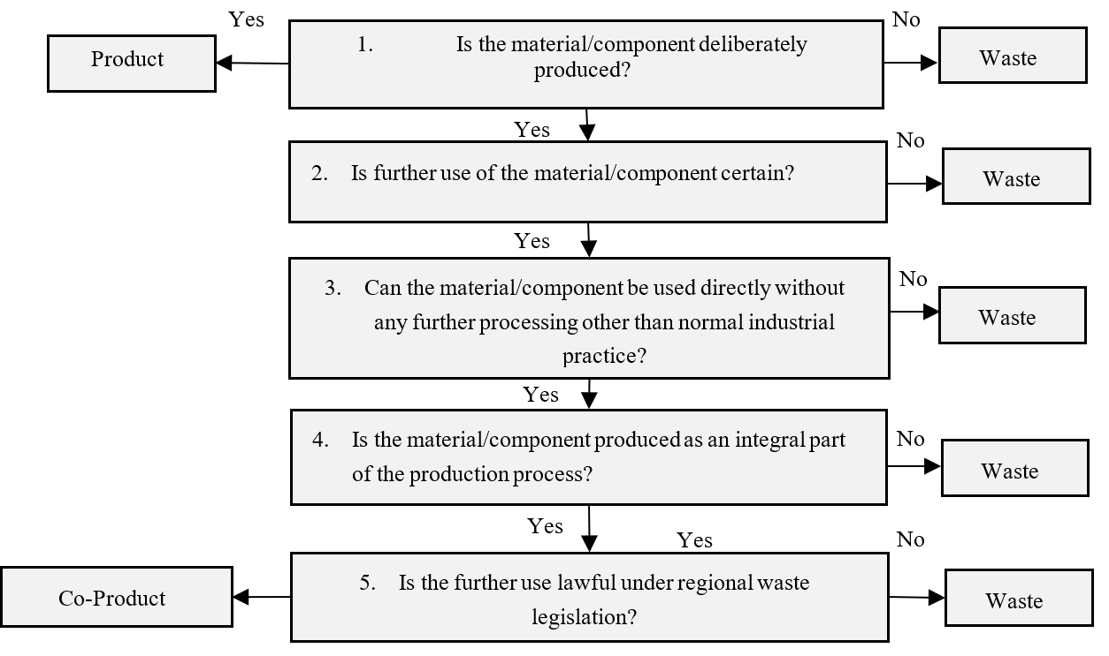Note: This is based on EU Waste Framework Directive
Residues classified as waste following the hierarchy can also be transformed into recycled feedstock. However, this transformation would require further processing other than normal industry practice (see point 3 in Figure 10), such that the residue would be classified as waste in the first instance.
Pre-consumer scrap that is not reintroduced into the same process (i.e., all scrap except run-around scrap) shall be defined as waste unless legal evidence (following legislation of the region where scrap is generated, e.g., legal judgement or legal report from regional waste legislation) exists that classifies the pre-consumer scrap material as co-product.
7.15.2. Multi-output allocation
Allocation shall be avoided whenever possible. If allocation cannot be avoided, follow the approach in Figure 11.
Figure 11
Multi-output allocation decision procedure
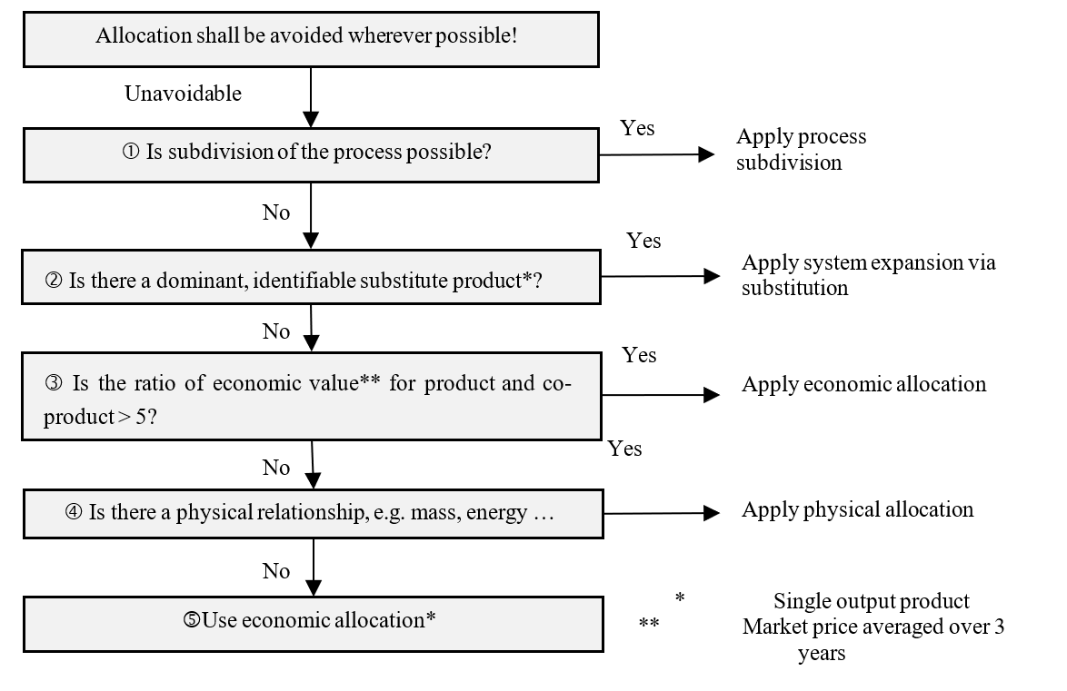
7.15.2.1. If allocation cannot be avoided and subdivision is possible, subdivision shall be applied. Subdivision refers to disaggregation of multifunctional processes or facilities to isolate the input flows directly associated with each process or facility output.
7.15.2.2. If subdivision cannot be applied, but a dominant substitute product can be identified, expanding the product system to include the additional functions related to the co-products shall be applied. System expansion via substitution shall only be used if no new multi-output allocation is introduced.
System expansion via substitution should only be used if there is a dominant, identifiable displaced product and production path for the displaced product based on sector consensus. Dominant means that the production process is the main process on the market. If available, positive lists of co-products and displaced products based on sector consensus shall be used to model the system expansion and the respective substitution credits. For the emissions data, primary data shall be used, and secondary data may only be used if primary data is not available. In case of secondary data, the requirements in paragraph 7.10 shall apply to guarantee that the dataset and source for calculating system expansion credits are compliant. If no sector consensus exists, the following requirements shall always be fulfilled:
(a) The production of the co-product is an integral part of the production process;
(b) A dedicated, single-output process to produce the co-product exists;
(c) The alternative dataset must be representative of the dominant production route;
(d) A clear description of the process for selecting the alternative product substituted by the co-product shall be documented.
Double counting shall be avoided. No market-mediated effects shall be applied, as the attributional LCA approach shall be used.
7.15.2.3. When allocation cannot be avoided, no subdivision is possible and no dominant substitute product can be identified, LCA practitioners shall calculate the ratio of the economic value of the reference product to each co-product per declared unit. This ratio is employed in the next step of the decision tree to determine the most suitable allocation approach. For the use of economic values, sales prices shall be averaged over the last 3-5 years to smooth out fluctuations. If sales prices are not available or not applicable, other economic factors can be applied (e.g., cost).
7.15.2.4. If the calculated [economic value ratio is equal to or lower than five][If physical relationships are not used, the validity of the allocation method used in the study should be demonstrated], companies shall apply allocation using a physical relationship to partition inputs and outputs between the studied co-product(s). The physical relationships to choose from are:
(a) produced masses;
(b) produced pieces;
(c) contained exergy;
(d) contained energy.
7.15.2.5. If the calculated ratio is higher than five, companies shall apply an economic allocation using economic value as criterion to partition inputs and outputs between the studied co-product(s).
For the determination and use of economic allocation factors, the following hierarchy shall be applied. Only one type of economic allocation factor shall be chosen consistently in the order of priority of the hierarchy. Only if the respective prioritised factor is not available, the next factor in the hierarchy may be chosen. The chosen factor shall always be averaged over the last multiple years to smooth out fluctuations. A period of 3-5 years is recommended, and a systematic approach should be internally documented for materials with high fluctuations of the selected factor of price/ cost.
(a) Global market price (global market prices are usually only available for commodities);
(b) Regional market price;
(c) Other economic allocation factors (i.e., production costs or sales price).
7.16. Chain of custody
In the automobiles supply chain, the multiple inputs (resources), outputs (products), and processes exist, and the LCA of automotive products is generally conducted within a complex system. As a method for the appropriate allocation and management of environmental attributes within such a system, Chain of Custody may be applied. ISO 22095:2020 specifies five models of Chain of Custody (Table 4, Figure 12).
Table 4
Chain of Custody Models
Input/Output Relation | Identity preserved | Segregated | Controlled blending | Mass balance | Book and claim
All input characteristics translate unchanged to output characteristics | ✓ | ー | ー | ー | ー
Mixing of inputs from different sources | ー | ー | ✓ | ✓ | ✓
Output characteristics reflect the average of input flow characteristics | ✓ | ー | ✓ | ー | ー
Physical connection | ✓ | ✓ | ✓ | ✓ | ー

Figure 12
Overview of chain of custody models
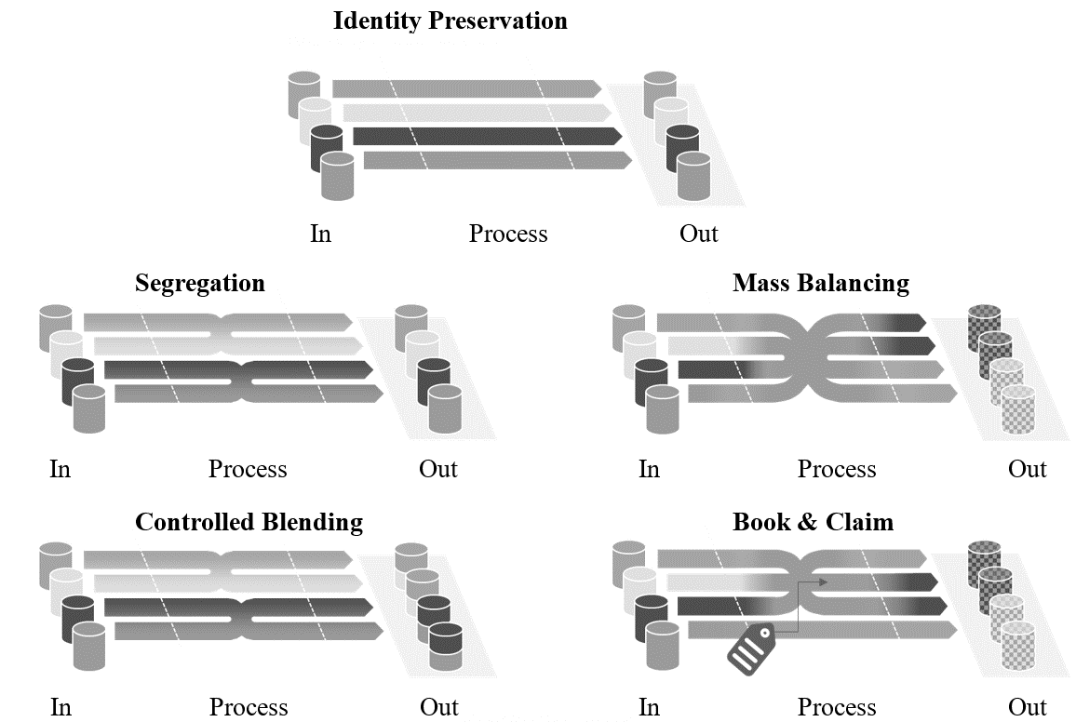
The Mass Balance model and Book and Claim model may enable a flexible allocation of environmental attributes; however, in order to ensure transparency and credibility, its application requires prudent consideration. More detailed provisions on Mass Balance are currently under discussion in ISO 13662, while ISO 14077 is addressing its application to LCA.
Accordingly, in automotive LCA, minimum requirements shall be established to prevent diverse interpretations and misuse of Mass Balance and Book and Claim. These requirements shall be continuously reviewed and revised, taking into account the developments of global standards such as ISO and the GHG Protocol.
7.16.1. Verification and Assurance Requirements for Mass Balance and Book and Claim
(a) The reliability of these models shall primarily be ensured through verification, and at a minimum, an equivalent independent and transparent certification scheme shall be required.
(b) If these models are used, they shall be clearly explained to the verifier with sufficient information so that the verifier can judge the appropriateness and correct application of the model.
(c) When the environmental attributes of products using these models are claimed, clear and transparent information shall be provided to stakeholders.

7.16.2. Applicability and Certification Requirements for Book & Claim
In this resolution, Book and Claim may only be applied to energy carriers such as electricity, fuels, and biomethane. It shall be noted that the Book and Claim model is intended to be applied in the electricity domain, and electricity certificates shall follow Chapter 7.14.2 (Electricity). When a similar approach is applied to other energy carriers, the same level of reliability of contractual instrument defined in Chapter 7.14.2 shall be demonstrated and verified.
7.16.3. Operational and Technical Requirements for Mass Balance
This model shall correspond to “Mass Balance” as defined in ISO 22095:2020.
- This model shall in principle only be applied when a physical connection between input and output can be established. However, establishing the physical connection is not required if it would lead to additional GHG emissions due to, such as, transportation of products between multiple separate manufacturing sites within the system boundary.
(b) This model shall be operated under the management of the same company, corporate group, or joint venture.
(c) This model shall be operated under accounting controls that the claimed output exactly matches the actual input also taking into account material yields and scrap, to avoid any double counting.
(d) Technical feasibility: This model shall only be applied within the range that is technically feasible to produce the output from the input, and the environmental attributes allocated shall not exceed that range.
(e) Technical equivalence: When this model is applied, the environmental attributes shall only be allocated among products that have the same technical properties.
(f) This model shall only be applied to additional CFP reduction measures relative to the residual product. The residual product is the product without reduction measures used in mass balance within the respective reporting year. When this model is applied, the allocation of the CFP reduction resulting from the measure shall reflect an actual increase in green inputs, rather than a redistribution that merely makes some products appear greener without any change in production

7.17. Waste treatment, disposal and recycling modelling
Any GHG emissions arising from the treatment of production waste shall be included in the total CFP. Waste can be generated during different stages of a product’s life cycle (cradle-to-grave), including:
(a) Resource extraction, raw material sourcing;
(b) Production of materials, semi-finished products;
(c) Production of vehicle parts and components;
(d) Logistics to supplier, OEM, customer and recycler (including internal logistics);
(e) EoL of the vehicle.
All inputs and outputs shall be fully considered in the calculation of the product carbon footprint. Cut-off rules as described in 7.12 shall be applied.
The party generating waste is responsible for treatment until final disposal (for example, incineration or landfill). This is also referred to as the “polluter pays principle”. If there is no final disposal, then the further processes are attributed to the company using the recycled or reused material flow as a secondary material (see Section ‎7.15.1.).
The impact of preparatory steps and supporting activities such as collection, transportation, sorting, dismantling, or shredding shall be added to the inventory results of the product system generating the waste.
The impact of the process treating waste with energy recovery (e.g., incineration) shall be added to the inventory results of the product system that generated the waste treated in the process. Burdens and benefits coming from energy recovery are calculated based on paragraph ‎7.17.2.
Production processes may also generate material scrap that is recycled. In this case, please see paragraph 7.15.
7.17.1. Material recycling modelling
The Circular Footprint Formula (CFF) or Recycled Content Method (RCM) shall be applied to the evaluation of material recycling for all levels, based on regulation or market observation. The selected method shall be clearly indicated in the vehicle CFP declaration.
In the present guidelines, the material part of the CFF, as originally introduced in the EC recommendation 2021/2279 Annex I, has been rearranged as sum of the three components, having, overall, the same mathematical results of the original CFF introduced in the EC 2021/2279 Annex I.
The rearranged CFF presented in this document is indicated hereafter as “UNECE A-LCA CFF concept”, and it is composed by the three following elements:
(a) Production burdens (this term constitutes the RCM method);
(b) Burdens and benefits related to secondary materials input;
(c) Burdens and benefits related to secondary materials output.
Circular Footprint Formula (CFF) as per EC recommendation 2021/2279:

as Recycled Content Method (RCM)

as Modular Burdens and Benefits method (MBBM) which is the sum of 2) and 3)
1) Production burdens $\left(1-R_{1}\right)E_{V}+R_{1}×E_{rec}$

2) Burdens and benefits related to $-(1-A)R_{1}×\left(E_{rec}-E_{V}×\frac{Q_{sin}}{Q_{p}}\right)$
secondary materials input
3) Burdens and benefits related to $\left(1-A\right)R_{2}×\left(E_{recEoL}-E_{V}^{*}×\frac{Q_{sout}}{Q_{p}}\right)$
secondary materials output

Rearranged structure of the CFF, as introduced in this Mutual Resolution.
$$\left(1-R_{1}\right)E_{V}+R_{1}×\left(AE_{rec}+(1-A)E_{V}×\frac{Q_{sin}}{Q_{p}}\right)+\left(1-A\right)R_{2}×\left(E_{recEoL}-E_{V}^{*}×\frac{Q_{sout}}{Q_{p}}\right)$$

When applying the material part of the CFF, in the production stage for materials, the RCM term (corresponding to CFF part 1) shall be evaluated. For the complete vehicle CFP in addition to CFF part 1, the emission shares from recycling (corresponding to CFF parts 2 and 3) shall be evaluated with the Modular Burdens and Benefits Method (MBBM) term in the EoL stage.
Overall, the terms of the UNECE A-LCA CFF concept for material recycling have been defined as following:
${CEF}_{M}={CEF}_{M,CFF}= {CEF}_{M,RCM}+{CEF}_{M,MBBM}$ (10)
Where;
${CEF}_{M}$ means the specific GHG emissions of a material in kilogram of carbon dioxide equivalent per kilogram of material. [kgCO₂eq/kg_{material}]
${CEF}_{M,CFF}$ means the specific GHG emissions of a material calculated with the CFF in kilogram of carbon dioxide equivalent per kilogram of material. [kgCO₂eq/kg_{material}]
${CEF}_{M,RCM}$ means the specific GHG emissions of a material calculated with the RCM in kilogram of carbon dioxide equivalent per kilogram of material. [kgCO₂eq/kg_{material}]
${CEF}_{M,MBBM}$ means the specific GHG emissions of a material calculated with the MBBM in kilogram of carbon dioxide equivalent per kilogram of material. [kgCO₂eq/kg_{material}]
The ${CEF}_{M,RCM}$and ${CEF}_{M,MBBM}$ emission contributions are defined as follows:
${CEF}_{M,RCM}=\left(1-R_{1}\right)E_{V}+R_{1}×E_{rec}$ ; CFF part 1 (11)

$${CEF}_{M,MBBM}=-\left(1-A\right)R_{1}×\left(E_{rec}-E_{V}×\frac{Q_{sin}}{Q_{p}}\right)$$
$+ \left(1-A\right)R_{2}×\left(E_{recEoL}-E_{V}^{*}×\frac{Q_{sout}}{Q_{p}}\right)$ ; CFF part 2 and 3 (12)

Where;
$A$ means the allocation factor of burdens and credits between supplier and user of recycled materials.
${ Q}_{sin}$ means the quality of the ingoing secondary material or parts, i.e. the quality of the recycled material at the point of substitution.
${ Q}_{sout}$ means the quality of the outgoing secondary material or parts, i.e. the quality of the recyclable material at the point of substitution.
${ Q}_{p}$ means the quality of the primary material or parts, i.e. quality of the virgin material.
${ R}_{1}$ means the proportion of material input to the product that has been recycled from a previous system. [%]
${ R}_{2}$ means the proportion of the material in the product that will be recycled (or reused) in a subsequent system. [%]
${ E}_{rec}$ means the specific emissions and resources consumed (per unit of analysis) arising from the recycling process of the recycled (reused) material, including collection, sorting and transportation process. [kgCO₂eq/kg_{material}]
${ E}_{recEoL}$ means the specific emissions and resources consumed (per unit of analysis) arising from the recycling process at EoL, including collection, sorting and transportation process. [kgCO₂eq/kg_{material}]
${ E}_{V}$ means the specific emissions and resources consumed (per unit of analysis) arising from the acquisition and pre-processing of virgin material [kgCO₂eq/kg_{material}]
$E_{V}^{*}$ means the specific emissions and resources consumed (per unit of analysis) arising from the acquisition and pre-processing of virgin material assumed to be substituted by recyclable materials. [kgCO₂eq/kg_{material}]
In the case of CFF application, both $C_{M,RCM}$ which is total RCM value specified in paragraph 8.1. and $C_{M,MBBM}$ which is total MBBM value specified in paragraph 8.4. shall be reported as the part of the total vehicle CFP. The materials to which the CFF is applied shall be reported.
In the case of RCM application, only $C_{M,RCM}$ shall be evaluated in the material production stage and reported in the total vehicle CFP.
The meaning and definition of the parameters of the CFF are the same of the ones reported in the EC recommendation 2021/2279 Annex I Chapter 4.4.8.1.
Data set ($E_{V},E_{V}^{*}, E_{rec},E_{recEoL}$) to be used in CFF and CFF parameters ($A,R_{1}, R_{2},Q_{sin},Q_{sout}, Q_{p}$) may be referred to the secondary data set and reference documents in paragraph 8.4.
Parts recycling modelling is specified in paragraph 8.4.
7.17.2. Incineration with energy recovery
The incineration with energy recovery shall be evaluated by following the energy formula in the Circular Footprint Formula (CFF). (Equation 13).
Even in the case in which only RCM was applied in the material recycling modelling defined in paragraph 7.17.1., the incineration with energy recovery shall be anyway evaluated by following Equation 13.
${CEF}_{I}$=$\left(1-B\right)R_{3}×\left(E_{ER}-LHV×X_{ER,heat}×E_{SE,heat}-LHV×X_{ER,elec}×E_{SE,elec}\right)$ = $\left(1-B\right)R_{3}×\left(E_{ER}-{CEF}_{I,MBBM}\right)$
(13)
Where;
${CEF}_{I}$ means the specific GHG emissions of a material arising from incineration with energy recovery in kilogram of carbon dioxide equivalent per kilogram of material. [kgCO₂eq/kg_{material}]
${CEF}_{I,MBBM}$ means the specific GHG emissions related to the credit obtainable by an energy recovery process calculated per MBBM for energy in kilogram of carbon dioxide equivalent per kilogram of material. [kgCO₂eq/kg_{material}]
$B$ means the allocation factor of energy recovery processes.
$R_{3}$ means the proportion of the material in the product that is used for energy recovery at EoL.
$E_{ER}$ means the specific emissions and resources consumed (per unit of analysis) arising from the energy recovery process (e.g. incineration with energy recovery, landfill with energy recovery, …). [kgCO₂eq/kg_{material}]
$E_{SE,heat}$ means the specific emissions and resources consumed (per unit of analysis) that would have arisen from the specific substituted energy source (heat). [kgCO₂eq/MJ]
$E_{SE,elec}$ means the specific emissions and resources consumed (per unit of analysis) that would have arisen from the specific substituted energy source (electricity). [kgCO₂eq/MJ]
$X_{ER,heat}$ means the efficiency of the energy recovery process for heat.
$X_{ER,elec}$ means the efficiency of the energy recovery process for electricity.
$LHV$ means the Lower Heating Value of the material in the product that is used for energy recovery. [MJ/kg_{material}]
Thermal energy deduction $\left(-LHV×X_{ER,heat}×E_{SE,heat}\right)$ and electric energy deduction ($-LHV×X_{ER,elec}×E_{SE,elec}$) shall be evaluated and merged as Modular Burdens and Benefits method for energy.
CI which is total GHG emissions arising from incineration with energy recovery shall be reported as the part of the total vehicle CFP. In addition, CI,MBBM which is total MBBM value for energy specified in paragraph 8.4. shall be reported separately, as single contributions to the overall CI. The materials contained in the product that are sent to incineration with energy recovery shall be reported.
The meaning and definition of the parameters of the CFF are the same of the ones reported in the EC recommendation 2021/2279 Annex III Chapter 4.4.8.1.
Data set (${ E}_{ER}, { E}_{SE,heat}$,$E_{SE,elec}$) to be used in CFF and CFF parameters ($B,R_{3},X_{ER,heat}$,${ X}_{ER,elec}, LHV$) may be referred to the secondary data set and reference documents in paragraph 8.4..
7.17.3. Disposal
The disposal shall include all of waste treatment except for the material recycling and the incineration with energy recovery, e.g. landfill. The disposal shall be evaluated by following disposal formula in Circular Footprint Formula (CFF) (Equation 14).
Even in the case in which only RCM was applied in the material recycling defined in paragraph 7.17.1., the disposal shall be anyway evaluated by following Equation 14.
${CEF}_{D}=\left(1-R_{2}{-R}_{3}\right)×E_{D}$ (14)
Where;
${CEF}_{D}$ means the specific GHG emissions of a material arising from the disposal in kilogram of carbon dioxide equivalent per kilogram of material. [kgCO₂eq/kg_{material}]
$R_{2}$ means the proportion of the material in the product that will be recycled (or reused) in a subsequent system. [%]
$R_{3}$ means the proportion of the material in the product that is used for energy recovery at EoL.
$E_{D}$: means the specific emissions and resources consumed (per functional unit) arising from disposal of waste material at the EoL of the analysed product, without energy recovery. [kgCO₂eq/kg_{material}]
The meaning and definition of the parameters of the CFF are the same of the ones reported in the EC recommendation 2021/2279 Annex III Chapter 4.4.8.1.
Dataset (E_{D}) to be used in CFF and CFF parameter (R₂, R₃) may be referred to the secondary data set and reference documents in paragraph 8.4.
7.18. Logistics
In addition to emissions from production, manufacturing, use stage and EoL, there are also emissions from the transportation and logistics of vehicles, products, or materials.
Emissions from transportation shall cover emissions from well to wheel, i.e., the system boundaries span from energy provision, production and distribution ending at the transportation operation itself, and should be compliant with paragraph 7.6.
Figure 13
System boundaries for transportation
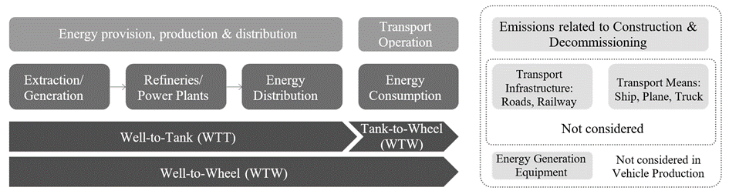
In case of transport chains (transport of a product by more than one transport mode) the chain links shall be individually quantified and subsequently summed up.
The ultimate approach of quantifying transportation emissions shall be based on measuring the fuel and energy consumption of a trip and multiplying it by the emission factor of the fuel/energy that covers all upstream emissions of the fuel/energy. Only transport emissions quantified on the basis of measured fuel/energy consumption shall be considered as primary data. In case of collective transport, the primary data based transport emissions require allocation to the individual product. Such allocations do not change the classification of emission data as being primary data.
Direct measurement of fuel/energy consumption of a transport operation may however not always be possible and modelling transport emissions is required. Calculation of transport emissions shall follow the recommendation set out in the GLEC Framework V3.1 or latest, except for the mandate to include emissions from the construction and dismantling of energy infrastructure. The GLEC framework allows for three approaches to establish transport distances: Shortest feasible distance (SFD), great circle distance (GCD) and actual distance. These approaches shall be used according to the following hierarchy:
(a) Actual distance
(b) SFD
(c) GCD
Emissions reduction from the use of low-carbon fuels may only be claimed if a statement of sustainability (origin and emissions reduction) for the fuel is provided as issued by a bonded warehouse.
8. Methodology per life cycle stages
8.1. Material production stage
Table 5 shows a level concept of material production phase. The development of the assessment method will be focused only on Level 3, and for other levels, only the concept and overview will be described.
Table 5
Level concept of material production stage
Level | Activity Data |  | Intensity Data
 | Material weight [kg] |  | Carbon Intensity of Material production  [kg-CO2eq/kg]
Level 1 | Primary and secondary data |  | Secondary data
Level 2 | Primary data |  | Secondary data
Level 3 | Primary data |  | Primary and secondary data
Level 4 | Primary data |  | Primary data

8.1.1. Level 1,2
The specific GHG emissions of a material are basically calculated with material weight multiplied by carbon intensity of the material production.
As for yield during material production process, it is practically complicated due to material related manufacturers as upstream side and couldn’t be traceable. On the other hand, the ratio of input to output of material weight during parts production and vehicle assembly process could be traceable. Therefore, yield shall be considered as parts production and vehicle assembly stage .
In Level 1, the material weight of the vehicle and the carbon intensity of each material (in kg CO₂eq per kg) are secondary data. LCA practitioner should assume a proportion of each material to vehicle weight.
In Level 2, the material weight of the vehicle are primary data. The carbon intensity of each material production are secondary data.

(15)
$$C_{M,RCM}=\sum_{i}{{(W}_{Mi}×1/{Y_{Mi}}×{CEF}_{Mi,RCM})}$$
Where;
$C_{M,RCM}$ means the specific GHG emissions of a material in carbon dioxide equivalent [kg CO₂e]
$i$ means each material classification
$W_{Mi}$ means material weight [kg]
$Y_{Mi}$ means yield of input to output of material weight during parts production and vehicle assembly process.
${CEF}_{Mi,RCM}$ means the specific GHG emissions of a material calculated with the RCM in kilogram of carbon dioxide equivalent per kilogram of material [kg CO₂eq. / kg material] (Specified in paragraph 7.17.1. Material recycling modelling)
8.1.2. Level 3,4
In Level 3, the specific GHG emissions of a material should be calculated with virgin material and recycled material separately based on the equation (16). When that’s not possible, it is applicable to the equation (15) with the description of recycled material information .
Details of Level 3 will be described in a later paragraph, but the assessment of the produced vehicle is set as the purpose of use. The weight of the material and carbon intensity should be collected as primary data as much as possible considering hotspots in the system boundary. The environmental impact shall be assessed compared to the actual process.
One of other factors which affects critically GHG emissions can be considered electricity utilised during material production stage. LCA practitioners should incorporate electricity effect which includes regionality and regenerated power in the equation.
Finally, in Level 4 is an ideal LCA, with the goal of compiling the basic carbon intensity of all materials as primary data. However, it is challenging to collect data on hundreds of thousands of items per vehicle. Secondary data applied due to any reason must be justified accordingly.
(16)
$C_{M,RCM}=\sum_{i}{\left[W_{Mi}×1/{Y_{M}}×\left\{R_{1i}×{CEF}_{Mi,RCM,RP}+\left(1-R_{1i}\right)×{CEF}_{Mi,RCM,VP}\right\}\right]}$
Where;
$R_{1}$ means the proportion of material input to the product that has been recycled from a previous system. [%]
${CEF}_{Mi,RCM,VP}$ means carbon intensity of virgin material primary data [kg CO₂eq./kg material]
${CEF}_{Mi,RCM,RP}$ means carbon intensity of recycled material primary data [kg CO₂eq./kg material]
8.1.3. Automotive material classification
In Level 3, material classification is basically extracted by investigating composed materials species in typical automotive vehicle models, i.e., ICE, HEV, FCV and PEV. As material information, BoM and IMDS are commonly referenced in worldwide automotive industry. The material classification shall be in accordance with other stages as Parts production and vehicle assembly, Use, and EoL.
Then the number of material types shall be set by taking cut-off into account after practitioners calculated GHG emissions of each material to total vehicle. The cut-off criteria, should be in line with paragraph ‎7.12.
As a base example of material classification in Level 3, Table 6 shows an automotive material list.
To reduce GHG emissions of material production stage, LCA practitioners shall determine cut-off criteria of the number of material classification and investigate a system boundary for the target materials. Especially, material upstream process is known to be relatively higher GHG emissions than material downstream process in Figur 14. Practitioners should identify hotspot process in the system boundary. System boundaries of typically high GHG emissions materials (steel, aluminium, copper, plastic and Lithium-ion battery materials) are shown in Figure 15, Figure 16, Figure 17, Figure 18 and Figure 19 referring to the documents from international institutions e.g., worldsteel, IAI (International Aluminium institute), EA (European Aluminium), ICA (International Copper Association), and TfS (Together for Sustainability) . Since the material classification and the system boundary depends on a target vehicle specification, procedures to select material classification and to assign carbon intensity shall be reported.
Table 6
Automotive material list
Material group | Material classification
Steel | Cast iron, Cast steel, Hot-rolled steel sheet, Cold-rolled steel sheet, Electromagnetic steel sheet, Hot-rolled hot-dip galvanised steel sheet, Hot-rolled electro-galvanised steel sheet, Cold-rolled hot-dip galvanised steel sheet, Cold-rolled electro-galvanised steel sheet, Carbon steel bar/wire rod, Special steel bars, Special steel wire rod/spring steel, Stainless steel sheet/bar, Sintered steel
Aluminium | Cast aluminium, Die cast aluminium, Wrought aluminium(sheet), Wrought aluminium(extruded)
Copper | Tough pitch bare/coated copper wire, Oxygen free bare/coated copper wire, Tough pitch copper strip/bar, Oxygen free copper strip/bar
Plastic | PP(Polypropylene), PE(Polyethylene), PVC(Polyvinyl Chloride), ABS (Acrylonitrile Butadiene Styrene), PA (Nylon), PC (Polycarbonate), PET (Polyethylene Terephthalate), PBT (Polybutylene Terephthalate), PUR (Polyurethane), POM (Polyacetal), ASA (Acrylonitrile Styrene Acrylate), PMMA (Acrylic resin), EP(Epoxy resin), PPS (Polyphenylene Sulphide), TPO (Thermoplastic Olefin), TPV (Thermoplastic Vulcanisate)
Non-ferrous metals | Magnesium alloy, Zinc alloy, Platinum/Rhodium, Lead, Other metals
Other organic materials | SBR (Styrene-Butadiene Rubber), EPDM (Ethylene Propylene Diene Monomer), Other thermoplastic resins, Other thermosetting resins, Natural rubber, Synthetic rubber, Anti-rust oil, Leather, Adhesives
Other materials | Laminated Glass, Paints, Electrodeposition Coating, Electronic Components (Populated PCB :Printed Circuit Board, i.e. substrate plus associated components like capacitors, resistors, integrated circuits etc.), Engine oil, Brake fluid, Coolant, Refrigerant, Other inorganic materials, Tyres, Battery materials (Lead-Acid battery, Ni-MH battery, LiB: Lithium-Ion Battery)
8.1.4. System boundaries
Figure 14 shows a system boundary of the material production stage.

Figure 14
A system boundary of materials production stage
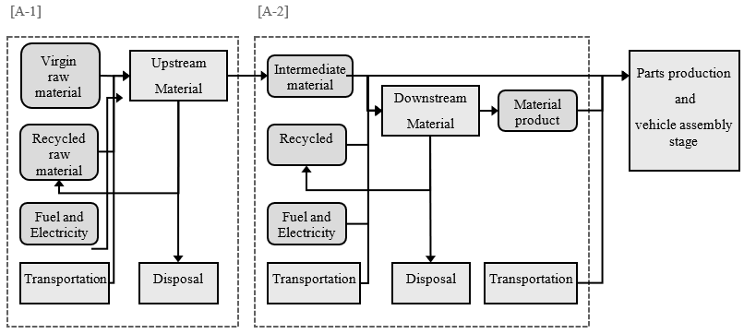
[A-1] Processes related to material mining, refining, and impurity removal (defined as upstream process in material production)
[A-2] Processes related to material production (defined as downstream process in material production)
In the material production stage, an actual production flow for each automotive part shall be reflected.
These materials production stages are mainly divided into two processes.
The first is ‘upstream process in material production’ which has mining, refining, and impurity removal with relatively high CO₂ impact.
Then, ‘downstream process in material production’ which has from the intermediate material stage (e.g. crude steel, aluminium ingot) to the material product stage (e.g. steel sheet, aluminium extruded bars).
After that, it is transferred to the Parts production and vehicle assembly stage.
System boundaries of the main dominant materials (steel, aluminium, copper, plastic, Lithium-Ion Battery) in automotive are shown in Figure 15, Figure 16, Figure 17, Figure 18 and Figure 19.

Figure 15
A system boundary of steel material production stage
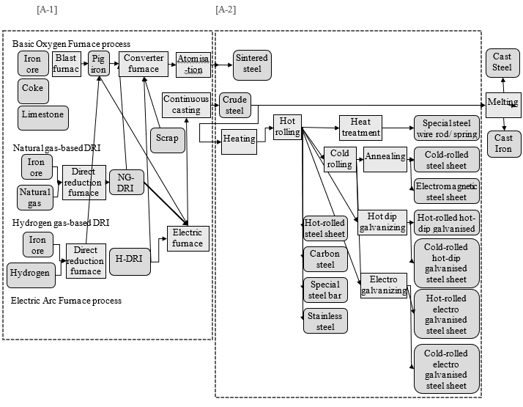

Figure 16
A system boundary of aluminium material production stage
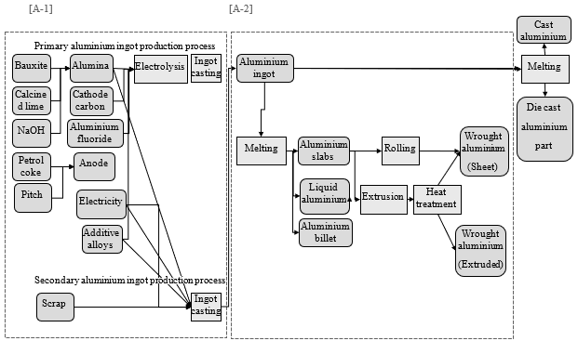

Figure 17
A system boundary of copper material production stage
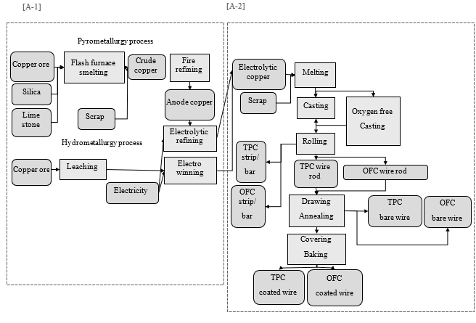

Figure 18
A system boundary of plastic material production stage
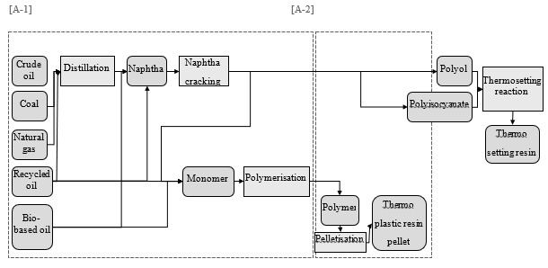

[Figure 19
A system boundary of Lithium-Ion Battery material production stage
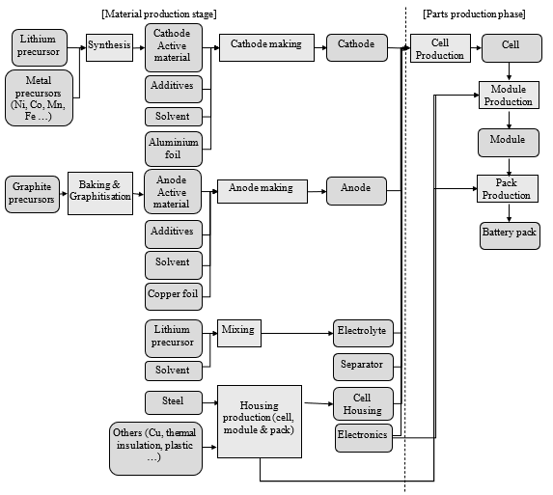
]

8.1.5. Data collection and data type
Material data collection for activity and intensity are conducted with data types of primary and secondary, and their related information as follows; material name, material classification (VDA, ISO code, and other standards), the number of materials, material weight, chemical substance composition, recycled material ratio, biomass blended ratio, yield, electricity, and fuel consumption, etc.
For a material production stage, the carbon footprint shall be calculated based on per 1 kg of material products, regardless of its state, as its specific density is considered.
8.1.5.1. Primary data collection
In level 3, the weight of the material used, its yield, and material carbon intensity are collected as primary data as much as possible, considering hotspots in the system boundary. The following points should be considered to clarify transparency and accuracy.
(a) High GHG emissions in the system boundary should be extracted to clarify hotspots.
(b) Unit process data of material production process should be confirmed
(i) country or region where material production was conducted
(ii) amount of electricity and fuel used, rate of renewable energy used
(iii) usage rate of recycled material and bio-derived material to total material weight
Then the environmental impact of primary data is assessed with data quality and shall be reported. The prerequisites shall be clarified as self-declaration of practitioners and related companies or certificated by external parties.
8.1.5.2. Secondary data collection
In case primary data is not practically collected, secondary data should be collected. When collecting secondary data from available databases, data quality shall be explained, and the following points should be considered to clarify transparency and accuracy.
(a) High GHG emissions in the system boundary should be extracted to clarify hotspots.
(b) Unit process data in material production process should be confirmed.
(c) It shall be utilised as attributional data and not be utilised as consequential data to avoid an assumption in the future
(d) Material carbon intensity using an allocation between some life cycle generations shall not be utilised to assure data consistency.
8.1.6. Energy Modelling
For general rules refer to paragraph 7.14..
8.1.6.1. Energy Mix
Practitioners shall account for the fuel or electricity production pathways associated with the production locations of each material. (detailed methodology shall be considered)
The energy mix shall be based on the latest dataset associated with the location or region of production in question.
The methods described in paragraph [3.2.8.] shall guide the modelling of fuel and electricity for these regions.
8.2. Parts production and vehicle assembly stage
8.2.1. Levels in parts production and vehicle assembly
The analysis of global warming potential can also be carried out for parts production and vehicle assembly in different levels of detail. In case the goal of the analysis is e.g. concerned with mobility concepts rather than individual vehicles or the specific details of the vehicle production are not the main interest, an archetypal vehicle production is included in the analysis. The cradle-to-gate carbon footprint of parts production or vehicle manufacturing can thus reflect:
(a) an average for a vehicle fleet (various segments, models on global or national level) –> Level 1
(b) an average for vehicles of a specific segment (various models on global or national level) or a vehicle chosen as representative for a specific segment both based on BoM-Data –> Level 2
(c) an average for specific vehicle models (with different equipment variants on global, national or local production site level) –> Level 3
(d) a specific vehicle model. –> Level 4
In the ideal case, the average values are calculated as weighted averages of a population of individual vehicles. If the analysis of the individual vehicle were based on real emission data (primary data), even the averages would reflect the correct averages of real emissions. As there is no abundance of analysis data on individual vehicles very often the average vehicle is defined by assumptions and modelling and secondary data is used to quantify the environmental impact.
Within this Resolution four levels detail are differentiated.
8.2.1.1. Level 1
As described in Section ‎7.1. there are multiple approaches possible for Level 1, the following section minimum standard for calculation. GHG emissions due to the production of vehicle parts and vehicle assembly are quantified with a (lump) carbon emission factor which is a function of net vehicle weight. All specific emission effects due to different materials, gross material input, different production processes or transport of parts or vehicles is included in the carbon emission factor. The calculation of vehicle carbon footprint from production is simply given by:
$$C_{VP}={C_{MP}+ C}_{PVA}+C_{TP}$$
$C_{VP}={C_{MP}+ CEF}_{MP}×M_{NM }× S_{CV}+C_{TP}$ (17)
Where;
C_{VP} means carbon emissions due to material production, component and vehicle manufacturing in kilogram of carbon dioxide equivalent [kg CO₂eq]
C_{MP} means carbon emissions due to material production in kilogram of carbon dioxide equivalent [kg CO₂eq]
C_{PVA} means carbon emissions due to parts production and vehicle assembly in kilogram of carbon dioxide equivalent [kg CO₂eq]
C_{EFMP} means carbon emission intensity of material production in kilogram of carbon dioxide equivalent per-vehicle net mass [kg CO₂eq/kgNM]
M_{NM} means the net mass of the vehicle in kilogram [kg], i.e. mass of the vehicle in running order minus the mass of the driver (75kg) minus the mass of any fuels.
S_{CV} means the surcharge factor for carbon emissions from parts/component and vehicle manufacturing on top of carbon emissions due to material production.
C_{TP} means carbon emissions due to transport of the fully assembled vehicle to customer in kilogram of carbon dioxide equivalent [kg CO₂eq]
The S_{CV} may be determined from literature, OEM publications or secondary databases. The factor may reflect geographical differences, if there is evidence that parts/component and vehicle production is more CO₂eq-intense in some parts of the world than in others. For transparency all the factors used in calculation shall be reported.
8.2.1.2. Level 2
GHG emissions due to the production of vehicle parts and vehicle manufacturing are quantified by breaking down the vehicle as delivered to the customer by mass of materials. Breaking down by material is common in automotive industry because material and mass declaration systems are mandatory for decades. The calculation of the cradle-to-gate vehicle carbon footprint is given by:
$$C_{VP}=C_{MP}+C_{PVA}+C_{TP}$$
$C_{VP}=C_{OP} +\sum_{i}{(C_{MP,i}×S_{C,i})+}C_{TP}$ (18)
Where;
C_{VP} means carbon emissions due to material production, component and vehicle manufacturing in kilogram of carbon dioxide equivalent [kg CO₂eq]
C_{MP} means carbon emissions due to material production in kilogram of carbon dioxide equivalent [kg CO₂eq]
C_{PVA} means carbon emissions due to parts production and vehicle assembly in kilogram of carbon dioxide equivalent [kg CO₂eq]
C_{OP} means carbon emissions due to manufacturing processes at the OEM in kilogram of carbon dioxide equivalent [kg CO2eq]
C_{MP,i} means carbon emissions due to production of material i in kilogram of carbon dioxide equivalent [kg CO₂eq]
S_{C,i} means the surcharge factor for carbon emissions from parts/component and vehicle manufacturing on top of carbon emissions due to production of material i.
C_{TP} means carbon emissions due to transport of the fully assembled vehicle to customer in kilogram of carbon dioxide equivalent [kg CO₂eq]
Again, all specific emission effects due to different production processes, production rejects or transport of parts or vehicles is included in the surcharge factor. C_{OP} may be determined from literature or OEM publications. For transparency all the factors used in calculation shall be reported.
8.2.1.3. Level 3
The contribution of different subsystems of a vehicle to the GHG emissions of vehicle production is by far not evenly distributed. Accounting these most relevant subsystems in terms of GHG emissions from vehicle production (so called ‘hotspots’) in a more detailed manner differentiates Level 3 from Level 2 in the calculation of the cradle-to-gate vehicle carbon footprint.]
For a hotspot, company-specific (OEM-specific / supplier-specific) data shall be used for at least one material or component of choice.
This means, for the selected component / material:
(a) for at least one process at OEMs’ and/or preceding suppliers’ production sites (depending on availability and vertical integration);
(b) it is required to collect primary information on,
(c) which is then utilised for the calculation of the cradle-to-gate carbon footprint.
The selected component as well as the chosen process or material or supplier component shall be named including type of primary information collected.
As a recommendation, the following should be taken into account:
(a) steel, aluminium,
(b) body-in-white, battery, wheel rims, tyres.
For hotspot primary data based reporting is the preferred approach and the use of available site-specific primary data is mandated. In case primary data cannot be obtained, secondary data shall be used. Secondary data shall be traceable and based on field survey data and designated by government authorities, if available.
The calculation of vehicle carbon footprint from production is given by:
$C_{VP}=C_{MP}+C_{PVA}+C_{TP}$
$C_{PVA}= \sum_{i}{{(\sum_{j}{{(C}_{MP,j,i})}+C}_{HS,i}})+C_{BV}$ (19)
Where;
C_{VP} means the carbon emissions due to material production, component and vehicle manufacturing in kilogram of carbon dioxide equivalent [kgCO₂eq]
C_{MP} means carbon emissions due to material production in kilogram of carbon dioxide equivalent [kgCO₂eq]
C_{PVA} means carbon emissions due to parts production and vehicle assembly in kilogram of carbon dioxide equivalent [kgCO₂eq]
C_{MP,j} means carbon emissions due to production of material j in kilogram of carbon dioxide equivalent [kgCO₂eq]
C_{HS} means the carbon emissions due to manufacturing of hotspot subsystems (including material production processes and component production) and their assembly to the vehicle in kilogram of carbon dioxide equivalent [kgCO₂eq]
Index i refers to a specific hotspot subsystem.
C_{BV} means the carbon emissions due to material production, component and vehicle manufacturing with the exception of hotspot subsystems in kilogram of carbon dioxide equivalent [kgCO₂eq]
C_{TP} means the carbon emissions due to transport of the fully assembled vehicle to customer in kilogram of carbon dioxide equivalent [kgCO₂eq]
C_{HS} is calculated according to Level 4 definitions. C_{BV} for the remaining vehicle materials, parts and production processes excluding hotspots follow the calculation defined for Level 2. Intermediate transport operations are covered by C_{HS} and C_{BV}.
8.2.1.4. Level 4
GHG emissions due to the production of vehicle parts and vehicle assembly are quantified by a stepwise attributional reporting of real emissions (site-specific, primary data) for the material and components along the supply chain until the final assembly in the vehicle. For each Tier level this requires to add the GHG emissions for the manufacturing of a product in its own operations to the sum of GHG emissions of the purchased parts or materials for that product. Transport within the supply chain is accounted according to the definitions in paragraphs 7.18 and ‎8.2.5.
The calculation of vehicle carbon footprint from production is given by:
$C_{VP}=C_{MP}+C_{PVA}+C_{TP}$
$C_{PVA}=\sum_{i}{\left(\sum_{j}{{(C}_{MP,j,i})}+C_{TP1,i}+C_{T1,i}\right)+C_{op}}$ (20)
$C_{Tj}=\sum_{i}{({C_{TPj-1,i}+C}_{Tj-1,i})}+ C_{op,j}$ (21)
Where;
C_{VP} means the carbon emissions due to component and vehicle manufacturing in kilogram of carbon dioxide equivalent [kgCO₂eq]
C_{MP} means carbon emissions due to material production in kilogram of carbon dioxide equivalent [kgCO₂eq]
C_{PVA} means carbon emissions due to parts production and vehicle assembly in kilogram of carbon dioxide equivalent [kgCO₂eq]
C_{MP,j} means carbon emissions due to production of material j in kilogram of carbon dioxide equivalent [kgCO₂eq]
C_{op} means the carbon emissions due to manufacturing processes at the OEM in kilogram of carbon dioxide equivalent [kgCO₂eq]
C_{TP1} means the carbon emissions due to transport from Tier 1 supplier to the OEM in kilogram of carbon dioxide equivalent [kgCO₂eq] per part
C_{T1} means the carbon emissions reported from the Tier 1 supplier for supplied parts in kilogram of carbon dioxide equivalent [kgCO₂eq] per part
C_{TP} means the carbon emissions due to transport of the fully assembled vehicle to customer in kilogram of carbon dioxide equivalent [kgCO₂eq]
C_{Ti} means the carbon emissions reported from the Tier j supplier for the component production of supplied parts in kilogram of carbon dioxide equivalent [kgCO₂eq]
C_{TPj} means the carbon emissions due to transport of parts from Tier j-1 supplier to Tier j in kilogram of carbon dioxide equivalent [kgCO₂eq] per part
C_{op,j} means the carbon emissions due to manufacturing processes at the Tier j in kilogram of carbon dioxide equivalent [kgCO₂eq] per part
In case primary data cannot be obtained, secondary data shall be used. Secondary data shall be traceable and based on field survey data and designated by government authorities, if available.
Any product during parts and vehicle production generating material/parts for recycling, reuse or remanufacturing follows a cut-off approach in a cradle-to-gate scope, i.e. only the RCM methodology is applied. Preparatory steps for recycling shall generally be allocated to the waste receiving system (i.e., the product system using the (to be) recycled material/parts). This deviation from the polluter pays principle is a pragmatic exemption as following the polluter pays principle in this context would require defining material and component specific system boundaries. Other than the emissions from the respective preparatory steps and the recycling, reused or remanufactured treatment emissions, to be recycled, to be reused, or to be remanufactured materials/parts enter the product system using recycled material/parts burden-free.
For pre-consumer scrap, preparatory steps shall be accounted for by the producer of the waste (they might be insignificant; cut-off rules apply).
8.2.1.5. Level overview
Table 7 gives an overview how relevant aspects in vehicle and parts production should/shall be handled in the different levels.

Table 7
Level overview for parts production and vehicle assembly stage
 | Level 1 | Level 2 | Level 3 | Level 4
Waste | Included in S_{CV} | Included in S_{C,i} | Hotspot:  Considered explicitly.  Rest of vehicle:  Included in S_{C,i} | Considered explicitly
Gross vs. net material input (Scrap/yield) | Included in S_{CV} | Included in S_{C,i} | Hotspot:  Considered explicitly.  Rest of vehicle:  Included in S_{C,i} | Considered explicitly
Transport | Included in C_{TP} & S_{CV} | Included in C_{TP} & S_{C,i} | Transport from OEM gate to customer  reported explicitly.  Hotspot:  Considered explicitly.  Rest of vehicle:  Included in S_{C,i} | Considered explicitly
Primary/ secondary material use | Included in CEF_{MP} | Included in C_{MP,i} | Hotspot:  Considered explicitly.  Rest of vehicle:  Included in C_{MP,i} | Considered explicitly
Temporal validity | Most recent data | Most recent data | Hotspot:  Reference year  Rest of vehicle:  Most recent data | Reference year
Geographical Representativity | As specific as possible for research question | As specific as possible for research question | Hotspot:  Plant level  Rest of vehicle:  As specific as possible | Plant level
Energy Modelling | Recommendation: Location-based | Recommendation: Location-based | Hotspot:  Marked based  Rest of vehicle:  Location-based | Marked based approach
8.2.2. Declared unit
The product carbon footprint shall be assessed for a declared unit. A functional equivalent is established by the data recipient and is defined from a product use perspective (see 3.2.3).
For countable products, i.e., a component or part, the declared unit shall be 1 piece as described in the part description including a defined weight and a unique identifier (part number).
For materials, i.e., mass products or commodities, the declared unit shall be 1 kg of products, regardless of its state (solid, liquid, gas), as its specific density is considered.
If packaging is included, the declared unit is 1 kg or 1 piece of unpackaged product at the factory gate. The PCF however includes the PCF contribution of packaging.
For the vehicle manufacturer the declared unit it the fully assembled vehicle delivered to customer at show room.
8.2.3. System boundaries
The system boundary of the parts and vehicles production stage is outlined in Figure 20.
Figure 20
System boundaries in production.
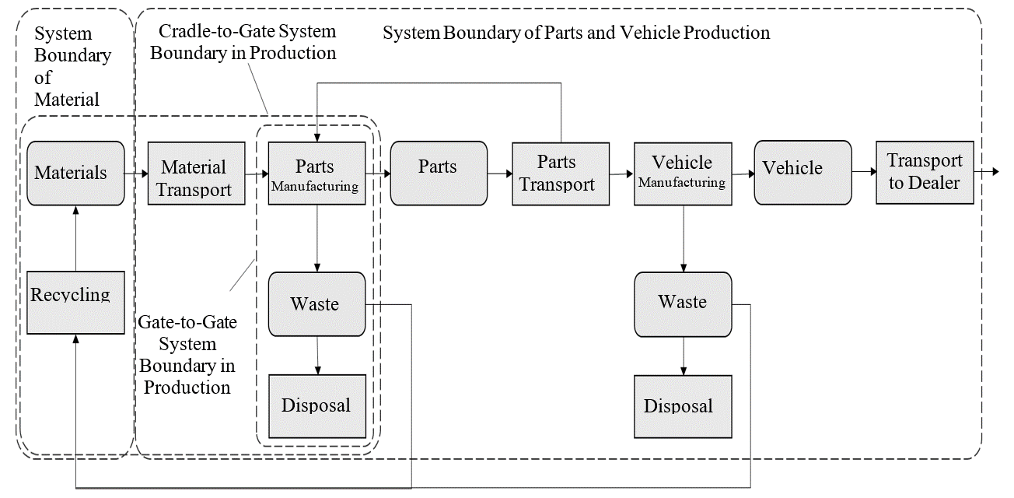
The system boundary towards material production is generally defined by the outbound gate of the production site processing material inputs to a neat material or an initial semi-finished product in a tradable form, e.g. steel bar, aluminium ingot, plastic granulate.
Transport of the final assembled vehicle to the end customer is also included in the parts and vehicle production and therefore to be included in the CFP of the vehicle in production.
The cradle-to gate CFP includes all attributable upstream and direct emissions of producing a product, including all upstream transportation activities.
When accounting for emissions all attributable processes shall be listed to clearly define the cradle-to-gate boundary of their studied product.
The system boundaries for parts/components and vehicle production are therefore including:
(a) Production of materials from virgin or recycled materials, semi-finished products
(b) Production of vehicle parts and components
(c) Auxiliary production processes (e.g., lighting, air conditioning, storage facilities)
(d) Disposal of production waste
(e) Packaging of vehicle parts and components, including all operations required for performing packaging
(f) Disposal of production waste (incl. packaging waste, see 7.17)
(g) Logistics (including internal logistics and transport packaging, see 7.18 and ‎8.2.5)
(h) Quality control in production
(i) Energy consumption of IT for process and manufacturing control
Despite of being included in the system boundaries in principle, insignificant processes may be excluded based on the cut-off rules (see 7.12).
In general, GHG emissions not connected directly to the production system relevant for the product shall be excluded from the system boundaries. These are amongst others:
(a) Employee commuting and work travel
(b) Research and development, administration, or sales processes
(c) Auxiliary inputs not directly related to the production process (such as heating and lighting of associated office rooms, secondary services like maintenance, sanitary facilities, canteen services, facility management e.g., plant security and fire safety and general IT)
(d) Auxiliary inputs to maintain the manufacturing equipment
(e) Emissions from construction or dismantling of capital good (such as buildings, manufacturing equipment or any other infrastructure for transport, media or energy distribution and energy generation, within or outside the control of the reporting company).
Data collection and data types
Emissions shall by default be reported averaged over the period of one year (reporting or calendar year) to avoid seasonal fluctuations and reflect typical production conditions.
Shorter periods may be considered if data on a full year are not yet available. Longer averaging periods may be considered but shall not exceed five years. Any averaging period deviating from the default shall be flagged and justified.
Emissions shall by default be reported for the most recent year (reporting or calendar year). In case there is the intention to extend the validity period of the CFP report beyond the reference year of reporting, an annual check is recommended to ensure that data is up to date.
To perform the annual check, the initial screening analysis should be updated based on data for the most recent year. An update of data is recommended if the reported emission increases by 10% or more based on the screening analysis compared to the previous reporting period. Additionally, an update of data is mandatory in the following situations.
(a) Structural changes in operation to the product system under study, including significant process change in operation, change in production technologies or technology advancement, as well as changes in raw material or energy supply.
(b) Changes in calculation methodology or improvements in the accuracy of emission factors or activity data or inclusion of new types of sources that result in a significant impact on the emissions data.
(c) Discovery of significant errors, or a number of cumulative errors that are collectively significant.
Emissions shall by default be reported as granular as the purpose of the CFP study allows for. Averaging globally or over a region, country, continent may be considered but shall be flagged as such. Reasoning shall be provided if continental or global average values are used in cases where the use of primary data is recommended.
8.2.4. [Energy modelling
For the general rules reference is made to paragraph 7.14.
In case of electricity supply from the grid and marked based energy modelling (Level 4 & hotspots in Level 3) the following rules shall apply:
(a) If no contractual instruments are applied the residual electricity mix shall be used if available.
(b) If no residual grid mix is provided, secondary data shall be applied reflecting the country specific grid mix.
For Level 3 and partially Level 4 the risk of double counting cannot completely be avoided (parallel use of market-based and location-based reporting). On the one hand the consistent deployment of secondary data based on residual mixes - if available - represents substantial effort that is out of scope for the LCA practitioner. On the other hand, the use of contractual instruments is not limited to hotspots in the vehicle.]
8.2.5. Logistics
This section deals with transportation from a supplier to its customer. The general rules for logistics apply (see paragraph 7.18)
Figure 21
Definition of scopes
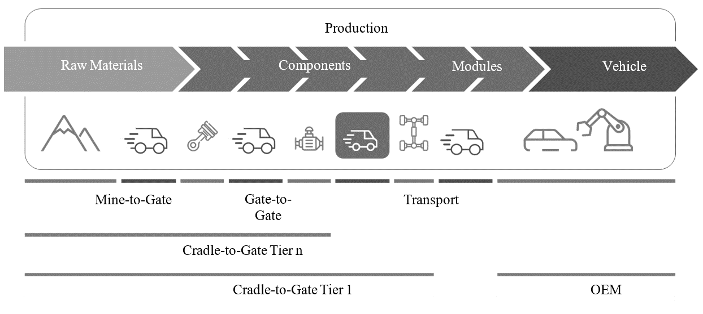
As for the product carbon footprint, the cradle-to-gate boundaries end at the suppliers' outbound gates (cf. paragraph 7.5 System Boundaries). This boundary applies independently from the responsibilities in economic or operative terms for transportation processes.
In case the transport details are known the following section defines the reporting responsibilities of supplier and customer.
Nonetheless, if a supplier is responsible in economic or operative terms for the outbound logistics (i.e., transportation from the supplier to its customer), the supplier shall report the product carbon footprint from this transportation in addition to and separately from the product carbon footprint (Table 8). Otherwise, the customer shall account for transportation between the supplier’s and its own shipping site (factory gate or distribution centre, see Figure 22 and Figure 23).
The table below describes different cases of responsibility and accountability for transportation from supplier to customer:

Table 8
Transportation between supplier and customer.
Case | Description | Economic/operative responsibility for transportation from supplier to customer | Accounting for transportation emissions
1 | Multiple shipping sites, and/or multiple unloading sites  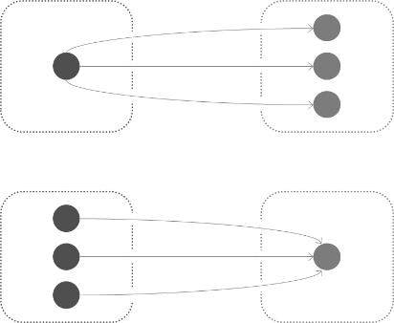  Customer  Supplier | Inbound transportation contracted or operated by customer | Customer responsible for quantification of transportation emissions.  As for multiple transportation relations, emissions shall be attributed by mass between the respective products
2 | Multiple shipping sites, and/or multiple unloading sites  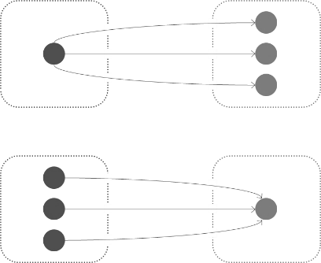  Customer  Supplier | Outbound transportation contracted or operated by supplier | Transportation emissions to be reported separately by supplier to the customer (additionally to supplier's PCF).  As for multiple transportation relations, emissions shall be attributed by mass between the respective product

Transports from production sites to suppliers' distribution centres are deemed as suppliers' in-house logistics, i.e., the distribution centre is regarded as the shipping point (Figure 22).
Figure 22
Distribution centre on supplier side.
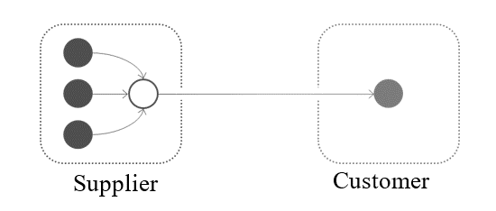
Transports from customers' distribution centres to production sites are deemed as customers' in-house logistics, i.e., the distribution centre is regarded as the unloading point (see Figure 23).
Figure 23
Distribution centre on customer side.
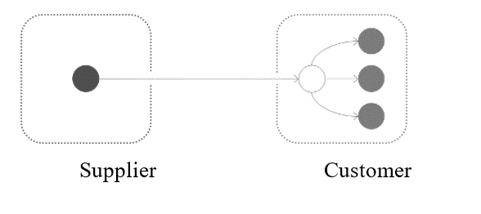
Regardless of whether transportation emissions are quantified by a supplier or a customer, they shall be consolidated within the customers' PCFs.
8.3. Use stage
8.3.1. Service life/Vehicle lifetime activity
The vehicle lifetime (or service life) is defined as the full period of time during which a vehicle is operated and thereby contributes to GHG emissions. This lifetime is expressed in terms of kilometres (km) driven and is chosen to represent typical usage patterns. Alongside the distance travelled, the years of operation for a vehicle is defined as the assumed total number of years a vehicle remains in active use between point of sale and point of recycling/scrapping. Both are relevant for the purpose of the methodology.
Vehicle lifetime mileage is required to translate vehicle production emissions (in tonnes of CO₂eq) into the functional unit (gCO₂eq per km driven over the lifetime). Vehicle lifetime in years is needed to calculate the lifetime mileage, but also to determine the period of time over which the changes in the emission intensity of the fuel and electricity will be accounted for. Lifetime duration is also needed to calculate the number of replacements/refills for certain maintenance and consumable items. As for the annual driven distance, a constant average annual mileage is assumed, based on gathered data on total vehicle activity (in kilometres) and vehicle lifetime. , (i.e., L/N km are driven each of the N years of lifetime operation, where L = total lifetime activity in km).]
8.3.1.1. Service life: methodology and guideline
Precisely assessing these values for each region may present further challenges, underscoring the need for flexibility and regional adaptation in their definition and application.]
The actual service life and lifetime distance reference flow of a vehicle can vary significantly depending on the region and its specific applications. This variability makes it challenging to accurately estimate these values universally. Therefore, this guideline proposes to define service life for each region or country of usage.
De-registration in a country (i.e., as indicated by “survival curves”) can be significantly earlier than reaching end-of-life. In some countries, a significant share of vehicles is exported before reaching the end of service life. Hence, the average age when being de-registered is lower than the average age when being recycled. In general, these guidelines recommend to consider statistical evidence on the average vehicle age at the point of recycling. For the reasons discussed above, statistics on the average age at the point of de-registration in a country is not recommended, as these values exclude the potential export and continued operation of a proportion of the vehicle in other countries. Therefore, for all vehicles, the lifetime used to calculate life cycle emissions should align with the average age of vehicles at the time of recycling, considering only those registered and recycled within the same country.
Some frameworks adopt different lifetime values by vehicle segment. There are both advantages and disadvantages to offering differentiation by segments. (1) Differentiation offers a more accurate representation of the typical usage expected, which also partly highlights the greater potential utility that larger vehicles can provide. (2) However, near the boundaries between segments, it may unintentionally influence consumer decisions (for instance, a specific user is unlikely to choose a vehicle solely because it belongs to a different segment – it's typically bought for a particular use). Until further in-depth analysis is conducted, this guideline does not recommend differentiating service life by segment.
Although statistics indicate that service life varies considerably between powertrains, this may be influenced by user behaviour, as well as current economic/taxation policies, which are subject to change. Since one of the objectives of LCA is to compare different powertrains, based on the same functionality, i.e., the same use case, this guideline does not recommend assigning different service lives to different powertrains.
Generally, the annual mileage of vehicles decreases as they age. Therefore, it is important to assign greater weight to the higher mileage recorded in the initial years, as the emissions intensity of electricity mixes is generally higher during this period. For regions that have officially adopted a method for modelling the distribution of annual vehicle activity over time, this should be prioritised. Although the guidelines do not prescribe a specific method to model the annual mileage distribution as function of the vehicle age, it is permissible to assume a constant value, as mentioned earlier. Alternatively, practitioners might adopt a different approach, provided that the chosen method is clearly documented and transparently reported. Section 8.3.5.2.2 deals with the calculation for the average representative energy mix composition over the full service life of the vehicle, for both homogeneous and age-dependant annual mileage approaches.
Some vehicles, such as special purpose or sports vehicles, have very low usage, leading to a significantly reduced service life. Practitioners could in principle indicate a shorter service life, where justified and supported by primary data, for communication purposes (in addition to default value). However, the guidelines currently do not advise declaring a longer service life than the regional default value, as this could result in a more favourable functional unit.
8.3.1.2. Service life values
Service life (in both km and years) will be defined by each contracting parties according to official available data on vehicle service life until point of recycling.
In the absence of the above values, the following values as defined in official databases or peer-reviewed reports (see the Annex to this Resolution for reference) can be used as an indication of typical service life as fall-back option for passenger cars only.

Table 9
[Average age of end-of-life vehicles reported in a selection of countries]
Region / Country | Year of publication | Duration  (Years) | Source
EU27 | 2024 | 20 | Multiple sources as in the Annex to this Resolution
United Kingdom | 2022 | 18 | Centre for Economic Performance 2024
Japan | 2024 | 17 | Ministry of Economy, Trade and Industry, 2025 - Status of the Enforcement of the Automobile Recycling Law
USA³⁴ | 2025 | varies | United States Energy Information Administration (2025). Annual Energy Outlook 2025
Brazil | 2020 | 22 | Ministry of Science, Technology and Innovations of Brazil, 2020

Table 10
Average annual mileage of end-of-life vehicles reported in a selection of countries
Region / Country | Year of publication | Service Life (km) | Annual Mileage  (km) | Source
EU27 | 2024 | 240,000 km | 12,000 km | Kraftfahrt-Bundesamt (2025); Agence de la Transition Écologique, Enerdata, & Fraunhofer ISI (2025) https://www.acea.auto/fact/fact-sheet-cars/*  https://www.acea.auto/fact/fact-sheet-cars/*
United Kingdom | 2022 | 210,000 km | 11,424 km (7,100 miles per year for all powertrains) | Vehicle mileage and occupancy - GOV.UK (2025)
Japan | - | - | - | No statistics available
USA34 | 2025 | Varies | Varies | United States Energy Information Administration (2025). Annual Energy Outlook 2025
Brazil | 2012 | 288,000 km | 13,000 km (Derived from service life over the first 22 years of usage) | Ministry of Environment (2013)
Notes: *ACEA 2025 fact sheet reports an annual mileage of 12,000 km.
8.3.2. System boundaries
When defining the system boundaries, it is pivotal to highlight that the scope is to provide a comprehensive methodology for calculating realistic GHG emissions and energy consumption over vehicle use stage at various levels of detail and considering the availability of different information and datasets. Therefore, in an intermediate step this requires the calculation of energy consumption as activity data for electrified vehicles such as HEV, PHEV, FCHV and PEV. As outlined in the figure below, the use stage encompasses the operation of the vehicle itself and direct impacts from this, as well as impacts from the production and distribution of fuel/electricity, and for impacts relating to vehicle maintenance and replacement parts.
Impacts directly from the energy used in operation of the vehicle include in the CO₂ equivalent calculation the tank to wheel (TtW) contribution are hereby addressed, hence:
(a) Electric energy: from vehicle charging port to the wheels, if already included in the certification protocol i.e. includes vehicle internal charging losses);
(b) Fuel: CO₂e emissions related to fuel use from tank to wheel.
Conversely, impacts resulting from the production and distribution of fuel and electricity for the operation of the vehicle, i.e. well to tank (WtT), shall follow the methodology outlined in paragraph 7.5 and paragraph 7.14.
These latter WtT GHG emissions shall be covered in the conversion factor of each energy type according to paragraph 7.14.
Use stage boundaries are depicted in the figure below:
Figure 24
Use stage Life cycle flow schematic
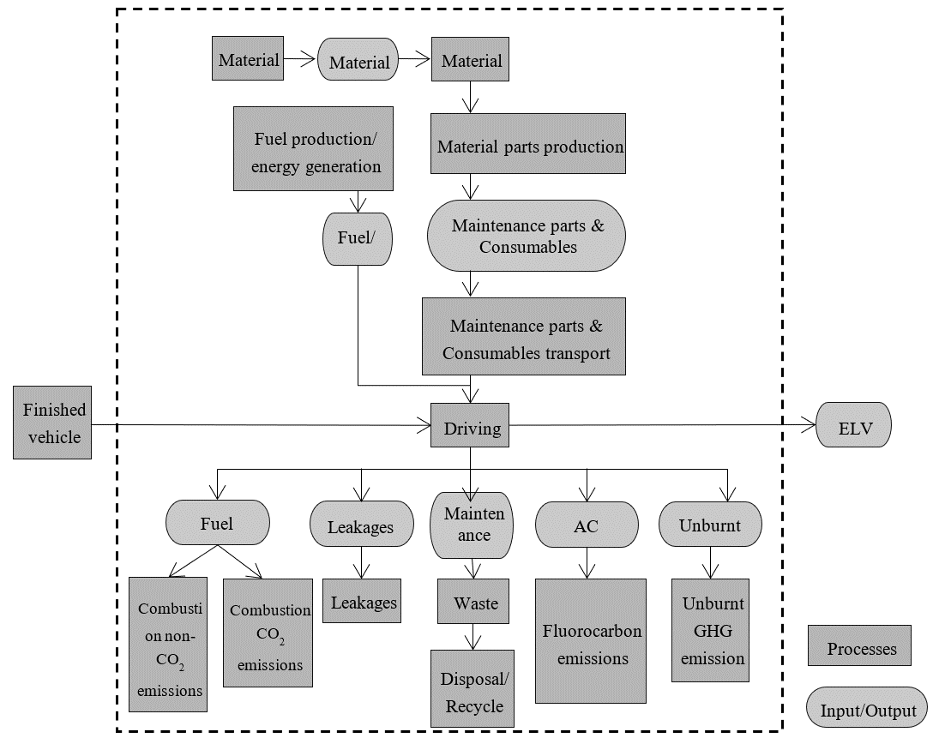
As a matter of fact, the use stage covers mainly two aspects of the whole life cycle, such as the “In-use energy consumption and GHG emissions” (covering WtT and TtW impacts), and the “Maintenance and consumables” impacts. It is relevant to address also leakages such as emissions of methane and other hydrocarbons, together with emissions of climate active species from the vehicles (e.g. methane leakage from CNG cars) and the formation of non-CO₂ GHG gasses (e.g. N₂O) during the fuel combustion. More in detail, the figure below shows the system boundaries related to vehicle operation.
Figure 25
Vehicle operation system boundaries
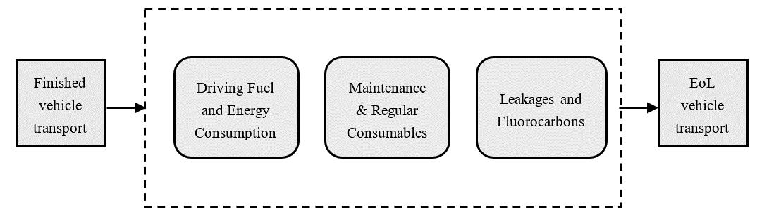
The handover point from the “Parts Production and Vehicle Assembly” stage is defined at the point of delivery to the final customer, once the finished vehicle has been handed over. On the disposal and recycling side, GHG emissions after the vehicle service lifetime fall within the EoL (End-of-Life) domain. Therefore, it is acknowledged that the transportation of the vehicle to EoL treatment facilities is included within the EoL domain.
Considering the proposed system boundaries, the CO₂ equivalent emissions for the use stage comprise emissions from in-use consumption, emissions due to maintenance parts and consumables, and the contribution of leakages and fluorocarbon emissions. The following equation highlights these components:
$C_{ Use Stage}=C_{ Fuel}+C_{ Leakages}+C_{ Maintenance}$ (22o)
Where;
$C_{ Use Stage}$ means carbon emissions for the whole use stage [kg CO₂eq];
$C_{ Fuel}$ means carbon emissions due to the fuel combustion, including both CO₂ and non-CO₂ exhaust emissions and fuel leakages [kgCO₂eq];
$C_{ Maintenance}$ means carbon emissions due to maintenance and consumables [kg CO₂eq];
$C_{ Leakages}$ means carbon emissions due to leakages, including unburnt GHG species emissions [kg CO₂eq];
In the following paragraphs, the methodology for assessing each term of the equation is detailed.
8.3.3. Use phase consumption
Contrary to upstream activities where carbon footprint is unique for a vehicle, downstream activities are different for different regions for the same vehicle. The LCA vehicle's GHG emissions are declared at the point of sale, but it is difficult to measure energy consumption after sale. As a matter of fact, for Level 1 and Level 2 analysis, projections or estimations can be made based on available information such as certification values. These should be considered as minimum requirements and do not prevent the use of more realistic or detailed data to better characterise vehicle behaviour, where such data is available. For Level 3 and Level 4, where stricter requirements are in place, please refer to guidelines in [Table 11].
Usage of light-duty vehicles depends on regional customer behaviour. To provide a standard approach that ensures repeatability, comparability and verifiability by authorities, each region has defined homologation driving cycles and test conditions to be followed. In some regions, these certification values are repeatedly found to underestimate the average fuel consumption in real-life operation. In this regard, Table 12 provides an overview of the primary certification protocols used globally. This table serves as an illustrative example of the methodologies employed in key regions to determine fuel and energy consumption for light-duty vehicles, depending on the powertrain type. The selection and verification of the appropriate homologation procedure remain the responsibility of each contracting party, to be determined on a case-by-case basis. As a result, using regional certification values is considered to be a good starting point to later reach an accurate representation of in-use energy consumption, compared to using globally standardised values.
The scientific community widely acknowledges that there remains a substantial disparity between certification values and actual energy or fuel consumption in real-world conditions across all types of powertrains in some regions. This gap is particularly pronounced for plug-in hybrid electric vehicles, as evidenced by numerous scientific studies. The gap may vary per powertrain, region, driving behaviour and other variables that have to be taken into account. However, in some regions such as Europe and Japan, real-world fuel consumption can be monitored through on-board systems. This data is compiled annually and shows the gap between certified values and actual usage for each powertrain. To address this, the guidelines propose using a "discrepancy factor" if data are available for the region in question. If the factor is not available for a specific region, then the factor should be calculated based on best available data and expert qualified assumptions with a minimum value of ‘1’. For vehicles that have more than one mode of operation (e.g. PHEVs working in Charge-Depleting and Charge-Sustaining mode), distinct discrepancy factors should be applied to accurately characterise each operational mode.
In a ‘Level 4’ calculation context (see paragraph ‎7.1), the substitution of publicly available official data, such as the EU OBFCM data, with OEM-specific average data is not permitted. In instances where publicly available official data is unavailable for a particular manufacturer or model, related to a specific powertrain type or region under consideration, OEM-specific average data may be employed to determine the "Discrepancy Factor." This factor should be based on an analysis of real-world data from vehicles with similar powertrains (e.g., internal combustion engine vehicles (ICEVs) or zero-emission/electric powertrains such as plug-in electric vehicles (PHEVs), fuel cell hybrid vehicles (FCHVs), etc.) and aligned with the specified region of operation (i.e., sale region). OEM-specific average data may also be utilized to provide supplementary information. It is imperative for to disclose detailed information about the fleet sample used to derive the data, including, but not limited to, the sample size and period of data collection. These factors should be defined and updated regularly by the relevant authorities. .
Vehicle emissions may increase over time due to wear, component deterioration and other factors. If emissions "Deterioration factors" for the specific modules are available for a particular region, they should be used to account for this issue. Emissions deterioration factors based upon measurement and used for vehicle emissions certification and/or type approval shall be considered primary data. If a deterioration factor is not available for a region, then a deterioration factor could be calculated based on best available data and expert qualified assumptions with a minimum value of ‘1’. Since the deterioration effect covers vehicle aging, it is important to note that this factor may also be reflected in on-board fuel consumption monitoring data used to quantify the “Discrepancy factor”, and hence double counting shall be avoided.
As far as the mere Fuel and/or Energy consumption is considered, the in-use consumption, EC_{in-use} shall be calculated as follows for vehicles with powertrains with only one mode of operation:
${EC}_{in-use}={EC}_{certification}×f_{discrepancy}×f_{deterioration}$ (23)
Where;
${EC}_{certification}$ means the energy consumption or fuel consumption [MJ/km or Wh/km];
$f_{discrepancy}$ means the discrepancy factor (if not available for a region, then 1 should be used)
$f_{deterioration}$ means the deterioration factor (if not available for a region, then 1 should be used)

[For vehicles with powertrains with two modes of operation the in-use energy consumption shall be defined separately for each mode of operation, so that overall in-use energy consumption may be defined. An additional formula shall be used to account also for changes to the share of operation in Mode 1 and Mode 2 that may result from accounting for the discrepancy and deterioration factors for each mode of operation.
In the specific case of OVC-HEVs, also called plug-in hybrid vehicles (PHEVs), including range-extended electric vehicles (REEVs), the two main modes of operation are the vehicle battery charge-depleting (CD) mode and the charge-sustaining (CS) mode. In some OVC-HEV architectures (e.g., REEVs), this may be 100% operation on electricity. In other PHEV architectures, depending also on factors like power demand and temperature, the CD mode also includes a contribution of the combustion engine. Therefore, the energy consumption in the CD mode need to account for both electricity and fuel consumption. In the CS mode, the on-board battery is not being depleted, and the vehicle is essentially operating as a non-plug-in hybrid vehicle mode. In this case there is only fuel consumption and no net consumption of electricity. The share of operation in CD mode is typically expressed by the utility factor (UF), which is estimated as a function of the vehicle’s range in CD mode.
Based on the mode of operation, both the in-use fuel and electricity consumption should be calculated as follows:
$${FEC}_{in-use}={FEC}_{in-use [CD mode]}×\left({UF}_{ in-use \left[CD mode\right]}\right)+{FEC}_{in-use [CS mode]}×(1-{UF}_{ in-use \left[CS mode\right]})$$
$${EEC}_{in-use}={EEC}_{in-use [CD mode]}×\left({UF}_{ in-use \left[CD mode\right]}\right)$$

Where;
${FEC}_{in-use}$ means the weighted in-use fuel consumption of driving in CD and CS mode combined [L/100 km].
${EEC}_{in-use}$ means the weighted in-use electricity consumption of driving in CD and CS mode combined [MJ/km].
${FEC}_{in-use[CD mode]}$ means the in-use fuel consumption of driving in CD mode [L/100 km].
${EEC}_{in-use[CD mode]}$ means the in-use electricity consumption of driving in CD mode [MJ/km].
${FEC}_{in-use[CS mode]}$ means the in-use fuel consumption of driving in CS mode [L/100 km].
${UF}_{ in-use [CD mode]}$ means the in-use utility factor representing the share of operation in CD mode.

And,
Mode 1  (e.g., CD mode) | $${FEC}_{in-use \left[CD mode\right]}={FEC}_{certification [CD mode]}×f_{discrepancy, fuel [CD mode]}×f_{deterioration, fuel [CD mode]}$$  $${EEC}_{in-use \left[CD mode\right]}={EEC}_{certification [CD mode]}×f_{discrepancy, electricity [CD mode]}×f_{deterioration, electricity [CD mode]}$$
Mode 2  (e.g., CS mode) | $${FEC}_{in-use \left[CS mode\right]}={FEC}_{certification \left[CS mode\right]}×f_{discrepancy, fuel \left[CS mode\right]}×f_{deterioration, fuel \left[CS mode\right]}$$
Where;
${FEC}_{Certification [CD mode]}$ means the in-use fuel consumption of driving in CD mode [L/100 km].
$f_{discrepancy, fuel [i mode]}$ means the real-world discrepancy factor for fuel consumption in each (i) mode. One for CD and one for CS mode shall be derived [-].
$f_{deterioration, fuel [i mode]}$ means the real-world deterioration factor for fuel consumption in each (i) mode. One for CD and one for CS mode shall be derived [-].
${EEC}_{certification [CD mode]}$ means the electric-only energy consumption in CD mode [Mj/km];
$f_{discrepancy, electricity [CD mode]}$ means the real-world discrepancy factor for electricity consumption in CD mode [-].
$f_{deterioration, electricity [CD mode]}$ means the real-world deterioration factor for electricity consumption in CD mode [-].
${FEC}_{Certification [CS mode]}$ means the in-use fuel consumption of driving in CS mode [L/100 km].
In many certification procedures, the UF of PHEVs initially has been estimated under the assumption that the vehicle’s battery is fully charged once per driving day and the vehicle drives in the CD mode as much as possible until the battery is depleted and continues driving in the CS for the remainder of the day. In real-world operation, however, it is observed that PHEVs on average are charged less frequent than once per driving day, resulting in a lower share of driving in CD mode and thereby higher fuel consumption than the values considered in certification values.
In reaction to the large-scale evidence on the difference in observed in-use and certified fuel consumption values for PHEVs, the governments in some major markets including China, the EU and the US have updated the official UF assumptions and will gradually introduce these for the certification of new vehicles. For vehicles in markets with such updated certification UF assumptions, such as the European Union, the United States and China, the in-use distribution between of CD and CS mode operation shall be based on the in-use CD mode range and the most recent certification UF curve throughout the vehicle’s lifetime. If new UF values are anticipated and officially released for future years, these values should be adopted and replace the previous UF figures in the lifetime assessment.
For vehicles in markets where the official certification UF has not yet been updated based on the large-scale evidence of the average real-world operation of PHEVs, the same UF as in markets with such updated certification UF shall be used. This is justified by the finding that the updated certification UF in China, the EU, and US reflect a similar PHEV usage across these regions. Also for other markets, the updated UF curves from these regions are thus likely to be more representative than earlier UF curves that are not based on large-scale evidence.
The in-use UF shall consider such updated certification UF and be based on the in-use instead of the certification electricity consumption in Mode 1 (e.g., CD mode). As the range of PHEVs in Mode 1 (e.g., CD mode) is determined by the electricity depleted from the battery, only the electricity consumption in that mode needs to be reflected. The in-use range in Mode 1 shall be determined according to the following equation:
${Range}_{in-use [CD mode]}={Range}_{certification [CD mode]}×\frac{{EEC}_{certification [CD mode]}}{{EEC}_{in-use [CDmode]}}$ (27)
Where;
${Range}_{certification [CD Mode]}$ means the certified range in CD Mode, e.g. Mode 1, as defined in the regional certification procedure. In some procedures, this may be defined as the full or equivalent all-electric range. In other regions, such as the EU WLTP, the CD mode range may include also some use of the combustion engine in mixed operation, which is included in the certified charge-depleting cycle range (R_{CDC}).
Note that in WLTP, the equivalent all electric range (EAER) is the proportion of the R_{CDC} where the combustion engine is not running. Although the EAER typically is included in public disclosures, it is the R_{CDC} that is used for the weighting of the CD and CS drive modes in WLTP.

Alternatively, in situations where Contracting Parties require the exclusive use of real-world data, such as OBFCM for the EU, to determine the UF, this directive shall be adhered to. Practitioners shall utilize official certification values and, if these are unavailable for specific calculations, OEM-specific data. The entire process must be thoroughly documented, as stipulated by the Contracting Parties.]

Table 11
Level Concept for Use phase Energy Consumption certification values*
Level | Representativeness | Energy Consumption _{Certification}
Level 1 | LCA family representative vehicle (at the practitioner’s discretion) | Regional typical consumption values or other local representative realistic data**
Level 2
Level 3 | Specific vehicle configuration | Official certification values or OEM-specific data in case the former are not available
Level 4 | Specific vehicle configuration

Note *: in defining regional discrepancy and deterioration factors for different modes of operation based on real-world energy consumption monitoring, care should be taken to avoid double counting of the effects of the Utility Factor.
Note**: for Level 1 and Level 2, these guidelines are considered as minimum requirements and do not prevent the use of more realistic or detailed data to better characterise vehicle behaviour.
Table 12
Energy consumption certification protocols for main regions
Region | Powertrain | Protocol
EU27 | ICE, HEV, PHEV, FCHV, PEV | WLTP (WLTC 4 phases)
United Kingdom | ICE, HEV, PHEV, [FCHV], PEV | WLTP (WLTC 4 phases)
Japan | ICE, HEV, PHEV, FCHV, PEV | WLTP (WLTC 3 phases)
China | ICE, HEV, PHEV | WLTP (WLTC 4 phases)
 | FCHV, PEV (Pass. Car) | CLTC-P
 | FCHV, PEV (Vans/LCV) | CLTC-C
Korea | ICE, HEV, PHEV, FCHV, PEV | Combined (FTP-75+HWFET)
US | ICE, HEV, PHEV, PEV, FCHV | Combined (FTP-75+HWFET)
Canada | ICE, HEV, PHEV, PEV, FCHV | Combined (FTP-75+HWFET)

Accurate characterization of methane (CH₄) these emissions is critical for comprehensive LCA, ensuring alignment with climate policy targets and improving the accuracy of GHG mitigation strategies.
In regions where methane is monitored as a pollutant and hence considered in fuel consumption calculations, emissions of methane ( CH₄) is already included in the calculation of type approval fuel consumption. Hence no further consideration is required.
In regions where methane is not monitored as a pollutant and hence not considered in fuel consumption calculations: for Level 3 and Level 4, methane emissions shall not be included to ensures that result variability does not impact official reporting or comparisons between vehicles. For Level 1 and Level 2, emissions in the use phase shall be accounted with the application of the 100-year GWP (i.e. consistent with the overall carbon footprint requirements). In this case, practitioners shall use specific values for methane emissions, accounting for real-world use effects. Practitioners are allowed to use values derived from general studies, provided that they refer to new and fully functional vehicles, using a similar methodology.
As an example, based on studies on Euro 6 cars in Europe (Prussi et al., 2020); Valverde & Giechaskiel, 2020; Vojtíšek-Lom et al., 2018; Hagos & Ahlgren, 2018), the methane emissions from gasoline, diesel, and CNG cars are considered with 5 mg CH₄/km, 9 mg CH₄/km, and 60 mg CH₄/km. This corresponds to about additional 0.15 g CO₂eq/km, 0.12 g CO₂eq/km, and 1.81 g CO₂eq/km for the 100-year GWP.]
8.3.3.1. Calculation of ‘Discrepancy Factor’
A significant gap remains between certification values and real-world energy or fuel consumption across all powertrains in some regions. To address this, guidelines suggest applying a "discrepancy factor" where official regional data exists. If unavailable, the factor should be estimated using the best available data and expert assumptions, with a minimum value of 1. For vehicles with multiple modes, such as PHEVs, discrepancy factors should reflect each mode of operation separately, as outlined in the previous section.
Table 13
Prioritisation for discrepancy factor calculation
Level | Discrepancy Factor
Level 1 | If OEM/ CPs / supplier-specific data is not available, assume official monitoring info, inventories like EMEP/EEA Guidebook, COPERT, MOVES, APEI, etc…
Level 2
Level 3 | Default values provided by CPs based on methodology development/impact assessment/internal studies on real-world gap (OBFCM or equivalent standardised)
Level 4 | Default values provided by CPs shall be used. Verifiable OEM-specific average data from all vehicles of the same powertrain type operating in the real-world (e.g. PEVs, FCHVs, etc.), matched to the region of operation, can be declared for informational purposes.

8.3.3.2. Calculation of ‘Deterioration Factor’
Given the loss in (charge/discharge) efficiency of batteries over the lifetime of the vehicle is reportedly relatively low, and no approaches have been identified to quantify this objectively, it is not proposed to include this aspect for PEVs. However, the situation for OVC-HEVs and fuel cells is different, where efficiency degradation is expected to be significant. Therefore, the following overall methodological approach is proposed for determining fuel cell and OVC-HEV battery efficiency degradation over lifetime of the vehicle.
Where emissions deterioration factors are already incorporated into vehicle emissions certification or type approval procedures, those factors shall be utilized. This ensures alignment with regulatory requirements and harmonization across jurisdictions. In cases where a deterioration factor is not mandated or available for a specific region, practitioners may employ the hierarchical approach listed in Table 14 and Table 15 and may adopt the following methodology for FCHVs and OVC-HEVs. Given the current state of technical knowledge and data availability, practitioners may apply a minimum “Discrepancy factor” of 1.0 where no region-specific data exists. Future revisions to this guideline will incorporate advancements in measurement methodologies and data collection.
[Fuel Cell Hybrid Electric Vehicles]
[ For fuel cells, efficiency losses occur over the operational life of the vehicle. It is proposed to calculate the average loss of efficiency (used to calculate an amended lifetime average energy consumption in MJ/km) based on the fuel cell durability assumptions and operational lifetime km, as outlined below. Fuel cell durability is defined as the number operational hours to reach 10% degradation of the original fuel cell rated power (in kW). The following general methodological approach is therefore proposed to determine the average loss in efficiency over the service life of a vehicle using fuel cell based powertrain (i.e. an FCHV or FC-REEV powertrain).
Potential for further development of knowledge in this area is expected. To adjust to this perspective, the recommended practices allow OEM or suppliers to propose an alternative owned methodology to define operational fuel cell efficiency loss, as long as it is validated by an independent third party expert on fuel cells.
For operation on hydrogen for FCHV – amended to account for fuel cell degradation, the efficiency loss should be to a maximum of 5% degradation over the life of the vehicle, i.e. in the case where FC [lifetime energy] >FC [max energy], where a fuel cell replacement will be required in any case. The following formula is proposed to calculate the average efficiency reduction in the intermediate cases up to this point:
$EnCon \left[AvLife\right]= \frac{ EnCon [Start]}{1- 10\% * \frac{\frac{FCEV[lifetime energy]}{FC[max energy]}}{2}}$ (26)
Where;
EnCon [AvLife] means the average input hydrogen energy consumption in MJ/km over the entire lifetime of the vehicle.
EnCon [Start] means the input hydrogen energy consumption in MJ/km at the start of the vehicle life (i.e. before any FC degradation), as defined in vehicle certification (i.e. before any real-world adjustments being applied).
FCHV [lifetime energy] means the lifetime vehicle operational electrical energy requirement (i.e. fuel cell output, kWh) based on the input hydrogen energy consumption (in kWh/km), the lifetime activity (in km) and the average fuel cell efficiency (%).
FC [max energy] means the maximum energy delivered by the fuel cell (in kWh) over the defined service life (in hours) at the average fuel cell running power (in kW). As per the formula given below.
NB: Fuel cell durability/service life is defined as based on the number of operational hours to 90% of original peak power rating, hence an efficiency loss of 10% over the life of the fuel cell, equal to an average reduction in overall efficiency of 10% divided by 2.
The (i) maximum lifetime energy that can be delivered by the fuel cell before reaching 10% degradation (FC [max energy]), and (ii) fuel cell electric vehicle lifetime energy requirements (FCHV [lifetime energy]) is proposed be calculated as follows:
(i) Fuel cell lifetime maximum electrical energy output (FC [max energy]):
$FC[max energy](kWh)=Fuel cell durability (hrs)* Fuel cell average running power (kW)$ (27)
Where;
Fuel cell average running power (kW) means the maximum rated fuel cell power (kW) * average operation % of rated fuel cell power. See paragraph underneath to define assumptions and values.
(ii) Fuel cell electric vehicle lifetime electrical energy requirement (i.e. energy output from fuel cell)
(= FCHV [lifetime energy]):
$$FC\left[lifetime energy\right]\left(kWh\right)=EnCon\left[Start\right]\left(\frac{MJ}{km}\right)*Fuel cell average efficiency*EnConConversion\left(\frac{kWh}{MJ}\right)* Lifetime activity (km)$$
(28)
Where;
EnCon [Start] means the input hydrogen energy consumption in MJ/km at the start of the vehicle life (i.e. before any FC degradation), as defined in vehicle certification (i.e. before any real-world adjustments being applied).
EnConConversion means the conversion factor for converting MJ to kWh = 3,6 MJ/kWh
Prioritisation for fuel cell durability assumptions:
The following recommended prioritisation is proposed for the underlying assumptions of fuel cell life and average operational efficiency, with the choice of which option is most appropriate or feasible left to the practitioner (i.e. depending on the availability of data and objective of the study).
The different options are listed in order of accuracy and preference. The third option is proposed as a mandatory minimum default approach, where sufficient information is not available for the other options.
Table 14
Prioritisation for fuel cell durability assumptions
Level | Fuel Cell Deterioration Factor
Level 1 | If OEM/ supplier-specific data is not available, assume an operational life of 6000/24000 hours (for LDVs/HDVs)^{(a)}, an efficiency of 55%/52% (at the start of the fuel cell life for LDVs/HDVs)^{(b)}, with efficiency loss of 10% over the life of the fuel cell, and running at an average of 25%^{(c)}/25%^{(d)} (for LDVs/HDVs) of the peak power rating
Level 2
Level 3 | Optional, depending on availability  OEM-specific / supplier-specific data on fuel cell life (to 10% loss in power) and average operational power level (as % of the peak power of the fuel cell, according to regulatory testing cycles)
Level 4 | Optional, depending on availability  OEM-specific / supplier-specific methodological approach to define operational fuel cell efficiency loss, if validated by an independent third party expert on fuel cells.
Notes: (a) based on 2025 targets from FCH2JU KPIs FCH 2 JU - MAWP Key Performance Indicators (KPIs) - European Commission (europa.eu); (b) based on Ricardo review of typical fuel cell efficiency for LDV and HDV applications; (c) based on Fuel Cell Electric Vehicle Durability and Fuel Cell Performance (nrel.gov), (d) average approximation based on Ricardo analysis of VECTO simulation results for different HDVs and cycles.
]
[Off-Vehicle Charging Hybrid Electric Vehicles (OVC-HEV)]
[For OVC-HEVs (i.e. including plug-in hybrid electric vehicles – PHEVs - and range-extended electric vehicles – REEVs), the proposed methodology should account for the effect of the change in the battery energy capacity (i.e. State of Health / Certified Energy as defined in UN GTR 22) over the lifetime of the vehicle and its impact on electric range and via the Utility Factor (UF) on the share of operation in charge-sustaining and charge-depleting modes, which ultimately affects the combined fuel consumption and CO₂ emissions]
[The average lifetime in-use electric range for vehicles operating in dual-mode shall be calculated according to the following formula, accounting for the average loss in energy capacity (i.e. as defined by the battery SoH – state of health):
$${Range}_{in-use [electric]}={Range}_{certification [electric]} ×\frac{{Battery Capacity}_{in-use average}}{{Battery Capacity}_{Start} }$$
(29)
Where;
${Range}_{certification [electric]}$ means the certified electric range (i.e. in charge-depleting mode of operation) in km or miles.
${Range}_{in-use [electric]}$ means the in-use electric range (i.e. in charge-depleting mode of operation) in km or miles, i.e. including accounting for the discrepancy and deterioration factors.
${Battery Capacity}_{Start}$ means the net usable battery energy capacity (in kWh) available at the start of the vehicle lifetime, defined as UBE_{certified} in UN GTR 22.
${Battery Capacity}_{in-use average}$ means the average net usable battery capacity (in kWh) available over the lifetime of the vehicle, which may be defined as the average of the capacity available at the start of the vehicle lifetime, and the capacity left at the end-of-life of the vehicle (i.e. according to the state of health – SoH), i.e. according to the following equation:
${Battery Capacity}_{vehicle EoL}$ = ${SoH}_{vehicle EoL}×{Battery Capacity}_{Start}$ (30)
And Where;
${Battery Capacity}_{vehicle EoL}$ means the average net usable battery energy capacity (in kWh) available at the end of the vehicle lifetime.
${SoH}_{vehicle EoL}$ means the average battery state of health (SoH) in % of the original capacity at the end-of-life of the vehicle (or battery, whichever comes first).
(* UN GTR 22 defines the “State Of Certified Energy” - SOCE to provide a precise definition of battery state of health based on energy, and should be used as the primary definition/basis where available).
The average available battery capacity at end-of-life of the vehicle (or ${SoH}_{vehicle EoL}$) may be defined according to alternative methodologies, as outlined in [Table 16] below. Where OEM-specific / supplier-specific calculated value for end-of-life available battery capacity or ${SoH}_{vehicle EoL}$ is not available, the following formula shall be used to estimate the ${SoH}_{vehicle EoL}$, which assumes as an approximation a linear relationship for battery degradation based on the number of full charge/discharge cycles:
${SoH}_{vehicle EoL}=1-(20\% × \frac{{Battery}_{lifetime cycles}}{{Battery}_{cycle life}}$ ) (31)
Where;
${Battery}_{cycle life}$ means the operational cycle lifetime (i.e. number of full charge/discharge cycles) of the battery to reach 80% SoH. (Note: depending on the definition of, for example minimum battery durability requirements, in different regions for different vehicle types, the equation may be adjusted to account for the defined minimum SoH for end-of-life use in a vehicle).
${Battery}_{lifetime cycles}$ means the average number of full battery charge/discharge cycles over the use stage vehicle lifetime, which may be estimated according to the following formula:

${Battery}_{lifetime cycles}$ $=\frac{{EC}_{in-use \left[CD\right]} × Service Life×{UF}_{certification}}{{Battery Capacity}_{Start} × (1+Charging Losses)}$ (32)
Where;
Service Life means the number of km driven over the use stage lifetime.
Charging Losses means the charging losses included within the certified or in-use vehicle electricity consumption in charge-depleting mode of operation.
Other parameters are defined as earlier.

Table 15
Prioritisation for average battery SoH reduction assumptions
Level | Traction Battery Deterioration Factor
Level 1 | If OEM / supplier-specific data is not available, assume an operational cycle life of 2000 charge/discharge cycles hours to calculated the average SOH according to the defined formula.
Level 2
Level 3
Level 4 | Optional, depending on availability  OEM-specific / supplier-specific data on battery cycle life (i.e. to 80% loss in energy capacity*), according to regulatory durability testing requirements.
Notes: * Depending on the definition of battery end-of-life in a vehicle in different regions for example via minimum battery durability requirements for different vehicle types, the SoH/SOCE cycle life definition may be adjusted. [For jurisdictions with standards defining a minimum SOCE at specific points of vehicle life, the SOH_{vehicle EoL} shall be consistent with the SOCE standards in that particular jurisdiction. For example, the U.S. has standards requiring minimum SOCE of 80% @ 5 years or 62,000 miles and 70% @ 8 years or 100,000 miles. For that jurisdiction, vehicle scrappage at or below 5 years or 62,000 miles would require a minimum SOCE of 80%; and vehicle scrappage at more than 5 years or 62,000 miles and less than 100,000 miles would require a minimum SOCE of 70%.]
8.3.3.3. Quantification of Leakages
This section deals with GHG emissions arising from the fuel system, such as evaporation, hydrogen and methane leakages.
Evaporative emissions
Evaporative emissions occur in vehicles due to the nature of the fuel system and the volatility of petrol fuel. As part of the homologation process, vehicles are subjected to emissions testing to ensure compliance with regulations, including limits on evaporative emissions.
Limits of evaporative emission (2g to 0.5g of HC) and duration of measurement (24h to 48h) varies between different regions of the world (worst case limit is 2g / 24h).
Given the very low impact on the entire use stage GHG emissions, this recommended practices neglect the emissions arising from fuel evaporation.
Hydrogen leakages
Hydrogen emissions primarily occur during production and distribution, mainly due to fugitive leakage. To a lesser extent, emissions can also arise directly from hydrogen-fuelled vehicles, although standardised test methods to quantify these emissions are currently lacking. Hydrogen can also escape from combustion engines and storage systems, particularly in the case of liquefied hydrogen.
Recent research suggests that hydrogen leakage rates across the supply chain may be comparable to methane losses in the natural gas supply chain. Estimates indicate that green hydrogen supply chains could experience net leakage rates between 2.6% and 6.9% (Cooper, Dubey, Bakkaloglu, & Hawkes, 2022).
Hydrogen emissions are not commonly included in life cycle inventory (LCI) datasets, and a characterisation factor for hydrogen is currently absent from established impact assessment methods (e.g., the Environmental Footprint (EF) method), due to its omission from the explicit list of greenhouse gases in the latest IPCC Assessment Report. As such, it is recommended that the inclusion of hydrogen as a greenhouse gas in default LCA calculations be deferred until formal consensus is reached on its global warming potential (GWP) and/or its integration into the EF method.
In the interim, for Level 1 and Level 2, practitioners are required to account for hydrogen emissions as a mandatory flow indicator until a standardised GWP value is formally adopted. From both the supply chain and vehicle use, where available, practitioners should use official governmental estimates or supplier-specific data on typical fugitive hydrogen emissions. These should differentiate between various hydrogen production pathways, local versus imported hydrogen, and distinct hydrogen vehicle types. For Levels 3 and 4 LCA, practitioners may apply the methodology for Levels 1 and 2 or omit hydrogen leakage until future guideline revisions mandate inclusion, due to current data limitations and evolving measurement standards.
Methane leakage
Methane fugitive emissions from vehicle storage systems can significantly impact use-phase greenhouse gas inventories for certain vehicle using methane as a fuel. In the absence of harmonized measurement standards, practitioners should prioritize official governmental estimates of CH₄ leakage when available. Supplementary data from OEMs or suppliers may be used to corroborate these estimates. For Level 1 and Level 2 assessments where official governmental data remains unavailable, validated peer-reviewed literature may constitute an acceptable alternative, provided they are appropriately documented.
8.3.3.4. Quantification of fluorocarbons emissions
Refrigerant fluids have a direct environmental impact, primarily due to the use of hydrofluorocarbons (HFCs), a class of synthetic gases that replaced hydrochlorofluorocarbons (HCFCs). However, there is no standardized leakage measurement methods available; and refrigerant leakages are considered to be very low. For this reason, this recommended practices neglect the emissions arising from fluorocarbons..
On the other side, refrigerant emissions shall be included in the life cycle inventory as elementary flows pertaining to the maintenance and consumables area, as explained in section 8.3.6.
8.3.3.5. Quantification of vehicle emissions exported out of region of sales
Ideally, the GHG emissions related to operation of vehicles exported from the country where they are sold/used shall be evaluated by using energy consumption performance (and fuel mix) and vehicle lifetime (and km activity) of the country where they are exported, used and eventually disposed/recycled. However, to avoid unnecessary complexity, if data in the region to which they are exported cannot be tracked down or it is difficult to grasp the needed values of the country where they are exported, used and eventually disposed/recycled, a simplified approach can be adopted. Hence, the full lifetime period (and km activity) shall be considered but the energy consumption performance (and fuel mix) and vehicle life (activity) of the primary region of sale/use are adopted for the calculations. For those countries and regions that export used vehicles, the actual average vehicle lifetime is higher than the average period during which the vehicles are used domestically.
Therefore, for all vehicles, the lifetime used to calculate life cycle emissions shall align with the average age of vehicles at the time of recycling, considering only those registered and recycled within the same country.
8.3.4. Data Collection and data type
Data shall be collected for the items outlined below. Where applicable, activity data shall be collected as primary data. In case of the difficulty, secondary data may be applied to activity data. GHG emission intensity data shall be collected as secondary data. Secondary data source shall be reported. The following data shall be collected:
Table 16
Processes and Data to be included in Use stage
Processes | Activity data | GHG emissions Intensity Data
Processes | (Primary Data basis) | (Secondary Data basis)
Driving | Certified Fuel consumption [l/100km] and/or electricity consumption [kWh/100km]
Driving |  | Discrepancy factor RW data
Driving |  | Degradation factor
Driving | Separate Certified fuel/electricity consumption for the charge-depleting (CD) and charge-sustaining (CS) modes for OVC-HEVs
Driving | Utility Factor definition for dual-mode powertrains (e.g. OVC-HEVs)
Driving | Certified charge-depleting (CD) range [km] for dual-mode powertrains (e.g. OVC-HEVs)
Driving |  | Average lifetime Battery SoH loss for dual-mode powertrains (e.g. OVC-HEVs)
Driving |  | Average PHEV, FCHV, PEV charging/discharging efficiency if not included in certification values
Driving | Vehicle lifetime (years), and activity (km) | Vehicle recycling statistics/ Nationally authorised statistics/OEM's average vehicle life
Driving |  | GHG emission factor for burning fuel
Driving |  | Vehicle occupancy rates for potential scenario analysis
Leakages | Hydrogen, Methane
Emitting Fluorocarbons | Out of scope | Out of scope
Maintenance and Consumables Production | List of maintenance parts and consumables
Maintenance and Consumables Production | Frequency of replacement/service intervals
Maintenance and Consumables Production |  | GHG emission factor for producing maintenance parts, in line with Section ‎8.2.1
Maintenance and Consumables Transportation | List of maintenance parts and consumables
Maintenance and Consumables Transportation | Frequency of replacement/service intervals
Maintenance and Consumables Transportation | Transport Weight [kg]  Transport Distance [km] | GHG emission factor for transporting maintenance parts
Maintenance and Consumables End-of-Life | To be evaluated in line with Section ‎0 | To be evaluated in line with Section ‎0
Vehicle activity out of region of sales | Out of scope | Out of scope
Second life of components | Out of scope | Out of scope

8.3.5. Application of the energy modelling schemes
For general rules, refer to paragraph 7.14..
8.3.5.1. Future Changes in Energy Mix:
Practitioners shall also account for any expected changes in the fuel or electricity production pathways during the lifetime of the vehicle. (detailed methodology shall be considered)
The energy mix for the use stage shall be based on the latest available dynamic scenario following the defined hierarchy for prioritising this outlined below[; a static scenario may be used only where a dynamic scenario is not available for the geographical region of interest, or to meet specific corporate GHG emission reporting requirements (if relevant)].
For renewable fuels, [future scenarios issued or recognised by an official source or by a regional association can be considered, specifying the future evolution of the share of renewable fuel versus fossil fuel in a specific geographical region or country of interest/future changes in the average fuel mix can be considered with the same methodology and the same hierarchy of scenarios as for electricity modelling outlined below. A static scenario for the average fuel mix shall be used where no official general scenario based on implemented policies or no Stated Policy Scenario from the IEA is available].
Specifically, the following recommendations are made on how to model electricity inputs to the use phase:
8.3.5.2. Use phase electricity:
8.3.5.2.1. [A scenario for the expected future evolution of the electricity grid mix in the geographical region of interest shall be selected, according to the following order of preference:
The official published scenario specifically for electricity supply mix for the country or geographical region of interest.
(a) The official general scenario based on currently implemented policy for the country or geographical region of interest (providing this has been updated within < 3 years).
(b) Stated Policies Scenario (STEPS) from the most recent International Energy Agency’s World Energy Outlook (IEA WEO) report, for the geographical region of interest. The Sustainable Development Scenario (SDS) shall be used as a sensitivity case.
(c) [(reinstate) If none of the previous options above are available for the geographical region of interest, a projected future grid mix (or LCI for this) from either dispatch modelling or peer-reviewed published literature based dispatch modelling may be used.]
(Note) Dispatch modelling: An electric power sector dispatch model is a mathematical representation of how sources of electricity generation are chosen and scheduled (i.e., “dispatched”) to meet a given electricity demand. It essentially models the decision making process of electricity system operators and is capable of making projections of future generation and future emissions given cost constraints, environmental policy and emissions constraints, and constraints related to resource adequacy. Dispatch models also include representations of individual electricity generation units (EGU) and regional interconnection of EGUs as part of regional, national, and international electricity grids.
8.3.5.2.2. The grid mix composition for each year of vehicle operation shall be estimated (i.e., the shares S_{i,n} of electricity supplied by each technology i in the year n), by applying linear interpolation between the respective electricity supply shares reported for the nearest pre-defined time horizons in the scenario selected at point 1 above.The average representative grid mix composition over the full service life of the vehicle shall be calculated as follows:
(a) By default, as the arithmetic average of the individual electricity supply shares at point 2 above. Doing so entails the implicit simplifying assumption that the vehicle’s use is distributed homogenously over its full service life (i.e., L/N km are driven each of the N years of operation, where L = total lifetime activity).
(b) Alternatively, if there is reason to expect that the vehicle’s use intensity will change over time, and if year-specific activities may be estimated with sufficient confidence, then a more refined (and accurate) modelling approach may be adopted, employing a weighted average (as opposed to a simple arithmetic average) of the individual shares S_{i,n} of electricity supplied by each technology i in the year n, i.e.: $\sum_{n=1}^{N}{W_{n}S_{i,n}}$ , where Wn = An/L (An = vehicle activity in year n, L = total lifetime activity).
8.3.5.2.3. A bespoke grid mix model shall finally be built using the grid mix composition calculated at point 3 above and leveraging the most up to date database processes available for the individual electricity generation technologies. The resulting grid mix thus modelled shall be used to estimate the Emission Factor of the electricity input to the use phase of the vehicle.]
8.3.6. Maintenance
Vehicle maintenance refers to the recommended regular inspection defined by the vehicle manufacturer in order to ensure its optimal performance, longevity, and safety by preventing issues from arising and preserving its overall condition. Maintenance in the use stage of a vehicle's life cycle can have a none-negligible impact on its carbon footprint. Recent life cycle assessment studies estimate that the greenhouse gas emissions produced by vehicle maintenance during the use stage can have a significant impact on total vehicle carbon footprint, depending on the powertrain type and vehicle segment.
8.3.6.1. Maintenance scope
Two types of maintenance are included in this methodology:
(a) Consumables: These are materials, fluids, and components that are regularly used, replaced, or replenished during the operation and maintenance of a vehicle. These items typically have a limited lifespan and require periodic replacement to ensure the vehicle's proper functioning, safety, and performance. This includes items such as engine oil, transmission fluid, brake fluid, windshield washer fluid, filter, brake pads and discs, etc… Carbon footprint related to material, production and EoL should be considered.
(b) Maintenance parts: This refers to the replacement of parts due to normal wear and tear, including components that are not designed to last the entire lifespan of a vehicle, such as the brakes, clutch, tyres, starter battery etc... The range of parts that need to be replaced during maintenance varies between different cars, depending on factors such as the driver's behaviour, road conditions and other variables (weather etc.). Hence, it is difficult for OEMs to recommend a frequency of exchange of these parts to the customer. The frequency of maintenance of such parts can only be estimated with acceptable probability through statistical analysis and a generic frequency of these parts shall be used for the purpose of carbon footprint estimation. For these parts recycling aspects must be considered and are same as that of original production parts.
Other repair or maintenance activities not included in the methodology are:
(a) Unexpected repairs (i.e., accident): Looking at the challenge of estimating the consequences of road accidents and premature fails (for components expected to last for service life), the guideline does not address such cases. Furthermore, impact of such cases is not very significant compared to overall carbon footprint of a car.
(b) Cleaning operations: Effect of car wash may not be a significant factor in the calculation as it is a very small fraction of the overall carbon footprint of a car. Hence, the guideline does not address cleaning operations.
8.3.6.2. Maintenance carbon emission estimation
Since the carbon footprint related to maintenance occurs after the vehicle is placed on the market, it can only be calculated based on the known frequency specified by the vehicle manufacturer.
To account for maintenance and consumables emissions , there are two possibilities (considered in a hierarchical order):
(a) List of maintenance parts/consumable and associated frequency provided by the manufacturer.
(b) List of maintenance parts/consumable not available
For Level 3 and Level 4, only option a) shall be selected.
For Level 1 and Level 2, the approach for maintenance and consumables emissions estimation may instead alternatively follow point (b) where a suitable methodology may be defined and documented by the practitioner (e.g. based on assumptions on the parts replaced and the number/frequency, or alternative methods).
8.3.6.2.1. Maintenance Data Availability
If a list of maintenance parts/consumable and associated frequency is provided by the manufacturer or parts supplier, then the following estimation shall be used.
As this will reflect the effort from the manufacturer to reduce carbon footprint of maintenance, the manufacturer or part supplier should provide all the assumptions (list, frequency, carbon emission) used for carbon footprint estimation.
$C_{maintenance}= \sum_{i=1}^{n}{{CEF}_{i}*f_{i.maintainence}}$ (33)
Where;
i means consumable/ maintenance parts
$f_{i.maintainence}$means the maintenance frequency of the consumable/maintenance parts defined
${CEF}_{i}$ means the carbon emission factor of the consumable/maintenance parts as used for calculation of upstream emissions (kgCO₂e).
8.3.6.2.2. Determination of list of consumables and parts
The following table provides a list of consumables and parts for guidance and should not be considered as exhaustive. The manufacturer should provide the list adapted to the powertrain and vehicle segment for which the carbon footprint is calculated. However, for Level 3 and Level 4, last column of the table indicates items responsible for the most significant potential impacts that shall be included if a replacement is needed (to be justified) in the considered lifetime of the vehicle.

Table 17
List of consumables and maintenance parts
 |  | Petrol | Diesel | CNG | NOVC-HEV | OVC-HEV | Pure EV | FCHV | OVC-FCHV | H2-ICE | Level 3/ Level 4
Consumables | Engine coolant |  |  |  |  |  | N/A | N/A | N/A
Consumables | Engine lubricant |  |  |  |  |  | N/A | N/A | N/A
Consumables | Screen wash
Consumables | Brake fluids
Consumables | Engine air/oil filter |  |  |  |  |  | N/A | N/A | N/A
Consumables | AdBlue/Urea/Reagent | N/A |  | N/A | N/A | N/A | N/A | N/A | N/A | N/A | YES
Maintenance parts | Passenger air filter
Maintenance parts | HVAC Refrigerants
Maintenance parts | Spark plug |  | - |  |  |  | N/A | N/A | N/A
Maintenance parts | Windshield wiper blades
Maintenance parts | Tyres |  |  |  |  |  |  |  |  |  | YES
Maintenance parts | Brake linings |  |  |  |  |  |  |  |  |  | YES
Maintenance parts | Brake discs
Maintenance parts | SLI battery (i.e. 12V) |  |  |  |  |  |  |  |  |  | YES
Maintenance parts | Aftertreatment |  |  |  |  |  | N/A | N/A | N/A
The impacts resulting from different maintenance items can vary greatly, with some items being less significant and others usually accounting for a significant proportion of overall impacts. It is therefore proposed that the following items should be mandatorily included (where relevant for a given vehicle powertrain type):
(a) Consumables: AdBlue/Urea, Refrigerants for HVAC (heating, ventilation and air conditioning) systems
(b) Maintenance and wear parts: Tyres, SLI battery, brake pads, brake discs, additional auxiliary batteries (if relevant for commercial vehicles – e.g. for temperature controlled payload areas)
.
Refrigerant emissions shall be included if the refrigerant used has a GWP₁₀₀ value of 150 kg CO₂eq/kg or higher. Practitioners may also choose to report refrigerant emissions with a GWP₁₀₀ below this threshold as non-exhaust emissions.
Additionally, the guidelines require the assessment of key components for potential replacement, such as the traction or storage battery in electric vehicles and the fuel cell stack in fuel cell electric vehicles. This assessment is necessary and required only if replacements are likely within the vehicle's typical operational lifetime. Any inclusions based on these considerations should be clearly justified.

For certain items, including mandatory items, replacements might not be needed in the vehicle’s typical operational lifetime based on the supplier assessment. In these cases, exclusions made on this basis should be justified.
8.3.6.2.3. Determination of Frequency
For most maintenance items frequency can be simply calculated by the following two approach:
Frequency by distance
${Frequency}_{distance}= \frac{Service life [km]}{Maintainence interval [km]}$ (34)
Frequency by duration
${Frequency}_{duration}= \frac{Service life [years]}{Maintainence interval [years]}$ (35)
In case the manufacturer/supplier recommends frequency by both distance and duration, both calculations should be performed, and most conservative frequency shall be considered for the carbon footprint estimation.
[ Based on consultations with experts, stakeholders, and manufacturers, there is no evidence to suggest that battery or fuel cell replacement is a common or routine occurrence. In fact, traction batteries and fuel cell systems are generally designed to last for the entire lifetime of the vehicle without the need for replacement.
However, due to the substantial influence of batteries and fuel cells on vehicle life cycle assessments, their inclusion in the study is required in all cases where their duration is shorter than the overall vehicle lifetime. This applies to situations such as niche applications, small battery capacities, low-durability chemistries, or other conditions identified by the practitioner.
This Resolution proposes the following approaches are adopted to provide a structured hierarchy for determining the need for replacements of traction batteries and fuel cells, which could be applied across all types of LCA study (i.e. for general analyses and scientific studies, as well as product LCA or prospective LCA).]
8.3.6.2.4. Methodology for calculating the need for traction battery /fuel cell system replacement(s)]
The following recommended prioritisation is proposed for the underlying assumptions of traction battery/fuel cell system replacement, with the choice of which option is most appropriate or feasible left to the practitioner (i.e. depending on the availability of data and objective of the study). The different options are listed in order of accuracy and preference. It is recognised that OEMs and battery/ fuel cell system suppliers will likely have more sophisticated battery/ fuel cell system performance modelling supporting their product development and specification. The most important point is that in all cases the study should clearly indicate whether a battery/ fuel cell system replacement is included or not, and the basis/explanation for this assumption.
Table 18
Prioritisation for traction battery/ fuel cell system replacement in order of accuracy and specificity (highest to lowest)
Level | Traction Battery / fuel cell system Replacement
Level 1 | Simple assumption on whether battery/ fuel cell system replacement is needed or not, including explanation for this.
Level 2
Level 3 | Standardised methodology based on battery cycle life and lifetime operational activity (below) fuel cell system dusrability. An explanation/justification for the result should be provided.
Level 4 | Optional, depending on availability  OEM-specific / supplier-specific methodological/modelling approach to define the need for a battery replacement (or not) over the operational life of the vehicle. An explanation/justification for the result should be provided.

8.3.6.2.5. Standardised Methodology for calculating the need for traction battery replacement (s)
For vehicle traction batteries, the following approach for accounting for the frequency of energy storage replacement for Option 2, which is based on a combination of parameters including the anticipated battery cycle life (i.e. number full charge/discharge cycles). This methodology also provides a dynamic link to the vehicle battery capacity and the lifetime activity/service life (as defined in the study Goal & Scope), which can be used in product LCA, prospective LCA or other more generic studies.
The methodology for determining the number of traction battery replacements is as follows (i.e. where a value of N > 1 means at least one replacement is likely to be needed):
$N= \frac{\left(E \left[Average\right]×A [Lifetime]\right)}{\left(C \left[Battery usable\right]×CL [Battery]\right)}$ (36)
Where;
N means the total number of traction batteries needed over the vehicle lifetime
C [Battery usable] means the usable (i.e. ‘net’) traction battery capacity in kWh
CL [Battery] means the average battery cycle life – number of full charge/discharge cycles (within the usable capacity)
A [Lifetime] means the vehicle lifetime activity (in km). Note: As a sensitivity it is recommended to also explore the potential number of replacements needed based on the warrantied number of km for the battery (where this is present).
E [Average] means the vehicle average electrical energy consumption, in kWh per km
In the absence of OEM-specific data on the battery cycle life (parameter ‘CL’ above), then it is proposed to use a value of 2000 charge/discharge cycles, which is representative of a typical value for current technology. Should the battery come with an expected calendar lifetime lower than the defined vehicle lifetime in the Goal & Scope of the LCA study, then a replacement will also be required.]
8.3.6.2.6. [Standardised Methodology for calculating the need for fuel cell system replacement(s)]
[Fuel cell durability(/life) is defined as the number operational hours to reach 10% degradation of the original fuel cell rated power (in kW). The following general methodological approach is therefore proposed to determine the need for one or more fuel cell replacements over the service lifetime of a vehicle using fuel cell based powertrain (i.e. an FCHV or FC-REEV powertrain), consistent with the similar methodology proposed for fuel cell efficiency degradation (see earlier paragraph ‎0[x.x.x)).
(Recognising the potential for further development of knowledge in this area, it is also proposed to that should an OEM-specific / supplier-specific methodological approach be subsequently developed to define operational fuel cell efficiency loss and/or replacements, this would also be acceptable, if validated by an independent third party expert on fuel cells.)
Fuel cell lifetime max energy output (= FC [max energy]):
$Lifetime max energy output (kWh) = Fuel cell durability (hrs)*Fuel cell average running power (kW)$ (37)
Where;
Fuel cell average running power (kW) means the maximum rated fuel cell power (kW) * average operation % of rated fuel cell power
Fuel cell vehicle lifetime energy requirement (energy output from fuel cell) (= FC [lifetime energy]):
$$Lifetime vehicle energy requirement \left(fuel cell output\right)\left(kWh\right)=\frac{MJ}{km}*Lifetime km*\frac{kWh}{MJ}*fuel cell average efficiency (\%)$$
(38)
Where;
MJ/km means the hydrogen energy input to the vehicle, i.e. hydrogen energy consumption.
The number of fuel cells needed (and therefore the number replacements) is defined by the ratio of the vehicle’s lifetime energy requirements and the maximum fuel cell lifetime energy delivered:
$$Number of fuel cell replacements =roundup to integer \left(\frac{FC[lifetime energy] }{FC\left[max energy\right]}-1 \right)$$
(39)
]
8.3.6.2.7. Maintenance Data not available
The maintenance parts/consumable are already included in the upstream emission as they are part of the vehicle before placing the vehicle on the market. Hence, if list of maintenance parts/consumables is not available then a fixed percentage of upstream emissions can be attributed to maintenance depending upon powertrain, service life, vehicle segment and region of use.
For all light-duty vehicles it can be assumed that there is no variation within segments.
$C_{maintenance}= f_{maintainence}*\left(C_{.Material }+C_{Production }+C_{Recycling }\right)$ (40)
Where;
$f_{maintainence}$ means the maintenance frequency factors
$C_{Material }$ means the carbon footprint of material acquisition stage of the vehicle,
$C_{Production }$ means the carbon footprint of production stage of the vehicle
$C_{Recycling }$ means the carbon footprint of recycling stage of the vehicle for maintenance parts, to be evaluated in line with paragraph 7.17. This guideline does not prescribe default values for maintenance frequency factors. In the absence of contracting party-provided data, practitioners should apply technically justified judgments to determine appropriate maintenance factors, accompanied by transparent documentation of the methodological rationale and any inherent assumptions.
8.4. EoL
8.4.1. Levels in disposal and recycling stage
As introduced in paragraph ‎7.1., the analysis of global warming potential can also be carried out for Disposal and recycling stage in different levels of detail according to the chart below.

Table 19
Level concept of disposal and recycling stages
 | Level Concept of Disposal and Recycling stage
 | 1. Activity data of each EoL processes | 2. Intensity data of each EoL processes | 3. Recovered parts disposal and recycling process
 | e.g. Weight of vehicle, parts, material etc | e.g. Dismantling and shredding/sorting, ASR thermal recovery, Materials. recycle etc | e.g. Tyre, SLI battery, Traction battery, etc
Level 1 | Global or Generic secondary data | Global or Region or Country primary data or secondary data can be chosen, depend on the study | Global or Region or Country process can be chosen, depend on the study
Level 2 | Primary data  (BoM & MDS)
Level 3 | Primary data  (BoM & MDS) | Global or Region or Country primary data or secondary data shall be specified by LCA owner (e.g. CPs) | Global or Region or Country process shall be specified by LCA owner (e.g. CPs)
Level 4 | Primary data  (BoM & MDS)

8.4.2. System boundaries
The system boundary of the disposal and recycling stage as well as its calculation method are outlined below.
Figure 26
System boundaries of Disposal and Recycling stages
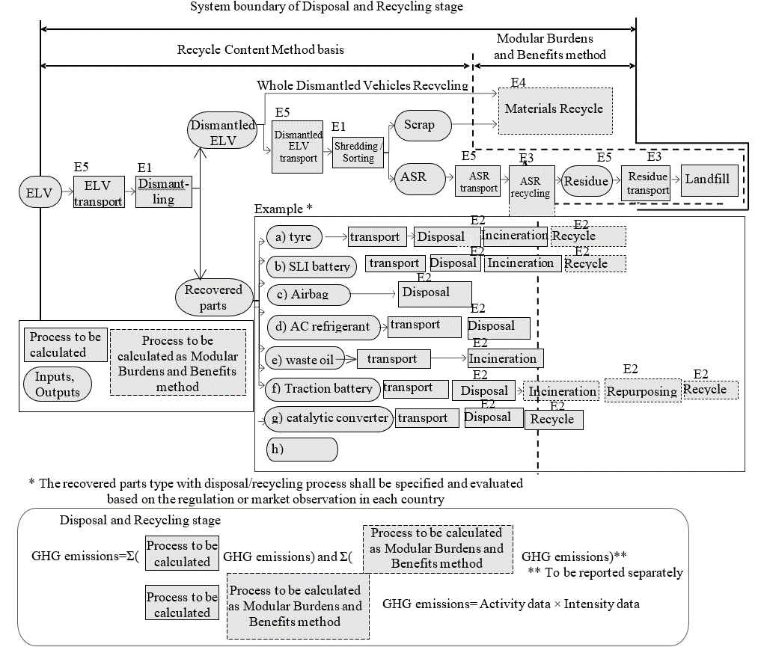
Data collection applies to the processes outlined below.
E1; End-of-life vehicle (ELV) dismantling and shredding/sorting process
E2; Recovered parts disposal and recycling process
E3; Automobile shredder residue (ASR) disposal and recycling process
E4; Materials recycling processes
E5; Transport processes
8.4.3. Data collection and data types
Data shall be collected for the item outlined below. Activity data shall be collected as primary data in level 2 or 3 or 4. The secondary data may be applied to activity data in level 1. GHG emission intensity data shall be collected as primary or secondary data in all levels. Scenarios for secondary data and secondary data source shall be reported. Secondary data may be referred, among others, to the following data set.
(a) Environmental Footprint (EF) compliant data sets
(b) IDEA
(c) JAMA CFP guideline

Table 20
Data types for disposal and recycling stages with each symbols
Processes |  |  | Activity data | GHG emissions intensity data
 |  |  | (Primary data basis) | (Secondary data basis)
E1; End-of-life vehicle (ELV) dismantling and shredding/sorting process (C_{E1}) |  |  | ･ELV Weight [kg_{component}] (W_{E1}) | ･ELV dismantling and shredding/sorting [kgCO₂eq/kg _{applicable ELV}] (${CEF}_{D,E1}$))
E2; Recovered parts disposal and recycling process  Remarks)  The recovered parts type with disposal and recycling process shall be specified and evaluated based on the regulation or market observation in each country | (a) Tyre (C_{E2a}) | (a-1) Disposal, Incineration  (C_{E2a-1}) | ･Tyre weight [kg_{component}] (W_{E2a})  ･Wearing ratio [%] (R_{E2a})  ･Weight fractions of each material in the tyre [kg_{material}/kg_{component}]  (T_{Ii,E2a}, T_{Di,E2a}) | ･Tyre incineration with thermal and electricity recovery [kgCO₂eq/kg_{material}] (${CEF}_{Ii,E2a}$)) and disposal [kgCO₂eq/kg_{material}] (${CEF}_{Di,E2a}$) which may include residue landfill and transport.
 | (a) Tyre (C_{E2a}) | (a-2) Recycle  (C_{M,MBBM,E2a}) | ･Material weight to which CFF is applied  [kg_{material}] (W_{Mi,E2a}) | ･Modular Burdens and Benefits method (MBBM) of each material [kgCO₂eq/kg_{material}] (${CEF}_{Mi,MBBM}$)
 | (b) SLI battery (C_{E2b}) | (b-1) Disposal, Incineration  (C_{E2b-1}) | ･SLI battery weight [kg_{component}] (W_{E2b})  ･Weight fractions of each material in the battery [kg_{material}/kg_{component}]  (T_{Ii,E2b}, T_{Di,E2b}) | ･SLI battery incineration with thermal and electricity recovery [kgCO₂eq/kg_{material}] (${CEF}_{Ii,E2b}$) and disposal [kgCO₂eq/kg_{material}] (${CEF}_{Di,E2b}$) which may include lead scrap treatment and electrolyte neutralisation treatment and transport.
 | (b) SLI battery (C_{E2b}) | b-2) Recycle  (C_{M,MBBM,E2b}) | ･Material weight to which CFF is applied  [kg_{material}] (W_{Mi,E2b}) | ･MBBM of each material [kgCO₂eq/kg_{material}] (${CEF}_{Mi,MBBM}$)
 | (c) Airbag (C_{E2c}) |  | ･Airbag weight [kg] [kg_{component}] (W_{E2c}) | ･Airbag proper disposal [kgCO₂eq/kg_{component}] (${CEF}_{Mi,MBBM}$)
 | (d) Air conditioner (AC) refrigerant (C_{E2d}) |  | ・AC refrigerant weight [kg_{material}], filled in air conditioner at vehicle production. (W_{E2d}) | ･AC refrigerant (fluorocarbons) disposal [kgCO₂eq/kg_{material}] (${CEF}_{D,E2d}$),, which may include fluorocarbons destruction, CO₂ from destruction and transport
 | (e) Waste oil (C_{E2e}) |  | ･Waste oil weight [kg_{material}] (W_{E2e}) | ･Waste oil incineration with thermal and electricity recovery [kgCO₂eq/kg_{material}] (${CEF}_{I,E2e}$)
 | (f) Traction battery (C_{E2f}) | (f-1) Disposal, Incineration  (C_{E2f-1}) | ･Used battery pack weight[kg] (W_{E2f})  ･Weight fractions of each material in the battery [kg_{material}/kg_{component}]  (T_{Ii,E2f}, T_{Di,E2f}) | ･Used battery pack proper treatment which includes battery pack incineration (where allowable) with thermal and electricity recovery (${CEF}_{Ii,E2f}$) and disposal (${CEF}_{Di,E2f}$) which may include residue landfill and transport. [kgCO₂eq/kg_{material}]
 | (f) Traction battery (C_{E2f}) | (f-2) Secondary use (Repurposing)  (C_{TBR,MBBM}) | ･Number of Driving battery pack | ･MBBM for the battery repurposing [kgCO₂eq/pack] (C_{TBR,MBBM})
 | (f) Traction battery (C_{E2f}) | (f-3) Material recycle (C_{M,MBBM,E2f}) | ･Material weight to which CFF is applied [kg_{material}] (W_{Mi,E2f,Material}) and battery cell weight to which CFF is applied [kg _{battery cells}] (W_{E2f,Cells}) | ･MBBM of each single material [kgCO₂eq/kg _{Material}] (${CEF}_{Mi,MBBM,Material}$) recovered from the battery disassembly process and sent to material recycling, and Modular Burdens and Benefits method of battery cells specific recycling process [kgCO₂eq/kg _{battery cells}] (${CEF}_{MBBM,cells}$), if applicable according to regional regulations
 | (g) Catalytic converters (C_{E2g}) | (g-1) Disposal  (C_{E2g-1}) | ･Catalytic converters weight [kg_{component}] (W_{E2g})  ･Weight fractions of each material in the converters [kg_{material}/kg_{component}]  (T_{Di,E2g}) | ･Catalytic converters disposal [kgCO₂eq/kg_{material}] (${CEF}_{Di,E2g}$), which may include residue landfill after recycling process
 | (g) Catalytic converters (C_{E2g}) | (g-2) Material recycle  (C_{M,MBBM,E2g}) | ･Material weight to which CFF is applied [kg_{material}] (W_{Mi,E2g}) | ･MBBM of each material [kgCO₂eq/kg_{material}] (${CEF}_{Mi,MBBM}$)
E3; Automobile shredder residue (ASR) disposal and recycling process(C_{E3}) | ASR |  | ･ASR combustible material material weight [kg_{material}] (W_{i,ASR}) | ･ASR incineration with thermal and electricity recovery [kgCO₂eq/kg_{material}] (${CEF}_{Ii,ASR}$) and disposal [kgCO₂eq/kg_{material}] (${CEF}_{Di,ASR}$) which may include the residue landfill
 | Wood (mainly for truck/bus use) |  | ･Wood material weight [kg_{material}] (W_{i,Wood}) | ･Wood incineration with thermal and electricity recovery [kgCO₂eq/kg_{material}] (${CEF}_{Ii,Wood}$) and disposal [kgCO₂eq/kg_{material}] (${CEF}_{Di,Wood}$), not including CO₂ absorption effect
E4; Materials recycling processes (C_{M,MBBM,E4}) |  |  | ･Material weight to which CFF is applied  [kg_{material}] (W_{Mi},_{E4}) | ･MBBM of each material [kgCO₂eq/kg_{material}] (${CEF}_{Mi,MBBM}$)
E5; Transport processes (C_{E5}) |  |  | ・Each transported goods weight [t] (W_{i,E5})  ・Each transport distance [km] (D_{i,E5}) | Transport per transport goods weight and per transport distance [kgCO₂eq/t-km] (${CEF}_{Ti}$)

8.4.4. Recycling modelling for second life parts
The second life parts for Remanufacturing, Reuse or Repurposing shall be evaluated in all levels based on regulation or market observation, data availability for parameters and verification criteria. In any case the second life parts traceability shall be confirmed with following recommendation of recycling modelling.
Table 21
Recycling modelling recommendations for second life
Second life application | Definition | Recycling modelling Recommendation
1. Remanufacturing | ELV parts recycling  to new vehicle parts | RCM
2. Reuse | ELV parts recycling  to repair vehicle | RCM
3. Repurposing | ELV parts recycling  to another function in other industries  e.g. Traction battery from EoL PEV repurposed to the stationary battery in a building | CFF

RCM formula for Remanufacturing or Reuse shall be referred to ${CEF}_{M,RCM}$formula in 7.17.1. Material recycling modelling. CFF formula for Repurposing shall be referred to ${CEF}_{M,MBBM}$formula in 7.17.1. Material recycling modelling and (f-2) Secondary use (Repurposing) of E2; (f) Traction battery in 8.4.8. GHG calculation for each process. The type of date for RCM or CFF parameter shall be confirmed according to the regulation or market observation.
8.4.5. EoL emissions treatment of ELV exported out of region of sales
Ideally, the EoL GHG emissions of vehicles exported from the country where they were originally sold and used shall be evaluated based on the EoL processes of the country where they are eventually used and disposed/recycled. However, to avoid complexity, if the country to which the vehicle is exported cannot be tracked or the EoL process of the country where they were exported, used and disposed/recycled cannot be determined, a simplified approach can be adopted. In such cases, the EoL emissions may be evaluated using the process of the country where the vehicle was first registered and primarily used.
8.4.6. Future recycling process and technology modelling
GHG emissions intensity for each disposal and recycling process and CFF parameters shall be set in view of the process and recycling technology about 13-17 years later in the future. For recycling, process data should be those available at the point of declaration of the vehicle (First time vehicle registration). When a specific recycling process does not yet exist, and assumptions on such a future process cannot be appropriately justified, a scenario based on the current process and recycling technology may be applied.
8.4.7. Energy modelling
For general rules refer to paragraph 7.14.
8.4.7.1. Future Changes in Energy Mix
Practitioners shall also account for any expected changes in the fuel or electricity production pathways during the lifetime of the vehicle. (detailed methodology shall be considered)
Specifically, the following recommendations are made on how to model electricity inputs to the EoL phase:
8.4.7.2. EoL phase electricity
1. The same scenario for the expected future evolution of the electricity grid mix in the geographical region of interest shall be adopted, as previously selected for the dynamic modelling of the use phase electricity input in paragraph [x.x.x].
2. The grid mix composition for the specific year of vehicle decommissioning (i.e., year of vehicle registration + expected lifetime) shall be estimated (i.e., the shares S_{i,N} of electricity supplied by each technology i in the year N), by applying linear interpolation between the respective electricity supply shares reported for the two nearest pre-defined time horizons in the scenario selected at point 1 above
3. A bespoke grid mix model shall be built using the grid mix composition calculated at point 2 above and leveraging the most up to date database processes available for the individual electricity generation technologies. The resulting grid mix thus modelled shall be used to estimate the Emission Factor of the electricity input to the EoL phase of the vehicle.
For dynamically evolving fuel mixes (e.g., “green”/”grey” hydrogen; bio/fossil diesel blends; etc.), a similar approach to the one described above for electricity should be employed, whereby the respective fuel mix models for the use phase and EoL phase are arrived at by considering the existing future scenarios. "
In case of the process in the EoL phase is not a hotspot, the static energy modelling may be applied.
8.4.8. GHG calculation for each process
The total GHG emission in the EoL stage shall be calculated and reported by the following equation for the complete vehicle.
C_{EoL} = C_{EoL,RCM} + C_{EoL,MBBM} (41)
Where;
$C_{EoL}$ means the total GHG emissions in EoL stage [kgCO₂eq]
$C_{EoL, RCM}$ means the GHG emissions arising from the ELV treatment when using the RCM basis system boundaries as defined in Figure 26 [kgCO₂eq]
$C_{EoL,MBBM}$ means the GHG emissions arising from the ELV treatment when using the MBBM system boundaries as defined in Figure 26 [kgCO₂eq]
In case of RCM application, only $C_{EoL, RCM}$shall be calculated, $C_{EoL,MBBM}$ shall not be calculated. In case of CFF application both $C_{EoL, RCM}$ and $C_{EoL,MBBM}$ shall be calculated.
$$C_{EoL,RCM}=C_{E1}+\sum_{j}{C_{E2j,RCM}+C_{E3,RCM}}+C_{E5}$$
(42)
$$C_{E2j,RCM}=W_{E2j}×\{\sum_{i}{\left(T_{Ii,E2j}×E_{ERi,E2j}\right)}+\sum_{i}{\left(T_{Di,E2j}×{CEF}_{Di,E2j}\right)}\}$$
(43)
$$C_{E3,RCM}=\sum_{i,ASRorWood}{{\{W}_{i,ASRorWood}×(E_{ERi,ASRorWood}+{CEF}_{Di,ASRorWood})\}}$$
(44)
Where;
C_{EoL} means the total GHG emissions in EoL stage [kgCO₂eq]
C_{E1} means the GHG emissions in ELV dismantling and shredding/sorting process [kgCO₂eq]
C_{E2j,RCM} means the GHG emissions in each recovered parts disposal and incineration process [kgCO₂eq]
$W_{E2j}$ means each parts weight [kg_{component}]
$T_{Ii,E2j}$ means the i-th material weight fraction of each parts for the incineration [%]
$T_{Di,E2j}$ means the i-th material weight fraction of each parts weight that is sent to disposal [%]
$E_{ERi,E2j}$ means the specific emissions and resources consumed (per unit of analysis) arising from the energy recovery process of each material in each parts in kilogram of carbon dioxide equivalent per kilogram of material. [kgCO2e/ kg_{material}]
${CEF}_{Di,E2j}$ means the specific GHG emissions arising from the disposal of of each material in each parts in kilogram of carbon dioxide equivalent per kilogram of material. [kgCO2eq/ kg_{material}]
$C_{E3,RCM}$ means the GHG emissions in the automobile shredder residue (ASR) disposal and incineration process [kgCO₂eq]
$W_{i,ASRorWood}$ means the weight of each combustible materials in ASR or wood material [kg_{material}]
$E_{ERi,ASRorWood}$ means the specific emissions and resources consumed (per unit of analysis) arising from the energy recovery process of each combustible materials in ASR or wood in kilogram of carbon dioxide equivalent per kilogram of material. [kgCO2e/ kg_{material}]
${CEF}_{Di,ASRorWood}$ means the specific GHG emissions arising from the disposal of combustible materials in ASR or Wood in kilogram of carbon dioxide equivalent per kilogram of material. [kgCO2eq/kg_{material}]
C_{E5} means the GHG emissions in the transport processes [kgCO₂eq]
Each MBBM value in $C_{EoL,MBBM}$, which are $C_{M,MBBM}$, $C_{I,MBBM}$ and $C_{TBR,MBBM}$, shall be separately reported with the following equation.
$$C_{EoL,MBBM}= C_{M,MBBM}+ C_{I,MBBM}+ C_{TBR,MBBM}$$
(45)
C_{M,MBBM} = Σ_{j}C_{M,MBBM,E2j} + C_{M,MBBM, E4} (46)
Where;
C_{M,MBBM} means the specific GHG emissions calculated per MBBM in the total materials recycling processes [kgCO₂eq]
C_{M,MBBM, E2j} means the specific GHG emissions calculated per MBBM in each parts material recycling [kgCO₂eq]
C_{M,MBBM, E4} means the specific GHG emissions calculated per MBBM in the materials recycling processes [kgCO₂eq]
C_{I,MBBM} = Σ_{i,j}(W_{E2j}×T_{Ii,E2,j}×CEF_{Ii,MBBM,E2j}) + Σ_{i,ASRorWood} (W_{i, ASRorWood}×CEF_{Ii,MBBM,ASRorWood} ) (47)
Where;
C_{I,MBBM} means the specific GHG emissions related to the credit obtainable by total material energy recovery process [kgCO₂eq]
W_{E2j} means each parts weight [kg_{component}]
T_{Ii,E2j} means each material weight fraction of each parts for the incineration [%]
CEF_{Ii,MBBM,E2j} means the specific GHG emissions related to the credit obtainable by the energy recovery process of each material in each parts calculated per MBBM for energy in kilogram of carbon dioxide equivalent per kilogram of material. [kg CO₂e/ kg_{material}]
W_{i, ASRorWood} means the weight of each combustible materials in ASR or wood material [kg_{material}]
CEF_{Ii,MBBM,ASEorWood} means the specific GHG emissions related to the credit obtainable by the energy recovery process of each combustible materials in ASR or wood calculated per MBBM for energy in kilogram of carbon dioxide equivalent per kilogram of material. [kg CO₂e/ kg_{material}]
C_{TBR,MBBM} means the specific GHG emissions calculated per MBBM of traction battery repurposing [kg CO₂eq]
8.4.8.1. E1; End-of-life vehicle (ELV) dismantling and shredding/sorting process
C_{E1} = W_{E1} × ${T_{E1}×CEF}_{D,E1}$ (48)
Where;
C_{E1} means the GHG emissions in ELV dismantling and shredding/sorting process [kg CO₂eq]
W_{E1} means the ELV weight [kg_{component}]
T_{E1} means the applicable ELV weight fraction of the ELV weight [%]
${CEF}_{D,E1}$ means the specific GHG emissions intensity for ELV arising from dismantling and shredding/sorting in kilogram of carbon dioxide equivalent per kilogram of the applicable ELV weight [kg CO₂eq/kg applicable ELV]
8.4.8.2. E2; Recovered parts disposal and recycling process
The recovered parts type with disposal and recycling process shall be specified and evaluated based on the regulation or market observation in each country following GHG calculation example for each processes.
8.4.8.2.1. Tyre
8.4.8.2.1.1. Disposal, Incineration
$$C_{E2a-1}={{(1-R}_{E2a})×W}_{E2a}×\{\sum_{i}{\left(T_{Ii,E2a}×{CEF}_{Ii,E2a}\right)}+\sum_{i}{\left(T_{Di,E2a}×{CEF}_{Di,E2a}\right)}\}$$
(49)
Where;
$C_{E2a-1}$ means the GHG emissions in tyre incineration with thermal and electricity recovery $(C_{I,E2a}$) and disposal ($C_{D,E2a}$), which may include residue landfill and transport [kgCO2eq]
$R_{E2a}$ means the percentage of weight loss during total tyre wear based on calculations of tyre specifications [%]
$W_{E2a}$ means the tyre weight [kg_{component}]
$T_{Ii,E2a}$ means the i-th material weight fraction of the tyre weight at EoL{$W_{E2a}$×(1-$R_{E2a}$)} that is sent to incineration [%]
$T_{Di,E2a}$ means the i-th material weight fraction of the tyre weight at EoL{$W_{E2a}$×(1-$R_{E2a}$)} that is sent to disposal [%]
${CEF}_{Ii,E2a}$ means the specific GHG emissions arising from incineration with energy recovery of tyre materials, expressed in kilogram of carbon dioxide equivalent per kilogram of material. [kgCO2eq/ kg_{material}]
${CEF}_{Di,E2a}$ means the specific GHG emissions arising from the disposal of tyre materials, expressed in kilogram of carbon dioxide equivalent per kilogram of material. [kgCO2eq/ kg_{material}]
${CEF}_{Ii,E2a}$ and ${CEF}_{Di,E2a}$ shall be evaluated following paragraphs 7.17.2.and 7.17.3.
8.4.8.2.1.2. Recycle
$C_{M,MBBM,E2b}=(1-R_{E2a})×\sum_{i}{{(W}_{Mi,E2a}×{CEF}_{Mi,MBBM})}$ (50)
Where;
$C_{M,MBBM,E2b}$ means the specific GHG emissions in tyre materials recycling [kgCO2eq]
$W_{Mi,E2a}$ means each tyre material weight to which CFF is applied [kg_{material}]
${CEF}_{Mi,MBBM}$ means the specific GHG emissions of a tyre material calculated with the MBBM in kilogram of carbon dioxide equivalent per kilogram of material. [kgCO2eq/ kg_{material}]
${CEF}_{Mi,MBBM}$ shall be evaluated following paragraph 7.17.1.
8.4.8.2.2. SLI battery
8.4.8.2.2.1. Disposal, Incineration
$$C_{E2b-1}=W_{E2b}×\{\sum_{i}{\left(T_{Ii,E2b}×{CEF}_{Ii,E2b}\right)}+\sum_{i}{\left(T_{Di,E2b}×{CEF}_{Di,E2b}\right)}\}$$
(51)
Where;
$C_{E2b-1}$ means the GHG emissions in SLI battery incineration with thermal and electricity recovery ($C_{I,E2b}$) and disposal ($C_{D,E2b}$), which may include lead scrap treatment, electrolyte neutralisation treatment and transport [kgCO2eq]
$W_{E2b}$ means the weight of the SLI battery [kg_{component}]
$T_{Ii,E2b}$ means the i-th material weight fraction of the SLI battery weight that is sent to incineration [%]
$T_{Di,E2b}$ means the i-th material weight fraction of the SLI Battery weight that is sent to disposal [%]
${CEF}_{Ii,E2b}$ means the specific GHG emissions arising from incineration with energy recovery of SLI battery materials, expressed in kilogram of carbon dioxide equivalent per kilogram of material. [kgCO2eq/kg_{material}]
${CEF}_{Di,E2b}$ means the specific GHG emissions arising from the disposal of SLI battery materials, expressed in kilogram of carbon dioxide equivalent per kilogram of material. [kgCO2eq/ kg_{material}]
${CEF}_{Ii,E2b}$ and ${CEF}_{Di,E2b}$ shall be evaluated following paragraphs 7.18.2.and 7.17.3.
8.4.8.2.2.2. Recycle
$C_{M,MBBM,E2b}=\sum_{i}{{(W}_{Mi,E2b}×{CEF}_{Mi,MBBM})}$ (52)
Where;
$C_{M,MBBM,E2b}$ means the specific GHG emissions in SLI battery materials recycling [kgCO2eq]
$W_{Mi,E2b}$ means the weight of each SLI battery material to which CFF is applied [kg_{material}]
${CEF}_{Mi,MBBM}$ means the specific GHG emissions of a SLI battery material calculated with the MBBM in kilogram of carbon dioxide equivalent per kilogram of material. [kgCO2eq/ kg_{material}]
${CEF}_{Mi,MBBM}$ shall be evaluated following paragraph 7.17.1.
8.4.8.2.3. Airbag
$C_{E2c}=W_{E2c}×{CEF}_{D,E2c}$ (53)
Where;
$C_{E2c}$ means the GHG emissions in Airbag disposal [kgCO2eq]
$W_{E2c}$ means the weight of the Airbag(s) [kg_{component}]
${CEF}_{D,E2c}$ means the specific GHG emissions of airbag arising from the proper disposal in kilogram of carbon dioxide equivalent per kilogram of airbag. [kgCO2eq/kg_{component}]
8.4.8.2.4. Air conditioner (AC) refrigerant
$C_{E2d}=W_{E2d}×{CEF}_{D,E2d}$ (54)
Where;
$C_{E2d}$ means the GHG emissions in AC refrigerant disposal [kgCO2eq]
$W_{E2d}$ means the weight of the AC refrigerant, filled in air conditioner at vehicle production. [kg_{material}]
${CEF}_{D,E2d}$ means the specific GHG emissions of AC refrigerant arising from the disposal in kilogram of carbon dioxide equivalent per kilogram of material., which may include fluorocarbons destruction, CO2 from destruction and transport. [kgCO2eq/ kg_{material}]
${CEF}_{D,E2d}$ shall be evaluated following paragraph 7.17.1.
8.4.8.2.5. Waste Oil
$C_{E2e}=W_{E2e}×{CEF}_{I,E2e}$ (55)
Where;
$C_{E2e}$ means the GHG emissions in waste oil incineration with thermal and electricity recovery [kgCO2eq]
$W_{E2e}$ means the weight of waste oil [kg_{material}]
${CEF}_{I,E2e}$ means the specific GHG emissions of waste oil arising from incineration with energy recovery in kilogram of carbon dioxide equivalent per kilogram of material. [kgCO2eq/ kg_{material}]
${CEF}_{I,E2e}$ shall be evaluated following paragraph 7.17.1.
8.4.8.2.6. Traction battery
8.4.8.2.6.1. Disposal, Incineration
$$C_{E2f-1}={{(1-R}_{E2f-2}-R_{E2f-3})×W}_{E2f}×\{\sum_{i}{\left(T_{Ii,E2f}×{CEF}_{Ii,E2f}\right)}+\sum_{i}{\left(T_{Di,E2f}×{CEF}_{Di,E2f}\right)}\}$$
(56)
Where;
$C_{E2f-1}$ means the GHG emissions in used battery pack proper treatment which includes battery pack incineration (where allowable) with thermal and electricity recovery ($C_{I,E2f}$) and disposal ($C_{D,E2f}$)which may include residue landfill and transport [kgCO2eq]
$R_{E2f-2}$ means the battery repurposing ratio [%] in paragraph 8.4.8.2.6.2
$R_{E2f-3}$ means the battery material recycling ratio [%] in paragraph 8.4.8.2.6.3
$W_{E2f}$ means the weight of the used battery pack [kg_{component}]
$T_{Ii,E2f}$ means the i-th material weight fraction of the traction battery weight at EoL{${{(1-R}_{E2f-2}-R_{E2f-3})×W}_{E2f}$}that is sent to incineration [%]
$T_{Di,E2f}$ means the i-th material weight fraction of the traction battery weight at EoL${\{{(1-R}_{E2f-2}-R_{E2f-3})×W}_{E2f}$}that is sent to disposal [%]
${CEF}_{Ii,E2f}$ means the specific GHG emissions arising from incineration with energy recovery of traction battery materials, expressed in kilogram of carbon dioxide equivalent per kilogram of material. [kgCO2eq/ kg_{material}]
${CEF}_{Di,E2f}$ means the specific GHG emissions arising from the disposal of traction battery materials, expressed in kilogram of carbon dioxide equivalent per kilogram of material. [kgCO2eq/ kg_{material}]
${CEF}_{Ii,E2f}$ and ${CEF}_{Di,E2f}$ shall be evaluated following paragraphs 7.17.2.and 7.17.3.
8.4.8.2.6.2. Secondary use (Repurposing)
The repurposing of the traction battery shall be specified and evaluated based on the regulation or market observation, data availability for parameters and verification criteria.
Battery repurposing Environmental Footprint (EF) compliant studies shall follow EF recommendations and regional regulations. Battery repurposing for other studies/other regions can follow other recommendations (e.g., the JAMA CFP guidelines)
Strong evidence shall be provided by the industry and the practitioner about the definition of the parameters, the definition of the new product substituted by the repurposed one, and the source of data to be used for modelling
In the case of applying the UNECE A-LCA CFF concept to the repurposing of the traction battery from the vehicle substituting a virgin battery into a different application, the evaluation will be based on the regulation or market observation, and the availability of data for parameters and verification criteria.
The evaluation will consist of two parts, each corresponding to the CFF components outlined in the CFF equation in paragraph ‎7.17.1.
The production burden for the traction battery, which corresponds to CFF part 1, will be evaluated in the production stage of the traction battery. The burdens and benefits related to the output of secondary batteries, corresponding to CFF part 3, will be evaluated in the disposal and recycling stage as the Modular Burdens and Benefits method for traction battery repurposing. The value derived from the Modular Burdens and Benefits method for traction battery repurposing shall be reported and included in the total vehicle CFP.
Modular Burdens and Benefits Method formula for traction battery repurposing
$C_{TBR,MBBM}=\left(1-A_{TBR}\right)R_{2,TBR}×\left(E_{recEoL,TBR}-E_{V,TBR}^{*}×\frac{Q_{sout,TBR}}{Q_{p,TBR}}\right)$ (57)
Where;
$C_{TBR,MBBM}$ means the specific GHG emissions of traction battery repurposing in kilogram of carbon dioxide equivalent per kilogram of battery pack. [kg CO₂eq/battery pack]
$A_{TBR}$ means the allocation factor of burdens and credits between supplier and user of repurposed battery.
${ R}_{2,TBR}$ means the proportion of the battery at EoL that will be reused in a subsequent system. [%]
$\frac{Q_{sout,TBR}}{Q_{p,TBR}}$ means the quality of outgoing secondary traction battery / quality of virgin battery substituted by the repurposed battery
$E_{V,TBR}^{*}$ means the specific GHG emissions (per unit of analysis) arising from the production of virgin battery that is going to be substituted by the repurposed battery. [kg CO₂eq/battery pack]
$E_{recEoL,TBR}$ means the specific GHG emissions (per unit of analysis) arising from the recycling process at EoL, including collection, sorting and transportation process. [kg CO₂eq/battery pack]
Datasets (${ E}_{V,TBR}^{*}, { E}_{recEoL,TBR}$) to be used in the Modular Burdens and Benefits method for the traction battery repurposing may be collected as primary data. Parameters in the Modular Burdens and Benefits Method for traction battery repurposing ($A$_{TBR}$, { R}_{2,TBR}, \frac{Q_{sout,TBR}}{Q_{p,TBR}}$) may be defined as default values in reference documents.
8.4.8.2.6.3. Material recycle
$$C_{M,MBBM,E2f}=\sum_{i}{{(W}_{Mi,E2f,Material}×{CEF}_{Mi,MBBM,Material}})+\sum_{i}{{(W}_{E2f,cells}×{CEF}_{MBBM,cells}})$$
(58)
Where;
$C_{M,MBBM,E2f}$ means the specific GHG emissions arising from traction battery materials recycling. [kgCO2eq]
$W_{Mi,E2f,Material}$ means the weight of each traction battery material to which CFF is applied except battery cells. [kg_{material}]
$W_{E2f,cells}$ means the weight of traction battery cells derived from battery pack dismantling to which CFF is applied. [kg_{battery cells}]
${CEF}_{Mi,MBBM,Material}$ means the specific GHG emissions arising from of the material recycling of a traction battery pack material except for material in cells calculated with the MBBM in kilogram of carbon dioxide equivalent per kilogram of material. [kgCO2eq/kg_{material}]
${CEF}_{MBBM,cells}$ means the specific GHG emissions arising from the recycling process applied to traction battery cells calculated with the MBBM in kilogram of carbon dioxide equivalent per kilogram of traction battery cells. [kgCO₂eq/kg_{battery cells}]
${CEF}_{Mi,MBBM,Material}$ or ${CEF}_{MBBM,cells}$ shall be evaluated following paragraph 7.17.2.
In case that the used battery is repurposed, the recycle of the material which is used in the repurposed traction battery shall not be evaluated.
8.4.8.2.7. Catalytic converters
8.4.8.2.7.1. Disposal
$C_{E2g-1}=W_{E2g}×\sum_{i}{(T_{Di,E2g}×{CEF}_{Di,E2g})}$ (59)
Where;
$C_{E2g-1}$ means the GHG emissions in catalytic converters disposal, which may include residue landfill after recycling process. [kgCO2eq]
$W_{E2g}$ means the weight of the catalytic converters [kg_{component}]
$T_{Di,E2g}$ means the i-th material weight fraction of the catalytic converters weight that is sent to disposal [%]
${CEF}_{Di,E2g}$ means the specific GHG emissions arising from the disposal of catalytic converters materials, expressed in kilogram of carbon dioxide equivalent per kilogram of material. [kgCO₂eq/kg_{material}]
${CEF}_{Di,E2g}$ shall be evaluated following paragraph 7.17.2.
8.4.8.2.7.2. Recycle
$C_{M,MBBM,E2g}=\sum_{i}{{(W}_{Mi,E2g}×{CEF}_{Mi,MBBM})}$ (60)
Where;
$C_{M,MBBM,E2g}$ means the specific GHG emissions in catalytic converters materials recycling [kgCO2eq]
$W_{Mi,E2g}$ means the weight of each catalytic converters material to which CFF is applied [kg_{material}]
${CEF}_{Mi,MBBM}$ means the specific GHG emissions of a catalytic converters material calculated with the MBBM in kilogram of carbon dioxide equivalent per kilogram of material. [kgCO2eq/ kg_{material}]
${CEF}_{Mi,MBBM}$ shall be evaluated following paragraph 7.17.1.
8.4.8.3. E3; Automobile shredder residue (ASR) disposal and recycling process
$C_{E3}=\sum_{i}{{\{W}_{i,ASR}×({CEF}_{Ii,ASR}{+ CEF}_{Di,ASR})\}}+\sum_{i}{{\{W}_{i,Wood}×({CEF}_{Ii,Wood}{+ CEF}_{Di,Wood})\}}$ (61)
Where;
$C_{E3}$ means the GHG emissions in ASR incineration with thermal and electricity recovery ($C_{I,ASR or wood}$) and disposal ($C_{D,ASR or wood}$) which may include the residue landfill and the transport [kgCO2eq]
$W_{i,ASR}$ means the weight of each combustible material in ASR [kg_{material}]
$W_{i,Wood}$ means the weight of each wood material [kg_{material}]
${CEF}_{Ii,ASR}$ means the specific GHG emissions arising from incineration with energy recovery of combustible materials in ASR, expressed in kilogram of carbon dioxide equivalent per kilogram of material. [kgCO2eq/kg_{material}]
${CEF}_{Ii,Wood}$ means the specific GHG emissions arising from incineration with energy recovery of wood materials, expressed in kilogram of carbon dioxide equivalent per kilogram of material. [kgCO2eq/kg_{material}]
${CEF}_{Di,ASR}$ means the specific GHG emissions arising from the disposal of combustible materials in ASR, expressed in kilogram of carbon dioxide equivalent per kilogram of material. [kgCO2eq/kg_{material}]
${CEF}_{Di,Wood}$ means the specific GHG emissions arising from the disposal of wood materials, expressed in kilogram of carbon dioxide equivalent per kilogram of material. [kgCO2eq/kg_{material}]
${CEF}_{Di,ASR or Wood}$and ${CEF}_{Di,ASR or Wood}$ shall be evaluated following paragraphs 7.17.2. and 7.17.3.
8.4.8.4. E4; Materials recycling processes
$C_{M,MBBM,E4}=\sum_{i}{{(W}_{Mi,E4}×{CEF}_{Mi,MBBM})}$ (62)
Where;
$C_{M,MBBM,E4}$ means the specific GHG emissions in materials recycling [kgCO2eq]
$W_{Mi,E4}$ means the weight of each material to which CFF is applied [kg_{material}]
${CEF}_{Mi,MBBM}$ means the specific GHG emissions of a material calculated with the MBBM in kilogram of carbon dioxide equivalent per kilogram of material. [kgCO2eq/kg_{material}]
${CEF}_{Mi,MBBM}$ shall be evaluated following paragraph 7.17.1.
8.4.8.5. E5; Transport processes
$C_{E5}=\sum_{i}{{(W}_{i,E5}×D_{i,E5}×{CEF}_{Ti})}$ (63)
Where;
$C_{E5}$ means the specific GHG emissions in transport processes [kgCO2eq]
$W_{Mi,E4}$ means the weight of each transported goods [t]
$D_{i,E5}$ means each transport distance [km]
${CEF}_{Ti}$ means specific GHG emissions arising from a transport in kilogram of carbon dioxide equivalent per ton of transport goods and per kilometre of transport distance. [kgCO2eq/t-km]
Transport processes in disposal and recycling stage may cover following transport processes.
- Dealer → Dismantler
- Dismantler → Shredder
- Shredder → ASR recycler
- ASR recycler → Landfill
$D_{i,E5}$ and ${CEF}_{Ti}$ shall be evaluated according to paragraph 7.18.
9. Reporting
The results of the A-LCA based on this Resolution shall be reported without bias to the intended audience and in accordance with paragraph 6 “Reporting” of ISO 14040: 2006. The results, data, methods, assumptions and limitations described in the background report shall be presented in sufficient detail to allow the reviewers/verifiers and the targeted audience to comprehend the determination process and its CFP value. For all levels of the level concept, this background report is the basis for critical review / verification. Additionally, the following information shall be described within the background report as a summary report whenever the results of the A-LCA are available to the public.
Table 22
Required information in the summary report
General information
 | practitioner |  |  |  |  |  |  |  | Name, affiliation, qualifications
 | date of report |  |  |  |  |  |  |  | DD-MM-YYYY
Goal of the study:
 | purpose of the study; |  |  |  |  |  |  |  | Reporting/strategy
 | target audiences;
Applicable Methodology Level |  |  |  |  |  |  |  |  | 1/2/3/4
Applicable Chain of Custody model |  |  |  |  |  |  |  |  | if applicable
 | MassBalance |  |  |  |  |  |  |  | ✓/lifestage or no-use
 | Book&Claim |  |  |  |  |  |  |  | ✓/lifestage or no-use
 | tbd
Vehicle configuration (Level 3&4)
 | Declared vehicle configuration |  |  |  |  |  |  |  | Model name and version, vehicle type, powertrain type, specific features or variants considered
 | Mass without traction battery
 | Battery configuration, if applicable |  |  |  |  |  |  |  | Model identifier, battery capacity (kWh), battery chemistry, number of cells or modules, battery weight (kg or lb)
 | LCA group ID
Geographic considerations
 | Location of the vehicle production factory(ies)
 | Use-stage regions considered
 | Geographical considerations for end-of-life
Results (t CO₂eq/veh. or g CO₂eq/p-km) |  |  |  |  |  |  |  |  | 123456.7
 | Material & parts & vehicle production stage |  |  |  |  |  |  |  | 1.234
 | Material production stage |  |  |  |  |  |  |  | if available
 | Parts and vehicle production stage |  |  |  |  |  |  |  | if available
 | Use stage |  |  |  |  |  |  |  |  |  | derived from
 |  | Fuel consumption, if applicable |  |  |  |  |  |  |  |  | type approval
 |  | Electric consumption, if applicable |  |  |  |  |  |  |  |  | type approval
 |  | Discrepancy factor
 |  | Deterioration factor
 |  | Service life (km)
 |  | Vehicle lifetime (years)
 |  | Carbon intensity factor (fuel), if applicable
 |  |  |  | Modelling |  |  |  |  | Statistic/dynamic/dispatch
 |  | Total leakages from the vehicle
 |  | Maintenance and consumables
 | End-of-Life stage (Traction battery excluded, MBBM included) |  |  |  |  |  |  |  | -0.4
 |  | RCM based EoL result *1 |  |  |  |  |  |  | 0.4
 |  | MBBM result *2 |  |  |  |  |  |  | Material; -0.6 Energy;-0.2
 | Traction batteries
 |  | Material & production stage
 |  | Material production stage |  |  |  |  |  |  | if available
 |  | Production stage |  |  |  |  |  |  | if available
 |  | End of Life stage (MBBM included)
 |  | RCM based EoL result *1
 |  | MBBM result *2 |  |  |  |  |  |  | Material; Energy; Repurposing;
Representative vehicle
 | Configuration |  |  |  |  |  |  |  | Model name and version, model identifier, vehicle type, powertrain type, specific features or variants considered
 | Mass without traction battery
 | LCA Group ID
 |  | group criteria (a) up to RV discussion
 |  | group criteria (b) up to RV discussion
 |  | group criteria (c) up to RV discussion
 |  | group criteria (e) up to RV discussion
Results of RV without traction battery
[appi] | Material production and assembly stage: |  |  |  |  |  |  |  | 1.234
[appi] |  | Material production stage |  |  |  |  |  |  | if available
[appi] |  | Parts & vehicle production stage |  |  |  |  |  |  | if available
[appi] |  | Applied energy modelling
[appi] |  | Applied secondary data base or set name |  |  |  |  |  |  | (if single source applied)
[appi] |  | Primary data share
[appi] | Detailed information is available on the background report and verified by reviewers / verifiers
[appi] | End-of-Life stage |  |  |  |  |  |  |  | -0.4
[appi] |  | RCM based EoL result *1 |  |  |  |  |  |  | 0.4
[appi] |  | MBBM result *2 |  |  |  |  |  |  | Material;-0.6 Energy;-0.2
[appi] |  | Applicable recycling modelling |  |  |  |  |  |  | RCM or CFF
[appi] |  | In case of CFF application, CFF applied material type according to paragraph 7.17.1 |  |  |  |  |  |  | Steel, Aluminum, Cupper
[appi] |  | Applicable material type sent to incineration with energy recovery to paragraph 7.17.2 |  |  |  |  |  |  | PP, ABS, Rubber
[appi] |  | Applied energy modelling
[appi] |  | Applied secondary data base or set name |  |  |  |  |  |  | (if single source applied)
Reviewers/ Verifiers
Signature of Reviewers / Verifiers
*1 Impacts of the ELV treatment according to RCM basis system boundaries as defined in Figure 26, corresponding to C_(EoL,RCM) specified in paragraph 8.4.8.
*2 Burdens and Benefits of the ELV treatment and material recycling according to MBBM method system boundaries as defined in Figure 26 corresponding to C_(EoL,MBBM) specified in paragraph 8.4.8.
As outlined in ISO 14044, data quality considerations and uncertainty shall be documented in the study summary report and assessed using a suitable methodology such as those described by ILCD, ecoinvent, and U.S. EPA .
10. Verification process
Verification shall be conducted to confirm that the results of the A-LCA have been obtained in accordance with this Resolution while ensuring transparency and consistency. Therefore, for A-LCA studies of level 1, 2, 3 and 4 a critical review shall be conducted according to ISO 14040:2006 paragraph 7 („Critical Review“) with additional focus on compliance with this Resolution. The verification statement shall be available on the report of A-LCA studies intended for publication .
Verification thus refers to
(a) methodology applied,
(b) input data used,
(c) interpretation of results,
(d) interpretation of robustness of the study
(e) reporting of these topics in the background report and
(f) check of the numerical results of the calculation.
For Level 1 and 2, LCA practitioners should decide whether to perform an internal or external critical review in accordance with ISO 14040:2006 paragraph 7 whereas for Level 3 and 4 an external third party review is mandatory. For Level 3 and 4, the verification shall be done from the perspective of the vehicle and therefore will be conducted at OEM level. It shall also include the definition of the LCA upstream group as well as the choice of the representative vehicle for which the OEM calculates the LCA. Where the OEM’s LCA includes verified primary information / primary data from suppliers, no re-verification of these data is necessary. The verification of the OEM's LCA calculation system shall include data collection, internal sources, assumptions, calculation processes and tools applied. In case an LCA calculation system is verified and that verification is still valid, no reverification of the system is required for an LCA study based on the verified LCA calculation system. OEMs shall make the system verification statements available to the contracting parties’ according to their requests. The same holds true for suppliers who are responsible for providing data in accordance with this Mutual Resolution.
In the case that no verification body has been nominated by the Contracting Party to the UNECE secretariat, the current practice referring to ISO 14071:2024 and ISO 14064-3:2019 should be continued.
Annex
Service life (in km and years) values for European countries
Region / Country | Year | Duration  (Years) | Source
Belgium | 2023 | 18.5 | Febelauto (2023), rapport annuel 2023 (Febelauto is the extended producer responsibility organisation for vehicles in Belgium)
Finland | 2024 | 22.8 | Finnish Information Centre of Automobile Sector (2025), based on Statistics Finland
France | 2022 | 19.8 | Agence de l'environnement et de la maîtrise de l'énergie (2024), Véhicules : données 2022
Germany | 2022 | 18.6 | Federal Ministry for the Environment and Umweltbundesamt (2024), Jahresbericht über die Altfahrzeug-Verwertungsquoten in Deutschland im Jahr 2022
Netherlands | 2023 | 19.6 | Auto Recycling Nederland (2024), Highlights of the Sustainability Report 2023 (ARN covers 84% of vehicles recycled in the Netherlands)
Portugal | 2022 | 23.8 | Portuguese Environment Agency (2024), Reporte de Qualidade VFV 2022
Spain | 2023 | 21.1 | SIGRAUTO (Spanish Association for the Environmental Treatment of End-of-Life Vehicles)

* In accordance with the programme of work of the Inland Transport Committee for 2025 as outlined in proposed programme budget for 2025 (A/79/6 (Sect. 20), table 20.6), the World Forum will develop, harmonize and update UN Regulations in order to enhance the performance of vehicles. The present document is submitted in conformity with that mandate.
https://www.ipcc.ch/site/assets/uploads/2018/02/ipcc_wg3_ar5_chapter8.pdf
[missing reference]
https://pfa-auto.fr/wp-content/uploads/2023/04/DT_Me%CC%81thodologie_2023_V15_ENGLISH.pdf
https://webshop.vda.de/VDA/en/vda-900-100-082022
https://www.jama.or.jp/operation/ecology/LCA/pdf/JAMA_guidelines_CFP_2024_en.pdf
ISO 14040, Feb. 2021
WBCSD Pathfinder
PEF guidelines (EC-JRC, 2021)
ILCD Handbook - General guide on LCA
Adapted from PEF guidelines (EC-JRC, 2021)
ISO 14067, Feb. 2019
ISO 14021
ISO 14050:2020
EC recommendation 2021/2279 Annex I
adapted from TFS PCF Guideline and in reference to ISO 14067 6.3.4.2 System boundary options
ISO 59004
ISO 14040 : 2006
adapted from WBCSD Pathfinder
Adapted from ISO 14040:2006/44
IPCC Glossary
ISO 21067: 2007
Adapted from ISO 14067: 2019
Weidema, B. P., et al. (2008). "Overview of the Recycling Credit Method." International Journal of Life Cycle Assessment.
Renewable Energy Directive (2018/2001)
ISO 14025, Oct. 2011
ILCD handbook
Batteries for starting-lighting-ignition (SLI) and auxiliary applications only - does not apply to primary battery packs used for electric-drive powertrains
Life Cycle Assessment of Electricity Generation Options | UNECE
www.greet.anl.gov for the model and reports
Ricardo study: Determining the environmental impacts of conventional and alternatively fuelled vehicles through LCA, Section A1.1.2.1 Figure A13
CATARC study: Exemplary research cases of the different levels and Hotspot analysis, LCA-SG3-04-03
The phrase "pars pro toto" is a Latin expression meaning "a part (taken) for the whole." It refers to a figure where a specific part of something is used to represent the entire thing.
https://ens.dk/sites/ens.dk/files/Affald/guidance_on_the_interpretation_of_key_provisions_on_waste.pdf
Annual vehicle distance travelled and vehicle scrappage are functions through an analytical end date (2050 for AEO 2025) and vary by vehicle type and by location (U.S. state)
While the term "deterioration factor" is commonly used for emissions certification, note that emissions deterioration may be expressed as a multiplicative term, an additive term, or a complex polynomial
https://eur-lex.europa.eu/eli/reg/2023/443/oj/eng
https://www.epa.gov/regulations-emissions-vehicles-and-engines/final-rule-multi-pollutant-emissions-standards-model
http://zxd.catarc.org.cn/zxd/portal/detail/zqyj/622
https://unece.org/sites/default/files/2023-01/ECE_TRANS_180a22e.pdf
As also previously implemented in (Ricardo et al., 2020) based on consultation with stakeholders.
FCH 2 JU - MAWP Key Performance Indicators (KPIs) - European Commission (europa.eu)
European Commission. (2010). ILCD handbook: General guide for Life cycle Assessment - Detailed guidance. Italy: European Union.
U.S. EPA. (2016). Guidance on Data Quality Assessment for Life Cycle Inventory Data. EPA Document No. EPA/600/R-16/096. https://nepis.epa.gov/Exe/ZyPDF.cgi/P100R8JX.PDF?Dockey=P100R8JX.PDF
U.S. EPA. (2024). Data Quality Assessment Method to Support the Label Program for Low Embodied Carbon Construction Materials (Version 1). https://www.epa.gov/system/files/documents/2024-08/dqa-method_v2_final.pdf

