 | United Nations | ECE/TRANS/WP.29/GRPE/2025/17
 | Economic and Social Council |  | Distr.: General  5 August 2025  Original: English
Economic Commission for Europe
Inland Transport Committee
World Forum for Harmonization of Vehicle Regulations
Working Party on Pollution and Energy
Ninety-third session
Geneva, 14-17 October 2025
Item 14 of the provisional agenda
Automotive Life Cycle Assessment (A-LCA)
Proposal for a new Mutual Resolution No. 5 (M.R.5) concerning Automotive Life Cycle Assessment (A-LCA)
Submitted by the Informal Working Group on Automotive Life Cycle Assessment *
The text reproduced below was prepared by the Informal Working Group on Automotive - Life Cycle Assessment (A-LCA). It is a proposal for a new Mutual Resolution No. 5 (M.R.5) concerning Automotive Life Cycle Assessment (A-LCA). It is submitted to the Working Party on Pollution and Energy consideration at its 93rd session.

    - Data quality
Data selection should follow data quality requirements outlined in ISO 14044:2006 (see sec. 4.2.3.6 of ISO 14044:2006) including:
      - Temporal representativity:
The data collection period must correspond to the activity data that is most relevant to the process.
For retrospective data emissions shall by default be reported averaged over the period of one year (reporting or calendar year) to avoid seasonal fluctuations and e.g. reflect typical production and operation conditions. Shorter periods may be considered if data on a full year are not yet available. Longer averaging periods may be considered but shall not exceed three years. Any averaging period deviating from the default shall be flagged and justified.
      - Geographical representativity:
The geographical location of data collection must correspond to the activity data that is [] geographically representative to the process.
For material, parts and vehicle production emissions shall be reported as geographically specific as possible by default (e.g. on the plant level). Averaging over a region or country may be considered but shall be flagged as such.
      - Technological representativity:
The data shall be collected/selected for the processes used in the activity to ensure technological representativeness.
If the practitioner cannot access such information and instead refers to data of a technically similar process from a secondary dataset or other sources, the reason shall be documented and justified.
      - Completeness:
The Life cycle assessment shall include all processes and flows that are attributable to the analysed system. Processes and flows being able to exclude are determined according to the cut-off threshold (see paragraph ‎7.13).
      - Consistency:
The data selection shall ensure uniform application of the methodology to the various components of the analysis.
      - Traceability:
The source of data used in a study shall be documented.
Primary data are to be prioritised if available, otherwise secondary data shall be used.
Specific details on data quality requirements are provided for individual life cycle stages in paragraphs ‎8.1.
    - Primary data share
To create visibility on the share of primary data in CFP calculations for vehicle product, a primary data share (PDS) indicator can be defined. The PDS is the proportion (percentage) of a (partial) CFP that is derived from primary data.
A CFP calculation might include both primary, secondary data and a mix of both expressed by the primary data share. For example, calculating emissions from the consumption of electricity could involve primary activity data, such as data on consumption in kWh, multiplied by a secondary emission factor in CO₂eq per kWh. [When calculating the primary data share, a contribution to the primary data share shall only be attributed, if both the activity data (e.g., amount in kWh) and the GHG emission factor (expressed in kgCO_{2eq} per unit) information is derived from primary data.] or [The combination of a measured consumptions (primary) and a secondary GHG emission factor or vice versa is reflected in the primary data share calculation by an attribution factor of 50%]
Reporting of a PDS is relevant in case of detailed supply chain and vehicle modelling. Therefore, the PDS shall be determined and communicated for material production stage (paragraph 4.1), and parts production and vehicle assembly stage (paragraph 4.2) and may optionally be determined and communicated for use (paragraph 4.3) and end-of-life phases (paragraph 4.4). [For the calculation of CFP according to Level 3 and Level 4, reporting of a primary data share may be requested by the contracting party (for application on Level 3 refer to paragraphs 4.2.1.3 and 4.2.4).]
The PDS of each product on the output side is reported for the total CFP (C_{total}), which is algebraic sum of the positive and negative CFP contributions on the input side and the companies own operations (C_{i}). ] To ensure that a consistent PDS can be reported no matter if reporting is done stepwise or collectively for multiple process steps, C_{as}, the absolute sum of C_{i}, is also to be calculated. Figure 8 illustrates the definition of C_{total} and C_{as}.
Ctotal=iCi; Cas,i=iCi (9)

ΣCi
Contribution | C_{i} | Ci
a | 1.00 | 1.00
b | 1.50 | 1.50
c | 2.00 | 2.00
d | -1.00 | 1.00
e | -0.75 | 0.75
Sum | C_{total} = 2.75 | C_{as} = 6.25
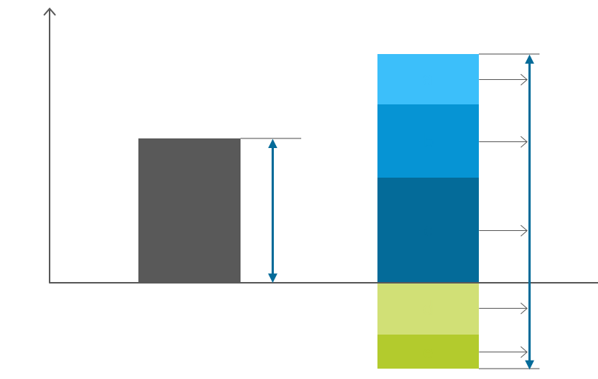
Figure 8: Definition of C_{as}
c
b
a
e
d
CFP
C_{as}
C_{total}
e
d
c
b
a
Result
Contribution

In case there are no negative CFP contributions, C_{total} is equal C_{as}. Having introduced C_{as} the primary data share of each process/company on the output side is defined by:
PDSCFPiPDS=iPart of Cibased on primary dataPart of CFP based on primary data Cas,i (10)
The aggregated primary data share on the output side for multiple CFP contributions reported with individual PDS (i.e. PDS_{i}) from the input side or own operations
PDS=PDSaggregated=iCtotal,iCas,i⋅PDSiiCas,i (11)
As an example, three suppliers, Company A, Company B and Company C, provide parts to Company D. Each part has a different primary data share and contribution to the total CFP value of the product of Company D (Figure 9). According to formula above, the primary data share of Company D’s part is calculated from the primary data share and contributions to the absolute value total CFP (Table 3).

Figure 9
Cascading PDS
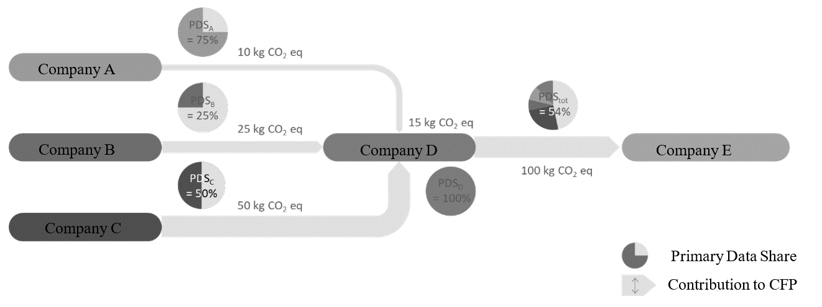

Table 3
Primary data share of the example as in Figure 9
 | PDS_{i} | C_{total},_{i} | PDS Contribution
Company A | 75% | 10 $kg CO_{2} eq$ | 75% * 10 $kg CO_{2} eq$ = 7.5 $kg CO_{2} eq$
Company B | 25% | 25 $kg CO_{2} eq$ | 25% * 25 $kg CO_{2} eq$ = 6.3 $kg CO_{2} eq$
Company C | 50% | 50 $kg CO_{2} eq$ | 50% * 50 $kg CO_{2} eq$ = 25 $kg CO_{2} eq$
Company D | 100% | 15 $kg CO_{2} eq$ | 100% * 15 $kg CO_{2} eq$ = 15 $kg CO_{2} eq$
Total | 54% | 100 $kg CO_{2} eq$ | 54 kg CO2 eq, (7.5 + 6.3 + 25 + 15)$kg CO_{2} eq$

The primary data share is not directly linked to the accuracy of the total CFP. In addition, while LCA analysis by obtaining primary data is beneficial, it should be known that obtaining primary data itself does not necessarily lead to carbon neutrality, and neither does a high Primary Data Share. However, a contracting party may review this indicator, for example, to assess data sources.
Note: When a product with a high PDS in the supply chain (e.g., the product of Company A in Figure 9) is decarbonised through carbon reduction measures, the PDS of the final product (e.g., the product of Company D in Figure 9) may rather decrease as a result of the lowered total CFP. Therefore, while the PDS can be an indicator of the primary data usage, it shall be considered only in conjunction with the total CFP value.

EC Comments on 10/24/2025

The proposed 50% calculation rule refers to cases where GHG emission factors are based on secondary data. We have discussed this, and our understanding is that emission factors are rarely directly measured (there may be exceptional cases on the materials side, but this is not a common practice). In most cases, and certainly for electricity, emission factors are modelled and calculated by official entities or government organisations, rather than by vehicle manufacturers or suppliers themselves. Would this be your understanding as well?

We would also like to better understand the need to encourage reporting parties to develop primary emission factors. Is this considered feasible, and is it within their remit to do so? Based on previous discussions in the IWG, the main challenge for reporting parties is collecting and developing primary activity data (e.g. kg of material, kWh of energy), which already requires significant efforts.

Having said that, as indicated before, the existing frameworks such as PEF and EPD, allow the combination of primary activity data with related emission factors (i.e. intensity data from secondary data sources) and still consider these as primary data. Moreover, the Guideline already includes provisions to ensure that secondary data meet quality requirements, such as technological, geographical, and temporal representativeness.

We also looked into ISO 14064 (ISO 14064-1 Greenhouse gases – Part 1: Specification with guidance at the organization level for quantification and reporting of greenhouse gas emissions and removals), which considers a GHG emission factor as a ‘coefficient relating GHG activity data to the GHG emissions’. This means that the GHG emission factor is a coefficient used to convert a certain activity (e.g. production of x kg of steel) into a corresponding quantity of emissions per unit.

In this context our proposed approach (which de facto account the emission factors as contributing 100% to the calculation of the primary data) has the advantage that it allows to have a clear calculation of the share of the activity data (e.g., amount in kWh) that is primary data, which is important to reflect reporting parties’ efforts to improve the quality of activity data. This would not be possible using a coefficient of 50% or 0% as discussed in the draft proposal, which would make the primary data share as calculated very difficult to interpret.

Finally, please note also that the current definition in the draft Informal Document of 251015 recognises that emission factors can fall into the scope of primary data, as it states in the point 3.20.1: ‘Primary data can include greenhouse gas emission factors and/or greenhouse gas activity data.’ In this sense, the proposed 50% or 0% contribution from emission factors seems confusing and possibly at odds with this current definition. The definition should in any event be clarified.

* In accordance with the programme of work of the Inland Transport Committee for 2025 as outlined in proposed programme budget for 2025 (A/79/6 (Sect. 20), table 20.6), the World Forum will develop, harmonize and update UN Regulations in order to enhance the performance of vehicles. The present document is submitted in conformity with that mandate.

