Proposal

2. Definitions
…
2.xx. "Time-to-Collision (TTC) trigger” means longitudinal and lateral calculation of the Time-to-Collision (TTC), which is the relative Euclidean distance divided by the relative Euclidean velocity between the vehicle and the safety relevant object, calculated based on the fused sensor data. TTC is calculated in cases the current trajectories of the ADS and the object along their current routes are crossing.

(…)

3. Data Storage and Security
(…)

3.1.1. However, as regards times series data recorded following the trigger referred to in point 6.3.2. (c), the data storage system shall be sufficient to store the data corresponding to 5 occurrences. The recorded data shall be overwritten by the current occurrence data, on a first-in first-out basis.

(…)

6. Data Elements

6.3.2. The data elements shall be recorded [in compliance with paragraph 6.3.1] if the following thresholds are reached or conditions occur:

a) Detected collision
b) EDR trigger input (excluding last stop trigger)
(c) TTC trigger threshold of 0.2s, where the speed of the vehicle is 10kph or more.
.

Justification

The proposal introduces limitation to cases where the predicted velocity vectors of the ADS and the object along their current routes are crossing. This proposal takes into account the concerns of the industry related to the risk of high number of false positives.

The proposal includes all additional conditions proposed by the Commission at the DSSAD session in Paris. The text of paragraph 6.3.2. is in square brackets, as the final structure of this paragraph has not been decided, the text between square brackets should refer to the table listing the data elements together with the prescribed format.

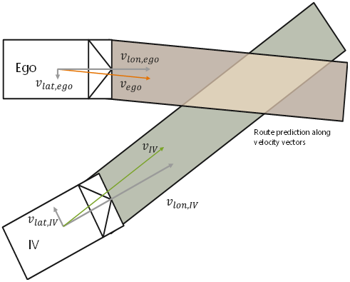

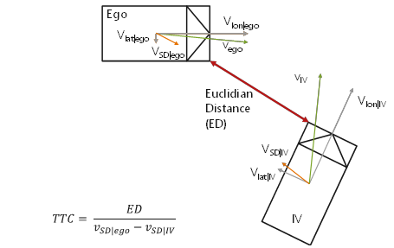

TTC Threshold reasoning

Reaction time of humans is in average 1.0 sec.
TTC < 1.0 is critical
TT0=0 is collision

Threshold between 0 and 1 sec.
In order to keep false positive rate as low as possible and still capture most critical near miss scenarios a TTC=0.2 sec is selected.

