ORG | Paragraph # | Type of comment¹ | Original text (Consolidated version prepared by OICA) | Proposed change | Comments / Justification
France | Contents | Ge/Ed | 6 Provisions for a label for liquefied hydrogen vehicles of categories M2/M3 and N2 /N3……..43 | 6 Provisions for a label for liquefied hydrogen vehicles of categories M2/M3 and N2 /N3……..43  7 Periodic technical inspections | As the scope of this regulation is limited to M2/M3 and N2/N3 vehicles, there is no need to mention those categories here.  Completed in v15- Add a line to the Annexes section of (table of ) Contents related to Periodic technical inspection
TMC | 0.1 | Ge |  | 0.1.1. This is a transposition of paragraph 7. of GTR 13, which has been adopted as optional for the Contracting Parties, into a UN Regulation. Due to the introduction of hydrogen propelled vehicles in UN-R 105 on the construction of vehicles for the transport of dangerous goods, establishment of a UN Regulation incorporating appropriate administrative provision for type approval has been desired.  0.1.2. It was not intended to introduce new technical requirements deviated from those established in GTR 13, except for adjustment of deficiencies or clarifications considered as indispensable for facilitating the type approval of the related products.  0.1.3. It was decided to develop a new UN Regulation for vehicles and systems fuelled with liquefied hydrogen rather than incorporating them into UN Regulation No. 134, to allow the Contracting Parties applying UN Regulation No. 134 not to apply the new UN Regulation until such Contracting Parties will complete necessary examinations to introduce new technology into their respective national regulatory framework  0.1.4. The test procedures for the verification of post-crash hydrogen leakage and concentration given in GTR 13 were deemed premature and not ready to use for type approval regulation.  0.1.5. On the other hand, current focus of the application of liquefied hydrogen is given to heavy duty vehicles (i.e. categories M₂, M₃, N₂ & N₃) to which vehicle crash tests are not applied in the most of Contracting Parties. Therefore, the scope of this Regulation is limited to heavy duty vehicles and the post-crash requirements are not adopted in this Regulation.  0.1.6. Hydrogen storage technology is still evolving. Cryo-compressed hydrogen storage is one of such new technologies that stores hydrogen at very low temperature and relatively high pressure. Since paragraph 7. of GTR 13 was developed without taking any account for such a technology, this UN Regulation does not apply to cryo-compressed hydrogen storage. The definition of liquefied hydrogen is considered to determine the boundary of liquefied hydrogen and cryo-compressed hydrogen.  0.1.6 This Regulation does not apply to cryo-compressed or compressed hydrogen systems.  0.1.7. It is expected that the next phase of GTR 13 will address the missing items such as post-crash requirements of vehicles with a liquefied hydrogen storage system, cryo-compresses hydrogen storage system, etc. and will accommodate the updated technical requirements being developed at ISO/TC 197. | TMC:  Introduction to be prepared  DT:  I don‘t think this is useful. Liquid hydrogen automatically excludes ccH2. Otherwise we would also have to add such a note in UN R134 as in many aspects ccH2 is closer to CGH2 than to LH2 being compressed gaseous hydrogen at very low temperatures  12.08.2025 Group:  If really needed reduce the text to just exclude cCH2  Completed in v15 –  Includes proposal and provision to use both liquified and liquid hydrogen  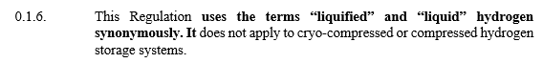
TMNA | 0.1.7. | Ge/Ed | 0.1.7. It is expected that the next phase of GTR 13 will address the missing items such as post-crash requirements of vehicles with a liquefied hydrogen storage system, cryo-compresses hydrogen storage system, etc. and will accommodate the updated technical requirements being developed at ISO/TC 197. | 0.1.7. It is expected that the next phase of GTR 13 will address the missing items such as post-crash requirements of hydrogen fuelled vehicles. liquefied hydrogen storage system, cryo-compressed hydrogen storage system, etc. and will accommodate the updated technical requirements being developed at ISO/TC 197. | TMNA  Suggest simplified wording and include all fuel types as “hydrogen fuelled.”  Should probably confirm if post-crash requirements are being developed at TC197 before including this in the regulation.  Includes proposal and provision to use both liquified and liquid hydrogen  Completed in v15 –
Pilots / Group | 0 |  | Include introduction on sLH2 |  | DT/Group:  Reject - No, from a storage homologation perspective, sLH2 is not relevant. sLH2 describes the fuelling process
TMC | 2.1 | Ge | 2.1. "Boil-off system" means a system that... |  | TMC:  Definition of “boil-off system” will be necessary but should be technology neutral.  Forvia:  Agree definitions are needed here. However, the generic term „system“ is not precise enough in this context regarding the included functions: does a Boil-off system only control the inner container pressure or is a conversion also included? I would propose to split the definition and harmonize to ISO:  boil-off valve: valve that vents the excess hydrogen gas pressure (boil-off gas) at a setting below the container’s first pressure relief valve setting  boil-off converter: system that converts boil-off hydrogen to water and heat to prevent hydrogen discharge and associated risks of generating flammable atmospheres around the vehicle  12.08.2025 Group:  Agree that more precise definitions are needed. Added 2.1 Boil-off converter and 2.2 Boil-off valve  Completed in v15 – 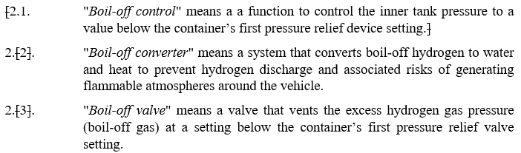
METI/ KHK | 2.6. | ge | "Container" (for hydrogen storage) means the component within the hydrogen storage system that stores the primary volume of hydrogen fuel. | "Container" (for hydrogen storage) means the component within the hydrogen storage system, consisting of an inner container and a vacuum jacket that stores the primary volume of hydrogen fuel. | In Figure 1, the term “Vacuum Jacket” appears.  However, no definition of Vacuum Jacket is provided in the Definitions section.  It is necessary to add a definition of Vacuum Jacket, either under the Liquefied Hydrogen Storage System (LHSS) or the Container.  Accordingly, the definition of Container has been revised to cover both the inner container and the Vacuum Jacket.  Forvia: OKAY.  6 Oct Group Mtg – Check “Container” à “Container assembly” in the document to see if appropriate.  Completed in v15 – No use of “container assembly” in v15. Will not change unless TF deems necessary.
TMC | 2.7 | Ge | “Date of manufacture” (of a liquefied hydrogen container) means the date (month and year) of the final inspection test carried out during manufacture. | “Date of manufacture” (of a liquefied hydrogen container) means the date (month and year) of the final inspection test carried out during manufacture. | TMC:  In GTR13 Phase 2, it is allowed to use final inspection date as the date of manufacturer.  For LHSS, proof pressure test is conducted during the manufacturing process but not on completed product.  12.08.2025 Group:  Agree with TMC, accept proposed change.  Completed in v15 –
Forvia | 2.14. | Ge | 2.14. “Liquefied hydrogen” means … look at ISO definition  ISO 14687:2019(en) Hydrogen fuel quality — Product specification  3.15  liquid hydrogen – hydrogen that has been liquefied, i.e. brought to a liquid state. |  | Forvia:  Equivalent to ISO. Propose to keep it as adding more would rather confuse and probably trigger more discussions.  For sLH2 maybe we can simply add a note that subcooled is considered to be included in LH2.  DT:  Supporting proposal from Richard. No reference to sLH2 needed. sLH2 tanks have been homologated according to the text of this document without deviation. The tanks themselves are not different  12.08.2025 Group: Reject  Can we use the word liquefied to define liquid H2 or do we need to specify temperature?  No definition of compressed H2 in R 134, so no definition for liquid needed.  Therefore, delete proposal.
TMC | 2.14 | Ge | "Liquefied Hydrogen Storage System (LHSS)” means liquefied hydrogen storage container(s), PRDs, shut-off device, a boil-off system and the interconnection piping (if any) and fittings between the above components | "Liquefied Hydrogen Storage System (LHSS)” means liquefied hydrogen storage container(s), PRDs, shut-off device, a boil-off system and the interconnection piping (if any) and fittings between the above components. | TMC:  The treatment system for boil-boil off hydrogen should not be a part of LHSS since it is outside of the boundary (para.5).  Forvia:  I would make this „boil-off valve“  DT:  Ok, except if we consider it convered by the PRDs  12.08.2025 Group:  Modify definition “boil-off system” to “boil-off valve”  Completed in v15 –  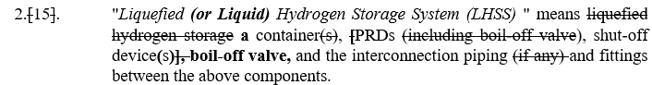
METI/ KHK | 2.15. | ge | "Liquefied Hydrogen Storage System (LHSS) " means liquefied hydrogen storage container(s), [PRDs (including boil-off valve), shut-off device] and the interconnection piping (if any) and fittings between the above components. | "Liquefied Hydrogen Storage System (LHSS) " means liquefied hydrogen storagea container(s), [PRDs (including boil-off valve), shut-off device] and the interconnection piping (if any) and fittings between the above components. | The term Container is already defined in paragraph 2.6., therefore the phrase “liquefied hydrogen storage container” is unnecessary.  In addition, the term “storage container” is used in the following provisions and should be unified as “container”:  - 2.24.  - 5.2.1.  - Annex 3, 1.1.2.  Comment FORVIA: OKAY, but propose to keep BoV separate and not as a type of PRV.  6 Oct Group Mtg – Revised definition  Completed in v15 –
TMC | 2.17 | Ge | "Maximum Fuelling Pressure (MFP)" means the maximum pressure applied to compressed system during fuelling. The maximum fuelling pressure is 125 per cent of the Nominal Working Pressure. | "Maximum Fuelling Pressure (MFP)" means the maximum pressure applied to a LHSS during fuelling defined by the manufacturer.  Add “defined by manufacturer” | 26.08.2025 Group:  Check ISO definition  Agree to use ISO definition  Maximum dispensing system pressure expected during normal (fault-free) vehicle fuelling  Completed in v15 –
TMC | 2.20 | Ge | "Nominal Working Pressure (NWP)" means the gauge pressure that characterizes typical operation of a system. ] | "Nominal Working Pressure (NWP)" means the gauge pressure that characterizes typical operation of a system. ] | TMC:  Different from CHSS.  This pressure will be the pressure downstream of the pressure regulator  DT:  Delete, there is one occurrence remaining that should be turned to MAWP  12.08.2025 Group:  Agree to delete  v15 – is deleted from definitions. However, it is still in Annex 1 – Part 1 – Model 1 and II for shut-off device. Confirm this should be deleted?
METI/ KHK | 2.20. | te | "Pressure Relief Device (PRD)" means a device that, when activated under specified performance conditions, is used to release hydrogen from a pressurized system and thereby prevent failure of the system. It can include first and second pressure relief devices as a reclosing or non-reclosing type (e.g., safety relief valve and burst disc)[ as well as boil off valve]. | "Pressure Relief Device (PRD)" means a device that, when activated under specified performance conditions, is used to release hydrogen from a pressurized system and thereby prevent failure of the system. It can include first and second pressure relief devices as a reclosing or non-reclosing type (e.g., safety relief valve and burst disc)[ as well as boil off valve and vacuum jacket pressure relief devices]. | It is necessary to provide a PRD for the vacuum jacket.  - GTR13 Part I, para. 155 states: “In case of malfunction of the boil-off system, vacuum failure, or external fire, the hydrogen storage container(s) are protected against overpressure by two independent Pressure Relief Devices (PRDs) and the vacuum jacket(s) is protected by a vacuum jacket pressure relief device.”  - This provision assumes, as a worst-case scenario, that the burst of the inner container leads to internal overpressure in the vacuum jacket.  - Therefore, a specific test procedure should be established to demonstrate that the PRD protects the vacuum jacket from burst due to internal overpressure.  In addition, the liquid hydrogen fill line is generally constructed with vacuum insulation. When the vacuum space for the container and that for the piping are separated, a PRD shall be installed for each vacuum space.  Comment FORVIA: Propose to NOT have BOV or vacuum jacket PRV withing this definition. This is mixing things up would require checking the whole document carefully for consistence of the individual requirements.  6 Oct Group Mtg – Revised definition  Completed in v15 –  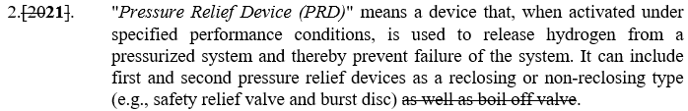
Pilots / Group | 2.19 | Ge | "Pressure Relief Device (PRD)" means a device that, when activated under specified performance conditions, is used to release hydrogen from a pressurized system and thereby prevent failure of the system. | "Pressure Relief Device (PRD)" means a device that, when activated under specified performance conditions, is used to release hydrogen from a pressurized system and thereby prevent failure of the system. It can include first and second pressure relief devices as a reclosing or non-reclosing type (e.g., safety relief valve and burst disc). | 12.08.2025 Group:  First and second PRDs to differentiate between „primary“ and „secondary“ primary closure devices, consistent with ISO 13985. Both the first and second PRDs are considered primary closure devices. Instances of “secondary” will be changed to “second.”  Completed in v15 –
METI/KHK | 2.20. | ge | "Pressure Relief Device (PRD)" means a device that, when activated under specified performance conditions, is used to release hydrogen from a pressurized system and thereby prevent failure of the system. It can include first and second pressure relief devices as a reclosing or non-reclosing type (e.g., safety relief valve and burst disc)[ as well as boil off valve]. | "Pressure Relief Device (PRD)" means a device that, when activated under specified performance conditions, is used to release hydrogen from a pressurized system and thereby prevent failure of the system. It can include a first and second pressure relief devices as a reclosing or non-reclosing type (e.g., safety relief valve and burst disc), and a second pressure relief device as a reclosing or non-reclosing type (e.g., burst disc) [ as well as boil off valve]. | 1st PRD should be limited to a reclosing type in accordance with GTR No.13, Part 1, justification paragraph 169:  “The primary pressure relief device should be a re-closing type relief valve so that hydrogen venting will cease when the effect of a fault subsides.”  Group October 20, 2025:  Ok  Completed in v15 –
Pilots / Group | 2.xx | Ge | Do we need a definition for container attachments? |  | DT:  Would say no container attachment needed for now, postpone to GTR13 Phase 3 if we realize that the same differentiation is needed as for CGH2  12.08.2025 Group:  Reject. Agree with DT no need.
TMC | 2.25 | Te | “Type of hydrogen storage system” …  (cb) the nominal maximum allowable working pressure (NWPMAWP); |  | TMC:  MAWP might be better to specify the LHSS characteristics.  NWP will be the system pressure after pressure regulator that does not belong to LHSS.  DT:  MAWP is fine. NWP is very specific to CHG2 with the reference pressure at 15°C  12.08.2025 Group:  Delete compressed gas. Agree NWP should be MAWP.  Reflected in v15 – only MAWP.
TMC | 2.26 | Te | "Type of specific components of hydrogen storage system" means a component or an assembly of components which do not differ significantly in such essential aspects as:  (a) the manufacturer's trade name or mark;  (b) the sort of component: (T)PRD, check-valve or shut-off device, and  (c) the structure, materials and essential characteristics. | "Type of specific components of hydrogen storage system" means a component or an assembly of components which do not differ significantly in such essential aspects as:  (a) the manufacturer's trade name or mark;  (b) the sort of component: (T)PRD (boil-off valve, safety relief valve or burst disc), check-valve or shut-off valvedevice, and  (c) the structure, materials and essential characteristics. | TMC:  Typically, primary PRD is safety relief valve and secondary PRD is burst disc.  DT:  ISO 13985 is preferring first and second PRD rather than primary and secondary.  Check the whole document if agreed  12.08.2025 Group:  Switch to first and second PRD, consistent with ISO 13985.  Completed in v15 – para 2.29  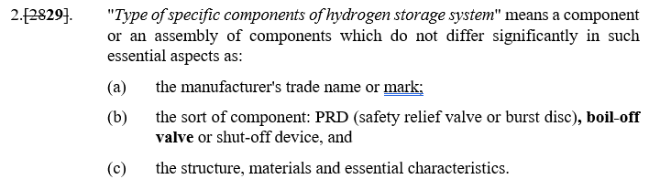
TMC | 4.4.2. | Ge | the number of this Regulation, followed by the letter "R", a dash and the approval number to the right of the circle prescribed in paragraph 4.4.1. | the number of this Regulation, followed by the letter "R", a dash and the approval number six digit number, of which the first two digits indicate the series of amendments to this Regulation to which the approval is granted and the subsequent four digits indicates section 3 of the type approval number granted, to the right of the circle prescribed in paragraph 4.4.1. | TMC:  This is not correct (although this text is standard text for the most of UNR.)  12.08.2025 Group:  Agree  Reflected in v15
TMC | 5. |  | This part specifies the requirements for the liquefied hydrogen storage system.  The boundaries of the LHSS are defined by the interfaces which can isolate the stored liquefied (and/or gaseous) hydrogen from the remainder of the fuel system and the environment. All components located within this boundary are subject to the requirements defined in this paragraph. - Figure 1 shows a typical LHSS. The closure devices shall include the following functions, which may be combined:  - Automatic shut-off device;  - Boil-off system;  (b) Pressure Relief Device (PRD). | This part specifies the requirements for the liquefied hydrogen storage system.  The boundaries of the LHSS are defined by the interfaces which can isolate the stored liquefied (and/or gaseous) hydrogen from the remainder of the fuel system and the environment. All components located within this boundary are subject to the requirements defined in this paragraph. - Figure 1 shows a typical LHSS. The closure devices shall include the following functions, which may be combined:  - Automatic sShut-off device;  - Boil-off system;  (b) Pressure Relief Device (PRD). | TMC:  The valve for boil-off system and pressure relief device for vacuum jacket are considered as “specific component” subject to type approval?  12.08.2025 Group:  Group accepts change to (a). For (b), Group requires more discussion re: boil-off valve function or boil-off control. Should be consistent with the definitions. (c) Agree to change to Pressure Relief function  25.08.2025 Group:  Group accepts change to functions instead of devices. Also add language that the functions are minimally specified.  Completed in v15  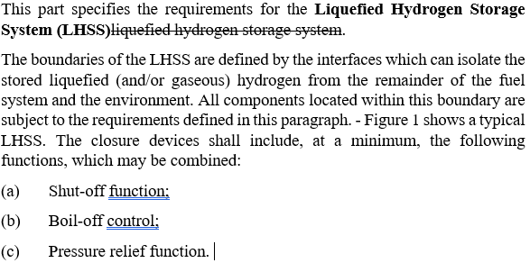
METI/ KHK | 5. | te |  | It is necessary to specify a test for the strength of the vacuum insulated liquid hydrogen fill line. | The liquid hydrogen fill line is generally constructed with vacuum insulation.  Comment FORVIA: Propose to NOT require this. Comparing this to R134 for CGH2 the filling line is also not part of the CHSS and not tested.  6 Oct Group Mtg – Reject. Phase 3 topic
Pilots / Group | 5 Figure 1 |  | 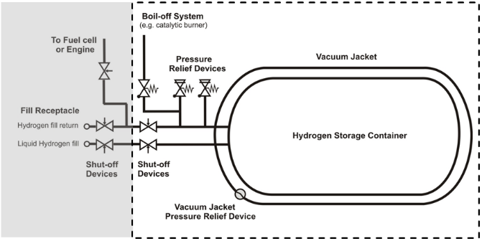 | 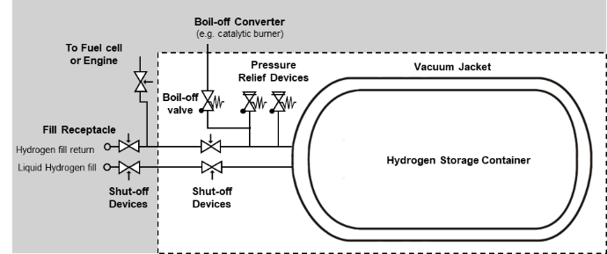 | TMC:  In Figure 1, “Vacuum Jacket Pressure Relief Device” is described. I understand that this device is not a scope of Part II component approval and therefore should not use “Pressure Relief Device” or delete this device from the Figure 1.  12.08.2025 Group:  Add label to boil-off valve  Change boil-off system to boil-off converter  Delete Vacuum Jacket PRD and change drawing  Completed in v15  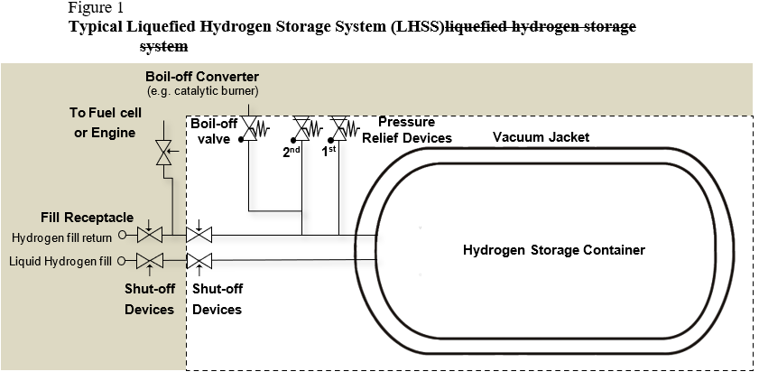
France | 5 Figure 1 | ed |  |  | Could be useful to mention which one is the 1st PRD and which is the 2nd PRD on figure 1  Completed in v15 – see above figure
METI/ KHK | 5 Figure 1 | ge | 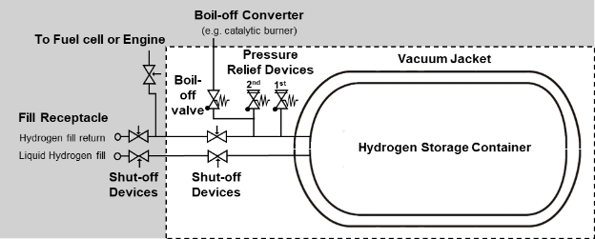 | 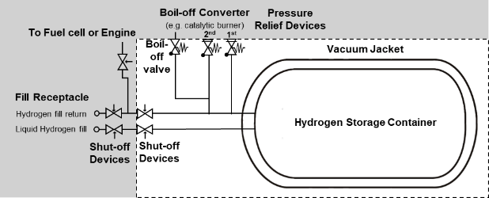 | According to the definition in para. 2.15, the LHSS includes the interconnection piping (if any) and fittings between the above components.  Here, “the above components” refers to the container, PRDs, and the shut-off device.  In this case, piping located outside these components is not included in the LHSS.  Therefore, the scope of the LHSS shown in Figure 1 should exclude such external piping.  Comment FORVIA: OKAY.  6 Oct Group Mtg – Agree.  Completed in v15 – see above figure
TMC | 5 Figure 1 Note | Ge | Note: The boil-off system is not required but can be used for the test in paragraph 5.2.2. | Note: The boil-off system is not a part of LHSS but may be used for the test in paragraph 5.2.2., at the manufacturer’s discretion. | TMC: Further clarification  DT:  Take out of the note if there is a requirement and use boil-off converter  12.08.2025 Group:  Delete note, the text in para 5.2.2. already allows for boil-off system.  Completed in v15 – see above figure
TMC | 5 Table 1 | Ge | Table 1  Overview of performance requirements | Table 1  Overview of performance requirements | Pilots:  Correct once the title has been finalized  Group 26.08.25  Change 5.2.2. to Boil-off discharge rate  Completed in v15 –  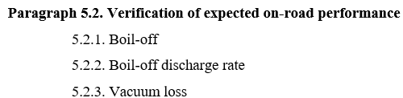
  Paragraph 5.1. Verification of baseline metrics
  5.1.1. Proof pressure
  5.1.2. Baseline initial burst pressure, performed on the inner container
  5.1.3. Baseline Pressure cycle life
  Paragraph 5.2. Verification of expected on-road performance
  5.2.1. Boil-off
  5.2.2. Leak
  5.2.3. Vacuum loss
  Paragraph 5.3. Verification for service-terminating conditions: Bonfire test
  Paragraph 5.2.4. Requirements for pressure relief device and shut-off device
  Paragraph 5.1. Verification of baseline metrics
  5.1.1. Proof pressure
  5.1.2. Baseline initial burst pressure, performed on the inner container
  5.1.3. Baseline Pressure cycle life
  Paragraph 5.2. Verification of expected on-road performance
  5.2.1. Boil-off
  5.2.2. Boil-off hydrogen emissions Leak
  5.2.3. Vacuum loss
  Paragraph 5.3. Verification for service-terminating conditions: Bonfire test
  Paragraph 5.2.4. Requirements for pressure relief device and shut-off device
TMC | 5.1.1 | Ge | A system is pressurized to a pressure p_{test} ≥ 1.3 * (MAWP + 0.1 MPa) in accordance with the test procedure in Annex 3, paragraph 1.1. without visible deformation, degradation of container pressure, or detectable leakage. | The inner container and the pipe work situated between the inner container and the outer jacket A system is pressurized to a pressure p_{test} ≥ 1.3 * (MAWP (in MPa) + 0.1 MPa) in accordance with the test procedure in Annex 3, paragraph 1.1. without visible deformation, degradation of container pressure, or detectable leakage. | TMC:  The test object should be clarified.  12.08.2025 Group:  Agree  Completed in v15 –  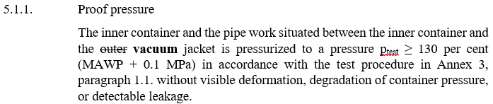
France | 5.1.1 | ed | The inner container and the pipe work situated between the inner container and the outer jacket A system is pressurized to a pressure ptest ≥ 1.3 * (MAWP (in MPa) + 0.1 MPa) in accordance with the test procedure in Annex 3, paragraph 1.1. without visible deformation, degradation of container pressure, or detectable leakage. | The inner container and the pipe work situated between the inner container and the outer jacket A system is pressurized to a pressure ptest ≥ 1.3 * (MAWP (in MPa) + 0.1 MPa) 130 per cent (MAWP + 0,1 MPa) in accordance with the test procedure in Annex 3, paragraph 1.1. without visible deformation, degradation of container pressure, or detectable leakage. | Prefer the following wording : “130 per cent (MAWP + 0,1 MPa)“ which is consistent to the wording used for vacuum loss test (Annex 3 §2.3) and Verification test for service-terminating performance due to fire (Annex 3 § 3.2)  Completed in v15 –
METI/ KHK | 5.1.1. to 5.1.2. | te | 5.1.1. Proof pressure  The inner container and the pipe work situated between the inner container and the outer jacket is pressurized to a pressure ptest ≥ 130 per cent (MAWP + 0.1 MPa) in accordance with the test procedure in Annex 3, paragraph 1.1. without visible deformation, degradation of container pressure, or detectable leakage.  5.1.2. Baseline initial burst pressure  The burst test is performed in accordance with the test procedure in Annex 3, paragraph 1.2. on one sample of the inner container that is not integrated in its outer jacket and not insulated.  The burst pressure shall be at least equal to the burst pressure used for the mechanical calculations. For steel containers that is either:  (a) Maximum Allowable Working Pressure (MAWP) (in MPa) plus 0.1 MPa multiplied by 3.25;  or  (b) Maximum Allowable Working Pressure (MAWP) (in MPa) plus 0.1 MPa multiplied by 1.5 and multiplied by Rm/Rp, where Rm is the minimum ultimate tensile strength of the container material and Rp is the minimum yield strength where Rp1.0 shall be used for austenitic steels and Rp0.2 for other steels. | It is necessary to specify a test for the strength of the vacuum jacket. | It is necessary to specify a test for the strength of the vacuum jacket.  - GTR13 Part I, para. 155 states: “In case of malfunction of the boil-off system, vacuum failure, or external fire, the hydrogen storage container(s) are protected against overpressure by two independent Pressure Relief Devices (PRDs) and the vacuum jacket(s) is protected by a vacuum jacket pressure relief device.”  - This provision assumes, as a worst-case scenario, that the burst of the inner container leads to internal overpressure in the vacuum jacket.  - Therefore, it is necessary to specify a test to verify that the vacuum jacket shall be capable of withstanding the internal pressure occurring in case of vacuum loss until the vacuum jacket PRD is activated.  Comment FORVIA: Propose to NOT require this. Common Vacuum jackets designs have significant thickness to resist to the outer pressure and have a vacuum plug that will pop out in case of positive inner pressure (“natural” PRV function). Therefore, requiring a test does not pose any added safety value, but would only add an unnecessary burden for the industry.  6 Oct TF Mtg – Phase 3
METI/ KHK | 5.1.1. to 5.1.3. | te | 5.1.1. Proof pressure  The inner container and the pipe work situated between the inner container and the outer jacket is pressurized to a pressure ptest ≥ 130 per cent (MAWP + 0.1 MPa) in accordance with the test procedure in Annex 3, paragraph 1.1. without visible deformation, degradation of container pressure, or detectable leakage.  5.1.2. Baseline initial burst pressure  The burst test is performed in accordance with the test procedure in Annex 3, paragraph 1.2. on one sample of the inner container that is not integrated in its outer jacket and not insulated.  ...  5.1.3. Baseline pressure cycle life  When using metallic containers and metallic vacuum jackets, the manufacturer shall either provide a calculation in order to demonstrate that the container is designed according to current regional legislation or accepted standards (e.g. the ASME Boiler and Pressure Vessel Code, EN 1251-1:2000 and EN 1251-2:2000 or other applicable regulations for the design of metallic pressure containers), or define and perform suitable tests (including Annex 3, paragraph 1.3.) that prove the same level of safety compared to a design supported by calculation according to accepted standards.  ... | 5.1.1. Proof pressure  The inner container and the pipe workas well as interconnection piping (if any) and fittings situated between the inner container and the outer jacket is pressurized to a pressure ptest ≥ 130 per cent (MAWP + 0.1 MPa) in accordance with the test procedure in Annex 3, paragraph 1.1. without visible deformation, degradation of container pressure, or detectable leakage.  5.1.2. Baseline initial burst pressure  The burst test is performed in accordance with the test procedure in Annex 3, paragraph 1.2. on one sample of the inner container as well as interconnection piping (if any) and fittings that is not integrated in its outer jacket and not insulated.  ...  5.1.3. Baseline pressure cycle life  When using metallic containers and metallic vacuum jackets as well as interconnection piping (if any) and fittings, the manufacturer shall either provide a calculation in order to demonstrate that the container is designed according to current regional legislation or accepted standards (e.g. the ASME Boiler and Pressure Vessel Code, EN 1251-1:2000 and EN 1251-2:2000 or other applicable regulations for the design of metallic pressure containers), or define and perform suitable tests (including Annex 3, paragraph 1.3.) that prove the same level of safety compared to a design supported by calculation according to accepted standards.  ... | In the definition of LHSS (para. 2.15), the interconnection piping (if any) and fittings between the above components are included. However, no test is specified for the strength of these piping and fittings.  As with the container, these piping and fittings are pressure-bearing parts and include structural discontinuities such as weld joints.  Therefore, it is necessary to specify a test to verify their strength as well as inner container, as shown below.  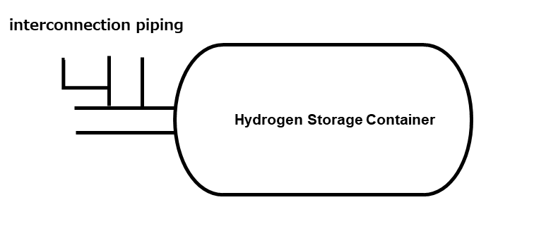  Comment FORVIA: Propose to NOT require this and keep the original text.  - All piping between inner container and vacuum jacket is fine to be tested in the proof pressure test.  - Piping external to the vacuum jacket connecting PRVs, BOVs, shut-offs or CVs, however, are typically assembled after the proof test and after vacuum jacket assembly. Requiring to add this piping in the proof pressure test would be an unnecessary burden involving re-design of existing well proven designs and would also add no safety value, as the piping is for sure included in the final leak test that the industry is generally performing.  6 Oct TF Mtg – Phase 3
METI/ KHK | 5.1.2. | te | Baseline initial burst pressure  The burst test is performed in accordance with the test procedure in Annex 3, paragraph 1.2. on one sample of the inner container that is not integrated in its outer jacket and not insulated.  The burst pressure shall be at least equal to the burst pressure used for the mechanical calculations. For steel containers that is either:  (a) Maximum Allowable Working Pressure (MAWP) (in MPa) plus 0.1 MPa multiplied by 3.25;  or  (b) Maximum Allowable Working Pressure (MAWP) (in MPa) plus 0.1 MPa multiplied by 1.5 and multiplied by Rm/Rp, where Rm is the minimum ultimate tensile strength of the container material and Rp is the minimum yield strength where Rp1.0 shall be used for austenitic steels and Rp0.2 for other steels. | Baseline initial burst pressure  The burst test is performed in accordance with the test procedure in Annex 3, paragraph 1.2. on one sample of the inner container as well as interconnection piping (if any) and fittings that is not integrated in its outer jacket and not insulated.  The burst pressure shall be at least equal to the burst pressure used for the mechanical calculations. For steel containers that is either:  (a) Maximum Allowable Working Pressure (MAWP) (in MPa) plus 0.1 MPa multiplied by 3.25;  or  (b) Maximum Allowable Working Pressure (MAWP) (in MPa) plus 0.1 MPa multiplied by 1.5 and multiplied by Rm/Rp, where Rm is the minimum ultimate tensile strength of the container material and Rp is the minimum yield strength where Rp1.0 shall be used for austenitic steels and Rp0.2 for other metallic materials. | Regarding formula (b) for the baseline initial burst pressure, the following concerns are noted:  1. The provision requires Rp1.0 for austenitic steels. However, in Japan Rp0.2 has consistently been used as the reference value, and the application of Rp1.0, which may correspond to the strain-hardening region, is not common.  2. For EN10088-2 1.4404 (cold rolled strip), the specified mechanical properties are Rm: 530–680 MPa, Rp0.2: 240 MPa, and Rp1.0: 270 MPa. Substituting these values gives:  - Rp0.2: (MAWP + 0.1 MPa) × 3.31  - Rp1.0: (MAWP + 0.1 MPa) × 2.94  In this case, the result using Rp1.0 falls below the value of formula (a) (3.25)  3. The criteria for the burst pressure of the inner container should be defined with a uniform safety factor. Therefore, instead of using formula (b), which varies depending on the material properties, formula (a) should be applied consistently.  In addition, the wording “Rp0.2 for other steels” is understood to cover not only steels but also aluminium alloys and other metallic materials.  Comment FORVIA: General background is that some materials do not have a sharp, distinct yield point so that determining the materials Rp0.2 is not accurate. Using Rp1.0 for these materials instead is significantly more accurate and reproduceable.  In EU standards the use of Rp1.0 is common for stainless steel whereas Rp0,2 is used for ferritic steels e.g., general harmonized PED standard for unfired pressure vessels EN 13445-3. The ISO standard for cryogenic transport vessels ISO 21029-1 is another example using Rp1.0 for austenitic and Rp0.2 for other steels.  For aluminum ISO 21029-1 also uses Rp0.2, so we would tend to agree this would be okay to also consider in the UNR.  6 Oct Group – Agree with Forvia. The burst pressure shall be at least equal to the burst pressure used for the mechanical calculations. For steel inner containers that is either:  (a) Maximum Allowable Working Pressure (MAWP) (in MPa) plus 0.1 MPa multiplied by 3.25;  or  (b) Maximum Allowable Working Pressure (MAWP) (in MPa) plus 0.1 MPa multiplied by 1.5 and multiplied by Rm/Rp, where Rm is the minimum ultimate tensile strength of the container material and Rp is the minimum yield strength where Rp1.0 shall be used for austenitic steels and Rp0.2 for other metals steels.  Completed in v15 –  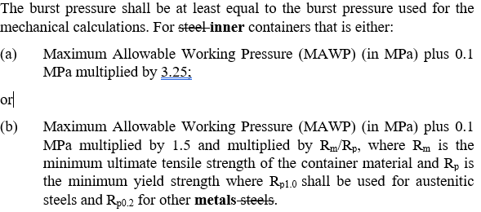
METI/KHK | 5.1.3. | te | Baseline pressure cycle life  The manufacturer shall either provide a calculation in order to demonstrate that the container is designed according to current regional legislation or accepted standards (e.g. the ASME Boiler and Pressure Vessel Code, EN 1251-1:2000 and EN 1251-2:2000 or other applicable regulations for the design of metallic pressure containers), or define and perform suitable tests (including Annex 3, paragraph 1.3.) that prove the same level of safety compared to a design supported by calculation according to accepted standards. | Baseline pressure cycle life  The manufacturer shall either provide a calculation in order to demonstrate that the container is designed according to current regional legislation or accepted standards (e.g. the ASME Boiler and Pressure Vessel Code, EN 1251-1:2000 and EN 1251-2:2000 or other applicable regulations for the design of metallic pressure containers), or define and perform suitable tests (including Annex 3, paragraph 1.3.) that prove the same level of safety compared to a design supported by calculation according to accepted standards.  The pressure cycle test shall be performed in accordance with the test pressure specified in Annex 3, paragraph 1.3., on one sample of the inner container, as well as the interconnection piping (if any) and fittings, that are not integrated in the outer jacket and not insulated. Leakage shall not occur during the pressure cycle test. | It is considered necessary to demonstrate how many cycles can be applied to prove the baseline pressure cycle life by calculation.  However, even EN 1251-1:2000 and EN 1251-2:2000 do not specify a calculation method to prove the pressure cycle life.  Therefore, the method should be unified by conducting a test instead of using a calculation approach.  Group October 20, 2025:  Richard to check -Proposal from Forvia to discuss in Phase 3  Hyundai: discuss in Phase 3 (see presentation), no change to current language  Current v15:  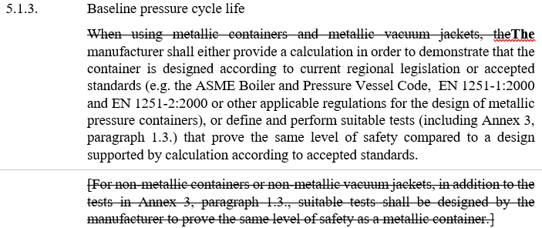
TMC | 5.1.3 | Ge | When using metallic containers and/or metallic vacuum jackets, the manufacturer shall either provide a calculation in order to demonstrate that the container is designed according to current regional legislation or accepted standards (e.g. in US the ASME Boiler and Pressure Vessel Code, in Europe EN 1251-1:2000 and EN 1251-2:2000 and in all other countries an applicable regulation for the design of metallic pressure containers), or define and perform suitable tests (including Annex 3, paragraph 1.3.) that prove the same level of safety compared to a design supported by calculation according to accepted standards.  For non-metallic containers and/or vacuum jackets, in addition to the tests in Annex 3, paragraph 1.3., suitable tests shall be designed by the manufacturer to prove the same level of safety as a metallic container. | When using metallic containers [and/or metallic vacuum jackets], the manufacturer shall either provide a calculation in order to demonstrate that the container is designed according to current regional legislation or accepted standards (e.g. in US the ASME Boiler and Pressure Vessel Code, in Europe EN 1251-1:2000 and EN 1251-2:2000 and in all other countries an applicable regulation for the design of metallic pressure containers), or define and perform suitable tests (including Annex 3, paragraph 1.3.) that prove the same level of safety compared to a design supported by calculation according to accepted standards.  [For non-metallic containers [and/or non-metallic vacuum jackets], in addition to the tests in Annex 3, paragraph 1.3., suitable tests shall be designed by the manufacturer to prove the same level of safety as a metallic container.] | TMC:  Does the material of vacuum jacket critical for cycle life?  “and/or” is not appropriate. “and” will be correct.  DT:  Probably that and is fine. It is indeed not seeing pressure cycles over its life time, but may at least need a design to withstand vacuum  TMC:  What is exactly required?  Is this practicable for type approval?  DT:  The requirement is to use one of this standard to qualify the pressure bearing container as a pressure vessel. Standard pressure vessels  TMC:  Limitation of metallic container to be considered.  12.08.2025 Group:  Keep as it is.  Currently in v15 – Expand to other metals beyond steel, but prohibit non-metallic
METI/ KHK | 5.2.1. | ed | Boil-off  The boil-off test is performed on a liquefied hydrogen storage system equipped with all components as described in paragraph 5. (Figure 1). The test is performed on a system filled with liquid hydrogen in accordance with the test procedure in Annex 3, paragraph 2.1. and shall demonstrate that the boil-off valve limits the pressure in the inner storage container to below the maximum allowable working pressure. | Boil-off  The boil-off test is performed on a liquefied hydrogen storage system equipped with all components as described in paragraph 5. (Figure 1). The test is performed on a system filled with liquid hydrogen in accordance with the test procedure in Annex 3, paragraph 2.1. and shall demonstrate that the boil-off valve limits the pressure in the inner storage container to below the maximum allowable working pressureMAWP. | The term MAWP is already defined in para. 2.18.  6 Oct Group – Agree.  Completed in v15 –  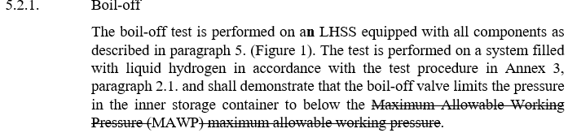
METI/KHK | 5.2.1, etc. | ge | 5.2.1. Boil-off  The boil-off test is performed on a liquefied hydrogen storage system equipped with all components as described in paragraph 5. (Figure 1).  ... | 5.2.1. Boil-off  The boil-off test is performed on a liquefied hydrogen storage systemLHSS equipped with all components as described in paragraph 5. (Figure 1).  ... | The term “Liquefied Hydrogen Storage System (LHSS)” is defined in paragraph 2.15 but is used inconsistently in the text, appearing as “Liquefied Hydrogen Storage System,” “Hydrogen Storage System,” and “LHSS.”  It should be consistently unified as “LHSS.”  Please also refer to the relevant paragraphs below:  2.6.,2.9., 2.23., 2.27., 2.28., 4.6.2., 5.2.2., 5.2.3., 5.3., 7.,7.2.3.3., 7.2.4., 8.1., Annex 1 Part 1 Model 1 to 3 and Annex 3 3.  Group October 20, 2025:  Done  Secretaries to revise in v15 – harmonize all terms to “LHSS”. (5.2.1., not checked for the other relevant paragraphs (2.6, 2.9, etc) as identified above)
TMC | 5.2.2 | Ge | Leak  After the boil-off test in paragraph 2.1. of Annex 3, the LHSS is kept at boil-off pressure and the total discharge rate due to leakage shall be measured in accordance with the test procedure in Annex 3, paragraph 2.2. The maximum allowable discharge from the hydrogen storage system is R*150 Nml/min where  R = (V_{width}+1)*(V_{height}+0.5)*(V_{length}+1)/30.4 and  V_{width}, V_{height}, V_{length} are the vehicle width, height, length (m), respectively. | Boil-off hydrogen emissions  After the boil-off test in paragraph 2.1. of Annex 3, the LHSS is kept at boil-off pressure and the total discharge rate due to leakage boil-off shall be measured in accordance with the test procedure in Annex 3, paragraph 2.2. The boil-off system recommended by the LHSS manufacturer may be installed for this test if requested by the manufacturer.  The maximum allowable discharge from the hydrogen storage system is R*150 Nml/min where  R = (V_{width}+1)*(V_{height}+0.5)*(V_{length}+1)/30.4 and  V_{width}, V_{height}, V_{length} are the vehicle width, height, length (m), respectively.  In case that the vehicle dimensions are not determined, the LHSS manufacturer shall specify the minimum values of V_{width}, V_{height} and V_{length},  The LHSS manufacturer shall provide the instruction to vehicle manufacturers for the installation of the LHSS that contains:  (a) Necessary specifications of the boil-off system; and  (b) Minimum dimensions of the vehicle.  New proposal by Forvia & DT (14.08.2025)  5.2.2 Boil-off discharge rate  After the boil-off test in paragraph 2.1. of Annex 3, the LHSS is kept at boil-off pressure and the total discharge rate due to boil-off shall be measured in accordance with the test procedure in Annex 3, paragraph 2.2.  The boil-off system recommended by the LHSS manufacturer may be installed for this test if requested by the manufacturer. The maximum allowable discharge from the hydrogen storage system is R*150 Nml/min where R = (V_{width}+1)*(V_{height}+0.5)*(V_{length}+1)/30.4 and V_{width}, V_{height}, V_{length} are the vehicle width, height, length (m), respectively. | TMC:  For clarity.  Boil-off system will be installed by the vehicle manufacturer, not LHSS manufacturer.  Forvia:  I would propose to keep it open „manufacturer“. A LHSS may be sold together with a suitable boil-off converter OR it could also be attached by the vehicle manufacturer.  DT:  Not sure it is even needed.  I am checking internally but this boil-off rate may be given independently from the boil-off converter, rather reflecting the insulation quality of the storage  TMC:  Need administrative provisions for independent LHSS manufacturer.
Forvia:
I have quite a concern here: Without specifying the maximum number of tanks to be installed in a vehicle this information is incomplete and potentially misleading …
I would propose to rather only include the measured leakage value for the LHSS according to these test conditions in the instructions. It is then up to the vehicle manufacturer to determine if this is sufficient for the vehicle tanking service conditions and the number LHSS to be installed in the vehicle into account, or to possibly apply modifications to vehicle installation to meet the needed overall vehicle leakage limits.

DT:
Good proposal

12.08.2025 Group:
Forvia to propose language for test

30.10.2025 Secretaries: Keep language as is, technical discussion is required in Phase 3

TMC | 5.2.2 | Ge |  |  | TMC:  At the last OICA/CLEPA call, we concluded that the “Leak” test of paragraph 5.2.2. after boil-off test should be the measurement of the amount of hydrogen emitted from boil-off system (after conversion). But the test procedure seems to be not appropriate for such a measurement since external gas source with pressure is used. We have to find out a pragmatic solution for this. Some idea could be:  - Remove this requirement from Part I (LHSS approval) and include somewhat general requirement in Part III (vehicle approval).  - Remove this requirement from Part I (LHSS approval) and include additional test and requirement in Part III (vehicle approval) based on the exhaust system requirements.  We need the inputs from companies experienced in LHSS system/vehicle.  Group 25.08.25  (Square bracket language stays and will be modified later with informal)  5.2.2 Boil-off discharge rate  After the boil-off test in paragraph 2.1. of Annex 3, the LHSS is kept at boil-off pressure and the total discharge rate due to boil-off shall be measured in accordance with the test procedure in Annex 3, paragraph 2.2.  The boil-off system recommended by the LHSS manufacturer may be installed for this test if requested by the manufacturer. [The maximum allowable discharge from the hydrogen storage system is R*150 Nml/min where R = (V_{width}+1)*(V_{height}+0.5)*(V_{length}+1)/30.4 and V_{width}, V_{height}, V_{length} are the vehicle width, height, length (m), respectively.]  Completed in v15 – Square brackets are removed.  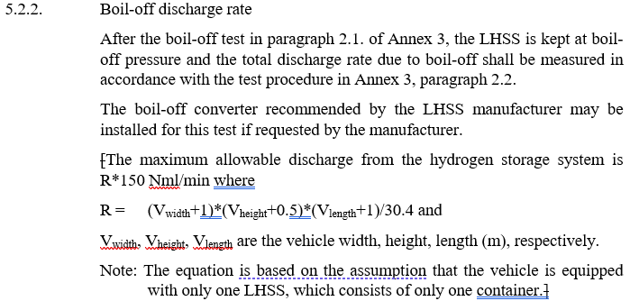
France | 7.1.1.3 | Ge | The fuelling receptacle shall not be mounted within the external energy absorbing elements of the vehicle (e.g. bumper) and shall not be installed in such a way that access for refilling shall not be required in the passenger compartment, luggage compartment, or in any other unventilated compartment. in the passenger compartment, luggage compartment and other places where hydrogen gas could accumulate and where ventilation is not sufficient. Test procedure is by visual inspection. |  | Before modification, this paragraph prohibited the installation of the fuelling receptacle in the passenger compartment. After modification, the access for refilling shall not be required in the passenger compartment but nothing forbid the installation of the fuelling receptacle in the passenger compartment anymore.  Need further explanations.  Change was rejected.
TMC | 7.1.1.4 |  | If appropriate, the geometry of the fuelling receptacle of liquefied hydrogen gas vehicles may be at the manufacturer’s discretion and in agreement with the technical service in absence of a standard. |  | TMC:  Not enforceable  Forvia:  Would propose to delete for now and add with reference to the standard when published in later amendment.  DT:  Remove and introduce later amendment when ISO 25578 published 01/2028  25.08.26 Group: Agree to delete current text, add reference to ISO 25578 in introduction  Completed in v15 – Paragraph 7.1.1.4. is deleted
TMC | New para. 7.1.2 | Ed |  | 7.1.2. LHSS installation  LHSS shall be installed in accordance with the instruction provided by the LHSS manufacturer. | TMC:  Need this kind of provision to ensure proper installation of LHSS.  Forvia:  I have quite a concern here: Without specifying the maximum number of tanks to be installed in a vehicle this information is incomplete and potentially misleading …  I would propose to rather only include the measured leakage value for the LHSS according to these test conditions in the instructions. It is then up to the vehicle manufacturer to determine if this is sufficient for the vehicle tanking service conditions and the number LHSS to be installed in the vehicle into account, or to possibly apply modifications to vehicle installation to meet the needed overall vehicle leakage limits.  DT:  Do we have the same wording in UNR134, if not we should be more specific here  26.08.25 Group: Agree to below language  7.1.2. LHSS installation  The LHSS shall be installed in accordance with the instructions provided by the manufacturer of the LHSS, and in conformity with the description provided in Annex 1, Part 2 to this Regulation  Completed in v15 –  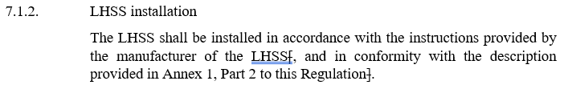
TMC | 7.2.2.1 | Te | Pressure relief systems  The hydrogen gas discharge from pressure relief devices shall not be directed:  (a) towards exposed electrical terminals, exposed electrical switches or other ignition sources;  (b) into or towards the vehicle passenger or luggage compartments;  (c) into or towards any vehicle wheel housing; and  (d) towards hydrogen storage containers. |  | TMC:  In GTR13 Amendment 1, the relevant paragraph only applies to TPRD.  The relevant provision of GTR13 phase 1is introduced.  25.08.25 Group: Adopt GTR13 phase 2 language  Pressure relief systems  The hydrogen gas discharge from pressure relief systems shall be directed such that the hydrogen exhaust does not impinge upon:  (i) enclosed or semi-enclosed spaces;  (ii) any vehicle wheel housing;  (iii) hydrogen gas containers;  (iv) the vehicle’s REESS  Completed in v15 –  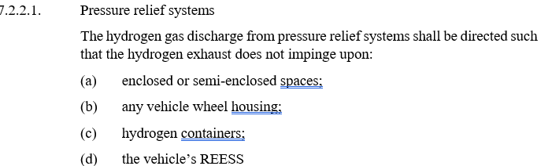
TMC | 7.2.3.1 |  | Hydrogen gas discharge, leakage and/or permeation from the vehicle fuel system shall not directly vent into the passenger compartment, luggage compartment, or to any enclosed or semi-enclosed spaces within the vehicle that contains unprotected ignition sources. |  | TMC:  Cargo compartment is not defined, but the enclosed cargo space for vans and trucks are considered as enclosed or semi-enclosed space.  Group 25.08.25 – Aligns with GTR13 Phase 2  No change in v15  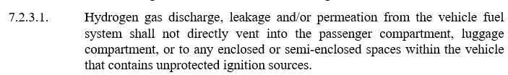
TMC | 7.3 | Ed | Container retention  LHSS shall be subject to the relevant accelerations in compliance with the acceleration corridors which are specified in Tables 2 to 3 in both positive and negative directions.  The storage container(s) shall remain attached to the vehicle at a minimum of one attachment point.  … | Container LHSS retention  LHSS shall be subject to the relevant accelerations in compliance with the acceleration corridors which are specified in Tables 2 to 3 in both positive and negative directions.  The storage container(s)LHSS shall remain attached to the vehicle at a minimum of one attachment point.  … | TMC:  Container --> LHSS.  Fixture will be applied to vacuum jacket (not the inner container).  Completed in v15 –  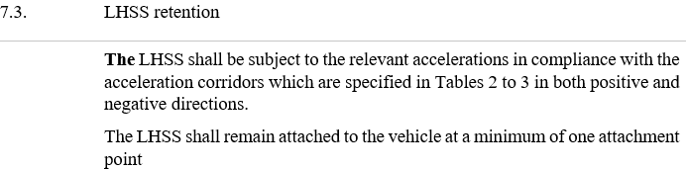
METI/ KHK | 9.4. | te | Every inner container and the pipe work situated between the inner container and the outer jacket shall be pressure tested according to Annex 3 paragraph 1.1. | Every inner container and the pipe work situated between the inner container and the outer jacket as well as interconnection piping (if any) and fittings shall be pressure tested according to Annex 3 paragraph 1.1. | As with the container, these piping and fittings are pressure-bearing parts and include structural discontinuities such as weld joints. Therefore, it is necessary to conduct a test on the finished product, as shown below.  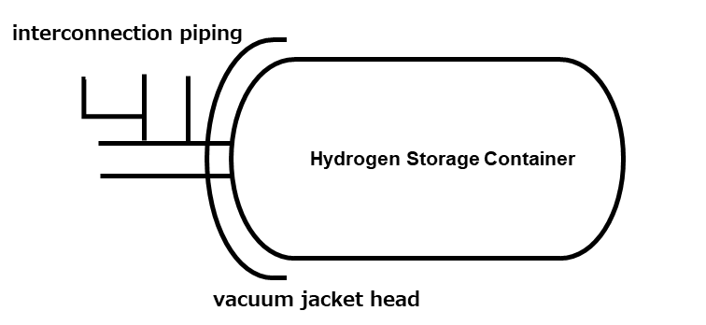  Comment FORVIA: Propose to NOT require this and keep the original text: See our comment on 5.1.1. to 5.1.3. above.  6 Oct Group – Agree with Forvia/HMC. Keep text as is, keeping consistency with 5.1.1. Can discuss other piping as part of Phase 3.
TMC | Annex 1 – Part 1  Model – I  0. | Ge | 0. General |  | TMC:  Minimum dimensions of vehicle may need to be specified for compliance with 5.2.2.  Forvia:  I have a concern here. If anything I would propose adding the leakage measured during testing.  Rejected. See comment for 5.2.2.
Forvia | Annex 1 – Part 1  Model – I  0. | Ge | 3.9.2.4. Nominal working pressure(s):  …  3.9.4.8. Nominal working pressure(s): |  | Forvia:  Propose to change to MAWP.  DT:  Remove NWP, MAWP is already included  12.08.2025 Group:  Delete compressed gas. Agree NWP should be MAWP.  Completed in v15 –
Forvia | Annex 1 – Part 1  Model – II | Ge | 3.9.2.4. Nominal working pressure(s):  …  3.9.3.8. Nominal working pressure(s): |  | Forvia:  Propose to change to MAWP.  12.08.2025 Group:  Delete compressed gas. Agree NWP should be MAWP.  Completed in v15 –
TMC | Annex 1 – Part 1  Model – III  2. | Ge | 2. MASSES AND DIMENSIONS (in kg and mm) (Refer to drawing where applicable)  2.4. Range of vehicle dimensions (overall)  2.4.1. For chassis without bodywork  2.4.1.1.2. Minimum permissible length:  2.4.1.2.2. Minimum permissible width:  2.4.1.3. Height (in running order) (for suspensions adjustable for height, indicate normal running position):  2.4.1.3.1. Maximum permissible height:  2.4.2. For chassis with bodywork  2.4.2.1. Length:  2.4.2.2. Width:  2.4.2.3. Height (in running order) (for suspensions adjustable for height, indicate normal running position): |  | TMC:  Need to check compliance to paragraph 5.2.2.  Completed in v15 –  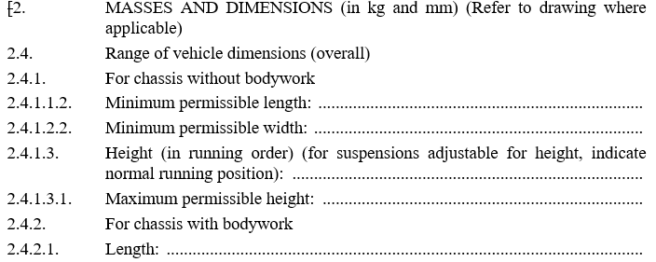  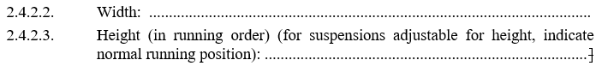  5.2.2. –  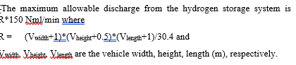
France | Annex 1  Part 2 | ed | 1. Trademark:  2. Type and trade names:  3. Name and address of manufacturer:  4. If applicable, name and address of manufacturer’s representative:  5. Brief description of vehicle/component:2  6. Date of submission of vehicle/component for approval:2  7. Technical Service performing the approval tests:  8. Date of report issued by that Service:  9. Number of report issued by that Service:  10. Approval with regard to the safety-related performance of hydrogen-fuelled vehicles is granted/refused: 2  11. Place:  12. Date:  13. Signature:  14. The information document annexed to this communication:  15. Any remarks: | 1. Trademark:  2. Type and trade names:  3. Name and address of manufacturer:  4. If applicable, name and address of manufacturer’s representative:  5. Brief description of vehicle/component:  6. Installation restrictions applicable to the LHSS as described in paragraph 5.2.2.:  6. 7. Date of submission of vehicle/component for approval:2  7. 8. Technical Service performing the approval tests:  … | In the boil off discharge rate test (§ 5.2.2), the max allowable discharge from the hydrogen storage system depends on the width, height and length of the vehicle in which the LHSS will be installed. Then, not every LHSS will be able to fit into every car. Installation restriction are then needed.  Completed in v15 –  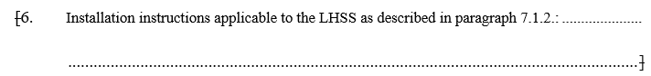
METI/ KHK | Annex 3  1.1. to 1.3. | te | 1. Verification tests for Baseline metrics  1.1. Proof pressure test  The inner container and the pipe work situated between the inner container and the outer jacket shall withstand an inner pressure test at room temperature according to the following requirements.  …  1.2. Baseline initial burst pressure  The test is conducted according to the following procedure:  (a) The test is conducted on the inner container at ambient temperature;  …  1.3. Baseline pressure cycle life  Containers and/or vacuum jackets are pressure cycled with a number of cycles at least three times the number of possible full pressure cycles (from the lowest to highest operating pressure) for an expected on-road performance.  … | 1. Verification tests for Baseline metrics  1.1. Proof pressure test  The inner container and the pipe work situated between the inner container and the outer jacketas well as interconnection piping (if any) and fittings shall withstand an inner pressure test at room temperature according to the following requirements.  ...  1.2. Baseline initial burst pressure  The test is conducted according to the following procedure:  (a) The test is conducted on the inner container as well as interconnection piping (if any) and fittings at ambient temperature;  …  1.3. Baseline pressure cycle life  Containers and/or vacuum jacketsas well as interconnection piping (if any) and fittings are pressure cycled with a number of cycles at least three times the number of possible full pressure cycles (from the lowest to highest operating pressure) for an expected on-road performance.  … | See comments on paras. 5.1.1 to 5.1.3.  Comment FORVIA: Propose to NOT require this and keep the original text: See our comment on 5.1.1. to 5.1.3. above  6 Oct Group – Reject proposed change, keep original text.  Completed in v15 –  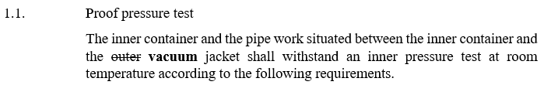  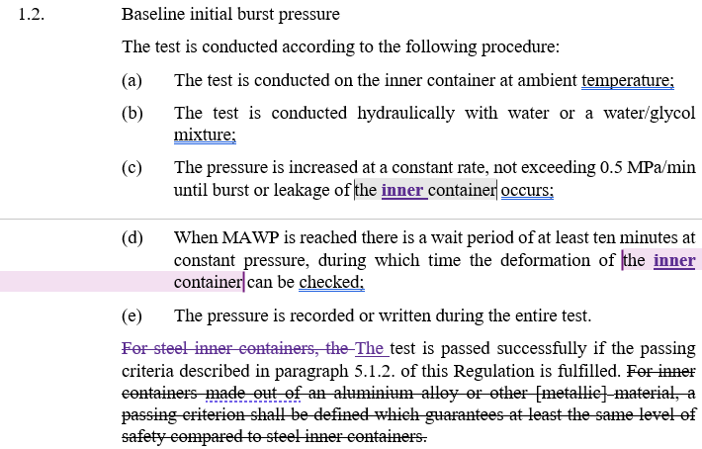  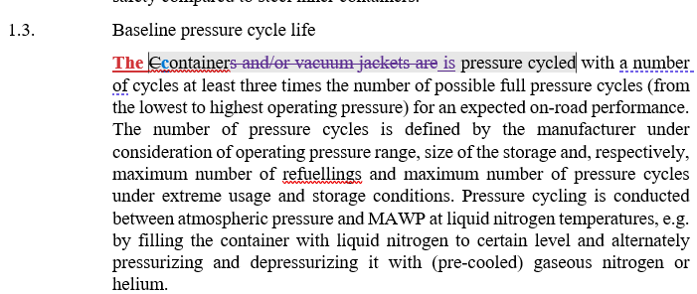
France | Annex 3  1.1.1 | ed | (a) For metallic containers, either ptest is equal to or greater than the maximum pressure of the inner container during fault management (as determined in Annex 3, paragraph 2.3.) or the manufacturer proves by calculation that at the maximum pressure of the inner container during fault management no yield occurs;  [(b) For non-metallic containers, ptest is equal to or greater than the maximum pressure of the inner container during fault management (as determined in Annex 3, paragraph 2.3.).] | (a) For metallic containers, either ptest is equal to or greater than the maximum pressure of the inner container during fault management vacuum loss test (as determined in Annex 3, paragraph 2.3.) or the manufacturer proves by calculation that at the maximum pressure of the inner container during fault management no yield occurs;  [(b) For non-metallic containers, ptest is equal to or greater than the maximum pressure of the inner container during fault management vacuum loss test (as determined in Annex 3, paragraph 2.3.).] | Why don’t we refer to vacuum loss test here instead of fault management ? Seems to be more comprehensible to refer to vaccum loss test directly here.  Completed in v15 –  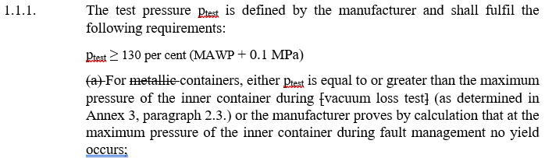
TMC | Annex 3  1.1.1 | Te | [(b) For non-metallic containers, p_{test} is equal to or greater than the maximum pressure of the inner container during fault management (as determined in Annex 3, paragraph 2.3.).] |  | TMC:  Limitation to metallic container to be considered.  Group 25.08.25 – Keep in square brackets.  Different in v15 – It is deleted  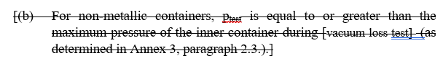
France | Annex 3  1.2 | ed | For steel inner containers, the test is passed successfully if at least one of the two passing criteria described in paragraph 5.1.2. of this Regulation is fulfilled. | For steel inner containers, the test is passed successfully if at least one of the two the passing criteria described in paragraph 5.1.2. of this Regulation is fulfilled. | There is only one passing criteria described in § 5.1.2: burst pressure shall be equal to the burst pressure used for the mechanical calculations. (with 2 methods to determine the burst pressure used for the mechanical calculations for steel containers)
France | Annex 3  1.2 | ed | For inner containers made out of an aluminium alloy or other material, a passing criterion shall be defined which guarantees at least the same level of safety compared to steel inner containers. | For inner containers made out of an aluminium alloy or other metallic material, a passing criterion shall be defined which guarantees at least the same level of safety compared to steel inner containers. | Limitation to metallic container to be considered.  Otherwise, this part should be in SQB if non metallic containers are considered here.
METI/ KHK | Annex 3  1.2. | te | 1.2. Baseline initial burst pressure  The test is conducted according to the following procedure:  (a) The test is conducted on the inner container at ambient temperature;  (b) The test is conducted hydraulically with water or a water/glycol mixture;  (c) The pressure is increased at a constant rate, not exceeding 0.5 MPa/min until burst or leakage of the container occurs;  (d) When MAWP is reached there is a wait period of at least ten minutes at constant pressure, during which time the deformation of the container can be checked;  (e) The pressure is recorded or written during the entire test.  For steel inner containers, the test is passed successfully if the passing criteria described in paragraph 5.1.2. of this Regulation is fulfilled. For inner containers made out of an aluminium alloy or other [metallic] material, a passing criterion shall be defined which guarantees at least the same level of safety compared to steel inner containers. | 1.2. Baseline initial burst pressure  The test is conducted according to the following procedure:  (a) The test is conducted on the inner container at ambient temperature;  (b) The test is conducted hydraulically with water or a water/glycol mixture;  (c) The pressure is increased at a constant rate, not exceeding 0.5 MPa/min until burst or leakage of the container occurs;  (d) When MAWP is reached there is a wait period of at least ten minutes at constant pressure, during which time the deformation of the container can be checked;  (e) The pressure is recorded or written during the entire test.  For steel inner containers, the test is passed successfully if the passing criteria described in paragraph 5.1.2. of this Regulation is fulfilled. For inner containers made out of an aluminium alloy or other [metallic] material, a passing criterion shall be defined which guarantees at least the same level of safety compared to steel inner containers. | The provision “For inner containers made out of an aluminium alloy or other [metallic] material, a passing criterion shall be defined which guarantees at least the same level of safety compared to steel inner containers” was originally intended for non-metallic materials and should therefore be deleted.  For aluminium alloys and other metallic materials, the same acceptance criteria as those for steel inner containers in para. 5.1.2 should apply.  Comment FORVIA: OKAY.  6 Oct Group – Accept proposed change  Included in v15  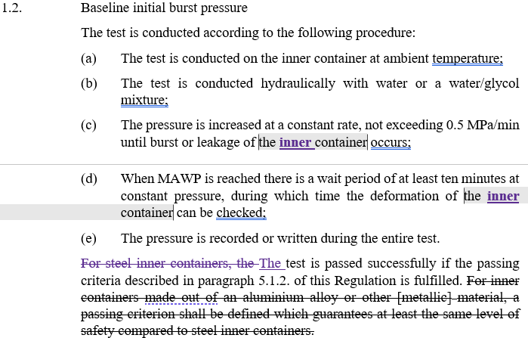
METI/KHK | Annex 3  1.3. | te | 1.3. Baseline pressure cycle life  Containers and/or vacuum jackets are pressure cycled with a number of cycles at least three times the number of possible full pressure cycles (from the lowest to highest operating pressure) for an expected on-road performance. | 1.3. Baseline pressure cycle life  Inner Ccontainers and/or vacuum jackets as well as the interconnection piping (if any) and fittings are pressure cycled with a number of cycles at least three times the number of possible full pressure cycles (from the lowest to highest operating pressure) for an expected on-road performance. | (1) Installation of the vacuum outer jacket is not required for the pressure cycle test.  (2) The test shall also be conducted for the interconnection piping (if any) and fittings.  Group October 20, 2025: Defer to Phase 3
METI/ KHK | Annex 3  2.1.2. | ge | 2.1.2. The pressure of the inner container shall be recorded during the entire test. The test is passed when the following requirements are fulfilled:  (a) The pressure shall stabilize and stay below MAWP during the whole test;  (b) The pressure relief devices are not allowed to open during the whole test. | 2.1.2. The pressure of the inner container shall be recorded during the entire test. The test is passed when the following requirements are fulfilled:  (a) The pressure shall stabilize and stay below MAWP during the whole test;  (b) The pressure relief devices except the boil-off valve are not allowed to open during the whole test. | Since the boil-off valve may actuate during the boil-off test, if the boil-off valve will be included in the definition of PRDs, it is necessary to exclude the acutuation of boil-off valve in this requirement.  23 Sep GRSP TF – Keep text as is  Comment FORVIA: Propose to NOT require this and keep the original text for 2.1.2 and rather change the PRV definition to NOT include BoV as this is clearer, simpler and would avoid other potential inconsistencies in the text where PRVs are meant and should not include the BoV.  6 Oct Group:  Keep original text since definition of PRD excludes BOV.  Unchanged in v15
TMC | Annex 3  2.2 |  | An LHSS shall be free from leakage through stem or body seals or other joints and shall not show evidence of porosity in casting when tested as described in Annex 4, paragraph 3.3. at any gas pressure between zero and its MAWP.  The test shall be performed on the same LHSS at the following conditions:  (a) At ambient temperature;  (b) At the minimum operating temperature or at liquid nitrogen temperature after sufficient conditioning time at this temperature to ensure thermal stability;  (c) At the maximum operating temperature after sufficient conditioning time at this temperature to ensure thermal stability.  During this test, the LHSS under test shall be connected to a source of gas pressure. A positive shut-off device and a pressure gauge having a pressure range of not less than 150 per cent and not more than 200 per cent of the test pressure shall be installed in the pressure supply piping; the accuracy of the gauge shall be 1 per cent of the pressure range. The pressure gauge shall be installed between the positive shut-off device and the sample under test.  Throughout the test, the sample shall be tested for leakage, with a surface-active agent without formation of bubbles or measured with a leakage rate less than 216 Nml/hr.  [The test shall be conducted according to the procedure described in Annex 4, paragraph 2.] |  | TMC:  Paragraph 3.3 applies to shut-off device.  Is this mean PRD and container are not subject to this provision?  Insert the test procedure of Annex 4, paragraph 2 with necessary clarifications, such as the operating temperature.  This test procedure seems to be not appropriate for measuring the boil-off hydrogen emission because external gas source is used.  Need to consider a pragmatic solution.  Forvia:  Agree: the LHSS is filled and conditions with LH2, so there is not need to use test gas.  AND  Additionally conducting this test at ambient external temperatures is sufficient as the closures have already been tested as a component at higher temperatures and any component beging subjected to cold LH2 temperatures in service will be subjected to these temperatures in this system test.  V15 – See Annex 4, para 2.  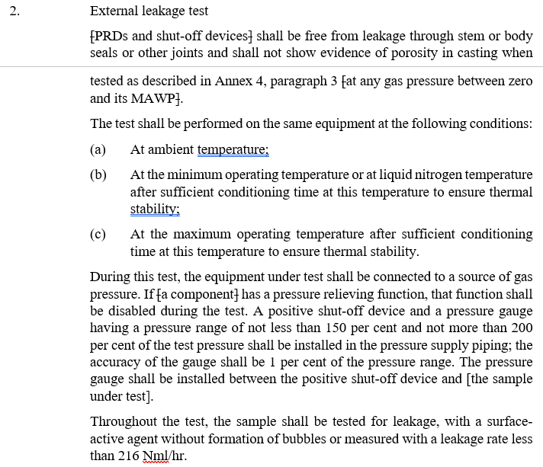
Forvia / DT | Annex 3  2.2 |  | An LHSS shall be free from leakage through stem or body seals or other joints and shall not show evidence of porosity in casting when tested as described in Annex 4, paragraph 3.3. at any gas pressure between zero and its MAWP.  The test shall be performed on the same LHSS at the following conditions:  (a) At ambient temperature;  (b) At the minimum operating temperature or at liquid nitrogen temperature after sufficient conditioning time at this temperature to ensure thermal stability;  (c) At the maximum operating temperature after sufficient conditioning time at this temperature to ensure thermal stability.  During this test, the LHSS under test shall be connected to a source of gas pressure. A positive shut-off device and a pressure gauge having a pressure range of not less than 150 per cent and not more than 200 per cent of the test pressure shall be installed in the pressure supply piping; the accuracy of the gauge shall be 1 per cent of the pressure range. The pressure gauge shall be installed between the positive shut-off device and the sample under test.  Throughout the test, the sample shall be tested for leakage, with a surface-active agent without formation of bubbles or measured with a leakage rate less than 216 Nml/hr. | - Boil-off discharge rate  2.2.1 The boil-off discharge rate test shall be performed directly after the boil-off test in paragraph 2.1 under the same conditions. In case a boil-off converter is used it shall be preconditioned until the nominal operating conditions are reached before conducting the measurement. The inner container pressure is kept at boil-off pressure during the entire test. The hydrogen boil-off discharge rate shall be measured by an appropriate method e.g., suitable hydrogen detector and mass flow meter, at the outlet of the boil-off valve, the boil-off vent line or the boil-off converter (if used) as applicable. The test shall at least last for 1 hour after stabilisation.  2.2.2 The boil-off discharge rate shall be recorded during the entire test. The test maximum boil-off discharge rate measured shall not exceed the value specified in paragraph 5.2.2. | Forvia & DT proposal (14.08.2025)  Group 25.08.25  2.2.1 The boil-off discharge rate test shall be performed directly after the boil-off test in paragraph 2.1 under the same conditions. In case a boil-off converter is used it shall be preconditioned until the nominal operating conditions are reached before conducting the measurement. The inner container pressure is kept at boil-off pressure during the entire test. The hydrogen boil-off discharge rate shall be measured by an appropriate method e.g., suitable hydrogen detector and mass flow meter, at the outlet of the boil-off valve, the boil-off vent line or the boil-off converter (if used) as applicable. The test shall at least last for 1 hour after stabilisation.  2.2.2 The boil-off discharge rate shall be recorded during the entire test.  Included in v15  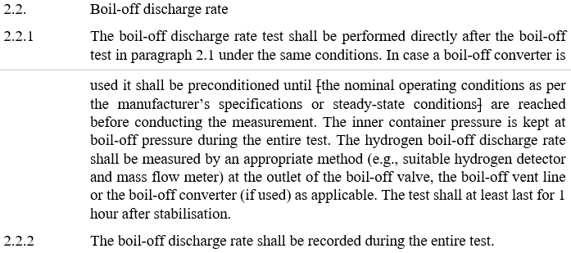
Pilots / Group | Annex 3  2.3.2 | te | The pressure of the inner container and the vacuum jacket is recorded or written during the entire test. The opening pressure of the first safety device is recorded or written. The first part of test is passed if the following requirements are fulfilled:  (a) The first pressure relief device opens ≤ below or at MAWP and limits the pressure to not more than 110 per cent of the MAWP;  (b) The first pressure relief device does not open close at pressure above MAWP ;  (c) The secondary pressure relief device does not open during the entire test. |  | Shall we define the maximum margin below MAWP?  Baptiste Ravinel to check  Forvia:  I would rather oppose to this change and propose to better delete (b):  The initial requirement menas „not open“. However, I would rather see this redundant to (a), so we don‘t need this and deleting would actually rather an editorial change.  I would oppose to change to „not close“ as PRVs in fact are reclosing devices that can practically entere a chattering mode (frequent opening and closing). When such chattering occurs the pressure could likely be above MAWP (and frequently changing -> no guidance on how to measure is included...) and this could be misinterpreted as „closing“.  DT:  B could be removed, it is just stating stronger what is already written in a)  Group 25.08.25  The pressure of the inner container and the vacuum jacket is recorded or written during the entire test. The opening pressure of the first safety device is recorded or written. The first part of test is passed if the following requirements are fulfilled:  (a) The first pressure relief device opens ≤ MAWP and limits the pressure to not more than 110 per cent of the MAWP;  (b) The second pressure relief device does not open during the entire test.  Included in v15  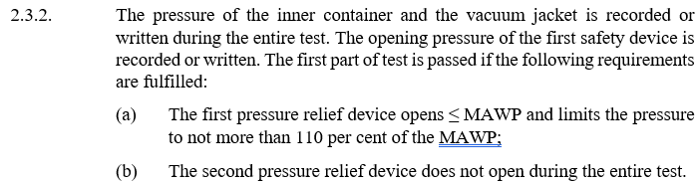
TMC | Annex 3  2.3.3 | Te | (e) The test is terminated when the second pressure relief device does not open any more even if the pressure of the container exceeds the value specified in paragraph 2.3.4. |  | TMC:  Clarify this is fail or void case.  DT:  At this stage it is only the description of the test, there is no pass criteria  Forvia:  Disagree, this would allow the PRV to NOT fulfill it‘s function in this test e.g., being jammed in closed position. =>propose to delete the added text.  Question: is there a concern to confuse a leakage somewhere around the setpoint as opening?  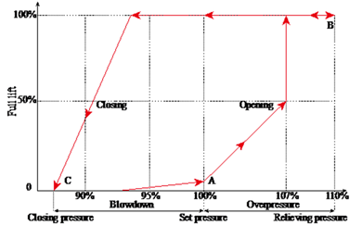  As a terminating condition the PRVs must stay closed, or potentially one could also thing of requiring the pressure to be constant a certain time, but this constant value needs to be below the PRVs setpoint (please note the PRVs usual behavior is to have a re-closing pressure below ist setpoint (hysteresis), see inserted picture...).  Group 25.08.25, delete (e)  2.3.3. After passing the first part, the test shall be repeated subsequently to re-generation of the vacuum and cool-down of the container as described above.  (a) The vacuum is re-generated to a value specified by the manufacturer. The vacuum shall be maintained at least 24 hours. The vacuum pump may stay connected until the time directly before the start of the vacuum loss;  (b) The second part of the vacuum loss test is conducted with a completely cooled-down container (according to the procedure in Annex 3, paragraph 2.1.);  (c) The container is filled to the specified maximum filling level;  (d) The line downstream the first pressure relief device is blocked and the vacuum enclosure is flooded with air at an even rate to atmospheric pressure;  Included in v15  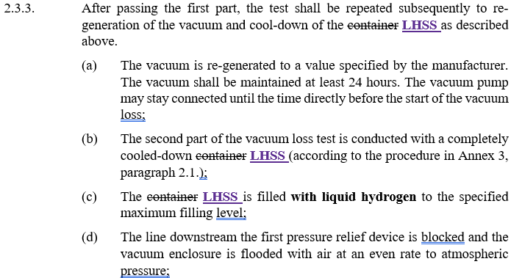
TMC | Annex 3  2.3.4 | Ge | The pressure of the inner container and the vacuum jacket is recorded during the entire test. For steel containers the second part of the test is passed if the secondary pressure relief device does not open below 110 per cent of the set pressure of the first pressure relief device and limits the pressure in the container to a maximum 136 per cent of the MAWP if a safety valve is used, or, 150 per cent of the MAWP if a burst disc is used as the secondary pressure relief device. [For other container materials, an equivalent level of safety shall be demonstrated.] |  | TMC:  Is this requirement specific to material?  Forvia:  I guess the idea may have been that the initial „level of safety“ was considered to be linked to the yield strength of metallic materials and this again being linked to the minimum burst pressure requirements.  I would propose to keep for the time being. However, in case a general limitation to metallic materials is decided, this would in fact be obsolete could be deleted.  26.08.25 – Requires CP input. Discussions for materials are deferred to GTR13 Phase 3. Keep in square brackets but strikethrough.  [For other container materials, an equivalent level of safety shall be demonstrated.]  Included in v15  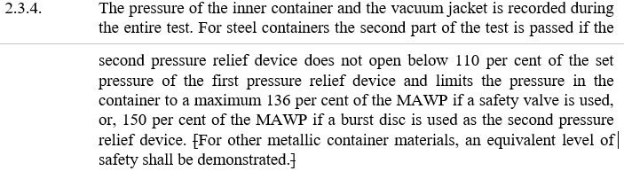
TMC | Annex 3  3.3 | Ge | …  (b) (b) If a burst disc is used outside the vacuum area as secondary pressure relief device, the pressure inside the container is limited to 150 per cent of the MAWP of the inner container;  (c) (c) If a burst disc is used inside the vacuum area as secondary pressure relief device, the pressure inside the container is limited to 150 per cent of the MAWP + 0.1 MPa of the inner container.  … |  | TMC:  Need clarification what is inside/outside.  Forvia:  I guess the point to differentiate here is if the burst disc reliefs into the vacuum space or if it externally reliefs. Would this be clearer?  Change proposal:  „(b) If a burst disc with a relief external to the vacuum space is used outside the vacuum area as secondary pressure relief device, [...]  (c)If a burst disc with a relief internal to the vacuum space is used inside the vacuum area as secondary pressure relief device, [...]”  DT:  The only difference is accounting for the relative prerssure  Group 25.08.25  (b) If (b) If a burst disc with a relief external to the vacuum space is used as second pressure relief device, the pressure inside the container is limited to 150 per cent of the MAWP of the inner container;  (c) (c) If a burst disc with a relief internal to the vacuum space is used as second pressure relief device, the pressure inside the container is limited to 150 per cent of the MAWP + 0.1 MPa of the inner container.  Included in v15 -  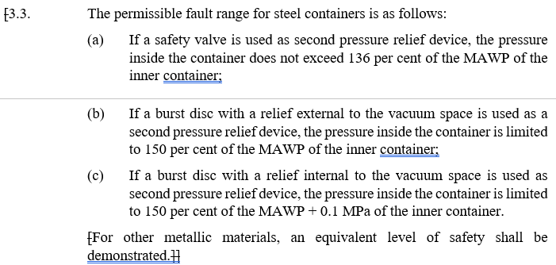
METI/KHK | Annex 4  Table 1 | te | Table 1  Applicability of the test procedures for specific components | Table 1  Applicability of the test procedures for specific components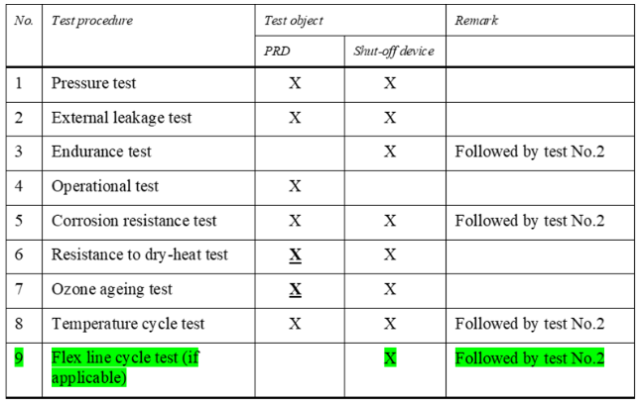 | No.6 Resistance to dry-heat test and No.7 Ozone ageing test are similar to the Atmospheric exposure test in GTR13 / UN R134.  In GTR13 Phase 2 / UN R134 02 series, this test is applied to TPRDs, check valves, and shut-off valves.  Therefore, in this regulation, these tests (No.6 and No.7) should also be applied not only to the shut-off device but also to the PRD.  Group October 20, 2025: Defer to Phase 3
METI/KHK | Annex 4 | ge | Testing shall be performed with hydrogen gas having gas quality compliant with ISO 14687:2025/SAE J2719_202003. All tests shall be performed at ambient temperature 20 (±5) °C unless otherwise specified. | Testing shall be performed with hydrogen gas having gas quality compliant with ISO 14687:2025/SAE J2719_202003 unless otherwise specified. All tests shall be performed at ambient temperature 20 (±5) °C unless otherwise specified. | Some of the test items (e.g., pressure test) in Annex 4 are not appropriate to be conducted with hydrogen gas.  Therefore, for such tests, an alternative test medium should be individually specified in the corresponding test item.  Group October 20, 2025:  Included in v15 – Changed by Secretary on 11/4  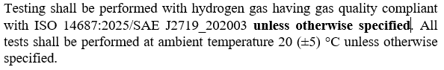
METI/KHK | Annex 4  1. | te | 1. Pressure test  A hydrogen containing component [PRDs and shut-off devices] shall withstand without any visible evidence of leak or deformation a test pressure of 150 per cent MAWP with the outlets of the high-pressure part plugged. The pressure shall subsequently be increased from 150 per cent to 300 per cent MAWP. The component shall not show any visible evidence of rupture or cracks.  The pressure supply system shall be equipped with a positive shut-off valve and a pressure gauge having a pressure range of not less than 150 per cent and no more than 200 per cent of the test pressure; the accuracy of the gauge shall be 1 per cent of the pressure range.  For components requiring a leakage test, this test shall be performed prior to the pressure test [in Annex 4 paragraph 2] | (1) Clarify the number of test samples to be conducted.  In addition, for the statement “For components requiring a leakage test, this test shall be performed prior to the pressure test [in Annex 4 paragraph 2]” clarify whether the pressure test is also conducted on the samples that have already undergone the leakage test.  (2) Clarify the test medium to be used in the test. | (1) In UN R134, as shown in the attached document, the number of test samples and the test procedures (e.g. conducting the external leakage test after the endurance test) are clearly specified.  The same level of clarity should be provided in this regulation as well.  (2) At the beginning of Annex 4, it is stated that hydrogen gas shall be used. However, since this test is conducted up to 300 per cent MAWP, the use of a gas is not appropriate.  Instead, a liquid should be used as the test medium.  Group October 20, 2025: Phase 3
METI/KHK | Annex 4  2. | te | 2. External leakage test  [PRDs and shut-off devices] shall be free from leakage through stem or body seals or other joints and shall not show evidence of porosity in casting when tested as described in Annex 4, paragraph 3 [at any gas pressure between zero and its MAWP].  The test shall be performed on the same equipment at the following conditions:  (a) At ambient temperature;  (b) At the minimum operating temperature or at liquid nitrogen temperature after sufficient conditioning time at this temperature to ensure thermal stability;  (c) At the maximum operating temperature after sufficient conditioning time at this temperature to ensure thermal stability.  During this test, the equipment under test shall be connected to a source of gas pressure. If [a component] has a pressure relieving function, that function shall be disabled during the test. A positive shut-off device and a pressure gauge having a pressure range of not less than 150 per cent and not more than 200 per cent of the test pressure shall be installed in the pressure supply piping; the accuracy of the gauge shall be 1 per cent of the pressure range. The pressure gauge shall be installed between the positive shut-off device and [the sample under test].  Throughout the test, the sample shall be tested for leakage, with a surface-active agent without formation of bubbles or measured with a leakage rate less than 216 Nml/hr. | See comments. | (1) Clarify the number of test samples to be conducted.  In addition, the statement “[PRDs and shut-off devices] shall be [omitted] when tested as described in Annex 4, paragraph 3” is unclear, because the test in paragraph 3 does not apply to PRDs.  It should be clarified whether this test is intended for new components or only for those that have already undergone the test specified in paragraph 3.  (2) The definitions of "minimum operating temperature" and "maximum operating temperature" are not provided and therefore should be clarified.  (3) The test pressure is not specified. It should be defined based on the set pressures of each PRD (e.g. 1st PRD: below MAWP; 2nd PRD: not less than 110% of the 1st PRD set pressure).  In addition, the statement “If [a component] has a pressure relieving function, that function shall be disabled during the test.” should not be required if the test pressure is set below the PRD set pressure.  (4) At the beginning of Annex 4, it is stated that hydrogen gas shall be used as the test medium. However, for tests conducted at the minimum operating temperature or at liquid nitrogen temperature, it is unclear whether hydrogen gas is intended to be used.  (5) If a gas other than hydrogen gas is used as the test medium, the acceptance criterion of a leakage rate below 216 Nml/hr should be converted to the equivalent rate for hydrogen.  Group October 20, 2025: Phase 3
TMC | Annex 4  2. |  | External leakage test  A component shall be free from leakage through stem or body seals or other joints and shall not show evidence of porosity in casting when tested as described in Annex 4, paragraph 3.3. at any gas pressure between zero and its MAWP.  … |  | TMC:  Paragraph 3.3 applies to shut-off device.  Is this mean PRD and container are not subject to this provision?  Forvia:  These tests are for PRDs and shut-off devices, see first para in annex 4. However, seeing this there is an issue with the test pressure for PRVs, that would open at 110%MAWP, see comment below.  MAWP will not work for PRVs. PRVs are usually considered to be leak tight up to 80% of their set-pressure:  Group 25.08.25  A component shall be free from leakage through stem or body seals or other joints and shall not show evidence of porosity in casting when tested as described in Annex 4, paragraph 3 [at any gas pressure between zero and its MAWP.]  During this test, the equipment under test shall be connected to a source of gas pressure. The PRV outlet shall be plugged. A positive shut-off device and a pressure gauge having a pressure range of not less than 150 per cent and not more than 200 per cent of the test pressure shall be installed in the pressure supply piping; the accuracy of the gauge shall be 1 per cent of the pressure range. The pressure gauge shall be installed between the positive shut-off device and the sample under test.  25.08.26 – Post-meeting – Changed for clarity: During this test, the equipment under test shall be connected to a source of gas pressure. If a component has a pressure relieving function, that function shall be disabled during the test. If a component has a pressure relieving function, that function shall be disabled during the test.  *“The PRV outlet shall be plugged“ should also be added to the pressure cycle test. Delete because Endurance Test is a component test only.  Included in v15 –  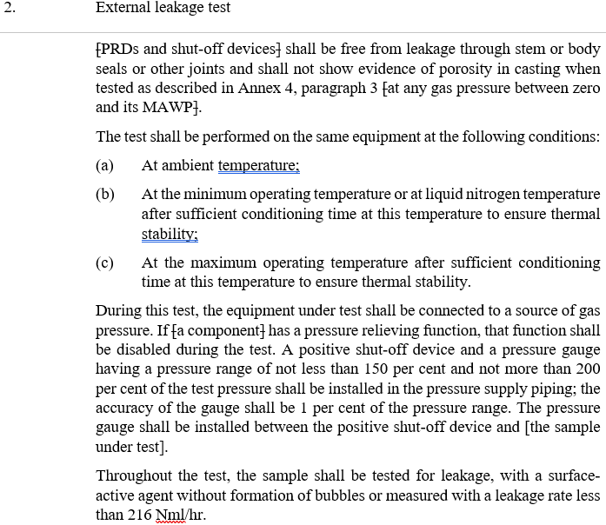  07.11.2025
METI/KHK | Annex 4  3. | te | 3. Endurance test  3.1. [A component] shall be capable of conforming to the leakage test requirements of Annex 4, paragraph 2., after being subjected to 20,000 operation cycles.  3.2. The external leakage test, as described in Annex 4, paragraph 2. shall be carried out immediately following the endurance test.  3.3. [The shut-off device] shall be securely connected to a pressurized source of dry air or nitrogen and subjected to 20,000 operation cycles. A cycle shall consist of one opening and one closing of the component within a period of not less than 10 ± 2 seconds.  3.4. [The component] shall be operated through 96 per cent of the number of specified cycles at ambient temperature and at the MAWP of [the component]. During the off cycle the downstream pressure of the test fixture shall be allowed to decay to 50 per cent of the MAWP of [the component].  3.5. [The component] shall be operated through 2 per cent of the total cycles at the maximum material temperature (-40 °C to +85 °C) after sufficient conditioning time at this temperature to ensure thermal stability and at MAWP. [The component] shall comply with Annex 4, paragraph 2. at the appropriate maximum material temperature (-40 °C to +85 °C) at the completion of the high temperature cycles.  3.6. [The component] shall be operated through 2 per cent of the total cycles at the minimum material temperature (-40 °C to +85 °C) but not less than the temperature of liquid nitrogen after sufficient conditioning time at this temperature to ensure thermal stability and at the MAWP of [the component]. [The component] shall comply with Annex 4, paragraph 2. at the appropriate minimum material temperature (-40 °C to +85 °C) at the completion of the low temperature cycles. | See comments. | (1) Clarify the number of test samples to be conducted.  (2) The definitions of "maximum material temperature (−40 °C to +85 °C)" in paragraph 3.5 and "minimum material temperature (−40 °C to +85 °C)" in paragraph 3.6 are not provided and therefore should be clarified.  (3) According to paragraph 3.1, it is understood that a leakage test in accordance with Annex 4, paragraph 2 shall be conducted after completion of this test (i.e. after all cycles).  On the other hand, paragraph 3.5. requires a leakage test after cycling at the maximum material temperature (2% of total cycles), and paragraph 3.6. also requires a leakage test after cycling at the minimum material temperature (2% of total cycles).  It should be clarified whether the leakage test shall be conducted (i) after the test at the maximum material temperature, (ii) after the test at the minimum material temperature, and (iii) after the entire test in accordance with paragraph 3.1.  Secretary comment 4 Nov: Phase 3
Pilots / Group | Annex 4  3.6 | Ge | The component shall be operated through 2 per cent of the total cycles at the minimum material temperature (-40 °C to +85 °C) but not less than the temperature of liquid nitrogen after sufficient conditioning time at this temperature to ensure thermal stability and at the MAWP of the component. The component shall comply with Annex 4, paragraphs 2. and 9. at the appropriate minimum material temperature (-40 °C to +85 °C) at the completion of the low temperature cycles. |  | Is the temperature range correct?  Group 25.08.25 – Ambient temp ranges are same as GTR13. No change to v15.  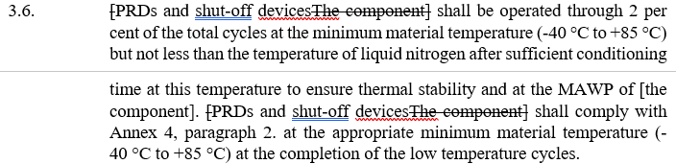
METI/KHK | Annex 4  4. | ge | 4. Operational test  The operational test shall be carried out in accordance with EN 13648-1:2009 or EN 13648-2:2002. The specific requirements of the standard are applicable. | See comments. | In EN 13648-1, operational testing is specified.  On the other hand, EN 13648-2 does not include such a provision.  Therefore, reference to EN 13648-2 is not appropriate.  Group October 20, 2025:  Check referenced standards and look for newer versions, if available or alternatives  5 Nov – Forvia proposal: Disagree & propose to re-discuss in depth in GTR 13 P3. This would be changing the requirement and causing disharmonization to the mandatory part of current GTR 13 P2.  Proposal to differentiate between reclosing and non-reclosing PRD in overview table to specify details for burst discs  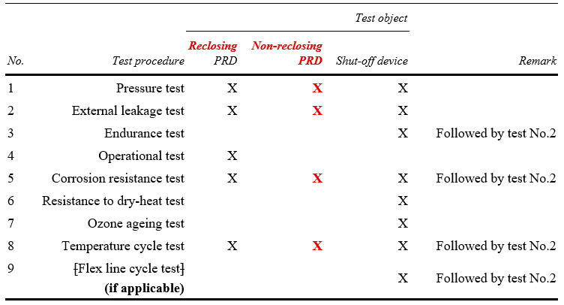
METI/KHK | Annex 4  9. | te | 9. Flex line cycle test  If applicable, a flexible fuel line shall be capable of conforming to the leakage test requirements referred to in Annex 4, paragraph 2., after being subjected to 6,000 pressure cycles.  The pressure shall change from atmospheric pressure to the MAWP of the container within less than five seconds, and after a time of at least five seconds, shall decrease to atmospheric pressure within less than five seconds.  The appropriate test for external leakage, as referred to in Annex 4, paragraph 2., shall be carried out immediately following the endurance test. | See comments. | (1) Clarify which part in Figure 1 corresponds to the flex line.  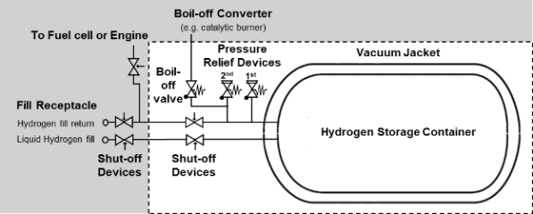  (2) Provide the basis for the 6,000 cycles. This number is not consistent with the number of cycles for the LHSS pressure cycle test specified in Annex 3, paragraph 1.3 (three times the number of cycles expected in on-road service).  Group October 20, 2025: Phase 3
France | Annex 6 | Ed | Annex 6 Provisions for a label for liquefied hydrogen vehicles of categories M2/N2 and M3/N3. | Annex 6 Provisions for a label for liquefied hydrogen vehicles of categories M2/N2 and M3/N3. | As the scope of this regulation is limited to M2/M3 and N2/N3 vehicles, there is no need to mention those categories here.  Completed in v15 –  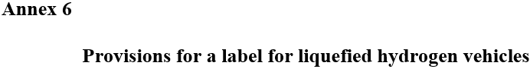
Pilots / Group | Annex 6 | Ge | Background: white or white reflecting  Border: Light-blue, RGB code 0, 176, 240 or similar  Letters: Light-blue, RGB code 0, 176, 240 or similar |  | Tolerances for approval?  DT:  Align with UN R134  Group 25.08.25 – Agree. Need “or similar” language, will not align with R134  Completed in v15 –  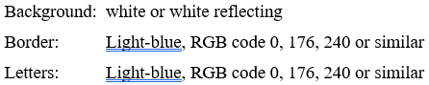
France | Annex 7 | Ge |  | Annex 7 Periodic technical inspection  Periodic technical inspection means the inspection of  vehicles performed at specified intervals according to  national regulations. Guidelines for the visual inspection  of each hydrogen system [during its service life] shall be  provided by the hydrogen system manufacturer on the  basis of use under service conditions specified herein.  Each hydrogen system shall be visually inspected at least  every 48 months after the date of its entry into service on  the vehicle (vehicle registration), and at the time of any  reinstallation, for external damage and deterioration.  The visual inspection shall be performed in accordance  with the manufacturer's specifications: hydrogen  system without a label containing mandatory  information or with labels containing mandatory  information that are illegible in any way shall be  removed from service.  If the hydrogen system can be positively identified by the  manufacturer and serial number, a replacement label  may be applied, allowing the hydrogen system to remain  in service. | PTI requirements for LHSS  Service life is in SQB because there is no information regarding service life of the LHSS in the regulation.  Completed in v15 – 20 Oct Group meeting(?)  