SLR-75-08

HOMEWORKS FROM GRE-93

- Consider moving out Annex 11 from UN Regulation No. 150 to a new document for reference

- Check if references to this Annex should be updated in UN Regulation No. 86

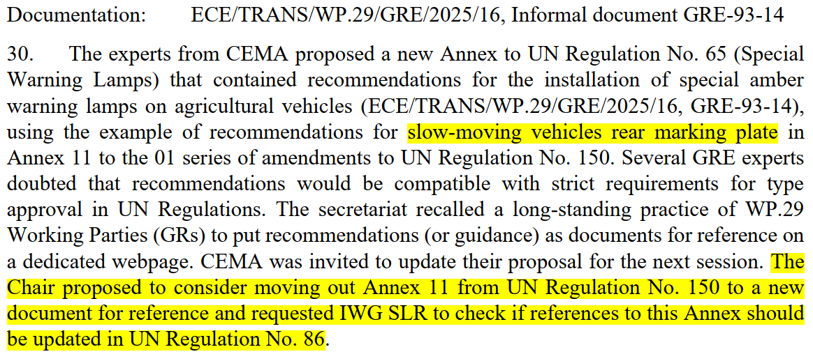
Excerpt of GRE-93 Report (doc. ECE/TRANS/WP.29/GRE/93)

Annex 11

Guidelines for installation of rear marking plates on slow-moving vehicles (by construction) and their trailers
1. It is recommended to the Governments to require on slow-moving vehicles which, by construction, cannot travel faster than 30 km/h, "Rear marking plates for slow-moving vehicles and their trailers" conforming to this Regulation and the specific requirements relating to its scope in accordance with the guidelines given in this annex.
2. Scope
The main purpose of these guidelines is to establish requirements for installation, arrangement, position and geometric visibility of rear marking plates on slow-moving vehicles and their trailers which, by construction, cannot travel faster than 30 km/h. It increases the visibility and permits an easy identification of these vehicles.
3. Number
At least one.
4. Arrangement
The rear marking plate(s) shall be type approved and meet the requirements of this Regulation.
The apex of a rear marking plate shall be directed upwards.
Every part of a rear marking plate shall lie within 5° of a transverse vertical plane at right angles to the longitudinal axis of the vehicle and shall face to the rear.
5. Position
In width: If there is only one rear marking plate, it must be on the opposite side of the median longitudinal plane of the vehicle to the direction of traffic prescribed in the country of registration.
In height: Above the ground, not less than 250 mm (lower edge), not more than 1,500 mm (upper edge).
In length: At the rear of the vehicle.
6. Geometric visibility
Horizontal angle: 30° inwards and outwards, covering by indispensable constructional parts of the vehicle up to 10 per cent of the rear marking plate surface is permitted;
Vertical angle: 15° above and below the horizontal;
Orientation: rearwards.

