Draft REPORT

8th meeting of GRRF Informal Working Group on
Automatically Commanded Steering Function

Venue: Hotel Nordic C - Vasaplan 4 - 111 20 Stockholm, (SE)
Chairman: Mr. Christian Theis (D) and Mr. Hidenobu Kubota (J)
Secretariat: Mr. Jochen Schaefer (CLEPA)
Dates: 6.-8. September 2016
Website: https://www2.unece.org/wiki/display/trans/ACSF+8th+session

- Participants:
see special attachment

- Welcome and Introduction
The chairmen welcomed the delegates to the 8th session of the IWG ACSF
- Approval of the report of the 7th Session
The report of the 7th Session was approved by the delegates
ACSF-07-20-Rev1 - (Secretary) Report of 7th session - approved by the delegates

- Approval of the agenda
The agenda was adopted and confirmed by the delegates without amendments.
ACSF-07-03-Rev1 (Secretary) Agenda 7th session

- List of Documents:

ACSF-08-01 - (SE+Secretary) Information about the 8th session which take place in Stockholm (SE)
ACSF-08-02 - Draft Agenda for the 8th session of the informal group
ACSF-08-03- (D) FU0 + TR0 Test for ACSF Cat. B1 Testing
ACSF-08-04 - (ROK) Hand-off warning time
ACSF-08-05 - (ROK) Proposal on CAT A based on ACSF-07-07
ACSF-08-06 - (D) CSF Compromise Proposal
ACSF-08-07- (F) FU0 Test amended by France - based on ACSF-08-03
ACSF-08-08 - (OICA-CLEPA) Industry proposal to document ECE-TRANS-WP 29-GRRF-2016-45e
ACSF-08-09 - (OICA) Hands-on detection for B1 systems
ACSF-08-10 - (OICA-CLEPA) ACSF Type Approval Number (ACSFTAN)
ACSF-08-11 - (Secretary) Consolidated Document to Corrective Steering Function - CSF
ACSF-08-12 - (Secretary) Consolidated Document for CAT B1 (attached also the document with amendments done in the 8th session)
ACSF-08-13 - (Secretary) Consolidated document to the proposal of CAT A ACSF

- General
Due to the fact, that in GRRF82 several amendments to the documents created by the informal group have been made, and the new created document has been agreed by the delegates, this report will focus only on the important issues, discussed in the meeting and will not contain all amendments proposed to GRRF82.
The delegates are invited to have a view on the “final” document of GRRF82:
GRRF-82-12-Rev.3 - (GRRF) Consolidated proposal for amendments to GRRF-82-08 (agreed)

  - Proposal for Amending UN Regulation No. 79
For GRRF82 a Working Document (WD) was submitted by the experts of the European Commission, France, Germany, Japan, Republic of Korea, the Netherlands and Sweden (ECE/TRANS/WP.29/GRRF/2016/45).
All delegates shared the opinion, that Option 4 should be modified and the amended version should be used to get an approval by the delegates in GRRF82.
Target for this session was to have a proposal for amendments in UN Regulation No. 79 for CSF, Category A and Category B1, incl. the appropriate test requirements
(UK): We should include clear requirements in the regulation, that a “interpretation” is not possible. We also should define clear test requirements for the Technical Service. Nevertheless, the test should be performed easily.
    - Corrective Steering Function CSF
The current definition for CSF was amended. Target is, that a continously lane keeping function with CSF shall not be possible anymore.
Discussions about whether the Lane Keeping Intervention should be possible within the lane or only outside the lane.
Finally the delegates concluded to the following definition, which was also presented to GRRF82:
The warning concept, proposed in the last session was agreed with adding the following (marked in bold):
The secretary prepared a consolidated document to CSF (ACSF-08-11-Rev.1).
Homework: OICA to prepare test requirements until GRRF82 (is: GRRF-82-12)
"Corrective steering function (CSF)" means the control function within an electronic control system whereby, for a limited duration, changes to the steering angle of one or more wheels may result from the automatic evaluation of signals initiated on-board the vehicle, in order
- to compensate a sudden, unexpected change in the side force of the vehicle or
- to improve the vehicle stability (e.g. side wind, μ-split) or
- to correct lane departure. (e.g. to avoid crossing lane markings, leaving the road).

In the case of two or more consecutive interventions within a rolling interval of 180 seconds and in the absence of a steering input by the driver during the intervention, an acoustic warning shall be provided by the system during the second and any further intervention within a rolling interval of 180 seconds. Starting with the 3rd intervention (and subsequent interventions) the acoustical signal shall continue for at least 10 seconds longer than the previous warning signal.
    - Requirements for Category A (incl. Remote Control Parking (RCP)
The delegates agreed to amend the definition for the RCP-Range:
(Chair-D): The “nearest point” is only dedicated to the motor vehicle and not to a trailer connected to the drawing vehicle.
Proposals from industry to increase the range was not accepted by Contracting Parties (CP).
The delegates supported to add following condition to the regulation:
There was no final wording agreed to what the vehicle should do when reaching the final parking position. Therefore the following paragraph remained in […] and was finally decided in GRRF82:
Final wording of CAT A, which was distributed to GRRF82 in ID GRRF82-08
If a door of the vehicle is opened during the parking manoeuvre, the vehicle shall stop immediately.
[If the vehicle has reached its final parking position either automatically or by confirmation from the driver, and the ignition is switched off, the parking braking system shall be engaged.]
2.4.9. "Specified maximum RCP operating range (S_{RCPmax})" means the maximum distance between the nearest point of the motor vehicle and the remote control device up to which ACSF is designed to operate.
5.6.1. Special Provisions for Category A ACSF
Any system of Category A ACSF shall fulfil the following requirements.
5.6.1.1. General
5.6.1.1.1 The system shall only operate until 10 km/h (+2 km/h tolerance)
5.6.1.1.2. The system shall be active only after a deliberate action of the driver and if the conditions for operation of the system are fulfilled (all associated functions – e.g. brakes, accelerator, steering, camera/radar/lidar etc. are working properly).
5.6.1.1.3. The system shall be able to be deactivated by the driver at any time.
5.6.1.1.4. In the case where the system includes accelerator and/or braking control of the vehicle, the vehicle shall be equipped with a means to detect an obstacle (e.g. vehicles, pedestrian) in the manoeuvering area and to bring the vehicle immediately to a stop to avoid a collision.
5.6.1.2. Additional provisions for RCP systems
5.6.1.2.1. The parking manoeuvre shall be initiated by the driver but controlled by the system. A direct influence on steering direction, acceleration and braking via the remote control device shall not be possible.
5.6.1.2.2. A continuous actuation of the remote control device by the driver is required during the parking manoeuvre.
5.6.1.2.3. If the continuous actuation is interrupted or the distance between vehicle and remote control device exceeds the specified maximum RCP operating range (S_{RCPmax}) or the signal between remote control and vehicle is lost, the vehicle shall stop immediately.
5.6.1.2.4 If a door of the vehicle is opened during the parking manoeuvre, the vehicle shall stop immediately.
5.6.1.2.5 The system shall be designed to protect against unauthorized activation or operation of the RCP systems and interventions into the system.
5.6.1.2.6 The specified maximum RCP operating range shall not exceed 6m.
5.6.1.2.7 [If the vehicle has reached its final parking position either automatically or by confirmation from the driver, and the ignition is switched off, the parking braking system shall be engaged.]
5.6.1.3. System information data
5.6.1.3.1. Following data shall be provided together with the documentation package required in Annex 6 of this Regulation to the Technical Service at the time of type approval
5.6.1.3.1.1. The value for the specified maximum RCP operating range (S_{RCPmax})
5.6.1.3.1.2. The conditions under which the system can be activated, i. e. when the conditions for operation of the system are fulfilled.
5.6.1.3.1.3 For RCP systems the Manufacturer shall provide the technical authorities with an explanation how the system is protected against unauthorized activation

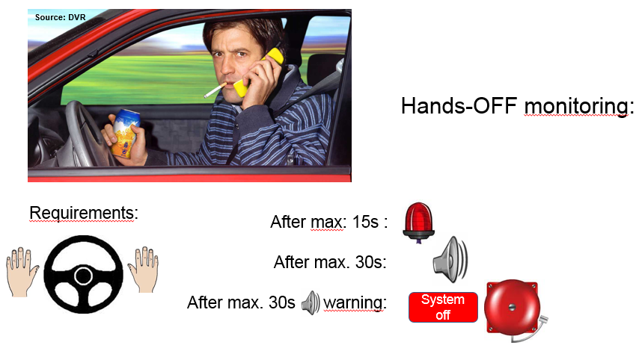
    - Requirements for Category B1
Lengthy discussion about the “flexibility” of “boundary conditions” and the need of regulating everything in detail.
(UK): This is a fundamental issue. We should not regulate something which is defined by the industry.
(Secretary): Complex systems cannot be defined by regulation in every detail (see ESC). The regulation should “guarantee”, that the system is safe.
Driver monitoring – Hands-OFF
Discussion about the warning sequence, which shall be provided by the system.
It is clear for the delegates, that a CAT B1 system is a “Hands-ON” system.
With regard of the detection time, if a driver is “Hands-OFF”, the opinions differ between CPs and industry. The survey of ROK (ACSF-08-04) shows only typical values. Values in a regulation must be achieved under all conditions.
The final agreement of the group is shown below:
Performance requirements - ay_{smax}
The delegates concluded to define the limits for ay_{smax} in a table:
Source: GRRF-82-17 - (ACSF) Presentation of GRRF-82-08
For vehicles of category M₁, N₁
Speedrange | 10-60 km/h | >60-100 km/h | >100-130 km/h | >130 km/h
Specified maximum lateral acceleration shall be lower than | 3m/s² | 3m/s² | 3m/s² | 3m/s²
Specified maximum lateral acceleration shall be higher than | no req. | 0,5 m/s² | [1]m/s² | 0,3 m/s²
For vehicles of category M₂, M₃, N₂, N₃
Speedrange | 10-30 km/h | >30- 60 km/h | > 60 km/h
Specified maximum lateral acceleration shall be lower than | 2.5 m/s² | 2.5 m/s² | 2.5 m/s²
Specified maximum lateral acceleration shall be higher than | no req. | 0.3 m/s² | 0.5 m/s²

The value in […] should be defined in GRRF82.
(Remark: in GRRF82 this value was fixed to 0,8 m/s²)
    - Test requirements for CSF, CAT B1
Several amendments have been discussed during the meeting.
The final conclusion is, that OICA shall prepare a Informal Document for GRRF82 with a consolidated proposal of the discussion. Document shall be shared with the delegates in parallel of providing it to GRRF. (was: GRRF-82-12)
    - Periodical Technical Inspection (PTI)
Discussion about the proposal from D to have specific requirements for PTI in ACSF systems in the regulation.
(UK): If we define something like that, we have to have a “standard interface”
(NL): If necessary, we have to mandate such an interface. A bulb in the dashboard should be sufficient.
(Chair-D): Compromise: Delete this paragraph and focus on it in the future for the other categories. Should be there at least for a CAT E system.
=> The compromise was agreed by the delegates.
    - Categories B2, C, D and E
It was decided to include all categories, which have been defined until now in the definition, but to exclude them in the scope of the regulation as long as there are no requirements specified.
    - Unauthorized use and system security
This is relevant for all categories, especially CAT A (RCP).
Requirements will be handeled in future sessions.
- Next meeting
The next meeting is planned on 22-24. November 2016
Venue: TKP Garden City Higashi-Umeda
Address: 2-11-16, Sonezaki, Kitaku, Osaka-city, Osaka, Japan
Further information to the next meeting:
ACSF-09-01-Rev.1 - Info on the 9th meeting
Please provide the documents for the next meeting at least one week prior to the meeting start

