|  |
| --- |
| **12th EVS-GTR meeting**  **79 rue Jean-Jacques Rousseau - 92150 SURESNES**  ***Starting on September 19, 2016***  ***Ending on September 23, 2016*** |

EVS12-03

**It’s a pleasure for Union Technique de l’Automobile du motocycle et du Cycle (Technical Union for the Automobile, Motorcycle and Cycle Industries - UTAC), Fédération des Industries des Equipements pour Véhicules (French Vehicle Equipment Industries – FIEV) and in cooperation with the European Commission, to host this meeting.**

**You will find on this short document some information to facilitate your business trip.**

# LOCATION

Close to La Defense, the meeting will take place in the FIEV building, 79 rue Jean-Jacques Rousseau - 92150 SURESNES (<http://www.fiev.fr>). For safety reasons, remember to bring a proof of identity (passport or identity card) to access the site.

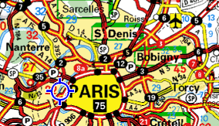FIEV

[79, rue Jean-Jacques Rousseau](https://www.google.fr/maps/place/F%C3%A9d%C3%A9ration+des+Industries+des+Equipements+pour+V%C3%A9hicules+-+FIEV/@48.8661213,2.2215909,17z/data=!3m1!4b1!4m2!3m1!1s0x47e664d1b2c63ff3:0x472df316e519d0ce?hl=fr)

[92150 SURESNES](https://www.google.fr/maps/place/F%C3%A9d%C3%A9ration+des+Industries+des+Equipements+pour+V%C3%A9hicules+-+FIEV/@48.8661213,2.2215909,17z/data=!3m1!4b1!4m2!3m1!1s0x47e664d1b2c63ff3:0x472df316e519d0ce?hl=fr)

Tel: +33 (0)1 46.25.02.44

[www.fiev.fr](http://www.fiev.fr)

**Maps**

Subway ([metro, RER](http://www.ratp.info/picts/plans/gif/reseaux/metro.gif))

Tramway [T2](http://www.ratp.info/picts/plans/gif/reseaux/t2.gif)

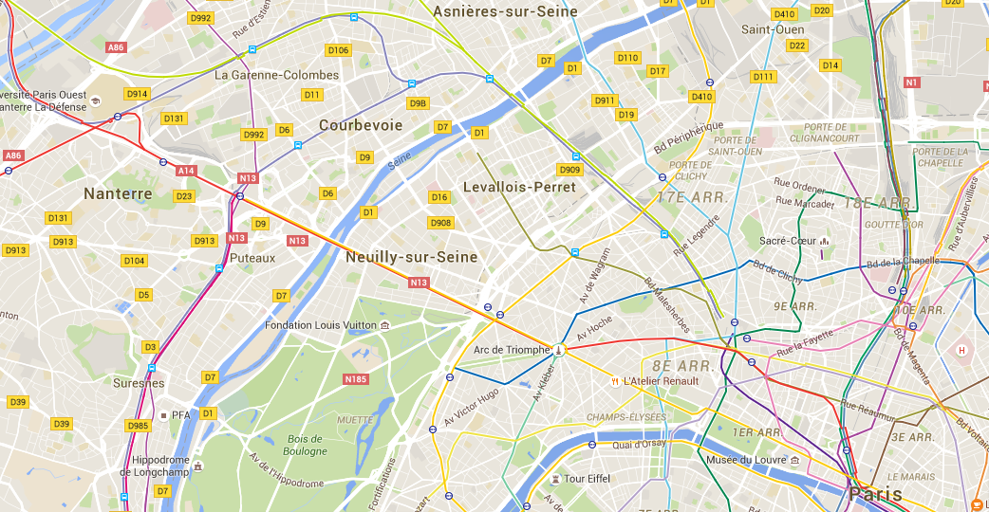

Eiffel Tower

Louvre Museum

Meeting place

# TRANSPORTS

## How to go to Paris from Charles de Gaulle Airport (CDC)

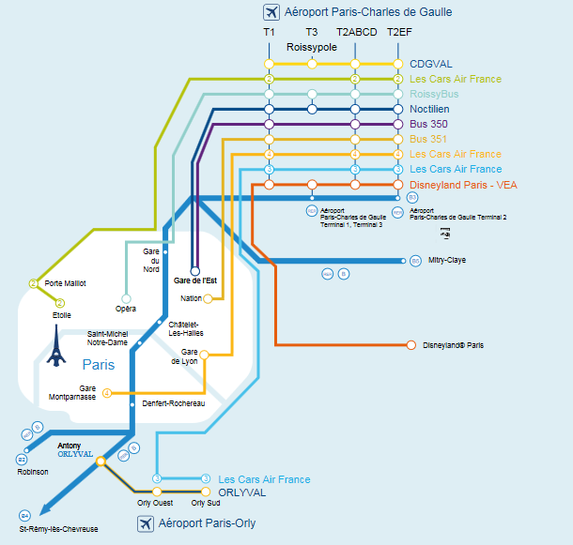**By taxi :**

Between 50 to 70€ to go to Paris

* **Les Taxis Bleus**: 01 49 36 10 10
* **Alpha Taxis :** 01 45 85 85 85
* **Taxis G7 :** 01 47 39 47 39 or 36 07
* **G7 Horizon :** 01 47 39 00 91

To go to the suburb :

* **ABC Taxis 01 43 83 64 00**

**By train :** the RER B line makes a liaison from CDC airport to Paris

**By bus :**

|  |  |  |
| --- | --- | --- |
| Line | Cost | Duration |
| Bus 351 | 6 € | From CDC to Paris (place de la nation) 90min |
| By night Notilien N143 et N140 | 7,60 € | 30 min |
| Airs France Cars | 17-21€ | 90min |

## How to go to Paris from Orly Airport

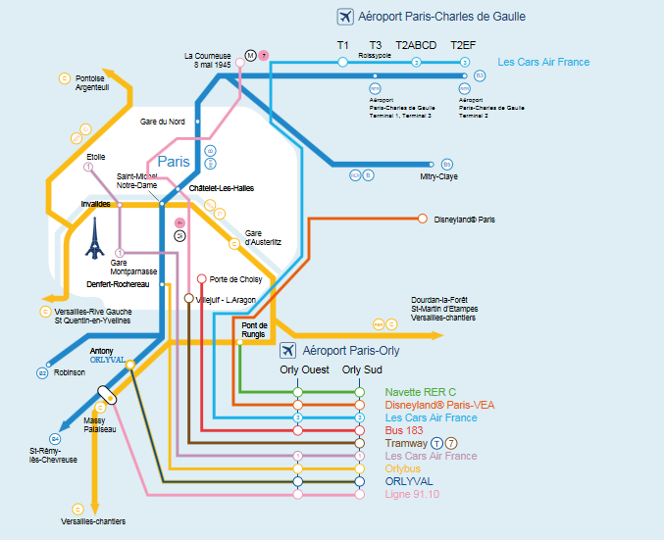**By taxi :**

Between 40 to 55€ to go to Paris

* **Les Taxis Bleus**: 01 41 52 54 25
* **Alpha Taxis :** 01 45 85 85 85
* **Taxis G7 :** 01 47 39 47 39 or 36 07
* **G7 Horizon :**  01 47 39 00 91

To go to the suburb :

* **ABC Taxis** 01 46 87 12 00

**By train :** 2RER lines (B&C) lines makes a liaison from Orly airport to Paris

**By bus :**

|  |  |  |
| --- | --- | --- |
| Line | Cost | Duration |
| Orlybus | 7,5€ | From Orly to Paris (Denfert-Rochereau) 30min |
| Bus 183 | 2€ | Up to Paris Porte de Choisy 60min |

## How to go to the FIEV building

**By car**

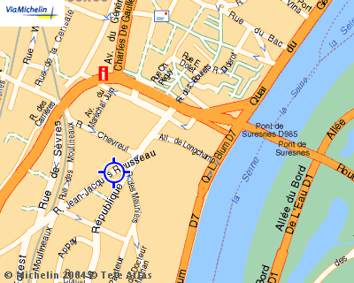

Coming from Paris, cross the Suresnes Bridge

(**Boulevard Henri Sellier**)

Stay on the left lane

Go straight on the **Boulevard Henri Sellier** to the tramway bridge

Just before the tramway bridge, turn left into the **Rue de Chevreul**

At the end of the street, turn right: **blue building**

Underground car park provided.

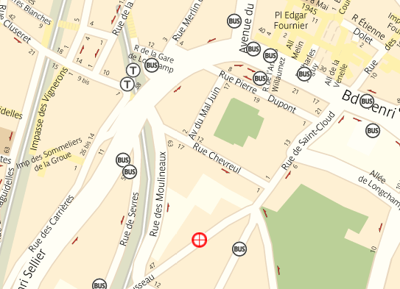**By tramway (T2)**

Take the metro **(C** yellow line or **A** red line) up to La Defense

**Take T2** (Tram Val de Seine) links Paris – La Défense with Issy-les-Moulineaux

Get off the tramway at **Suresnes – Longchamp station**

Then walk down the **Rue de Chevreul**

At the end of the street, turn right: **blue building**

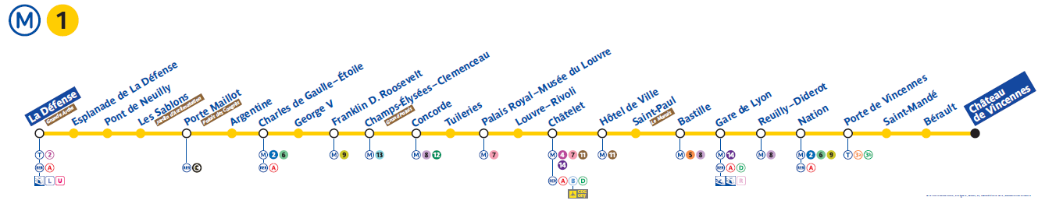

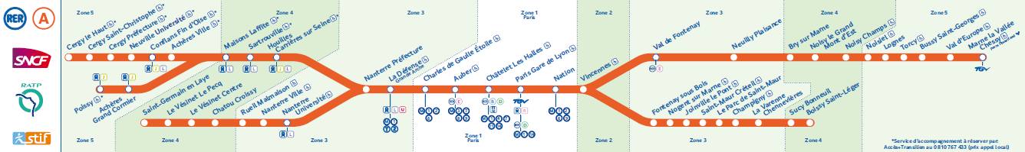

# Hotels & Restaurants

|  |  |
| --- | --- |
| **Here is a list of hotels close to the FIEV offices :** | **Here is a selection of restaurants in the center of Suresnes:** |
| **HOTEL IBIS**  6, rue des Bourets 92150 SURESNES  <http://www.accorhotels.com/fr/hotel-0716-ibis-paris-pont-de-suresnes/index.shtml>  **Tel.** +33 (0)1 45 06 44 88  [H0716@accor.com](mailto:H0716@accor.com) | **LE CAMPANILE**  15, Boulevard Henri Sellier  92150 SURESNES  <http://www.campanile-paris-ouest-pont-de-suresnes.fr/fr/restaurant>  Reservation : 0892 23 48 15  Information : +33 (0)1 58 47 55 66  Email : [suresnes@campanile.fr](mailto:suresnes@campanile.fr) |
| **HOTEL NOVOTEL**  7 rue du Port aux Vins 92150 SURESNES  <http://www.accorhotels.com/fr/hotel-1143-novotel-paris-suresnes-longchamp/index.shtml>  **Tel.** +33 (0)1 40 99 00 00  [H1143@accor.com](mailto:H1143@accor.com) | **L’ASSIETTE GOURMANDE**  59, rue Pasteur 92150 SURESNES  <http://www.lassiette-gourmande-suresnes.fr>  Reservation : +33 (0)1 42 04 41 52  Email : [lassiette-gourmande@hotmail.fr](mailto:lassiette-gourmande@hotmail.fr) |
| **HOTEL ATRIUM**  68/72, Boulevard  Henri Sellier  92150 SURESNES  <http://www.latriumhotel.com/>  **Tel.** +33 (0)1 42 04 60 76  [info@latriumhotel.com](mailto:info@latriumhotel.com) | **BISTROT DES TOQUES**  46, rue Pasteur 92150 SURESNES  <http://www.bistrotdestoques.fr>  Reservation : +33 (0)1 42 04 08 63 |
| **HOTEL CAMPANILE**  15, Boulevard Henri Sellier  92150 SURESNES  <http://www.campanile-paris-ouest-pont-de-suresnes.fr/fr>  Reservation : 0892 23 48 15  Information : +33 (0)1 58 47 55 66  Email : [suresnes@campanile.fr](mailto:suresnes@campanile.fr) | **AU PERE LAPIN**  10, rue du Calvaire  92150 SURESNES  <http://www.auperelapin.com>  Reservation : +33 (0)1 45 06 72 89 |

You’re rather be in the center of Paris but not far of the meeting room? Please find below some proposals:

|  |  |
| --- | --- |
| **Here is a list of hotels in PARIS:** | **Time to go to the meeting place (metro/tram)/price/website:** |
| **l'Hôtel Résidence Impériale 3\***  155 Avenue de Malakoff, 75116 Paris  **Tel.** +33 (0)1 45 00 23 45 | **29 minutes**  **Price** ≈ 85€  <http://paris-hotel-residenceimperiale.com/> |
| **Hôtel Etoile Saint-Ferdinand by HappyCulture 4\***  36 Rue Saint-Ferdinand, 75017 Paris  **Tel.** +33 (0)1 45 72 66 66 | **31 minutes**  **Price** ≈ 139€  <http://hotel-paris-ferdinand.com> |
| **Hôtel Fertel Maillot 3\***  269 Boulevard Pereire, 75017 Paris  **Tel.** +33 (0)1 44 09 92 92 | **30 minutes**  **Price** ≈ 85€  <http://hotelfertelmaillot.com> |
| **L’Adresse Hôtel 4\***  22 Rue du Débarcadère, 75017 Paris  **Tel.** +33 (0)1 58 05 08 88 | **30 minutes**  **Price** ≈ 120€  <http://ladresse-hotel.com> |
| **Hôtel Beauchamps 4\***  24 Rue de Ponthieu, 75008 Paris  **Tel.** +33 (0)1 53 89 58 58 | **35 minutes**  **Price** ≈ 166€  <http://hotelbeauchamps.com> |
| **Hôtel d'Argenson 2\***  15 Rue d'Argenson, 75008 Paris  **Tel.** +33 (0)1 42 65 16 87 | **40 minutes**  **Price** ≈ 70€  <http://hotel-argenson.com> |
| **Hotel Augustin – Astotel 3\***  9 Rue Roy, 75008 Paris  **Tel.** +33 (0)1 42 93 32 17 | **40 minutes**  **Price** ≈ 110€  <http://astotel.com> |
| **Hotel Albion Paris 3\***  15 Rue de Penthièvre, 75008 Paris  **Tel.** +33 (0)1 42 65 84 15 | **40 minutes**  **Price** ≈ 90€  <http://hotelalbion.net> |

You haven’t got any hotel? This French website can help you to find and hotel by localization: <http://www.hotelaparis.com/hotel-paris-arrondissement.html>

# MORE INFORMATION

To help you in your movements you can use the application 'Visiter Paris en Métro'.

Free and fully translated into Chinese, English, German, Dutch, Italian, Spanish, Japanese, the official application 'Visit Paris Métro’ is designed for those who want to visit Paris easily by Metro. The application gives access to a multitude of services to move just in Paris underground and discover the most beautiful places in the capital: the Eiffel Tower, the Louvre, the Sacred Heart, the Château Versailles or Disneyland Paris. Most features are accessible even when you're offline in order to enjoy the city without using your mobile internet package!

 

To get more information about Paris (what to see ? / Map /…) you can have a look on this website : <http://en.parisinfo.com/>

[](http://www.fiev.fr/mediatek_store/pdf/paris_architecture_masterpieces.pdf)



If you want to extend your stay, you can visit the Paris motor show to be held from 1 to 10 October <http://www.mondial-automobile.com/en/visiteurs/>.

Weather, our meeting will be held at the beginning of automn, we probably will have a nice weather for a temperature around 20 °C (68 °F), but don’t forget your umbrella ☺ !

