10th session of the
Informal Working Group on ACSF
11. – 13. January 2017
Paris/France

Meeting place :
DGEC (Direction Générale de l’Energie et du Climat)
LA DEFENSE Tour Pascal B
92800 Puteaux

situated very close to the Paris Metro Station “La Defense” of (Metro Ligne 1)

Registration (Meeting):
This meeting is limited to 50 persons!

Please send your registration not later than 20th December 2017 to the Secretary of the group:
Jochen Schaefer (Jochen.schaefer@de.bosch.com)
and to:
Pierre.Bazzucchi (pierre.bazzucchi@developpement-durable.gouv.fr)

In the case, we have more than 50 registrations, we have to limit the participation of NGOs to one person per company, and employees of associations. As well to persons who have frequently participated in the previous meetings of the group.
Please consider this before you book your travel!

Dear all,
The DGEC (Direction Générale de l’Energie et du Climat), is hosting us in their building in LA DEFENSE Tour Pascal B, just outside of Paris. The place can be easily reached from anywhere in Paris.
Please note that due to strict security issues, all names of participants shall be registered at least 1 week before the meeting, therefore let the leading team know as soon as possible if you will be attending.
We are happy to see you in Paris
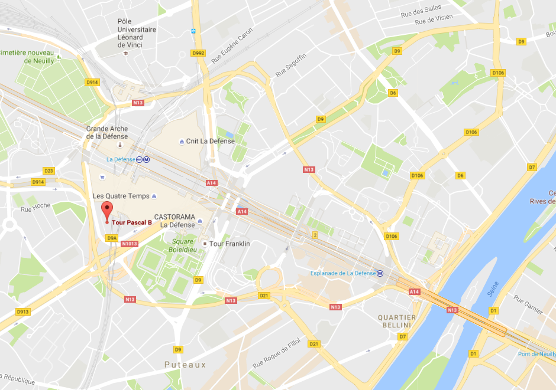
Céline

Hotel list
Hotel Name | Hotel contact information | Option | Price for 4 nights | Location of proximity
Ibis | IBIS  4 Boulevard de Neuilly  La Défense 1 – Pont de Neuilly  PARIS LA DEFENSE  92400 – COURBEVOIE  Tel : (+33)1.41.97.40.00  URL : http://www.ibis.com/fr/hotel-0771-ibis-paris-la-defense-centre/index.shtml | For a single room: Free cancellation, WIFI including, breakfast extra.  Price for one night : 116,50€ | 466,00€ | At 10 minutes on foot of the Grande Arche. At 3 stations of the Palais des Congrés «Porte Maillot" and at 5 minutes of The Etoile Champs-Elysées.  Not principal interest:  - Palais des Congrés (2 min)  Distance centre town:  - Paris la Défense (3 min)  Distance from the hotel at the station:  - La Défense (14min)  - Station Saint-Lazard (38 min)  - Station Montparnasse (32 min)  - Gare de Lyon (33 min)  - Gare du Nord (42 min)  Distance from the hotel to the airport in train and subway:  - Paris Roissy Charles De Gaulle (01h01 min)  - Paris Orly (01h22 min)
 |  | For a double room: No refundable with breakfast and WIFI including.  Price for one night : 137,50€ | 550,00€
 |  | Taxes not included in the price (5,28€ per person and per night)
Best Western Hôtel de Neuville | BEST WESTERN HOTEL DE NEUVILLE  3 Rue Verniquet  17e arrondissement  75017- PARIS  Tel: (+33) 1.43.80.26.30  URL : http://www.bestwestern-hotel-de-neuville.com/fr/index-fr.html | For classic bedroom: Free cancellation, possibility of paying the day of the arrival, breakfast and WIFI including.  Price for one night : 151,50€ | 606,00€ | At 35 min on foot the district of La Defense in subway.  Distance from the tourist worships :  Montmartre (30min), The Basilique of Sacré Cœur (29 min), The Tower Eiffel (37 min), The cathedral Notre-Dame de Paris (33 min) and the Museum of Louvre (25 min).  It is tourist place are accessible by the subway from Paris.  Distance from the hotel to the airport in train and subway:  - Paris Roissy Charles de Gaulle (1h02 in train and subway, 30 min in the car).  - Paris Orly (1h18 in train and subway, 31 min in the car).  Distance from the hotel at the station:  - La Défense (35 min)  - Station Saint-Lazard (17 min)  - Station Montparnasse (40 min)  - Gare de Lyon (51 min)  - Gare du Nord (45 min)
 |  | Order choice: WIFI including.  No refundable, breakfast extra (15,00€ per day).  Price for one night : 113,20€ | 452,80€
 |  | Taxes not included in the price (2,48€ per person and per night).

Hotel Name | Hotel contact information | Option | Price | Location of proximity
Hotel de Banville | HOTEL DE BANVILLE  166 Boulevard Berthier,  17e arrondissement.  75017 PARIS  Tel : (+33) 1.42.67.70.16  URL : https://www.secure-hotel-booking.com/smart/Hotel-de-Banville/2UJ4/fr/index?rate=&url= | For classic bedroom: Free cancellation, possibility of paying the day of the arrival, breakfast and WIFI including.  Price for one night : 125,00€ | 500,00€ | At 34 min on foot the district of La Defense in subway.  Not principal interest:  - Métro Porte de Champerret (2 min)  - Métro Pereire (3 min)  Distance from the tourist worships :  Montmartre (30min), The Basilique of Sacré Cœur (29 min), The Tower Eiffel (37 min), The cathedral Notre-Dame de Paris (33 min) and the Museum of Louvre (25 min).  It is tourist place are accessible by the subway from Paris.  Distance from the hotel to the airport in train and subway:  - Paris Roissy Charles de Gaulle (1h00 in train and subway, 27 min in the car).  - Paris Orly (1h26 in train and subway, 29 min in the car)  Distance from the hotel at the station:  - Défense (44 min)  - Station Saint-Lazard (16 min)  - Station Montparnasse (37 min)  - Gare de Lyon (51 min)  - Gare du Nord (44 min)
 |  | Order choice for classic bedroom: Breakfast and WIFI including.  No refundable, no rescindable.  Price for one night : 139,00€ | 556,00€
 |  | Taxes not included in the price (2,48€ per person and per night).
Hotel Magellan | HOTEL MAGELLAN  17-19 Rue Jean Baptiste Dumas, 17e arrondissement  75017 PARIS  Tel : (+33) 1.45.72.44.51  URL : http://www.hotelmagellan.com/Francais.html | For a semi-double room: WIFI including. Breakfast extra (18,00€ per day). No refundable. Online payment.  Price for one night : 100,30€ | 401,20€ | At 15 min on foot of the park Monceau and the Arc de triomphe.  Not principal interest:  - Métro Porte de Champerret (2 min)  - Métro Pereire (3 min)  Distance from the hotel to the airport in train and subway:  - Paris Roissy Charles de Gaulle (1h28 in train and subway, 32 min in the car).  - Paris Orly (1h02 in train and subway, 41 min in the car).  Distance from the hotel at the station:  - Défense (32 min)  - Station Saint-Lazard (34 min)  - Station Montparnasse (34 min)  - Gare de Lyon (30 min)  - Gare du Nord (38 min)
 |  | Order choice for a semi-double room: Breakfast and WIFI including. Rescindable and modifiable, and possibility of paying the day of the arrival.  Price for one night : 118,00€ | 472,00€
 |  | Taxes not included in the price (1,65€ per person and per night)

Hotel Name | Hotel contact information | Option | Price |  | Location of proximity
Melia Paris La défense | MELIA PARIS LA DEFENSE  2, Esplanade du Général De Gaulle CS 40056  92081-COURBEVOIE  Tel : (+33) 1.75.57.99.00  URL : http://www.melia.com/en/hotels/france/paris/melia-paris-la-defense/index.html | For a double room: Breakfast and WIFI including. No refundable.  Price for one night : 145,50€ | 582,00€ |  | Distance from the hotel to the airport in train and subway:  - Paris Roissy Charles de Gaulle (01h07 in train and subway, 34 min in the car).  - Paris Orly (01h17 in train and subway, 54 min in the car).  Distance from the hotel at the station:  - Défense ( 5 min)  - Station Saint-Lazard ( 31 min)  - Station Montparnasse (29 min)  - Gare de Lyon (29 min)  - Gare du Nord (38 min)
 |  | Order choice for a double room: Breakfast and WIFI including. Free cancellation and possibility of paying the day of the arrival.  Price for one night : 169,00€ | 676,00€
 |  | 10% of TVA
Hotel Maison FL | MAISON FL  6 Rue De La Tour, 16e arrondissement  75016 PARIS  Tel : (+33) 1.55.74.75.75  URL : http://maisonfl.com/fr/ | For classic bedroom: Free cancellation, possibility of paying the day of the arrival, and WIFI including. Breakfast extra (20€ per day).  Price for one night : 139,00€ | 556,00€ |  | At 21 min on subway of The Tower Eiffel.  Distance from the hotel to the airport in train and subway:  - Paris Roissy Charles de Gaulle (01h24 in train and subway, 38 min in the car).  - Paris Orly (57 min in train and subway, 37 min in the car).  Distance from the hotel at the station:  - Défense ( 21 min)  - Station Saint-Lazard ( 26 min)  - Station Montparnasse (15 min)  - Gare de Lyon (40 min)  - Gare du Nord (52 min)
 |  | Order choice for classic bedroom: Breakfast and WIFI including. Free cancellation and possibility of paying the day of the arrival.  Price for one night : 158,00€ | 632,00€
 |  | Taxes not included in the price (2,48€ per person and per night)
Pullman Paris La Défense | PULLMAN PARIS LA DEFENSE  11, Avenue De L’Arche, La Défense 6  92400-COURBEVOIE  Tel : (+33) 1.47.17.50.00  URL : http://www.pullmanhotels.com/fr/hotel-3013-pullman-paris-la-defense/index.shtml | For classic bedroom: WIFI including more one service tea/coffee offered. No refundable, Online payment and the breakfast extra.  Price for one night : 161,50€ |  | 646,38€ | At 10 min on foot of Champs-Elysées, at 12 min of Centre town and at 8 min of the Arc de triomphe.  Distance from the hotel to the airport in train and subway:  - Paris Roissy Charles de Gaulle (01h20 in train and subway, 35 min in the car).  - Paris Orly (1h11 min in train and subway, 38 min in the car).  Distance from the hotel at the station:  - Défense ( 4 min)  - Station Saint-Lazard ( 29 min)  - Station Montparnasse (39 min)  - Gare de Lyon (25 min)  - Gare du Nord (34 min)
 |  | Order choice for classic bedroom: Breakfast and WIFI including more one service tea/coffee offered. No refundable. Online payment.  Price for one night : 174,23€ |  | 696,94€
 |  | Taxes not included in the price (8,80€ per person and per night)

Meeting at :
LA DEFENSE Tour Pascal B
Place des Degrés 92800 Puteaux




