Submitted by the expert from OICA  In the context of the revision of the ASEP procedure | GRB IWG ASEP  1st Meeting 2016-11-07 in Tianjin, China

Proposals to clarify the 03 series of amendments of Regulation No. 51 (main body and annex 7)

The proposed amendments to the current Regulation No. 51 are incorporated into the consolidated text and marked in bold for new or strikethrough for deleted characters.

I. Proposal
Paragraph 2.18., amend to read:
"2.18. Gear "Locked gear ratios" means the control of transmission such that the transmission gear cannot change during a test.
2.18.1. "Gear" means in the context of this Regulation a discrete gear ratio either selectable by the driver or by an external device.
2.18.2. "Gear ratio" means in the context of this Regulation any ratio between vehicle speed and engine speed during the passage of the vehicle through the test track. Most relevant is the gear ratio at the point in the test track, when the rear of the vehicle passes line BB’.
2.18.3. "Locked gear ratios" means the control of the transmission such that the transmission gear cannot will not change during a test.
Note: The common understanding of a "low gear" or a "high gear" shall not be applied to gear ratios. For example the lowest gear for forward driving, the first gear, has the highest gear ratio of all forward driving gears.
While manual transmission have discrete gears, many non-manual transmissions can have not only discrete gears in the classical understanding, but can have more gear ratios engaged by the control unit of the transmission.
2.18.4. "gear_{i}" and "gear_{i+1}" are defined as two gears in sequence, where gear_{i} provides an acceleration greater than a_{wot_ref}, and gear_{i+1} an acceleration lower than a_{wot_ref}"
Insert new paragraph 2.25., to read:
"2.25. Modes
2.25.1. "Mode" means a distinct driver-selectable condition which does affect the sound emission of the vehicle.
[2.25.2. "Multi-mode" means that more than one operating mode can be selected by the driver or automatically set.
2.25.3. "Predominant mode" for the purposes of this Regulation means a single mode that is always selected when the vehicle is switched on regardless of the operating mode selected when the vehicle was previously shut down. The predominant mode must not be able to be redefined. The switch of the predominant mode to another available mode after the vehicle being switched on shall only be possible by an intentional action of the driver.]"
Insert new paragraph 2.26., to read:
"2.26. Stable Acceleration
2.26.1. "Stable acceleration" is a homogeneous constant acceleration within the test track area between line AA’ and BB’ plus the vehicle length.
2.26.2. "Unstable acceleration" means a deviation from the stable acceleration during acceleration.
2.26.2.1. Unstable acceleration might occur during the start of an acceleration from low speeds when the powertrain will react by bumping and jerking on the acceleration request.
2.26.2.2. Unstable acceleration exists when the acceleration of the vehicle is very non-linear and the proper acceleration to be related with the sound emission of the vehicle cannot be determined.
In the context of this Regulation such an unstable acceleration is given, when the acceleration between the PP’ line and the BB’ line is more than [xx] per cent higher compared to the acceleration between the AA’ line and the PP’ line.
The acceleration between line AA’ and line PP’ is calculated by:
a_{AA-PP} = ((v_{PP’}/3,6)² - (v_{AA’}/3,6)²)/20
where the speeds are given in km/h.
The acceleration between line PP’ and line BB’ is performed according to the formulae given in Annex 3 under paragraph 3.1.2.1.2."

Annex 7, amend to read:
"Annex 7
Measuring method to evaluate compliance with the Additional Sound Emission Provisions
Only applicable for vehicles as specified in paragraph 6.2.3. of this Regulation
1. General
This annex describes a measuring measurement method to evaluate compliance of the vehicle with the additional sound emission provisions (ASEP) conforming to paragraph 6.2.3. of this Regulation.
It is not mandatory to perform actual tests when applying for type-approval. The manufacturer shall sign the declaration of compliance set out in Appendix 1. The approval authority may ask for additional information about the declaration of compliance and carry out the tests described below.
The procedure set out in this annex requires the performance of a test in accordance with Annex 3. The test specified in Annex 3 shall be carried out on the same test track under conditions similar to those required in the tests prescribed in this annex intended for the measurements of this Annex 7 with the gears/gear ratios and weighting factors as during the type approval according to Annex 3, paragraph 2.2 until paragraph 3.1.3.1.
2. Measuring Measurement method
2.1. Measuring Measurement instruments and condition o f measurements
Unless otherwise specified, the measuring measurement instruments, the conditions of the measurements and the condition of the vehicle are equivalent to those specified in Annex 3, paragraphs 1. and 2.
If the vehicle has different modes that affect sound emission, all modes shall comply with the requirements in this annex. In the case where the manufacturer has performed tests to prove to the approval authority compliance with the above requirements, the modes used during those tests shall be reported in a test report.
2.2. Method of testing
Unless otherwise specified, the conditions and procedures of Annex 3, paragraphs 3.1. to 3.1.2.1.2.2. shall be used. For the purpose of this annex, single test runs are measured and evaluated.
2.3. Control range
Operation conditions are as follows:
Vehicle speed V_{AA_ASEP}: v_{AA} ≥ 20 km/h
Vehicle acceleration a_{WOT_ASEP}: a_{WOT} ≤ 5.0 m/s²
Engine speed n_{BB_ASEP} n_{BB} ≤ 2.0 * PMR^{-0.222} * S or
n_{BB} ≤ 0.9 * S, whichever is the lowest
Vehicle speed V_{BB_ASEP}:
if n_{BB_ASEP} is reached in one gear v_{BB} ≤ 70 km/h
in all other cases v_{BB} ≤ 80 km/h
gears κ ≤ gear i as determined in Annex 3
If the vehicle, in the lowest valid gear, does not achieve the maximum engine speed below 70 km/h, the vehicle speed limit is 80 km/h.
If n_{BB_ASEP} is reached in at least one valid gear below 80 km/h, the maximum vehicle speed is 70 km/h for all other valid gears.
If n_{BB_ASEP} cannot be reached in any valid gear below 80 km/h, the maximum vehicle speed is 80 km/h for all valid gears.
Valid gears: gear κ ≤ gear_{i}
Valid gear ratios: gear ratio χ ≥ gear ratio _{i}
with gear_{i} as defined in paragraph 2.18. of this Regulation.
2.4. Gear ratios
The ASEP requirements apply to every gear ratio κ / gear ratio χ that leads to test results within the control range as defined in paragraph 2.3. of this annex.
In case of vehicles with automatic transmissions, adaptive transmissions and CVT's tested with non-locked gear / gear ratios, the test may include a gear / gear ratio change to a lower range gear or a high gear ratio and a higher acceleration. A gear / gear ratio change to a higher range and a that results in a lower acceleration is not allowed. A gear / gear ratio shift which leads to a condition that is not in compliance with the boundary conditions shall should be avoided. In such a case, it is permitted to establish and use electronic or mechanical devices, including alternative gear selector positions.
2.5. Target conditions
The sound emission shall be measured in each valid gear ratio at the four test points as specified below. For all test points the boundary conditions as specified in paragraph 2.3. shall be met.
The gear ratio is valid if all four points and the anchor point meet the specifications of paragraph 2.3.
The first test point P₁ is defined by using an entry vehicle speed v_{AA} of 20 km/h < v_{AA_1} < 20 km/h +3 km/h. If a stable acceleration cannot be achieved according to paragraph 2.26.2.1. of this Regulation, the vehicle speed v_{AA} shall be increased in steps of 5 km/h until a stable acceleration is reached.
In cases of an unstable acceleration according to paragraph 2.26.2.2. of the main body the acceleration between PP-BB shall be calculated and used for further processing.
In case of non-locked automatic transmission where n_{BB ASEP} is exceeded during the test, the following measures shall be considered separately or together:
- provisions of paragraph 2.4.
- increase the vehicle speed in steps of 5 km/h.
The test vehicle speed for the The fourth test point P₄ in any gear is defined by the maximum vehicle speed at BB' in that gear ratio within the boundary conditions according to paragraph 2.3. either:
- 0,95 x n _{BB ASEP} ≤ n _{BB_4} ≤ n _{BB ASEP} or
- v_{BB_ASEP} - 3 km/h ≤ v_{BB_4} ≤ v_{BB_ASEP} with v_{BB_ASEP} as defined in paragraph 2.3.
The test vehicle speed of the other two test points are defined by the following formula:
Test Point P_{j}: v_{BB_j} = v_{BB_1} + ((j - 1) / 3) * (v_{BB_4} - v_{BB_1}) for j = 2 and 3 with a tolerance of ± 3 km/h
Where:
v_{BB_1} = vehicle speed at BB' of test point P₁
v_{BB_4} = vehicle speed at BB' of test point P₄
Tolerance for v_{BB_j}: ±3 km/h
For all test points the boundary conditions as specified in paragraph 2.3. shall be met.

2.6. Test of the vehicle
The path of the centreline of the vehicle shall follow line CC' as closely as possible throughout the entire test, starting from the approach of the reference point according to paragraph 2.11. of the main body to line AA' until the rear of the vehicle passes line BB'.
At line AA' the accelerator shall be fully depressed. To achieve a more stable acceleration or to avoid a down shift between line AA' and BB' pre-acceleration before line AA' may be used according to the provisions of paragraphs 3.1.2.1.2.1. and 3.1.2.1.2.2. The accelerator shall be kept in depressed condition until the rear of the vehicle reaches line BB'.
Per test point, one single run is carried out.
For every separate test run, the following parameters shall be determined and noted:
The maximum A-weighted sound pressure level of both sides of the vehicle, indicated during each passage of the vehicle between the two lines AA' and BB', shall be mathematically rounded to the first decimal place (L_{wot,κj}). If a sound peak obviously out of character with the general sound pressure level is observed, the measurement shall be discarded. Left and right side may be measured simultaneously or separately. For further processing the higher sound pressure level of both sides is to be used.
The vehicle speed readings at AA', PP’ and BB' shall be rounded and reported with the first significant digit after the decimal place. (v_{AA,κj}; , v_{PP,κj}; v_{BB,κj})
If applicable, the engine speed readings at AA' and BB' shall be reported as a full integer value (n_{AA,κj}; n_{BB,κj}).
The calculated acceleration shall be determined in accordance to the formula in paragraph 3.1.2.1.2. of Annex 3 and reported to the second digit after the decimal place (a_{wot,test,κj}).
3. Analysis of results Analysis Method 1: Slope-Assessment
3.1. Determination of the anchor point for each gear ratio
The anchor point is uniform for each gear ratio falling under the control range according to paragraph 2.3. The anchor point consists of the maximum sound level L_{wot,rep,i}, the reported engine speed n_{wot,I} and vehicle speed v_{woti} at BB' of gear ratio i of the acceleration test in Annex 3.
L_{anchor,κ} = L_{woti,Annex 3} is the higher sound pressure level of L_{wot,rep,i} of left and right side.
n_{anchor,κ} = n_{BB,woti,Annex 3} is the average of n_{BB,wot,i} of the 4 runs reported from annex 3 at line BB’. of the acceleration test.
v_{anchor,κ} = v_{BB,woti,Annex 3} is the average of v_{BB,wot,i} of the 4 runs reported from annex 3 at line BB’ of the acceleration test
3.2. Slope of the regression line for each gear ratio κ
The sound measurements shall be evaluated as function of engine speed according to paragraph 3.2.1.
3.2.1. Calculation of the slope of the regression line for each gear ratio κ
The linear regression line is calculated using the anchor point and the four correlated additional measurements as specified under 2.5 above.
(in dB(A)/1,000 min⁻¹)
With and ;
where n_{j} = engine speed measured at line BB'
3.2.2. Slope of the regression line for each gear ratio κ
The slope_{κ} of a particular gear for the further calculation is the derived result of the calculation in paragraph 3.2.1. rounded to the first decimal place, but not higher than 5 dB(A)/1,000 min⁻¹.
In case of non-locked automatic transmission, if slope_{κ} < 0, the selected transmission setup is not valid. In that case the L_{urban}-Assessment as specified in paragraph 6. shall be applied.
3.3. Calculation of the linear sound level increase expected for each measurement
The sound level L_{ASEP,κj} for measurement point j and gear ratio κ shall be calculated using the engine speeds measured for each measurement point, using the slope specified in paragraph 3.2. above to the specific anchor point for each gear ratio.
For n_{BB_κ,j} ≤ n_{anchor,κ}:
L_{ASEP_κ,j} = L_{anchor_κ} + (Slope_{κ} - Y) * (n_{BB_κ,j} - n_{anchor,κ}) / 1,000
For n_{BB_κ,j} > n_{anchor,κ}:
L_{ASEP_κ,j} = L_{anchor_κ} + (Slope_{κ} + Y) * (n_{BB_κ,j} - n_{anchor,κ}) / 1,000
Where Y= 1
3.4. Samples
On request of the type approval authority two additional runs within the boundary conditions according to paragraph 2.3. of this annex shall be carried out.
4. Interpretation of results Slope-Assessment- Specifications
Every individual sound measurement shall be evaluated.
The sound level of every specified measurement point shall not exceed the limits given below:
L_{κj} ≤ L_{ASEP_κ.j} + x
with:
x = 3 dB(A) + limit value - L_{urban} of Annex 3 for vehicle with a non-lockable automatic transmission or non-lockable CVT
x = 2 dB(A) + limit value - L_{urban} of Annex 3 for all other vehicles
If the measured sound level at a point exceeds the limit, two additional measurements at the same point shall be carried out to verify the measurement uncertainty. The vehicle is still in compliance with ASEP, if the average of the three valid measurements at this specific point fulfils the specification.
5. Reference sound assessment
The reference sound is assessed at a single point in one discrete gear, simulating an acceleration condition starting with an entry speed at v_{aa} equal to 50 km/h and assuming an exit speed at v_{bb} equal to 61 km/h. The sound compliance at this point can either be calculated using the results of paragraph 3.2.2. and the specification below or be evaluated by direct measurement using the gear as specified below.
5.1. General
The reference sound can be obtained by simulation or from direct measurement. The result of one assessment method has to comply with the specification of paragraph 5.4.
5.1.1 Conditions for simulation
For simulation, the reference sound is assessed at a single point in one discrete gear, simulating an acceleration condition assuming an exit speed at v_{bb} equal to 61 km/h. The sound compliance is calculated using the results of paragraph 3.2.2.
If the result of 3.2.2. is not available for the gear specified in paragraph 5.2, the slope of the missing gear can be determined according to paragraphs 2.5., 3.1. and 3.2.
5.1.2 Conditions for direct measurement
For direct measurement, the reference sound is assessed at a single run in an acceleration condition started at line AA as specified in paragraph 2.6. The gear shall be as specified in paragraph 5.2. for vehicles tested in locked position or in D for vehicles tested in non-locked position.
The target test speed v_{AA} is equal to 50 km/h ± 1 km/h unless v_{BB} exceeds 61 km/h.
If v_{BB} exceeds 61 km/h, the target test speed v_{BB} shall be set to 61 km/h ± 1 km/h. The entry speed shall be adjusted to achieve the target test speed.
5.1.2 The determination of gear κ is as follows:
κ = 3 for all manual transmission and for automatic transmission tested in locked position with up to 5 gears;
κ = 4 for automatic transmission tested in locked position with 6 or more gears, unless the acceleration does not exceed [1.8 m/s²] in this gear. In that case a gear κ > 4 shall be chosen, so that an acceleration of [1.8 m/s²] is not exceeded.
If no discrete gears are available, e.g. for non-lockable automatic transmissions or non-lockable CVTs, the gear ratio for further calculation shall be determined from the acceleration test result in Annex 3 using the reported engine speed and vehicle speed at line BB'.
5.2.3 Data-processing for simulation assessment
5.2.3.1. Determination of reference engine speed n_{ref_κ}
The reference engine speed, n_{ref_κ,} shall be calculated using the gear ratio of gear κ at the reference speed of v_{ref} = 61 km/h.
5.3.3.2. Calculation of L_{ref}
L_{ref} = L_{anchor_κ} + Slope_{κ} * (n_{ref_κ} - n_{anchor_κ}) / 1,000
5.4 Specifications
For vehicles of category M1, L_{ref} shall be less than or equal to 76 dB(A).
For vehicles of category N1 with a technically permissible maximum laden mass below 2000 kg, L_{ref} shall be less than or equal to 78 dB(A).
For vehicles of category N1 with a technically permissible maximum laden mass above 2000 kg and below 3500 kg, L_{ref} shall be less than or equal to 79 dB(A).
For vehicles fitted with a manual transmission gear box having more than four forward gears and equipped with an engine developing a rated maximum net power greater than 140 kW (according to Regulation No. 85) and having a maximum-power/maximum-mass ratio greater than 75, L_{ref} shall be less than or equal to 79 dB(A).
For vehicles fitted with an automatic transmission gear box having more than four forward gears and equipped with an engine developing a rated maximum net power greater than 140 kW (according to Regulation No. 85) and having a maximum-power/maximum-mass ratio greater than 75, L_{ref} shall be less than or equal to 78 dB(A).
For the vehicle equipped with a compression-ignition and direct injection internal combustion engine, the sound level shall be increased by 1 dB(A).
For vehicle types designed for off-road use and with a technically permissible maximum laden mass above 2 tonnes, the sound level shall be increased by 1 dB(A) if they are equipped with an engine having a rated maximum net power of less than 150 kW (according to Regulation No. 85 ) or by 2 dB(A) if they are equipped with an engine having a rate maximum net power of 150 kW (according to Regulation No. 85) or above.
6. Evaluation of ASEP using the principle of L_{urban} Analysis Method 2: L_{urban}-Assessment
6.1. General
This evaluation procedure is an alternative selected by the vehicle manufacturer to the procedure described in paragraph 3. of this annex and is applicable for all vehicle technologies. It is the responsibility of the vehicle manufacturer to determine the correct manner of testing. Unless otherwise specified, all testing and calculation shall be as specified in Annex 3 to this Regulation.
The measuring method is defined in paragraph 2. Each testing point shall be evaluated individually.
6.2. Calculation of L_{urban_ASEP}
6.2.1 Data-processing
From any L_{wot_ASEP} as measured according to this annex, L_{urban_ASEP} shall be calculated as follows:
(a) Calculate a_{wot_test_ASEP} using acceleration calculation from paragraph 3.1.2.1.2.1. or 3.1.2.1.2.2. of Annex 3 to this Regulation, as applicable;
(b) Determine the vehicle speed (v_{BB_ASEP}) at BB during the L_{wot_ASEP} test;
(c) Calculate k_{P_ASEP} as follows:
k_{P_ASEP} = 1 - (a_{urban} / a_{wot_test_ASEP})
Test results where a_{wot_test_ASEP} are less than a_{urban} shall be disregarded.
(d) Calculate L_{urban_measured_ASEP} as follows:
L_{urban_measured_ ASEP} = L_{wot_ASEP -} k_{P_ASEP} * (L_{wot_ASEP} - L_{_crs})
For further calculation, use the L_{urban} from Annex 3 to this Regulation without rounding, including the digit after the decimal (xx.x).
(e) Calculate L_{urban_normalized} as follows:
L_{urban_normalized} = L_{urban_measured_ASEP} - L_{urban}
(f) Calculate L_{urban_ASEP} as follows:
L_{urban_ASEP} = L_{urban_normalized} - (0.15 * (V_{_BB_ASEP} - 50))
(g)
6.2.2 Specifications
Compliance with limits:
L_{urban_ASEP} shall be less than or equal to 3.0 dB(A).
Annex 7 – Appendix

Figure 1: Flowchart for the assessment concept for ASEP according to Annex 7

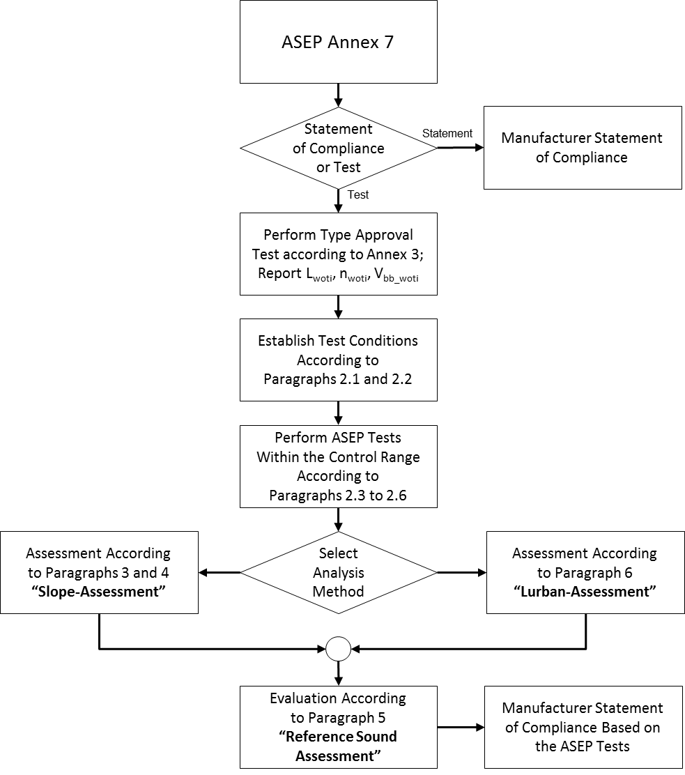

Figure 2: Flowchart for the vehicle sound assessment according to Annex 7 Paragraph 5. "Reference Sound Assessment"

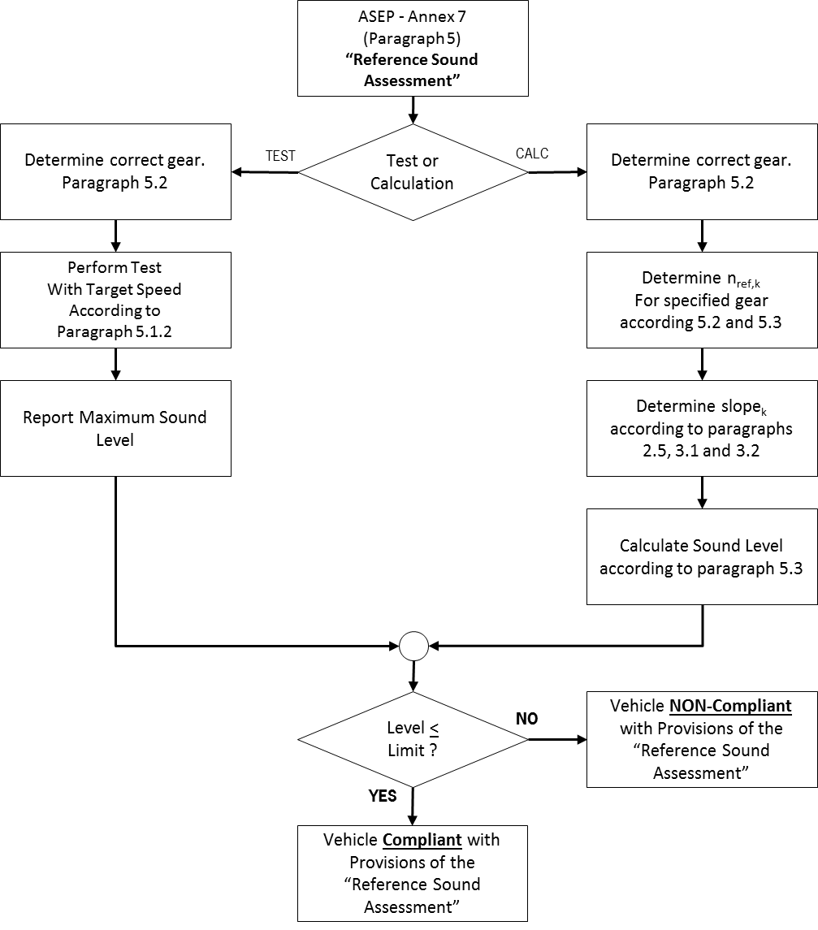
Figure 3: Flowchart for the determination of the individual test points P_{j} according to paragraph 2.

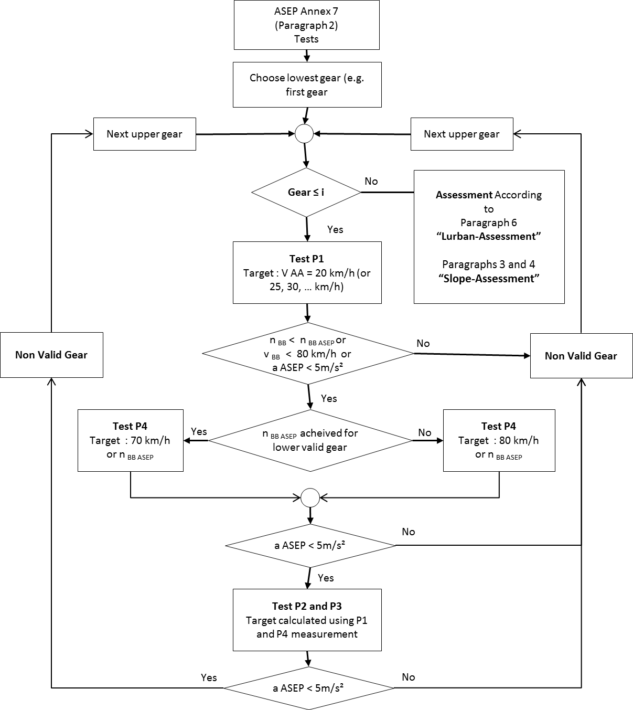"

II. Justification

There are several possibilities of misunderstanding and confusions which may induce different interpretations on application.

