Proposal to Regulation No.129 (this doc. is the follow up of CRS-60-xx discussed during 61st IWG CRS meeting, item 6.1.)
Paragraph 6.1.3.4., amend to read:
"6.1.3.4. Enhanced Child Restraint Systems of the i-Size booster seat category shall have a main load-bearing contact point, between the Enhanced Child Restraint System and the webbing of the adult safety belt. This point shall not be less than 65 mm above the test bench cushion [not be more than 115 mm above] and not be less than 150 mm from the Cr axis when measured with the Enhanced Child Restraint System on the dynamic test bench installed in accordance with paragraph 7.1.3.5.2.2. of this Regulation, without a dummy. This shall be measured in a longitudinal plane making use of the Standard seat belt configuration for the fitting session described in figure 1B of Annex 23. This shall apply to all adjustment configurations and variable belt paths.

Paragraph 6.2.1.6., amend to read:
"6.2.1.6. For i-Size or specific vehicle booster seats, the lap portion of the adult seat belt shall be positively guided on both sides to ensure that the loads transmitted by the adult lap belt are transmitted through the pelvis. The positive guidance of loads over the pelvis shall be realized from the moment that the child is installed and the lap belt shall cover the fold between thigh and pelvis. The angle between the tangent line in wjich the lap belt touches the thighs and the horizontal shall be greater than 10 °.
The shoulder portion of the adult safety belt shall be positively guided to ensure that the child torso and neck do not escape.
Moreover, the design shall be such that compression loads shall not be imposed on the crown of the child’s head in the event of a collision;"

Paragraph 6.2.1.7., amend to read:
"6.2.1.7. All straps of the restraint ECRS belts and used vehicle belts shall be so placed or guided that they cannot cause discomfort to the wearer in normal use or assume a dangerous configuration. In particular:
-Y-shaped belts are not permitted on forward facing Enhanced Child Restraint Systems and may only be used in dedicated rearward facing and or lateral facing Enhanced Child Restraint Systems (carrycots).
-The distance between the shoulder-straps in the vicinity of the neck should be at least the width of the neck of the appropriate dummy.
-In case of booster seats, the ease with which the straps and tongue of an adult belt pass through the fixture points shall be examined. This goes particularly for booster seats which are designed for the front seats of cars, which may have long semi-rigid stalks. The fixed buckle should not be allowed to pass through the fixture points of booster seats, or to permit a lie of belt completely different from that of the test-trolley. This latest point shall be tested during a separate fitting session on the test bench having replaced as well the central part of the standard safety belt (figure 3 of Annex 23) as part A2 with its X mm of flexible strap length, by respectively a tongue and a generic buckle both attached to webbing such that the top of the tongue is projecting 150 mm outside the Cr point; one and another defined in figure 5 of Annex 23.
Herein the CRS will be equipped with the adapted gabarit (Annex 22-extended, tool with a width of 225 mm (for stature 105 – 135 mm) and 255 mm for stature above 135 mm). In the zone with red horizontal lines, the lap belt and the lap belt/buckle tongue combination shall cover the distance between the Cr point and the point BP on the curved edge, in a straight line without twisting.

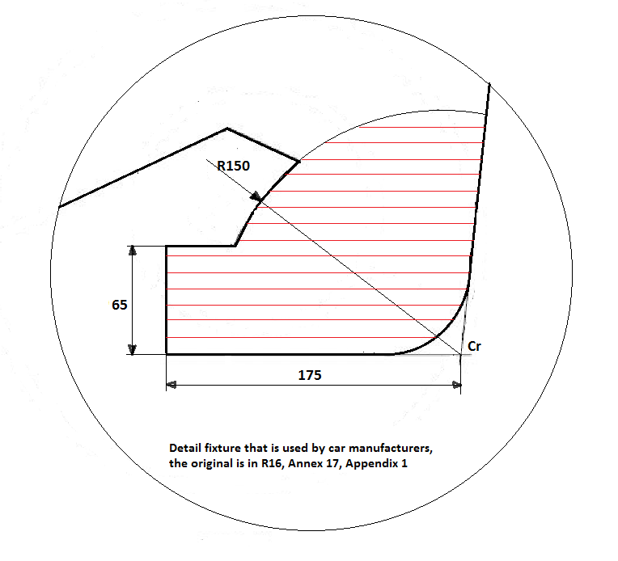
Photo’s of this assessment from both side have to be added to the test report.

"
Paragraph 6.7. - 6.7.1.1.., amend to read:
“6.7. Provisions applicable to individual components of the restraint
6.7.1. Buckle and tongue
6.7.1.1. The buckle shall be so designed as to preclude any possibility of incorrect manipulation. This means, inter/alia, that it shall not be possible for the buckle to be left in a partially closed position; it shall not be possible to exchange the buckle parts inadvertently when the buckle is being locked; the buckle shall only lock when all parts are engaged. Wherever the buckle is and/or tongue are in contact with the child, it the contact surface shall not be narrower than the minimum width of strap as specified in paragraph 6.7.4.1.1. below. This paragraph is not applicable to belt assemblies already approved according to Regulation No. 16 or any equivalent standard in force. In the case of a "Special Needs Restraint" only the buckle on the primary means of restraint need comply with the requirements of paragraphs 6.7.1.2. to 6.7.1.8. inclusive.”
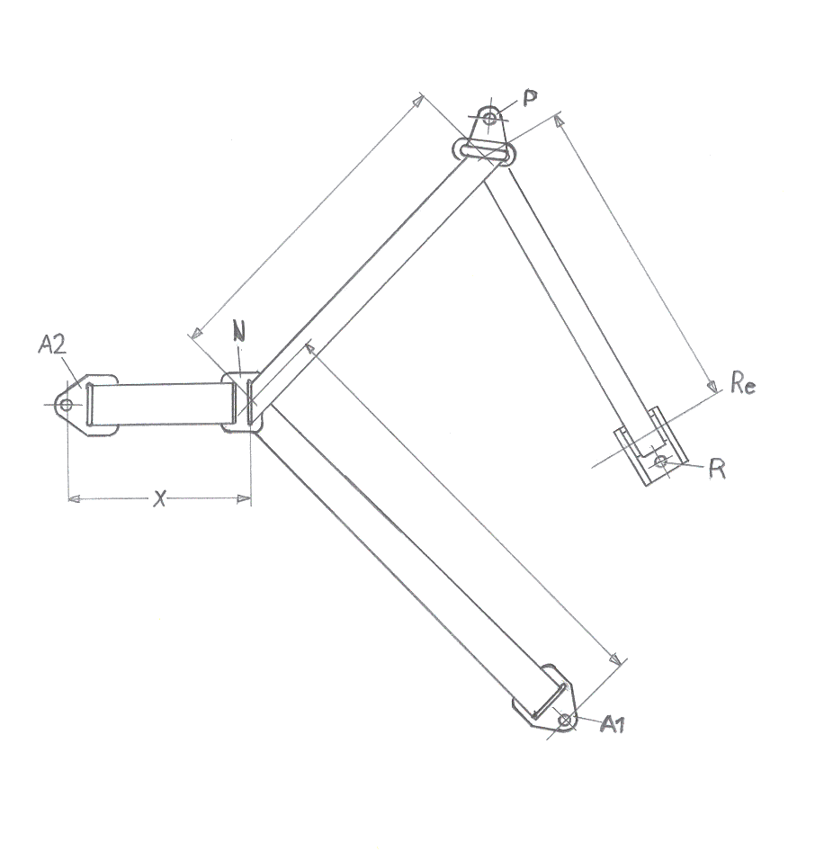
Annex 23, Figure 1, amend to read:

Figure 1A

Standard seat belt configurations, for dynamic test

Figure 1B

Standard seat belt configuration, for fitting session of par.6.1.3.4. and 6.2.12.
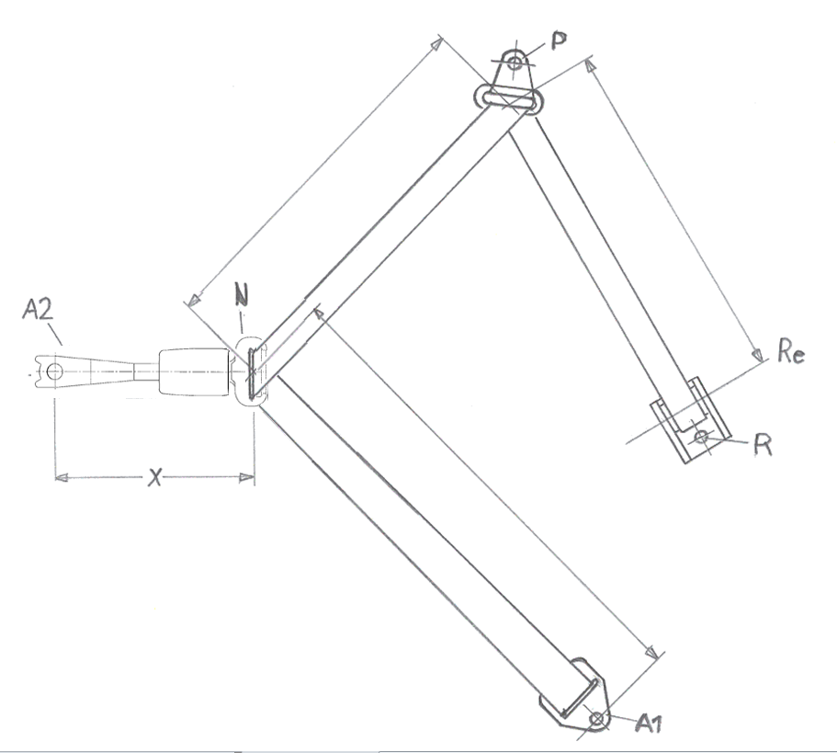
90-110

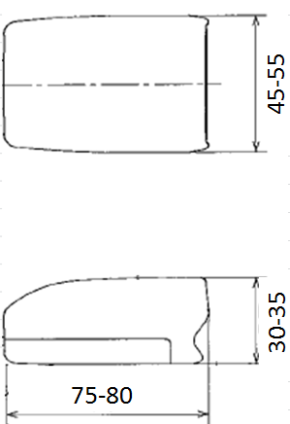
Buckle dimensions

Figure 1B

Standard seat belt configuration, for fitting session of par.6.2.12.dynamic test

II. Justification
- Requirements for car manufacturers (Regulation No. 16, Annex 17, Appendix 1, which allows a certain zone) are NOT compatible with requirements for Child Restraint System (CRS) manufacturers (Regulation No. 129, paragraph 6.1.3.4., asks for a different zone). The adult belt is supposed to run over the angle between adult thighs (that are more “fat” and the adult pelvis (that has a bigger depth). Therefore the required zone for the Child Restraint Systems has been adapted such that the routing of the adult belt over the child restraint has to closer to the intended use and design of the adult belt.
---------------------------

