Proposal for the 03 series of amendments as Phase 3 of
Regulation No. 129 (Enhanced Child Restraint Systems)

Prepared by CLEPA experts as input to Informal Group proposal to GRSP.

- Proposal
Paragraph 6.6.4.4.1.1., amend to read:
6.6.4.4.1.1. Forward facing Enhanced Child Restraint Systems
Head excursion: No part of the head of the dummy shall pass beyond the planes BA, DA and DE as defined in Figure 1 below. This shall be judged up to 300 ms or the moment that the dummy has come to a definitive standstill whatever occurs first. Except for booster seats when testing using Q10 dummy where:
- The value in relation tot he DA plane is 840 mm; and
- The value in relation tot he BA plane is 550 mm; and
- The rebound phase is not considered fort he assessment of plane DA and DE

- Figure 1
Arrangement for testing a forward-facing device
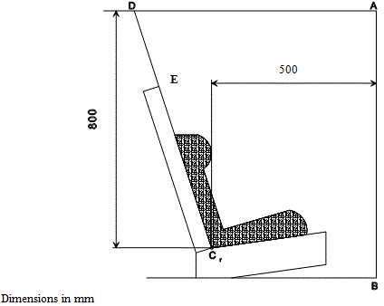

840

- Justification
A vertical displacement of 840 mm. should be accepted for all dummies, since it’s already accepted for the Q10 dummy.

- Proposal
Paragraph 6.6.4.4.1.2.1, amend to read:
6.6.4.4.1.2.1. Head excursion: no part of the head of the dummy shall pass beyond the planes FD, FG and DE, as shown in figure 2 below. This shall be judged up to 300 ms or the moment that the dummy has come to a definitive standstill whatever occurs first.

Figure 2
Arrangement for testing a rearward-facing device, not supported by the dashboard
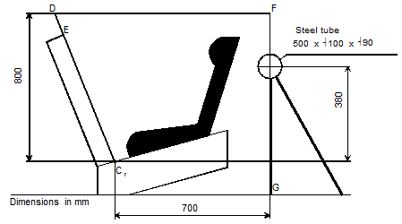

840

- Justification
A vertical displacement of 840 mm. should be accepted for all dummies, since it’s already accepted for the Q10 dummy.

