Proposal for:
- a “Base” definition;
- an approval label for a Universal Belted base
- an approval label for a Specific Vehicle belted base.

Phase 2 update.
Rationele:
In R129 we define and use the words “module”, “modules”and “Base” .
The module is defined in 2.57, but the base is not. This proposal is aimed to define the word “Base”.
Base is used in the regulation in the following locations:
2.57 Module definition,
6.3.4.2.3. ISOFIX SL requirements,
7.2.8. ISOFIX connector component test and in
Annex 2, Module mark.
To provide context, the R129 currently already writes:

2.57. "Module",
is a part of an ECRS that is separate from the ISOFIX attachments and is in direct contact with the child. A module can be used whether or not as a stand-alone to restrain a child in a car. A base is allowed to accept more than one module (Module A, Module B, etc.).

Proposals:

Part 1. to add a definition of a base as 2.60:

2.60. "Base",
is a part of an ECRS that forms an adapter between the vehicle and the module of an ECRS and has no direct contact with the child. A base could be connected to the vehicle using ISOFIX anchors, the vehicle belt, a top tether or a support leg or a combination thereof as specified in this regulation. A base is allowed to accept more than one module (Module A can be replaced by Module B, etc.).

Part 2. Adjust the “Module” definition in 2.57.
- No need to specify the connection type (“ISOFIX”) anymore, as now a base is defined.
- Remove the last sentence (talking about bases) from the Module definition, as bases are covered with this proposal for a base definition
- Replace ‘can’ with ‘may’ as the stand-alone, belted mode is optional, and not a must. A belted baby shell is a module with an optional mode to use it stand-alone; belted without base. The baby shell however is not required to have provisions for a stand- alone belted use.

2.57. "Module",
is a part of an ECRS that is separate from the ISOFIX attachments base and is in direct contact with the child. A module can may be used whether or not as a stand-alone to restrain a child in a car if approved according to annex 22. A base is allowed to accept more than one module (Module A, Module B, etc.).
Subsequently, Annex 2, chapter 2 needs approval mark examples for a Universal belted base and a Specific Vehicle belted base, as those product do not fall under the current approval possibilities presented (they are not ‘i-Size Universal ISOFIX’, nor ‘Vehicle Specific ISOFIX’)
Propose to add the following images and text at the end of Annex 2, Chapter 2 “Arrangements of the approval mark in combination with a module mark.”
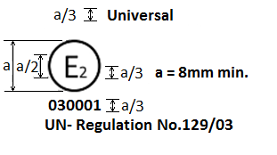
The Enhanced Child Restraint System bearing the above approval mark is a device, including module(s), capable of being fitted in any universal vehicle seating position. It is approved in France (E 2) under the number 030001. The approval number indicates that the approval was granted in accordance with the requirements of the Regulation concerning the approval of Enhanced Child Restraint Systems used on board of motor vehicles as amended by the 03 series of amendments. In addition the name of the regulation has to be identified on the approval mark followed by the series of amendment according to which the approval has been granted.
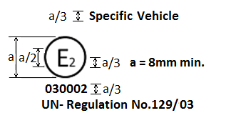

The Enhanced Child Restraint System bearing the above approval mark is a device, including module(s), capable of being fitted in a specific vehicle seating position. It is approved in France (E 2) under the number 030002. The approval number indicates that the approval was granted in accordance with the requirements of the Regulation concerning the approval of Enhanced Child Restraint Systems used on board of motor vehicles as amended by the 03 series of amendments. In addition the name of the regulation has to be identified on the approval mark followed by the series of amendment according to which the approval has been granted.

Proposal to correct the reference to the UN regulation (including the minus “-“sign):
Replace the following images of Annex 2, Chapter 2:
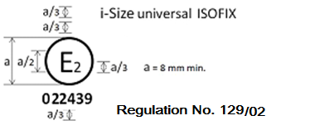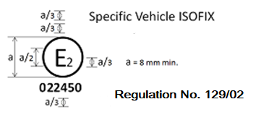
Both current Labels are also up for improvement:
- Second from top “a/3” size indication has no use (was the location of the size range).
- Should read UN-Regulation No. R129/02 (including ‘UN-’)
Suggestion see below
To be used for bases of modular systems of the Specific Vehicle category
To be used for bases of modular systems fitting Universal F2X / R2 ISOFIX products

With the following images:
