Annex 18

Geometrical dimensions of Enhanced Child Restraint Systems

Figure 1.
Applicable to all ECRS |  |  |  |  |  |  | Additional internal dimensions for ECRS with shield systems
 | Min | Min | Min | Min | Max |  | Min | Max | Min | Max
Stature | Sitting height  cm | Shoulder breadth  cm | Hip breadth  cm | Shoulder height  cm | Shoulder height  cm |  | Abdomen depth  cm | Abdomen depth  cm | Upper leg thickness cm | Upper leg thickness cm
A | B | C | D | E1 | E2 |  | F1 | F2 | G1 | G2
 | 95%ile | 95%ile | 95%ile | 5%ile | 95%ile |  | 5%ile | 95%ile | 5%ile | 95%ile
≤40 |  |  |  | < 27.4 |  |  | Not allowed for these dimensions and stature bellow 76 cm
45 | 39.0 | 12.1 | 14.2 | 27.4 | 29.0
50 | 40.5 | 14.1 | 14.8 | 27.6 | 29.2
55 | 42.0 | 16.1 | 15.4 | 27.8 | 29.4
60 | 43.5 | 18.1 | 16.0 | 28.0 | 29.6
65 | 45.0 | 20.1 | 17.2 | 28.2 | 29.8
70 | 47.1 | 22.1 | 18.4 | 28.3 | 30.0
75 | 49.2 | 24.1 | 19.6 | 28.4 | 31.3 |  | 12.5 | 15.1 | 5.7 | 8.4
80 | 51.3 | 26.1 | 20.8 | 29.2 | 32.6 |  | 12.7 | 15.7 | 5.8 | 8.4
85 | 53.4 | 26.9 | 22.0 | 30.0 | 33.9 |  | 12.9 | 16.2 | 5.9 | 8.5
90 | 55.5 | 27.7 | 22.5 | 30.8 | 35.2 |  | 13.1 | 16.8 | 6.2 | 8.5
95 | 57.6 | 28.5 | 23.0 | 31.6 | 36.5 |  | 13.3 | 17.8 | 6.5 | 8.9
100 | 59.7 | 29.3 | 23.5 | 32.4 | 37.8 |  | 13.5 | 18.2 | 6.5 | 9.6
105 | 61.8 | 30.1 | 24.9 | 33.2 | 39.1 |  | 13.6 | 18.8 | 6.6 | 10.3
110 | 63.9 | 30.9 | 26.3 | 34.0 | 40.4 |  | 13.9 | 19.6 | 6.6 | 10.3
115 | 66.0 | 32.1 | 27.7 | 35.5 | 41.7 |  | 13.9 | 19.9 | 6.6 | 10.4
120 | 68.1 | 33.3 | 29.1 | 37.0 | 43.0 |  | 14.3 | 20.2 | 6.8 | 10.5
125 | 70.2 | 33.3 | 29.1 | 38.5 | 44.3 |  | 14.7 | 20.7 | 7.5 | 10.9
130 | 72.3 | 33.3 | 29.1 | 40.0 | 46.1 |  | Not allowed for these dimensions and stature over 125 cm
135 | 74.4 | 33.3 | 29.1 | 41.5 | 47.9
140 | 76.5 | 34.2 | 29.6 | 43.0 | 49.7
145 | 78.6 | 35.3 | 30.8 | 44.5 | 51.5
150 | 81.1 | 36.4 | 32.0 | 46.3 | 53.3
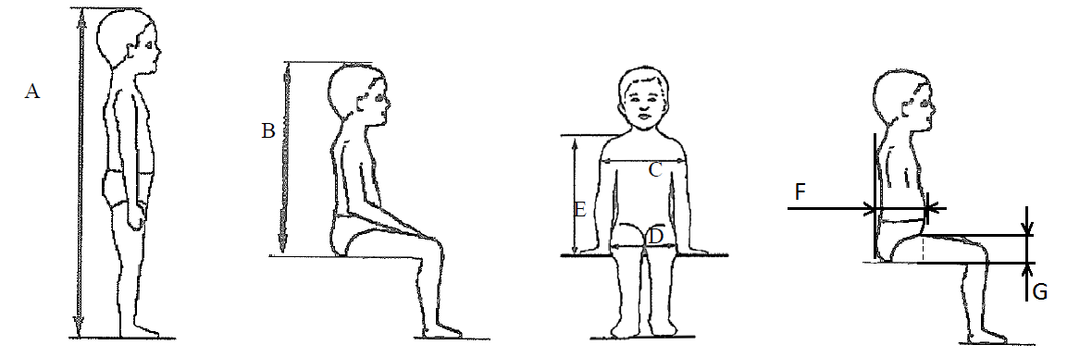

Table 1

All lateral dimensions are measured under a contact force of 50 N with the devices described in Figure 2 & Figure 3 of this annex and the following tolerances will applied:
Minimum Sitting height:
- up to 87 cm B - 5 per cent
- From stature from 87 cm and up to 150 cm B - 10 per cent,
Minimum shoulder height (5 percentile): E1 ₋₂⁺⁰ cm
Maximum shoulder height (95 percentile): E2 ₋₀⁺² cm
The mass of the devices described in Figure 2 & Figure 3 of this annex shall be 10 kg +/- 1 kg

Figure 2: ECRS Measurement Device
Side and Front View of the measuring device
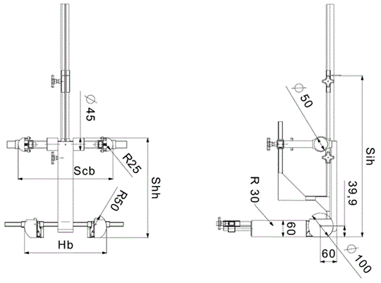
All dimensions in mm

Figure 3: Measurement Device for ECRS with Impact Shield
Side and Front View of the measuring device
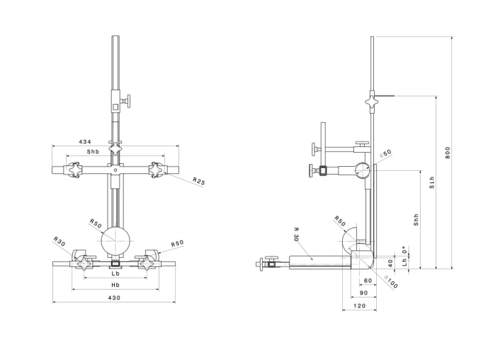
All dimensions in mm

Internal geometry assessment method
This method describes how to conduct the internal geometry assessment, as required by 6.3.2.1., to verify the stature range of the ECRS declared by the manufacturer.
This assessment shall be carried out for each of the following:
- For each ECRS orientation (e.g. rearward and forward facing)
- For each ECRS type (e.g. integral and non-integral)
- For any removable insert (e.g. for use as described by manufacturer’s instructions)
- For each occupant restraint method (e.g. harness & shield)
The internal geometry assessment should be conducted with the ECRS placed on a flat surface or connected to a base in the case of ECRS modules.
For integral or non-integral ECRS the device shown in Annex 18, Figure 2 shall be used.
For ECRS with an impact shield the device shown in Annex 18,Figure 3 shall be used.

Determining the Minimum Occupant size
The ECRS should be adjusted to fit the smallest occupant (i.e. headrest height, harness height adjustment, appropriate insert, internal padding, impact shield position), whilst still fitting within the required ISO volumetric envelope as defined in 6.3.2.2.
The measurement device shall then be placed in the ECRS. The device shall be aligned centrally to the ECRS.
All measurements shall be taken with the device base in contact with the seat pan of the ECRS and the device backrest in contact with the backrest of the ECRS
The measurements shall be taken in the following order:

Minimum Shoulder Height (E1)

For integral ECRS:
This measurement shall be taken when the top of the shoulder height cylinders of the device are aligned with the lowest harness slot position. For this alignment, the top of the shoulder cylinder shall be aligned perpendicular to the harness webbing outlet in the ECRS backrest.
A tolerance may be subtracted from this measurement to allow the shoulders of the occupant to be lower than the harness shoulder slots.
Either:
- If the ECRS instruction manual provided by the manufacturer quantifies the distance the child’s shoulder may be below the harness slots, then this distance shall be subtracted from the minimum shoulder height measurement.
- If no distance is specified a 2 cm tolerance may be subtracted from the minimum shoulder height measurement

For non-integral ECRS
This measurement shall be taken when the top of the shoulder height cylinders of the device are aligned without interference with the lowest part of the headrest.

For ECRS with an impact shield:
This measurement shall be taken when the top of the shoulder height cylinders of the device are aligned without interference with the lowest part of the headrest.

Minimum Upper Leg Thickness (G1)
This requirement only applies to ECRS with impact shields.
Whilst maintaining the minimum shoulder height position (E1), the minimum leg measurement shall be measured when the device is adjusted so that the simulated thighs contact the bottom of the impact shield.

Minimum Abdomen Depth (F1)
This requirement only applies to ECRS with impact shields
This measurement shall be taken whilst maintaining the minimum leg thickness measurement position (G1) and minimum shoulder height position (E1).
The bottom of the simulated abdomen of the device shall be aligned with the top of the simulated thighs.
The abdomen depth shall be measured when the simulated abdomen contacts the shield.

Determining the Maximum Occupant Size
Integral ECRS shall be adjusted to fit the largest occupant (i.e. headrest height, harness height adjustment, impact shield position), whilst still fitting within the required ISO volumetric envelope as defined in 6.3.2.2.1.
Non-integral ECRS shall be adjusted to accommodate children of 135 cm stature or to the largest size of its declared stature range if the upper limit is below 135 cm (i.e. headrest), whilst still fitting within the required ISO volumetric envelope as defined in 6.3.2.2.2.
The measurement device shall then be placed in the ECRS. The device shall be aligned centrally to the ECRS.
The measurements shall then be taken in the following order:

Sitting Height (B)
This measurement shall be taken to the highest part of the ECRS that is the effective headrest (head pad or backrest).
A tolerance is added to this measurement to allow part of the head to protrude from the ECRS:
- +5% for stature ranges below 87cm
- +10% for statures ranges above 87cm

Hip Breadth (D)
The hip breadth measurement shall be taken whilst maintaining the sitting height measurement (B).
The hip breadth measurement shall be taken whilst asserting a 50 N contact force on the ECRS.
If 50 N force cannot be achieved, because the ECRS restricts the space at the simulated thighs then the measurement should be taken at the point the simulated thighs contact the ECRS. There shall be no lateral deformation of the ECRS caused by the measuring device.

Maximum Shoulder Height (E2)
The maximum shoulder height measurement shall be taken whilst maintaining the sitting height (B) and hip breadth (D) measurements.

For integral ECRS
This measurement shall be taken when the top of the shoulder height cylinders of the device are aligned with the highest harness slot position still fitting within the required ISO volumetric envelope. For this alignment, the top of the shoulder cylinder shall be aligned perpendicular to the harness webbing outlet in the ECRS backrest.
A tolerance may be added to this measurement to allow the shoulders of the occupant to be higher than the harness shoulder slots. However if there is a physical restriction due to the design of the ECRS (e.g. the headrest) that would prevent a child with taller shoulders fitting the tolerance should not be added.
If there is no possible interference then the following tolerances may be added:
- If the ECRS instruction manual provided by the manufacturer quantifies the distance the child’s shoulder may be above the harness slots, then this distance shall be added to the maximum shoulder height measurement.
- If no distance is specified a 2 cm tolerance may be added to the maximum shoulder height measurement

For non-integral ECRS
This measurement shall be taken when the top of the shoulder height cylinders of the device are aligned without interference with the lowest point of the headrest, this includes any belt routing guide.
No tolerance shall be added to this measurement.

For ECRS with an impact shield
This measurement shall be taken when the top of the shoulder height cylinders of the device are aligned without interference with the lowest point of the headrest, this includes any belt routing guide.
No tolerance shall be added to this measurement.

Maximum Upper Leg Thickness (G2)
This requirement only applies to ECRS with impact shields.
This measurement shall be taken whilst maintaining the sitting height (B), hip breadth (D) and maximum shoulder height (E2) measurements.
The maximum upper leg thickness measurement shall be measured when the device is adjusted so that the simulated thighs contact the bottom of the impact shield.

Maximum Abdomen Depth (F2)
This requirement only applies to ECRS with impact shields.
This measurement shall be taken whilst maintaining the maximum upper leg thickness (G2), maximum shoulder height (E2), hip breadth (D) and sitting height (B) measurement positions.
The bottom of the simulated abdomen of the device shall be aligned with the top of the simulated thighs.
The abdomen depth shall be measured when the simulated abdomen contacts the shield.

Shoulder Breadth (C)
The shoulder breadth measurement shall be taken whilst maintaining the sitting height (B) and hip breadth (D) measurements.
The width of the ECRS at the maximum shoulder height measurement position shall be measured whilst asserting a 50N contact force on the ECRS.
If there is no side wing structure to the ECRS at the maximum shoulder height (E2), the shoulder breadth measurement shall be taken at a height, which is the closest proximity to the maximum shoulder height, with side wing structure.
If the width of the ECRS between the minimum and maximum shoulder height measurements is not a consistent width i.e. significantly narrower at any point between the E1 and E2 measurements, then an intermediate shoulder breadth measurements shall be taken.

Stature Calculation
The measurements taken in Section 1 & 2 shall then be compared to the values shown in Annex 18, Table 1.
Interpolation between the values shown in the table is allowed in one centimetre intervals
For each measurement the corresponding stature at the nearest whole lower centimetre shall be calculated.

For the measurements B, C, D, E2, F2 and G2 the measured value must be greater or equal to the value shown in the table to meet the stature requirement.
e.g. To declare a stature of 105 cm the measured sitting height must be greater or equal to 61.8 cm
For the measurements E1, F1 and G1 the measured value must be less than or equal to the value shown in the table to meet the stature requirement.
e.g. To declare a stature of 100 cm the measured sitting height must be less than or equal to 59.7 cm
The maximum stature is the smallest stature calculated from the measurements B, C, D, E2, F2 and G2.
The minimum stature is the largest stature calculated from the measurements E1, F1 and G1.

