Contents
EVS-02-13

1. Scope and Purpose 3
2. Application 3
3. Definitions 3
4. General requirements 6
5. Performance requirements 7
5.1. Requirements of a vehicle with regard to its electrical safety - in-use 7
5.1.1. Protection against electric shock 7
5.1.2. Rechargeable energy storage system (REESS) 10
5.1.3. Functional safety 11
5.2. Requirements of a vehicle with regard to its electrical safety - post-crash 11
5.2.1. General 11
5.2.2. Protection against electric shock 11
5.2.3. REESS post-crash requirements 13
5.3. Requirements with regard to the safety of REESS 14
5.3.1 General 14
5.3.2. Vibration 14
5.3.3. Thermal shock and cycling 14
5.3.4. Mechanical impact 15
5.3.5. Fire resistance 16
5.3.6. External short circuit protection 16
5.3.7. Overcharge protection 17
5.3.8. Over-discharge protection 17
5.3.9. Over-temperature protection 17
7. Test procedures 17
7.1 Test procedures for electrical safety 17
7.1.1. Isolation resistance measurement method 17
7.1.2. Confirmation method for functions of on-board isolation resistance monitoring system 22
7.1.3. Protection against direct contact to live parts 22
7.1.4. Test method for measuring electric resistance 24
7.1.5. Test conditions and test procedure regarding post-crash 25
7.2. REESS test procedures 29
7.2.1. Procedure for conducting a standard cycle 29
7.2.2. Vibration test 29
7.2.3. Thermal shock and cycling test 30
7.2.4. Mechanical shock test 31
7.2.5. Mechanical integrity test 33
7.2.6. Fire resistance test 34
7.2.7. External short circuit protection 39
7.2.8. Overcharge protection test 40
7.2.9. Over-discharge protection test 41
7.2.10. Over-temperature protection test 42

1. Scope and Purpose
This regulation specifies safety-related performance of electrically propelled road vehicles and their rechargeable energy storage systems. The purpose of this regulation is to avoid human harm that may occur from the electric power train.

2. Application
This regulation applies to all vehicles of Category 1-1 and 1-2, with a gross vehicle mass (GVM) of 4,536 kilograms or less, equipped with electric power train containing high voltage bus, excluding vehicles permanently connected to the grid.

In addition, the following vehicles are excluded:

a) A vehicle with four wheels whose unladed mass is not more than 350 kg, not including the mass of the batteries in case of electric vehicles, whose maximum design speed is not more than 45 km/h, and whose engine cylinder capacity does not exceed 50 cm³ for spark (positive) ignition engines, or whose maximum net power output does not exceed 4 kW in the case of other internal combustion engines, or whose maximum continuous rated power does not exceed 4 kW in the case of electric engines.

and

b) A vehicle with four wheels, other than that classified under a) above, whose unladed mass is not more than 400 kg, not including the mass of batteries in the case of electric vehicles and whose maximum continuous rated power does not exceed 15 kW.

3. Definitions
For the purpose of this Regulation the following definitions apply:

3.1. "Active driving possible mode" means the vehicle mode when application of pressure to the accelerator pedal (or activation of an equivalent control) or release of the brake system will cause the electric power train to move the vehicle.

3.2 "Automatic disconnect" means a device that when triggered, conductively separates the electric energy sources from the rest of the high voltage circuit of the electric power train.

3.3. “Cell” means a single encased electrochemical unit containing one positive and one negative terminal which exhibits a voltage differential across its two terminals and used as rechargeable energy storage device. This definition does not apply if described as "fuel cell".

3.4. "Conductive connection" means the connection using connectors to an external power supply when the rechargeable energy storage system (REESS) is charged.

3.5. "Coupling system for charging the rechargeable energy storage system (REESS)" means the electrical circuit used for charging the REESS from an external electric power supply including the vehicle inlet.

3.6. "C Rate" of "n C" is defined as the constant current of the Tested-Device, which takes 1/n hours to charge or discharge the Tested-Device between 0% SOC and 100% SOC.

3.7. "Direct contact" means the contact of persons with high voltage live parts.

3.8. "Electric energy conversion system" means a system (e.g. fuel cell) that generates and provides electric energy for electrical propulsion.

3.9. "Electric power train" means the electrical circuits which includes the traction motor(s), and may also include the REESS, the electric energy conversion system, the electronic converters, the associated wiring harness and connectors, and the coupling system for charging the REESS.

Need for a definition of a traction motor?

3.10. "Electrical chassis" means a set made of conductive parts electrically linked together, whose electrical potential is taken as reference.

3.11. "Electrical circuit" means an assembly of connected high voltage live parts which is designed to be electrically energized in normal operation.

3.12. "Electrical protection barrier" means the part providing protection against any direct contact to the high voltage live parts.

3.13. "Electronic converter" means a device capable of controlling and/or converting electric power for electrical propulsion.

3.14. "Enclosure" means the part enclosing the internal units and providing protection against any direct contact.

3.15. "Explosion" means the sudden release of energy sufficient to cause pressure waves and/or projectiles that may cause structural and/or physical damage to the surrounding of the Tested-Device.

3.16. "Exposed conductive part" means the conductive part which can be touched under the provisions of the protection IPXXB, and which becomes electrically energized under isolation failure conditions. This includes parts under a cover that can be removed without using tools.

3.17. "External electric power supply" means an alternating current (AC) or direct current (DC) electric power supply outside of the vehicle.

3.18. "Fire" means the emission of flames from a Tested-Device. Sparks and arcing shall not be considered as flames.

3.19. “Flammable electrolyte” means an electrolyte that contains substances classified as Class 3 “flammable liquid” under “UN Recommendations on the Transport of Dangerous Goods - Model Regulations (Revision 17 from June 2011), Volume I, Chapter 2.3” /

3.20. "High voltage" means the classification of an electric component or circuit, if its working voltage is > 60 V and ≤ 1500 V DC or > 30 V and ≤ 1000 V AC root mean square (rms).

3.21. "High voltage bus" means the electrical circuit, including the coupling system for charging the REESS, that operates on high voltage.

3.22. "Indirect contact" means the contact of persons with exposed conductive parts.

3.23. "Live parts" means conductive part(s) intended to be electrically energized in normal use.

3.24. "Luggage compartment" means the space in the vehicle for luggage accommodation, bounded by the roof, hood, floor, side walls, as well as by the barrier and enclosure provided for protecting the occupants from direct contact with live parts, being separated from the passenger compartment by the front bulkhead or the rear bulk head.

3.25. "Manufacturer" means the person or body who is responsible to the approval authority for all aspects of the approval process and for ensuring conformity of production. It is not essential that the person or body is directly involved in all stages of the construction of the vehicle or component which is the subject of the approval process.

3.26. "On-board isolation resistance monitoring system" means the device which monitors the isolation resistance between the high voltage buses and the electrical chassis.

3.27. "Passenger compartment (for electric safety assessment)" means the space for occupant accommodation, bounded by the roof, floor, side walls, doors, window glass, front bulkhead and rear bulkhead, or rear gate, as well as by the electrical protection barriers and enclosures provided for protecting the occupants from direct contact with live parts.

3.28. "Protection IPXXB" means protection from contact with high voltage live parts provided by either an electrical protection barrier or an enclosure and tested using a Jointed Test Finger (IPXXB) as described in 7.1.3.

3.29 "Protection IPXXD" means protection from contact with high voltage live parts provided by either an electrical protection barrier or an enclosure and tested using a Test Wire (IPXXD) as described in paragraph 7.1.3.

3.30 "Rechargeable energy storage system (REESS)" means the rechargeable energy storage system that provides electric energy for electrical propulsion.
A battery whose primary use is to supply power for starting the engine and/or lighting and/or other vehicle auxiliaries systems is not considered as a REESS.
The REESS may include subsystem(s) together with the necessary ancillary systems for physical support, thermal management, electronic control and casing.

3.31. "Rupture" means opening(s) through the casing of any functional cell assembly created or enlarged by an event, large enough for a 12 mm diameter test finger (IPXXB) to penetrate and make contact with live parts (see paragraphs 7.1.3. and 7.1.5.2.4.).

3.32. "Service disconnect" means the device for deactivation of the electrical circuit when conducting checks and services of the REESS, fuel cell stack, etc.

3.32. "Solid insulator" means the insulating coating of wiring harnesses, provided in order to cover and prevent the high voltage live parts from any direct contact. This includes covers for insulating the high voltage live parts of connectors; and varnish or paint for the purpose of insulation.

3.33. “State of charge (SOC)” means the available electrical charge in a Tested-Device expressed as a percentage of its rated capacity.

3.34. “Subsystem” means any functional assembly of REESS components.

3.35. "Tested-Device" means either the complete REESS or the subsystem of a REESS that is subjected to the tests prescribed by this regulation.

3.36. "Working voltage" means the highest value of an electrical circuit voltage root-mean-square (rms), specified by the manufacturer, which may occur between any conductive parts in open circuit conditions or under normal operating condition. If the electrical circuit is divided by galvanic isolation, the working voltage is defined for each divided circuit, respectively.

4. General requirements
4.1. The vehicle in the application of this regulation as prescribed in paragraph 2 shall meet the requirements of paragraphs 5.1. and 5.2. using the test conditions and procedures in paragraph 7.1.

4.2. The REESS for the vehicle in the application of this regulation as prescribed in paragraph 2, regardless of its nominal voltage or working voltage, shall meet the requirements of paragraph 5.3. using the test conditions and procedures in paragraph 7.2.

4.3. Each Contracting Party under the UN1998 Agreement shall maintain its existing national crash tests and use the limit values of paragraph 5.2.2. for compliance.

5. Performance requirements

5.1. Requirements of a vehicle with regard to its electrical safety - in-use

5.1.1. Protection against electric shock
These electrical safety requirements apply to high voltage buses under conditions where they are not connected to the external electric power supply.

5.1.1.1. Protection against direct contact
Protection against direct contact with live parts is also required for vehicles equipped with any REESS certified as a component and part of the vehicles high voltage bus.
The protection against direct contact with live parts shall comply with paragraphs 5.1.1.1.1.and 5.1.1.1.2. These protections (solid insulator, electrical protection barrier, enclosure, etc.) shall not be opened, disassembled or removed without the use of tools.

5.1.1.1.1. For protection of live parts inside the passenger compartment or luggage compartment, the protection IPXXD shall be provided.
5.1.1.1.2. For protection of live parts in areas other than the passenger compartment or luggage compartment, the protection IPXXB shall be provided.

5.1.1.1.3. Connectors
Connectors (including vehicle inlet) are deemed to meet this requirement if:
- they comply with paragraphs 5.1.1.1.1. and 5.1.1.1.2. when separated without the use of tools, or
- they are located underneath the floor and are provided with a locking mechanism, or
- they are provided with a locking mechanism and other components shall be removed with the use of tools in order to separate the connector, or
- the voltage of the live parts becomes equal or below DC 60V or equal or below AC 30V (rms) within 1 second after the connector is separated

5.1.1.1.4. Service disconnect
For a high voltage service disconnect which can be opened, disassembled or removed without tools, protection IPXXB shall be satisfied when it is opened, disassembled or removed without tools.

5.1.1.1.5. Marking
5.1.1.1.5.1. In the case of a REESS having high voltage capability the symbol shown in Figure 1 shall appear on or near the REESS. The symbol background shall be yellow, the bordering and the arrow shall be black.

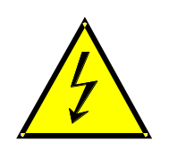
Figure 1 Marking of high voltage equipment

5.1.1.1.5.2. The symbol shall be visible on enclosures and electrical protection barriers, which, when removed, expose live parts of high voltage circuits. This provision is optional to any connectors for high voltage buses. This provision shall not apply to any of the following cases
- where electrical protection barriers or enclosures cannot be physically accessed, opened, or removed; unless other vehicle components are removed with the use of tools.
- where electrical protection barriers or enclosures are located underneath the vehicle floor

5.1.1.1.5.3. Cables for high voltage buses which are not located within enclosures shall be identified by having an outer covering with the color orange.

5.1.1.2. Protection against indirect contact
Protection against indirect contact is also required for vehicles equipped with any REESS certified as a component and part of the vehicle high voltage bus.

5.1.1.2.1. For protection against electric shock which could arise from indirect contact, the exposed conductive parts, such as the conductive electrical protection barrier and enclosure, shall be conductively connected and secured to the electrical chassis with electrical wire or ground cable, by welding, or by connection using bolts, etc. so that no dangerous potentials are produced.

5.1.1.2.2. The resistance between all exposed conductive parts and the electrical chassis shall be lower than 0.1 ohm when there is current flow of at least 0.2 amperes.
This requirement is satisfied if the connection has been established by welding. In case of doubts or the connection is established by other means than welding, a measurement shall be made by using one of the test procedures described in paragraph 7.1.4.

5.1.1.2.3. In the case of motor vehicles which are intended to be connected to the grounded external electric power supply through the conductive connection, a device to enable the conductive connection of the electrical chassis to the earth ground for the external electric power supply shall be provided.
The device shall enable connection to the earth ground before exterior voltage is applied to the vehicle and retain the connection until after the exterior voltage is removed from the vehicle.
Compliance to this requirement may be demonstrated either by using the connector specified by the car manufacturer, by visual inspection or drawings.

5.1.1.2.4. Isolation resistance
5.1.1.2.4.1. Electric power train consisting of separate Direct Current or Alternating Current buses.
If AC high voltage buses and DC high voltage buses are conductively isolated from each other, isolation resistance between the high voltage bus and the electrical chassis shall have a minimum value of 100 ohms/volt of the working voltage for DC buses, and a minimum value of 500 ohms/volt of the working voltage for AC buses.
The measurement shall be conducted according to 7.1.1.

5.1.1.2.4.2. Electric power train consisting of combined DC- and AC-buses
If AC high voltage buses and DC high voltage buses are conductively connected, isolation resistance between the high voltage bus and the electrical chassis shall have a minimum value of 500 Ω/volt of the working voltage.
However, if all AC high voltage buses are protected by one of the two following measures, isolation resistance between the high voltage bus and the electrical chassis shall have a minimum value of 100 ohms/volt of the working voltage.

Note FMVSS 305 requires the isolation monitoring sytem in the case there the lower level of isolation resistance is used
- at least two or more layers of solid insulators, electrical protection barriers or enclosures that meet the requirement in paragraph 5.1.1.1. independently, for example wiring harness;
- mechanically robust protections that have sufficient durability over vehicle service life such as motor housings, electronic converter cases or connectors.
The isolation resistance between the high voltage bus and the electrical chassis may be demonstrated by calculation, measurement or a combination of both.
The measurement shall be conducted according to paragraph 7.1.1.

5.1.1.2.4.3. Fuel cell vehicles
If the minimum isolation resistance requirement cannot be maintained over time, then protection shall be achieved by any of the following:

(a) at least two or more layers of solid insulators, electrical protection barriers or enclosures that meet the requirement in Paragraph 5.1.1.1. independently;
(b) on-board isolation resistance monitoring system together with a warning to the driver if the isolation resistance drops below the minimum required value. The isolation resistance between the high voltage bus of the coupling system for charging the REESS, which is not energized besides during charging the REESS, and the electrical chassis need not be monitored. The function of the on-board isolation resistance monitoring system shall be confirmed as described in 7.1.2.

5.1.1.2.4.4. Isolation resistance requirement for the coupling system for charging the REESS.
For the vehicle inlet intended to be conductively connected to the external AC electric power supply and the electrical circuit that is conductively connected to the vehicle inlet during charging the REESS, the isolation resistance between the high voltage bus and the electrical chassis shall be at least 1M ohms when the charger coupler is disconnected. During the measurement, the REESS may be disconnected.
The measurement shall be conducted according to paragraph 7.1.1.

5.1.2. Rechargeable energy storage system (REESS)
For a vehicle with a REESS, the requirement of either paragraph 5.1.2.1. or paragraph 5.1.2.2. shall be satisfied.

5.1.2.1. The REESS shall comply with the respective requirements of paragraph 5.3.

5.1.2.2. For a REESS which satisfies the requirements of paragraph 5.3. independently from the type of vehicle, the REESS shall be installed in accordance with the instructions provided by the manufacturer of the REESS.

5.1.3. Functional safety

5.1.3.1. At least a momentary indication shall be given to the driver when the vehicle is in "active driving possible mode''.
However, this provision does not apply under conditions where an internal combustion engine provides directly or indirectly the vehicle´s propulsion power upon start up.
5.1.3.2. When leaving the vehicle, the driver shall be informed by a signal (e.g. optical or audible signal) if the vehicle is still in the active driving possible mode.
5.1.3.3. The state of the drive direction control unit shall be identified to the driver.
5.1.3.4. If the REESS can be externally charged, vehicle movement by its own propulsion system shall be impossible as long as the connector of the external electric power supply is physically connected to the vehicle inlet.
This requirement shall be demonstrated by using the connector specified by the vehicle manufacturer.

5.2. Requirements of a vehicle with regard to its electrical safety - post-crash

5.2.1. General

The requirements of paragraphs 5.2.2. and 5.2.3. shall be checked in accordance with the methods set out in paragraph 7.1.5.
These requirements can be met by a separate crash test from that for the evaluation of occupant protection performance under the relevant crash regulations. This is only possible, if the electrical components do not influence the occupant protection performance.

5.2.2. Protection against electric shock
After the crash test at least one of the four criteria specified in paragraphs 5.2.2.1.to 5.2.2.4. shall be met.
If the vehicle has an automatic disconnect function, or device(s) that conductively divide the electric power train circuit during driving condition, at least one of the following criteria shall apply to the disconnected circuit or to each divided circuit individually after the disconnect function is activated.
However criteria defined in paragraph 5.2.2.4. shall not apply if more than a single potential of a part of the high voltage bus are not protected under the conditions of protection IPXXB.
In the case that the crash test is performed under the condition that part(s) of the high voltage system are not energized, the protection against electric shock shall be proved by either paragraph 5.2.2.3. or paragraph 5.2.2.4. for the relevant part(s).

5.2.2.1. Absence of high voltage
The voltages Vb, V1 and V2 of the high voltage buses shall be equal or less than 30 VAC or 60 VDC within 60 seconds after the impact when measured in accordance with paragraph 7.1.5.2.2.

5.2.2.2. Low electrical energy
The total energy (TE) on the high voltage buses shall be less than [0.2 joules] when measured and calculated in accordance with formula (a) of paragraph 7.1.5.2.3.
Alternatively the total energy (TE) may be calculated by the measured voltage Vb of the high voltage bus and the capacitance of the X-capacitors (Cx) specified by the manufacturer according to formula (b) of paragraph 7.1.5.2.3.
The energy stored in the Y-capacitors (TEy1, TEy2) shall also be less than [0.2 joules]. This shall be calculated by measuring the voltages V1 and V2 of the high voltage buses and the electrical chassis, and the capacitance of the Y-capacitors specified by the manufacturer according to formula (c) of paragraph 7.1.5.2.3.

5.2.2.3. Physical protection
For protection against direct contact with high voltage live parts, the protection IPXXB shall be provided.
The assessment shall be conducted in accordance with paragraph 7.1.5.2.4.
In addition, for protection against electric shock which could arise from indirect contact, the resistance between all exposed conductive parts and electrical chassis shall be lower than 0.1 ohm when there is current flow of at least 0.2 amperes.
This requirement is satisfied if the connection has been established by welding. In case of doubts or the connection is established by other means than welding, a measurement shall be made by using one of the test procedures described in paragraph 7.1.4.

5.2.2.4. Isolation resistance
The criteria specified in the paragraphs 5.2.2.4.1. and 5.2.2.4.2. below shall be met.
The measurement shall be conducted in accordance with paragraph 7.1.5.2.5.

5.2.2.4.1. Electrical power train consisting of separate DC- and AC-buses
If the AC high voltage buses and the DC high voltage buses are conductively isolated from each other, isolation resistance between the high voltage bus and the electrical chassis shall have a minimum value of 100 Ω/volt of the working voltage for DC buses, and a minimum value of 500 Ω/volt of the working voltage for AC buses.

5.2.2.4.2. Electrical power train consisting of combined DC- and AC-buses
If the AC high voltage buses and the DC high voltage buses are conductively connected they shall meet one of the following requirements:
- isolation resistance between the high voltage bus and the electrical chassis shall have a minimum value of 500 Ω/volt of the working voltage.
- isolation resistance between the high voltage bus and the electrical chassis shall have a minimum value of 100 Ω/volt of the working voltage and the AC bus meets the physical protection as described in paragraph 5.2.2.3.
- isolation resistance between the high voltage bus and the electrical chassis shall have a minimum value of 100 Ω/volt of the working voltage and the AC bus meets the absence of high voltage as described in paragraph 5.2.2.1.
Note – comment about measurement of isolation loss in RESS – diagrams in the test section may not cover this adequately

5.2.3. REESS post-crash requirements
If any vehicle crash test under this regulation is conducted, the requirements of paragraphs 5.2.3.1. to 5.2.3.3. shall be satisfied.
However, if the REESS satisfies the requirements of paragraph 5.3.4., the requirements of this paragraph are considered as satisfied for the respective direction of the crash test.

5.2.3.1. Electrolyte leakage
For a period from the impact until 30 minutes after the impact, there shall be no electrolyte leakage from the REESS into the passenger compartment and no more than 7 per cent by volume of the REESS electrolyte capacity spilled from the REESS to the outside of the passenger compartment.
The measurement shall be conducted in accordance with paragraph 7.1.5.2.6.

5.2.3.2. REESS retention

REESS located inside the passenger compartment shall remain in the location in which they are installed and REESS components shall remain inside REESS boundaries.
No part of any REESS that is located outside the passenger compartment for electric safety assessment shall enter the passenger compartment during or after the impact test.
The assessment shall be conducted in accordance with paragraph 7.1.5.2.7.

5.2.3.3. Fire hazard
For a period of 1 hour after the crash test, there shall be no evidence of fire or explosion of the REESS.

Note – duration of observation period – 1 hr enough or is longer period necessary

5.3. Requirements with regard to the safety of REESS

5.3.1 General

The procedures prescribed in paragraph 7.2. shall be applied.

5.3.2. Vibration
The test shall be conducted in accordance with paragraph 7.2.2.

During the test, there shall be no evidence of electrolyte leakage, rupture (applicable to high voltage REESS (s) only), fire or explosion.

The evidence of electrolyte leakage shall be verified by visual inspection without disassembling any part of the Tested-Device.

For a high voltage REESS, the isolation resistance measured after the test in accordance with paragraph 7.1.1. shall not be less than 100 Ω/Volt.

5.3.3. Thermal shock and cycling

The test shall be conducted in accordance with paragraph 7.2.3.

During the test, there shall be no evidence of electrolyte leakage, rupture (applicable to high voltage REESS(s) only), fire or explosion.[what about presence of smoke? – what about heat rise? Observation time interval - 1hr? Longer?

The evidence of electrolyte leakage shall be verified by visual inspection without disassembling any part of the Tested-Device.

For a high voltage REESS, the isolation resistance measured after the test in accordance with paragraph 7.1.1. shall not be less than 100 Ω/Volt.

5.3.4. Mechanical impact
At the choice of the manufacturer, the REESS shall satisfy either the requirements of paragraph 5.2.3. or paragraph 5.3.4.
If the vehicle complies with the requirements of paragraph 5.2.3., the REESS of the vehicle is considered to be in compliance with this paragraph 5.3.4.
The approval of a REESS tested under paragraph 5.2.3. shall be limited to the specific vehicle type.

5.3.4.1 Mechanical shock

The test shall be conducted in accordance with paragraph 7.2.4.

During the test there shall be no evidence of electrolyte leakage, fire or explosion.
The evidence of electrolyte leakage shall be verified by visual inspection without disassembling any part of the Tested-Device.
An appropriate coating shall, if necessary, be applied to the physical protection (casing) in order to confirm if there is any electrolyte leakage from the REESS resulting from the test. Unless the manufacturer provides a means to differentiate between the leakage of different liquids, all liquid leakage shall be considered as the electrolyte.

After the test the Tested-Device shall be retained by its mounting and its components shall remain inside its boundaries.

For a high voltage REESS the isolation resistance of the Tested-Device shall ensure at least 100 Ω/Volt for the whole REESS measured after the test in accordance with paragraph 7.1.1., or the protection IPXXB shall be fulfilled for the Tested-Device when assessed in accordance with paragraph 7.1.5.2.4.

5.3.4.2 Mechanical integrity
The test shall be conducted in accordance with paragraph 7.2.5.

The REESS certified according to this paragraph shall be mounted in a position which is between the two planes; (a) a vertical plane perpendicular to the centre line of the vehicle located 420mm rearward from the front edge of the vehicle, and (b) a vertical plane perpendicular to the centre line of the vehicle located 300mm forward from the rear edge of the vehicle.

The crush force specified in paragraph 7.2.5. may be replaced with the value declared by the manufacturer, where the crush force shall be documented in the relevant administration document as a mounting restriction, which shall also be referred to in compliance assessments for the vehicle. In this case, the vehicle manufacture who uses such REESS shall demonstrate that the contact force to the REESS will not exceed the figure declared by the REESS manufacturer. Such force shall be determined by the vehicle manufacturer using test data obtained from either actual or simulated crash tests as specified in the applicable crash regulations in relevant impact directions.
Manufacturers may use forces derived from data obtained from alternative crash test procedures, but these forces shall be equal to or greater than the forces that would result from using data in accordance with the applicable crash regulations.

Need to address test procedures to be acceptable for self certification environment

During the test there shall be no evidence of; electrolyte leakage, fire or explosion. The evidence of electrolyte leakage shall be verified by visual inspection without disassembling any part of the Tested-Device.
An appropriate coating shall, if necessary, be applied to the physical protection (casing) in order to confirm if there is any electrolyte leakage from the REESS resulting from the impact test. Unless the manufacturer provides a means to differentiate between the leakage of different liquids, all liquid leakage shall be considered as the electrolyte.

For a high voltage REESS, the isolation resistance of the Tested-Device shall ensure at least 100 Ω/Volt for the whole REESS measured in accordance with paragraph 7.1.1., or the protection IPXXB shall be fulfilled for the Tested-Device when assessed in accordance with paragraph 7.1.5.2.4.

5.3.5. Fire resistance

The test shall be conducted in accordance with paragraph 7.2.6.

This test is required for REESS containing flammable electrolyte.

This test is not required when the REESS as installed in the vehicle, is mounted such that the lowest surface of the casing of the REESS is more than 1.5m above the ground. At the choice of the manufacturer, this test may be performed where the lower surface of the REESS’s is higher than 1.5m above the ground. The test shall be carried out on one test sample.

During the test, the Tested-Device shall exhibit no evidence of explosion.

5.3.6. External short circuit protection

The test shall be conducted in accordance with paragraph 7.2.7.

During the test there shall be no evidence of; electrolyte leakage, rupture (applicable to high voltage REESS(s) only), fire or explosion. The evidence of electrolyte leakage shall be verified by visual inspection without disassembling any part of the Tested-Device.

For a high voltage REESS, the isolation resistance measured after the test in accordance with paragraph 7.1.1. shall not be less than 100 Ω/Volt.

5.3.7. Overcharge protection
The test shall be conducted in accordance with paragraph 7.2.8.

During the test there shall be no evidence of electrolyte leakage, rupture (applicable to high voltage REESS(s) only), fire or explosion.
The evidence of electrolyte leakage shall be verified by visual inspection without disassembling any part of the Tested-Device.

For a high voltage REESS, the isolation resistance measured after the test in accordance with paragraph 7.1.1. shall not be less than 100 Ω/Volt.

5.3.8. Over-discharge protection

The test shall be conducted in accordance with paragraph 7.2.9.

During the test there shall be no evidence of; electrolyte leakage, rupture (applicable to high voltage REESS(s) only), fire or explosion.

The evidence of electrolyte leakage shall be verified by visual inspection without disassembling any part of the Tested-Device.

For a high voltage REESS, the isolation resistance measured after the test in accordance with paragraph 7.1.1. shall not be less than 100 Ω/Volt.

5.3.9. Over-temperature protection
The test shall be conducted in accordance with paragraph 7.2.10.

During the test there shall be no evidence of; electrolyte leakage, rupture (applicable to high voltage REESS(s) only), fire or explosion.

The evidence of electrolyte leakage shall be verified by visual inspection without disassembling any part of the Tested-Device.

For a high voltage REESS, the isolation resistance measured after the test in accordance with paragraph 7.1.1. shall not be less than 100 Ω/Volt.

7. Test procedures

7.1 Test procedures for electrical safety

7.1.1. Isolation resistance measurement method

7.1.1.1. General
The isolation resistance for each high voltage bus of the vehicle is measured or shall be determined by calculating the measurement values of each part or component unit of a high voltage bus.

7.1.1.2. Measurement method
The isolation resistance measurement is conducted by selecting an appropriate measurement method from among those listed in paragraphs 7.1.1.2.1. to 7.1.1.2.2., depending on the electrical charge of the live parts or the isolation resistance.

Megohmmeter or oscilloscope measurements are appropriate alternatives to the procedure described below for measuring isolation resistance. In this case it may be necessary to deactivate the on-board isolation resistance monitoring system.

The range of the electrical circuit to be measured is clarified in advance, using electrical circuit diagrams. If the high voltage buses are conductively isolated from each other, isolation resistance shall be measured for each electrical circuit.

If the operating voltage of the Tested-Device (Vb, Figure 2) cannot be measured (e.g. due to disconnection of the electric circuit caused by main contactors or fuse operation), the test may be performed with a modified test device to allow measurement of the internal voltages (upstream the main contactors).

Moreover, modifications necessary for measuring the isolation resistance may be carried out, such as removal of the cover in order to reach the live parts, drawing of measurement lines and change in software.

In cases where the measured values are not stable due to the operation of the on-board isolation resistance monitoring system, necessary modifications for conducting the measurement may be carried out by stopping the operation of the device concerned or by removing it. Furthermore, when the device is removed, a set of drawings will be used to prove that the isolation resistance between the live parts and the electrical chassis remains unchanged.

These modifications shall not influence the test results.

Utmost care shall be exercised to avoid short circuit and electric shock since this confirmation might require direct operations of the high-voltage circuit.

7.1.1.2.1. Measurement method using DC voltage from external sources
7.1.1.2.1.1. Measurement instrument
An isolation resistance test instrument capable of applying a DC voltage higher than the working voltage of the high voltage bus shall be used.

7.1.1.2.1.2. Measurement method
An isolation resistance test instrument is connected between the live parts and the electrical chassis. The isolation resistance is subsequently measured by applying a DC voltage at least half of the working voltage of the high voltage bus.
If the system has several voltage ranges (e.g. because of boost converter) in conductively connected circuit and some of the components cannot withstand the working voltage of the entire circuit, the isolation resistance between those components and the electrical chassis can be measured separately by applying at least half of their own working voltage with those components disconnected.

7.1.1.2.2. Measurement method using the vehicle’s own REESS as DC voltage source
7.1.1.2.2.1. Test vehicle conditions
The high voltage-bus is energized by the vehicle’s own REESS and/or energy conversion system and the voltage level of the REESS and/or energy conversion system throughout the test shall be at least the nominal operating voltage as specified by the vehicle manufacturer.

7.1.1.2.2.2. Measurement instrument

The voltmeter used in this test shall measure DC values and has an internal resistance of at least 10 MΩ.

7.1.1.2.2.3. Measurement method

7.1.1.2.2.3.1. First step

The voltage is measured as shown in Figure 2 and the high voltage bus voltage (Vb) is recorded. Vb shall be equal to or greater than the nominal operating voltage of the REESS and/or energy conversion system as specified by the vehicle manufacturer.

Electrical Chassis
Electrical Chassis
High Voltage Bus
EnergyConversion
System Assembly
REESS Assembly
V2
V1
Vb
+
-
+
-
Energy
Conversion
System
REESS
Traction System
Figure 2 Measurement of VB, V1, V2

7.1.1.2.2.3.2. Second step

The voltage (V1) between the negative side of the high voltage bus and the electrical chassis is measured and recorded (see Figure 2).

7.1.1.2.2.3.3. Third step

The voltage (V2) between the positive side of the high voltage bus and the electrical chassis is measured and recorded (see Figure 2).

7.1.1.2.2.3.4. Fourth step

If V1 is greater than or equal to V2, a standard known resistance (Ro) is inserted between the negative side of the high voltage bus and the electrical chassis. With Ro installed, the voltage (V1’) between the negative side of the high voltage bus and the electrical chassis is measured (see Figure 3).
The electrical isolation (Ri) is calculated according to the following formula:

Ri = Ro*(Vb/V1’ – Vb/V1) or Ri = Ro*Vb*(1/V1’ – 1/V1)

The resulting Ri, which is the electrical isolation resistance value (in Ω), is divided by the working voltage of the high voltage bus in volt (V):

Ri Ω / V = Ri Ω / Working voltage (V)

Electrical Chassis
Electrical Chassis
High Voltage Bus
Energy Conversion
System Assembly
REESS Assembly
V1´
Vb
+
-
+
-
Energy
Conversion
System
REESS
Traction System
R₀
Figure 3 Measurement of V1´

If V2 is greater than V1, a standard known resistance (Ro) is inserted between the positive side of the high voltage bus and the electrical chassis. With Ro installed, the voltage (V2’) between the positive side of the high voltage bus and the electrical chassis is measured. (See Figure 4). The electrical isolation (Ri) is calculated according to the formula shown below. This electrical isolation value (in ohms) is divided by the nominal operating voltage of the high voltage bus (in volts). The electrical isolation (Ri) is calculated according to the following formula:

Ri = Ro*(Vb/V2’ – Vb/V2) or Ri = Ro*Vb*(1/V2’ – 1/V2)

The resulting Ri, which is the electrical isolation resistance value (in Ω), is divided by the working voltage of the high voltage bus in volts (V):

Ri Ω / V = Ri Ω / Working voltage

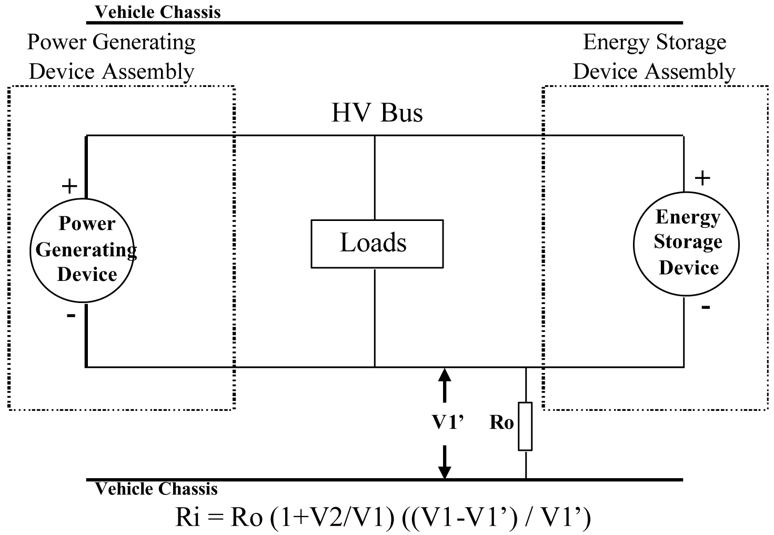
Electrical Chassis
Electrical Chassis
High Voltage Bus
Energy Conversion
System Assembly
REESS Assembly
V2'
+
-
+
-
Energy
Conversion
System
REESS
Traction System
R₀
Figure 4 Measurement of V2

7.1.1.2.2.3.5. Fifth step
The electrical isolation value Ri (in ohms) divided by the working voltage of the high voltage bus (in volts) results in the isolation resistance (in ohms/volt).

(Note 1: The standard known resistance Ro (in ohms) is the value of the minimum required isolation resistance (in ohms/V) multiplied by the working voltage of the vehicle plus/minus 20 per cent (in volts). Ro is not required to be precisely this value since the equations are valid for any Ro; however, a Ro value in this range should provide good resolution for the voltage measurements.)

7.1.2. Confirmation method for functions of on-board isolation resistance monitoring system

The function of the on-board isolation resistance monitoring system shall be confirmed by the following method or a method equivalent to it.

A resistor that does not cause the isolation resistance between the terminal being monitored and the electrical chassis to drop below the minimum required isolation resistance value shall be inserted. The warning signal shall be activated.

7.1.3. Protection against direct contact to live parts

7.1.3.1. Access probes
Access probes to verify the protection of persons against access to live parts are given in Table 1.

7.1.3.2. Test conditions
The access probe is pushed against any openings of the enclosure with the force specified in Table 1. If it partly or fully penetrates, it is placed in every possible position, but in no case shall the stop face fully penetrate through the opening.
Internal electrical protection barriers are considered part of the enclosure.
A low-voltage supply (of not less than 40 V and not more than 50 V) in series with a suitable lamp is connected, if necessary, between the probe and live parts inside the electrical protection barrier or enclosure.
The signal-circuit method is also applied to the moving live parts of high voltage equipment.
Internal moving parts may be operated slowly, where this is possible.

7.1.3.3. Acceptance conditions
The access probe shall not touch live parts.
If this requirement is verified by a signal circuit between the probe and live parts, the lamp shall not light.
In the case of the test for protection IPXXB, the jointed test finger may penetrate to its 80 mm length, but the stop face (diameter 50 mm x 20 mm) shall not pass through the opening. Starting from the straight position, both joints of the test finger are successively bent through an angle of up to 90 degree with respect to the axis of the adjoining section of the finger and are placed in every possible position.
In case of the tests for protection IPXXD, the access probe may penetrate to its full length, but the stop face shall not fully penetrate through the opening.

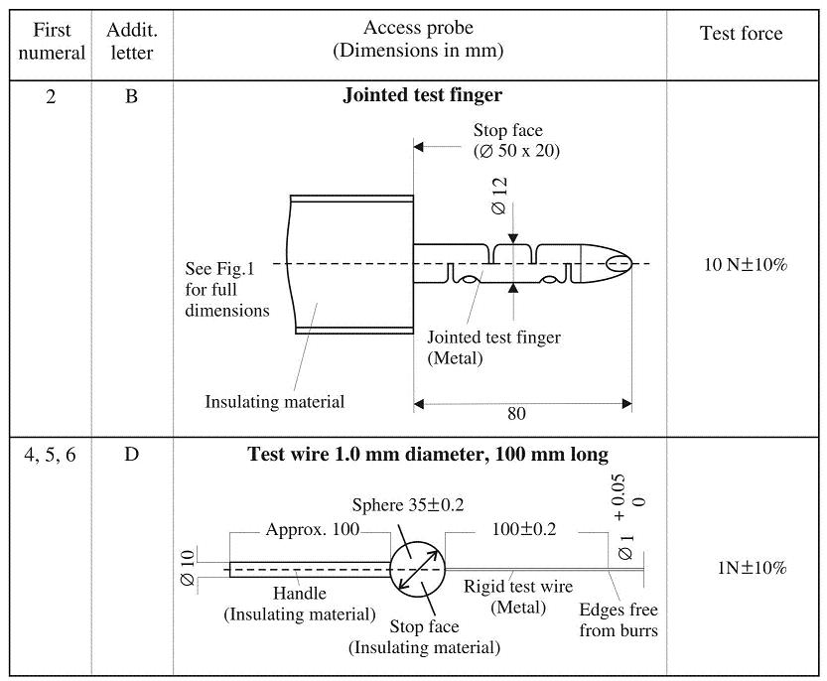

Table 1 Access probes for the tests for protection of persons against access to hazardous parts

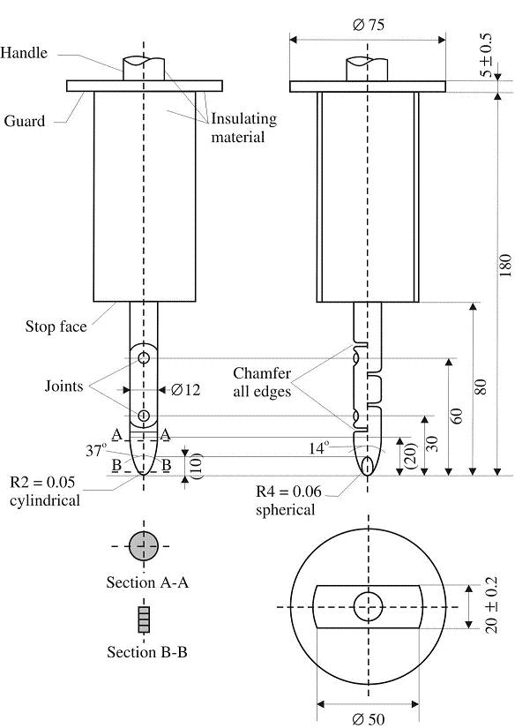
Figure 5 Jointed Test Fingers

Material: metal, except where otherwise specified
Linear dimensions in millimeters
Tolerances on dimensions without specific tolerance:
on angles, 0/10'
on linear dimensions:
up to 25 mm: 0/-0.05
over 25 mm: ±0.2
Both joints shall permit movement in the same plane and the same direction through an angle of 90° with a 0 to +10° tolerance.

7.1.4. Test method for measuring electric resistance

a) Test method using a resistance tester.
The resistance tester is connected to the measuring points (typically, electrical chassis and electro conductive enclosure/electrical protection barrier) and the resistance is measured using a resistance tester that meets the specification that follows:
Resistance tester: Measurement current at least 0.2 A
Resolution: 0.01 Ω or less
The resistance R shall be less than 0.1 ohm.

b) Test method using D.C. power supply, voltmeter and amp meter.
Example of the test method using D.C. power supply, voltmeter and amp meter is shown below.

D.C.
Power Supply
A
V
Connection to
Electrical Chassis
I
V
R
Electrical protection barrier / Enclosure
Electrical Chassis
Connection to Electrical protection barrier/Enclosure

Figure 6 Example of test method using D.C. power supply

Test Procedure
The D.C. power supply, voltmeter and ammeter are connected to the measuring points (Typically, electrical chassis and electro conductive enclosure/electrical protection barrier).
The voltage of the D.C. power supply is adjusted so that the current flow becomes at least 0.2 A.
The current "I" and the voltage "V" are measured.
The resistance "R" is calculated according to the following formula:
R = V / I
The resistance R shall be less than 0.1 ohm.

Note:
If lead wires are used for voltage and current measurement, each lead wire shall be independently connected to the electrical protection barrier/enclosure/electrical chassis. Terminal can be common for voltage measurement and current measurement.

7.1.5. Test conditions and test procedure regarding post-crash

7.1.5.1. Test conditions
7.1.5.1.1. General
The test conditions specified in paragraphs 7.1.5.1.2. to 7.1.5.1.4. are used.
Where a range is specified, the vehicle shall be capable of meeting the requirements at all points within the range.

7.1.5.1.2. Electric power train adjustment

7.1.5.1.2.1. The REESS may be at any state of charge, which allows the normal operation of the electric power train as recommended by the manufacturer.

7.1.5.1.2.2. The electric power train shall be energized with or without the operation of the original electrical energy sources (e.g. engine-generator, REESS or electric energy conversion system), however:

7.1.5.1.2.2.1. It is permissible to perform the test with all or parts of the electric power train not being energized insofar as there is no negative influence on the test result. For parts of the electric power train not energized, the protection against electric shock shall be proved by either physical protection or isolation resistance and appropriate additional evidence.

7.1.5.1.2.2.2. If the electric power train is not energized and an automatic disconnect is provided, it is permissible to perform the test with the automatic disconnect being triggered. In this case it shall be demonstrated that the automatic disconnect would have operated during the impact test. This includes the automatic activation signal as well as the conductive separation considering the conditions as seen during the impact.

7.1.5.1.3. Contracting parties may allow modifications to the fuel system so that an appropriate amount of fuel can be used to run the engine or the electric energy conversion system.

7.1.5.1.4. The vehicle conditions other than specified in paragraphs 7.1.5.1.1. to 7.1.5.1.3. are in the crash test protocols of the contracting parties.

7.1.5.2. Test procedures for the protection of the occupants from high voltage and electrolyte leakage
This section describes test procedures to demonstrate compliance with the electrical safety requirements of paragraphs 5.2.2. and 5.2.3.
Before the vehicle impact test conducted, the high voltage bus voltage (Vb) (see Figure7) is measured and recorded to confirm that it is within the operating voltage of the vehicle as specified by the vehicle manufacturer.

7.1.5.2.1. Test setup and equipment

If a high voltage disconnect function is used, measurements are taken from both sides of the device performing the disconnect function.
However, if the high voltage disconnect is integral to the REESS or the electric energy conversion system and the high-voltage bus of the RESS or the electric energy conversion system is protected according to protection IPXXB following the impact test, measurements may only be taken between the device performing the disconnect function and electrical loads.
-
-
The voltmeter used in this test measures DC values and have an internal resistance of at least 10 MΩ.

7.1.5.2.2. Voltage measurement
After the impact test, determine the high voltage bus voltages (Vb, V1, V2) (see Figure 7).
The voltage measurement is made not earlier than 5 seconds, but not later than 60 seconds after the impact.
This procedure is not applicable if the test is performed under the condition where the electric power train is not energized.
Energy Conversion
System Assembly
REESS Assembly
High Voltage Bus
V2

+
+

Vb

Energy
Conversion
System
Traction System
REESS

-
-

V1

Electrical Chassis

Figure 7 Measurement of Vb, V1, V2

7.1.5.2.3 Assessment procedure for low electrical energy

Prior to the impact a switch S₁ and a known discharge resistor R_{e} is connected in parallel to the relevant capacitance (ref. Figure 8).
Not earlier than 5 seconds and not later than 60 seconds after the impact the switch S₁ shall be closed while the voltage V_{b} and the current I_{e} are measured and recorded. The product of the voltage V_{b} and the current Ie shall be integrated over the period of time, starting from the moment when the switch S₁ is closed (t_{c}) until the voltage V_{b} falls below the high voltage threshold of 60 V DC (t_{h}),. The resulting integration equals the total energy (TE) in joules.
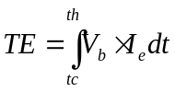
(a)

When V_{b} is measured at a point in time between 5 seconds and 60 seconds after the impact and the capacitance of the X-capacitors (C_{x}) is specified by the manufacturer, total energy (TE) shall be calculated according to the following formula:
(b) TE = 0.5 x C_{x} x(V_{b}² – 3 600)
When V₁ and V₂ (see Figure 8) are measured at a point in time between 5 seconds and 60 seconds after the impact and the capacitances of the Y-capacitors (C_{y1}, C_{y2}) are specified by the manufacturer, total energy (TE_{y1}, TE_{y2}) shall be calculated according to the following formulas:

(c) TE_{y1} = 0.5 x C_{y1} x (V₁² -3 600)
TE_{y2} = 0.5 x C_{y2} x (V₂²- 3 600)
This procedure is not applicable if the test is performed under the condition where the electric power train is not energized.

Electrical Chassis
High Voltage Bus
Energy Conversion
System Assembly
REESS Assembly
V_{b}
+
+
Energy
Conversion
System
REESS
R_{e}
S₁
Electrical Chassis
-
-
I_{e}
Traction System

Figure 8 Example of measurement of high voltage bus energy stored in X-capacitors

7.1.5.2.4. Physical protection

Following the vehicle crash test, any parts surrounding the high voltage components shall be opened, disassembled or removed to the extent possible without the use of tools. All remaining surrounding parts are considered as the physical protection.
The Jointed Test Finger described in paragraph 7.1.3. is inserted into any gaps or openings of the physical protection with a test force of 10 N ± 10 per cent for electrical safety assessment. If partial or full penetration into the physical protection by the Jointed Test Finger occurs, the Jointed Test Finger shall be placed in every position as specified below.
Starting from the straight position, both joints of the test finger are rotated progressively through an angle of up to 90 degrees with respect to the axis of the adjoining section of the finger and are placed in every possible position.
Internal electrical protection barriers are considered part of the enclosure
If appropriate, a low-voltage supply (of not less than 40 V and not more than 50 V) in series with a suitable lamp is connected between the Jointed Test Finger and high voltage live parts inside the electrical protection barrier or enclosure.

The requirements of paragraph 5.2.2.3. are met if the Jointed Test Finger described in paragraph 7.1.3. is unable to contact high voltage live parts.
If necessary a mirror or a fiberscope may be used in order to inspect whether the Jointed Test Finger touches the high voltage buses.
If this requirement is verified by a signal circuit between the Jointed Test Finger and high voltage live parts, the lamp shall not light.

7.1.5.2.5. Isolation resistance

The measurement shall be conducted according to paragraph 7.1.1. with the following precaution.
All measurements for calculating voltage(s) and electrical isolation are made after a minimum of 5 seconds after the impact.

7.1.5.2.6. Electrolyte leakage

Appropriate coating shall be applied, note – what is an appropriate coating? – specification needed? Gas sampling to detect electrolyte vapor? Difficult to measure on vehicle. Treat gas emissions in the environmental restrictions on hazardous substances? if necessary, to the physical protection in order to confirm any electrolyte leakage from the REESS resulting from the crash test.
Unless the manufacturer provides the means to differentiate among the leakage of different liquids, all liquid leakage is considered as an electrolyte.

How is leakage measured?

7.1.5.2.7. REESS retention

Compliance shall be determined by visual inspection.

7.2. REESS test procedures

7.2.1. Procedure for conducting a standard cycle

A standard cycle shall start with a standard discharge followed by a standard charge.

Standard discharge :
Discharge rate: The discharge procedure including termination criteria shall be defined by the manufacturer. If not specified, then it shall be a discharge with 1C current.
Discharge limit (end voltage): Specified by the manufacturer
Rest period after discharge: minimum 30 min

Standard charge:
The charge procedure including termination criteria shall be defined by the manufacturer. If not specified, then it shall be a charge with C/3 current.

7.2.2. Vibration test

7.2.2.1. Purpose
The purpose of this test is to verify the safety performance of the REESS under a vibration environment which the REESS will likely experience during the normal operation of the vehicle.

7.2.2.2. Installations
7.2.2.2.1. This test shall be conducted either with the complete REESS or with related REESS subsystem(s) including the cells and their electrical connections. If the manufacturer chooses to test with related subsystem(s), the manufacturer shall demonstrate that the test result can reasonably represent the performance of the complete REESS with respect to its safety performance under the same conditions. If the electronic management control unit for the REESS is not integrated in the casing enclosing the cells, then the electronic management unit may be omitted from installation on the Tested-Device if so requested by the manufacturer.

7.2.2.2.2. The Tested-Device shall be firmly secured to the platform of the vibration machine in such a manner as to ensure that the vibrations are directly transmitted to the Tested-Device.

[The Test-Device should be mounted with its original mounting points and holders as mounted in the vehicle. The holders should be firmly secured to the platform of the vibration machine in such a manner as to ensure that the vibrations are directly transmitted to the holders of the Tested-Device.]

7.2.2.3. Procedures
7.2.2.3.1. General test conditions
The following conditions shall apply to the Tested-Device:
(a) the test shall be conducted at an ambient temperature of 20 ± 10 °C.
(b) at the beginning of the test, the SOC shall be adjusted to a value in the upper 50% of the normal operating SOC range [note - any justification of why not test at full SOC?] of the Tested-Device.
(c) at the beginning of the test, all protection devices which affect the function(s) of the Tested-Device that are relevant to the outcome of the test shall be operational.

7.2.2.3.2.2 Test procedures
The Tested-Device shall be subjected to a vibration having a sinusoidal waveform with a logarithmic sweep between 7 Hz and 50 Hz and back to 7 Hz traversed in 15 minutes. This cycle shall be repeated 12 times for a total of 3 hours in the vertical direction of the mounting orientation of the REESS as specified by the manufacturer.

The correlation between frequency and acceleration shall be as shown in Table 2: [fix missing data in table below]

Frequency  [Hz] | Acceleration  [m/s²]
7 - 18 | 10
18 - 30 | gradually reduced from 10 to 2
30 - 50 | 2

Table 2 Frequency and acceleration

At the request of the manufacturer, a higher acceleration level as well as a higher maximum frequency may be used.

At the choice of the manufacturer, a vibration test profile determined by the vehicle-manufacturer verified for the vehicle application may be used as a substitute for the frequency - acceleration correlation of Table 2. The REESS certified according to this condition shall be limited to the installation for a specific vehicle type.

After the vibration profile, a standard cycle as described in paragraph 7.2.1. shall be conducted, if not inhibited by the Tested-Device.

The test shall end with an observation period of 1 h at the ambient temperature conditions of the test environment.

7.2.3. Thermal shock and cycling test

7.2.3.1. Purpose
The purpose of this test is to verify the resistance of the REESS to sudden changes in temperature. The REESS shall undergo a specified number of temperature cycles, which start at ambient temperature followed by high and low temperature cycling. It simulates a rapid environmental temperature change which a REESS would likely experience during its life.

7.2.3.2. Installations
This test shall be conducted either with the complete REESS or with related REESS subsystem(s) including the cells and their electrical connections. If the manufacturer chooses to test with related subsystem(s), the manufacturer shall demonstrate that the test result can reasonably represent the performance of the complete REESS with respect to its safety performance under the same conditions. If the electronic management unit for the REESS is not integrated in the casing enclosing the cells, then the electronic management unit may be omitted from installation on the Tested-Device if so requested by the manufacturer.

7.2.3.3. Procedures
7.2.3.3.1. General test conditions
The following conditions shall apply to the Tested-Device at the start of the test:
(a) the SOC shall be adjusted to a value in the upper 50% of the normal operating SOC range.
(b) all protection devices, which would affect the function of the Tested-Device and which are relevant to the outcome of the test shall be operational.

7.2.3.3.2. Test procedure
The Tested-Device shall be stored for at least six hours at a test temperature equal to 60 ± 2 °C or higher if requested by the manufacturer, followed by storage for at least six hours at a test temperature equal to -40 ± 2°C or lower if requested by the manufacturer. The maximum time interval between test temperature extremes shall be 30 minutes. This procedure shall be repeated until a minimum of 5 total cycles are completed, after which the Tested-Device shall be stored for 24 hours at an ambient temperature of 20 ± 10 °C.

After the storage for 24 hours, a standard cycle as described in paragraph 7.2.1. shall be conducted, if not inhibited by the Tested-Device.

The test shall end with an observation period of 1 h at the ambient temperature conditions of the test environment.

7.2.4. Mechanical shock test

7.2.4.1. Purpose
The purpose of this test is to verify the safety performance of the REESS under inertial loads which may occur during a vehicle crash.

7.2.4.2. Installations
7.2.4.2.1. This test shall be conducted either with the complete REESS or with related REESS subsystem(s) including the cells and their electrical connections. If the manufacturer chooses to test with related subsystem(s), the manufacturer shall demonstrate that the test result can reasonably represent the performance of the complete REESS with respect to its safety performance under the same conditions. If the electronic management unit for the REESS is not integrated in the casing enclosing the cells, then the electronic management unit may be omitted from installation on the Tested-Device if so requested by the manufacturer.

7.2.4.2.2. The Tested-Device shall be connected to the test fixture only by the intended mountings provided for the purpose of attaching the REESS or REESS subsystem to the vehicle.

7.2.4.3. Procedures
7.2.4.3.1. General test conditions and requirements
The following condition shall apply to the test:
(a) the test shall be conducted at an ambient temperature of 20 ± 10 °C.
(b) at the beginning of the test, the SOC shall be adjusted to a value in the upper 50% of the normal operating SOC range.
(c) at the beginning of the test, all protection devices which effect the function of the Tested-Device and which are relevant to the outcome of the test, shall be operational.

7.2.4.3.2. Test procedure
The Tested-Device shall be decelerated or accelerated in compliance with the acceleration corridors which are specified in Figure 9 and Tables 3 or 4. The manufacturer shall decide whether the tests shall be conducted in either the positive or negative direction or both.

For each of the test pulses specified, a separate Tested-Device may be used.

The test pulse shall be within the minimum and maximum value as specified in Tables 3 or 4. A higher shock level and /or longer duration as described in the maximum value in Tables 3 or 4 can be applied to the Tested-Device if recommended by the manufacturer.

Time
Acceleration
Maximum curve
Minimum curve
A
B
C
D
E
F
G
H

Figure 9 Generic description of test pulses

Point | Time (ms) | Acceleration (g)
Point | Time (ms) | Longitudinal | Transverse
A | 20 | 0 | 0
B | 50 | 20 | 8
C | 65 | 20 | 8
D | 100 | 0 | 0
E | 0 | 10 | 4.5
F | 50 | 28 | 15
G | 80 | 28 | 15
H | 120 | 0 | 0

Table 3 Values for category 1-1 vehicles
May be a challenge to conduct this test for heavy battery systems – subject to test equipment capabilities

Point | Time (ms) | Acceleration (g)
Point | Time (ms) | Longitudinal | Transverse
A | 20 | 0 | 0
B | 50 | 10 | 5
C | 65 | 10 | 5
D | 100 | 0 | 0
E | 0 | 5 | 2.5
F | 50 | 17 | 10
G | 80 | 17 | 10
H | 120 | 0 | 0

Table 4 Values for category 1-2 vehicles

The test shall end with an observation period of 1 h at the ambient temperature conditions of the test environment.

7.2.5. Mechanical integrity test

7.2.5.1. Purpose
The purpose of this test is to verify the safety performance of the REESS under contact loads which may occur during vehicle crash situation.

7.2.5.2. Installations
7.2.5.2.1. This test shall be conducted with either the complete REESS or with related REESS subsystem(s) including the cells and their electrical connections. If the manufacturer chooses to test with related subsystem(s), the manufacturer shall demonstrate that the test result can reasonably represent the performance of the complete REESS with respect to its safety performance under the same conditions. If the electronic management unit for the REESS is not integrated to the casing enclosing the cells, then the electronic management unit may be omitted from installation on the Tested-Device if so requested by the manufacturer.

7.2.5.2.2. The Tested-Device shall be connected to the test fixture as recommended by the manufacturer.

7.2.5.3. Procedures

7.2.5.3.1. General test conditions
The following condition and requirements shall apply to the test:
(a) the test shall be conducted at an ambient temperature of 20 ± 10 °C.
(b) at the beginning of the test, the SOC shall be adjusted to a value in the upper 50% of the normal operating SOC range.
(c) at the beginning of the test, all internal and external protection devices which would affect the function of the Tested-Device and which are relevant to the outcome of the test shall be operational.

7.2.5.3.2 Crush test

7.2.5.3.2.1. Crush force
The Tested-Device shall be crushed between a resistance and a crush plate as described in Figure 10 with a force of at least 100 kN but not exceeding 105 kN unless otherwise specified in accordance with paragraph 5.3.4.2., with an onset time less than 3 minutes and a hold time of at least 100 ms but not exceeding 10 s.

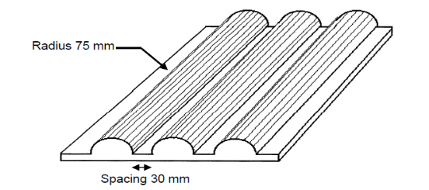
Dimension of the crush plate:
600 mm x 600 mm or smaller

Figure 10 Dimension of the crush plate

A higher crush force, a longer onset time, a longer hold time, or a combination of these, may be applied at the request of the manufacturer.
The application of the force shall be decided by the manufacturer having consideration to the direction of travel of the REESS relative to its installation in the vehicle. The application force being applied horizontally and perpendicular to the direction of travel of the REESS.

The test shall end with an observation period of 1 h at the ambient temperature conditions of the test environment.

7.2.6. Fire resistance test

7.2.6.1. Purpose
The purpose of this test is to verify the resistance of the REESS, against exposure to fire from outside of the vehicle due to e.g. a fuel spill from a vehicle (either the vehicle itself or a nearby vehicle). This situation should leave the driver and passengers with enough time to evacuate.

7.2.6.2. Installations
7.2.6.2.1 This test shall be conducted either with the complete REESS or with related REESS subsystem(s) including the cells and their electrical connections. If the manufacturer chooses to test with related subsystem(s), the manufacturer shall demonstrate that the test result can reasonably represent the performance of the complete REESS with respect to its safety performance under the same conditions. If the electronic management unit for the REESS is not integrated in the casing enclosing the cells, then the electronic management unit may be omitted from installation on the tested-Device if so requested by the manufacturer. Where the relevant REESS subsystems are distributed throughout the vehicle, the test may be conducted on each relevant REESS subsystem.

7.2.6.3. Procedures
7.2.6.3.1. General test conditions
The following requirements and conditions shall apply to the test:
(a) the test shall be conducted at a temperature of at least 0°C.
(b) at the beginning of the test, the SOC shall be adjusted to a value in the upper 50% of the normal operating SOC range.
(c) at the beginning of the test, all protection devices which effect the function of the Tested-Device and are relevant for the outcome of the test shall be operational.

7.2.6.3.2. Test procedure
A vehicle based test or a component based test shall be performed at the discretion of the manufacturer.

7.2.6.3.2.1. Vehicle based test
The Tested-Device shall be mounted in a testing fixture simulating actual mounting conditions as far as possible; no combustible material should be used for this with the exception of material that is part of the REESS. The method whereby the Tested-Device is fixed in the fixture shall correspond to the relevant specifications for its installation in a vehicle. In the case of a REESS designed for a specific vehicle use, vehicle parts which affect the course of the fire in any way shall be taken into consideration.

7.2.6.3.2.2. Component based test
The Tested-Device shall be placed on a grating table positioned above the pan, in an orientation according to the manufacturer’s design intent.

The grating table shall be constructed by steel rods, diameter 6-10 mm, with 4-6 cm in between. If needed the steel rods could be supported by flat steel parts.

7.2.6.3.3. The flame to which the Tested-Device is exposed shall be obtained by burning commercial fuel for positive-ignition engines (hereafter called "fuel") in a pan. The quantity of fuel shall be sufficient to permit the flame, under free-burning conditions, to burn for the whole test procedure.

The fire shall cover the whole area of the pan during whole fire exposure. The pan dimensions shall be chosen so as to ensure that the sides of the Tested-Device are exposed to the flame. The pan shall therefore exceed the horizontal projection of the Tested-Device by at least 20 cm, but not more than 50 cm. The sidewalls of the pan shall not project more than 8 cm above the level of the fuel at the start of the test.

7.2.6.3.4. The pan filled with fuel shall be placed under the Tested-Device in such a way that the distance between the level of the fuel in the pan and the bottom of the Tested-Device corresponds to the design height of the Tested-Device above the road surface at the unladed mass if paragraph 7.2.6.3.2.1. is applied or approximately 50 cm if paragraph 7.2.6.3.2.2. is applied. Either the pan, or the testing fixture, or both, shall be freely movable.

7.2.6.3.5. During phase C of the test, the pan shall be covered by a screen. The screen shall be placed 3 cm +/- 1 cm above the fuel level measured prior to the ignition of the fuel. The screen shall be made of a refractory material, as prescribed in Figure 12. There shall be no gap between the bricks and they shall be supported over the fuel pan in such a manner that the holes in the bricks are not obstructed. The length and width of the frame shall be 2 cm to 4 cm smaller than the interior dimensions of the pan so that a gap of 1 cm to 2 cm exists between the frame and the wall of the pan to allow ventilation. Before the test the screen shall be at least at the ambient temperature. The firebricks may be wetted in order to guarantee repeatable test conditions.

7.2.6..6. If the tests are carried out in the open air, sufficient wind protection shall be provided and the wind velocity at pan level shall not exceed 2.5 km/h.

7.2.6.3.7. The test shall comprise of three phases B-D, if the fuel is at temperature of at least 20 °C. Otherwise the test shall comprise four phases A-D.

7.2.6.3.7.1. Phase A: Pre-heating (Figure 11-A)
The fuel in the pan shall be ignited at a distance of at least 3 m from the Tested-Device. After 60 seconds pre-heating, the pan shall be placed under the Tested-Device. If the size of the pan is too large to be moved without risking liquid spills etc. then the Tested-Device and test rig can be moved over the pan instead.

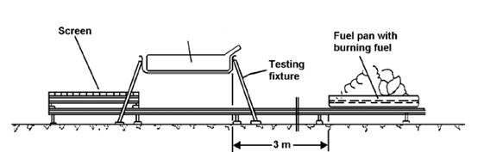
Tested Device

Figure 11-A Phase A: Pre-heating

7.2.6.3.7.2. Phase B: Direct exposure to flame (Figure 11-B)
The Tested-Device shall be exposed to the flame from the freely burning fuel for 70 seconds.

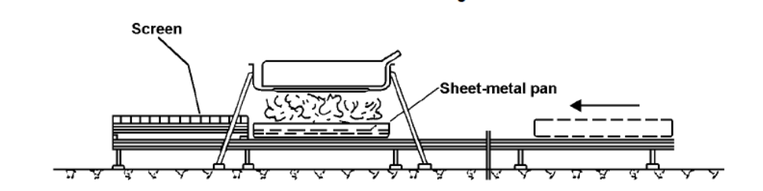

Figure 11-B Phase B: Direct exposure to flame

7.2.6.3.7.3. Phase C: Indirect exposure to flame (Figure 11-C)
As soon as phase B has been completed, the screen shall be placed between the burning pan and the Tested-Device. The Tested-Device shall be exposed to this reduced flame for a further 60 seconds.

As a compliance alternative to conducting Phase C of the test, Phase B may, at the choice of the manufacturer, be continued for an additional 60 seconds.

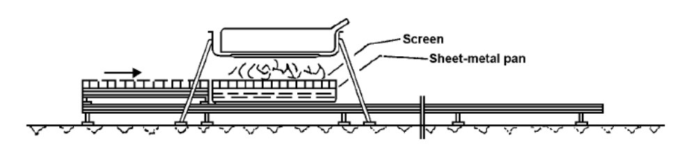
Figure 11-C Phase C: Indirect exposure to flame

7.2.6.3.7.4. Phase D: End of test (Figure 11-D)
The burning pan covered with the screen shall be moved back to the position described in phase A. No extinguishing of the Tested-Device shall be done. After removal of the pan the Tested-Device shall be observed until such time as the surface temperature of the Tested-Device has decreased to ambient temperature or has been decreasing for a minimum of 3 hours.

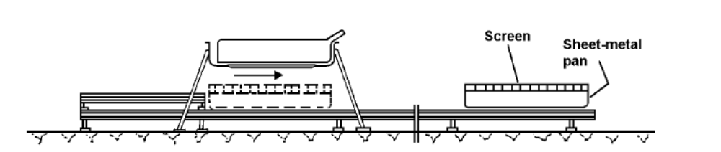

Figure 11-D Phase D: End of test

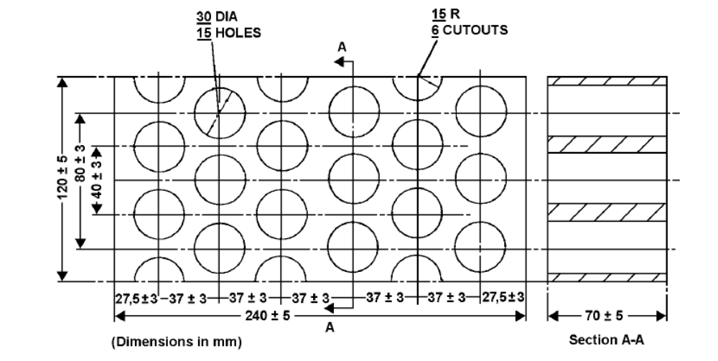

Figure 12 Dimension of Firebricks

Fire resistance (Seger-Kegel) SK 30

Al2O3 content 30 - 33 per cent

Open porosity (Po) 20 - 22 per cent vol.

Density 1,900 - 2,000 kg/m3

Effective holed area 44.18 per cent

7.2.7. External short circuit protection

7.2.7.1. Purpose
The purpose of this test is to verify the performance of the short circuit protection. This functionality, if implemented, shall interrupt or limit the short circuit current to prevent the REESS from any further related severe events caused by short circuit current.

7.2.7.2. Installations
This test shall be conducted either with the complete REESS or with related REESS subsystem(s), including the cells and their electrical connections. If the manufacturer chooses to test with related subsystem(s), the manufacturer shall demonstrate that the test result can reasonably represent the performance of the complete REESS with respect to its safety performance under the same conditions. If the electronic management unit for the REESS is not integrated in the casing enclosing the cells, then the electronic management unit may be omitted from installation on the Tested-Device at the request of the manufacturer.

7.2.7.3. Procedures
7.2.7.3.1. General test conditions
The following condition shall apply to the test:
(a) the test shall be conducted at a ambient temperature of 20 ± 10 °C or at higher temperature if requested by the manufacturer.
(b) at the beginning of the test, the SOC shall be adjusted to a value in the upper 50% of the normal operating SOC range.
(c) at the beginning of the test, all protection devices which would affect the function of the Tested-Device and which are relevant to the outcome of the test shall be operational.

7.2.7.3.2. Short circuit
At the start of the test all, relevant main contactors for charging and discharging shall be closed to represent the active driving possible mode as well as the mode to enable external charging. If this cannot be completed in a single test, then two or more tests shall be conducted.

The positive and negative terminals of the Tested-Device shall be connected to each other to produce a short circuit. The connection used for this purpose shall have a resistance not exceeding 5 mΩ.

The short circuit condition shall be continued until the operation of the REESS´s protection function to interrupt or limit the short circuit current is confirmed, or for at least one hour after the temperature measured on the casing of the Tested-Device has stabilized, such that the temperature gradient varies by a less than 4 K through 1 hour.

7.2.7.3.3. Standard Cycle and observation period
Directly after the termination of the short circuit a standard cycle as described in paragraph 7.2.1. shall be conducted, if not inhibited by the Tested-Device.

The test shall end with an observation period of 1 h at the ambient temperature conditions of the test environment.

7.2.8. Overcharge protection test

7.2.8.1. Purpose
The purpose of this test is to verify the performance of the overcharge protection.

7.2.8.2. Installations
This test shall be conducted, under standard operating conditions, either with the complete REESS (this maybe a complete vehicle) or with related REESS subsystem(s), including the cells and their electrical connections. If the manufacturer chooses to test with related subsystem(s), the manufacturer shall demonstrate that the test result can reasonably represent the performance of the complete REESS with respect to its safety performance under the same conditions.
The test may be performed with a modified Tested-Device provided these modifications shall not influence the test results.

7.2.8.3. Procedures
7.2.8.3.1. General test conditions
The following requirements and conditions shall apply to the test:
(a) the test shall be conducted at an ambient temperature of 20 ± 10 °C or at higher temperature if requested by the manufacturer.
(b) at the beginning of the test, all protection devices which would affect the function of the Tested-Device and which are relevant to the outcome of the test shall be operational.

7.2.8.3.2. Charging
At the beginning of the test, all relevant main contactors for charging shall be closed.

The charge control limits of the test equipment shall be disabled.

The Tested-Device shall be charged with a charge current of at least 1/3C rate but not exceeding the maximum current within the normal operating range as specified by the manufacturer.

The charging shall be continued until the Tested-Device (automatically) interrupts or limits the charging. Where an automatic interrupt function fails to operate, or if there is no such function, the charging shall be continued until the Tested-Device is charged to twice of its rated charge capacity.

7.2.8.3.3. Standard Cycle and observation period
Directly after the termination of charging a standard cycle as described in paragraph 7.2.1. shall be conducted, if not inhibited by the Tested-Device.

The test shall end with an observation period of 1 h at the ambient temperature conditions of the test environment

7.2.9. Over-discharge protection test

7.2.9.1. Purpose
The purpose of this test is to verify the performance of the over-discharge protection. This functionality, if implemented, shall interrupt or limit the discharge current to prevent the REESS from any severe events caused by a too low SOC as specified by the manufacturer.

7.2.9.2. Installations
This test shall be conducted, under standard operating conditions, either with the complete REESS (this maybe a complete vehicle) or with related REESS subsystem(s), including the cells and their electrical connections. If the manufacturer chooses to test with related subsystem(s), the manufacturer shall demonstrate that the test result can reasonably represent the performance of the complete REESS with respect to its safety performance under the same conditions.
The test may be performed with a modified Tested-Device provided these modifications shall not influence the test results.

7.2.9.3. Procedures
7.2.9.3.1. General test conditions
The following requirements and condition shall apply to the test:
(a) the test shall be conducted at an ambient temperature of 20 ± 10 °C or at higher temperature if requested by the manufacturer.
(b) at the beginning of the test, all protection devices which would affect the function of the Tested-Device and which are relevant for the outcome of the test shall be operational.

7.2.9.3.2. Discharging
At the beginning of the test, all relevant main contactors shall be closed.

A discharge shall be performed with at least 1/3 C rate but shall not exceed the maximum current within the normal operating range as specified by the manufacturer.

The discharging shall be continued until the Tested-Device (automatically) interrupts or limits the discharging. Where an automatic interrupt function fails to operate, or if there is no such function, then the discharging shall be continued until the Tested-Device is discharged to 25% of its nominal voltage level.

7.2.9.3.3. Standard charge and observation period
Directly after termination of the discharging the Tested-Device shall be charged with a standard charge as specified in paragraph 7.2.1. if not inhibited by the Tested-Device.

The test shall end with an observation period of 1 h at the ambient temperature conditions of the test environment.

7.2.10. Over-temperature protection test

7.2.10.1. Purpose
The purpose of this test is to verify the performance of the protection measures of the REESS against internal overheating during operation even under the failure of the cooling function if applicable. In the case that no specific protection measures are necessary to prevent the REESS from reaching an unsafe state due to internal over-temperature, this safe operation must be demonstrated.

7.2.10.2. Installations

7.2.10.2.1. The following test may be conducted with the complete REESS (maybe as a complete vehicle) or with related REESS subsystem(s) including the cells and their electrical connections. If the manufacturer chooses to test with related subsystem(s), the manufacturer shall demonstrate that the test result can reasonably represent the performance of the complete REESS with respect to its safety performance under the same conditions. The test may be performed with a modified Tested-Device provided these modifications shall not influence the test results.

7.2.10.2.2. Where a REESS is fitted with a cooling function and where the REESS will remain functional without a cooling function system being operational, the cooling system shall be deactivated for the test.

7.2.10.2.3. The temperature of the Tested-Device shall be continuously measured inside the casing in the proximity of the cells during the test in order to monitor the changes of the temperature. The onboard sensor if existing may be used.

7.2.10.3. Procedures
7.2.10.3.1. At the beginning of the test, all protection devices which affect the function of the Tested-Device and are relevant to the outcome of the test shall be operational, except for any system deactivation implemented in accordance with paragraph 7.2.10.2.2.

7.2.10.3.2. During the test, the Tested-Device shall be continuously charged and discharged with a steady current that will increase the temperature of cells as rapidly as possible within the range of normal operation as defined by the manufacturer.

7.2.10.3.3. The Tested-Device shall be placed in a convective oven or climatic chamber. The temperature of the chamber or oven shall be gradually increased until it reaches the temperature determined in accordance with paragraph 7.2.10.3.3.1 or paragraph 7.2.10.3.3.2 below as applicable, and then maintained at a temperature that is equal to or higher than this, until the end of the test.

7.2.10.3.3.1 Where the REESS is equipped with protective measures against internal overheating, the temperature shall be increased to the temperature defined by the manufacturer as being the operational temperature threshold for such protective measures, to insure that the temperature of the Tested-Device will increase as specified in paragraph 7.2.10.3.2.

7.2.10.3.3.2. Where the REESS is not equipped with any specific measures against internal over-heating the temperature shall be increased to the maximum operational temperature specified by the manufacturer.

7.2.10.3.4. The test will end when one of the followings is observed:
(a) the Tested-Device inhibits and/or limits the charge and/or discharge to prevent the temperature increase.
(b) the temperature of the Tested-Device is stabilised, which means that the temperature varies by a gradient of less than 4 K through 2 hour.
(c) any failure of the acceptance criteria prescribed in paragraph 5.3.9.

http://www.unece.org/trans/danger/publi/unrec/rev17/17files_e.html

