Transposition of GTR 15 into a UN Regulation
Analysis of the 3 approaches discussed within the Task Force

1. Background
- At its November 2015 session WP.29 agreed to transpose UN GTR on WLTP into a UN Regulation in a hierarchical manner with different levels of stringency that reflect different national / regional requirements.
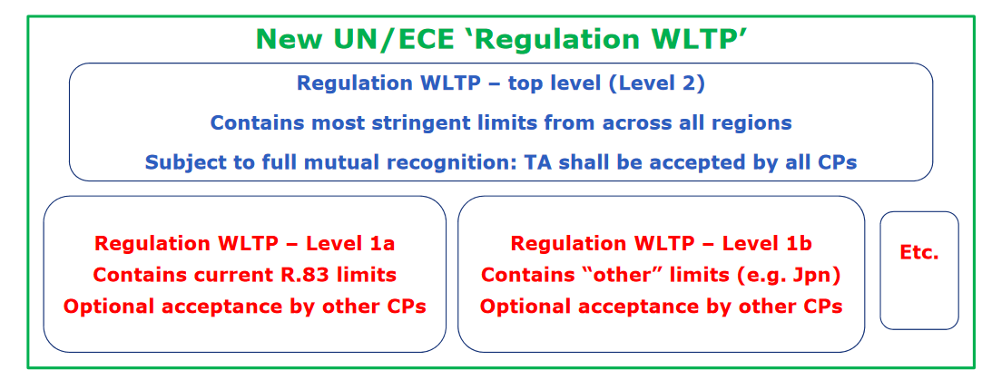
- UNECE Secretariat proposed possible way forward to avoid options of requirements level 1a, 1b, and 2 at 73rd GRPE session (June 2016). Refer to document GRPE-73-26.
The approach proposed by UNECE Secretariat corresponds to “Approach 2” explained below.
- Creation of WLTP Transposition Task Force was endorsed in June 2016 at the 169th session of WP.29.
- Kick-off meeting for WLTP Transposition Task Force was held in February 2017 and seven meetings have been held so far.
- Discussions in the Task Force resulted in the proposal to have the new UNR “WLTP” accompanied by a new 08 series of amendments to UNR 83 which would include all the other emissions approval requirements that are not included in the new UNR WLTP.
- At the 24th Session of the Informal Group on IWVTA (Madrid, June 2017) an OICA representative of the WLTP Transposition Task Force presented the Task Force update (GRPE-75-18) including the schematic of the concerned UN Regulations, i.e. UN R83/08 and UN R “WLTP”. Following a Q&A session on the proposals, the Co-Chair of IWVTA IWG touched on the importance of harmonization even if it is realised by compromise.
- At the 6th WLTP Transposition Task Force held in August 2017, in addition to Approach 2, two other possible approaches (Approach 1 and Approach 3) were discussed. Further discussions were held during the 7th meeting of the Task Force in October.
- Approaches 1, 2 & 3, for consideration by the IWVTA IWG, are described in § 3 below.
- The Task Force will seek guidance on this issue from WP.29 at its March 2018 session.

2. Request to IWVTA Informal Group
- Any feedback on the preference to the specific approach to be taken and its reasons are requested. The comments provided by IWVTA IWG would be included in the documents to be submitted to WP.29 at its March 2018 session after endorsement by GRPE at its January 2018 session.

3. Comparison of the 3 potential approaches

Approach 1
Brief description:
- UN R.00 covers regional level 1a
- UN R.01 covers regional level 1b
- UN R.02 covers top level 2
- UN R.00, UN R.01 and UN R.02 are adopted at the same time
- Entry into force of UN R.00: 6 months after adoption
- Entry into force of UN R.01: 12 months after adoption (6 months after entry into force of UN R.00)
- Entry into force of UN R.02: 18 months after adoption (6 months after entry into force of UN R.01)
- Amendments to regional levels through series of amendments.
- CPs can notify which version they apply, but all must accept top level 2

Analysis:
- Entry into force of UN R.00: 6 months after adoption
EU can start applying UN R.00. For Japan: see below
- Entry into force of UN R.01: 12 months after adoption (6 months after entry into force of UN R.00)
This is questionable. WP29 could urge Legal Office OLA to accept simultaneous notification and entry into force (if necessary with a 1 day gap?) If this is not possible, then the 6 months difference would not create any problem: Japan could simply delay application, as foreseen by the 58 Agreement, Article 1, §3-4:
"3. When a UN Regulation has been adopted, the Secretary-General shall …specifying which Contracting Parties have …notified their agreement but intention not to begin applying the UN Regulation at the date of entry into force, and in respect of which the UN Regulation shall not enter into force.
4. The adopted UN Regulation shall enter into force on the date(s) specified therein as a UN Regulation annexed to this Agreement for all Contracting Parties which have not notified …or their intention not to apply it on that date."
See also WP29/2017/107, §26: "… Furthermore, the new series of amendments may contain a transitional provision for Contracting Parties applying the UN Regulation after the date of entry into force of the amendments, indicating that such Contracting Parties are not obliged to accept the existing approvals."
In conclusion, even if the time gap is unavoidable, it does not create a real problem. It would be similar to the current situation of UN R83 since Japan today does not apply it. Japan can vote in favour of UN R.00, but the actual application would only start once UN R.01 is in force.
- Entry into force of UN R.02: 18 months after adoption (6 months after entry into force of UN R.01)
See above: the time gap is questionable. If it is unavoidable, it might however create some problem in that EU (applying UN R.00) would be forced to accept approvals to UN R.01 since the latter would be the latest series. Possibly we might then need to include some transitional provisions in UN R.01, as was recently done for UN R83?
Last but not least, the OLA interpretation not to notify an amendment until entry into force of the original version very probably does not apply here: the original version would already be in force, and two consecutive series of amendments would be notified at the same time and this should be perfectly possible.
- Amendments to regional levels through series of amendments
If for instance Level 1a needs to be upgraded, Level 1a* becomes UN R.03
Top level UN R.02 would become UN R.04
Level 1b (UN R.01) could remain unchanged also in terms in numbering:
- Japan and EU must accept the new top level UN R.04
- EU has UN R.03 as minimum requirement
- Japan has UN R.01 as minimum requirement
- Japan refuses UN R.03 (no obligation in the 58 Agreement to accept intermediate levels)
No problem, except a little more administrative work
- CPs can notify which version they apply, but all must accept top level 2
Is fully in line with 58 Agreement
Allows IWVTA: top level 2 for U-IWVTA and regional level(s) for L-IWVTA
Draft Evaluation by Task Force: It seems this approach is fully in line with the 58 Agreement. In case a time gap for the entry into force of UN R.02 is unavoidable, some transitional provisions might however be necessary to allow EU to continue applying UN R, but not accepting approvals to UN R.01 till UN R.02 is in place.
However, such situation can most likely be avoided, if indeed OLA agrees that, once a UN Regulation is in place, subsequent series of amendments can be notified (and enter into force) simultaneously (or if needed with one day difference?).

Approach 2
Brief description:
- UN R.00 covers all regional levels 1a, 1b, …as options to choice of the CPs
- UN R.01 covers top level 2
- UN R.00 and UN R.01 are adopted at the same time
- Entry into force of UN R.00: 6 months after adoption
- Entry into force of UN R.01: 12 months after adoption (6 months after entry into force of UN R.00)
- Amendments to regional levels through supplements or series of amendments as applicable (to be discussed)
- Amendments to regional levels trigger new series (02) for top level 2: UN R.02 etc.
Analysis:
- UN R.00 covers all regional levels 1a, 1b, …as options to choice of the CPs:
It is true that mutual recognition only applies to the latest series, but as long as UN R.01 is not in force, this is not in line with Article 3 of the 58 Agreement. Options within a UN Regulation are not acceptable – see WP29/1044/Rev 1, §12 and WP29/2017/107, §11-12.
Even if "special provisions" are used for this, it needs to be seen in light of WP29/2017/107, §3, (a): "… Special provisions, if any, in UN Regulations shall also respect the objectives of international harmonization and mutual recognition of approvals."
Even when UN R.01 is in force, it would create legal difficulties anyway: for instance, EU (mandating level 1a and accepting top level 2) would need to know if an approval to UN R.00 was granted to level 1a or level 1b. This could be possible by foreseeing different approval numbers, but it is still questionable from a legal point of view and anyway creates administrative difficulties.
- UN R.01 covers top level 2
OK, no problem
- UN R.00 and UN R.01 are adopted at the same time
OK, no problem
- Entry into force of UN R.00: 6 months after adoption
OK, no problem
- Entry into force of UN R.01: 12 months after adoption (6 months after entry into force of UN R.00)
This might be questioned. WP29 could urge Legal Office OLA to accept simultaneous notification and entry into force (if necessary with a 1 day gap?) of both the new Regulation and its 01 series of amendments.
If however this is not possible, then the 6 months difference would create serious legal problems since all CPs applying UN R would have to accept approvals to UN R.00, regardless of the regional levels.
In other words, if they do not accept such approvals, they are considered in violation of the 58 Agreement (see also above comments: "special provisions" would be needed, the legality of which would be very questionable).
The only solution would then be that all CPs delay application of UN R until UN R.01 enters into force (this is possible in the new 58 Agreement).
- Amendments to regional levels through supplements
This is not in line with the principles (see e.g. WP29/1044/Rev 1 and especially WP29/2017/107): supplements should not be used when technical requirements change and/or when CPs need to recognise the level through the approval number. It is true that the 58 Agreement now foresees that also the supplement can be identified in the approval number, but in principle such technical changes must be made through series of amendments (see Approach 1 above). In addition, supplements in principle only apply to new types/approvals, so that it would be very difficult for CPs to mandate an upgraded regional level to existing types (new registrations), unless transitional provisions are included in the supplement, and this is not usual (and makes things very complicated)
Therefore, major changes to any of the regional levels 1 will need to be done through series of amendments
Transitional provisions will then need to be tailored to each of the regional levels without affecting other levels (that would remain unchanged); this would be an extremely complex process and quickly become an administrative nightmare
- Amendments to regional levels trigger new series (02) for top level 2: UN R.02 etc.
This is certainly true if the regional levels are upgraded by series of amendments and not by supplements (see Approach 1 above).
If however the path of supplements for the regional levels is used, then possibly UN R.01 might (repeat: might) remain unchanged, as long as its stringency exceeds any of the regional levels (upgraded or not upgraded) – this is however very questionable. In any case, if indeed an upgrade to a regional level will most likely trigger a new series of amendments for the top level 2, then we are virtually identical with Approach 1.
Draft Evaluation by Task Force: this approach might be technically feasible, but there are several implications that need to be carefully checked, since they may be considered as not in line with the 58 Agreement and its spirit as well as with the regulatory procedures. Bringing Approach 2 fully in line with the procedures will most likely make it identical to Approach 1! Finally, if indeed there is a time gap between UN R.00 and UN R.01, then there could be serious legal problems.

Approach 3
Brief description: All levels (Top level 2 as well as the regional levels 1a, 1b, …) within the same version of the UN R, as options to the choice of the Contracting Parties (CPs).
Reasoning: Article 1.2 of the 58 Agreement; this article allows UN R0 (IWVTA) to have different levels of stringency within the same version of UN R0 (U-IWVTA and L-IWVTA). The idea is that a common interpretation could be reached such that this possibility is extended to other UN Regulations.
Analysis: this is against the 58 Agreement. Such interpretation would be against the spirit of the 58 Agreement and would be very difficult to put in place, unless the 58 Agreement is amended again. It would also make it impossible to include the new UN R on WLTP into U-IWVTA, since only the top level 2 could be subject to full mutual recognition and therefore part of U-IWVTA.
Draft Evaluation by Task Force: this approach should not be pursued any longer.

