Integration of Regulation X Software Identification Number (RXSWIN) in existing and new UN Regulations
I. Introduction
1. The members of the ad hoc session on software updates (2 August 2017) have detailed the principle of a RXSWIN “Regulation X Software Identification Number” in order to trace type approval relevant software modifications.
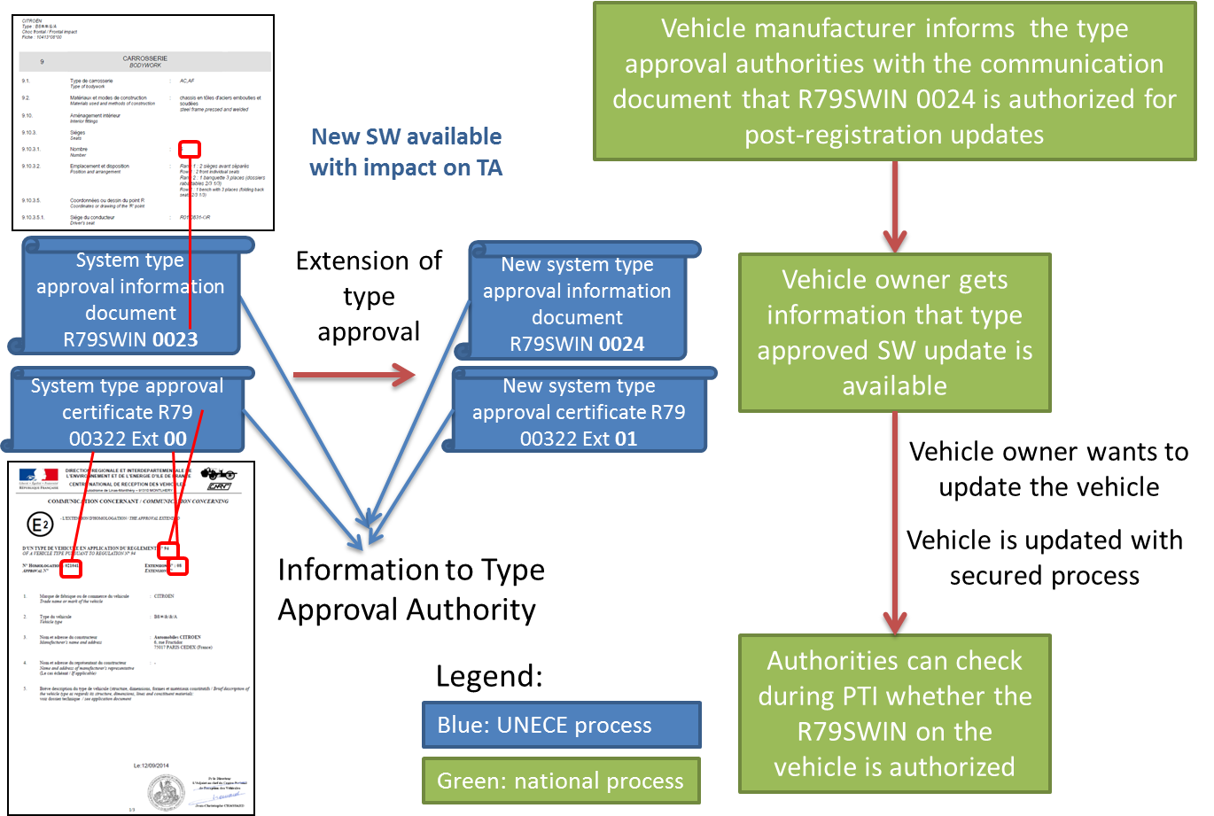
2. One part of the RXSWIN principle (in blue) can be integrated in existing and new UN Regulations. Another part (in green) can be added in national/regional regulations on vehicle registrations, software update of registered vehicles and periodical technical inspections:

3. This document gives an example, how existing UN regulations could be amended in order to introduce the principle of RXSWIN.

II. Example for draft amendments to UN Regulation N° X
…

2.Y.1. An “RX Software Identification Number” (RXSWIN) is a dedicated identifier with [11] alphanumerical characters, defined by the vehicle manufacturer, representing information about the type approval relevant software of the Electronic Control System contributing to the Regulation N° X type approval relevant characteristics of the vehicle.

[In case the type approval relevant software is modified by the vehicle manufacturer, the RXSWIN will be updated leading to a type approval extension. Modification of software are type approval relevant if they lead to a modification of the vehicle type according to this regulation or if functionalities are extended regarding the communication information in Annex 1.]
See *) for information.

2.Y.2. “Electronic Control System” means a combination of units, designed to co-operate in the production of the stated vehicle control function by electronic data processing. Such systems, often controlled by software, are built from discrete functional components such as sensors, electronic control units and actuators and connected by transmission links. They may include mechanical, electro-pneumatic or electro-hydraulic elements. “The System”, referred to herein, is the one for which type approval is being sought.

2.Y.3. “Software” is the part of an Electronic Control System that consists of digital data and instructions.

…

5.Z.1. It shall be possible to read the RXSWIN via the use of an electronic communication interface. [This shall be verified by the technical service at the time of type approval.]

5.Z.2. At the time of Type Approval, the means implemented to protect against unauthorized modification of the RXSWIN chosen by the manufacturer shall be confidentially outlined.

5.Z.3. The manufacturer shall provide the following information in the communication according to Annex 1:
- the RXSWIN
- how to read the RXSWIN

5.Z.4. The manufacturer may provide in the communication according to Annex 1:
- the list of the relevant parameters that will allow the identification of those vehicles that can be retrofitted with the software represented by the RXSWIN.

*): For information, the definition of extensions in the current guidelines WP.29/1044/Rev.1:
B. Extension
41. The modification shall be designated as an "extension" if, in addition to the change of the data recorded in the information documents:
(a) Further inspections or tests are required, or
(b) Any information on the communication document (with the exception of its attachments) has changed, or
(c) Approval to a later series of amendments is requested after its entry into force.

Annex 1

COMMUNICATION

(Maximum format: A4 (210 x 297 mm))

issued by : Name of administration:
......................................
......................................
......................................

concerning: 2/ APPROVAL GRANTED
APPROVAL EXTENDED
APPROVAL REFUSED
APPROVAL WITHDRAWN
PRODUCTION DEFINITELY DISCONTINUED

of a vehicle type with regard to xxx equipment pursuant to Regulation No. X

Approval No. ……….. Extension No.

- Trade name or mark of vehicle

2. Vehicle type

3. Manufacturer’s name and address

4. If applicable, name and address of manufacturer’s representative

5. Brief description of the steering equipment

5.1. Type of steering equipment

5.2. Steering control

5.3. Steering transmission

5.4. Steered wheels

5.5. Energy source

6. Results of tests, vehicle characteristics

6.1. Steering effort required to achieve a turning circle of 12 m radius with an intact system and 20 m radius with a system in the failed condition

6.1.1. Under normal conditions

6.1.2. After failure of special equipment

6.2. Other tests required by this Regulation pass/fail 2/

6.3. Adequate documentation in accordance with Annex 6 was supplied in respect of the following parts of the steering system:

6.4 RXSWIN ([11] alphanumerical characters):

6.4.1 Information how to read the RXSWIN:

6.4.2 If applicable, list the relevant parameters that will allow the identification of those vehicles that can be retrofitted with the software represented by the RXSWIN under point 6.4:

7. Vehicle submitted for approval on

8. Technical service responsible for conducting approval tests

9. Date of report issued by that service

10. Number of report issued by that service

11. Approval granted/extended/refused/withdrawn 2/

12. Position of approval mark on vehicle

13. Place

14. Date

15. Signature

16. Annexed to this communication is a list of documents in the approval file deposited at the administration services having delivered the approval and which can be obtained upon request.

_______________

1/ Distinguishing number of the country which has granted/extended/refused/withdrawn approval (see approval provisions in the Regulation).

2/ Strike out what does not apply.

