Please provide information about following list.
- Venue
  - Exact address
    - Conference room for IWG meeting (open 8am)
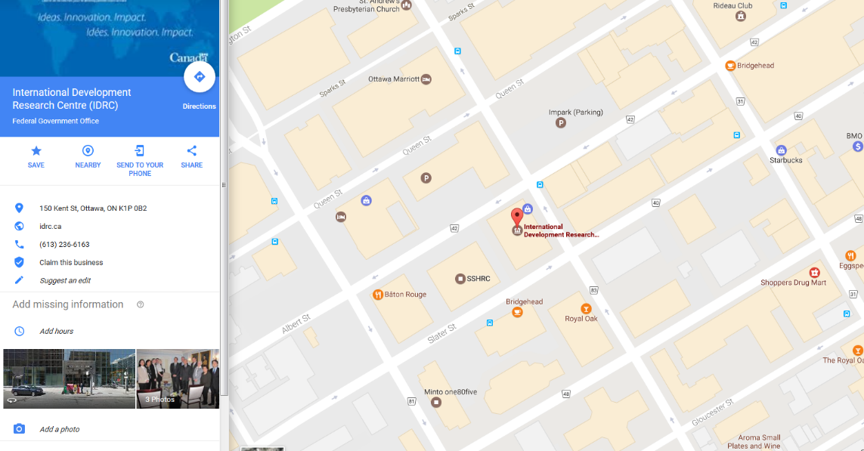
Conference facilities is located at 150 Kent St, Constitution Square, Tower 3, corner of Albert Street, on the 8th floor. https://goo.gl/maps/vvYNLVM734J2

    - Conference room for cosponsor and CP meeting
Place de Ville, Tower C
330 Sparks Street,
Ottawa ON, K1A 0N5
Room: FC 24
Meeting room is located in the food court. To reach food court: Enter main entrance, go through glass doors on your right and go down the escalator.
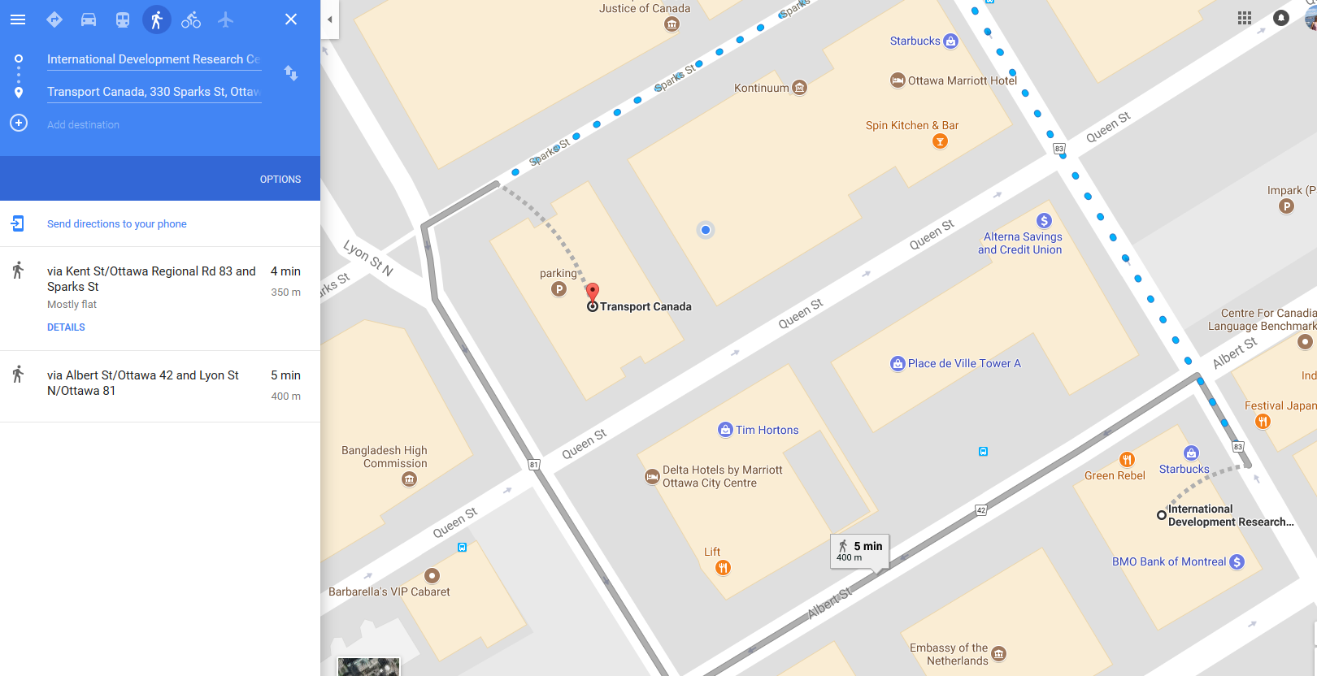

  - Business hours
8:00am until 5pm
  - Access from Airport
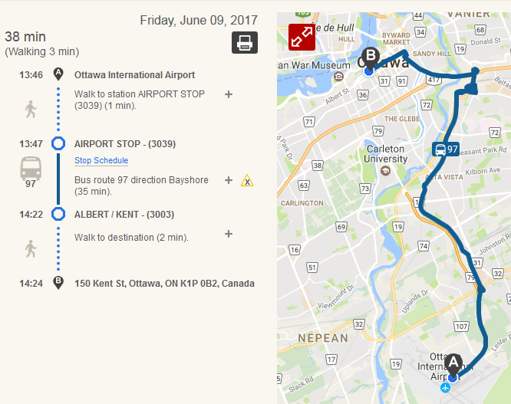
Taxi or Public Transportation is available. There is a direct bus route running from the airport to the Conference/Hotel area in downtown Ottawa.

  - Access by public transportation
Ottawa’s public transit organization is called OC Transpo. A travel planner is available on the main page of the website: http://www.octranspo.com/
Single Faire - $3.40
Daily Faire - $10.25
  - Recommended hotels and areas (near or easy access to the venue)
There are several hotels within a few blocks of the conference facility.
Delta Hotel - https://goo.gl/maps/5jDfBkkJLKU2
Marriott Hotel - https://goo.gl/maps/7HuT6c2T6nw
Alt Hotel Ottawa - https://goo.gl/maps/KSu1rB2aXV32
ARC The Hotel - https://goo.gl/maps/q2qknjZZKDs
There are many more hotels within easy walking distance as well.
- Lunch, breakfast, snacks and beverages
  - Lunch will be provided? If not, please let us know the near restaurants.
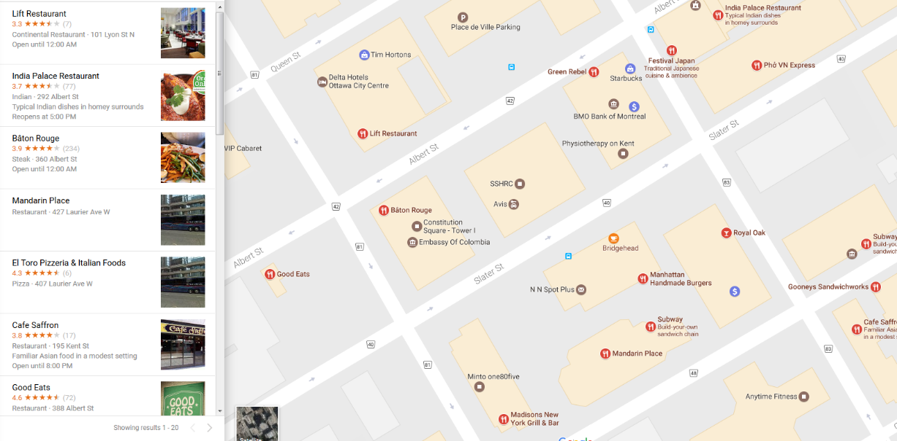
Lunch will not be provided. There are many sit down/fast food restaurants and several food courts within a few blocks of the venue.
  - Breakfast will be provided?
Breakfast will not be provided.
  - Snacks and beverages (coffee, tea and water) will be provided? If not, can we buy bottles of water near the meeting room?
Snacks and beverages will be provided

