Proposal for Supplement 3 to the 02 series of amendments to UN Regulation No. 129 (Enhanced Child Restraint Systems)
Submitted by the expert from France
The text reproduced below was prepared by the expert from France. It introduces the Supplement 3 to the 02 series of amendments to Regulation No. 129 (Enhanced Child Restraint Systems (ECRS) that were agreed upon by the experts of the Informal Working Group on Child Restraint Systems (IWG CRS). The modifications to the existing text of the UN Regulation in its 02 series of amendments, including:
- Proposal for supplement 1 to the 02 series of amendments - ECE/TRANS/WP.29/2017/63
- Proposal for supplement 2 to the 02 series of amendments - ECE/TRANS/WP.29/2017/126
are underlined and marked in bold for new or strikethrough for deleted characters. It includes all proposals of modifications made by the IWG ECRS during the two last meetings (2017/06/22&23 and 2017/08/31).

I. Proposal
Paragraph 1., amend to read:
"1. Scope
This Regulation applies (in Phases 1, 2) to the following child restraint system for child occupants of power driven vehicles:
(a) Integral Universal ISOFIX Enhanced Child Restraint Systems (i-Size);
(b) Integral Specific vehicle ISOFIX Enhanced Child Restraint Systems;
(c) nNon-integral Universal Enhanced Child Restraint Systems (i-Size booster seat);
(d) nNon-integral sSpecific vehicle eEnhanced cChild rRestraint sSystems (sSpecific vehicle booster seat);

Paragraph 2.12., amend to read:

"2.12. "Anti-rotation device"
means a device intended to limit the rotation of the Enhanced Child Restraint System during a vehicle impact and consisting of:
(a) A top-tether strap; or
(b) A support-leg.
meeting the requirements of this Regulation and fitted to an ISOFIX anchorage system and ISOFIX top tether anchorages or vehicle floor contact surface meeting the requirements of Regulation No. 14 or Regulation No XX.
An "Anti-rotation device" for a "specific vehicle ISOFIX" Enhanced Child Restraint System may comprise a top tether, a support-leg or any other means capable of limiting the rotation only for Rearward facing Enhanced Child Restraint System, a dashboard."
Paragraph 2.17.1., amend to read:

"2.17.1. "ISOFIX Vehicle seat fixture" means a fixture, according to ISOFIX size envelopes whose dimensions are given in Figures 1 to 7 of Appendix 2 to Annex 17 to Regulation No. 16, used by an Enhanced Child Restraint System manufacturer to determine the appropriate dimensions of an ISOFIX Enhanced Child Restraint System and including the location of its ISOFIX attachments."
Paragraphs 2.56.1. and 2.56.2., amend to read:
"2.56.1. "Class A device" prevents the child from pulling the webbing of the retractor through to the lap part of the belt, when the adult belt is used to restrain the child directly (Non-Integral Enhanced Child Restraint System).
2.56.2. "Class B device" (to be used in phase III) allows the retention of an applied tension in the lap part of an adult safety belt, when the adult belt is used to restrain the Integral Enhanced Child Restraint System. The device intends to prevent the webbing from slipping from the retractor through the device, which would release the tension and place the restraint in a non-optimal position."
Paragraph 2.57., amend to read:
"2.57. "Module", is a part of an Enhanced Child Restraint System that is separate from the ISOFIX attachments and is hosting and restraining the child, in direct contact with the child. A module can be used in combination with one or more a base whether or, not and if allowed in this regulation, as a stand-alone to restrain a child in a car. A base is allowed to accept more than one module (Module A, Module B, etc.)."

Insert new paragraph 2.58., to read:
2.58. “Base”, is a part of an Enhanced Child Restraint System that forms an interface between the vehicle and the module of an Enhanced Child Restraint System and has no direct contact with the child. A base is connected to the vehicle using ISOFIX anchorages or vehicle belt and an anti-rotation device if applicable.
A base is allowed to accept more than one module (Module A can be replaced by Module B, etc.).

Insert new paragraph 2.59., to read:
2.59. “Built in”, is an Enhanced Child Restraint System made as an integral part or incorporated as an add-on part of a vehicle. The vehicle manufacturer shall be the applicant for approval.
Paragraph 3.2.2., amend to read:
"3.2.2. The applicant shall indicate the kind of application:
(a) Application for an i-Size Enhanced Child Restraint Systems; or
(b) Application for a specific vehicle ISOFIX Enhanced Child Restraint System; or
(c) Application for a i-Size booster seat Enhanced Child Restraint System; or
(d) Application for a specific vehicle booster seat Enhanced Child Restraint System; or
(e) Or any combination of (a),(b),(c) and (d) as long as they fulfil paragraph 5.4.2.2.[, 6.1.2.] and 6.1.3.[3.] "
Paragraph 4.3., amend to read:
"4.3. The following information shall be clearly indicated on the product:
(a) The orientation of the Enhanced Child Restraint System relative to the vehicle;
(b) The size range(s) of the Enhanced Child Restraint System in centimetres;
(c) The maximum occupant mass allowed for the Integral Enhanced Child Restraint System in kilograms.
If the Enhanced Child Restraint System is to be used in combination with an adult safety-belt, the correct webbing path shall be clearly indicated by means of a drawing permanently attached to the Enhanced Child Restraint System. If the restraint is held in place by the adult safety-belt, the webbing paths shall be clearly marked on the product by colour coding. The colours used for the path of the safety-belt when the device is installed in the forward-facing position shall be red and when installed in the rearward-facing shall be blue. The same colours shall also be used on the labels on the device that illustrate the methods of use.
There shall be a clear differentiation between the intended paths for the lap section and the diagonal section of the safety belt. Indication such as colour coding, words, shapes, etc. shall distinguish between sections of the safety belt.
The marking defined in this paragraph shall be visible with the Enhanced Child Restraint System in the vehicle, with the child in the Enhanced Child Restraint System."
Insert new paragraphs 4.6. to 4.6.1., to read:
"4.6. Webbing path.
The markings defined in this paragraph shall be permanently and durably attached and visible with the Enhanced Child Restraint System installed in the vehicle, and with the child seated in the Restraint System. The markings shall be placed on both sides of the Enhanced Child Restraint System. The vehicle seat illustrated on the marking shall face the same direction as the real vehicle seat.
There shall be a clear differentiation between the intended paths for the lap section and the diagonal section of the safety belt. Indication such as colour coding, words, shapes, etc. shall distinguish between sections of the adult safety belt.
4.6.1. The adult safety belt route markings shall be placed on all belt guides and lock off devices. The adult safety belt route markings shall be at least the width of the adult belt path."

Paragraphs 4.6. to 4.7.2.(former), renumber as paragraphs 4.7. to 4.8.2.
Delete old Paragraph 4.7.3.
4.7.3. An impact shield that is not permanently attached to the child seat shall have a permanently attached label to indicate the make and model of the ECRS to which it belongs. The minimum size of the label shall be 40 x 40 mm.
Paragraph 4.8. (former), renumber as paragraph 4.11.

Paragraph 5.4.3.1., amend to read:
"5.4.3.1. The words "R129" followed by a dash and the same approval number as the part of the Enhanced Child Restraint System which includes the ISOFIX attachments or main load bearing contact points;"

Paragraph 6.1.3.4., amend to read:
"6.1.3.4. Enhanced Child Restraint Systems of the i-Size booster seat categoryies shall have a main load-bearing contact point, between the Enhanced Child Restraint System and the adult safety belt. This point shall not be less than 150 mm from the Cr axis when measured with the Enhanced Child Restraint System on the dynamic test bench installed in accordance with paragraph 7.1.3.5.2.2. of this Regulation, without a dummy. This shall apply to all adjustment configuration setups and variable belt paths."
Paragraph 6.2.1.7., amend to read:
6.2.1.7. All straps of the restraint shall be so placed that they cannot cause discomfort to the wearer in normal use or assume a dangerous configuration. Y-shaped belts are not permitted on forward facing Enhanced Child Restraint Systems and may only be used in dedicated rearward facing and or lateral facing Enhanced Child Restraint Systems (carrycots). The distance between the shoulder-straps in the vicinity of the neck should be at least the width of the neck of the appropriate dummy.
During the dynamic tests, the standard safety-belt used to install a non-integral Enhanced Child Restraint System, shall not become disengaged from any guide or locking device utilized for the test conducted; however, for the shoulder portion of the standard safety-belt this shall be judged up to the moment that the maximum horizontal head excursion of the dummy is reached.
Paragraph 6.2.1.10., amend to read:
"6.2.1.10. At least the worst case configuration of the dynamic test for the Enhanced Child Restraint System shall be performed after conditioning according to paragraph 7.2.6."

Paragraph 6.2.3., amend to read:
"6.2.3. It shall not be possible to remove or detach without the use of specific tools, any components not designed to be removable or detachable for maintenance or change of configuration purpose. Any components that are designed to be removable or detachable for maintenance or adjustment purpose shall be so designed as to avoid any risk of incorrect assembly and use, as the assembly and disassembly processes shall be explained in detail in the restraint user guides. For integral Enhanced Child Restraint Systems Aany harness belt or impact shield shall be capable of its full range of adjustment without disassembly,"

Paragraph 6.3.2.2.1., amend to read:
"6.3.2.2.1. Integral Class Enhanced Child Restraint Systems
The maximum external dimensions for the width, height and depth of the Enhanced Child Restraint System and if fitted, the locations of the ISOFIX anchorages system, with which its attachments shall engage, shall be defined by the ISOFIX Vehicle Seat Fixture as defined in paragraph 2.17.1. of this Regulation.
(a) i-Size Forward facing Enhanced Child Restraint Systems shall fit within the ISO/F2x size envelope for a reduced-height forward-facing toddler CRS;
(b) i-Size Rearward facing Enhanced Child Restraint Systems shall fit within the ISO/R2 size envelope for a reduced-size rearward-facing toddler CRS;
(c) Specific vehicle ISOFIX Enhanced Child Restraint Systems shall fit:
(i) in vehicle(s) specified in a list or
(ii) at least in one of the ISO (R1,R2X, R2, R3, F2X, F2, , F3, L1, L2) size envelopes as described in Annex 17 Appendix 2 of Regulation No. 16.
When conducting this assessment, the Integral Enhanced Child Restraint System shall be adjusted to the largest size of its declared stature range (height, depth and width dimensions as defined in Annex 18). If the Enhanced Child Restraint System is capable of being adjusted to different positions of seat surface inclination, the fitting assessment shall be done in at least one position. If other positions of inclination are outside the limits of the applicable size envelope, the user manual shall indicate that the child restraint may not fit in all approved vehicles when used in one of these positions.
i-Size booster seats shall be adjusted to accommodate children of 135 cm stature (height, depth and width dimensions as defined in Annex 18) or to the largest size of its declared stature range in case the upper limit is below 135 cm. In this case, it must fit within each of its declared Vehicle Seat Fixtures in at least one adjustable position. The Enhanced Child Restraint System may be adjusted to other inclined positions (less or more reclined) that are outside the Vehicle Seat Fixture’s height; in this case, the child restraint manufacturer’s user manual shall clearly indicate that when used in one of these configuration arrangements, the Enhanced Child Restraint System may not fit in all vehicles approved for a Universal fixture.
Paragraph 6.3.2.2.2., amend to read:
"6.3.2.2.2. Non-Integral Class Enhanced Child Restraint Systems
The maximum external dimensions for the width, height and depth of the Enhanced Child Restraint System and the locations of the ISOFIX anchorages system if any, with which its attachments shall engage, shall be defined by the i-Size booster seat fixture as defined in paragraph 2.17.2. of this Regulation.
(a) i-Size booster seat Enhanced Child Restraint Systems shall fit within the ISO/B2 size envelope;
(b) Specific vehicle booster seat Enhanced Child Restraint Systems shall fit:
(i) in vehicle(s) specified in a list; or
(ii) at least in one of ISO/B2 –ISO/B3 size envelope as described in Annex 17, Appendix 2 of regulation No. 16.
When conducting this assessment, the non-integral Enhanced Child Restraint System shall be adjusted to accommodate children of 135 cm stature (height, depth and width dimensions as defined in Annex 18) or to the largest size of its declared stature range if the upper limit is below 135 cm.
If the Non-integral Enhanced Child Restraint System is capable of being adjusted to different positions of seat surface inclination, the fitting assessment shall be done in at least one position.
The Non-integral Enhanced Child Restraint System shall fit within the booster seat fixture in all angles of inclination of the fixture (90º-110º). The Enhanced Child Restraint System may be adjusted between inclination angles or positions to fit within the different booster seat fixture angles.
If other positions of inclination are outside the limits of the applicable size envelope, the user manual shall indicate that the child restraint may not fit in all approved vehicles when used in one of these positions. If the Non-integral Enhanced Child Restraint System has a declared stature range above 135 cm, and if it is necessary to adjust the child restraint outside the limits of the applicable size envelope for such adjustments (height, depth and width dimensions), the user manual shall indicate that the child restraint may not fit in all approved vehicles when used in one of these positions
Paragraph 6.6.4.1.2., amend to read:
"6.6.4.1.2. Enhanced Child Restraint Systems of the specific vehicle categories shall be assessed for fit with each vehicle model for which the Enhanced Child Restraint System is intended. The Technical Service responsible for conducting the test may reduce the number of vehicle configurations arrangements tested if they do not differ greatly in the aspects listed in paragraph 6.6.4.1.2.3. of this Regulation. This Enhanced Child Restraint System shall be dynamically tested in one of the following ways: …"
Paragraph 6.6.4.3.1., Table 5 amend to read:
"…
Abdominal pressure**** | P | Bar | NA | NA | 1.2 | 1.0 | 1.0 | 1.2
* HPC: see Annex 17.
** To be reviewed within 3 years following entry into force of the series 01 of this Regulation.
*** Cum 3ms means cumulative 3ms value.
**** Abdominal pressure, the highest recorded value is applicable for injury assessment (i.e, when the right handed sensors record 1.3 bar and the left handed sensor 1.0 bar, the recorded 1.3 bar is to be used for injury assessment)"

Paragraph 6.6.4.4.1.1.1., amend to read:
“6.6.4.4.1.1.1. Where a test is conducted in accordance with paragraphs 6.6.4.1.6.1.1.2., 6.6.4.1.6.1.2. or paragraph 6.6.4.1.8.2. above, a tolerance of +10 per cent shall be applicable to the head excursion value distance between Cr point and plane AB.”
Paragraph 6.6.4.4.1.2.1, amend to read:
6.6.4.4.1.2.1. Head excursion: no part of the head of the dummy shall pass beyond the planes FD, FG and DE, as shown in figure 2 below. This shall be judged up to 300 ms or the moment that the dummy has come to a definitive standstill whatever occurs first.
Except when testing using Q6 or Q3 dummy where the value in relation to the FD plane is 840 mm
Where a test is conducted with paragraphs 6.6.4.1.6.1.1.2., 6.6.4.1.6.1.2. or paragraph 6.6.4.1.8.2. above, only the second configuration test results without 100 mm diameter bar will be considered.
Figure 2
Arrangement for testing a rearward-facing device, not supported by the dashboard
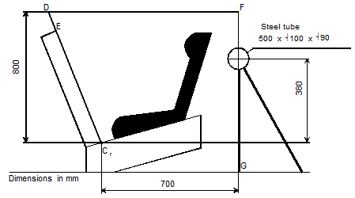

"
Paragraph 7.1.2.7., amend to read:
"7.1.2.7. These tests shall be carried out using both the smallest and the largest appropriate dummy of the size range for which the restraining device is intended. Any adjustment of the dummy or Enhanced child Child restraint Restraint systems Systems during the complete test cycle is not allowed."
Paragraph 7.1.3., amend to read:
"7.1.3. …
(e) The lateral dynamic test(s) will be performed in this(ese) configuration arrangement(s);
…"

Insert new paragraph 7.1.3.6.5., to read:
“7.1.3.6.5. The test specified in 6.6.4.1.8. above is a requirement only for:
7.1.3.6.5.1. The smallest dummy for which the Enhanced Child Restraint System is designed, if the means of restraint is an impact shield.
7.1.3.6.5.2. The largest dummy for which the Enhanced Child Restraint System is designed, if the means of restraint is a harness.”
Paragraph 7.2.3.2., amend to read:
"7.2.3.2. The free end of the strap shall be arranged in the same configuration way as when the device is in use in the vehicle, and shall not be attached to any other part."
Paragraph 7.2.5.2.6.2., amend to read:
"7.2.5.2.6.2. The table below sets out the general conditions for each test:
Table 8
 | Load (N) | Cycles per minute | Cycles (No.)
Type 1 procedure | 10 60 ± 0.15 | 30 ± 10 | 1 000 ± 5
Type 2 procedure | 5 10 ± 0.0510 | 30 ± 10 | 5 000 ± 5

Where there is insufficient strap to test over 300 mm of shift, the test may be applied over a shorter length subject to a minimum of 100 mm. The dynamic tests shall be conducted with the largest dummy and the smallest dummy as defined in the following tables according to the size range indicated by the manufacturer for the Enhanced Child Restraint System."
Paragraphs 7.2.5.2.6.3. to 7.2.5.2.6.3.2., amend to read:
"7.2.5.2.6.3. Particular test conditions
7.2.5.2.6.3.1. Type 1 procedure: for cases where the strap slides through the quick adjusting device. The 10 N load shall be vertically and permanently applied on one of the straps. The other strap, set horizontally, Apply a load of 10 N, if necessary the load may be increased by 10 N steps so as to permit correct sliding, but limited to a maximum of 60 N. This load shall be vertically and permanently applied on the straps. The part of the strap set horizontally shall pass through the quick adjuster it is fitted to and shall be attached to a device, giving the webbing a back and forth motion. The quick adjusting device shall be so placed that the horizontal strap of the webbing remains under tension (see Annex 5, figure 1). Activate the quick adjuster while pulling the straps in the direction to slacken the harness and deactivate it while pulling the straps in the direction to tighten the harness.
7.2.5.2.6.3.1. Type 2 procedure: for cases where the strap changes direction in passing through a rigid part. During this test, the angles of both webbing straps shall be as shown in webbing shall pass through the rigid part it is intended for and the test set up shall reproduce the angles as in the real installation (in three dimensions), see Annex 5, figure 2 for examples. The 5 N 10N load shall be permanently applied. For cases where the strap changes direction more than once in passing through a rigid part, the load of 5 N 10N may be increased so as to by 10 N steps so as to permit correct sliding and achieve the prescribed 300 mm of strap movement through that rigid part."

Insert new paragraphs 7.2.9. to 7.2.9.2., to read:
"7.2.9. Lock-off devices
7.2.9.1. Class A devices
The child restraint and the largest manikin for which the child restraint is intended shall be set up as shown in Figure 4 below. The webbing used shall be as specified in Annex 23 to this Regulation. The lock-off shall be fully applied and a mark made on the belt where the belt enters the lock-off. The force gauges shall be attached to the belt via a D ring, and a force equal to twice (±5 per cent) the mass of the heaviest dummy of group I shall be applied for at least one second. The lower position shall be used for lock-offs in position A and the upper position for lock-offs in position B. The force shall be applied for a further 9 times. A further mark shall be made on the belt where it enters the lock-off and the distance between the two marks shall be measured. During this test, the retractor shall be unlocked.

- Figure 4
Retractor
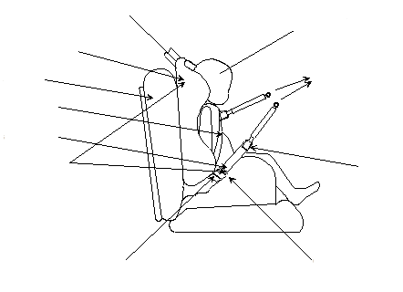
Regulation No. 129
Test seat
15 kg manikin
Buckle/tongue
Examine for slippage
"D" ring
"Lock off" clip
Abdominal
Diagonal
Child seat

7.2.9.2. Class B devices.
The child restraint shall be firmly secured, and the webbing as specified in Annex 23 to this Regulation, shall be passed through the lock-off and frame following the routing described in the manufacturer's instructions. The belt shall pass through the testing equipment as described in Figure 5 below and be attached to a mass of 5.25 ± 0.05 kg. There shall be 650 ± 40 mm of free webbing between the mass and the point where the webbing leaves the frame. The lock-off shall be fully applied and a mark made on the belt where it enters the lock-off. The mass shall be raised and released so that it falls freely over a distance of 25 ± 1 mm. This shall be repeated 100 times ±2 at a frequency of 60 ± 2 cycles per minute, to simulate the jerking action of a child restraint in a car. A further mark shall be made on the belt where it enters the lock-off and the distance between the two marks shall be measured.
The lock-off device shall cover the full width of the webbing in the installed condition with Q3 dummy installed. This test is to be conducted using the same webbing angles as those formed in normal use. The free end of the lap belt portion shall be fixed. The test shall be conducted with the child restraint system firmly attached to the test bench used in the overturning or dynamic test. The loading strap can be attached to the simulated buckle."
Paragraph 8.1., amend to read:
8.1. The test report shall record the results of all tests and measurements including the following test data:
(a) The type of device used for the test (acceleration or deceleration device),
(b) The total velocity change,
(c) The trolley speed immediately before impact only for deceleration sleds,
(d) The acceleration or deceleration curve during all the velocity change of the trolley and at least 300 ms,
(e) The time (in ms) when the head of the manikin reaches its maximum displacement during the performance of the dynamic test,
(f) The place occupied by the buckle during the tests, if it can be varied, and
(g) The name and address of the laboratory where tests have been performed,
(h) And any failure or breakage,
(i) The following dummy criteria: HPC, Head acceleration Cum3ms, Upper neck tension force, Upper neck moment, Chest acceleration
Cum3ms, Chest deflection; Abdominal Pressure (in frontal and rear impact); and
(j) Adult Seat belt bench installation forces.

Paragraphs 14.2.3. to 14.2.9. (former), renumber as paragraphs 14.2.4. to 14.2.10.
Annex 2, replace current Annex 2 by the following to read:
"Annex 2

1. Arrangements of the approval mark
…

2. Arrangements of the approval mark in combination with a module mark
…

2.1. Arrangements of the module mark in combination with an approval mark
2.1.1. Where a module is approved for use with more than one base, the individual base and module combinations shall be indicated on the module in separate module marks, each bearing their applicable size ranges.

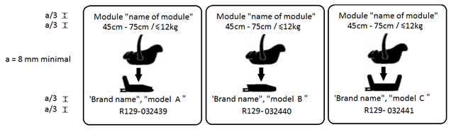

An Enhanced Child Restraint System that bears an approval mark for the stand-alone mode of use and a module mark for its use on three different bases, shall carry the following arrangement of approval and module marks:
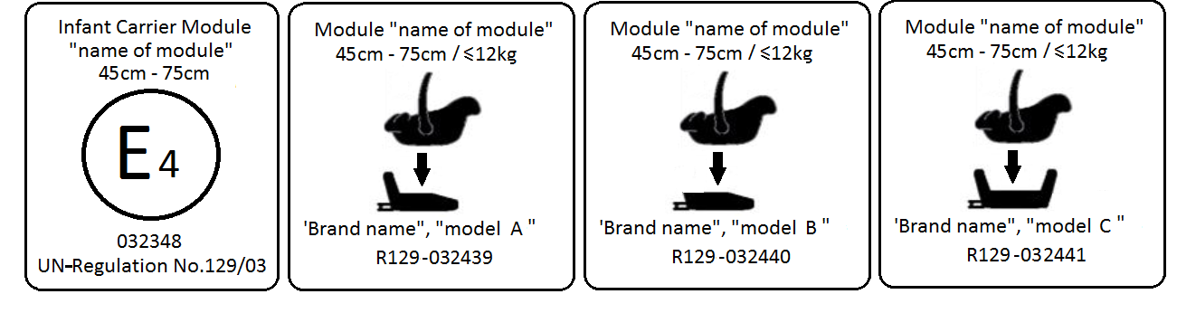
The Enhanced Child Restraint System bearing the above marks is capable of being used as an Infant Carrier Module with a vehicle belt for the 45 cm - 75 cm size range; it is approved according to regulation No. 129-03 under the number 032348.
The Enhanced Child Restraint System can also be used as a module in combination with the base "brand name & model A’, for the 45 cm - 75 cm size range and mass limit of 12 kg; approved according to Regulation No. 129-03 under the number 032439.
The Enhanced Child Restraint System can also be used as a module in combination with the base "brand name & model B’, for the 45 cm - 75 cm size range and mass limit of 12 kg; approved according to Regulation No. 129-03 under the number 032440.
The Enhanced Child Restraint System can also be used as a module in combination with the base "brand name and model C", for the 45 cm - 75 cm size range and mass limit of 12 kg; approved according to Regulation No. 129-03 under the number 032441.
The approval numbers indicate that the approval was granted in accordance with the requirements of the Regulation concerning the approval of Enhanced Child Restraint Systems used on board of motor vehicles as amended by the 03 series of amendments.

2.1.2. Where a module is capable of being installed in different orientations, separate module marks shall be indicated on the module, each bearing their applicable size ranges.

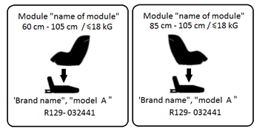
The Enhanced Child Restraint System bearing the above marks is capable of being used in a rearward facing mode with the base "brand name & model A’, for the 60 cm - 105 cm size range and with a mass limit of 18 kg; approved according to Regulation No. 129-03 under the number 032441.
The Enhanced Child Restraint System bearing the above marks is also capable of being used in a forward facing mode with the base "brand name and model A", for the 85 cm - 105 cm size range and with a mass limit of 18 kg; approved according to Regulation No. 129-03 under the same number 032441.
The approval number indicates that the approval was granted in accordance with the requirements of the Regulation concerning the approval of Enhanced Child Restraint Systems used on-board motor vehicles as amended by the 03 series of amendments.

2.2 Examples of the symbols to be used on the module mark are given in the figures below. As chosen by the Enhanced Child Restraint Systems manufacturer, one of the symbols or an equivalent shall be used on the module mark. ”
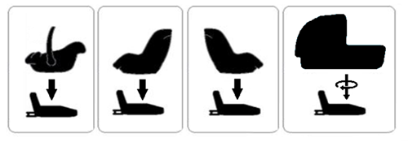

Annex 5, Figures 1 and 2 , amend to read:
"Annex 5
Abrasion and microslip test

Figure 1
Procedure type 1
F = 10 ± 0.1 N, can be increased up to F = 60 ± 0.5 N
Total travel:
300 ± 20 mm

Support
Protective strap for inner bar
Example a

Example b
Examples of test arrangements corresponding
to the type of adjusting device

F = 10 ± 0.1 N, can be increased up to F = 60 ± 0.5 N
Total travel:
300 ± 20 mm
Lower stop
Rotating pin

Figure 2
Procedure type 2
Following two examples of test set up

Example 1
Straps in horizontal plane
F = 10 ± 0.1 N F = 5 ± 0.05 N
α
±
5°
Total travel:
300 ± 20 mm
Test in the buckle
Example 2
α
±

5º
β
±

5º
F = 10 ± 0.1 N F = 5 ± 0.05 N

Total travel:
300 ± 20 mm
Test in a guide or pulley

Where α and β reproduce the angles as in the real installation (in three dimensions)
..."

Annex 8, Note Table 1, amend to read:

The installation of Abdominal Pressure Twin Sensors (APTS) in frontal and rear impact may add up 0.2 kg to the Q1.5 and 0.5kg to the Q3, Q6 and Q10 dummies.

Annex 8, Table 2, amend to read:
Table 2
Q-dummy dimensions
No. |  | Q0 | Q1 | Q1.5 | Q3 | Q6 | Q10  (design targets)
 |  | Dimensions in mm
17 | Seating height  (head tilted forward) | 355 ± 9 | 479 ± 9 | 499 ± 9 | 544 ± 9 | 601 ± 9 | < 748 ± 9  733.7 ± 9
18 | Shoulder height  (sitting) | 225 ± 7  255 ± 5 | 298 ± 7 | 309 ± 7 | 329 ± 7 | 362 ± 7 | 473 ± 7
 | Stature  (head tilted forward) | - | 740 ± 9 | 800 ± 9 | 985 ± 9 | 1143 ± 9 | < 1443 ± 9  1453.2 ± 12
5 | Chest depth | - | 114 ± 5 | 113 ± 5 | 146 ± 5 | 141 ± 5 | 171 ± 5
15 | Shoulder width | 230 ± 7  145 ± 5 | 227 ± 7 | 227 ± 7 | 259 ± 7 | 305 ± 7 | 338 ± 7
12 | Hip width | - | 191 ± 7 | 194 ± 7 | 200 ± 7 | 223 ± 7 | 270 ± 7
1 | Back of buttocks to front of knees | 130 ± 5 | 211 ± 5 | 235 ± 5 | 305 ± 5 | 366 ± 5 | 488 ± 5  485.4 ± 6
2 | Back of buttocks to popliteus | - | 161 ± 5 | 185 ± 5 | 253 ± 5 | 299 ± 5 | 418 ± 5  414,9 ± 6
21 | Thigh height, sitting |  | 69 | 72 | 79 | 92 | 114 ± 3
 | Height of spacer device for positioning of dummy¹ |  | 229 ± 2 | 237 ± 2 | 250 ± 2 | 270 ± 2 | 359 ± 2

Annex 12, paragraph 2.2.1.4., Notes, amend to read:
"Notes:
MH means harder configuration condition (the least good results obtained in approval or extension of approval)
LH signifies a less hard configuration condition."

Annex 18, amend to read:
"Annex 18
Geometrical dimensions of Enhanced Child Restraint Systems

Figure 3
Side and Front View of the measuring device for measurements applicable to Enhanced Child Restraint Systems that feature an impact shield
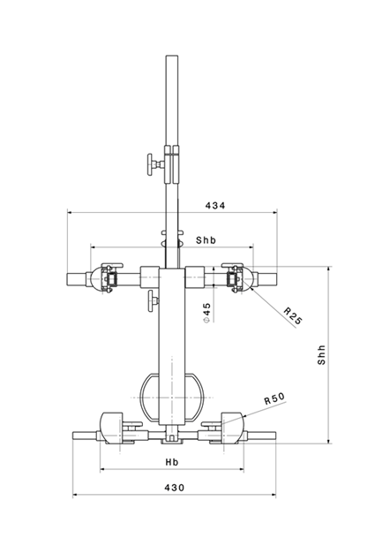 | 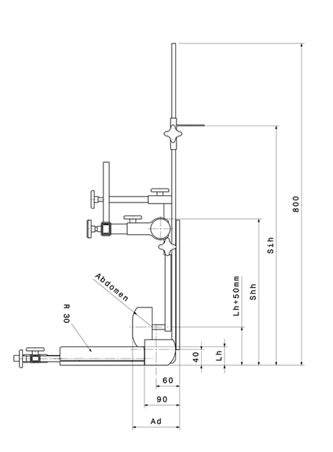
New 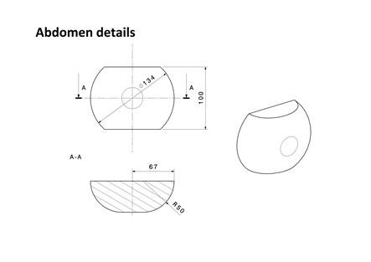
All dimensions in mm

Internal geometry assessment method
Replace in the entire paragraph ECRS by Enhanced Child Restraint System

Annex 18, insert new paragraph 3
3. Stature Calculation
The measurements taken in Section 1 & 2 shall then be compared to the values shown in Annex 18, Table 1.
Interpolation between the values shown in the table is allowed in one-centimetre intervals
For each measurement, the corresponding stature at the nearest whole lower centimetre shall be calculated.
For the measurements B, C, D, E2, F2 and G2 the measured value must be greater or equal to the value shown in the table to meet the stature requirement.
e.g. To declare a stature of 105 cm the measured sitting height must be greater or equal to 61.8 cm
For the measurements E1, F1 and G1 the measured value must be less than or equal to the value shown in the table to meet the stature requirement.
e.g. To declare a stature of 100 cm the measured sitting height must be less than or equal to 59.7 cm
The maximum stature is the smallest stature calculated from the measurements B, C, D, E2, F2 and G2.
The minimum stature is the largest stature calculated from the measurements E1, F1 and G1."

Annex 23, amend to read:
"1. The safety-belt for the dynamic test and for the maximum length requirements shall be made according to the configuration definition shown in Figure 1. These are a three-point retracting belt system.
…"
II. Justification
1. This represents Supplement 3 to Phase 2 of the UN Regulation. The text includes mainly correction of wording or chapter references, clarification of test procedures and new definitions.
2. The text includes all modifications proposed by GRSP up to and including its sixty-first (8-12 May 2017) as well as those of the Informal Working Group on Child Restraint Systems up to and including its sixty-seventh session (Brussels, 31th August 2017).
3. This proposal refers to the series 02 text of Regulation No. 129, including the following amendments:
- Proposal for supplement 1 to the 02 series of amendments - ECE/TRANS/WP.29/2017/63
- Proposal for supplement 2 to the 02 series of amendments - ECE/TRANS/WP.29/2017/126

