ECE/TRANS/180/Add.9

26 January 2009
GTR9-10-03

GLOBAL REGISTRY

Created on 18 November 2004, pursuant to Article 6 of the
AGREEMENT CONCERNING THE ESTABLISHING OF GLOBAL TECHNICAL REGULATIONS FOR WHEELED VEHICLES, EQUIPMENT AND PARTS WHICH CAN BE FITTED AND/OR BE USED ON WHEELED VEHICLES
(ECE/TRANS/132 and Corr.1)

Done at Geneva on 25 June 1988

Addendum

Global technical regulation No. 9

PEDESTRIAN SAFETY

(Established in the Global Registry on 12 November 2008)

Consolidated version including corrigendum 1, amendment 1 and corrigendum 2

Incl. documents ECE/TRANS/WP.29/GRSP/2014/15,
ECE/TRANS/WP.29/GRSP/2014/30 und GRSP-60-17

UNITED NATIONS

TABLE OF CONTENTS

Page

I. STATEMENT OF TECHNICAL RATIONALE AND JUSTIFICATION 5

A. PHASE 1 5

1. Safety need 5

2. Summary: description of the proposed regulation 7

3. Procedural background 9

4. Existing regulations, directives, and international voluntary standards 10

5. General issues 12

6. Pedestrian head protection 17

7. Pedestrian leg protection 23

8. Other issues 27

9. Regulatory impact and economic effectivenes 29

10. Appendix 31

B. PHASE 2

1. Introduction and General Background

2. Procedural Background

3. Requirements

4. Key elements of the amendment

5. Recommendations and Limitations for introducing the
flexible lower legform impactor

6. Task Force Bumper Test Area (TF-BTA)

II. TEXT OF THE REGULATION 37

1. Purpose 37

2. Application / scope 37

3. Definitions 37

4. General requirements 47
4.1. Legform test to bumper 47
4.2. Child headform impact 47
4.3. Adult headform impact 47

5. Performance requirements 48
5.1. Legform to bumper 48
5.2. Headform tests 48

TABLE OF CONTENTS

Page

6. Test specifications 49
6.1. General test conditions 49
6.2. Preparation of the vehicle 50
6.3. Test impactor specifications 50

7. Test procedures 59
7.1. Legform to bumper test procedures 59
7.2. Headform test procedures 61
7.3. Child headform test procedure 62
7.4. Adult headform test procedure 63

8. Certification of impactors 63

8.1. Lower legform impactor certification 64
8.2. Upper legform impactor certification 67
8.3. Child and adult headform impactors certification 68

I. STATEMENT OF TECHNICAL RATIONALE AND JUSTIFICATION

- PHASE 1

- Sections 1. to 10. reflect the development of phase 1 of gtr No. 9 and concern the legform test procedure with the lower legform impactor designed by the European Enhanced Vehicle-Safety Committee (EEVC) and the upper legform impactor for the high bumper vehicles as well as the headform test procedure.

1. SAFETY NEED

1. Each year, thousands of pedestrians and cyclists are struck by motor vehicles. Most of these accidents take place in urban areas where serious or fatal injuries can be sustained at relatively low speed, particularly in the case of children. This global technical regulation (gtr) will significantly reduce the levels of injury sustained by pedestrians involved in frontal impacts with motor vehicles.

2. This gtr is based on data from a number of sources, including the International Harmonized Research Activities (IHRA) / Pedestrian Safety working group (IHRA/PS). The data was sourced from Australia, Germany, Japan and the United States of America. Data from IHRA /, Germany /, Italy /, the UNECE /, Spain /, Canada /, the Netherlands /, Sweden /, and Korea / indicate that, annually: in the European Union about 8,000 pedestrians and cyclists are killed and about 300,000 injured; in North America approximately 5,000 pedestrians are killed and 85,000 injured; in Japan approximately 3,300 pedestrians and cyclists are killed and 27,000 seriously injured; and in Korea around 3,600 pedestrians are killed and 90,000 injured.

3. The IHRA/PS study indicates the following:

(a) Distribution of the injuries

4. Comparing the ages of those involved, statistics show the highest frequency of accidents is for children of five to nine years old, and for adults over 60 years old. Children (aged 15 and under) account for nearly one-third of all injuries in the dataset, even though they constitute only 18 percent of the population in the four countries included in the IHRA data.

5. The frequency of fatal and serious injuries (Abbreviated Injury Scale: AIS 2-6) is highest for the child and adult head and adult leg body regions (INF GR/PS/3).

(b) Crash speeds

6. Crash speeds between vehicles and pedestrians were collected from pedestrian accident data. The cumulative frequency of the crash speeds shows that a crash speed of up to 40 km/h can cover more than 75 percent of total pedestrian injuries (AIS 1+) in all regions.

(c) Target population for this gtr

7. The IHRA injury data indicate the injury distribution by body regions. Fatal and serious head injuries (AIS2+) of children and adults as well as AIS2+ adult leg injuries were extracted from the IHRA data base for clearly identified injury causing parts on the vehicle and on the road (INF GR/PS/131 and 169). It was found that bonnet/wing contacts caused 41 percent of child head injuries of AIS2+ and 19 percent of the adult AIS2+ head injuries. Bumper contacts lead to 64 percent of adult AIS2+ leg injuries. The cumulative frequency curves versus vehicle impact speed for these injuries and their respective injury causing parts show that 58 percent of the child head AIS2+ injuries are addressed to a vehicle impact speed up to 40 km/h, 40 percent to adult head AIS2+ injuries and 50 percent of the adult leg AIS2+ injuries respectively. Based on these figures of injuries by injury source and vehicle contact area, the target population of the above-mentioned AIS2+ injuries for this proposed gtr is 24 percent of child pedestrian head injuries, 8 percent of adult pedestrian head injuries, and 32 percent of adult leg injuries.

8. Each of these body regions, i.e. head of child/adult and adult leg, covers more than 30 percent of total fatal and severe injuries (INF GR/PS/3). This gtr focuses on protecting these body regions.

9. The major source of child head injuries is the top surface of the bonnet/wing, while adult head injuries result from impacts to the top surface of bonnet/wing and windscreen area. For adult leg injuries, the major source is the front bumper of vehicles.

(d) Applicability to motor vehicle categories

10. The maximum benefit from making vehicles pedestrian friendly would occur if all types of vehicles comply with these technical provisions, but it is recognized that their application to heavier vehicles (large trucks and buses) as well as to very small and light vehicles could be of limited value and may not be technically appropriate in their present form. The tests proposed in this gtr have been developed on the basis of current light vehicles, taking into account the pedestrian kinematics when impacted by such vehicles. For this reason, the scope of application is limited to passenger cars, sport utility vehicles (SUV), light trucks and other light commercial vehicles. Since these vehicle categories represent the vast majority of vehicles currently in use, the proposed measures will have the widest practicable effect in reducing pedestrian injuries.

2. SUMMARY: DESCRIPTION OF THE PROPOSED REGULATION

(a) Introduction

11. It is generally accepted that in the most representative pedestrian to car accident the pedestrian is in normal walking posture, meaning that the pedestrian is standing sideways to the vehicle, and is struck by the vehicle from the side. This scenario is therefore also the basis for this gtr.

12. When an adult pedestrian is struck by vehicles addressed by this gtr, the first impact is generally between the pedestrian knee region and the vehicle's front bumper. Because this initial contact is usually below the pedestrian's centre of gravity, the upper body in such a case begins to rotate toward the vehicle. The pedestrian's body accelerates linearly relative to the ground because the pedestrian is being carried along by the vehicle. The second contact is usually between the upper part of the grille or front edge of the bonnet and the pedestrian's pelvic area. The pedestrian's legs and pelvis have reached the linear velocity of the vehicle at this point and the upper body (head and thorax) are still rotating toward the vehicle. The final phase of the collision involves the head and thorax striking the vehicle with a linear velocity approaching that of the initial striking velocity of the vehicle. IHRA research has shown that the linear head impact velocity averages about 80 percent of the initial contact velocity.

13. Through the pedestrian accidents analysis, it has been concluded that child and adult heads and adult legs are the body regions most affected by contact with the front end of vehicles. On vehicles, the bumper, the bonnet top and the windscreen area, including the A-pillars, are the vehicle regions mostly identified with a high potential for contact. According to the IHRA/PS study, the above-mentioned areas can cover more than 65 percent of the fatal and serious injuries.

14. Based on these study results, the informal group prioritized the development of approaches to simulate a pedestrian impact and encourage countermeasures that will improve pedestrian protection. This gtr would improve pedestrian safety by requiring vehicle bonnets and bumpers to absorb energy more efficiently when impacted in a 40 kilometre per hour (km/h) vehicle-to-pedestrian impact, which accounts for more than 75 percent of the pedestrian injured accidents (AIS 1+) reported by IHRA/PS of the injury frequency.

15. During the activities of the gtr informal group, headform to windscreen testing was proposed to be included in the gtr. IHRA accident studies mentioned above identify the windscreen, windscreen frame and A-pillars as injury causing parts of the vehicle in pedestrian to car collisions.

16. After several discussions on this issue the group decided not to include these kinds of tests into the gtr at this stage for the following reasons:

(i) The group recognized that the A-pillars, windscreen roof and lower frame have to be very stiff vehicle parts due to their functional requirements. As an example in the lower windscreen area, the required deformation space to meet a head impact requirement is restricted by the instrument panel. Some components that are required to meet governmental safety standards, such as defrost/demist etc., make it impossible to lower the dashboard significantly. In addition, the structural components of the dashboard represent important load paths in front or side crashes. On the other hand, the entire windscreen frame would need to be softened extremely to pass any HIC (Head Injury Criterion) requirement. This strongly contradicts roll over requirements and other existing legal and consumer demands (see INF GR/PS/059 and INF GR/PS/035). In addition the group received detailed data showing that extremely high HIC measurements are frequently obtained in these difficult areas (see INF GR/PS/072, 094, 102 and 103) and agreed that there are no technical design solutions or countermeasures available so far to drastically reduce HIC levels.
(ii) The windscreen glass itself does not produce severe injuries and therefore the amount of saved casualties will be very low. The effectiveness of testing the windscreen inner part is seen as very questionable.
(iii) In addition, it was noted that vehicle manufacturers believed that there are problems related to scatter of HIC when performing tests in the windscreen and that the reasons for the scatter are not yet fully understood (see INF GR/PS/134, 163 and 164).

17. However, some delegates expressed interest in having domestic regulations that apply head protection requirements to the windscreen area. The informal group did not believe the gtr would foreclose any jurisdiction from applying head protection requirements to the windscreen area by way of domestic regulations.

(b) Overview

18. This gtr consists of two sets of performance criteria applying to: (a) the bonnet top and wings; and (b) the front bumper. Test procedures have been developed for each region using sub-system impacts for adult and child head protection and adult leg protection. /

19. The head impact requirements will ensure that bonnet tops and wings will provide head protection when struck by a pedestrian. The bonnet top and wings would be impacted with a child headform and an adult headform at 35 kilometres per hour (km/h). The HIC must not exceed 1,000 over one half of a child headform test area and must not exceed 1,000 over two thirds of a combined child and adult headform test areas. The HIC for the remaining areas must not exceed 1,700 for both headforms.

20. The leg protection requirements for the front bumper would require bumpers to subject pedestrians to lower impact forces. This gtr specifies that the vehicle bumper is struck at 40 km/h with a legform that simulates the impact response of an adult's leg. Vehicles with a lower bumper height of less than 425 millimetre (mm) are tested with a lower legform, while vehicles with a lower bumper height of more than 500 mm are tested with an upper legform test device. Vehicles with a lower bumper height between 425 mm and 500 mm are tested with either legform chosen by the manufacturer. In the lower legform to bumper test, vehicles must meet limits on lateral knee bending angle, knee shearing displacement, and lateral tibia acceleration. In the upper legform to bumper test, limits are placed on the instantaneous sum of the impact forces with respect to time and the bending moment of the test.

21. The performance requirements, test procedures and supplementary information explaining the rationale for this gtr are discussed in detail in later sections of this preamble.

3. PROCEDURAL BACKGROUND

22. During the one-hundred-and-twenty-sixth session of WP.29 in March 2002, AC.3 concluded their considerations of priorities for developing future global technical regulations. WP.29 adopted the 1998 Global Agreement Programme of Work, which included pedestrian safety, and decided to start the work on pedestrian safety at the thirty-first session of GRSP in May 2002, by establishing an informal group to draft the gtr. The formal proposal to develop a gtr (TRANS/WP.29/AC.3/7) was considered and adopted by the AC.3 at its tenth session, in March 2004. It is based on document TRANS/WP.29/2004/26, which had been submitted by the European Community, the technical sponsor of the project.

23. Informal document No. 10 of the thirty-first session of GRSP lays down the terms of reference of the group and the document was adopted by GRSP (INF GR/PS/2).

24. Informal document No. 7 of the thirty-second session of GRSP reported on the result of the first meeting of the informal group (INF GR/PS/9).

25. Informal document No. 2 of the thirty-third session of GRSP (INF GR/PS/47 Rev.1) was the first preliminary report of the informal group and responds to paragraph 5 of documents TRANS/WP.29/2002/24 and TRANS/WP.29/2002/49 as adopted by AC.3 and endorsed during the one-hundred-and-twenty-seventh session of WP.29. The documents were consolidated in the final document TRANS/WP.29/882. The preliminary report was adopted as TRANS/WP.29/2003/99 by AC.3 in November 2003.

26. Informal document No.GRSP-34-2 of the thirty-fourth session of GRSP reported on the action plan of the informal group (INF GR/PS/62).

27. Informal document No. GRSP-35-5 of the thirty-fifth session of GRSP was the second preliminary report of the informal group (INF GR/PS/86 Rev2 and PS/88). This report was considered by AC.3 in June 2004 as informal document No. WP.29-133-7.

28. Informal document No. GRSP-36-1 of the thirty-sixth session of GRSP was the first draft gtr of the informal group (INF GR/PS/116).

29. TRANS/WP.29/GRSP/2005/3 was proposed at the thirty-seventh session of GRSP and was a revised draft gtr including the preamble, of the informal group (INF GR/PS/117).

30. The group had held the following meetings:
(a) 4-5 September, 2002, Paris, France
(b) 10 December, 2002, Geneva, Switzerland
(c) 15-16 January, 2003, Santa Oliva, Spain
(d) 15-16 May, 2003, Tokyo, Japan
(e) 10-12 September, 2003, Ottawa, Canada
(f) 24-26 February, 2004, Paris, France
(g) 28-30 September, 2004, Paris, France
(h) 11-13 July, 2005, Brussels, Belgium
(i) 5-6 December, 2005, Geneva, Switzerland
(j) 16-19 January, 2006, Washington DC, USA

31. The meetings were attended by representatives of:

32. Canada, France, Germany, European Community (EC), Italy, Japan, Korea, the Netherlands, Spain, Turkey, the United States of America (USA), Consumers International (CI), the European Enhanced Vehicle-safety Committee (EEVC) /, the European Association of Automotive Suppliers (CLEPA) and the International Organization of Motor Vehicle Manufacturers (OICA).

33. The meetings were chaired by Mr. Mizuno (Japan) and Mr. Friedel/Mr. Cesari (EC), while the secretariat was provided by Mr. Van der Plas (OICA).

4. EXISTING REGULATIONS, DIRECTIVES, AND INTERNATIONAL VOLUNTARY STANDARDS

34. At the present time, there are no regulations concerning the provision of improved protection for pedestrians and other vulnerable road users in the Compendium of Candidates.

35. The following is a summary of national and regional legislation and of work in international forums:

36. The Japanese Government has established a regulation on pedestrian protection. The regulation addresses the issues of providing protection for the child and adult heads. It applies to passenger cars with up to 9 seats and to small trucks of up to 2,500 kg Gross Vehicle Mass (GVM) with application from 2005 for new vehicle types and from 2010 for existing vehicle types (certain other vehicles have a timetable which is postponed by two years). The regulation requires compliance with test requirements using representative head impactors.

37. The European Parliament and Council adopted the Directive 2003/102/EC which provides for the introduction of requirements for leg injuries, and adult and child head injuries. The Directive and its requirements are incorporated into Community legislation under the European Union (EU) whole vehicle type approval system set up by EU Framework Directive 70/156/EEC. It applies to passenger cars of category M₁ and to light commercial vehicles derived from passenger cars of M₁ category, both up to 2,500 kg gross vehicle mass, with application dates in two phases starting in 2005 and 2010. The requirements and the tests are based on the research results that were published by EEVC in the 1990's and that were introduced in a less severe form for the first phase and intended to be introduced in the originally proposed form for the second phase. However, since EEVC results have never been fully accepted by all involved parties, the Directive provided for a feasibility review of the requirements for the planned second phase in 2004. This feasibility review has taken place and may result in amendments to the European requirements in its second phase, starting in 2010.

38. Canada is currently reviewing its bumper regulation. The Canadian bumper regulation is one of the most stringent in the world (all the safety features of the vehicle have to be functional after an 8 km/h impact). In addition, Canada and the USA are conducting a preliminary investigation of the effects of bumper design on different leg test devices (Transport Research Laboratory (TRL) legform impactor; Polar dummy and flexible pedestrian legform impactor (Flex-PLI)).

39. The United States research programmes have addressed how vehicles could be modified to reduce the severity of head and leg impacts. / / The current US pedestrian protection research programme supports the IHRA objectives. Current activities include (1) pedestrian field data analysis to develop test conditions, (2) evaluation of pedestrian head and leg test tools, (3) experimental impact testing of vehicle structures to assess aggressivity, (4) pedestrian case reconstructions using a combination of field data, computer simulation, and testing to better understand injury mechanisms, (5) computer model development using available biomechanical literature, and (6) completion of other IHRA Pedestrian Safety Working Group action items.

40. The IHRA Pedestrian Safety working group has conducted in-depth accident studies based on pedestrian accident data collected from the member countries. In addition, this group carefully studied the front shape of passenger vehicles including SUVs, and used best available computer simulation models to study the effective head mass, adult and child head impacting speed during the impact with vehicles and the impact angles.

41. Based on these research results, the IHRA group developed test procedures and test devices for adult and child head protection and for adult leg protection.

42. The International Organization for Standardization (ISO) created the pedestrian protection working group (ISO/TC22/SC10/WG2) in 1987 to develop test methods for the reduction of serious injuries and fatalities for pedestrian to car accidents. The mandate for ISO/WG2 was to produce test methods, covering crash speeds up to 40 km/h, which will contribute to make cars pedestrian friendly. Since then, the WG2 has developed pedestrian test procedures and has described the necessary test tools. The study results were fully used in the IHRA/PS group when IHRA/PS developed the adult and child impactors.

43. The ISO standards and draft standards are:
(a) ISO 11096 2002 Road vehicles - Pedestrian protection - Impact test method for pedestrian thigh, leg and knee,
(b) ISO/DIS 14513 2006 Road vehicles - Pedestrian protection - Head impact test method,
(c) ISO 16850 2007 Road vehicles - Pedestrian protection - Child head impact test method.

5. GENERAL ISSUES

(a) Scope

44. From the review of pedestrian fatality and injury statistics from several countries, it was shown that the head and the legs are the most frequently injured body regions in pedestrian accidents. It was recommended that the gtr would encompass tests for the adult head and leg, and the child head. The studies also showed that the majority of pedestrian injuries are occurring in urban environments. Therefore, the gtr should test those vehicles found in this environment, including passenger vehicles, vans, and light trucks.

45. As suggested by the terms of reference of the informal group, consideration was given to the use of the best available technology and improvements in technology that will provide significant steps in developing methods and in achieving and improving benefits, including both active and passive safety measures (TRANS/WP.29/GRSP/30). There was a discussion on whether the proposed pedestrian gtr should regulate passive and/or active safety systems. Active safety systems, such as brake assist, anti-lock brakes and day-light running lights were suggested as solutions for the reduction of pedestrian injuries, but it was ultimately counselled by GRSP and WP.29 to concentrate on passive systems for this gtr, as this is the main domain of expertise of the GRSP working party, and only to provide advice on the use of active systems.

46. The group understood that active safety and infrastructure measures were not within the remit of the group, but determined that it could be useful and efficient to inform WP.29/AC.3 as well as other authorities of the need to take these issues into account for real world safety improvements. The group also noted the importance of educational measures and the need to enforce existing road traffic legislation. Some experts noted that consideration of other safety measures, if properly balanced with the passive safety requirements, might help in ensuring that the vehicle passive safety requirements are kept at a realistic and feasible level.

47. OICA, in particular, mentioned brake assist systems which can, in emergency situations, substantially improve the braking performance and consequently reduce the impact speed when the impact is unavoidable. A study on the effectiveness of such a system was presented by OICA using the German In-Depth Accident Studies (GIDAS) database (INF GR/PS/25). This showed that if the vehicle speed is 50 km/h at the start of braking, the collision speed (car versus pedestrian) would be reduced to 40 km/h in general, to 35 km/h for an experienced driver and to 25 km/h for cars equipped with brake assist systems. Another study performed by the Technical University of Dresden on behalf of the European Automobile Manufacturers' Association (ACEA) was presented by OICA (INF GR/PS/92). This study confirmed the positive effect of brake assist systems on pedestrian fatalities and injuries.

48. As for infrastructure measures that could improve pedestrian safety, OICA presented the results of a 1998 study conducted on behalf of ACEA by the consultants ORIENTATIONS (France) and TMS Consultancy (United Kingdom) (INF GR/PS/29). This study, which evaluated the effect of infrastructural measures based on real data evaluations, concluded that such measures could dramatically reduce the number of pedestrian victims (fatalities/injuries) at low cost.

(b) Applicability

49. The application of the requirements of this gtr refers, to the extent possible, to the revised vehicle classification and definitions outlined in the 1998 Global Agreement Special Resolution No. 1 (S.R.1) concerning the common definitions of vehicle categories, masses and dimensions.

50. Difficulties, due to differing existing regulations and divergent vehicle fleets, were encountered in determining which vehicles would be included in the scope. The Japanese regulation applies to passenger cars for up to nine occupants and commercial vehicles up to a GVM of 2,500 kg. The IHRA recommends tests and procedures for passenger vehicles of GVM 2,500 kg or less. The European Union (EU) Directive applies to M₁ vehicles up to 2,500 kg and N₁ vehicles up to 2,500 kg, which are derived from M₁. The ISO recommendations are for M₁ and N₁ vehicles that have a GVM of 3,500 kg or less. In addition, some countries, taking into account their current fleet composition, wanted to ensure that larger vehicles, such as light trucks and sport utility vehicles with a GVM of 4,500 kg or less, were not excluded.

51. The group originally reviewed in detail the IHRA recommendation in detail to take into account the shape of the front of the vehicle as an important parameter when discussing the types of pedestrian injuries to be mitigated. IHRA specifies three groups of vehicle shape: sedan, SUV, and 1-box. For the adult and child head impacts, IHRA foresees different impact test speeds and different impact angles. The Japanese legislation is based on the IHRA recommended method. The EU requirements, on the contrary, do not differentiate between the various test speeds and impact angles.

52. The group compared these various considerations and, on the basis of simulations (INF GR/PS/129), concluded that the EU requirements in effect are more severe than the Japanese proposals. For safety reasons, the group therefore uses the EU approach, not taking into account the shape of the vehicle front in defining the requirements. Furthermore, the group also determined that the IHRA recommendations would be difficult to put in place in the context of a regulatory and certification approach.

53. There was considerable discussion over the mass of vehicles to which this gtr should apply. Using the categories described in S.R.1, several options were examined. Some delegates wanted to limit application of the gtr to vehicles in category 1-1 with a vehicle mass of less than 2,500 kg GVM. Other delegates did not agree with a 2,500 kg limit on GVM, believing that since the front-end structure of vehicles with a mass up to 4,500 kg GVM is usually similar to that of lighter vehicles, the application of the gtr should include the heavier vehicles. In addition, some delegates sought to limit application of the gtr to vehicles of a GVM of more than 500 kg, while other delegates expressed concern about having a lower mass limit, believing that a particular jurisdiction might determine there is a need to apply the gtr requirements in that jurisdiction to vehicles with a GVM of less than 500 kg. There was a suggestion that the gtr should also apply to vehicles in category 2 that had the "same" general structure and shape forward of the A-pillars as vehicles in category 1-1. However, some were concerned that it would be unfeasible to define objectively what was meant by "same".

54. After considering these issues, it was recommended that the gtr should be drafted to have a wide application to vehicles, to maximize the ability of jurisdictions to effectively address regional differences in pedestrian accident crash characteristics. The gtr would establish that if a jurisdiction determines that its domestic regulatory scheme is such that full applicability is inappropriate, it may limit domestic regulation to certain vehicle categories or mass limits. The jurisdiction could also decide to phase-in the requirements for certain vehicles. A footnote was added to the gtr text to make it clear that jurisdictions can decide to limit the applicability of the regulation. This approach recognizes that niche vehicles that are unique to a jurisdiction would best be addressed by that jurisdiction, without affecting the ability or need for other jurisdictions to regulate the vehicles. When a Contracting Party proposes to adopt the gtr into its domestic regulations, it is expected that the Contracting Party will provide reasonable justification concerning the application of the standard.

55. While this approach maximizes the discretion of jurisdictions to decide whether vehicles should be excluded from the gtr for feasibility or practical reasons, or because there is no safety need to regulate the vehicles, the group also decided to recommend excluding one unique vehicle type from the regulation. The test procedures in the gtr are based largely on the classic vehicle shape with a long bonnet. Certain vehicles, generally cargo vehicles, have a very short bonnet and a front shape that is very close to the vertical. Because of the short, vertical bonnet, the design leaves very little soft space once the hinges, latches, and other hardware are considered. There are additionally feasibility concerns for the bumpers of these vehicles. The different shape of the front leaves little room to incorporate existing countermeasures, such as those used on passenger vehicles, and new countermeasures have not been identified. The pedestrian kinematics with these vehicles may be very different. The head to bonnet impact is occurring earlier and leg injuries are occurring at a reduced frequency than with traditional long bonnet vehicles. In addition, there are difficulties in applying the head tests to these vehicles, particularly with regard to determination of test zone reference lines. For these reason, the group recommends that those vehicles of category 1-2 and category 2, where the distance, measured longitudinally on a horizontal plane, between the transverse centre line of the front axle and the R-point of the driver's seat is less than 1,100 mm, be exempt from the requirements of the regulation. To prevent inconsistencies in the market, Contracting Parties can exempt category 1-1 vehicles if they have components of the front structure that are interchangeable with exempted category 1-2 and category 2 vehicles. The group agreed to recommend allowing Contracting Parties this option even though not all Contracting Parties have these vehicles in their fleet and were therefore not able to fully evaluate the exemption..

56. For these reasons, with the exception of the exemption discussed above, the gtr is recommended to apply to category 1-1 vehicles with a GVM exceeding 500 kg; and to category 1-2 and category 2 vehicles with a GVM exceeding 500 kg but not exceeding 4,500 kg. In addition, the group recommends that a Contracting Party may restrict application of the requirements in its domestic legislation if it decides that such restriction is appropriate.

57. Regarding the applicability of this gtr, it should be noted that the requirements of the draft gtr are substantially more severe than any existing legislation at the time of adoption of the gtr. In addition, many countries do not yet have pedestrian safety requirements. It is therefore recommended that Contracting Parties implementing this gtr allow adequate lead time before full mandatory application, considering the necessary vehicle development time and product lifecycle.

58. Furthermore, during the development phase of this gtr, the main focus was on vehicles of a GVM of 2,500 kg or less, that are also addressed in all existing legislation. The later extension to other vehicles however needs to recognise that some additional lead-time may be necessary, because many current vehicles, exempted from existing national or regional requirements, are now included. In addition, while the test procedures and requirements of this gtr were based on requirements originally developed for "classical" (sedan type) passenger cars, the gtr now also covers vehicles with specific shapes or features (High Front Vehicles, special purpose vehicles, etc.), for which it is recognised that special consideration may be needed.

(c) Implementation generally

59. The informal group considers all tests in this proposed gtr to be technically feasible and able to evaluate objectively the ability of vehicle bonnets and bumpers to absorb energy more efficiently. However, pedestrian accident crash characteristics and vehicle baseline performance may differ regionally. It will be the decision of each jurisdiction to determine whether the benefits achieved by requiring these tests justify the costs. Based on this determination, a jurisdiction can choose to limit the application in its own regulation to specific vehicle categories, specific tests, and/or it may decide to phase in the regulations over time.

(d) Points tested

60. The informal group considered whether to specify both the number of test points and the minimum spacing of such test points. On consideration, the group determined that the specification of such points did not have a place within this proposed gtr for the following reasons:

(i) For governments that use a self-certification regulatory framework, it was not considered necessary to mention the number of tests required for testing or their spacing, as it would be incumbent on vehicle manufacturers to ensure that vehicles comply with all the impact zone requirements defined within this proposed gtr when tested by the regulating authority.

(ii) For type approval, the number of tests that need to be carried out to satisfy the relevant authority that vehicles meet the requirements is an issue for that authority, which may specify the number of tests and the spacing between the test points.

(iii) The mention of a minimum number of tests or a minimum distance apart between tests could result in manufacturers being burdened with unnecessary tests and/or authorities being unnecessarily restricted in test programs, as it would be difficult to set a target that would encompass both the largest and smallest test zones, and the situation could arise where test zones could be smaller than the minimum number of tests required that could be fitted into that zone.

(e) Vehicle design position

61. As vehicles come in many variants and modifications, the ride height may vary greatly. Taking into account the differences between type approval and self certification, it is recommended that Contracting Parties take this into account upon national implementation of the gtr. As guidance to Contracting Parties, the EU addresses this issue by defining the concept of "primary reference marks". This definition (paragraph 2.2 of EU Commission Decision of 23 December 2003) reads: "Primary reference marks" means holes, surfaces, marks and identification signs on the vehicle body. The type of reference mark used and the vertical (Z) position of each mark relative to the ground shall be specified by the vehicle manufacturer according to the running conditions specified in paragraph 2.3. These marks shall be selected such as to be able to easily check the vehicle front and rear ride heights and vehicle attitude.

62. If the primary reference marks are found to be within ± 25 mm of the design position in the vertical (Z) axis, then the design position shall be considered to be the normal ride height. If this condition is met, either the vehicle shall be adjusted to the design position, or all further measurements shall be adjusted, and tests performed, to simulate the vehicle being at the design position.

(f) Future consideration

63. During the discussions, it became clear that some issues could not be fully resolved within the timeframe of the terms of reference for the informal group. The group determined that the following issues should be considered further beyond this gtr.

(i) Lower legform impactor

64. The lower legform impactor currently used for testing in Europe was designed by the Transport Research Laboratory (TRL) in the United Kingdom. However, it is known to also have certain limitations regarding the biofidelity and the repeatability of the test results. Therefore, Japan proposed to use a completely new legform, the so-called Flexible Pedestrian Legform Impactor (FlexPLI). As the FlexPLI legform is considered by some to have high biofidelity and an excellent ability to assess potential leg injuries, the FlexPLI should be considered to replace the TRL lower legform impactor in the future. However, because of the lack of experience in using the FlexPLI as a certification tool, a further confirmation process is needed. Therefore, a Technical Evaluation Group (TEG) was established to evaluate the reliability of the FlexPLI as a certification tool (TRANS/WP.29/GRSP/36). The TEG is currently assessing the FlexPLI and will advise GRSP by the end of 2007 as to the suitability of the FlexPLI for testing and compliance verification purposes (TRANS/WP.29/GRSP/37). The TEG is also expected to provide its recommendation as to the effective date of entry into force and the date on which the FlexPLI could replace the rigid lower legform impactor. TEG will also consider a transitional period during which the FlexPLI and the rigid lower legform impactor can be used as alternatives.

(ii) Upper legform impactor to high bumper test

65. Some delegates had concerns about the biofidelity of the upper legform impactor and the limitations of the test tool in assessing injury. IHRA/PS is working on recommendations for an improved upper legform impactor for possible future use.

(iii) Upper legform impactor to bonnet leading edge test

66. Several accident studies from some regions comparing modern "streamline" vehicle fronts registered in or after 1990 and old vehicles from the eighties or seventies indicate a decrease in AIS 2+ upper leg and pelvis injuries caused by the bonnet leading edge. The accident studies were performed by the LAB using French data (INF GR/PS/30), and by the University of Dresden using German GIDAS data (INF GR/PS/92). In addition, EEVC Working Group 17 (WG17) summarized in their 1998 report that no serious (AIS 2+) upper leg or pelvis injuries caused by the bonnet leading edge were found for post-1990 car models impacting a pedestrian at a speed up to 40 km/h (INF GR/PS/187 Rev.1). In contrast, data from the United States of America indicate a high incidence of above-the-knee injuries due to the prevalence of light trucks and vans in the United States fleet, and that consideration should be given to evaluating thigh, hip, and pelvis injuries in future test procedures.

67. Despite the desire to address any potential injuries in the upper leg or pelvic area, the group was also concerned that there was a serious lack of biofidelity for the existing test device and the respective test procedure to assess injury caused by the bonnet leading edge of high profile vehicles. Therefore, the group recommended excluding the upper legform impactor to bonnet leading edge test at this stage. IHRA/PS is carrying out further research into an improved impactor and test procedures for this test.

6. PEDESTRIAN HEAD PROTECTION

68. IHRA data show that a major source of child and adult pedestrian head injuries is the top surface of the bonnet/wing of the striking vehicle. As explained in this section, this gtr requires the bonnet/wing to perform at levels that decrease the likelihood that head impact with the bonnet/wing in a 40 kilometre per hour (km/h) pedestrian-to-vehicle impact will result in fatal or serious injury.

69. The bonnet/wing would be impacted with a headform at 35 km/h. The bonnet/wing would be divided into a "child headform test area" and an "adult headform test area". The child headform test area is the area of the bonnet/wing that is likely to be impacted by the head of a 6-year-old child in a pedestrian impact. A child headform is used to evaluate the bonnet/wing in that area. Likewise, the adult headform test area corresponds to the area of the bonnet/wing that the head of a mid-size adult male pedestrian is likely to impact. An adult headform is used to test the bonnet/wing in the latter area.

(a) Test areas

70. The bonnet top is an area bounded by reference lines corresponding to the bonnet leading edge, the sides of the vehicle, and the rear of the bonnet (all terms are objectively defined in this gtr). The gtr divides the bonnet top into test areas using a parameter called the "wrap around distance" (WAD). The WAD is the distance from a point on the ground directly below the bumper's leading edge to a designated point on the bonnet, as measured with a flexible device, such as a cloth tape measure. A WAD of a specified distance, measured as described in the gtr, defines points on the vehicle's bonnet from which test areas can be determined.

71. The WAD is a good indicator of where head impacts are likely to occur on the bonnet. Head impact locations on the bonnet are largely explained by the standing height of the pedestrian and the frontal geometry of the striking vehicle. The WAD measurement is based on both pedestrian height and vehicle configuration. By use of the WAD, it can reasonably be estimated where on a vehicle a child or adult pedestrian's head may impact.

72. The WAD boundaries were selected based in large part on accident data from Australia, Europe, Japan and the United States of America of areas commonly struck by the head of a child and adult pedestrian. They were also selected considering the technical feasibility of regulating within a test area. The child headform test area is bounded in the front by a boundary determined by a WAD of 1,000 mm, and at the rear by a WAD of 1,700 mm line. A WAD of 1,000 mm was selected for the front boundary of the child headform test area because accident data show that most child pedestrian head contacts are above a WAD of 1,000 mm. Discussion also took place on possibly using a WAD of 900 mm. However, it was concluded that for many vehicles, a WAD of 900 mm would be located in the headlamp assembly area, where there would be feasibility problems in meeting the head protection requirements of this gtr.

73. Based on accident studies of adult pedestrian head impacts to the bonnet area, the adult headform test area begins in the front at a wraparound distance of 1,700 mm, and ends at the rear with a boundary determined by a WAD of 2,100 mm (or the rear edge of the bonnet for shorter vehicles). The child and adult headform test zones cover approximately 62 percent of the pedestrian cases (United States of America). Although 35 percent of the cases (United States of America) occurred at WADs exceeding 2,100 mm, many of these occurred in impacts greater than 40 km/h (Three percent occurred below WAD 1,000). An overlap area was also considered with a WAD of 1,400 mm to 1,700 mm, where both adults and children have received head injuries in actual accidents. However, a defined boundary at 1,700 mm was determined to be more suitable, because little difference in the life-saving rate was perceived between the two approaches and because the boundary method provided a clearer approach.

(b) Head Injury criterion

74. The majority of pedestrian fatalities in road accidents are caused by head injuries. The informal group determined that the head protection performance should be based on the Head Injury Criterion (HIC) /, given the ability of HIC to estimate the risk of serious to fatal head injury in motor vehicle crashes. An HIC value of 1,000 is equivalent to approximately a 15 percent risk of AIS 4+ head injury.

75. The gtr specifies that HIC must not exceed 1,000 over one half of the child headform test area and must not exceed 1,000 over two thirds of the combined child and adult headform test areas. The HIC for the remaining areas must not exceed 1,700 for both headforms (The need for "relaxation zones," in which the HIC limit is 1,700, is discussed in the next section of this preamble).

76. HIC would be calculated within a 15 ms interval. The main reason that a longer interval was not used was that head impacts to external car structures are very short, occurring within a few milliseconds of contact. As the pulse itself is so short in time, there is no risk to lose part of the pulse during the HIC calculation--and no risk of a lower calculated HIC value--if a 15 ms interval were used rather than a longer interval (INF GR/PS/168). Accordingly, using either a 15 ms or a 36 ms pulse window will provide the same HIC value. Moreover, the test is not intended to record more than one impact. A short time duration avoids the risk that a second impact could be recorded after rebound. A longer duration for the time interval could result in distortions in the data recorded by the headform, which may lead to inaccurate HIC values.

(c) Relaxation zones

77. Within the child and adult headform test areas are "relaxation zones" in which the HIC threshold is 1,700 instead of 1,000. Virtually all bonnets have hard substructures (e.g., shock struts) beneath them that prevent attainment of a 1,000 HIC performance criterion at all areas within the test area. The feasibility study detailed in INF GR/PS/91 and 101 showed the problem areas on the bonnet. Also, the feasibility study conducted on behalf of the European Commission (INF GR/PS/89) acknowledged the need to define an area on the bonnet for which a higher HIC limit is needed. As the problems on the bonnet are not the same for every vehicle model, it was felt necessary to set a maximum area with relaxed requirements that could be defined for every vehicle by the manufacturer.

78. The informal group considered the feasibility of applying the relaxation zone separately for the child and adult headform test areas, i.e., applying an HIC 1700 limit to a maximum of one third of the child test zone. It was determined that, because the location of necessary under-bonnet components, such as locks and suspension towers, cannot be fundamentally changed; they need to be located in the child headform test area. For vehicle types with small child headform test areas, the under bonnet components which are essential for functionality will be located in this test area. As a result, the relaxation zone for the child headform test area may be greater than one third of the zone (see illustrations 1 and 2 of INF GR/PS/158). /

79. The relaxed value of 1,700 HIC was the subject of much discussion within the informal group. It was noted that IHRA/PS recognized the technical infeasibility of a headform test area without a relaxation zone with a HIC of more than 1,000 (INF GR/PS/5). The group also considered that current regulations in Japan and Europe, as enforced since 2005, limit the HIC in the relaxation zone to 2000. Although the European legislation also defines a Phase 2, beginning in 2010 and containing the original EEVC WG17 requirements, that does not allow any relaxation in the headform test area, the European legislation has provided for a review of the Phase 2 requirements. This review is ongoing, and has led to the conclusion that the Phase 2 requirements (that specify no relaxation zone) are technically infeasible (INF GR/PS/89, 91, 92 and 120). The European legislation also requires any new requirements replacing the existing ones to be more effective than those proposed by the EEVC WG17. The feasibility study performed on behalf of the European Commission (INF GR/PS/120) has determined that, among other requirements, a HIC of 1,700 in the relaxation zone not only represents the maximum achievable criterion, but will also lead to higher effectiveness, taking also into account feasibility aspects, whereas HIC values of less than 1,700 would bring back the feasibility problems. The group therefore decided to adopt the most demanding and maximum achievable criterion for the relaxation zone, a HIC of 1,700.

(d) Headform

80. A child headform is used to test the bonnet in the child headform test area, and an adult headform is used in the adult headform test area. The appropriate headform impactor size and mass, determined based on the characteristics of the human body, are explained below (INF GR/PS/46, 74 and 93).

(i) Headform diameter

81. The diameter of the child headform is 165 mm. Due to the fact that the majority of child pedestrian victims are 5 or 6 years old, this value was determined based on the average head diameter of a 6-year-old child (by averaging the diameter obtained from the circumference of the head and the longitudinal and lateral measurements of the head).

82. The diameter of the adult headform is 165 mm, which is the same diameter used in the test procedures of EEVC and ISO. The value was considered to represent the diameter mainly of the forehead portion of the 50th percentile adult male, rather than the maximum outer diameter of the head. The average height and weight of all adult pedestrian victims in the IHRA dataset is about the same as those of the 50th percentile male.

83. Thus the diameter of both the child and adult headforms is 165 mm. Although the diameter is different from the diameter of actual child and adult human heads, the diameter and moment of inertia are appropriately designed so that the child and adult headforms can properly estimate severity of injury to actual child and adult human heads (see IHRA/PS N231).

84. Testing experience with the headforms show them to be highly repeatable and reproducible.

(ii) Headform mass and moment of inertia

85. Computer simulations conducted in the IHRA study show that the effective mass of the head in an impact with vehicles is identical to the actual mass of the head. Accordingly, the headform mass was therefore determined as follows:
a. The mass of the child headform is 3.5 kilograms (kg), representing the mass of the head of a 6-year-old child.
b. The mass of the adult headform is 4.5 kg, representing the mass of the head of a 50th percentile adult male.

86. This proposed gtr specifies the moment of inertia of the child and adult headforms as analyzed by IHRA (INF GR/PS/177) based on the EEVC/WG17 proposal (INF GR/PS/148) and the Japanese proposal (INF GR/PS/149). The IHRA proposal is 0.0084 – 0.0102 kgm² for the child headform and 0.0103 – 0.0127 kgm² for the adult headform. The informal working group on pedestrian safety adopted the proposal using the following rounded numbers: 0.008 – 0.010 kgm² for the child headform and 0.010 – 0.013 kgm² for the adult headform at the tenth informal meeting. Some members wanted to check these new limits and, after that meeting, it was revealed the above moment of inertia requirement is difficult to achieve for a child headform impactor which is developed in Europe. Therefore, the informal group slightly adjusted the upper limit for the child head impactor and finally adopted following values for the gtr headform impactors: 0.008 – 0.012 kgm² for the child headform and 0.010 – 0.013 kgm² for the adult headform.

87. The informal group noted that the mass of the child headform impactor (3.5 kg) differs from that specified in the corresponding EU Directive (2.5 kg) and that the European Commission intends to modify the latter to provide consistency.

(iii) Headform accelerometer

88. This proposed gtr recommends a damped accelerometer (as specified in INF GR/PS/133) in the adult and child headform impactors. As explained in INF GR/PS/96, in a research program in 2002 using the Japanese New Car Assessment Program (J-NCAP) headform test with undamped accelerometers, abnormal acceleration signals with high HIC values were recorded frequently in windshield impacts, and also in bonnet impacts. It was determined that this was due to the resonance vibration of the undamped accelerometer, which would occur if the spectrum of the impact waveform was near to the resonance frequency of the accelerometer. Once a high resonance, over the Channel Amplitude Class (CAC) setting level, occurs, it has a high chance to deform the acceleration waveform, i.e. one cannot obtain a correct acceleration waveform from the undamped accelerometer.

(e) Headform test speed and angle

89. The head impact conditions (speed and angle) were considered together. The head impact test is representative of a vehicle-to-pedestrian impact at 40 km/h.

90. The gtr specifies that the child headform impacts the bonnet top at 35 km/h at an angle of 50 degrees to the horizontal. The adult headform impacts the bonnet at 35 km/h at a 65 degree angle.

91. In determining test speeds and angles of impact, the informal group considered the findings of IHRA and the EEVC. IHRA had explored whether various vehicle shapes influenced the angle at which a pedestrian's head impacted the bonnet top. Computer simulations were conducted, as part of the IHRA study, by the Japan Automobile Research Institute (JARI), the United States National Highway Traffic Safety Administration (NHTSA), and the Road Accident Research Unit of Adelaide University (RARU). The simulations used a 50th percentile adult male model and a 6-year-old child model. The distribution of headform impact speeds and angles in various impacts was obtained by simulating head impacts using three types of walking positions, three types of vehicle frontal shapes and two types of bonnet stiffness as parameters. The studies showed that the same headform impact speed could be used for any type of vehicle frontal shape. Further, the interpretation of the results indicated an average speed of 32 km/h, which is 0.8 times the vehicle impact speed of 40 km/h. In addition, various angles for adult and child impact conditions and for the three different shapes were defined as well.

92. In contrast, EEVC had concluded that one set of angles (50 degrees for the child headform test and 65 degrees for the adult headform test) for all vehicles is reasonable, simplifying any head test procedure dramatically. EEVC's decisions concerning head impact angles for child and adult tests were based on two reports used as working documents: Glaeser K.P. (1991), "Development of a Head Impact Test Procedure for Pedestrian Protection," BASt Report under contract N° ETD/89/7750/M1/28 to the E.C. (INF GR/PS/150); and Janssen E.G., Nieboer J.J. (1990), "Protection of vulnerable road users in the event of a collision with a passenger car, part 1 – computer simulations," TNO Report N° 75405002/1.

93. The EEVC values were based on post-mortem human subject (PMHS) tests and simulation results. The PMHS tests indicated a peak of the distribution of adult head impact angles to be 60 degrees, with all the results falling between 50° and 80°. Simulations gave a result around 67 degrees for adults, and indicated that vehicle shape had little influence on the angle of impact. EEVC chose a value of 65 degrees, which was close to the 67 degree angle resulting from the simulation and to the average of the PMHS results.

94. For child head impacts, EEVC considered simulations of a small adult female (close in anthropometry to a 12-year-old child) and of a 6-year-old child. Results of the small adult female simulations were very close to the results of the simulations for the 50th percentile male adult, while the simulations involving the 6-year-old child suggested a value around 50 degrees. EEVC picked the value of 50 degrees, believing that the simulations of a 6-year-old child were more relevant than those of a 12-year-old child for child pedestrian protection.

95. The informal group noted that the one set of angles from EEVC involves a different (higher) impact speed than that specified by IHRA. The group considered which of the two approaches of EEVC and IHRA was most stringent and thus offering the most protection to pedestrians. Working paper INF GR/PS/129 showed, by both numerical calculation and by simulation, that the set of requirements defined by EEVC is more severe than the requirements defined by IHRA. The group thus decided to use the EEVC 50 degrees and 65 degrees impact angle for child and adult head testing while maintaining the higher EEVC impact speed to the bonnet of 35 km/h (compared to the IHRA speed of 32 km/h).

96. The informal group noted that the headform velocity, at the time of impact, was lower than specified in the corresponding EU Directive and that the European Commission intends to modify the latter to provide consistency.

7. Pedestrian Leg Protection

(a) General

(i) Purpose

97. This proposed gtr would specify minimum performance requirements for vehicle bumpers to provide leg protection by subjecting pedestrians to lower impact forces. As the majority of victims of leg injuries are adults, this proposed gtr specifies use of a legform impactor that simulates the leg of a mid-size adult male. The performance of the bumper would be evaluated by impacting the bumper with either of the two legforms, a lower legform impactor or an upper legform impactor, depending on the height of the bumper. The impact speed for both legform tests is the same as that of the striking vehicle in a 40 km/h impact, and thus determined to be 40 km/h.

98. The lower legform impactor is used to test vehicles with low bumpers, i.e., bumpers of heights less than 425 mm to a reference line on the lower surface of the bumper. The large majority of current passenger cars of the sedan type, as well as monospace (mini-van) type vehicles, have a lower bumper height around 200 to 250 mm above the ground. Therefore, these vehicles will be tested using the lower legform test procedure. Upper legform to bumper tests shall be carried out if the lower bumper height is more than 500 mm, typically represented by vehicles with off-road capabilities (SUVs). For vehicles that have a lower bumper height between 425 mm and 500 mm, the vehicle manufacturer can elect to perform either a lower legform test or an upper legform test.

(ii) Rationale for limiting the lower legform test

- The reason that the lower legform test would not be applied to certain vehicles is due to the height limitations of the impactor, and the feasibility limitations of high-bumper vehicles to meet the test. The contact point between impactor and bumper should be below the knee, due to the impactor's structure and characteristics. / The EEVC WG17 states in its report, paragraph 7.2.1. (INF GR/PS/159):

Some vehicles, like off-road vehicles, have high bumpers for certain functional reasons. These high bumpers will impact the femur part of the legform impactor, where no acceleration is measured to assess the risk of fractures. Moreover, there is often no structure below the bumper to restrain the tibia part of the legform, for instance because an off-road vehicle needs a certain ramp angle and ground clearance. Therefore WG17 decided to include an optional, alternative horizontal upper legform test with an impact speed of 40 km/h, when the lower bumper height is more than 500 mm above the ground.

100. The informal group concurs with the determination of WG17 that the lower leg impactor test would be inappropriate for vehicles with high bumpers /.

101. At the same time, the informal group believes that high bumpers should be more energy absorbing, and for that reason adopts in this gtr the upper legform test for vehicles with a lower bumper height of more than 500 mm.

102. For vehicles that have a lower bumper height between 425 mm and 500 mm, the gtr provides that the vehicle manufacturer can elect to perform either a lower legform test or an upper legform test. Investigations conducted with vehicles with lower bumper heights between 400 and 500 mm indicate that a large majority of these vehicles have features for off-road capability. For these off-road vehicles, it is technically not feasible to have a countermeasure that will enable the vehicle to support the tibia part of the lower legform. That is, data show (see INF GR/PS/175/Rev.2) that the absence of a lower structure to support the lower part of the leg, due to the necessary off road capacities, make it very difficult for these vehicles to meet the proposed lower leg criteria, especially the bending angle. Therefore, the group recommends to use the upper legform to bumper test as an optional alternative to the lower legform to bumper test for these vehicles.

103. The group recognizes that excluding vehicles from the lower legform test will affect the target population of a lower extremity pedestrian regulation, and will reduce the benefits of the leg protection requirements, particularly with regard to knee injuries.

(iii) Handling procedures

104. Delegates to the informal group were concerned about the effects of humidity on the foam flesh used in the legforms, recognizing that the material can vary significantly in performance depending on the humidity to which it is exposed. These concerns are addressed by specific controls in the regulatory text of this gtr regarding the humidity and other conditions (such as soaking time and a maximum time between removal from the soaking room and testing) under which the legform tests should be performed.

105. In addition, the group noted that legforms must also be carefully handled, as handling of the legform can affect variability in the bending angle, shearing displacement, and acceleration measured by the impactors due to the sensitivity to humidity. The group believed that handling instructions generally were not necessary to be specified in the gtr text, because the impactors are usually provided with handling instructions, which are the normal working tools for test houses and are therefore believed to be sufficient to cover the normal handling procedures. Nonetheless, the informal group emphasized that careful and controlled handling procedures, such as those developed by the German Federal Highway Research Institute BASt (INF GR PS/154/Rev.1), are highly important to ensure reliable test results.

(b) Lower legform test

(i) Impactor

106. It was agreed to recommend using the legform impactor developed by TRL, for the time being, to evaluate the performance of vehicles in protecting the lower leg. However, it was also recommended to consider the possible future use of the Flex-PLI, which is considered by some to be more biofidelic and expected to be highly usable and repeatable, following the evaluation to be conducted by the Technical Evaluation Group (INF GR/PS/106) /.

107. The TRL legform is able to estimate human knee injury risk and has been shown to be a durable and repeatable test tool, provided that handling procedures for the legform are carefully followed /.

(ii) Injury criteria

108. Knee injuries, which are one of the typical leg injuries in pedestrian to car collisions, most frequently involve the elongation or rupture of knee ligaments, and/or crush of knee articulation surfaces (tibia plateau and/or femur condyle). Lower leg injuries are not typically fatal, but leg injuries generally involve longer periods of recuperation. Knee injuries can be permanently debilitating. The most common mechanism causing pedestrian knee injury is a lateral bending between the thigh and the leg, which can be associated with shearing motion (horizontal displacement between the tibia top and the femur lower extremity in the direction of impact).

109. The 2001 Report of the IHRA/PS Working Group and the September 2002 Report of EEVC WG 17 / discuss several experimental research programs that were conducted in Europe, Japan and the United States of America using PMHS components during the last decade. There were also numerical simulations conducted to understand better what happens inside the knee joint during the loading process.

110. These studies suggest a bending limit in the range of 15° to 21° for knee protection. The informal group determined that a value close to the upper limit (21°) of this range should be considered, and not the average. The absence of muscle tone in the PMHS tests reduced the knee stiffness of the subjects, and the high rigidity of the impactor bones transferred to the knee joint a part of the impact energy normally absorbed by the deformation of human long bones. For these reasons, a bending limit of 19º was selected for this gtr.

111. With regard to knee shearing limits, the informal group selected a limit of 6 mm, based on the analysis of PMHS by EEVC WG17 and WG10 that showed that a 6 mm shear displacement corresponds to a 4 kN shear force. The 4 kN shear force in the TRL device approximates the 3 kN average peak shearing force acting at the knee joint level that was found associated in the PMHS tests with diaphysis/metaphysis failure.

112. With regard to limiting the maximum acceleration on the tibia, results of a series of pedestrian PMHS tests performed with modern cars suggests that the maximum tibia acceleration for the PMHS sustaining a tibia fracture was 170g to 270g, with the average value of 222g. A value of 200g would correspond to a 50 percent injury risk. To protect a higher proportion of the population at risk, the informal group recommends a maximum lateral tibia acceleration limit of 170g.

113. In summary, it was concluded that the acceptance levels for the lower legform test should be set at the following limits:

Maximum lateral knee bending angle ≤ 19.0°;
Maximum lateral knee shearing displacement ≤ 6.0 mm;
Maximum lateral tibia acceleration ≤ 170g.

114. These values are identical to those under consideration by the EC in its review of the Phase 2 requirements of the European directive.

(iii) Relaxation of acceleration limit

115. In order for the vehicle to provide adequate occupant protection in frontal crashes, portions of the vehicle bumper structure will have to be stiff enough to enable the vehicle to absorb a sufficient amount of the impact energy. In addition, the bumper structure contains towing hooks and other devices. Because of these factors, certain portions of the bumper will not be able to meet the maximum lateral tibia acceleration limit of 170g across the full length of the bumper. For feasibility reasons, this gtr allows manufacturers to nominate bumper test widths up to 264 mm in total where the acceleration measured at the upper end of the tibia shall not exceed 250g. The relaxation zone of 264 mm corresponds to an area that is twice the width of the legform.

(c) Upper legform test for high bumpers

116. As discussed above, the informal group recognized that the lower leg impactor test would be inappropriate for vehicles whose bumpers strike the legs above knee level, but the group believed that vehicles with high bumpers should be subject to a test that would require the bumper to be more energy absorbing. For that reason, the informal working group recommends an upper legform test for vehicles with a lower bumper height of more than 500 mm.

117. Data provided in INF GR/PS/175 Rev.2 indicate that, in order to meet the proposed criteria for the upper legform test, energy absorbing foam will have to be added to the bumper; such modifications are expected to reduce the risk of fractures which also constitutes an important injury risk.

(i) Impactor

118. As the majority of victims of upper leg injuries are adults, the informal group generally agreed to recommend a subsystem test using a legform impactor that represents an upper adult leg. The impactor specifications in this proposed gtr are those used in the EU Directive 2003/102/EC for the upper legform impactor.

(ii) Injury criteria

119. The gtr specifies that the instantaneous sum of the impact forces with respect to time shall not exceed 7.5 kN and that the bending moment on the test impactor shall not exceed 510 Nm. Biomechanical research of WG17 has found an upper leg tolerance in the range of 4 to 7 kN peak force, and 300 to 600 Nm bending moment. These values are based on PMHS test results, for a three-point bending in the middle of the femur. The absence of muscle tone in the PMHS tests and the difference in the impact point between the PMHS tests and the car impact would support a higher tolerance, especially for the peak force value. Accordingly, the informal group decided to recommend a 7.5 kN peak force limit, and a limit on bending moment of 510 Nm. These limits are the same as those under consideration by the EC for Phase 2 of the European directive.

(iii) Limits of the upper legform test

120. Some delegates to the informal group were concerned that, although a test that encourages high bumpers to be more energy absorbing has merit, the benefits resulting from the existing upper legform test for high bumpers should be more quantified and the suitability of the existing upper legform as a test device should be further examined. Interest was also expressed in developing a test device that could be used to test high bumpers to assess their potential for knee, thigh, hip, and pelvis injuries. Research is continuing in this area.

8. OTHER ISSUES

(a) Systems or components that change position

121. Any vehicle system or component which could change shape or position, such as pop-up headlights or headlamp cleaners, other than active devices to protect pedestrians, were considered by the informal group to possibly create additional injury risks for pedestrians. It was therefore discussed whether such systems need to meet the requirements in their "normal position of use" or in any other possible position. During the discussion it became clear that currently, due to the fact of the latest developments in lighting technology, no vehicles with pop-up headlights exist on the market. Other systems such as headlamp cleaners move back to their stowed position under a small preload. Finally, the informal group decided to recommend such active systems to be set to their stowed position when determining the test areas. When performing the tests, the vehicle shall comply with the requirements with the components in each fixed shape or position (e.g. stowed and popped-up).

(b) Active devices to protect pedestrians

122. The issue of active devices to protect pedestrians, such as deployable bonnets, was also discussed in detail. The group fully agreed that such devices must not create a higher risk of injuries for the pedestrians. A document entitled "Certification Standard for Type Approval Testing of Active Deployable Systems of the Bonnet/Windscreen Area," proposed by the industry (INF GR/PS/141) was found to be acceptable as a guideline for certification of deployable devices, but the deployable devices clearly also need to satisfy all other requirements of this gtr. Contracting Parties who wish to implement national test procedures for these deployable devices may use the certification standard as its basis.

(c) Impact on existing standards

123. During the discussions of the informal group, it was generally recognized that any proposed legislative requirements on pedestrian protection should be assessed against other vehicle parameters.

124. It was pointed out that both existing and future vehicle requirements should be taken into account, internationally as well as nationally, to ensure that potential conflicts are reduced as much as possible. The group also stressed that, in addition to legislative requirements, other vehicle parameters also need verification, in terms of customer satisfaction, repairability, insurance classification, comfort, handling, etc. A list of all necessary parameters was drafted for evaluation (INF GR/PS/35). Impacts of these standards and requirements were taken into account amongst others in the feasibility studies detailed in working papers INF GR/PS/91 and 101.

9. REGULATORY IMPACT AND ECONOMIC EFFECTIVENESS

125. This global technical regulation is expected to reduce the number of pedestrian fatalities and injuries resulting from head impacts against the bonnet and leg impacts with the bumper. It will also maximize economic effectiveness of pedestrian protection regulations globally.

126. It should not, however, be allowed to impose any restrictions on other measures, either active or passive, which may be utilised by any Contracting Party to provide additional benefits for the safety of vulnerable road users.

(a) Benefits

127. The informal working group recognizes that there are many variables affecting the potential benefits of this gtr, such as region-to-region differences in vehicle fleet composition, in driver behaviour, in the degree to which existing vehicles now meet the pedestrian protection requirements of this gtr or are otherwise equipped with safety features beneficial to pedestrians, and in the prevalence of pedestrian-friendly infrastructure. The group also recognizes that in estimating the potential benefits of this gtr, jurisdictions differed to a degree in their methodology and assumptions so that a direct comparison of benefits between regions was not possible. However, various delegates have made very preliminary estimates of benefits based on limited data currently available to the informal working group.

128. It is estimated that this gtr will prevent between 1 and 5 percent of all pedestrian fatalities, depending on the region. Based on preliminary data, it is estimated that, mainly due to the head protection requirements, the measures would result in the following reduction in pedestrian fatalities annually: in the European Union, about 320 lives saved; in Republic of Korea, 175 lives saved; in Japan, 111 lives saved; and in the United States of America, between 61 to 92 lives saved. It is also expected that the head protection requirements would be beneficial for pedal-cyclists. In the European Union, an estimated 46 pedal-cyclist lives would be saved. Additionally, it is expected that the gtr will provide some level of benefit in impacts with speeds greater than 40 km/h because of a reduction in injury levels ( i.e. severe/serious injuries will become moderate/minor injuries).

129. In addition to the fatality estimates, the European Union also provided estimates for the impact of this gtr on serious injuries. In 2003, there were an estimated 68,016 to 160,504 serious pedestrian injuries and 46,286 to 109,226 pedal-cyclist injuries in the 25 European Union countries.

130. The estimated proportional savings in fatalities and injuries are based on data from the GIDAS and IHRA databases and an examination of the European Union vehicle fleet composition. The final resulting analysis estimates an annual reduction of 18,893 serious pedestrian injuries and 5,168 serious pedal-cyclist injuries. /

(b) Costs

131. The European Union analysis also provides cost estimates to implement necessary changes to the vehicles to meet the gtr leg and head requirements (Table 1). These costs include the price of parts and the costs to the manufacturer for tooling and assembly line outlays. These costs are dependant on lead time to implement the regulation and advancements in technologies developed to address the gtr requirements. It is expected that some of these costs will decrease with time.

Table 1

Vehicle Style | Cost per vehicle (Euros)
Super Mini | 45.98
Small Family Car | 27.76
Large Family Car | 36.93
Executive Car | 37.64
Sports Car | 85.77
Small MPV | 30.80
Large MPV | 34.53
Large Off-Roader | 47.41

(c) Other Analysis

132. The group did not have separate assessments of the potential leg/knee injury benefits and costs from each of the other regions. Other countries are currently conducting such studies and will consider the results when the gtr is established in their national legislation. The preamble may be amended to incorporate the completed analyses.
10. APPENDIX – REFERENCE DOCUMENTS USED BY THE WORKING GROUP

A list of working papers used by the informal working group is listed and available on the UNECE WP.29 website (http://www.unece.org/trans/main/welcwp29.htm).
Number of working paper | Title of informal document
INF GR/PS/1 and Rev 1 | Agenda 1st meeting
INF GR/PS/2 | Terms of rReference of the GRSP Informal Group on Pedestrian Safety adopted by GRSP at its thirty first session
INF GR/PS/3 | IHRA accident study presentation
INF GR/PS/4 and Rev 1 | JMLIT proposed legislation - Comparison of draft regulations
INF GR/PS/5 | IHRA feasibility study (doc. IHRA/PS/224 - Chapter 9)
INF GR/PS/6 | Japanese proposal for the scope of Global Technical Regulations on Pedestrian Protection
INF GR/PS/7 | Attendance list 1st meeting
INF GR/PS/8 and Rev 1 | Draft Meeting Minutes 1st meeting
INF GR/PS/9 and Rev 1 | Report of the First Meeting (Informal Document GRSP 32-07)
INF GR/PS/10 | Draft GRSP/Pedestrian Safety Ad hoc Action Plan
INF GR/PS/11 | Agenda 2nd meeting
INF GR/PS/12 | Pedestrian Protection In Europe - The Potential of Car Design and Impact Testing (GIDAS Study)
INF GR/PS/13 | Pedestrian Protection In Europe - The Potential of Car Design and Impact Testing (GIDAS Presentation)
INF GR/PS/14 | Italy 1999 – 2000 [accident data]
INF GR/PS/15 | Pedestrians killed in road traffic accidents [UN Statistics of Road Traffic Accidents in Europe and North America]
INF GR/PS/16 | Pedestrians injury profile evaluation in a hospital-based multicenter polytrauma survey [Spanish accident data]
INF GR/PS/17 | European Accident Causation Survey (EACS)
INF GR/PS/18 | Draft Meeting Minutes 2nd meeting
INF GR/PS/19 | Agenda 3rd meeting
INF GR/PS/20 | Canadian Pedestrian Fatalities and Injuries 1990 – 2000
INF GR/PS/21 | Data from the Netherlands for the years 1990-2001: Pedestrian and Cyclists Casualties
INF GR/PS/22 | Vehicle Category (Proposal for the Scope)
INF GR/PS/23 | Draft content preliminary report
INF GR/PS/24 | Attendance list 3rd meeting
INF GR/PS/25 | Extract from the GIDAS study for pedestrian safety
INF GR/PS/26 | ITARDA Leg Injury Data
INF GR/PS/27 and Rev 1 | Draft Meeting Minutes 3rd meeting
INF GR/PS/28 | Technical feasibility – general
INF GR/PS/29 | Study of the Efficiency of Infrastructure Measures for Pedestrian Protection
INF GR/PS/30 | Frequency of Pelvis/Femur Fractures for Pedestrians more than 11 Years
INF GR/PS/31 | IHRA/PS-WG Pedestrian accident data
INF GR/PS/32 | ESV summary paper on IHRA/PS-WG report
INF GR/PS/33 | Introduction of the regulation of pedestrian head protection in Japan (Nishimoto, Toshiyuki, 18th ESV Conference, Nagoya 2003)
INF GR/PS/34 | Proposal for a directive of the European Parliament and the Council relating to the protection of pedestrians and other vulnerable road users in the event of a collision with a motor vehicle and amending Directive 70/156/EEC; Commission of the European Communities, Brussels, February 2003
INF GR/PS/35 | List of conflicts with existing legislation / requirements
INF GR/PS/36 | Draft preliminary report
INF GR/PS/37 | Agenda 4th meeting
INF GR/PS/38 | Technical prescriptions concerning test provisions for pedestrian safety
INF GR/PS/39 and Rev 1 | Vehicle safety standards report 1
INF GR/PS/40 | US Cumulative 2002 Fleet GVMR
INF GR/PS/41 | Swedish pedestrian fatalities 1994-2002
INF GR/PS/42 | Proposal for a new draft global technical regulation concerning uniform provisions for common definitions and procedures to be used in Global Technical Regulations TRANS/WP.29/GRSG/2003/10
INF GR/PS/43 | Vehicles of Category 1-1 in Japan
INF GR/PS/44 | Light duty truck
INF GR/PS/45 | Analysis of Euro NCAP data
INF GR/PS/46 | Development of JAMA / JARI pedestrian child and adult headform impactors
INF GR/PS/47 and Rev 1 | Preliminary report to GRSP 33rd session
INF GR/PS/48 and Rev 1 | Draft meeting minutes 4th meeting
INF GR/PS/49 | IHRA child head test method
INF GR/PS/50 | IHRA adult head test method
INF GR/PS/51 | Attendance list 4th meeting
INF GR/PS/52 | Provisional agenda for the 5th meeting
INF GR/PS/53 | Draft gtr format
INF GR/PS/54 | gtr proposal to WP.29
INF GR/PS/55 | Proposal for a new draft gtr (Japan)
INF GR/PS/56 and Rev 1 | Pedestrian Safety Comparison Table
INF GR/PS/57 | Pedestrian Safety gtr Preparation Schedule (Draft)
INF GR/PS/58 | Contents of headform test procedure
INF GR/PS/59 | Comments on windscreen/A pillars as headform test area
INF GR/PS/60 | Document ISO/TC22/SC10/WG2 N613
INF GR/PS/61 | IHRA Computer simulation results (document IHRA PS 237)
INF GR/PS/62 | Action plan from 5th meeting
INF GR/PS/63 | Attendance list 5th meeting
INF GR/PS/64 and Rev 1 | Draft meeting minutes 5th meeting
INF GR/PS/65 and Rev 1 | Provisional agenda for the 6th meeting
INF GR/PS/66 | Australian NCAP pedestrian report
INF GR/PS/67 | CLEPA proposal for a test-method - active hood / bonnet systems
INF GR/PS/68 | Initial Assessment of Target Population for Potential Reduction of Pedestrian Head Injuries in the US (Mallory/Stammen 2004)
INF GR/PS/69 and Rev 1 | Proposed draft global technical regulation (gtr) on pedestrian protection - Transmitted by OICA
INF GR/PS/70 | Current Status in Korea for Pedestrian Safety Rule-making Researches
INF GR/PS/71 | Possibility to define an impact zone in the windscreen/A-pillar area to fulfil HIC criteria
INF GR/PS/72 | Head impact to windscreen
INF GR/PS/73 | Re-assessment of headform impactor test parameters
INF GR/PS/74 | Specification of headform impactor (document IHRA/PS 270)
INF GR/PS/75 | "Active hood" systems test method, CLEPA proposal
INF GR/PS/76 | IHRA Discussions on Legform Test - Reviewing the 14th IHRA Meeting Minutes
INF GR/PS/77 | UVA Dynamic Bending Corridors for Mid-Thigh, Knee, and Mid-Leg; Explained by JARI instead of UVA
INF GR/PS/78 | Explanation of the Bio-Rating Method of Maltese M. R. (NHTSA) and Application the Method to Flex-PLI 2003R using UVA Dynamic Bending Corridors for Mid-Thigh, Knee, and Mid-LegBio
INF GR/PS/79 | [IHRA anthropometric leg proposal]
INF GR/PS/80 | IHRA developed/IHRA recommendation to gtr [IHRA/PS/278]
INF GR/PS/81 | Schedule for legform impactor for gtr
INF GR/PS/82 | Discussion on Injury Threshold for Pedestrian Legform Test
INF GR/PS/83 | Action plan / decisions resulting from the 6th meeting
INF GR/PS/84 | Draft meeting minutes of the 6th meeting
INF GR/PS/85 | Attendance list of the 6th meeting
INF GR/PS/86 and Rev 1 / 2 | Proposed draft global technical regulation (gtr) on pedestrian protection
INF GR/PS/87 | IHRA PS 273 Development of FlexPLI2003
INF GR/PS/88 | Second interim report to GRSP 35
INF GR/PS/89 | A study on the feasibility of measures relating to the protection of pedestrians and other vulnerable road users. Final Report. [European Commission]
INF GR/PS/90 | Provisional agenda for the 7th meeting
INF GR/PS/91 | Study on Technical Feasibility of EEVC WG17 (Matra/ACEA)
INF GR/PS/92 | Equal Effectiveness Study on Pedestrian Protection Phase 2(TU Dresden/ACEA)
INF GR/PS/93 | Design of JAMA/JARI pedestrian headform impactor
INF GR/PS/94 | J-NCAP Pedestrian Headform Test - HIC Values in Windshield Impact
INF GR/PS/95 | Proposed Global Technical Regulation (GTR) on Pedestrian Protection - JPN comment on PS 86 Rev 2
INF GR/PS/96 | Problem of Undamped Accelerometer in Headform Impact Test - Generation of Abnormal Acceleration in Headform Impact Tests - Causes and Solutions
INF GR/PS/97 | Durability and repeatability of headform skin
INF GR/PS/98 | IHRA/PS Decisions for the IHRA/PS Legform Test Procedures - IHRA/PS Working Group (IHRA PS 310)
INF GR/PS/99 | Aging Effect of PVC Headform Skin on the Drop Certification Testing
INF GR/PS/100 | OICA proposed amendments to INF/GR/PS/86/Rev.2 J - 28 September 2004
INF GR/PS/101 | JAMA Technical Feasibility Study on EEVC/WG17 - Pedestrian Subsystem Test
INF GR/PS/102 | Windscreen Testing according to Euro NCAP Protocol (example)
INF GR/PS/103 | [Windscreen and A-Pillar testing on one car model]
INF GR/PS/104 | Minimum Standard for Type Approval Testing of Active Deployable Systems of the Bonnet / Windscreen Area (CLEPA / OICA)
INF GR/PS/105 | Human Biomechanical Responses to support the Design of a Pedestrian Leg Impactor
INF GR/PS/106 | Information on the Flexible Pedestrian Legform Impactor (Flex-PLI) from J-MLIT Research
INF GR/PS/107 | Knee ligament figure
INF GR/PS/108 | Comment for IHRA or gtr regarding Legform Test
INF GR/PS/109 | [Flex-PLI as a certification tool]
INF GR/PS/110 | DRAFT: Definition of the windscreen reference lines
INF GR/PS/111 and Rev 1 | Pedestrian Safety Global Technical Regulation Preamble [draft and guideline]
INF GR/PS/112 | Action plan resulting from the 7th meeting
INF GR/PS/113 | Proposed Draft Global Technical Regulation (gtr) on Pedestrian Protection
INF GR/PS/114 | Attendance list 7th meeting
INF GR/PS/115 and Rev 1 | Draft meeting minutes of the 7th meeting
INF GR/PS/116 | Proposed Draft Global Technical Regulation (gtr) on Pedestrian Protection [working version]
INF GR/PS/117 | Proposed Draft Global Technical Regulation (gtr) on Pedestrian Protection [Proposal for 37th GRSP]
INF GR/PS/118 and Rev 1 | Provisional agenda for the 8th meeting
INF GR/PS/119 | Proposal from the Chairman to include the history of ISO work in the Preamble under item III. Existing Regulations, Directives, and International Voluntary Standards
INF GR/PS/120 | A study on the feasibility of measures relating to the protection of pedestrians and other vulnerable road users - Addendum to Final Report (EC)
INF GR/PS/121 | TRANS/WP.29/GRSP/2005/3 incl. amendments of the 37th GRSP session)
INF GR/PS/122 | GRSP-37-18 – USA Comments on Draft GTR on Pedestrian Head and Leg Protection (TRANS/WP.29/GRSP/2005/3)
INF GR/PS/123 | GRSP-37-15 – Japan’s Comment to TRANS/WP.29/GRSP/2005/3
INF GR/PS/124 | GRSP-37-16 – Flex-PLI Technical Evaluation Group (Flex-PLI TEG) Activities
INF GR/PS/125 | Short report on comments received during GRSP-37
INF GR/PS/126 | Request for submission of the justifications for PS gtr proposal [task list]
INF GR/PS/127 | Pedestrian Protection Phase 2 [EU]
INF GR/PS/128 | The need for harmonized legislation on pedestrian protection
INF GR/PS/129 | Comparison of the severity between the Japanese regulation based on IHRA andPhase 2 proposal based on EEVC
INF GR/PS/130 | Derivation of [head] impact direction; extract from Glaeser 1995
INF GR/PS/131 | Analysis of pedestrian accident situation and portion addressed by this gtr
INF GR/PS/132 | Gtr Head Tests of US Fleet Vehicle
INF GR/PS/133 and Rev 1 | Miniature Damped Accelerometer Series Kyowa ASE-A
INF GR/PS/134 | Head Impact Testing in the Centre of the Windscreen
INF GR/PS/135 | Definition of Windscreen Lower Reference Line
INF GR/PS/136 | Action 10 of INF GR/PS/112: Clarification of values upper legform/bumper impactor
INF GR/PS/137 | Definition of High Bumper Vehicles
INF GR/PS/138 | Economic Appraisal for Technical Regulation on Pedestrian Protection, focused on head protection
INF GR/PS/139 | Action items from the 8th meeting
INF GR/PS/140 | IHRA Injury Breakdown (All Ages)
INF GR/PS/141 and Rev 1 | Certification Standard for Type Approval Testing of Active Deployable Systems of the Bonnet Area
INF GR/PS/142 | Relative humidity of Korea
INF GR/PS/143 and Rev 1 | Draft gtr based on INF GR/PS/121 as amended during the 8th meeting
INF GR/PS/144 and Rev 1 | Draft meeting minutes of the 8th meeting
INF GR/PS/145 | Attendance list 8th meeting
INF GR/PS/146 | FlexPLI TEG Activities
INF GR/PS/147 | Proposals from Mr Césari for amendments to the preamble as agreed in the action items INF GR/PS/139
INF GR/PS/148 | Assessment of the FTSS 4.5 kg aluminium headform as a possible alternative for EEVC WG17
INF GR/PS/149 | New Requirement Proposal for the GTR Adult Headform Impactor Specification – Moment of Inertia
INF GR/PS/150 | Development of a Head Impact Test, Procedure for Pedestrian Protection (Glaeser, 13th ESV Conference, Paris 1991)
INF GR/PS/151 | Proposed wording by Japan for thepreamble on the headform (damped) accelerometer issue
INF GR/PS/152 | Provisional agenda for the 9th meeting
INF GR/PS/153 | Explanation of amendments to INF GR/PS/143 resulting in INF GR/PS/143 Rev. 1
INF GR/PS/154 and Rev 1 | Handling Guideline for the EEVC WG17 Legform Impactor (Draft)  and (Version 1.0)
INF GR/PS/155 | Proposal for a Definition of the Lower Windscreen Reference Line and Justification
INF GR/PS/156 | Proposal for Impact Angles for Headform to Windscreen Tests and Justification
INF GR/PS/157 | Proposal for HIC Limits for Headform to Windscreen Tests and Justification
INF GR/PS/158 | Proposal for New Criteria for Headform Impactor to Bonnet Tests and Justification
INF GR/PS/159 | Proposal for a Definition of Vehicles with High Bumper and Justification
INF GR/PS/160 | Revised preamble replacing the preamble in document INF GR/PS/143 Rev. 1
INF GR/PS/161 and Rev 1 | EU proposed amendments to doc. INF GR/PS/143 Rev. 1
INF GR/PS/162 | Explanation of EU proposals (in INF GR/PS/161) to amend INF GR/PS/143 Rev. 1
INF GR/PS/163 | SUV - Windshield Head Impacts
INF GR/PS/164 | Observation of different windscreen glass fracture modes during headform impactor tests
INF GR/PS/165 | Leg feasibility testing
INF GR/PS/166 | Relaxation zone and GVWR application for US
INF GR/PS/167 | EU field data on crossbeam height
INF GR/PS/168 | Relationship between HIC15, HIC36, Peak Acceleration and Pulse duration
INF GR/PS/169 | Revised Analysis of Pedestrian Accident Situation and Portion Addressed by this gtr
INF GR/PS/170 | Draft preamble: Target population for this gtr
INF GR/PS/171 | Draft meeting minutes of the 9th meeting
INF GR/PS/172 | Attendance list 9th meeting
INF GR/PS/173 | Provisional agenda for the 10th meeting
INF GR/PS/174 and Rev 1 | –Euro NCAP test results, Phase 12 – 17, lower leg tests - OICA presentation for Jan. 2006 meeting
INF GR/PS/175 and Rev 1 / 2 | Lower/Upper Bumper Reference Lines, Data on existing vehicles - OICA presentation for Jan. 2006 meeting
INF GR/PS/176 and Rev 1 / 2 | Headform test data - OICA presentation for Jan. 2006 meeting
INF GR/PS/177 | IHRA/PS Proposal for the Moment of Inertia of gtr Adult-/Child Headform Impactors
INF GR/PS/178 | Expected life-saving of introducing the GTR Head Protection Regulation in Japan
INF GR/PS/179 | Ongoing Researches on Pedestrian Leg Injuries Assessment Performed by INRETS in Relation with EEVC WG17
INF GR/PS/180 | OICA position on the change of the definition of the ble reference line
INF GR/PS/181 | Lower Extremity Pedestrian Injury in the US: A Summary of PCDS Data (from IHRA/PS 333)
INF GR/PS/182 | Factor causing scatter in dynamic certification test results for compliance with EEVC WG17 legform impactor standard (Matsui/Takabayashi, IJCrash 2004 Vol. 9 No. 1 pp. 5–13)
INF GR/PS/183 | OICA position on bonnet leading edge 165 mm exemption zone
INF GR/PS/184 | Final draft gtr (without preamble)
INF GR/PS/185 | Mr Saul letter dated on 3/1/2006
INF GR/PS/186 | NHTSA revision of preamble PS/160
INF GR/PS/187  and Rev 1 | EEVC WG17 report December 1998  and with September 2002 updates
INF GR/PS/188 | Draft meeting minutes of the 10th meeting
INF GR/PS/189 | Attendance list 10th meeting
GRSP-47-18/Rev.2 | (USA) Proposal for amendments to global technical regulation  No. 9 (Pedestrian Safety)

- Phase 2

133. Sections 1. to 6. reflect the development of Phase 2 of gtr No. 9 and concern the legform test procedure with the flexible lower legform impactor (FlexPLI) without changing the requirements for the upper legform impactor and the test procedure for the high bumper vehicles as well as the headform impactors and the respective test procedures.

- INTRODUCTION AND GENERAL BACKGROUND

134. At the thirty-sixth session of GRSP (7-10 December 2004) the expert from Japan proposed to evaluate the possibility to replace the European Enhanced Vehicle safety Committee (EEVC) lower legform impactor by a flexible lower legform impactor. A technical evaluation group (TEG) was thus established by GRSP.

135. Under the chairmanship of Japan, the TEG prepared a draft proposal submitted by Japan for the May 2011 session of GRSP, to introduce the flexible lower legform impactor in the global technical regulation (gtr) No. 9 on pedestrian safety. After the review, GRSP decided that pending issues should addressed by a reconstituted Informal Working Group (IWG).

136. The representatives of Germany and Japan proposed the development of Phase 2 (PH2) of the global technical regulation (gtr) No. 9 on pedestrian safety. The main objective of PH2 is the development of a draft proposal to amend gtr No. 9 by introducing the flexible pedestrian legform impactor (FlexPLI) as a single harmonized test tool aimed at enhancing the level of protection for the lower legs of pedestrians.

137. The work of the IWG shall not be limited to draft proposals to amend the gtr No. 9, but shall cover the development of a complementary draft proposal to amend Regulation No. 127.

138. The IWG should also review proposals to improve and/or clarify aspects of the legform test procedure.

139. The changes introduced by this amendment do not intend to change the severity of the original requirements significantly. However, with the introduction of the flexible lower legform impactor, Contracting Parties and domestic economic integration organizations are able to adopt, by preference, a particular tool with superior performance into their national or domestic legislation.
- PROCEDURAL BACKGROUND

140. At its forty-ninth session, GRSP considered ECE/TRANS/WP.29/ GRSP/2011/13 and GRSP-49-15 concerning the introduction of the flexible pedestrian legform (FlexPLI) into the gtr. The expert from the United States of America (USA) gave a presentation on the outcome of a comparison research study conducted in his country between the FlexPLI and the current lower legform. He concluded that additional research, testing and additional world fleet data would be needed to address the injury criteria concerns and to justify its introduction on the FlexPLI. The expert from Japan gave a presentation (GRSP-49-24), showing that the FlexPLI and the current legform have totally different structures and injury criteria. Therefore, he concluded that direct comparison between the two legforms would give misleading results. GRSP agreed that pending issues should be addressed by an IWG, co-chaired by Germany and Japan. The IWG would finalizing proposals for introducing the FlexPLI into the gtr and, simultaneously, into the draft Regulation on pedestrian safety in the same time.
141. GRSP agreed to seek consent from WP.29 and the Executive Committee of the 1998 Agreement (AC.3) at their June 2011 sessions to mandate an IWG on the FlexPLI. GRSP also noted the draft terms of reference of the IWG (GRSP-49-38) and agreed to refer to this group for finalization. Finally, it was agreed to resume consideration on this agenda item on the basis of revised proposals, if any.

142. At the 154th session of the WP.29, the representative of the USA informed AC.3 that, as an outcome of a research study conducted in her country, concerns were expressed by her delegation at the May 2011 session of GRSP on the readiness of FlexPLI as a test tool. She added that GRSP had agreed that pending issues should be addressed by a reconstituted IWG. The representative of Germany clarified that the IWG GTR9-PH2, would be co-chaired and co-sponsored by Germany and Japan with the secretariat tasks assigned to the International Organization of Motor Vehicle Manufacturers (OICA). AC.3 gave its consent to mandate the IWG subject to the submission of appropriate terms of references to AC.3. It was agreed to set up an IWG to solve the pending issues on incorporating the FlexPLI into PH2 of gtr No. 9 and in Regulation No. 127 on pedestrian safety.

143. The Chair of GRSP reported on the forty-ninth session where GRSP agreed to seek the consent of WP.29 and AC.3 to mandate a new informal group to solve the pending issues for incorporating the FlexPLI in Phase 2 of the gtr No. 9 and in the draft Regulation on pedestrian safety at the same time. The World Forum agreed to set up another IWG, subject to the submission to WP.29 of the appropriate terms of references.

144. The IWG began its work on 3 November 2011 with a constitutional meeting in Bonn (Germany) to draft the terms of references, the rules of procedure, the time schedule and the work plan. There, the participants also agreed with the proposal of the co-sponsors on the IWG position of Chair, Vice-Chair and Secretariat as mentioned in para. 142 above.

145. At the 155th session of WP.29 and the thirty-third session of AC.3, Germany and Japan informed delegates about the outcome of the constitutional meeting, the management of the group and the ongoing activities of the IWG (document WP.29-155-35). WP.29 and AC.3 noted that the first meeting of the IWG was planned for 1 and 2 December 2011 to start the technical discussion and to finalize the draft terms of references as well as the work plan for submission to GRSP at its December 2011 session.

146. The first meeting of IWG was held on 1 and 2 December 2011 in Geneva (Switzerland). Technical discussions began and the draft document on the terms of reference, the rules of procedures, the time schedule and the work plan for submission to GRSP in December 2011 were concluded. The first progress report was submitted to GRSP in December 2011 and to WP.29 at its 156th session as well as to AC.3 at its thirty-fourth session in March 2012. At its 156th session, the World Forum, endorsed, in principle, the noted terms of references, pending the adoption of the report of the December 2011 session of GRSP. AC.3 also endorsed, in principle, the terms of reference of the IWG and requested the secretariat to distribute WP.29-156-11 with an official symbol for consideration at its June 2012 session.

147. The second meeting of the IWG took place in Osaka (Japan) on 28 and 29 March 2012. The discussion focused on the technical aspects including the accident and benefit analysis. High priority was given to the activities on the further development of the certification procedures. A task force was established to initiate a further work item on the bumper test area for the lower legform impact.

148. The second progress report was submitted to GRSP in May 2012 and to WP.29 for consideration at its 157th session and to AC.3 at its thirty-fifth session in June 2012. During these sessions, the first progress report (ECE/TRANS/WP.29/2012/58) and the terms of references including the rules of procedures, the time schedule and the work plan were formally adopted. The second progress report (WP.29-157-21) was distributed with an official symbol at the November 2012 sessions of WP.29 and AC.3.

149. The third meeting of the IWG was held on 29 and 30 May 2012 in Paris. During the meeting, the experts discussed main topics related to accident data on pedestrian injuries, the cost-benefit assessment and the set-up of certification corridors.

150. The fourth meeting of the IWG took place on 17 to 19 September 2012 in Washington, D.C. The group resumed discussions from the third meeting, while the main focus was given to finalizing the certification corridors and the cost-benefit assessment for introducing the FlexPLI. Priority was given to agree on an international round robin vehicle test programme with the FlexPLI.

151. The draft third progress report was submitted to WP.29 at its 158th session and to AC.3 at its thirty-sixth session. AC.3 requested the secretariat to distribute the draft third progress report (WP.29-158-28) with an official symbol for consideration at the next session and adopted the second progress report (ECE/TRANS/WP.29/2012/120).

152. The fifth meeting was held on 6 and 7 December 2012 in Bergisch Gladbach (Germany). Main discussions during this meeting were the review of the cost-benefit analysis, an exchange of information on the first results of the repeatability and reproducibility of the FlexPLI tests with vehicles, and a discussion on the threshold values for the injury criteria. Furthermore, the IWG agreed to seek the consent of GRSP and WP.29/AC.3 for extending the mandate (working schedule) to take all test results into account for the amendment of the gtr.

153. Delegates noted that GRSP had adopted the revised terms of reference of the IWG group as reproduced in Annex II to the GRSP report (ECE/TRANS/WP.29/GRSP/52) during the 159th session of WP.29 and at the thirty-seventh session of AC.3. The World Forum endorsed the extension of the mandate of the IWG until June 2014 (expected adoption at WP.29/AC.3) and, in principle, the revised terms of references, pending the adoption of the GRSP report of its December 2012 session at the 160th session of the World Forum in June 2013.

154. The third progress report (ECE/TRANS/WP.29/2013/36) was recalled at the 159th session of WP.29 and at the thirty-seventh session of AC.3 together with the amendments proposed by GRSP (WP.29-159-20) at the December 2012 session. AC.3 adopted ECE/TRANS/WP.29/2013/36, as amended by Annex III of the report of that session of WP.29 (ECE/TRANS/WP.29/1102).

155. The sixth meeting of the IWG took place in Washington, D.C. from 19 to 20 March 2013. The group agreed on the approach to review the FlexPLI drawing package to prepare the addendum of the Mutual Resolution No. 1 (M.R.1). The review of the controversial discussion on the cost-benefit studies was finalised and the results of the different regions and laboratories on the vehicle repeatability and reproducibility tests were discussed.

156. The draft fourth progress report of the IWG was presented at the fifty-third session of GRSP. It was added that the group had made good progress and that it was ready to submit an official proposal to the December session of GRSP with possible pending decisions on threshold values of injury criteria. GRSP agreed to resume consideration of this subject on the basis of a proposal submitted by the IWG.

157. At the 160th WP.29 session, the experts were informed by the representative of the United States of America that GRSP was expected to recommend that Amendment 2 (Phase 2) of the gtr on pedestrian safety, aimed at including the FlexPLI and the definition of the head form impact point into the gtr No. 9 test as well as into Regulation No. 127. He also announced the submission of another amendment to the gtr on pedestrian safety on an updated definition of the head form impact point.

158. At the same session, the representative of Japan, Vice-Chair of the IWG on Phase 2 of gtr No. 9, introduced the fourth progress report of the group together with a presentation. He confirmed the good progress of the IWG and that an official proposal for incorporating the flexible pedestrian legform impactor would be submitted to the December 2013 session of GRSP. AC.3 adopted the fourth progress report and requested the secretariat to distribute it with an official symbol at its November 2013 session.

159. The seventh meeting of the IWG (3 July 2013) was a telephone and online meeting. The group discussed specific issues, especially regarding the threshold values for the injury criteria, the definition of the rebound phase and the tolerances of FlexPLI output values during the free-flight phase. The latter two were agreed in principle while a decision on the threshold values is still pending. A further work item agreed would be an analysis on the necessity and possibility of introducing certification corridors for the femur bending moment.

160. The eighth meeting of the IWG was held on 9 and 10 September 2013. The meeting was dedicated mainly to discuss the open items like the injury criteria, the femur certification corridors and to review the preamble and the regulatory text of the gtr No. 9.

161. The ninth meeting of the IWG was held on 16 and 17 December 2013. During the meeting open items were discussed and resolved during the final review of the proposed amendment of the text for the gtr and Regulation No. 127. One pending issue on the performance limits for the injury criteria has to be discussed within GRSP involving all Contracting Parties.

- REQUIREMENTS

(a) Assessment of biofidelity

162. Japan Automobile Standard Internationalization Centre (JASIC) highlighted the improved biofidelity of the FlexPLI compared to the legform impactor currently used in gtr No. 9. The superior biofidelity was shown at component and assembly level using both the testing and the simulation tools. The improvements in the knee and tibia area were presented. A comparison study of the FlexPLI and post-mortem human subject (PMHS) test data was done for the performance limits. The FlexPLI was shown as more human-like with regard to the injury mechanism of the tibia.

163. The biofidelity study was performed with data from Japan and the USA. Some concerns were raised by the Alliance of Automobile Manufacturers on the validity of the method used by JASIC in comparing the finite element models with human body models. These concerns were not shared by the expert from Japan.

164. The expert from United Kingdom of Great Britain and Northern Ireland (UK) expressed that the FlexPLI could have limitations in assessing knee injuries. The expert from Japan explained that both, knee injuries and tibia fractures could be assessed. But during the development, higher priority was given to tibia fractures as the knee injuries are less represented compared to tibia fractures according to the accident data analyses.

165. The IWG received additional information on the superior performance of the FlexPLI compared to the current lower legform impactor.

166. The discussion on the limitations of the FlexPLI in assessing knee injuries was closed pending the submission of new information on this subject.

(b) Cost benefit analysis

167. At the start of the IWG, participants were asked to provide accident data. This request was also raised at the fiftieth session of GRSP by the Chair of the IWG. The expert of the USA informed the IWG that they were investigating if information on accidents with pedestrians could be supplied for discussion.

168. The expert from the National Highway Traffic Safety Administration (NHTSA) informed delegations about a research project in the USA to investigate the accident situation for pedestrians using the Pedestrian Crash Data Study (PCDS) and the German In-Depth Accident Study (GIDAS). The analyses only covered AIS 3-6 injuries and looked at disabling injuries according to the Functional Capacity Index (FCI) based on AIS.

169. According to both data sources, bumper-caused injuries represent up to 40 per cent of all pedestrian injuries. Notwithstanding, there are notable differences between the two sources on the number of injuries to the different body regions: the number of injuries to lower extremities are primarily caused by the bumper; and is in both cases close to 100 per cent (94 per cent for PCDS and 99 per cent for GIDAS). The presentation also showed the ranking of injured body regions for serious and disabling injuries, with the most frequent combination being the lower extremity to bumper impact.

170. The German Federal Highway Research Institute (BASt) submitted detailed information on the expected reduction of costs in Germany due to the introduction of the FlexPLI within the test procedures according to gtr No. 9. The study was based on both, national accident data as well as German in-depth accident data, using the injury shifting method. Here, the assumption was made that in case of a pedestrian being struck by a passenger car equipped with a frontend system designed for the protection of pedestrians, all corresponding AIS 1-3 injuries related to lower extremities could be shifted downwards by -1. In total, 498 accidents were vehicle to pedestrian accidents in the German in-depth study GIDAS. As a result, the study concluded that due to pedestrian friendly bumper designs, 25 per cent of all Maximum Abbreviated Injury Scale (MAIS) 3 injuries could be shifted to MAIS 2, and almost 8 per cent of all MAIS 2 injuries could be shifted to MAIS 1. Finally, the portion of MAIS 1 injuries would increase by approximately 2.5 per cent.

171. Applying this shifted injury distribution to the national database, the introduction of pedestrian friendly bumper designs was estimated at an annual decrease of 11 fatally injured pedestrians and an annual decrease of 506 severely injured pedestrians. In the same period of time, the number of slightly injured pedestrians would increase by 231. Finally, the maximum annual cost reduction in Germany due to vehicles designed with pedestrian friendly bumpers was calculated at approximately € 63.5 million. According to an injury risk function developed by JASIC based on Nyquist and Kerrigan PMHS data and using the Weibull survival model, a 30 per cent tibia bone fracture risk when complying with the proposed FlexPLI tibia bending moment requirement of 340 Nm was calculated at 330 Nm bending moment of the human tibia. Thus, under consideration of a 70 per cent injury risk that is consistently assumed to be covered by the FlexPLI, the annual cost reduction due to the introduction of the FlexPLI was calculated by BASt at approximately € 44.5 million.

172. JASIC introduced detailed information on the possible benefit to tibia injuries that can be expected with the introduction of the FlexPLI. Based on accident data, it was presumed that tibia fractures mainly occur due to indirect loading (approximately 80 per cent). Only in a minor number of cases, the fracture of the tibia occurs due to direct loading of the bumper. It was also shown that the most significant improvement can be achieved by mitigation of leg fractures.

173. It was concluded that the FlexPLI can provide improved biofidelity for the tibia and the knee. Compared to the currently used legform impactor the cost savings due to mitigation of tibia fractures were estimated to be 100 million United States dollars for the USA and 50 million United States dollars for Japan based on calculation models using the annual medical costs for such types of injuries.

174. At the second meeting, the experts again reviewed the information from JASIC on the benefit of the FlexPLI, showing a significantly better biofidelity of the FlexPLI compared to the current legform impactor. It was concluded that the cost savings due to mitigation of tibia fractures were estimated to be around 77 million United States dollars for Japan based on calculation models using the annual economic cost for such types of injuries.

175. The expert from the Alliance of Automobile Manufacturers in the USA (Alliance) explained that the USA accident data used in the study might be processed in another way, as the current procedure is using the police-reported injury severity system KABCO (K - fatal, A – incapacitating, B – non-incapacitating, C – possible injury, O – no-injury) to classify injury severity might not be correct for pedestrian injuries. The expert from JASIC admitted that for some cases the injury severity classification based on the KABCO scale used for the study was not correct. A modified version of the study showed better results than the original document.

176. At the third and fourth meeting the pedestrian experts again reviewed JASIC information on the benefit of the FlexPLI. The Alliance had undertaken an investigation of the methodology that was presented by JASIC. One major concern of the Alliance was that the data used in the JASIC analysis does not correctly reflect the current accident situation in the United States due to the outdated data set and the assumptions for the injury levels taken as a basis for the benefit calculation.

177. During the fifth and the sixth meeting, the pedestrian experts further reviewed information from JASIC and the Federal Highway Research Institute of Germany (BASt) on calculating the benefits that would result from introducing the FlexPLI. The Alliance of Automobile Manufacturers in the USA repeated the concerns that the two approaches presented may not be valid for every market depending on the situation of accidents and the vehicle fleet.

178. The IWG finally agreed that this argument may be valid for some regions which would result in the need to undertake, within the individual countries or regions, a cost-benefit analysis using their national or regional data on accidents and the situation of the domestic vehicle fleet to verify the scope of the new provisions and the possible introduction of the FlexPLI in their territory.

(c) Technical specifications (drawings) and PADI (user manual)

179. Several items were raised on the user manual for the FlexPLI. An updated user manual incorporating the proposals was drafted including additional information for a visual inspection of the impactor.

180. Experts were informed that the drawings and specifications of the FlexPLI would be needed before the regulatory text can be approved by GRSP and adopted by WP.29 and AC.3. Humanetics confirmed that this is well known and such information would be submitted to the IWG.

181. The expert from OICA asked for more transparent documentation on the
set-up of the flexible pedestrian legform impactor. The expert from Humanetics confirmed that information would be provided if the documentation for the FlexPLI could be made available for the informal group with a disclaimer against its use for commercial purposes.

182. The expert from the UK informed the participants about the ongoing activity at WP.29 to set up a repository that would form a kind of library for dummies and other test devices used in regulations. He informed GRSP that the experts from the UK and the USA were jointly preparing a mutual resolution (M.R.1.) of the 1958 and 1998 Agreements on the description and performance of test tools and devices necessary for assessing the compliance of wheeled vehicles, equipment and parts according to the technical prescriptions specified in Regulations and global technical regulations.

183. The IWG GTR9-PH2 was informed about a proposal of global technical regulation No. 7 (gtr No. 7) Phase II on the BioRID developed by the IWG working on this subject, where it was agreed that engineering drawings of dummies and dummy parts would be shared but not production drawings. The current proposal foresees that drawings would be made available during the discussion period only for information purposes and covered by a disclaimer that it may not be used for commercial purposes. The disclaimers would be withdrawn when dummies and dummy parts were agreed upon and engineering drawings would be made available.

184. It was then noted that the M.R.1 was adopted on 14 November 2012 by WP.29 (ECE/TRANS/WP.29/1101) and that Contracting Parties and manufacturers refer to this Mutual Resolution when establishing the suitability of their test tools and devices for assessing compliance with the prescriptions of Regulations or global technical regulations in the framework of the 1958 or 1998 Agreements respectively.

185. Humanetics provided a full drawing package for the FlexPLI in December 2012. The group discussed the plan to review the drawing package. It was agreed that a comparison of 100 per cent of the parts of one impactor would be done with the drawings. Additionally, the drawings would be checked for conformity with the requirements as defined by the IWG on Head Restraints Phase II, the IWG on Child Restraint Systems and the IWG GTR9-PH2. Only minor remarks for corrections resulted from the review of the drawing package.

186. IWG also reviewed the user manual for compliance with the defined requirements. Humanetics updated the drawings and the user manual with guidance from the IWG. A draft proposal for an addendum to the Mutual Resolution No. 1 (M.R.1) was prepared by the IWG.

(d) Evaluation of durability

187. The expert from OICA presented information on the long-term durability of the FlexPLI. Several items were mentioned, of which the durability of the bone core material led to extensive discussions. The bone core material suffers small cracks of the material during the testing. While several experts mentioned that the performance is still acceptable with these minor damages, information was given by the company Bertrandt that deviations in the performance may be seen during calibration of the legform impactor. Experts would further investigate this issue and present further information on the long-term performance at the second meeting of the IWG. Investigations showed no major issue.

188. The expert from the USA presented further information on the durability of the FlexPLI. Comparison tests of the earlier and the current versions of the FlexPLI found that the durability had improved for the current version of the impactor and, therefore, was not a major issue for the moment.

(e) Test procedure

189. The experts from BASt, JASIC and OICA presented proposals to define the rebound phase for the FlexPLI test. While JASIC and OICA were of the opinion that a definition cannot be currently introduced into gtr No. 9, BASt showed a procedure to define a biofidelic assessment interval (BAI). The IWG finally agreed to introduce an assessment interval (AI) as the current most appropriate method to objectively determine the valid maxima of the measurements.

190. The expert from OICA presented a proposal for the vehicle set-up in terms of riding height. The proposal to cover tolerances in built-up, adjustment and alignment of a test vehicle in actual testing recommends including the concept of the primary reference mark. The definitions would give clearer guidelines needed to perform the type approval or self-certification tests of vehicles.

191. The experts from BASt and OICA proposed to define the tolerances of FlexPLI output values during the free-flight phase for vehicle tests. Based on a BASt proposal, a definition for the free flight phase was introduced in the amendment.

(f) Certification tests

192. The IWG agreed to establish a task force, chaired by Japan, for reviewing and updating the certification corridors (TF-RUCC) to resolve issues with the current certification test procedures. Certification tests were performed with several legforms in a limited number of labs to check the performance of the flexible pedestrian legform impactors. The objective of the task force was to prepare a recommendation for the IWG on the certification procedures and the corridors to be used for the certification of the FlexPLI.

193. The results showed a good and repeatable performance of the three flexible pedestrian legform impactors with the final build level (three "master legs") tested. A round robin certification test series confirmed a stable performance of the legform impactors. The task force finalized the work and succeeded in proposing updated certification corridors based on proposals made by BASt for the dynamic tests and by Japan Automobile Research Institute (JARI) for the static tests for the certification of the flexible legform impactors on the assembly and component level.

194. The corridors were agreed by the IWG as final. It was also indicated that an evaluation of the stability of performance of the flexible legform impactors would be done during vehicle testing.

(g) Review of test results

195. The expert from OICA introduced results of impactor to vehicle tests. He added that the results were quite promising but for some peak values a deviation of up to 20 per cent was observed. IWG discussed if the impactors as well as the vehicles would really be comparable as the test results presented were generated during a period of several years (2009 - 2011), during which the impactors and the vehicles may have undergone some changes.

196. The Concept Tech GmbH presented information on the influence of friction in the test device used for inverse testing. Further information from the different laboratories investigating their own test apparatus was shown. Based on the presentations and the conclusions, the IWG agreed on the limit for the friction of test devices for inverse testing.

(h) Evaluation of reproducibility and repeatability

197. The IWG started an international round robin vehicle test programme in September 2012. The vehicle testing was finalised by March 2013. Results were presented by test houses from Europe, Republic of Korea and USA. Apart from minor issues, the results of the different test houses showed a stable performance of the legform impactors with a good repeatability. Problems in durability did not occur during vehicle testing. During the vehicle tests at BASt, the lower test results with the FlexPLI with the final build level (named "master legs" during the process of establishing certification corridors) compared with the test results with former prototype flexible legform impactors, but tested with the same cars, led to discussions about the threshold values for the impactor. However, OICA showed an example for test results with the FlexPLI against a test rig, where the output values were not lower than the results during the tests with the former flexible legform impactors. The IWG finally agreed to keep the limit values for the impactor unchanged.

(i) Performance / injury criteria and threshold values

198. JASIC introduced information on the performance and injury criteria for the FlexPLI (GTR9-1-05r1, GTR9-1-06r1). The validation of criteria for the tibia fracture and the medial collateral ligament (MCL) and anterior cruciate ligament (ACL) failure was presented in detail and compared to the legform impactor currently used in gtr No. 9. The results are mainly based on data from different sources of specimen testing and from which a probability function for the injury risk was developed. Performance limits for the tibia bending moment, the ACL and the MCL proposed by the Technical Evaluation Group (TEG) on FlexPLI were presented to participants.

199. The expert from the USA raised some concerns regarding the injury thresholds that were chosen for the FlexPLI in relation to the EEVC legform impactor. With the ability of the flexible impactor it may be possible to achieve better protection with more stringent criteria. The USA do not see a necessity to just achieve a protection level that is comparable to the EEVC legform impactor. NHTSA will investigate this in more detail.

200. The IWG started discussion on the injury threshold values at its fifth meeting. The experts agreed on the injury criteria, but had an in-depth discussion on the threshold values for the different injury criteria and the injury probability that is chosen using risk curves. BASt proposed to lower the threshold values because of the FlexPLI with the final build level producing lower output values than the prototype legform impactors in inverse certification tests. This would also lead to difficulties in validating the original FlexPLI FE model against the FlexPLI prototype impactors that were used to establish the first dynamic certification corridors. BASt explained that it might be necessary to review all test results from former round robin test series prototype impactors. OICA was supportive of keeping the threshold values as proposed by the Technical Evaluation Group (TEG) on FlexPLI.

201. At the sixth meeting of the IWG, OICA presented further test data obtained using their FlexPLI with the final build level used for the round robin testing. These tests showed higher output values than those measured with the three FlexPLI with the final build level during vehicle tests.

202. In addition to the discussion on the injury threshold values, the IWG also begun discussing the underlying injury risk functions. NHTSA requested information from which the proposed threshold values were derived, because the injury probability needs to be estimated for their cost-benefit analysis. At the Technical Evaluation Group (TEG) on FlexPLI, two different approaches to derive threshold values were used, one proposed by BASt and the other proposed by JASIC. Upon request from NHTSA, BASt and JASIC provided information on the derivation of the injury risk function using their own approaches (GTR9-6-08r1, GTR9-6-26). Since BASt used a direct correlation between the knee bending angle of the EEVC legform impactor and the MCL elongation of the FlexPLI to derive the threshold value for MCL failure as well as the FlexPLI knee geometry to derive the threshold value for ACL/PCL failure, focus of the IWG discussion was given to the risk functions for tibia fracture.

203. From data on the peak human leg bending moment in dynamic 3-point lateral bending tests conducted by Nyquist et al., BASt used data for male subjects. Geometric data scaling was applied to the dataset using the standard length obtained from the German Industry Standard anthropometric database (DIN). As the used data was normally distributed according to the Shapiro Wilk Normality Test, the injury risk function for tibia fracture was derived from a normally distributed probability density function (GTR9-6-08r1).

204. JASIC chose to use both male and female data from the Nyquist study on the basis of past studies not showing significant difference in bone material property between males and females. In addition, JASIC also used more recently conducted leg 3-point bending test data from Kerrigan et al. The standard lengths taken from the anthropometric study by the University of Michigan Transportation Research Institute (UMTRI), which was also referred to when determining the legform dimensions, were used to geometrically scale the data. Since the peak moment data from the Nyquist study were attenuated by filtering, the survival model was applied to the dataset and the data from the Nyquist study were treated as right censored data, as opposed to the data from the Kerrigan study which were treated as uncensored (exact) data. Weibull distribution was assumed to allow asymmetric probability density distribution.

205. At the sixth meeting of the IWG, a comparison of both approaches carried out by BASt revealed that the calculated threshold values depend on various factors such as the underlying set of PMHS data, the scaling method, the particular anthropometrical database for human data scaling, the injury risk to be covered, and the statistical procedure used for the development of the injury risk function (GTR9-6-08r1). At the same meeting, JASIC presented a complete description of their approach by referring to the SAE technical paper already presented at the 2012 SAE World Congress (GTR9-6-26).

206. At the seventh meeting of the IWG, NHTSA preferred to recommend one single approach. JASIC, therefore, investigated and BASt contributed to further clarifications of their approaches by providing additional technical information to NHTSA (GTR9-7-07), but an effort to come up with one common proposal was not successful. Therefore, JASIC investigated the effect of each factor (human data sources, standard lengths for geometric data scaling, statistical procedure, etc.) on the injury risk function, so that any interested Contracting Party could refer to the provided information and determine its preferred approach. The information was shared by JASIC at the eighth meeting of the IWG (GTR9-8-11).

207. In the investigation done by JASIC, it was found that the choice of the standard length used to scale the human data is one of the most significant contributors to the injury risk functions. The dimensions of the EEVC legform impactor and the FlexPLI were determined from the anthropometric measurements for fiftieth percentile male conducted by the University of Michigan Transportation Research Institute (UMTRI). NHTSA pointed out at the eighth meeting that for any test dummy the scaling of a risk curve (in theory) should be consistent with the actual anthropometry represented by the dummy. Accordingly, the legform injury risk scaling based on the fiftieth percentile UMTRI anthropometry would probably be the most accurate.

208. In previous work under the TEG, FlexPLI measurements were correlated with human injury risks with the aid of human body computer models and FlexPLI computer models. An injury transfer function was developed from the results of paired simulations of vehicle to pedestrian interactions. These simulations, which consisted of pedestrian leg or FlexPLI impacts into a series of simplified vehicle front-ends, provided a human vs. FlexPLI comparison under conditions that match actual gtr tests. BASt acknowledged the good correlation between the human FE model and the FlexPLI version GTR FE model of the final build level in terms of the tibia loadings; however, the knee correlation especially for the MCL elongation still shows potential for being further improved. The Alliance members indicated that the MCL response correlation between the two simulation models (FlexPLI & human body) would not be considered statistically significant (R < 0.8). Therefore, it is proposed that the threshold limits for the MCL based on this analysis should be used as a guide but should not be used as a pass-fail criterion.

209. At the seventh meeting of the IWG, JASIC presented results that validated their FlexPLI FE model against the final build level of the actual FlexPLI (GTR9-7-08). The validation was based on the certification tests and corridors agreed to by the IWG. It was also shown that the injury threshold values derived using the transfer functions determined from the FlexPLI FE model were virtually the same as those proposed earlier by the TEG. BASt questioned how the original FlexPLI FE model could be validated against the FlexPLI prototype impactors – i.e. not the mass production model – that were used to establish the first dynamic certification corridors because of the master legs producing slightly different output values than the prototypes in inverse certification tests.

210. At the eighth meeting, the IWG agreed that the methodologies for establishing the injury risk curves should be stated for all Contracting Parties in the preamble of the gtr no. 9. In addition the injury threshold values proposed by the TEG should be incorporated into the document taking into account the text of the preamble, that for some Contracting Parties further studies may be necessary to evaluate the appropriateness of the thresholds for their domestic regions.

211. In order to meet the time line of Phase 2, the USA proposed at the ninth meeting of the IWG to include both the current injury threshold values in the gtr as well as the injury risk curves in the regulatory text of the gtr as Contracting Party options. The injury risk curves would be used by contracting parties selecting that option to determine the injury threshold values based on their domestic benefit assessment. The IWG deferred the discussion on this to GRSP to get all Contracting Parties involved in the discussion and the decision.

(j) Evaluation of vehicle countermeasures

212. During the fifth and sixth IWG meetings, information on the technical feasibility and possible vehicle countermeasures was provided by the experts from OICA, JASIC and NHTSA. OICA informed IWG that the feasibility may be a problem for some small volume products for which currently no detailed information on the performance with the FlexPLI was available.

213. Automakers from the USA explained that, for some heavier trucks and Sport Utility Vehicles (SUV), there would be a conflict between the customer requests for the US-market and the pedestrian requirements in the bumper area. The IWG agreed that, for some markets, it may be necessary to further consider the scope of the gtr and to review, for specific vehicles, the lead time for the transposition of gtr No. 9 into regional or national law.

(k) Other items

Finite element models

214. The European Association of Automotive Suppliers (CLEPA) requested information on the development of finite element models for the FlexPLI. It was decided that the IWG would not develop such models but would serve as a platform for a regular exchange of information on this subject. This task was started at the second meeting of the IWG.

215. The expert from Humanetics informed participants about the status of work on developing a finite element model for the FlexPLI. Currently a model is available for purchase. The further development of the model is currently stopped and would be restarted as soon as the status of the impactor is final.

4. KEY ELEMENTS OF THE AMENDMENT

216. The key elements introduced by this amendment to the gtr No. 9 are:
(a) the introduction of the flexible pedestrian legform impactor;
(b) the introduction of new dynamic certification corridors;
(c) the introduction of new static certification corridors;
(d) the process of using an assessment interval for identifying maximum measurements.

5. RECOMMENDATIONS AND LIMITATIONS FOR INTRODUCING THE FLEXIBLE LOWER LEGFORM IMPACTOR

217. At the sixth meeting of the IWG, the USA noted that while they would be in a position to agree with the injury risk curves within the timeline of the amendment 2 of this gtr, they may not be in a position to agree to injury risk values without delaying the timeline. The expert from USA suggested that, given that cost benefits may vary depending on the fleets of different countries, the gtr should include only the injury risk curves, with Contracting Parties choosing appropriate injury assessment reference values (IARVs) when implementing the gtr in national legislation. In subsequent discussions to this meeting, the USA agreed to accept the proposed IARVs so Phase 2 of the GTR could move forward, and would propose changes to the IARVs through the normal UN process if changes to the IARVs are warranted by a benefits analysis conducted during the adoption process in their domestic regulations.

218. While the IWG rejected the suggestion of including only the injury risk curves, it is understood that the USA will conduct a full analysis of the impacts of the IARVs of the gtr. The USA will conduct fleet testing with the FlexPLI to evaluate the benefits. It would be also examined possible incremental improvements, such as the effect of lowering injury threshold values. These efforts could result in future recommendations to adjust the injury risk values and other aspects of this gtr. The USA will report back to the UN any recommended adjustments to the IARVs once its cost benefit analysis has been completed.

219. As described in paragraphs 74 and 75, in some domestic regions introducing pedestrian safety requirements automobile manufacturers may find it challenging if offering a specific vehicle design. Therefore an adequate lead time during the transposition of the requirements of gtr No. 9 should be foreseen on the basis of cost benefit data. This is indispensable especially for Contracting Parties without any requirements on pedestrian safety for vehicles and planning the introduction of pedestrian safety requirements.

220. Without obligation, it is recommended for Contracting Parties without requirements on pedestrian safety in their domestic law, to use the FlexPLI rather than the EEVC LFI during the transposition process due to its superior performance compared to the lower legform impactor of Phase 1 of the gtr No. 9.

221. The IWG noted that the simultaneous application of the EEVC legform impactor and the FlexPLI in various regulative and consumer rating requirements worldwide can lead to market distortions and an unnecessary burden on manufacturers. Therefore it is recommended that Contracting Parties implement this amendment for compliance at the earliest possible date as an option at the choice of the car manufacturer. However in those regions where there is existing legislation relating to legform testing with the EEVC legform impactor, vehicles fulfilling the requirements of Phase 1 of this legislation already provide protection of the lower leg. Where this is the case, a review of costs and benefits of changing to the use of the FlexPLI may not be justified if it were to require a general redesign of existing vehicle types. Contracting Parties should consider exempting vehicles from meeting FlexPLI requirements when these vehicles were designed and proven to comply with the requirements for the EEVC LFI.

6. TASK FORCE BUMPER TEST AREA (TF-BTA)

222. On request of the expert from the European Commission a discussion on the current bumper test area, mostly for the lower legform impact, took place. The necessity of improving and notably widening the test area on the bumper for the lower legform test was shown as the area of the bumper is quite restricted as a result of angled front fascia designs and protrusions or other features on the fascia of some vehicles that interact with the 60 degree planes that in the current test procedure define the test area. The decision was to discuss the whole subject in detail in a specific task force on the bumper test area (TF-BTA).

223. The IWG agreed to establish such a task force. However it was also agreed that, depending on the progress of the task force, at a later stage it may be needed to separate the discussion on this subject from that on the FlexPLI. The bumper test area task force would be part of the informal group but it should also not restrict the progress on the FlexPLI as the main subject of the group. The expert of the European Commission chaired the task force’s discussions.

224. A first web meeting of tThe task force took place on 4 September 2012met eight times between September 2012 and November 2014 in face-to-face and web meetings. First results of the task force’s work showed that, for newer vehicles, the test areas for the lower legform impact were narrower than in the past. A contractor therefore was requested to further investigate possibilities to solve this issue, in cooperation with stakeholders. Based on the investigations of the contractor, members of the task force made different proposals on how to possibly modify the bumper test area.

225. The different proposals were discussed in the task force and finally led to proposed further amendments to this gtr regarding the determination of the bumper test area (document ECE/TRANS/WP.29/2014/30). These proposed amendments are subsequently considered for phase 2 of the gtr, together with some further slight modifications proposed by GRSP. ; a work plan and an action list were adopted. The task force was expected to forward, if possible, a proposal to update the lower legform test procedure within the gtr No. 9 to the IWG. This would improve the procedure for the lower legform test. The TF-BTA will assess all available and provided information.

225. The European Commission sought guidance on this topic by commissioning a contractor to investigate the different issues. First results of this work showed that, for the newer vehicles, the test area for the lower legform impact was narrowed. The contractor therefore was requested to further investigate possibilities to solve this issue, in cooperation with stakeholders.

226. In three further meetings from December 2012 to September 2013 first research results were presented, confirming that there is a need to test outside the currently defined narrow test area. However, it was also recognised that tests outside the current bumper test area could lead to other issues which need to be assessed and addressed, if necessary. Notably, the reliability of the test results needs further investigation. Therefore, the issue will be further considered, along with all relevant assessment, to determine if and how the current and new pedestrian lower legform impactors (EEVC LFI, FlexPLI) can be used to test outside the currently defined bumper corners.

227. It was also recognized that TF-BTA will likely not finalise the necessary assessments in line with the schedule of the IWG concerning the introduction of the FlexPLI and will therefore submit a separate proposal in due course.

7. LIST OF DOCUMENTS DISCUSSED IN THE IWG ON GTR NO. 9 – PHASE 2

Doc. No. | Rev. | Name
GTR9-C-01 | 1 | Agenda of the Constitutional Meeting of the Informal Group on GTR No. 9 - Phase 2 (IG GTR9-PH2)
GTR9-C-02 | 1 | Minutes of the Constitutional Meeting of the Informal Group on Global Technical Regulation No. 9 – Phase 2 (IG GTR9-PH2)
GTR9-C-03 |  | Informal document GRSP-49-38: Draft terms of reference for the informal group on pedestrian safety phase 2 (IG PS2)
GTR9-C-04 | 1 | History of Development of the FlexPLI
GTR9-C-05 |  | Review of the FlexPLI TEG Activities (2 parts)
GTR9-C-06 |  | Comments on the Draft Terms of Reference for the Informal Group on Pedestrian Safety Phase 2 (28/10/2011)
GTR9-C-07 | 1 | Final Operating Principles and Terms of Reference for the IG GTR9-PH2
GTR9-C-08 |  | TEG document matrix
GTR9-1-01 | 1 | Agenda for the 1st meeting of the Informal Group on Global Technical Regulation No. 9 - Phase 2 (IG GTR9-PH2)
GTR9-1-02 | 1 | Minutes of the 1st meeting of the Informal Group on Global Technical Regulation No. 9 - Phase 2 (IG GTR9-PH2)
GTR9-1-03 | 1 | Document TF-RUCC-K-03-Rev.1: Work plan of Task Force Review and Update of Certification Corridors (TF-RUCC)
GTR9-1-04 | c | FlexPLI Version GTR Prototype SN-02 - Durability Assessment
GTR9-1-05 | 1 | Technical Discussion – Biofidelity
GTR9-1-06 | 1 | Technical Discussion – Injury Criteria
GTR9-1-07 | 1 | Technical Discussion – Benefit
GTR9-1-08 | 1 | FlexPLI GTR Status, 1 – 2 December 2011
GTR9-1-09 |  | Informal document WP.29-155-35: Report to the November session of WP.29 on the activities of the IG GTR9-PH2
GTR9-1-10 | c | Changes to Flex PLI GTR Since Prototype Build, Status Dec. 2010
GTR9-1-11 |  | Scatter of pendulum test results, 09.11.2010
GTR9-1-12 |  | Informal document GRSP-49-23: Update on Pedestrian Leg Testing
GTR9-2-01 | 1 | Agenda for the 2nd meeting of the Informal Group on Global Technical Regulation No. 9 - Phase 2 (IG GTR9-PH2) - Final
GTR9-2-02 | 1 | Minutes of the 2nd meeting of the Informal Group on Global Technical Regulation No. 9 – Phase 2 (IG GTR9-PH2) - Final
GTR9-2-03 |  | Proposal for a Modification of the Bumper Test Area for Lower and Upper Legform to Bumper Tests
GTR9-2-04 | 1 | Robustness of SN02 prototype test results - Revision 1
GTR9-2-05 |  | Comparison of Filter Classes for FlexPLI
GTR9-2-06 |  | Technical Specification and PADI
GTR9-2-07 | 1 | Technical Discussion – Benefit (Update of document GTR9-1-07 Rev. 1)
GTR9-2-08 |  | FlexPLI GTR meeting actions
GTR9-2-09 |  | FlexPLI GTR – FE model v2.0
GTR9-2-10 | 2 | FlexPLI Comparison - test experiences with different impactors (completed during the 3rd meeting)
GTR9-2-11 |  | Informal document WP.29-156-11: First progress report of the informal group on Phase 2 of gtr No. 9
GTR9-2-12 |  | Re-examination of Number of Pedestrians by Injury Severity
GTR9-2-13 |  | FLEX PLI Update for Alliance of Automobile Manufacturers
GTR9-2-14 |  | Updated Japan Progress Report: Review and Update Certification Test Corridors and Test Methods (added pendulum Test data)
GTR9-3-01 | 1 | Agenda for the 3rd meeting of the Informal Group on Global Technical Regulation No. 9 - Phase 2 (IG GTR9-PH2) - Final
GTR9-3-02 | 1 | Minutes of the 3rd meeting of the Informal Group on Global Technical Regulation No. 9 - Phase 2 (IG GTR9-PH2) – Final
GTR9-3-03 |  | Informal document GRSP-51-15: Draft second progress report of the informal group on Phase 2 of UN GTR No. 9 (IG GTR9 - PH2)
GTR9-3-04 |  | Flex PLI GTR User Manual Rev. C
GTR9-3-05 |  | FlexPLI Prototype SN04 Robustness Test results
GTR9-3-06 |  | Proposal for a future vehicle test matrix
GTR9-4-01 | 1 | Agenda for the 4th meeting of the Informal Group on Global Technical Regulation No. 9 - Phase 2 (IG GTR9-PH2) - Final
GTR9-4-02 | 1 | Minutes of the 4th meeting of the Informal Group on Global Technical Regulation No. 9 - Phase 2 (IG GTR9-PH2) - Final
GTR9-4-03 | 3 | Status of activity list items
GTR9-4-04 |  | 1994 EEVC WG10 Report
GTR9-4-05 |  | 1996 EEVC WG10 report to the 15th ESV conference
GTR9-4-06 |  | 1998/2002 EEVC WG17 Report
GTR9-4-07 |  | TF-RUCC Activity Report 6 Sept. 2012
GTR9-4-08 |  | Guidelines To Conduct FlexPLI Round Robin Car Test Smoothly and Effectively
GTR9-4-09 |  | FlexPLI Round Robin Test Results
GTR9-4-10 |  | Informal document WP.29-157-16: Proposal for the establishment of Special Resolution No. 2 on description and performance of test tools and devices necessary for the assessment of compliance
GTR9-4-11 |  | Investigation of the Influences of Friction within the Inverse Certification Test Setup
GTR9-4-12 |  | Report addressing the Pedestrian Research performed by JASIC
GTR9-4-13 |  | JP Research Summary: JASIC Flex Injury Estimate
GTR9-4-14 |  | Comparison of FlexPLI Performance in Vehicle Tests with Prototype and Series Production Legforms
GTR9-4-15 |  | Informal document WP.29-157-21: Second progress report of the informal group on Phase 2 of gtr No. 9 (IG GTR9 - PH2)
GTR9-4-16 | 1 | Pedestrian Lower Extremity Injury Risk - Revision 1
GTR9-4-17 |  | FlexPLI Round Robin Car Test Schedule
GTR9-4-18 |  | FlexPLI vs. EEVC LFI Benefit Estimation
GTR9-4-19 |  | Overview of NHTSA Pedestrian Activities
GTR9-4-20 |  | Validation of Pedestrian Lower Limb Injury Assessment using Subsystem Impactors (IRCOBI conference, 12th – 14th Sept. 2012)
GTR9-4-21 |  | OSRP Pedestrian Lower Leg Response Research test series
GTR9-4-22 |  | Checklist for Vehicle Testing
GTR9-5-01 | 1 | Agenda for the 4th meeting of the Informal Group on Global Technical Regulation No. 9 - Phase 2 (IG GTR9-PH2) - Final
GTR9-5-02 | 1 | Minutes of the 5th meeting of the Informal Group on Global Technical Regulation No. 9 – Phase 2 (IG GTR9-PH2) - Final
GTR9-5-03 |  | Pedestrian Injuries By Source: Serious and Disabling Injuries in US and European Cases (Mallory et al. Paper for 56th AAAM Annual Conference)
GTR9-5-04 |  | Flex PLI GTR User Manual Rev. D, Oct. 2012
GTR9-5-05 | 2 | FlexPLI - Round Robin Tests
GTR9-5-06 |  | Informal document WP29-158-28: Draft 3rd progress report
GTR9-5-07 | c2 | Discussion on Feasibility of FlexPLI Countermeasures
GTR9-5-08 |  | Proposal for Procedure to Process FlexPLI Measurements in Rebound Phase
GTR9-5-09 |  | Applicability Information
GTR9-5-10 |  | FlexPLI Durability Against Larger Vehicles
GTR9-5-11 |  | FlexPLI Repeatability in Car Tests
GTR9-5-12 |  | Experimental Validation of Human and FlexPLI FE Models
GTR9-5-13 |  | FlexPLI vs. EEVC LFI Correlation
GTR9-5-14 |  | Benefit and Cost; Additional Analysis based on GTR9-2-07r1
GTR9-5-15 |  | Moving Ram Friction Effect
GTR9-5-16 | 1 | Round Robin Test Result (E-Leg)
GTR9-5-17 |  | FlexPLI Test Results (SN-03)
GTR9-5-18 |  | Flex PLI Logbook for the IG GTR9-PH2 Round Robin Tests
GTR9-5-19 |  | Estimation of Cost Reduction due to Introduction of FlexPLI within GTR9
GTR9-5-20 |  | Verification of Draft FlexPLI prototype impactor limits and application to FlexPLI serial production level
GTR9-5-21 |  | US Round Robin Test Status
GTR9-5-22 |  | Information on vehicle data used in NHTSA's studies
GTR9-5-23 | c | Initial comments of OICA representatives to the 5th IG GTR9-PH2 meeting in response to document GTR9-5-20
GTR9-5-24 |  | Height tolerance for pedestrian protection
GTR9-5-25 |  | Flex PLI Inverse Test Setup - Moving Ram Friction
GTR9-5-26 |  | Investigation of the Influences of Friction within the Inverse Certification Test Setup of the FlexPLI - Lower Legform Impactor
GTR9-5-27 |  | Clarification of Injury Threshold Determination Process Used by JAMA
GTR9-5-28 |  | Operating Principles and Terms of Reference for the IG GTR9-PH2, updated version 5th meeting
GTR9-5-29 |  | Draft gtr No 9 amendment, version 2012-12-06
GTR9-5-30 |  | Discussion of the Rebound Issue, ACEA comments
GTR9-5-31 | 1 | FlexPLI version GTR drawing package
GTR9-6-01 | 1 | Agenda for the 6th meeting of the Informal Group on Global Technical Regulation No. 9 – Phase 2 (IG GTR9-PH2) - Final
GTR9-6-02 | 2 | Minutes of the 6th meeting of the Informal Group on Global Technical Regulation No. 9 – Phase 2 (IG GTR9-PH2) - Final
GTR9-6-03 |  | FlexPLI Testing: Propelling Accuracy
GTR9-6-04 |  | Guidelines for the development of drawings for a test tool to be added as an Addendum to UN Mutual Resolution No. 1 (M.R.1) - (ECE/TRANS/WP.29/1101)
GTR9-6-05 |  | Schedule to prepare an Addendum for FlexPLI for the M.R.1
GTR9-6-06 |  | FlexPLI GTR User Manual Rev. E 2013
GTR9-6-07 |  | Definition of FlexPLI Biofidelic Assessment Interval
GTR9-6-08 | 1 | Derivation of FlexPLI thresholds
GTR9-6-09 |  | FlexPLI Drawings
GTR9-6-10 |  | FlexPLI Pre- & Post-Test Procedure
GTR9-6-11 |  | Consideration of the Rebound Phase
GTR9-6-12 |  | Validation of Flex-GTR model
GTR9-6-13 |  | Proposal for a wording to consider tolerances of the normal ride height
GTR9-6-14 | 1 | FlexPLI Round Robin Testing
GTR9-6-15 | 1 | Summary JPR Report Evaluating the Methodology and Assumptions Made in Doc. GTR9-5-14 and GTR9-5-19
GTR9-6-16 |  | JPR Report Evaluating the Methodology and Assumptions Made in Doc. GTR9-5-14 and GTR9-5-19
GTR9-6-17 |  | Large Truck/SUV Challenges
GTR9-6-18 |  | FlexPLI Round Robin Test Results
GTR9-6-19 | 1 | FlexPLI Round Robin Test Results
GTR9-6-20 |  | Discussion on Impactor Thresholds
GTR9-6-21 |  | Flex-PLI Rebound Issue: Industry Proposal (Update)
GTR9-6-22 |  | FlexPLI Drawing Review (Surface Level)
GTR9-6-23 | 2 | FlexPLI Drawings Review
GTR9-6-24 |  | Durability Study SN-03
GTR9-6-25 |  | Comments on GTR9-6-15 (JP Research review of JASIC & BASt FlexPLI Injury Reduction Estimate)
GTR9-6-26 |  | Development of Injury Probability Functions for the Flexible Pedestrian Legform Impactor
GTR9-6-27 |  | Comments on Alliance and JP Research Documents (GTR9-6-15 and GTR9-6-16)
GTR9-6-28 |  | Certification test results of the OEM legform used in document GTR9-6-20
GTR9-7-01 | 1 | Agenda for the 7th meeting of the Informal Group on Global Technical Regulation No. 9 – Phase 2 (IG GTR9-PH2) - Final
GTR9-7-02 | 1 | Minutes of the 7th meeting of the Informal Group on Global Technical Regulation No. 9 – Phase 2 (IG GTR9-PH2) - Final
GTR9-7-03 |  | Draft running order of the provisional agenda
GTR9-7-04 |  | Information on drawing package kindly provided by Humanetics
GTR9-7-05 | c | Result of drawing review (surface level)
GTR9-7-06 | c | Result of manual review
GTR9-7-07 |  | Injury Probability Function for Tibia Fracture and MCL Failure
GTR9-7-08 |  | Development of Flex-GTR Master Leg FE Model and Evaluation of Validity of Current Threshold Values
GTR9-7-09 |  | Flex-GTR Master Leg Level Impactor Test Data - Pendulum Test
GTR9-7-10 |  | FlexPLI Logbook - legform SN-01
GTR9-7-11 |  | FlexPLI Logbook - legform SN-03
GTR9-7-12 |  | FlexPLI Logbook - legform E-Leg
GTR9-7-13 |  | FlexPLI Rebound Phase
GTR9-7-14 |  | Detailed Review of Drawing Package and Itemized Check against Master Leg Impactor SN03
GTR9-7-15 |  | BASt comments on GTR9-7-13:JASIC position on FlexPLI rebound phase
GTR9-7-16 | 1 | Collation of FlexPLI Pendulum Certification Test Results
GTR9-7-17 | 1 | Collation of FlexPLI Inverse Certification Test Results
GTR9-8-01 | 1 | Agenda for the 8th meeting of the Informal Group on Global Technical Regulation No. 9 – Phase 2 (IG GTR9-PH2) - Final
GTR9-8-02 | 1 | Minutes of the 8th meeting of the Informal Group on Global Technical Regulation No. 9 – Phase 2 (IG GTR9-PH2) - Draft
GTR9-8-03 | 1 | GTR9 – Draft Working Document of IG GTR9 PH2; Version 1, 04 Sept. 2013
GTR9-8-04 |  | GTR9 – Draft Preamble of IG GTR9 PH2; Version 1, 04 Sept. 2014
GTR9-8-05 |  | (not used)
GTR9-8-06 |  | OICA comments on the draft text, based on document GRSP-53-29
GTR9-8-07 |  | Proposed Title Block for Regulation Drawings
GTR9-8-08 | 1 | Comments to JAMA presentation GTR9-7-06c and Proposed Changes, FlexPLI GTR Manual
GTR9-8-09 |  | Comments to Cellbond Flex PLI Drawing Check Document GTR9-6-23
GTR9-8-10 |  | Comments to JASIC's Comments Provided with Document GTR9-7-05c
GTR9-8-11 |  | Comparison of Effect of Different Approaches on Injury Risk Functions
GTR9-8-12 |  | Possible Influence of Temperature and Humidity on the FlexPLI Behavior
GTR9-8-13 |  | FlexPLI Manual: FlexPLI Preparation before Car Testing
GTR9-8-14 |  | Request for Transitional Provisions for FlexPLI Usage
GTR9-8-15 |  | FlexPLI Biofidelic Assessment Interval (BAI): Open Issues
GTR9-8-16 |  | Change to foam flesh used by EEVC lower & upper legforms
GTR9-8-17 |  | FlexPLI Version GTR - Testing of Vehicles with Different Bumper Systems
GTR9-8-18 |  | Femur Certification Corridors for the Inverse Test (Zero Cross Timing)
GTR9-8-19 |  | Femur Certification Corridors for the Pendulum Test (Zero Cross Timing)
GTR9-9-01 | 1 | Agenda for the 8th meeting of the Informal Group on Global Technical Regulation No. 9 – Phase 2 (IG GTR9-PH2) - Draft
GTR9-9-02 |  | (Minutes of the 9th Meeting, not yet available)
GTR9-9-03 |  | FlexPLI weight tolerances, Reduction of proposed weight tolerances
GTR9-9-04 | 1 | Lower Legform Test Area, Justification of the Need for a Relaxation Zone
GTR9-9-05 |  | Proposal of 01 series of amendments to Regulation No. 127: Transitional provisions
GTR9-9-06 |  | Proposed amendments of the three-point bending certification test figure
GTR9-9-07 | 1 | FlexPLI GTR User Manual Rev. F (Draft) 2013
GTR9-9-08 | 1 | Updates to Flex PLI Manual Rev E to Rev F
GTR9-9-09 |  | Max and Min Femur Certification Analysis FlexPLI
GTR9-9-10 |  | FlexPLI Weight Tolerance Review
GTR9-9-11 |  | Reviewed FlexPLI version GTR drawing package
GTR9-9-12 |  | Details of Drawing Updates to Flex GTR9 Regulation Drawings
GTR9-9-13 |  | Flesh Neoprene Corridor FlexPLI
GTR9-9-14 |  | Dimensional Tolerance Review FlexPLI
GTR9-9-15 |  | Confor Foam Change [for EEVC Impactors]
GTR9-9-16 |  | Flex PLI Drawing Review
GTR9-9-17 |  | Legform Tests, Results from Round 2, FlexPLI

B. TEXT OF THE REGULATION

1. PURPOSE

1.1. The purpose of this global technical regulation is to bring about an improvement in the construction of certain parts of the front of vehicles which have been identified as causing injury when in collision with a pedestrian or other vulnerable road user.

1.2. The vehicles to be tested under the regulation are representative of the majority of vehicles in circulation in the urban environment, where there is a greater potential for collision with pedestrians and other vulnerable road users, and include passenger cars, vans and light trucks.

2. APPLICATION / SCOPE

2.1. This global technical regulation (gtr) shall apply to the frontal surfaces of power driven vehicles of category 1-1 with a gross vehicle mass exceeding 500 kg; and of category 1-2 with a gross vehicle mass exceeding 500 kg but not exceeding 4,500 kg; and of category 2 with a gross vehicle mass exceeding 500 kg but not exceeding 4,500 kg. However, power driven vehicles of category 1-2 and category 2, where the distance, measured longitudinally on a horizontal plane, between the transverse centre line of the front axle and the R-point of the driver's seat is less than 1,100 mm, are exempt from the requirements of this regulation. Contracting Parties can exempt category 1-1 vehicles where the distance, measured longitudinally on a horizontal plane, between the transverse centre line of the front axle and the R-point of the driver's seat is less than 1,100 mm and having the components of the frontal structure that are interchangeable with the above-mentioned category 1-2 and category 2 vehicles.
All definitions of Special Resolution No. 1 shall apply as necessary.

3. DEFINITIONS

When performing measurements as described in this Part, the vehicle should be positioned in its normal ride attitude.

If the vehicle is fitted with a badge, mascot or other structure, which would bend back or retract under an applied load of maximum 100 N, then this load shall be applied before and/or while these measurements are taken.

Any vehicle component which could change shape or position, other than suspension components or active devices to protect pedestrians, shall be set to their stowed position.

For the purposes of this regulation:

3.1. "Adult headform test area" is an area on the outer surfaces of the front structure. The area is bounded, in the front, by a wrap around distance (WAD) of 1,700 mm and, at the rear, by the rear reference line for adult headform and, at each side, by the side reference line.

3.2. "A-pillar" means the foremost and outermost roof support extending from the chassis to the roof of the vehicle.
3.3. "Bonnet leading edge" means the edge of the front upper outer structure of the vehicle, including the bonnet and wings, the upper and side members of the headlight surrounds and any other attachments. The reference line identifying the position of the bonnet leading edge is defined by its height above the ground reference plane and by the horizontal distance separating it from the bumper (bumper lead).

3.4. "Bonnet leading edge height" means, at any point on the bonnet leading edge, the vertical distance between the ground reference plane and the bonnet leading edge reference line at that point.

3.5. "Bonnet leading edge reference line" means the geometric trace of the points of contact between a straight edge 1,000 mm long and the front surface of the bonnet, when the straight edge, held parallel to the vertical longitudinal plane of the car and inclined rearwards by 50° from the vertical and with the lower end 600 mm above the ground, is traversed across and in contact with the bonnet leading edge (see Figure 1).

For vehicles having the bonnet top surface inclined at 50°, so that the straight edge makes a continuous contact or multiple contacts rather than a point contact, determine the reference line with the straight edge inclined rearwards at an angle of 40° from the vertical.

For vehicles of such shape that the bottom end of the straight edge makes first contact with the vehicle then that contact is taken to be the bonnet leading edge reference line, at that lateral position.

For vehicles of such shape that the top end of the straight edge makes first contact with the vehicle then the geometric trace of 1,000 mm wrap around distance, will be used as bonnet leading edge reference line at that lateral position.

The top edge of the bumper shall also be regarded as the bonnet leading edge if it is contacted by the straight edge during this procedure.

3.6. "Bonnet rear reference line" means the geometric trace of the most rearward points of contact between a 165 mm diameter sphere and the front structure of the vehicle when the sphere is traversed across the front structure of the vehicle while maintaining contact with the windscreen (see Figure 2). The wiper blades and arms are removed during this process.

Where the bonnet rear reference line and the side reference line do not intersect, the bonnet rear reference line should be extended and/or modified using a semi-circular template, of radius 100 mm. The template should be made of a thin flexible sheet material that easily bends to a single curvature in any direction. The template should, preferably, resist double or complex curvature where this could result in wrinkling. The recommended material is a foam backed thin plastic sheet to allow the template to "grip" the surface of the vehicle. The template should be marked up with four points "A" through "D", as shown in Figure 3, while the template is on a flat surface.

The template should be placed on the vehicle with Corners "A" and "B" coincident with the side reference line. Ensuring these two corners remain coincident with the side reference line, the template should be slid progressively rearwards until the arc of the template makes first contact with the bonnet rear reference line. Throughout the process, the template should be curved to follow, as closely as possible, the outer contour of the vehicle's bonnet top, without wrinkling or folding of the template. If the contact between the template and bonnet rear reference line is tangential and the point of tangency lies outside the arc scribed by points "C" and "D", then the bonnet rear reference line is extended and/or modified to follow the circumferential arc of the template to meet the bonnet side reference line, as shown in Figure 4.

If the template cannot make simultaneous contact with the bonnet side reference line at points "A" and "B" and tangentially with the bonnet rear reference line, or the point at which the bonnet rear reference line and template touch lies within the arc scribed by points "C" and "D", then additional templates should be used where the radii are increased progressively in increments of 20 mm, until all the above criteria are met.

3.7. "Bonnet top" is the area which is bounded by (a), (b) and (c) as follows:
(a) the bonnet leading edge reference line;
(b) the bonnet rear reference line;
(c) the side reference lines.

3.8. "Bumper" means the front, lower, outer structure of a vehicle. It includes all structures that are intended to give protection to a vehicle when involved in a low speed frontal collision and also any attachments to this structure. The reference height and lateral limits of the bumper are identified by the corners and the bumper reference lines.

3.9. "Bumper beam" means the structural cross member, rearward of the bumper fascia if present, protecting the front of the vehicle. The beam does not include foam, cover support or any pedestrian protection devices.

3.10. "Bumper lead" means for any longitudinal section of a vehicle, the horizontal distance in the vehicle longitudinal plane between the upper bumper reference line and the bonnet leading edge reference line

3.11. "Bumper test area" means either the front vehicle fascia between the left and right corner of bumper as defined in paragraph 3.14., minus the areas covered by the distance of 42 mm inboard of each corner of bumper, as measured horizontally and perpendicular to the longitudinal median plane of the vehicle, or between the outermost ends of the bumper beam as defined in paragraph 3.9. (see Figure 5D), minus the areas covered by the distance of 42mm inboard of each end of the bumper beam, as measured horizontally and perpendicular to the longitudinal median plane of the vehicle, whichever area is wider.

3.12. "Centre of the knee" of the lower legform impactor is defined as the point about which the knee effectively bends.

3.13. "Child headform test area" is an area on the outer surfaces of the front structure. The area is bounded, in the front, by the front reference line for child headform, and, at the rear, by the WAD1700 line, and by the side reference lines.

3.14. "Corner of bumper" means the transversal position of the vehicle's point of contact with a corner gauge as defined in Figure 5B.

For determination of the corner of bumper, the front surface of the corner gauge is moved parallel to a vertical plane with an angle of 60° to the vertical longitudinal centre plane of the vehicle (see Figures 5A and 5C) at any height of the centre point of the corner gauge between:

(a) Equal to and above the point found on the vertical line intersecting the Lower Bumper Reference Line at the assessment position in transversal direction or at 75 mm above the ground reference plane, whichever is higher.

(b) Equal to and below the point found on the vertical line intersecting the Upper Bumper Reference Line at the assessment position in transversal direction or at 1,003 mm above the ground reference plane, whichever is lower.

For determination of the corner of bumper, the gauge is moved to contact the outer contour/front fascia of the vehicle touching at the vertical centre line of the gauge. The horizontal centre line of the gauge is kept parallel to the ground plane.

The corners of bumper on both sides are subsequently defined as the outermost points of contact of the gauge with the outer contour/front fascia of the vehicle as determined in accordance with this procedure. Any points of contact on the top and the bottom edges of the gauge are not taken into account. The external devices for indirect vision and the tyres shall not be considered.

3.15. "Femur" of the lower legform impactor is defined as all components or parts of components (including flesh, skin covering, damper, instrumentation and brackets, pulleys, etc. attached to the impactor for the purpose of launching it) above the level of the centre of the knee.

3.16. "Front reference line for child headform" means the geometric trace as described on the vehicle front structure using a WAD1000 line. In the case of vehicles where the wrap around distance to the bonnet leading edge reference line, is more than 1,000 mm at any point, then the bonnet leading edge reference line will be used as the front reference line for child headform at that point.

3.17. "Front structure" means all outer structures of the vehicle except the windscreen, the windscreen header, the A-pillars and structures rearward of these. It therefore includes, but is not limited to, the bumper, the bonnet, wings, scuttle, wiper spindles and lower windscreen frame.

3.18. "Ground reference plane" means a horizontal plane, either real or imaginary, that passes through the lowest points of contact for all tyres of a vehicle while the vehicle is in its normal ride attitude. If the vehicle is resting on the ground, then the ground level and the ground reference plane are one and the same. If the vehicle is raised off the ground such as to allow extra clearance below the bumper, then the ground reference plane is above ground level.

3.19. "Head Injury Criterion (HIC)" means the calculated result of accelerometer time histories using the following formula:

HIC = | 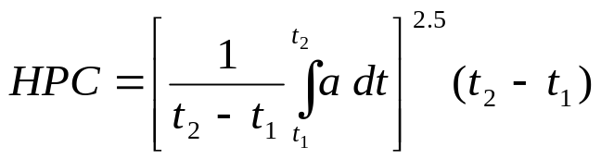

Where:
a is the resultant acceleration measured in units of gravity "g" (1 g = 9.81 m/s²);
t₁ and t₂ are the two time instants (expressed in seconds) during the impact, defining an interval between the beginning and the end of the recording period for which the value of HIC is a maximum (t₂ - t₁ ≤ 15 ms)

3.20. "Impact point" means the point on the vehicle where initial contact by the test impactor occurs. The proximity of this point to the target point is dependent upon both the angle of travel by the test impactor and the contour of the vehicle surface (see point B in Figure 6).

3.21. "Lower bumper height" means the vertical distance between the ground reference plane and the lower bumper reference line, with the vehicle positioned in its normal ride attitude.

3.22. "Lower bumper reference line" means the lower limit to significant points of pedestrian contact with the bumper. It is defined as the geometric trace of the lowermost points of contact between a straight edge 700 mm long and the bumper, when the straight edge, held parallel to the vertical longitudinal plane of the car and inclined forwards by 25° from the vertical, is traversed across the front of the car, while maintaining contact with the ground and with the surface of the bumper (see Figure 7).

3.23. "Normal ride attitude" means the vehicle positioned on a flat horizontal surface with its mass in running order (as defined in Annex 3, paragraph 3 of Special Resolution No. 1), with the tyres inflated to manufacturer recommended pressures, the front wheels in the straight-ahead position and with a passenger mass (as defined in Annex 3, paragraph 6.2. of Special Resolution No. 1) placed on the front passenger seat. The front seats are placed at the nominal mid-track position. The suspension shall be set in normal running condition as specified by the manufacturer for a speed of 40 km/h.

3.24. The “assessment interval” (AI) of the flexible lower legform impactor is defined and limited by the time of first contact of the flexible lower legform impactor with the vehicle and the timing of the last zero crossing of all femur and tibia segments after their first local maximum subsequent to any marginal value of 15 Nm, within their particular common zero crossing phases. The AI is identical for all bone segments and knee ligaments. In case of any bone segment not having a zero crossing during the common zero crossing phases, the time history curves for all bone segments are shifted downwards until all bending moments are crossing zero. The downwards shift is to be applied for the determination of the AI only.

3.25. "Primary reference marks" means holes, surfaces, marks and identification signs on the vehicle body. The type and the position of reference mark used and the vertical (Z) position of each mark relative to the ground shall be specified by the vehicle manufacturer according to the running conditions specified in paragraph 3.22. These marks shall be selected such as to be able to easily check the vehicle front and rear ride heights and vehicle attitude.

The primary reference marks shall be within ± 25 mm of the design position in the vertical (Z) axis. All tests are conducted with either the vehicle or all further measurements adjusted to simulate the vehicle being in the design position. This position shall be considered to be the normal ride attitude.

3.26. "Rear reference line for adult headform" means a geometric trace as described on the front structure of the vehicle using a WAD2100 line.

3.27. "Side reference line" means the geometric trace of the highest points of contact between a straight edge 700 mm long and the sides of the vehicle, when the straight edge, held parallel to the transverse vertical plane of the vehicle and inclined inwards by 45°, is traversed down, and maintains contact with the sides of the front structure (see Figure 8).

3.28. "Target point" means the intersection of the projection of the headform longitudinal axis with the front surface of the vehicle (see point A in Figure 6.).

3.29. "Tibia" of the lower legform impactor is defined as all components or parts of components (including flesh, skin covering, instrumentation and brackets, pulleys, etc. attached to the impactor for the purpose of launching it) below the level of the centre of the knee. Note that the tibia as defined includes allowances for the mass, etc., of the foot.

3.30. "Upper bumper reference line" means the upper limit to significant points of pedestrian contact with the bumper. For vehicles with an identifiable bumper structure it is defined as the geometric trace of the uppermost points of contact between a straight edge and the bumper, when the straight edge, held parallel to the vertical longitudinal plane of the car and inclined rearwards by 20° to the vertical, is traversed across the front of the car, while maintaining contact with the surface of the bumper (see Figure 9).

For vehicles with no identifiable bumper structure it is defined as the geometric trace of the uppermost points of contact between a straight edge 700 mm long and the bumper area, when the straight edge, held parallel to the vertical longitudinal plane of the car and inclined rearwards by 20° from the vertical is traversed across the front of the car, while maintaining contact with the ground and with the surface of the bumper area (see Figure 9).

3.31. "Wrap Around Distance (WAD)" means the geometric trace described on the outer surface of the vehicle front structure by one end of a flexible tape, when it is held in a vertical longitudinal plane of the vehicle and traversed across the front structure. The tape is held taut throughout the operation with one end held at the same level as the ground reference plane, vertically below the front face of the bumper and the other end held in contact with the front structure (see Figure 10). The vehicle is positioned in the normal ride attitude.

This procedure shall be followed, using alternative tapes of appropriate lengths, to describe wrap around distances of 1,000 mm (WAD1000), of 1,700 mm (WAD1700) and of 2,100 mm (WAD2100).

3.32. "Windscreen" means the frontal glazing of the vehicle situated between the A-pillars.

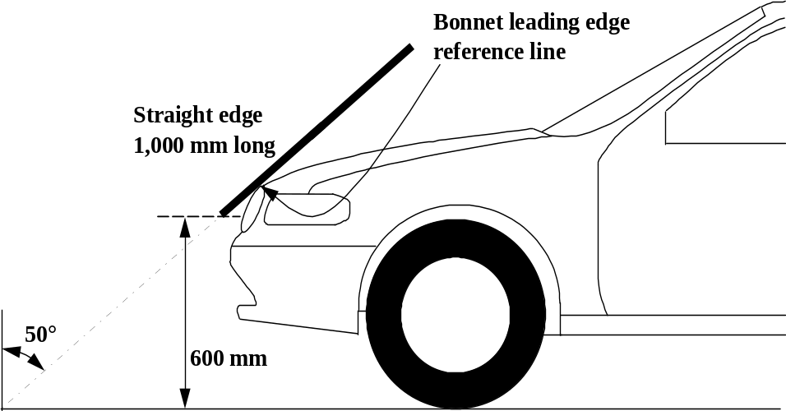

Figure 1: Bonnet leading edge reference line (see paragraph 3.5.)

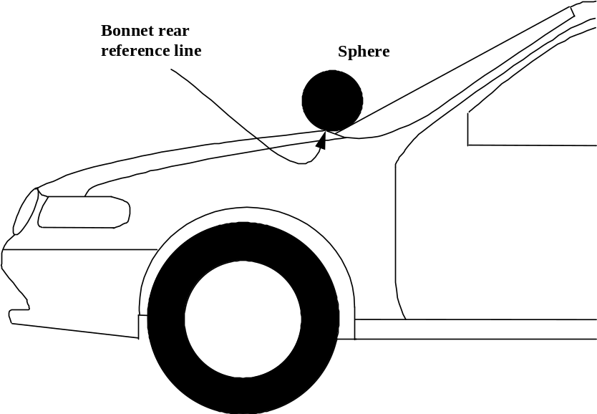

Figure 2: Bonnet rear reference line. (see paragraph 3.6.)

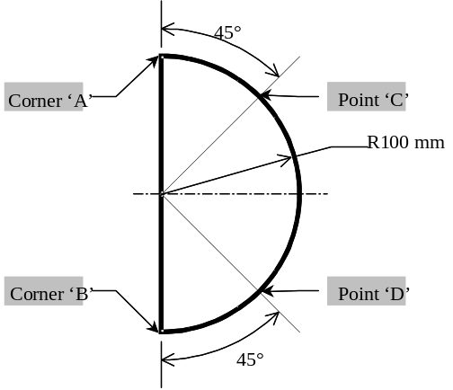

Figure 3: Template (see paragraph 3.6.)

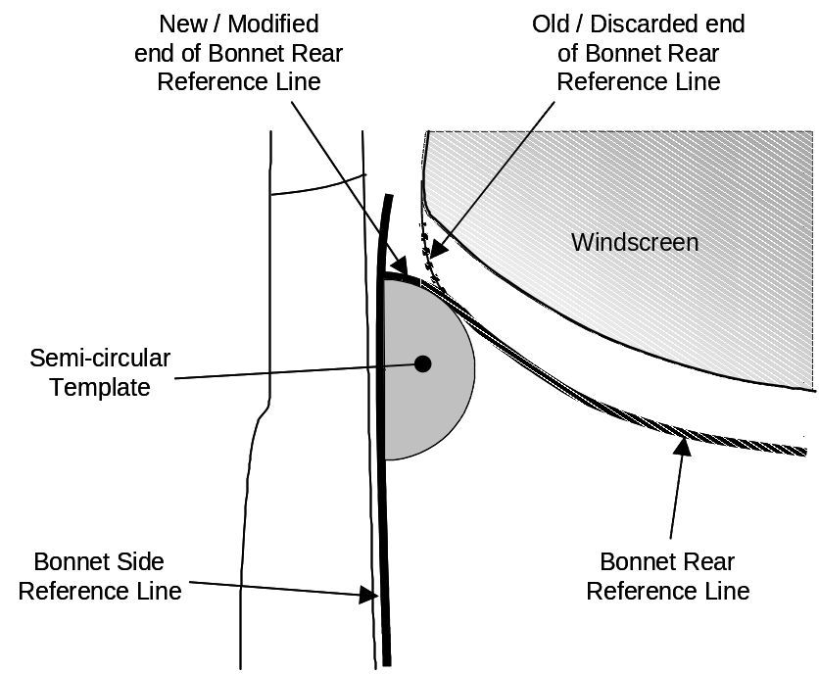

Figure 4: Marking of intersection between bonnet rear and side reference lines
(see paragraph 3.6.)

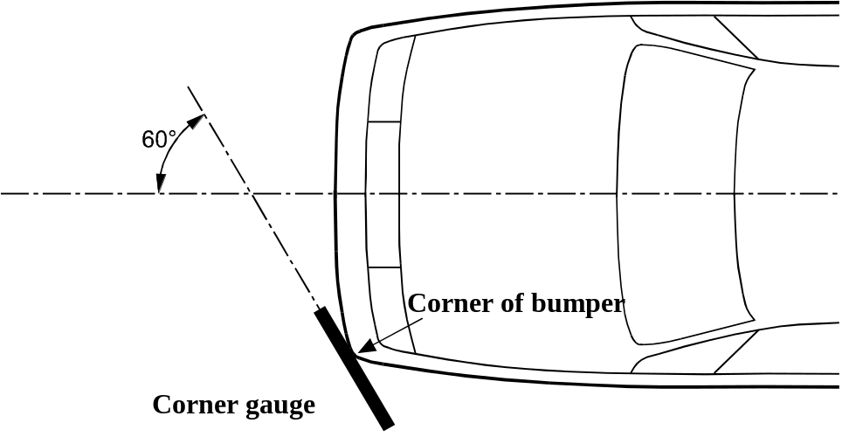

Figure 5A: Corner of bumper example (see paragraph 3.14., note that the corner gauge is to be moved in vertical and horizontal directions to enable contact with the outer contour and front fascia of the vehicle)

Figure 5B:
Corner gauge
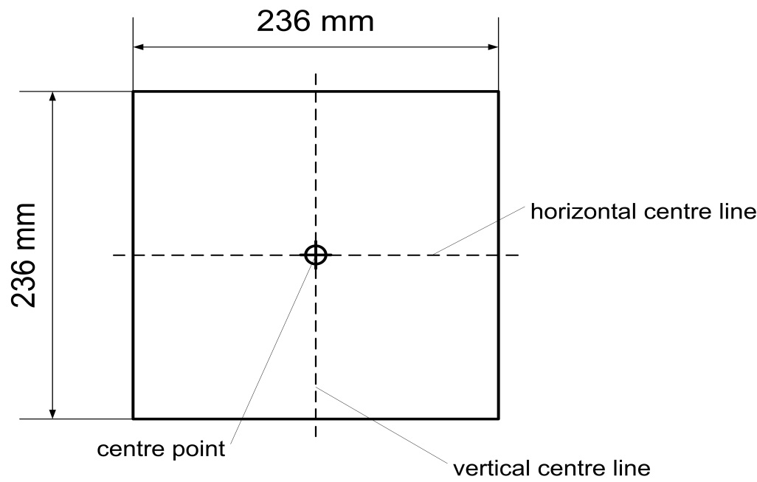
The front surface of the corner gauge is flat.
The centre point is the intersection of the vertical and horizontal centre lines on the front surface.

Figure 5C:
Determination of the corner of the bumper with the corner gauge (shown in random location)
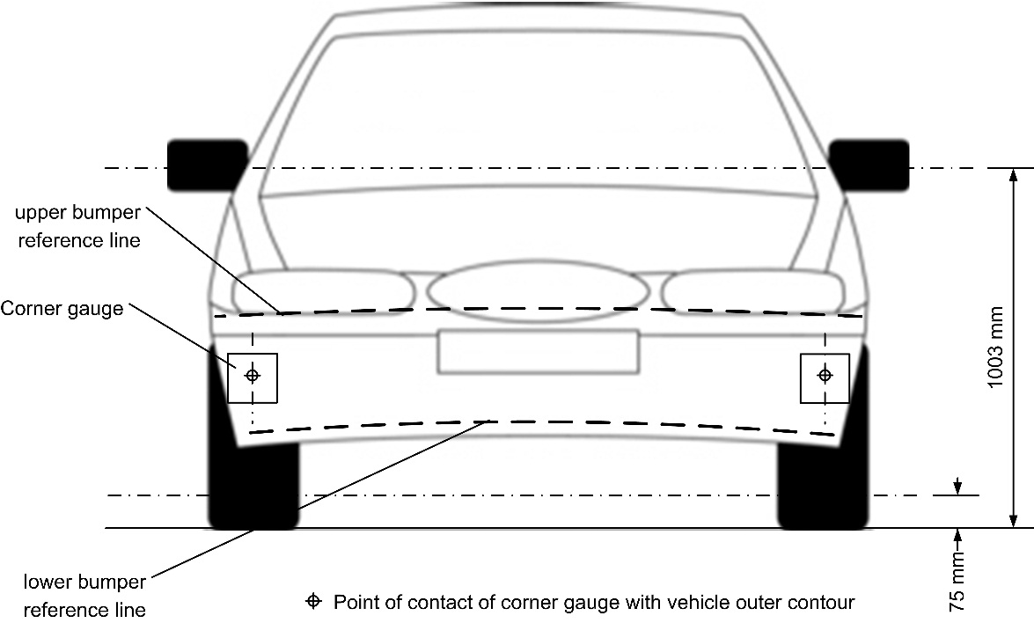
Figure 5D:
Determination of bumper test area (note that the corner gauges are to be moved in vertical and horizontal directions to enable contact with the outer contour and front fascia of the vehicle)
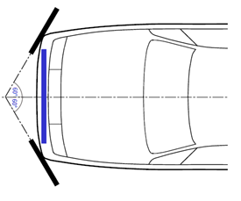"

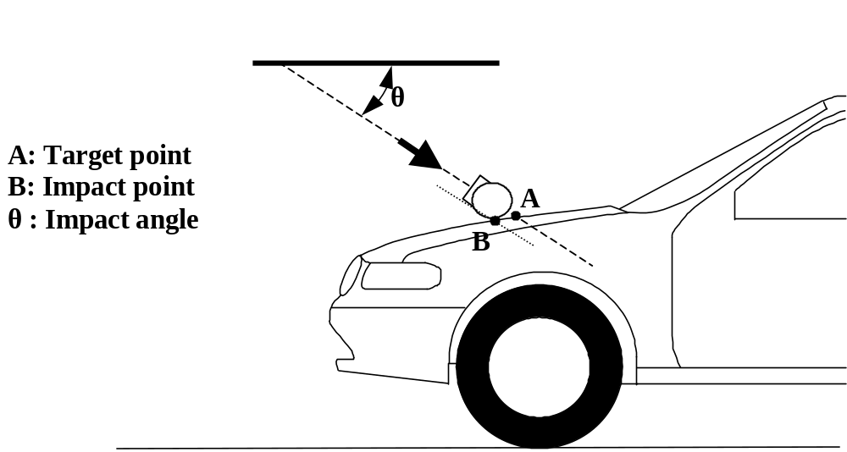

Figure 6: Impact and target point (see paragraphs 3.19. and 3.25.)

LBRL
LBRL
LBRL
25°
Straight edge
700mm Long

Figure 7: Lower bumper reference line, LBRL (see paragraph 3.21.)

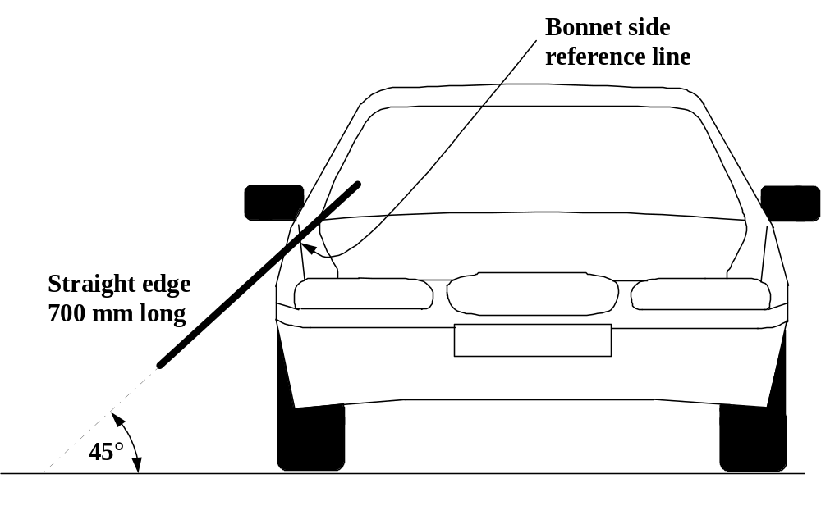

Figure 8: Side reference line (see paragraph 3.24.)

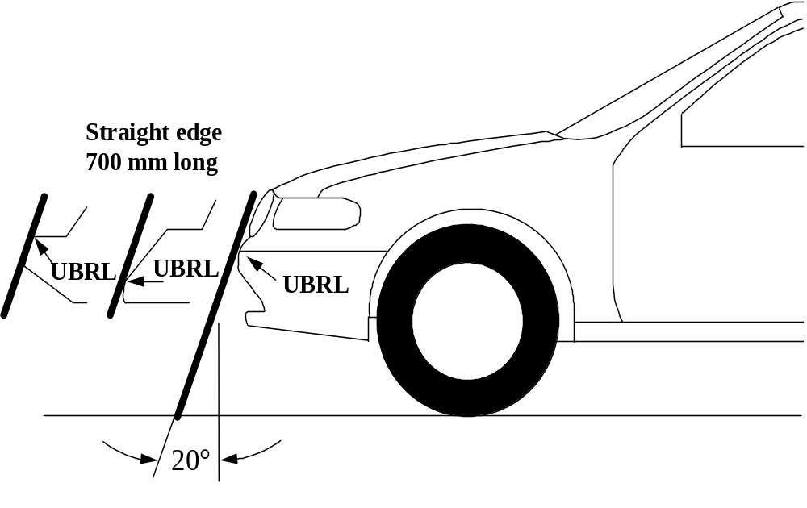

Figure 9: Upper bumper reference line, UBRL (see paragraph 3.27.)

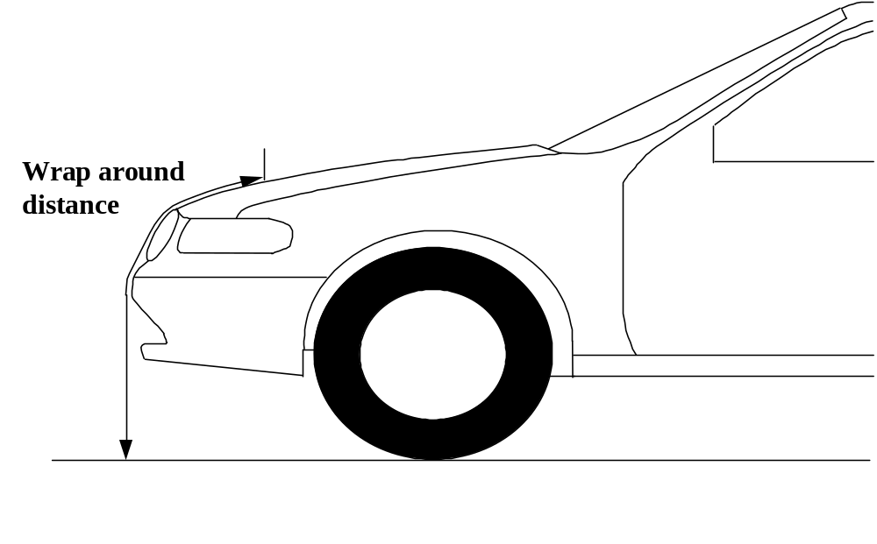

Figure 10: Wrap around distance measurement (see paragraph 3.28.)
4. GENERAL REQUIREMENTS

This global technical regulation specifies the following tests to verify compliance of vehicles.

4.1. Legform test to bumper:

For vehicles with a lower bumper height of less than 425 mm the requirements of paragraph 4.1.1. shall be applied.

For vehicles with a lower bumper height which is greater than, or equal to 425 mm and less than 500 mm the requirements of either paragraph 4.1.1. or 4.1.2., at the choice of the manufacturer, shall be applied.

For vehicles with a lower bumper height of greater than, or equal to, 500 mm the requirements of paragraph 4.1.2. shall be applied.

4.1.1. Lower legform to bumper:

To verify compliance with the performance requirements as specified in paragraph 5.1.1., both the test impactor specified in paragraph 6.3.1.1. and the test procedures specified in paragraph 7.1.1. shall be used.

4.1.2. Upper legform to bumper:

To verify compliance with the performance requirements as specified in paragraph 5.1.2., both the test impactor specified in paragraph 6.3.1.2. and the test procedures specified in paragraph 7.1.2. shall be used.

4.2. Child headform impact:

To verify compliance with the performance requirements as specified in paragraph 5.2.1., both the test impactor specified in paragraph 6.3.2.1. and the test procedures specified in paragraphs 7.2. and 7.3. shall be used.

4.3. Adult headform impact:

To verify compliance with the performance requirements as specified in paragraph 5.2.2., both the test impactor specified in paragraph 6.3.2.2. and the test procedures specified in paragraphs 7.2. and 7.4. shall be used.

5. PERFORMANCE REQUIREMENTS

5.1. Legform to bumper:

5.1.1. When tested in accordance with paragraph 7.1.1. (flexible lower legform to bumper), the absolute value of the maximum dynamic medial collateral ligament elongation at the knee shall not exceed 22 mm, and the maximum dynamic anterior cruciate ligament and posterior cruciate ligament elongation shall not exceed 13 mm. The absolute value of dynamic bending moments at the tibia shall not exceed 340 Nm. In addition, the manufacturer may nominate bumper test widths up to a maximum of 264 mm in total where the absolute value of the tibia bending moment shall not exceed 380 Nm. A Contracting Party may restrict application of the relaxation zone requirement in its domestic legislation if it decides that such restriction is appropriate.

5.1.2. When tested in accordance with paragraph 7.1.2. (upper legform to bumper), the instantaneous sum of the impact forces with respect to time shall not exceed 7.5 kN and the bending moment on the test impactor shall not exceed 510 Nm.

5.2. Headform tests

5.2.1. Child headform to the front structure:

When tested in accordance with paragraphs 7.2. and 7.3. the HIC shall comply with paragraph 5.2.3.

5.2.2. Adult headform to the front structure:

When tested in accordance with paragraph 7.2. and 7.4. the HIC shall comply with paragraph 5.2.3.

5.2.3. The HIC recorded shall not exceed 1,000 over a minimum of one half of the child headform test area and 1,000 over two thirds of the combined child and adult headform test areas. The HIC for the remaining areas shall not exceed 1,700 for both headforms.

In case there is only a child headform test area, the HIC recorded shall not exceed 1,000 over two thirds of the test area. For the remaining area the HIC shall not exceed 1,700.

5.2.4. Splitting of headform test zone

5.2.4.1. The manufacturer shall identify the zones of the bonnet top where the HIC must not exceed 1,000 (HIC1000 Zone) or 1,700 (HIC1700 Zone) (see Figure 11).

HIC1000 Zone
HIC1700 Zone
Figure 11: Example of marking of HIC1000 zone and HIC1700 zone

5.2.4.2. Marking of the "bonnet top" impact area as well as "HIC1000 Zone" and "HIC1700 Zone" will be based on a drawing supplied by the manufacturer, when viewed from a horizontal plane above the vehicle that is parallel to the vehicle horizontal zero plane. A sufficient number of x and y co-ordinates shall be supplied by the manufacturer to mark up the areas on the actual vehicle while considering the vehicle outer contour in the z direction.

5.2.4.3. The areas of "HIC1000 Zone" and "HIC1700 Zone" may consist of several parts, with the number of these parts not being limited. The determination of the impacted zone is done by the first contact point of the headform with the "bonnet top."

5.2.4.4. The calculation of the surface of the impact area as well as the surface areas of "HIC1000 Zone" and "HIC1700 Zone" shall be done on the basis of a projected bonnet when viewed from a horizontal plane parallel to the horizontal zero plane above the vehicle, on the basis of the drawing data supplied by the manufacturer.

6. TEST SPECIFICATIONS

6.1. General test conditions

6.1.1. Temperature and humidity

At the time of testing, the test facility and the vehicle or sub-system shall have a relative humidity of 40 percent ± 30 percent and stabilized temperature of 20 + 4 ºC.

6.1.2. Impact test site

The test site shall consist of a flat, smooth and hard surface with a slope not exceeding 1 percent.

6.2. Preparation of the vehicle

6.2.1. Either a complete vehicle, or a cut-body, adjusted to the following conditions shall be used for the test.

6.2.1.1. The vehicle shall be in its normal ride attitude, and shall be either securely mounted on raised supports or at rest on a flat horizontal surface with the parking brake applied.

6.2.1.2. The cut-body shall include, in the test, all parts of the vehicle front structure, all under-bonnet components and all components behind the windscreen that may be involved in a frontal impact with a vulnerable road user, to demonstrate the performance and interactions of all the contributory vehicle components. The cut-body shall be securely mounted in the normal vehicle ride attitude.

6.2.2. All devices designed to protect vulnerable road users when impacted by the vehicle shall be correctly activated before and/or be active during the relevant test. It shall be the responsibility of the manufacturer to show that any devices will act as intended in a pedestrian impact.

6.2.3. For vehicle components which could change shape or position, other than active devices to protect pedestrians, and which have more than one fixed shape or position shall require the vehicle to comply with the components in each fixed shape or position.

6.3. Test impactor specifications

6.3.1. Legform impactors:

6.3.1.1. Flexible lower legform impactor:

The flexible lower legform impactor shall consist of the flesh and skin, the flexible long bone segments (representing the femur and the tibia), and the knee joint as shown in Figure 12.

The assembled length of the impactor shall be 928 mm, having a total mass of 13.2 ± 0.4 kg. When fully assembled in the impactor, the measurable lengths of the femur shall be 339 mm, of the knee joint shall be 185 mm and of the tibia shall be 404 mm. The knee joint centre position shall be 94 mm from the top of the knee joint at the vertical centre line of the knee.

Brackets, pulleys, protectors, connection parts, etc. attached to the impactor for the purposes of launching and/or protection may extend beyond the dimensions and tolerances shown in Figures 12 and 13.

6.3.1.1.1. The cross-sectional shape perpendicular to the Z-axis of the femur and the tibia main body segments shall be 90 mm in width along the Y-axis, and 84 mm in width along the X-axis as shown in Figure 13 (a). The impact face shall be 30 mm in radius, 30 mm in width along the Y-axis, and 48 mm in width along the X-axis as shown in Figure 13 (a).

6.3.1.1.2. The cross-sectional shape perpendicular to the Z-axis of the knee joint shall be 108 mm in width along the Y-axis, and 118 mm in width along the X-axis as shown in Figure 13 (b). The impact face shall be 103 mm in radius, 12 mm in width along the Y-axis, and 86 mm in width along the X-axis as shown in Figure 13 (b).

6.3.1.1.3. The masses of the femur and the tibia without the flesh and skin, including the connection parts to the knee joint, shall be 2.46 ± 0.12 kg and 2.64 ± 0.13 kg respectively. The mass of the knee joint without the flesh and skin shall be 4.28 ± 0.21 kg. The assembled mass of the femur, the knee joint and the tibia without the flesh and skin shall be 9.38 ± 0.3 kg.

The centres of gravity of the femur and tibia without the flesh and skin, including the connection parts to the knee joint, shall be 159 ± 8 mm and 202 ± 10 mm respectively from the top, but not including the connection part to the knee joint, of each part as shown in Figure 12. The centre of gravity of the knee joint shall be 92 ± 5 mm from the top of the knee joint as shown in Figure 12.

The moment of inertia of the femur and the tibia without the flesh and skin, including the connection parts inserted to the knee joint, about the X-axis through the respective centre of gravity shall be 0.0325 ± 0.0016 kgm² and 0.0467 ± 0.0023 kgm² respectively. The moment of inertia of the knee joint about the X-axis through the respective centre of gravity shall be 0.0180 ± 0.0009 kgm².

6.3.1.1.4. For each test, the impactor (femur, knee joint and tibia) shall be covered by the flesh and skin composed of synthetic rubber sheets (R1, R2) and neoprene sheets (N1F, N2F, N1T, N2T, N3) as shown in Figure 14. The size of the sheets shall be within the requirements described in Figure 15. The sheets are required to have compression characteristics as shown in Figure 15. The compression characteristics shall be checked using material from the same batch as the sheets used for the impactor flesh and skin.

6.3.1.1.5. All impactor components shall be stored for a sufficient period of time in a controlled storage area with a stabilized temperature of 20 ± 4°C prior to the impactor removal for testing. After removal from the storage, the impactor shall not be subjected to conditions other than those in the test area as defined in paragraph 6.1.1.

6.3.1.1.6. Lower legform instrumentation

6.3.1.1.6.1. Four transducers shall be installed in the tibia to measure bending moments at locations within the tibia. The sensing locations of each of the transducers are as follows: tibia-1: 134 mm, tibia-2: 214 mm, tibia-3: 294 mm and tibia-4: 374 mm below the knee joint centre respectively as shown in Figure 16.

Three transducers shall be installed in the femur to measure bending moments applied to the femur. The sensing locations of each of the transducers are as follows: femur-1: 137 mm, femur-2: 217 mm and femur-3: 297 mm above the knee joint centre, respectively, as shown in Figure 16.

The measurement axis of each transducer shall be the X-axis of the impactor.

6.3.1.1.6.2. Three transducers shall be installed in the knee joint to measure elongations of the medial collateral ligament (MCL), anterior cruciate ligament (ACL), and posterior cruciate ligament (PCL). The measurement locations of each transducer are shown in Figure 16. The measurement locations shall be within ± 4 mm along the X-axis from the knee joint centre.

6.3.1.1.6.3. The instrumentation response value channel frequency class (CFC), as defined in ISO 6487:2002, shall be 180 for all transducers. The CAC response values, as defined in ISO 6487:2002, shall be 30 mm for the knee ligament elongations and 400 Nm for the tibia and femur bending moments.

6.3.1.1.6.4. The determination of all flexible lower legform impactor peak tibia bending moments and ligament elongations shall be limited to the assessment interval (AI) as defined in paragraph 3.23.

6.3.1.1.7. Flexible lower legform impactor certification

6.3.1.1.7.1. The flexible lower legform impactor shall meet the performance requirements specified in paragraph 8.

6.3.1.1.7.2. The impactor shall be certified using two certification tests as follows: First, the certification shall be conducted according to the inverse certification (IC) test procedure prescribed in paragraph 8.1.3 before starting a vehicle test series. Second, after a maximum of 10 vehicle tests, certification should be conducted according to the pendulum certification (PC) test procedure prescribed in paragraph 8.1.2. Ongoing certification testing then shall constitute the sequence IC – PC – PC – IC – PC – PC – etc. with a maximum of 10 tests between each certification.

In addition, the impactor shall be certified according to the procedures prescribed in paragraph 8.1. at least once a year.

Figure 12: Flexible lower legform impactor: Dimensions and centre of gravity locations of femur, knee joint and tibia (side view)

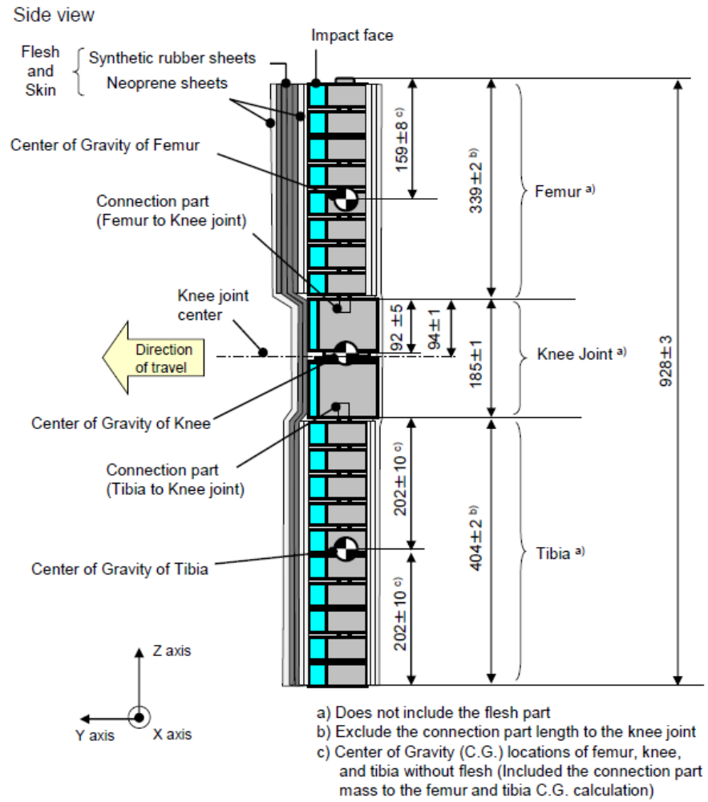
Figure 13:
Flexible lower legform impactor: Schematic plan views of femur, tibia, and knee dimensions (top view)

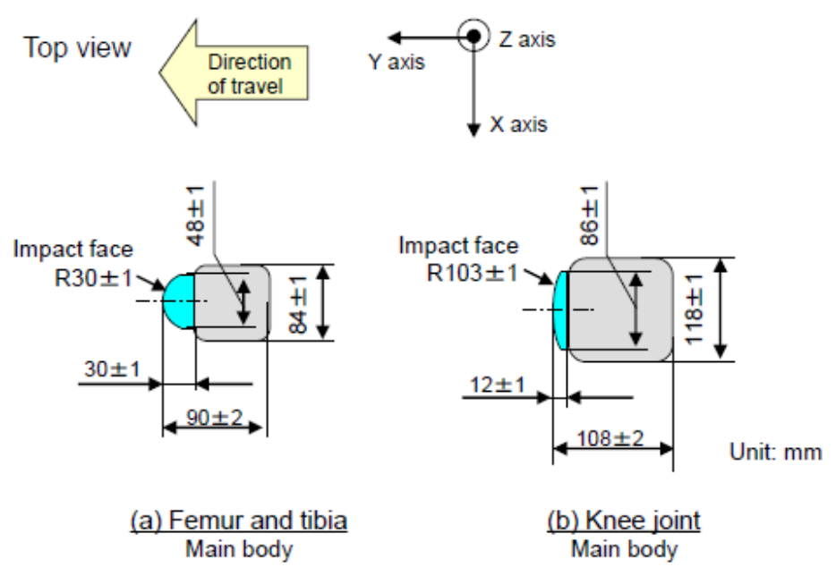

Figure 14:
Flexible lower legform impactor: Flesh and skin dimensions

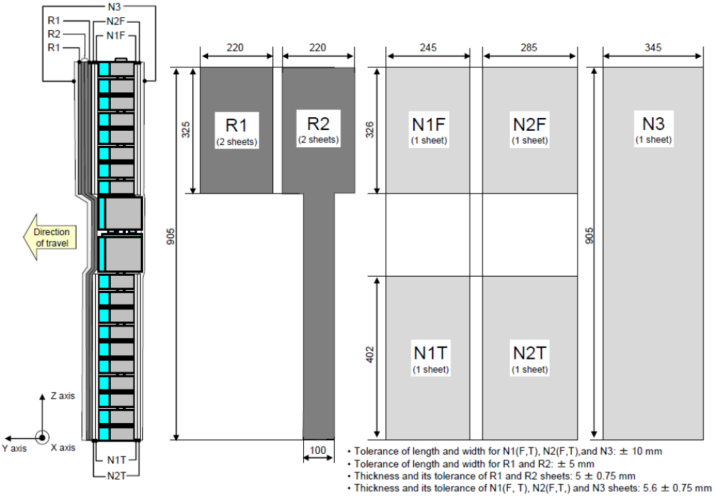
Figure 15
Flexible lower legform impactor: Flesh and skin compression characteristics
(a) Synthetic rubber sheets
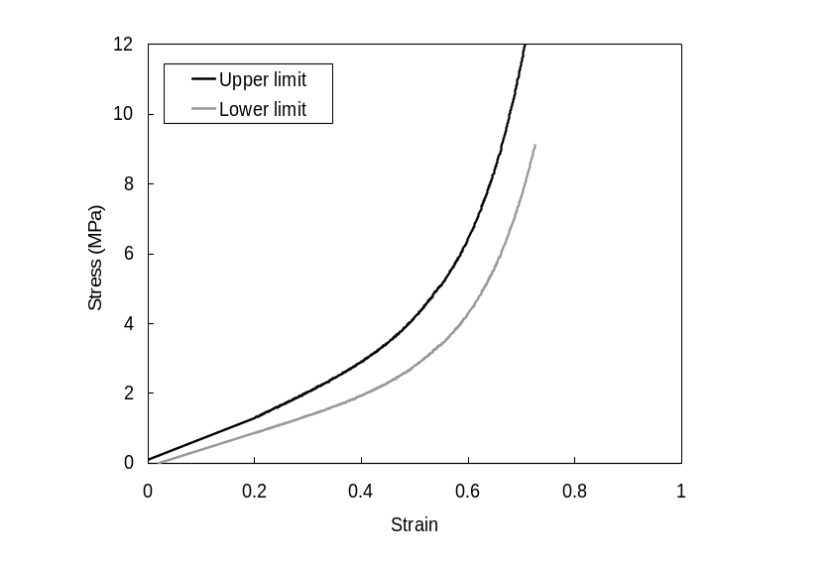

(b) [Neoprene sheets]

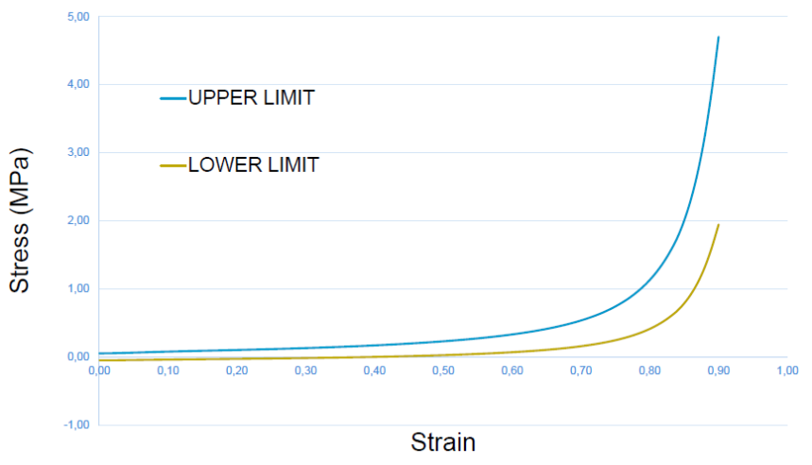
Figure 16
Flexible lower legform impactor; Instrument
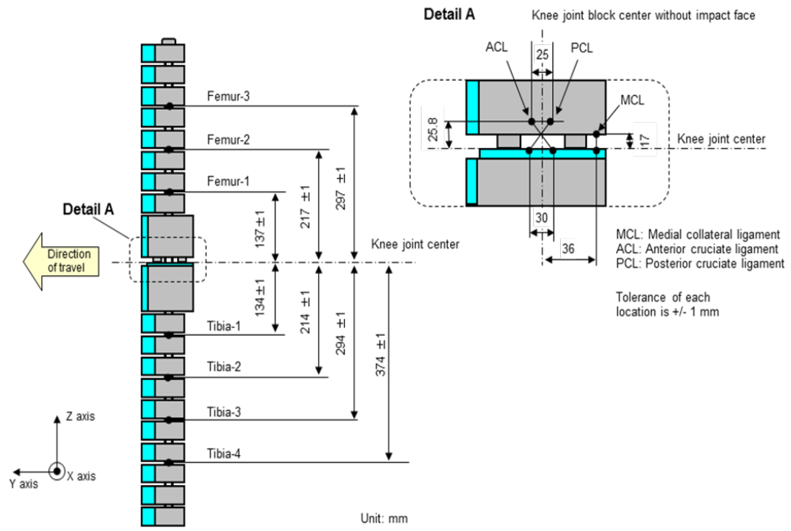

6.3.1.2. Upper legform impactor:

The upper legform impactor shall be rigid, foam covered at the impact side, and 350 ± 5 mm long (see Figure 17).

6.3.1.2.1. The total mass of the upper legform impactor including those propulsion and guidance components which are effectively part of the impactor during the impact shall be 9.5 kg ± 0.1 kg.

6.3.1.2.2. The total mass of the front member and other components in front of the load transducer assemblies, together with those parts of the load transducer assemblies in front of the active elements, but excluding the foam and skin, shall be 1.95 ± 0.05 kg.

6.3.1.2.3. The upper legform impactor for the bumper test shall be mounted to the propulsion system by a torque limiting joint and be insensitive to off-axis loading. The impactor shall move only in the specified direction of impact when in contact with the vehicle and shall be prevented from motion in other directions including rotation about any axis.

6.3.1.2.4. The torque limiting joint shall be set so that the longitudinal axis of the front member is vertical at the time of impact with a tolerance of ± 2°, with the joint friction torque set to 675 Nm ± 25 Nm.

6.3.1.2.5. The centre of gravity of those parts of the impactor which are effectively forward of the torque limiting joint, including any weights fitted, shall lie on the longitudinal centre line of the impactor, with a tolerance of ± 10 mm.

6.3.1.2.6. The length between the load transducer centre lines shall be 310 ± 1 mm and the front member diameter shall be 50 ± 1 mm.

6.3.1.2.7. For each test the foam flesh shall be two new sheets of 25 mm thick foam type CF-45 or equivalent, which shall be cut from the sheet of material used for the dynamic certification test. The skin shall be a 1.5 mm thick fibre reinforced rubber sheet. The mass of the foam and the rubber skin together shall be 0.6 + 0.1 kg (this excludes any reinforcement, mountings, etc. which are used to attach the rear edges of the rubber skin to the rear member). The foam and rubber skin shall be folded back towards the rear, with the rubber skin attached via spacers to the rear member so that the sides of the rubber skin are held parallel. The foam shall be of such a size and shape that an adequate gap is maintained between the foam and components behind the front member, to avoid significant load paths between the foam and these components.

6.3.1.2.8. The test impactor or at least the foam flesh shall be stored during a period of at least four hours in a controlled storage area with a stabilized humidity of 35 percent ± 15 percent and a stabilized temperature of 20 ± 4 °C prior to impactor removal for test. After removal from the storage the impactor shall not be subjected to conditions other than those pertaining in the test area.
6.3.1.2.9. Upper legform instrumentation

6.3.1.2.9.1. The front member shall be strain gauged to measure bending moments in three positions, as shown in Figure 17, each using a separate channel. The strain gauges are located on the impactor on the back of the front member. The two outer strain gauges are located 50 ± 1 mm from the impactor's symmetrical axis. The middle strain gauge is located on the symmetrical axis with a ± 1 mm tolerance.

6.3.1.2.9.2. Two load transducers shall be fitted to measure individually the forces applied at either end of the upper legform impactor, plus strain gauges measuring bending moments at the centre of the upper legform impactor and at positions 50 mm either side of the centre line (see Figure 17).

6.3.1.2.9.3. The instrumentation response value CFC, as defined in ISO 6487:2002, shall be 180 for all transducers. The CAC response values, as defined in ISO 6487:2002, shall be 10 kN for the force transducers and 1,000 Nm for the bending moment measurements.

6.3.1.2.10. Upper legform certification

6.3.1.2.10.1. The upper legform impactor shall meet the performance requirements specified in paragraph 8.

6.3.1.2.10.2. The certified impactor may be used for a maximum of 20 impacts before re-certification (this limit does not apply to propulsion or guidance components). The impactor shall also be re-certified if more than one year has elapsed since the previous certification or if any impactor transducer output, in any impact, has exceeded the specified CAC.

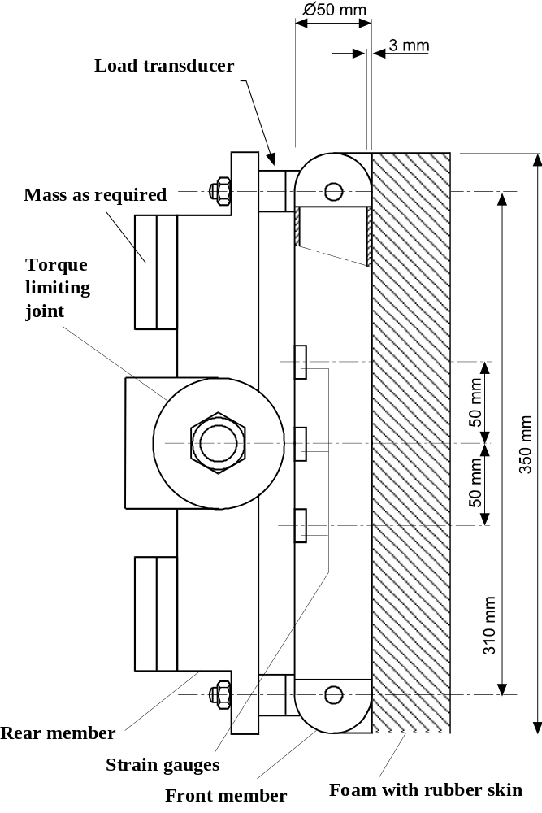

Figure 17: Upper legform impactor (see paragraph 6.3.1.2.)
6.3.2. Child and adult headform impactors

6.3.2.1. Child headform impactor (see Figure 18)

The child headform impactor shall be made of aluminium, be of homogenous construction and be of spherical shape. The overall diameter shall be 165 ± 1 mm. The mass shall be 3.5 ± 0.07 kg. The moment of inertia about an axis through the centre of gravity and perpendicular to the direction of impact shall be within the range of 0.008 to 0.012 kgm². The centre of gravity of the headform impactor including instrumentation shall be located in the geometric centre of the sphere with a tolerance of ± 2 mm.

The sphere shall be covered with a 14 ± 0.5 mm thick synthetic skin, which shall cover at least half of the sphere.

6.3.2.1.1. Child headform instrumentation

A recess in the sphere shall allow for mounting one triaxial or three uniaxial accelerometers within ± 10 mm seismic mass location tolerance from the centre of the sphere for the measurement axis, and ± 1 mm seismic mass location tolerance from the centre of the sphere for the perpendicular direction to the measurement axis.

If three uniaxial accelerometers are used, one of the accelerometers shall have its sensitive axis perpendicular to the mounting face A (see Figure 18) and its seismic mass shall be positioned within a cylindrical tolerance field of 1 mm radius and 20 mm length. The centre line of the tolerance field shall run perpendicular to the mounting face and its mid-point shall coincide with the centre of the sphere of the headform impactor.

The remaining accelerometers shall have their sensitive axes perpendicular to each other and parallel to the mounting face A and their seismic mass shall be positioned within a spherical tolerance field of 10 mm radius. The centre of the tolerance field shall coincide with the centre of the sphere of the headform impactor.

The instrumentation response value CFC, as defined in ISO 6487: 2002, shall be 1,000. The CAC response value, as defined in ISO 6487:2002, shall be 500g for the acceleration.

6.3.2.1.2. First natural frequency

The first natural frequency of the headform impactor shall be over 5,000 Hz.
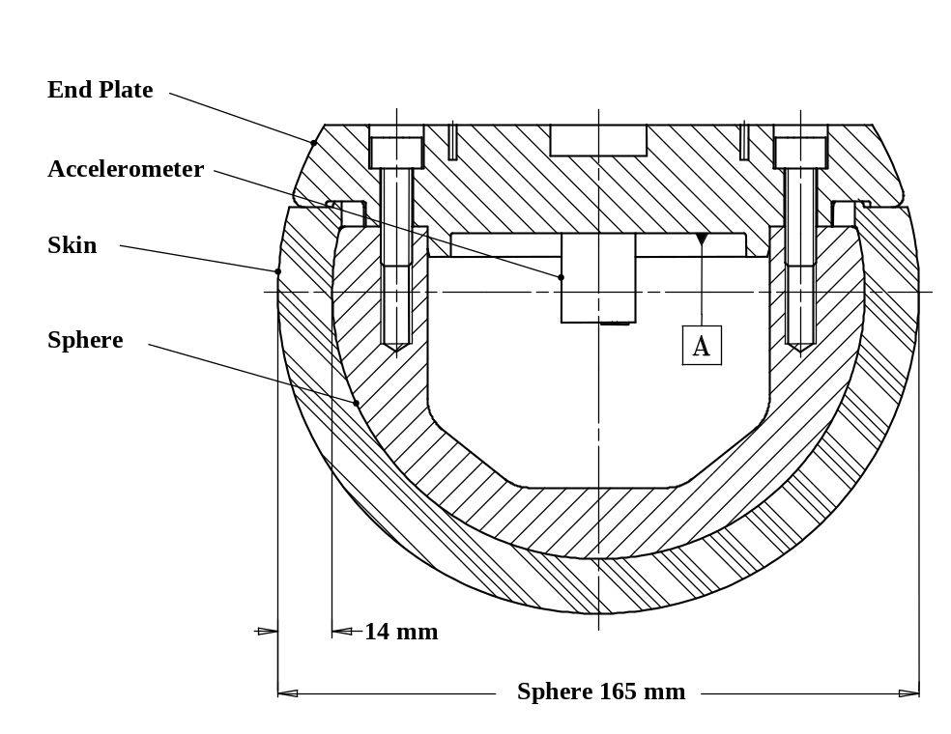
Figure 18: Child headform impactor (see paragraph 6.3.2.1.)

6.3.2.2. Adult headform impactor (see Figure 19)

The adult headform impactor shall be made of aluminium, be of homogenous construction and be of spherical shape. The overall diameter is 165 ± 1 mm as shown in Figure 19. The mass shall be 4.5 ± 0.1 kg. The moment of inertia about an axis through the centre of gravity and perpendicular to the direction of impact shall be within the range of 0.010 to 0.013 kgm². The centre of gravity of the headform impactor including instrumentation shall be located in the geometric centre of the sphere with a tolerance of ± 5 mm.

The sphere shall be covered with a 14 ± 0.5 mm thick synthetic skin, which shall cover at least half of the sphere.
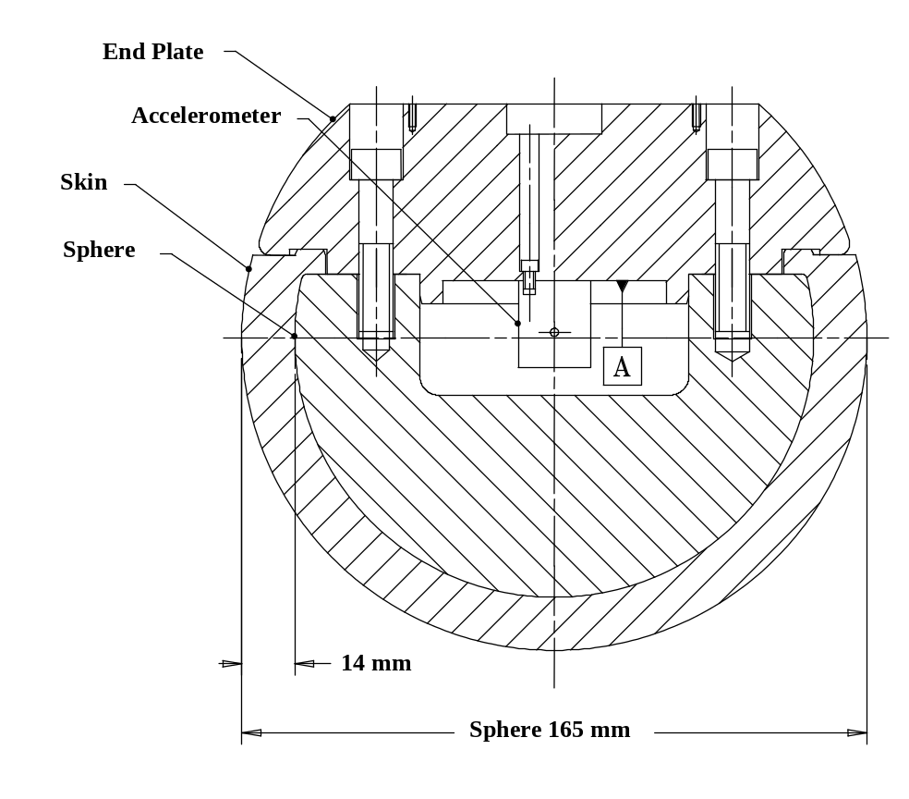

Figure 19: Adult headform impactor (see paragraph 6.3.2.2)

6.3.2.2.1. Adult headform instrumentation

A recess in the sphere shall allow for mounting one triaxial or three uniaxial accelerometers within ± 10 mm seismic mass location tolerance from the centre of the sphere for the measurement axis, and ± 1 mm seismic mass location tolerance from the centre of the sphere for the perpendicular direction to the measurement axis.

If three uniaxial accelerometers are used, one of the accelerometers shall have its sensitive axis perpendicular to the mounting face A (see Figure 19) and its seismic mass shall be positioned within a cylindrical tolerance field of 1 mm radius and 20 mm length. The centre line of the tolerance field shall run perpendicular to the mounting face and its mid-point shall coincide with the centre of the sphere of the headform impactor.

The remaining accelerometers shall have their sensitive axes perpendicular to each other and parallel to the mounting face A and their seismic mass shall be positioned within a spherical tolerance field of 10 mm radius. The centre of the tolerance field shall coincide with the centre of the sphere of the headform impactor.

The instrumentation response value CFC, as defined in ISO 6487: 2002, shall be 1,000. The CAC response value, as defined in ISO 6487: 2002, shall be 500g for the acceleration.

6.3.2.2.2. First natural frequency

The first natural frequency of the headform impactor shall be over 5,000 Hz.

6.3.2.3. Rear face of the headform impactors

A rear flat face shall be provided on the outer surface of the headform impactors which is perpendicular to the direction of travel, and typically perpendicular to the axis of one of the accelerometers as well as being a flat plate capable of providing for access to the accelerometers and an attachment point for the propulsion system.

6.3.2.4. Certification of the headform impactors

The headform impactors shall meet the performance requirements specified in paragraph 8. The certified impactors may be used for a maximum of 20 impacts before re-certification. The impactors shall be re-certified if more than one year has elapsed since the previous certification or if the transducer output, in any impact, has exceeded the specified CAC.

7. TEST PROCEDURES

7.1. Legform to bumper test procedures

7.1.1. Flexible lower legform impactor to bumper test procedure:

Each test shall be completed within two hours of when the impactor to be used is removed from the controlled storage area.

7.1.1.1. The selected target points shall be in the bumper test area.

7.1.1.2. The direction of the impact velocity vector shall be in the horizontal plane and parallel to the longitudinal vertical plane of the vehicle. The tolerance for the direction of the velocity vector in the horizontal plane and in the longitudinal plane shall be ± 2° at the time of first contact. The axis of the impactor shall be perpendicular to the horizontal plane, with a roll and pitch angle tolerance of ± 2° in the lateral and longitudinal plane. The horizontal, longitudinal and lateral planes are orthogonal to each other (see Figure 20).

7.1.1.3. The bottom of the impactor (without parts needed for the purposes of launching and/or protection) shall be 75 mm above the ground reference plane at the time of the first contact with the bumper (see Figure 21), with a tolerance of ± 10 mm. When setting the height of the propulsion system, an allowance must be made for the influence of gravity during the period of free flight of the impactor.

7.1.1.3.1. The lower legform impactor for the bumper tests shall be in 'free flight' at the moment of impact. The impactor shall be released to free flight at such a distance from the vehicle that the test results are not influenced by contact of the impactor with the propulsion system during the rebound of the impactor.

The impactor may be propelled by any means that can be shown to meet the requirements of the test.

7.1.1.3.2. At the time of first contact the impactor shall have the intended orientation about its vertical axis, for the correct operation of its knee joint, with a yaw angle tolerance of ± 5° (see Figure 20).

7.1.1.3.3. At the time of first contact the centre line of the impactor shall be within a ± 10 mm tolerance to the selected impact location.

7.1.1.3.4. During contact between the impactor and the vehicle, the impactor shall not contact the ground or any object which is not part of the vehicle.

7.1.1.4. The impact velocity of the impactor when striking the bumper shall be 11.1 ± 0.2 m/s. The effect of gravity shall be taken into account when the impact velocity is obtained from measurements taken before the time of first contact.

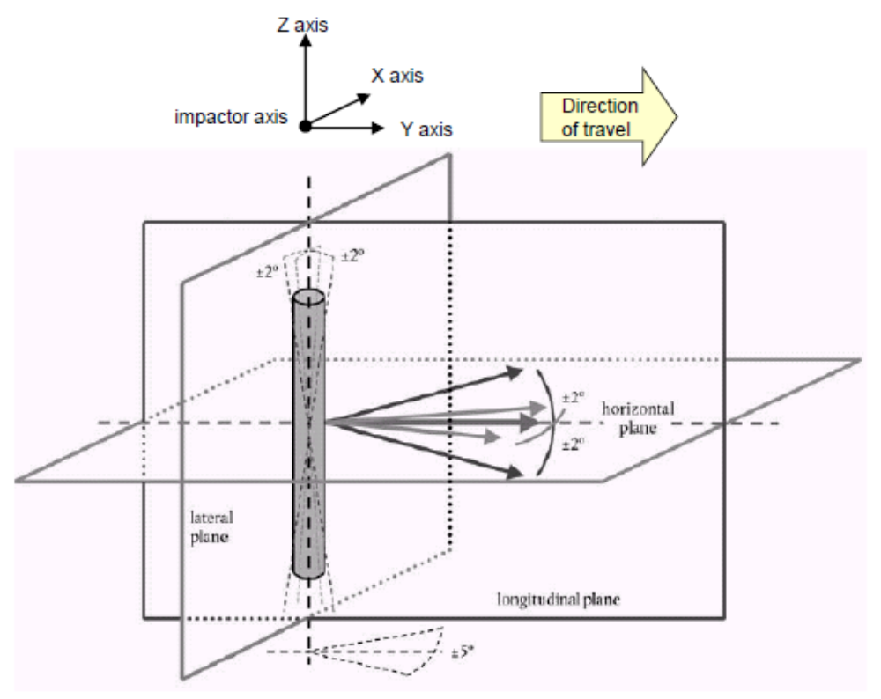

Figure 20: Tolerances of angles for the lower legform impactor at the time of the
first impact (see paragraphs 7.1.1.2 and 7.1.1.3.2.)

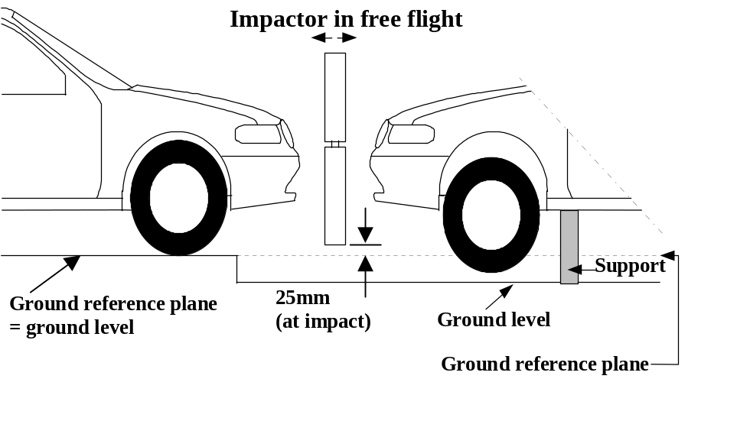

Figure 21: Flexible lower legform impactor to bumper tests for complete vehicle in normal ride attitude (left) and for cut-body mounted on supports (right) (see paragraph 7.1.1.3)

7.1.1.5. The tibia bending moments shall not exceed ± 15 Nm within an evaluation interval of 30 ms immediately prior to impact.

7.1.1.6. The offset compensation shall be done with the flexible lower legform impactor in resting position prior to the test / acceleration phase.

7.1.2. Upper legform to bumper test procedure:

Each test shall be completed within two hours of when the impactor to be used is removed from the controlled storage area.

7.1.2.1. The selected target points shall be in the bumper test area as defined in paragraph 3.10.

7.1.2.2. The direction of impact shall be parallel to the longitudinal axis of the vehicle, with the axis of the upper legform vertical at the time of first contact. The tolerance to this direction is ± 2°.

At the time of first contact the impactor centre line shall be vertically midway between the upper bumper reference line and the lower bumper reference line with a + 10 mm tolerance and the impactor vertical centre line shall be positioned laterally with the selected impact location with a tolerance of ± 10 mm.

7.1.2.3. The impact velocity of the upper legform impactor when striking the bumper shall be 11.1 ± 0.2 m/s.

7.2. Headform test procedures

7.2.1. Propulsion of the headform impactors

The headform impactors shall be in "free flight" at the moment of impact, at the required impact velocity (as specified in paragraphs 7.3.4. and 7.4.4.) and the required direction of impact (as specified in paragraphs 7.3.5. and 7.4.5.).
The impactors shall be released to "free flight" at such a distance from the vehicle that the test results are not influenced by contact of the impactor with the propulsion system during rebound of the impactor.

7.2.2. Measurement of impact velocity

The velocity of the headform impactor shall be measured at some point during the free flight before impact, in accordance with the method specified in ISO 3784:1976. The accuracy of velocity measurement shall be ± 0.01 m/sec. The measured velocity shall be adjusted considering all factors which may affect the impactor between the point of measurement and the point of impact, in order to determine the velocity of the impactor at the time of impact. The angle of the velocity vector at the time of impact shall be calculated or measured.

7.2.3. Recording

The acceleration time histories shall be recorded, and HIC shall be calculated. The first point of contact on the front structure of the vehicle shall be recorded. Recording of test results shall be in accordance with ISO 6487:2002.

7.3. Child headform test procedure

This test procedure is applicable with respect to the requirements of paragraphs 5.2.1. and 5.2.3.

7.3.1. Tests shall be made to the front structure within the boundaries as defined in paragraph 3.12. For tests on the rear area of the bonnet top, the headform impactor shall not contact the windscreen or A-pillar before impacting the bonnet top.

7.3.2. No impact point shall be located so that the impactor will impact the test area with a glancing blow resulting in a more severe second impact outside the test area.

Selected impact points on the bonnet for the child headform impactor shall be, at the time of first contact:
(a) a minimum of 82.5 mm inside the defined side reference lines, and;
(b) forward of the WAD1700 line, or,
a minimum of 82.5 mm forwards of the bonnet rear reference line,
- whichever is most forward at the point of measurement, and;
(c) be rearward of the WAD1000 line, or,
a minimum of 82.5 mm rearwards of the bonnet leading edge reference line,
- whichever is most rearward at the point of measurement.

These minimum distances are to be set with a flexible tape held tautly along the outer surface of the vehicle.

7.3.3. The point of first contact of the headform impactor shall be within a ± 10 mm tolerance to the selected impact point.

7.3.4. The headform velocity at the time of impact shall be 9.7 ± 0.2 m/s.

7.3.5. The direction of impact shall be in the longitudinal vertical plane of the vehicle to be tested at an angle of 50 ± 2° to the horizontal. The direction of impact of tests to the front structure shall be downward and rearward.

7.4. Adult headform test procedure:

This test procedure is applicable with respect to the requirements of paragraphs 5.2.2. and 5.2.3.

7.4.1. Tests shall be made to the front structure within the boundaries as defined in paragraph 3.1. For tests at the rear of the bonnet top, the headform impactor shall not contact the windscreen or A-pillar before impacting the bonnet top.

7.4.2. No impact point shall be located so that the impactor will impact the test area with a glancing blow resulting in a more severe second impact outside the test area.

Selected impact points on the bonnet for the adult headform impactor shall be, at the time of first contact:
(a) a minimum of 82.5 mm inside the defined side reference lines, and;
(b) forward of the WAD2100 line, or,
a minimum of 82.5 mm forward of the bonnet rear reference line,
whichever is most forward at the point of measurement, and;
(c) rearward of the WAD1700 line.

These minimum distances are to be set with a flexible tape held tautly along the outer surface of the vehicle.

7.4.3. The point of first contact of the headform impactor shall be within a ± 10 mm tolerance to the selected impact point.

7.4.4. The headform velocity at the time of impact shall be 9.7 ± 0.2 m/s.

7.4.5. The direction of impact shall be in the longitudinal vertical plane of the paragraph of the vehicle to be tested at an angle of 65° ± 2° to the horizontal. The direction of impact of tests to the front structure shall be downward and rearward.

8. CERTIFICATION OF IMPACTORS

The impactors that are used in the tests described in this gtr are required to comply with the following performance requirements.

The requirements for the lower legform impactor are specified in paragraph 8.1., the upper legform impactor requirements are specified in paragraph 8.2. and the adult and child headform impactors requirements are specified in paragraph 8.3.

8.1. Flexible lower legform impactor certification

8.1.1. Static certification tests

8.1.1.1. The femur and the tibia of the flexible lower legform impactor shall meet the requirements specified in paragraph 8.1.1.2. when tested according to paragraph 8.1.1.4. The knee joint of the lower legform impactor shall meet the requirements specified in paragraph 8.1.1.3. when tested according to paragraph 8.1.1.5. The stabilized temperature of the impactor during the certification tests shall be 20° ± 2°C.

The CAC response values, as defined in ISO 6487:2002, shall be 30 mm for the knee ligament elongations and 4 kN for the applied external load. For these tests, low-pass filtering at an appropriate frequency is permitted to remove higher frequency noise without significantly affecting the measurement of the response of the impactor.

8.1.1.2. When the femur and the tibia of the impactor are loaded in bending in accordance with paragraph 8.1.1.4., the applied moment and the generated deflection at the centre of the femur and the tibia (M_{c} and D_{c}) shall be within the corridors shown in Figure 22.

8.1.1.3. When the knee joint of the impactor is loaded in bending in accordance with paragraph 8.1.1.5., the MCL, ACL, and PCL elongations and applied bending moment or the force at the centre of the knee joint (M_{c} or F_{c}) shall be within the corridors shown in Figure 23.

8.1.1.4. The edges of the femur and tibia, not bending parts, shall be mounted to the support rig firmly as shown in Figure 24 and Figure 25. The Y-axis of the impactor shall be parallel to the loading axis within 180 ± 2° tolerance. To obtain repeatable loading, low friction Polytetrafluoroethylene (PTFE) plastic pads are used under each support (see Figures 24 and 25).

The centre of the loading force shall be applied at the centre of the femur and the tibia within ± 2mm tolerance along the Z-axis. The force shall be increased so as to maintain a deflection rate between 10 and 100 mm/minute until the bending moment at the centre part (M_{c}) of the femur or tibia reaches 380 Nm.

8.1.1.5. The ends of the knee joint shall be mounted to the support rig firmly as shown in Figure 26. The Y-axis of the impactor shall be parallel to the loading axis within ± 2° tolerance. To obtain repeatable loading, low friction Polytetrafluoroethylene (PTFE) plastic pads are used under each support (see figure 26). To avoid impactor damage, a neoprene sheet shall be set underneath the loading ram and the impactor face of the knee joint which is described in the Figure 13 shall be removed. The neoprene sheet used in this test shall have compression characteristics as shown in Figure 15.

The centre of the loading force shall be applied at the knee joint centre within ± 2°mm tolerance along the Z-axis (see figure 12). The external load shall be increased so as to maintain a deflection rate between 10 and 100 mm/minute until the bending moment at the centre part of the knee joint (M_{c}) reaches 400 Nm.

8.1.2. Dynamic certification tests (pendulum test)

8.1.2.1. The assembled flexible lower legform impactor shall meet the requirements specified in paragraph 8.1.2.3. when tested as specified in paragraph 8.1.2.4.

8.1.2.2. Certification

8.1.2.2.1. The test facility used for the certification test shall have a stabilized temperature of 20 ± 2 °C during the test.

8.1.2.2.2. The temperature of the certification area shall be measured at the time of certification and recorded in a certification report.

8.1.2.3. Requirements

8.1.2.3.1. When the flexible lower legform impactor is used for a test according to paragraph 8.1.2.4., the absolute value of the maximum bending moment of the tibia at tibia-1 shall be not more than 272 Nm and not less than 235 Nm, the absolute value of the maximum bending moment at tibia-2 shall be not more than 219 Nm and not less than 187 Nm, the absolute value of the maximum bending moment at tibia-3 shall be not more than 166 Nm and not less than 139 Nm, and the absolute value of the maximum bending moment at tibia-4 shall be not more than 111 Nm and not less than 90 Nm. The absolute value of the maximum elongation of MCL shall be not more than 24.0 mm and not less than 20.5 mm, the absolute value of the maximum elongation of ACL shall be not more than 10.5 mm and not less than 8.0 mm, and the absolute value of the maximum elongation of PCL shall be not more than 5.0 mm and not less than 3.5 mm.

For all these values, the readings used shall be from the initial impact timing to 200 ms after the impact timing.

8.1.2.3.2. The instrumentation response value CFC, as defined in ISO 6487:2002, shall be 180 for all transducers. The CAC response values, as defined in ISO 6487:2002, shall be 30 mm for the knee ligament elongations and 400 Nm for the tibia bending moments.

8.1.2.4. Test procedure

8.1.2.4.1. The flexible lower legform impactor, including the flesh and skin, shall be suspended from the dynamic certification test rig 15 ± 1° upward from the horizontal as shown in Figure 27. The impactor shall be released from the suspended position and fall freely against the pin joint of the test rig as shown in Figure 27.

8.1.2.4.2. The knee joint centre of the impactor shall be 30 ± 1 mm below the bottom line of the stopper bar, and the tibia impact face without the flesh and skin shall be located 13 ± 2 mm from the front upper edge of the stopper bar when the impactor is hanging freely as shown in Figure 27.

8.1.3. Dynamic certification tests (inverse test)

8.1.3.1. The assembled flexible lower legform impactor shall meet the requirements according to paragraph 8.1.3.3. when tested as specified in paragraph 8.1.3.4.

8.1.3.2. Certification

8.1.3.2.1. The test facility used for the certification test shall have a stabilized temperature of 20 ± 2 °C during certification.

8.1.3.2.3. The temperature of the certification area shall be measured at the time of certification and recorded in a certification report.

8.1.3.3. Requirements

8.1.3.3.1. When the flexible lower legform impactor is used for the test according to paragraph 8.1.3.4., the absolute value of the maximum bending moment of the tibia at tibia-1 shall be not more than 272 Nm and not less than 230 Nm, the absolute value of the maximum bending moment at tibia-2 shall be not more than 252 Nm and not less than 210 Nm, the absolute value of the maximum bending moment at tibia-3 shall be not more than 192 Nm and not less than 166 Nm, and the absolute value of the maximum bending moment at tibia-4 shall be not more than 108 Nm and not less than 93 Nm. The absolute value of the maximum elongations of the MCL shall be not more than 21.0 mm and not less than 17.0 mm, of the ACL shall be not more than 10.0 mm and not less than 8.0 mm and of the PCL shall be not more than 6.0 mm and not less than 4.0 mm.

For all these values, the readings used shall be from the initial impact timing to 50 ms after the impact timing.

8.1.3.3.2. The instrumentation response value CFC, as defined in ISO 6487:2002, shall be 180 for all transducers. The CAC response values, as defined in ISO 6487:2002, shall be 30 mm for the knee ligament elongations and 400 Nm for the tibia bending moments.

8.1.3.4. Test procedure

8.1.3.4.1. The assembled flexible lower legform impactor (with the flesh and skin) shall be hung vertically and freely suspended from a test rig as shown in Figure 28. It is then impacted by the upper edge of a linearly guided aluminium honeycomb impactor, covered by a thin paper cloth with a maximum thickness of 1 mm, at an impact speed of 11.1 ± 0.2 m/s. The legform shall achieve a free flight condition within 10 ms after the time of first contact of the honeycomb impactor.

8.1.3.4.2. The honeycomb of 5052 alloy, which is attached in front of the moving ram, shall be 200 ± 5 mm wide, 160 ± 5 mm high and 60 ± 2 mm deep and shall have a crush strength of 75 psi ± 10 per cent. The honeycomb should have cell sizes of either 3/16 inch or ¼ inch and a density of 2.0 pcf for the 3/16 inch cell size or a density of 2.3 pcf for the 1/4 inch cell size.
8.1.3.4.3. The upper edge of the honeycomb face shall be in line with the rigid plate of the linearly guided impactor. At the time of first contact, the upper edge of the honeycomb shall be in line with the knee joint centre line within a vertical tolerance of ± 2 mm. The honeycomb shall not be deformed before the impact test.

8.1.3.4.4. At the time of the first contact, the flexible lower legform impactor pitch angle (rotation around the Y-axis) and, therefore, the pitch angle of the velocity vector of the honeycomb impactor shall be within a tolerance of ± 2° in relation to the lateral vertical plane. The flexible lower legform impactor roll angle (rotation around the X-axis) and, therefore, the roll angle of the honeycomb impactor shall be within a tolerance of ± 2° in relation to the longitudinal vertical plane. The flexible lower legform impactor yaw angle (rotation around the Z-axis) and, therefore, the yaw angle of the velocity vector of the honeycomb impactor shall be within a tolerance of ±2°.
Figure 22
Flexible lower legform impactor: Requirement corridors of the femur and the tibia in the static certification test (see paragraph 8.1.1.2.)
(a) Femur bending corridor
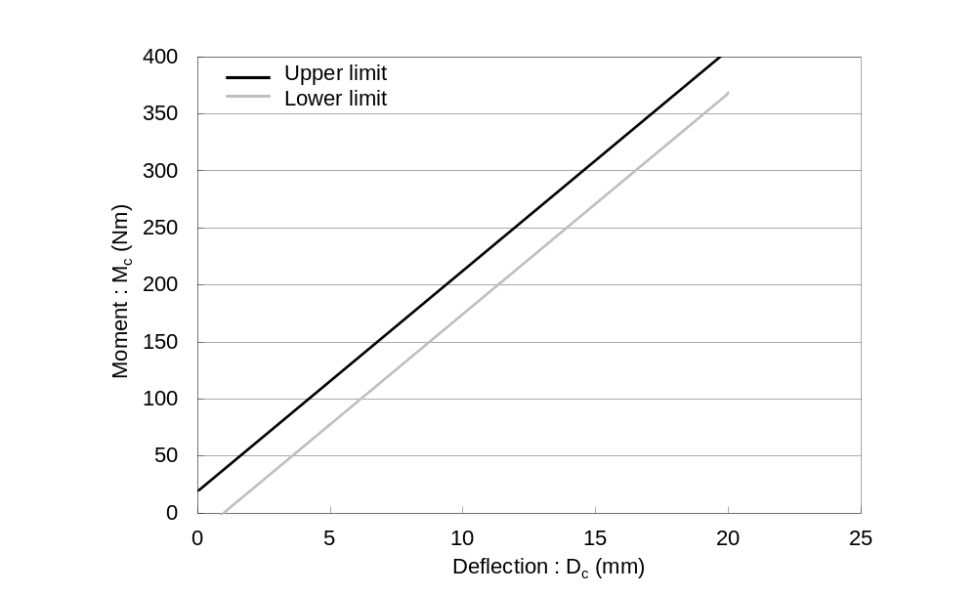

(b) Tibia bending corridor
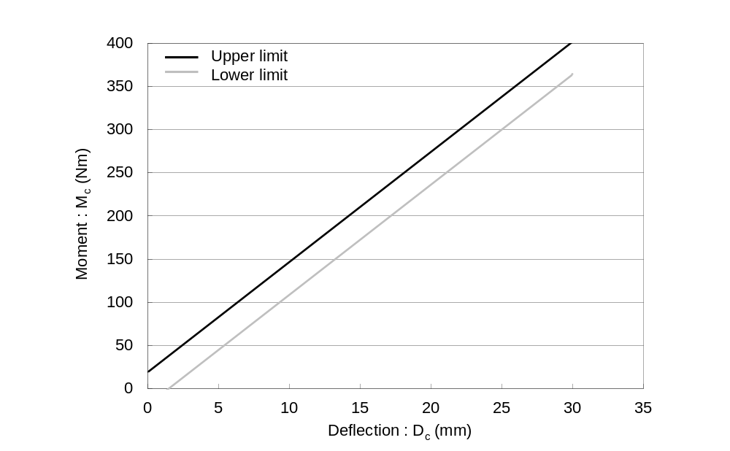
Figure 23
Flexible lower legform impactor: Requirement corridors for the knee joint in the static certification test (see paragraph 8.1.1.3.)
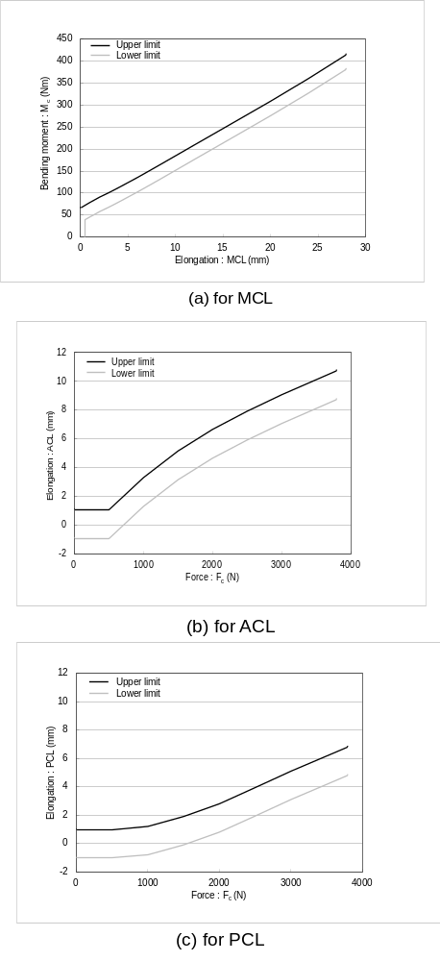
Figure 24
Flexible lower legform: Impactor test set-up for the femur in the static certification test (see paragraph 8.1.1.4.)

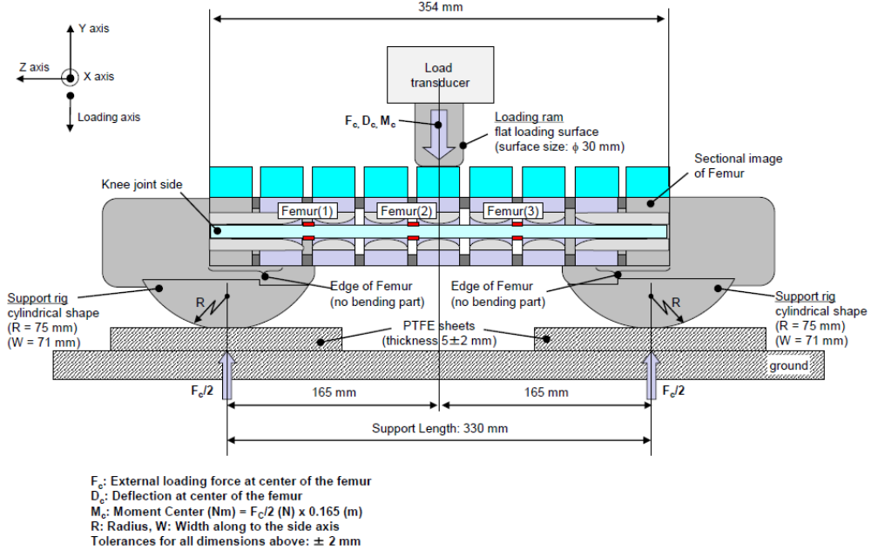

Figure 25
Flexible lower legform impactor: Test set-up for the tibia in the static certification test (see paragraph 8.1.1.4.)

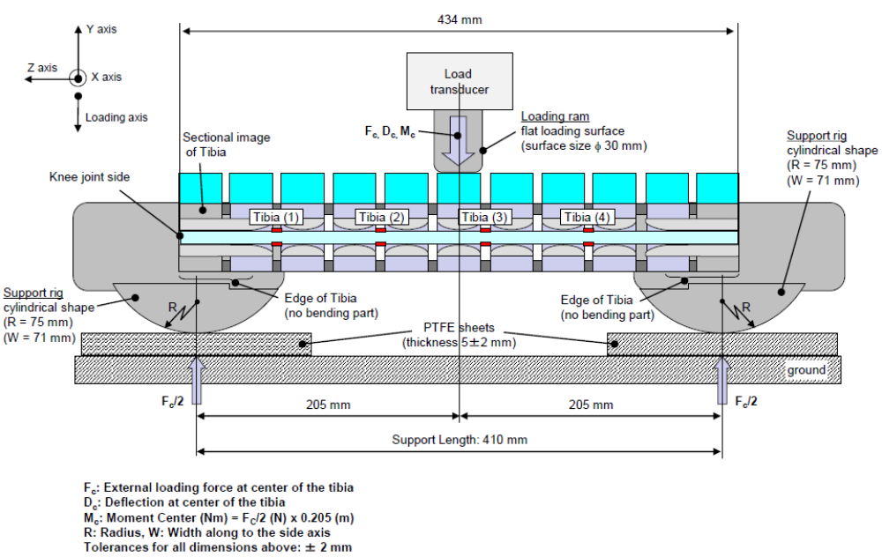
Figure 26
Flexible lower legform impactor: Test set-up for the knee joint in the static certification test (see paragraph 8.1.1.5.)

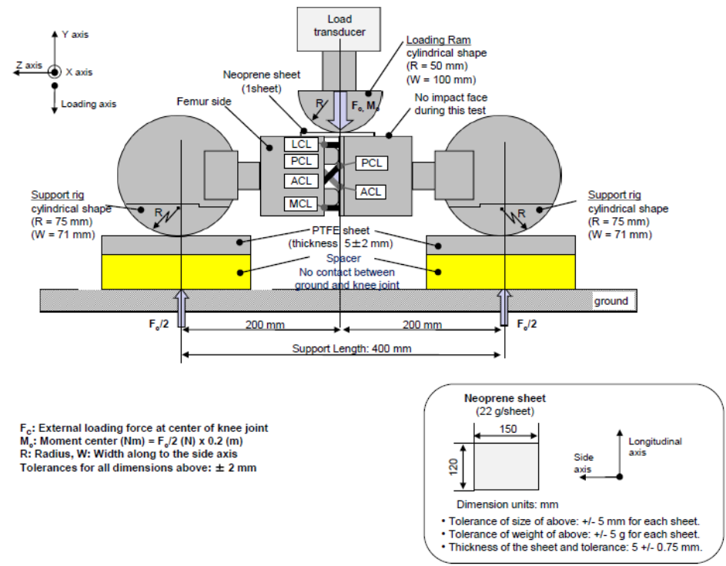
Figure 27
Flexible lower legform impactor: Test set-up for the dynamic lower legform impactor certification test (pendulum test, see paragraph 8.1.2.4.)
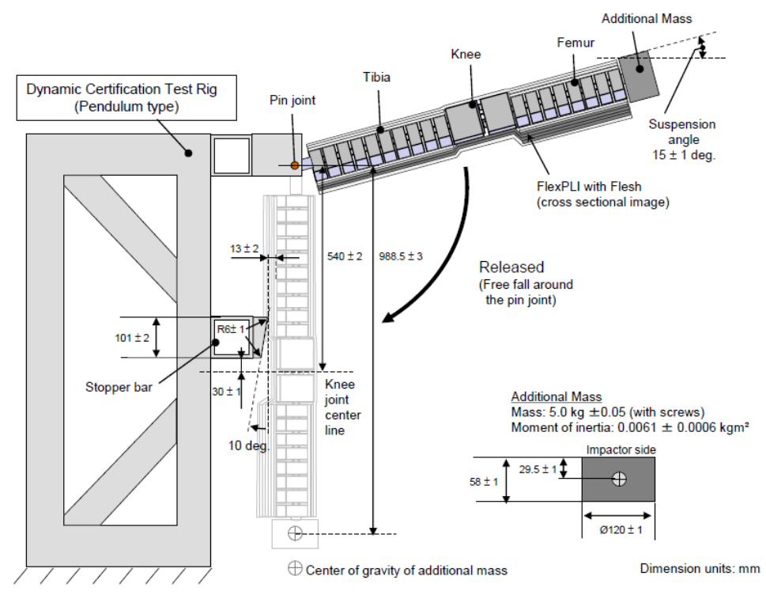
Figure 28
Flexible lower legform impactor: Test set-up for the dynamic lower legform impactor certification test (inverse test, see paragraph 8.1.3.4.)

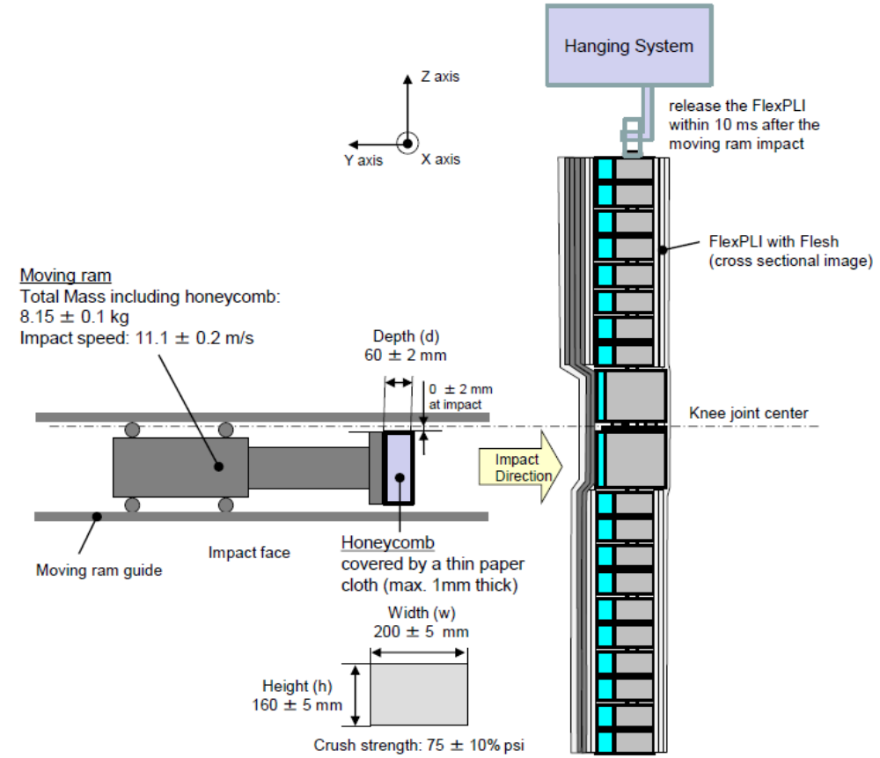

8.2. Upper legform impactor certification

8.2.1. The upper legform impactor shall meet the requirements specified in paragraph 8.2.3. when tested as specified in paragraph 8.2.4.

8.2.2. Calibration

8.2.2.1. The foam flesh for the test impactor shall be stored for a period of at least four hours in a controlled storage area with a stabilized humidity of 35 ± 10 percent and a stabilized temperature of 20° ± 2°C prior to impactor removal for calibration. The test impactor itself shall have a temperature of 20° ± 2°C at the time of impact. The temperature tolerances for the test impactor shall apply at a relative humidity of 40 ± 30 percent after a soak period of at least four hours prior to their application in a test.

8.2.2.2. The test facility used for the calibration test shall have a stabilized humidity of 40 ± 30 percent and a stabilized temperature of 20° ± 4°C during calibration.

8.2.2.3. Each calibration shall be completed within two hours of when the impactor to be calibrated is removed from the controlled storage area.

8.2.2.4. The relative humidity and temperature of the calibration area shall be measured at the time of calibration, and recorded in the calibration report.

8.2.3. Requirements

8.2.3.1. When the impactor is propelled into a stationary cylindrical pendulum the peak force measured in each load transducer shall be not less than 1.20 kN and not more than 1.55 kN and the difference between the peak forces measured in the top and bottom load transducers shall not be more than 0.10 kN. Also, the peak bending moment measured by the strain gauges shall not be less than 190 Nm and not more than 250 Nm on the centre position and not less than 160 Nm and not more than 220 Nm for the outer positions. The difference between the upper and lower peak bending moments shall not be more than 20 Nm.

For all these values, the readings used shall be from the initial impact with the pendulum and not from the arresting phase. Any system used to arrest the impactor or pendulum shall be so arranged that the arresting phase does not overlap in time with the initial impact. The arresting system shall not cause the transducer outputs to exceed the specified CAC.

8.2.3.2. The instrumentation response value CFC, as defined in ISO 6487:2002, shall be 180 for all transducers. The CAC response values, as defined in ISO 6487:2002, shall be 10 kN for the force transducers and 1000 Nm for the bending moment measurements.

8.2.4. Test procedure

8.2.4.1. The impactor shall be mounted to the propulsion and guidance system, by a torque limiting joint. The torque limiting joint shall be set so that the longitudinal axis of the front member is perpendicular to the axis of the guidance system, with a tolerance of ± 2°, with the joint friction torque set to 675 ± 25 Nm. The guidance system shall be fitted with low friction guides that allow the impactor to move only in the specified direction of impact, when in contact with the pendulum.

8.2.4.2. The impactor mass shall be adjusted to give a mass of 12 ± 0.1 kg, this mass includes those propulsion and guidance components which are effectively part of the impactor during impact.

8.2.4.3. The centre of gravity of those parts of the impactor which are effectively forward of the torque limiting joint, including the extra masses fitted, shall lie on the longitudinal centreline of the impactor, with a tolerance of ± 10 mm.

8.2.4.4. The impactor shall be certified with previously unused foam.

8.2.4.5. The impactor foam shall not be excessively handled or deformed before, during or after fitting.

8.2.4.6. The impactor with the front member vertical shall be propelled horizontally at a velocity of 7.1 ± 0.1 m/s into the stationary pendulum as shown in Figure 29.

8.2.4.7. The pendulum tube shall have a mass of 3 ± 0.03 kg, a wall thickness of 3 ± 0.15 mm and an outside diameter of 150 mm ^{+1 mm}/_{-4 mm}. Total pendulum tube length shall be 275 ± 25 mm. The pendulum tube shall be made from cold finished seamless steel (metal surface plating is permissible for protection from corrosion), with an outer surface finish of better than 2.0 micrometer. It shall be suspended on two wire ropes of 1.5 ± 0.2 mm diameter and of 2.0 m minimum length. The surface of the pendulum shall be clean and dry. The pendulum tube shall be positioned so that the longitudinal axis of the cylinder is perpendicular to the front member (i.e. level), with a tolerance of ± 2°, and to the direction of impactor motion, with a tolerance of ± 2°, and with the centre of the pendulum tube aligned with the centre of the impactor front member, with tolerances of ± 5 mm laterally and ± 5 mm vertically.

8.3. Child and adult headform impactors certification

8.3.1. Drop test

8.3.1.1. Performance criteria

The headform impactors shall meet the requirements specified in paragraph 8.3.2. when tested as specified in paragraph 8.3.3.

8.3.2. Requirements

8.3.2.1. When the headform impactors are dropped from a height of 376 ± 1 mm in accordance with paragraph 8.3.3. the peak resultant acceleration measured by one triaxial (or three uniaxial) accelerometer (accelerometers) in the headform impactor shall be:
(a) for the child headform impactor not less than 245g and not more than 300g;
(b) for the adult headform impactor not less than 225g and not more than 275g.
The acceleration time curve shall be uni-modal.

8.3.2.2. The instrumentation response values CFC and CAC for each accelerometer shall be 1,000 Hz and 500g respectively as defined in ISO 6487:2002.

8.3.2.3. Temperature conditions

The headform impactors shall have a temperature of 20 ± 2°C at the time of impact. The temperature tolerances shall apply at a relative humidity of 40 ± 30 percent after a soak period of at least four hours prior to their application in a test.

8.3.2.4. After complying with the certification test, each headform impactor can be used for a maximum of 20 impact tests.

8.3.3. Test procedure

8.3.3.1. The headform impactor shall be suspended from a drop rig as shown in Figure 30.

8.3.3.2. The headform impactor shall be dropped from the specified height by means that ensure instant release onto a rigidly supported flat horizontal steel plate, over 50 mm thick and over 300 x 300 mm square which has a clean dry surface and a surface finish of between 0.2 and 2.0 micrometers.

8.3.3.3. The headform impactor shall be dropped with the rear face of the impactor at the test angle specified in paragraph 7.3.5. for the child headform impactor and in paragraph 7.4.5. for the adult headform impactor with respect to the vertical as shown in Figure 30. The suspension of the headform impactor shall be such that it does not rotate during the fall.

8.3.3.4. The drop test shall be performed three times, with the headform impactor rotated 120° around its symmetrical axis after each test.

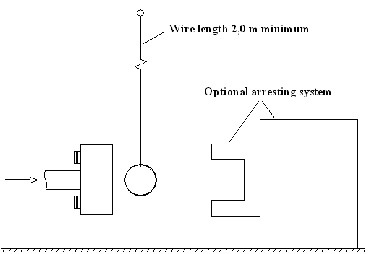
Figure 29. Test set-up for dynamic upper legform impactor certification test
(see paragraph 8.2.4.6)

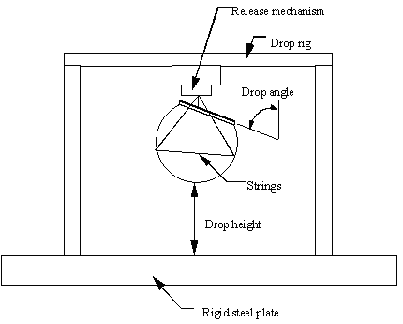
Figure 30. Test set-up for dynamic headform impactor biofidelity test
(see paragraph 8.3.3.1.)

- - - - -

/ IHRA is an inter-governmental initiative that aims to facilitate greater harmony of vehicle safety policies through multi-national collaboration in research.
/ A number of reference documents is listed in the appendix to this global technical regulation. The documents are available on the UNECE WP.29 website at the address: http://www.unece.org/trans/main/welcwp29.htm. IHRA data are set forth in working paper No. 3 of the informal group on pedestrian safety (INF GR/PS/3) at http://www.unece.org/trans/doc/2002/wp29grsp/inf-gr-ps-3e.ppt#262,1, 1st meeting of the Informal Group on Pedestrian Safety, and in working paper No. 31 (INF GR/PS/31).
/ INF GR/PS/12, /13 and /25
/ INF GR/PS/14
/ INF GR/PS/15
/ INF GR/PS/16
/ INF GR/PS/20
/ INF GR/PS/21
/ INF GR/PS/41
/ INF GR/PS/70
/ To develop these test procedures, the group carefully studied the availability of the pedestrian dummy as an alternative method for the test procedures. The group concluded that there is no test dummy presently available that could be considered suitable for regulatory use. Accordingly, the informal group decided to select subsystem test methods which are readily available, and which have the necessary reliability, repeatability and simplicity.
/ The steering committee of the EEVC is composed of representatives from European national governments. The EEVC conducts research in motor vehicle safety and develops recommendations for test devices and procedures that governments can decide to adopt into national regulations.
/ Saul, R.A., Edlefson, J.F., Jarrett, K.L., Marcus, J.R.; "Vehicle Interactions with Pedestrians," Accidental Injury: Biomechanics and Prevention, New York: Springer-Verlag, 2002.
/ "Report to Congress: Pedestrian Injury Reduction Research," NHTSA Report DOT HS 808 026, June 1993.
? Informal document No. GRSP-45-25
/ The resultant acceleration at the location of the accelerometer mounted in the headform will be limited so that, for any two points in time, t₁ and t₂, during the event which are separated by not more than a 15 millisecond time interval and where t₁ is less than t₂, the maximum calculated head injury criterion (HIC) shall not exceed 1,000, determined using the resultant head acceleration at the centre of gravity of the headform, a_{r}, expressed as a multiple of g (the acceleration of gravity), calculated using the expression: 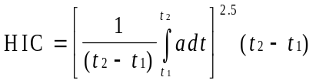
/ While the example in working paper INF GR/PS/158 shows a needed relaxation zone of around 40 percent in the child headform test area, the example represents only one vehicle. The informal group determined that a maximum 50 percent relaxation area in the child headform test area is a reasonable approach taking into account all envisaged vehicle types.
/ There is also a concern that the lower leg test could readily be met by simply allowing the lower legform to slide and/or rotate beneath the high bumper. This could have an unintended consequence of encouraging high bumpers as a way to meet the requirements, and lead to more pedestrian injury due to run-over.
/ WG17 stated that the alternative legform test should be available for vehicles with a lower bumper height of more than 500 mm. However, WG17 referenced a value that WG10 had associated with the upper (rather than lower) bumper reference line. Also, since pedestrians are usually wearing shoes, the bottom of the legform impactor was determined to be 25 mm above the ground, the same height as the sole of a shoe (INF GR/PS/98). Accordingly, the informal group believes that the value of 425 mm (not 500 mm), measured to the lower bumper reference line is consistent with WG17's provision.
/ The size and mass of both the present rigid lower legform and the Flex-PLI were determined to be equivalent to those of a 50th percentile adult male (INF GR/PS/79). The results of computer simulation analyses and experimental data indicate that the mass of the upper body need not be taken into consideration for those impacts where the bumper strikes the legs below knee level (INF GR/PS/105).
/ "Use of the TRL Legform to Assess Lower Leg Injury Risk," Stammen and Mallory, NHTSA VRTC, February 2006. INF GR/PS/XX
/ EEVC Working Group 17 Report: "Improved Test Methods to Evaluate Pedestrian Protection Afforded by Passenger Cars (December 1998 with September 2002 updates)," available at www.eevc.org
/ http://ec.europa.eu/enterprise/automotive/pagesbackground/pedestrianprotection/final_trl_2006.pdf
? The final report of the TEG is available as documents ECE/TRANS/WP.29/GRSP/2011/13 and GRSP-49-15: the documents discussed are listed in document GTR9-C-08 of the constitutional meeting of the IWG and are available in the section "FlexPLI subgroup" of the first Informal Group on Pedestrian Safety.
/ A contracting party may restrict application of the requirements in its domestic legislation if it decides that such restriction is appropriate.

