Report

EPPR Informal Working Group Meeting

10 January 2018
Salle XII, Palais de Nations, Geneva, Switzerland

- Participation link:
  - https://unog.webex.com/unog/j.php?MTID=m8ab9899af75cc5c17c865b696aa81780

- Documents for the meeting can be downloaded from the EPPR web page:
  - https://www2.unece.org/wiki/display/trans/EPPR+22nd+session

Welcome and introduction
The Chair welcomed the delegates and the interpreters.

Adoption of the draft agenda and past minutes
Documents
- EPPR-22-11 r2 revised agenda
EPPR-22-06 Oct 2017 EPPR-21 report

Discussion
Agenda was adopted as in EPPR-22-11 r1, after the addition of the last submitted documents
The report was adopted as circulated, since no objections were raised.

GTR 2

GTR2 Part B1
Documents
- EPPR-22-07 GTR2 part B1 overview updated 20171122.xlsx
- EPPR-22-08 GTR2 revision - Part B1 text updated 20171122
- EPPR-22-13_Japan_proposal_EPPR-22-07 GTR2 part B1 overview updated 20171122
- EPPR-22-18 (IMMA) NMHC
- EPPR-22-24 GTR2 part B1 overview updated 20180110
- EPPR-22-25 GTR2 revision - Part B1 & B2 text updated 20180111

Discussion
- Predominant mode vs worst case mode; see document No. EPPR-21-22, para. no. 3.4.5.1.2
  - In EPPR-22-05, India proposed a definition for predominant mode.
  - As explained in EPPR-22-12, Japan deemed not necessary to define the predominant mode, as long as the test is performed in the worst case mode.
  - India could accept it if worst case mode was defined.
  - Since the different views of Japan and India could not be resolved, the discussion will be resumed at the next session.
  - The group was invited to check the solution found by WLTP.
  - Open point.

- THC and NMHC
  - In EPPR-22-18, IMMA proposed to separate limits for THC and NMHC in draft GTR2 revision, part B1 (EPPR-22-13, line 154), like in Euro 5 regulation.
  - India raised a study reservation.
  - The group was invited to check the point for the next session. Open point.

- Supercharger:
  - The proposal about supercharger - para. 4.52, line 114 - sent via email by the WLTP Coordinator/Mr Dubuc’s proposal was reviewed. It was agreed to define Forced Induction System, as umbrella definition, adding relevant sub-definitions, and to provide the rationale in the Technical Report:
    - Forced induction is the umbrella term including supercharger, turbocharger, and all kinds of forced air systems (be they superchargers (Root blowers), exhaust gas-driven turbochargers, pressure systems such as Comprex, etc.)
  - Draft GTR2 text:
    - Forced induction is the process of delivering compressed air to the intake of an internal combustion engine.
    - A supercharger is an air compressor driven by the crankshaft of an engine, usually connected with a belt.
    - A turbocharger is simply an air compressor driven by an exhaust gas turbine.
  - EPPR to confirm above draft text proposed by the Secretariat for the next session
  - Open point.

- Pollution-control devices:
  - India & US proposal for amendment to clause 4.38: [‘Pollution-control device’ means those components (hardware or software) of a vehicle that control or reduce emissions;] was agreed upon.
  - Closed point.

GTR2 Part B2
Documents
- EPPR-21-17 Humidity and Temperature correction factors for NOx from diesel
- EPPR-22-09 GTR2 part B2 overview updated 20171122.xlsx
- EPPR-22-10 GTR2 revision - Part B2 text updated 20171122
- EPPR-22-02 (IMMA) Open_vs_Closed exhaust gas measurement system_Data
- EPPR-22-05 (India) comments on several open points
- EPPR-22-12_Japan_proposal GTR2 B2 (drive_mode)
- EPPR-22-14_Japan_proposal_EPPR-22-09 GTR2 part B2 overview updated 20171122
- EPPR-22-16 (IMMA) EPPR weighting factors
- EPPR-22-17 (IMMA) Additional explanation for OPEN and CLOSED systems
- EPPR-22-21 r1 (IMMA) comments for EPPR GTR2 discussion
- EPPR-22-25 GTR2 Part B1 & B2 consolidated text updated 20180111
- EPPR-22-26 GTR2 part B2 overview updated 20180110.xlsx

Open points before the meeting
- Soak room temperature and Test room humidity
  - India proposal submitted as EPPR-22-05 to be checked
  - IMMA to check whether Regulation 134-2014 has any humidity control requirement
- Exhaust gas measurement system (open/closed)
  - EPPR-22-02 IMMA proposal to be checked
- PM/PN:
  - Chair to check whether DI/CI engines are covered in PMP- text.
- Predominant mode, para. 3.4.5.1.2.
  - India proposal EPPR-22-05 on additional modes to be checked
  - RDW proposal to change the word ‘test agency’ with another appropriate term, in line with other GTRs, to be checked
- Extraordinary conditions, para. 3.4.6.2.1
  - EC to clarify “extraordinary conditions”
- Chassis dynamometer, Para 4.2.2.2.5.1
  - Clause 4.2.2.2.5.1, following India proposal (EPPR-22-05) to be checked
Chassis dynamometer with polygonal function
“In the case of a chassis dynamometer with polygonal function, in which the absorption characteristics are determined by load values at several specified vehicle speed points, at least five three specified vehicle speeds, including the reference vehicle speed, shall be chosen as the setting points. At each setting point, the chassis dynamometer shall be set to the value Fpau (vj) obtained in point 4.2.2.2.4”
- Pre-conditioning, Para. 4.2.4.5
  - To be concluded once the room temperature is decided upon.
- Weighting factors, para. 5.1.1.6:
  - EC to provide a table/summary to indicate the latest conclusion on weighting factors for Euro 4 and Euro 5

Discussion
- Temperature, unit of measurements
  - It was confirmed that temperature shall be measured in °C. Wherever temperature conversion is required in K for calculation purpose, the following equivalence shall be used, 0 °C = 273.15 K (not 273.2 K)
  - Closed point
- Test room humidity
  - It was clarified that EU Regulation 134-2014 has no humidity control requirement and finally agreed that there is no need for humidity control.
  - It was agreed that it is needed to measure, report and correct humidity, in order to use it for the NOx calculation.
  - It was discussed how to proceed when the test is performed outside the range of validity of the formula. India requested to re-do the test in this case. It was agreed that, if humidity is outside the range of 5.5 ≤ Ha ≤ 12.2 (g H2O/kg dry air), then test should be considered void.
  - EPPR to confirm deletion of following proposal “[The absolute humidity (Ha) of either the air in the test cell or the intake air of the engine shall be such that:5.5 ≤ Ha ≤ 12.2 (g H2O/kg dry air)]”;
  - Open point

- Deterioration Factors
  - India raised proposal 4 in EPPR-22-05
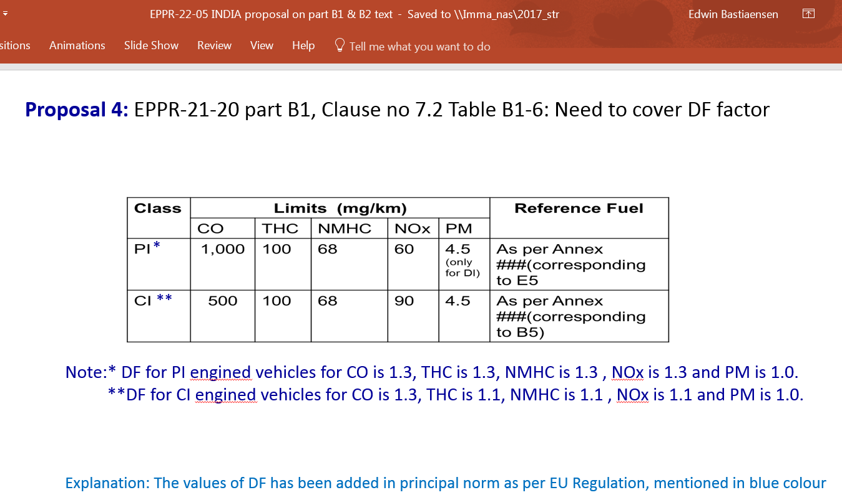
  - It was proposed to remove the note below table B.1-6 & B.1-7 on deterioration factors, since not clear and confusing. India deemed it necessary and asked to keep it.
  - Chairman asked IMMA to prepare an explanatory note

- Open/Closed system emission
  - India raised concerns that an open system might create large dilution.
  - In EPPR-22-17, complementing EPPR-22-02, IMMA provided data showing that the leakage effect is small enough to be negligible even in open system. Therefore, IMMA proposed to keep the possibility to use both open and closed systems.
  - Chair summarised that EPPR needs to minimise the risk to create extra dilution.
  - EC deemed the current proposal still valid, i.e. that it is up to the manufacturer to show that there is no dilution with an open system and type approval authorities have to decide on whether acceptable or not.
  - It was agreed to leave both open and closed system in GTR2, with indication that it is up to the TAA to accept or not the open system for the test.
  - Secretariat to propose text for the technical report that both open and closed system could be used, even if the usage of open system will be based on data and demonstration.
  - Closed point.
- PM/PN:
  - Chair informed the group that, for 4 stroke engines, there is not a problem and that the measurement procedure shall be equivalent to the case of LDV. However, for the case of 2 stroke engines, the presence of artefact is quite significant and therefore the procedure might not be applicable. The Chair wondered whether 2 stroke engines would meet the new emission limits (equivalent to EUR 5) and therefore the problem might not be posed. As requested by India, Chair will ask PMP if they are going to investigate 2-strokes, which is probably not the case.
  - The Chair contacted the PMP Chair on the topic after the meeting and he was informed the PMP group does not have at the moment the mandate to pursue this point.
  - Closed point.
- WF
  - EU Regs. makes no difference between Class 1 and Class 2.
  - It was agreed to change the WF from 50/50 to 30/70
  - Closed point
Soak and Test room Temperature
  - 25°C +/- 5 were agreed upon.
  - Closed point
- Extraordinary Conditions
  - It was agreed to keep the note on Extraordinary Conditions, based on ISO document referred by the EC.
  - The rationale will be added to the Technical Report.
  - Closed point
- Chassis dynamometer, Para 4.2.2.2.5.1
  - India proposed (EPPR-22-05) the following text:
Chassis dynamometer with polygonal function
“In the case of a chassis dynamometer with polygonal function, in which the absorption characteristics are determined by load values at several specified vehicle speed points, at least five three specified vehicle speeds, including the reference vehicle speed, shall be chosen as the setting points. At each setting point, the chassis dynamometer shall be set to the value Fpau (vj) obtained in point 4.2.2.2.4”
in order to increase accuracy
  - IMMA asked to keep “three” because at “least 3” contains “5” (the India proposal).
  - It was agreed to keep “3” ,
  - Closed point.

GTR2 Part B3-B4
Documents
- EPPR-22-03 GTR2 B3-B4 JPN_comments_on_EPPR-21-06 overview
- EPPR-22-04 GTR2 B3-B4 overview updated 20171117.xls

Discussion, B3
- The group reviewed EPPR-22-04
- Type II emission test, para. 3.6
  - IDIADA will send the IMMA test results in slide no. 3 of EPPR-21-12 to CITA, for evaluation that 70°C is not enough to reach the catalyst activation temperature.
  - NL and India recommended to consider also the temperature conditions used under periodical technical inspection and not only under type approval (as in GTR2).
  - Open point
- Para. 4.2.6., “Settings incompatible with the correct running of the engine”
  - India proposed to delete this para.
  - IMMA initially proposed to keep it, in order to keep it aligned to REPPR
  - Open point; Text will be kept in square brackets and EPPR was invited to review it.
- HC factors to be added in formula at line 61:
  - India will search relevant ISO and make the proposal.
- Fail criteria test type II for vehicles equipped with a PI combustion engine, Para. 6.
  - Agreed to delete, pending EC final agreement
- CO normal idle emissions, lines 71-73
  - Japanese proposal EPPR-22-03 to be checked

Action, B4
- Part B4 to be reviewed

GTR2 Part B5
Document
- EPPR-19-10_GTR2-Part B5_GTR2 vs EPPR-11-15 Rev3.xls
- EPPR-21-11 (IMMA) GTR2-Part B5_GTR2 vs EPPR-11-15 Rev3

Action
- Part B5 to be reviewed

OBD2
Document
- EPPR-21-16 (Japan) OBD2 propulsion
- EPPR-22-19 (Japan) Discussion of OBD2 by Correspondence Group
- EPPR-22-20 (IMMA) OBD2 Alignment of definitions summary

Context
- The Japanese proposal to initiate discussion on OBD 2 through a Correspondence Group (CG), with the aim to complete work by 2018, and the proposal for Vice-Chair as CG-coordinator was agreed upon.
- IMMA, EC and CLEPA supported the Japanese initiative and the timeframe set.
- Mr Matsukawa-san/MOE was welcomed as Vice-Chair.
- Japan was invited to prepare Terms of Reference of the CG by next meeting.

Roadmap
Document
- EPPR-22-15 (S.Korea) max. power
- EPPR-22-23 (IMMA) Proposal for EPPR Roadmap

Context
- Stakeholders’ view on the next priority of work:
  - EC: OBD2 and Durability
  - Japan: OBD2 and Durability
  - India: OBD2 and Durability; anyhow performance-related matter (power) should start in parallel, since also important for certification.
  - South Korea: Propulsion Unit Performance

Discussion
South Korea presented EPPR-22-15
IMMA presented EPPR-22-23
- Stakeholders were invited to further reflect on next priorities of work:
  - OBD2 and then Durability, or
  - OBD2 and then Propulsion Unit Performance

Next meetings
- 11.01.2018 GRPE
  - GTR2 Revision informal documents, with a progress report and the GTR2 B1+B2 Revision consolidated text.
- February 2018 EPPR telco will be scheduled by “doodle”-request
- 21-23.03.2018 EPPR-21 in India
- April 2018 EPPR telco - tbd
- 06.06.2018 EPPR at Palais Nations, Geneva
- 07.06.2018 GRPE
  - Consolidated (whole) GTR2 informal document, with a progress report

- 10-11.10.2018 EPPR in S.Korea – tbc
- Nov 2018 EPPR telco – tbd
- January 2019 GRPE
  - Consolidated GTR2 (all parts) formal document

_________________

