ACV informal group ACV-11-03

First ideas for response to comments in blue italics
Proposed amendment to ECE Regulation 13

The text reproduced below was prepared by the experts of the informal working group ACV for the amendment of Regulation No. 13. This is to enable the use of automatic couplings systems.
The modifications to the existing text of the Regulation are marked in bold characters.

I. Proposal
Insert new paragraphs 2.39. and 2.40., to read:
2.39. “Brake electric/electronic interface” means the part of a separable electrical/electronic connection between the towing vehicle and the towed vehicle which is dedicated to the braking system.

2.40. “Automated Connector” means a system through which the brake electric and brake pneumatic connection, between the towing vehicle and towed vehicle is made automatically without direct intervention of a human operator.
Does this prohibit automated interfaces which include lighting i.e. ISO 13044
R13 is about braking systems, not about lighting. To prevent misunderstandings the word “brake” could be added?
Amend paragraph 5.1.3.6. to read:

5.1.3.6. a) The electric control line shall conform to ISO 11992-1 and 11992-2:2003 including its amendment 1:2007 and be a point-to-point type using :
i) the seven pin connector according to ISO 7638-1 or 7638-2:2003 or,
ii) in the case of systems where the connection of the electric control line is automated, the automated connector shall provide as a minimum the same number of pins as the above mentioned ISO 7638 connector and meet the requirements specified in Annex 22 of this Regulation.

b) The data contacts of the ISO 7638 connector shall be used to transfer information exclusively for braking (including ABS) and running gear (steering, tyres and suspension) functions as specified in ISO 11992-2:2003 including its Amd.1:2007. The braking functions have priority and shall be maintained in the normal and failed modes. The transmission of running gear information shall not delay braking functions.

c) The power supply, provided by the ISO 7638 connector, shall be used exclusively for braking and running gear functions and that required for the transfer of trailer related information not transmitted via the electric control line. However, in all cases the provisions of Paragraph 5.2.2.18. of this Regulation shall apply. The power supply for all other functions shall use other measures.
Amend paragraph 5.1.3.8. and add new paragraph 5.1.3.9. to read :

5.1.3.8. Shut-off devices which are not automatically actuated shall not be permitted.

5.1.3.9. In the case of tractor and semi-trailer combinations, the flexible hoses and cables shall be a part of the power-driven vehicle. In all other cases, the flexible hoses and cables shall be a part of the trailer.

In the case of an automated connector, this requirement regarding the allocation of flexible hoses and cables is not applicable.

Amend paragraph 5.2.1.23. to read:

5.2.1.23. Power driven vehicles authorized to tow a trailer equipped with an anti-lock system shall also be equipped with a special electrical connector, conforming to ISO 7638:2003, for the electric control transmission.
Alternatively, or in addition, in the case of vehicles where the [brake]electric[al] connection of the electric control line is automated, the automated connector shall meet the requirements specified in Annex 22 of this Regulation.
Reference to the electric control line is irrelevant as this paragraph only relates to the powering of the trailer anti-lock. There is no requirement for vehicles with ABS or any other system to have electric control line capability.

The current text refers to the “…electric control transmission” That is not correct? Should the current text be amended?
Proposal; copy of the current text as much as possible.

Amend paragraph 5.2.2.17. to read:

5.2.2.17. Trailers equipped with an electric control line and O₃ and O₄ category trailers equipped with an anti-lock system, shall be fitted with a special electrical connector for the braking system and/or anti-lock system, conforming to ISO 7638:2003^{15,} Alternatively, or in addition, in the case of vehicles where the [brake]electric[al] connection of the electric control line is automated, the automated connector shall meet the requirements specified in Annex 22 of this Regulation.
Reference to the electric control line is irrelevant as this paragraph only relates to the powering of the trailer anti-lock. There is no requirement for vehicles with ABS or any other system to have electric control line capability.

The current text refers to the “…electric control transmission” That is not correct?
Proposal; to meet the objections, copy of the current text as much as possible.

Failure warning signals required from the trailer by this Regulation shall be activated via the above connectors. The requirement to be applied to trailers with respect to the transmission of failure warning signals shall be those, as appropriate, which are prescribed for motor vehicles in paragraphs 5.2.1.29.4., 5.2.1.29.5. and 5.2.1.29.6.
Trailers equipped with an ISO 7638:2003 connector as defined above shall be marked in indelible form to indicate the functionality of the braking system when the ISO 7638:2003 connector is connected and disconnected.³

The marking is to be positioned so that it is visible when connecting the pneumatic and electrical interface connections.

Annex 2 add new paragraph

14.15 The vehicle is equipped with an automated connector : yes/no²

14.15.1 If yes, does the automated connector fulfil the requirements of Annex 22 : yes/no²

Annex 6

2.5 In the case of power-driven vehicles having a pneumatic control line for full trailers and centre axle trailers, in addition to the requirements of paragraph 1.1. of this annex, the response time shall be measured at the extremity of a pipe 2.5 m long with an internal diameter of 13 mm which shall be joined to the coupling head of the control line of the service braking system. During this test, a volume of 385 + 5 cm³ (which is deemed to be equivalent to the volume of a pipe 2.5 m long with an internal diameter of 13 mm and under a pressure of 650 kPa) shall be connected to the coupling head of the supply line.

Tractors for semi-trailers shall be equipped with flexible pipes for making the connection to semi-trailers. The coupling heads will, therefore, be at the extremity of those flexible pipes. The length and internal diameter of the pipes shall be entered at item 14.7.3. of the form conforming to the model in Annex 2 to this Regulation.

In the case of tractors for semi-trailers the measurements shall be made at the coupling heads at the extremity of the flexible pipes. The length and internal diameter of the pipes shall be entered at item 14.7.3. of the form conforming to the model in Annex 2 to this Regulation. In the case of an automated connector the measurement is made at the connector interface.

It is still necessary to include the 385cc volume for all towing vehicles irrespective of the type of interface as this represents the trailer control line which is filled from the towing vehicle and must be retained to ensure the towing vehicle has sufficient stored energy to fulfil response requirements. The change to the first paragraph removes this requirement. In the case of measuring the response time with an automated coupling only the flexible pipes are omitted.

The conventional pneumatic trailer control line is, in the case of a semi trailer tractor, fitted on the tractor. In the case of a full trailer it is fitted on the trailer. (R13 par 5.1.3.8 & Annex 4 par 2.5).
Since the 385 cc volume represents the trailer control line it would only be necessary, for the measurement of the reaction time, in the case of a truck (non-tractor).

Or, the ”trailer control line” is not that part that makes the connection to the towing vehicle. In that case the volume of 385 cc would be necessary for both tractors and trucks. However, what part is the ”trailer control line” in that case?

However the measurement would still be at the interface since the current text of par 2.5 reads:
“the response time shall be measured at the extremity of a pipe 2.5 m long with an internal diameter of 13 mm which shall be joined to the coupling head of the control line of the service braking system” in case of a truck, or
“ the measurements shall be made at the coupling heads at the extremity of the flexible pipes” in case of the a tractor”.
The actual question is; has the volume of 385 cc to be regarded as a part of the measurement equipment or as a part of the vehicle?

Amend paragraph 3.3.3. to read :

3.3.3. The simulator shall be set, e.g. through the choice of orifice in accordance with paragraph 3.3.1. of this annex in such a way that, if a reservoir of 385 + 5 cm³ is
joined to it, the time taken for the pressure to increase from 65 to 490 kPa (10 and 75 per cent respectively of the nominal pressure of 650 kPa) shall be 0.2 + 0.01 seconds. If a reservoir of 1155 + 15 cm³ is substituted for the above-mentioned reservoir, the time taken for the pressure to increase from 65 to 490 kPa without further adjustment shall be 0.38 + 0.02 seconds. Between these two pressure values, the pressure shall increase in an approximately linear way. These reservoirs shall be connected to the coupling head without using flexible pipes and the connection shall have an internal diameter of not less than 10 mm.

These reservoirs shall be connected to the coupling head without using flexible pipes. The connection between the reservoirs and the coupling head shall have an internal diameter of not less than 10 mm.

The setting shall be carried out using a coupling head arrangement that is representative of the type fitted to the trailer for which type approval is being sought.

Add Annex 22 to read:
Annex 22
REQUIREMENTS FOR THE BRAKE ELECTRIC/ELECTRONIC INTERFACE OF AN AUTOMATED CONNECTOR

1. General
This annex defines the requirements applicable to installations where the connection and disconnection of the brake electric/electronic interface between the towing vehicle and the towed vehicle is achieved by an automated connector.

2. Requirements
The electric/electronic interface of the automated connector shall achieve the same functional requirements as specified for the ISO 7638 connector throughout this regulation and its annexes.
2.1. The contacts (pins and sockets) for the brake electric/electronic interface shall have the same electrical current carrying capability and electrical functionality as the ISO 7638 contacts.
2.1.1. The data contacts of the brake electric/electronic interface shall be used to transfer information exclusively for braking (including ABS) and running gear (steering, tyres and suspension) functions as specified in ISO 11992-2:2003 including its Amd.1:2007. The braking functions have priority and shall be maintained in the normal and failed modes. The transmission of running gear information shall not delay braking functions.

2.1.2. The power supply, provided by the brake electric/electronic interface, shall be used exclusively for braking and running gear functions and that required for the transfer of trailer related information not transmitted via the electric control line. However, in all cases the provisions of Paragraph 5.2.2.18. of this Regulation shall apply. The power supply for all other functions shall use other measures.

2.2. In the case of semi-trailer combinations equipped with an automated connector the maximum length of the cable for braking data communication shall be,
- tractor : 21 m
- semi-trailer : 19 m
in the running mode.

In all other cases the conditions of paragraphs 5.1.3.6. and 5.1.3.8. of this regulation apply with respect to maximum cable lengths.

2.3. Vehicles being equipped with both a connector conforming to ISO 7638 and an automated connector shall be built in such a way that only a single path is possible for the functioning of the electric control transmission or in the transmission of information in accordance with ISO 11992-2:2003 including Amendment 1:2007. See appendix 1 for examples.
In the case of automatic path selection the priority shall be given to the automated connector. This is an in service requirement and irrelevant for type approval
Cases like this are already in regulation R13. E. g. R13 par. 5.2.2.17.2;
5.2.2.17.2. It is permitted to connect the braking system to a power supply in addition to that available from the ISO 7638:2003 connector above. However, when an additional power supply is available the following provisions will apply:
(a) In all cases the ISO 7638:2003 power supply is the primary power source for the braking system, irrespective of any additional power supply that is connected. The additional supply is intended to provide a backup should a failure of the ISO 7638:2003 power supply occur.

To meet the objections the text could be changed to a form as in par 5.2.2.17.2:
“In the case of automatic path selection the priority shall be given to the automated connector is the primary connector for the braking system.”
2.4. During or following the coupling process, after a correct mechanical coupling, the driver shall be provided with a haptic (e.g. braked trailer) or optical or acoustic warning if the towing vehicle and towed vehicle parts of the automated connector are not positioned together so as to provide a fully functional [brake electric/electronic interface] connection. How can the trailer with an automated connector decide that a connection has not been made if the towing vehicles is not equipped with an automated connector or is installed with a connector that utilizes a different design concept? No power = No signal. The requirement of paragraph 5.2.1.29.5 is realized when the braking system of the trailer is first powered and the trailer has no idea where the power is coming from. It is impossible to fulfill this requirement when there is no compatibility on pneumatic/electric connections specified.
If there is no connection the brakes can give a haptic warning since the brakes are not released when the pneumatic lines are not connected.

This warning shall be given not later than two seconds after the motor vehicle has started to move. Vehicle movement can only be ascertained from the ABS wheel speed sensors and it is not required for them to generate a signal at speeds <10kmh and this is not time dependent
If the warning cannot be given by the ABS-sensors the manufacturer has to install another system to give the warning. E.g. by not releasing the brakes. The regulation only states that the warning has to be given not how it shall be realized.
A weak point could be a trailer with a parking brake operated by a spindle, after some time the air reservoirs will be empty and the brakes will be released and the haptic warning will not be given. However, in such a case the manufacturer could be forced to install spring brakes.
In the case of using the warning signal according to paragraph 5.2.1.29.2 to provide the warning, the illumination of the warning signal according to 5.2.1.29.5 shall be considered to indicate that the connection is fully functional.

2.5. Until all characteristics of this automated connector have been determined, the manufacturer applying for type approval shall submit an information document describing the functionality and any limitations in the use of the automated connector and any associated equipment.
This information document shall also include details of its compatibility with other automated connectors. This is unworkable as it has no meaning in practice and cannot define compatibility with products not currently on the market.
That is true, may be we should add that the information with regard to other automated connectors only refers to connectors on the market at the time of the type approval. May be we should also add that the connector to be approved shall have dimensions different enough from the dimensions of the other connectors, already on the market, to assure that the connector cannot be coupled to such another coupling because of the difference in dimensions. May be the applicant could be forced to show that he did a sound market research by e.g. showing a list of all automated couplings on the market world wide?
2.6. The vehicle users’ handbook provided by the manufacturer should warn the driver of the consequences of not checking the compatibility of the automated connector between the towing vehicle and the trailer.
A trailer fitted with an automated connector shall have a sticker specifying brand and type of the installed automated connector, requiring the driver to check the compatibility to the towing vehicle.
It is common practice today for the driver to mechanically connect the tractor to the semi-trailer before making the electrical and pneumatic connections. To ensure compatibility the driver would need to know the following:
    - That the tractor is equipped with an automated connector

We can assume that the driver knows that his truck/tractor is fitted with an automated connector. If not he will notice as soon as he tries to make the connections manually (at least in case the towing vehicle is equipped with only one system)

    - The design of the automated connector

Brand and type of the automated connector should be sufficient

    - What semi-trailer automated connectors are compatible with the one installed on the tractor.

If the brand and type are different he has to assume that the coupling are not compatible or he has to assure himself of the contrary by getting the right information

    - What automated connector is installed on the semi-trailer.

That information is on the sticker

Having a “sticker” on the trailer in an undefined position will cause problems – where will the driver find the information. Any means of identifying the design of automated connector on the trailer would need to be permanently fixed and be indelible. The most obvious place for the marking would be the headboard although this is subject to road dirt, snow, ice etc.

To meet the objection we could add the place where the sticker shall be placed. May be at the headboard and, in case of a semi-trailer, at the side of the trailer on the position of the coupling pin.
Or something as in par. 5.2.2.17:

5.2.2.17. Trailers equipped with …. etc….etc….etc

Trailers equipped with an ISO 7638:2003 connector as defined above shall be marked in indelible form to indicate the functionality of the braking system when the ISO 7638:2003 connector is connected and disconnected. This marking is to be positioned so that it is visible when connecting the pneumatic and electrical interface connections.

appendix 1
EXAMPLES OF THE layout of An automated connection between vehicles

Automated connection and manual connection equipped vehicles - Data bus requirements
Diagrams for electrical connections show routing of signals of pin 6 and 7 acc. to ISO 7638

LEGEND
Electrical
E1 ISO 11992-2 node in tractor, e.g. ECU ABS/EBS
E2 Tractor ISO 7638 socket
E3 Tractor ISO 7638 plug for automated connector
E4 Tractor part of automated connector
E5 Trailer ISO 7638 plug for automated connector
E6 Trailer ISO 7638 socket
E7 Trailer part of automated connector
E8 ISO 7638 coiled cable
E9 ISO 7638 park socket
E10 ISO 11992-2 node in traILER, e.g. ECU ABS/EBS
I Cable from E1 to E2
II Cable from E3 to E4
III Cable from E8 to E6
IV Cable from E7 to E9

Pneumatic
P1 Trailer control valve mounted on tractor
P2 T-piece
P3 Pneumatic coiled tube (control and supply)
P4 Tractor part of automated connector
P5 Pneumatic coupling head on trailer (control and supply)
P6 Pneumatic valve to seal the unused terminal (double check valve) (control and supply)
P7 Trailer part of automated connector
P8 Pneumatic coiled tube (control and supply)
P9 Pneumatic park socket (control and supply)

TRACTOR AND SEMI-TRAILER EXAMPLE

- AutomatED Connection and Manual CoNNECTIOn equipped Vehicles

Automated connection mode
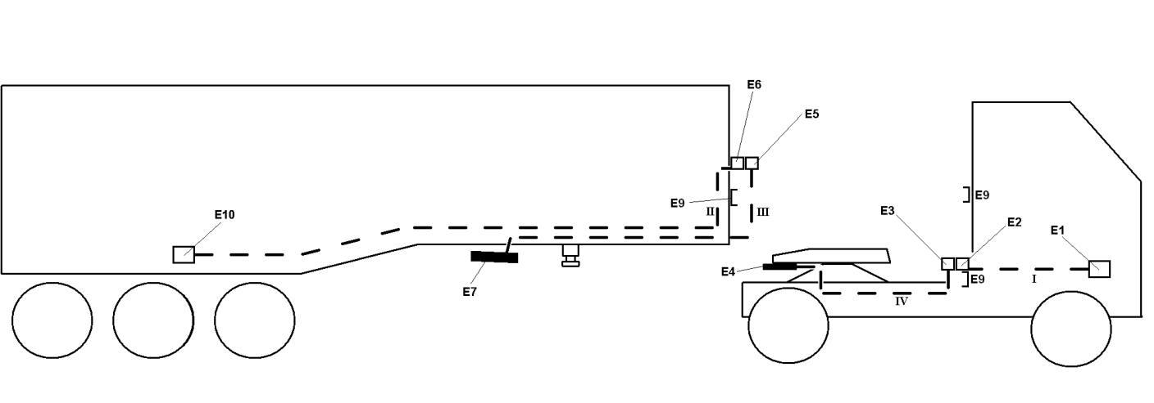

Figure A: Point-to-point connection ECU Tractor (E1) and ECU Trailer (E10) via ACV
Automated connection mode: No coiled cables connected, Connection between E1 and E10 when E4 and E7 are connected (i.e. when fifth wheel coupled)

Manual connection mode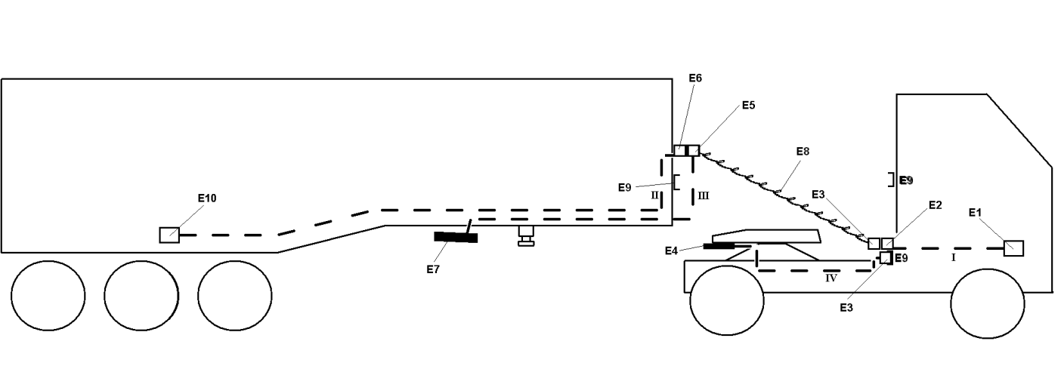

Figure B: Point-to-point connection ECU Tractor (E1) and ECU Trailer (E10) via coiled cable
Manual mode: Coiled cables connected, Connection between E3 and E4 as E5 and E7 are not in use
II. Only one part of the vehicle combination is equipped with an automated connection

Manual mode A (only the tractor equipped with automated connection)

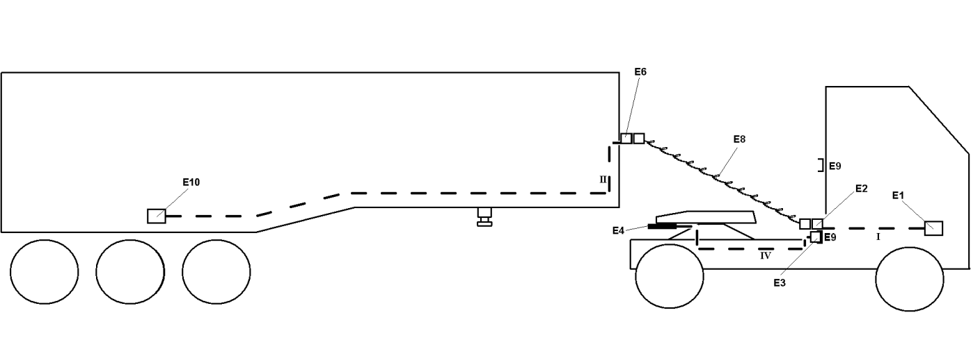
Figure C: Point-to-point connection ECU Tractor (E1) and ECU Trailer (E10) when Fifth Wheel is closed
Coiled cables connected, Line E3 to E4 is not in use

Manual mode B (only the semi-trailer equipped with automated connection)

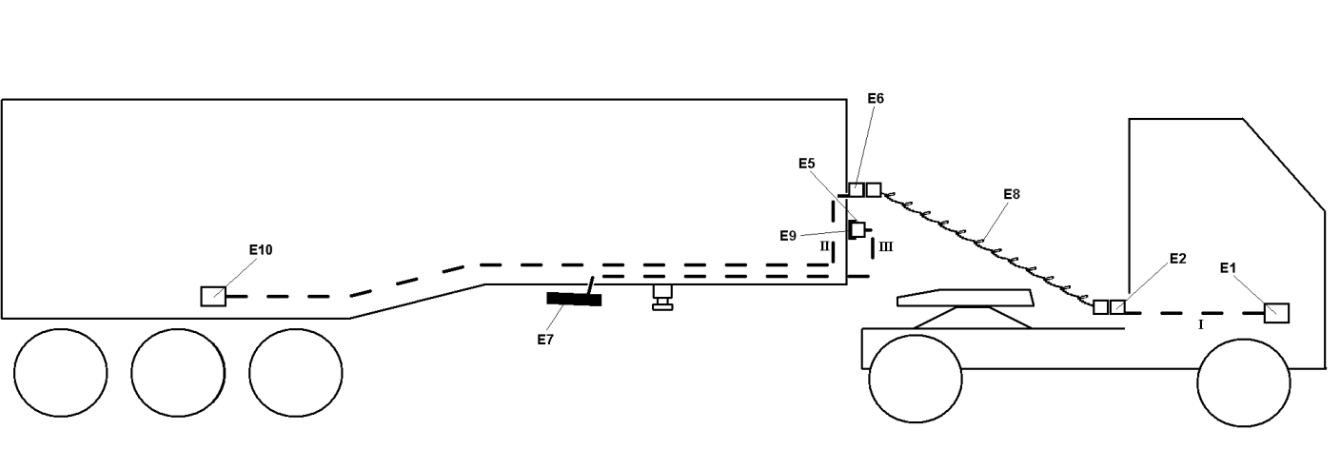

Figure D: Point-to-point connection ECU Tractor (E1) and ECU Trailer (E10)
Coiled cables connected, Line E5 to E7 is not in use

Automated connection mode
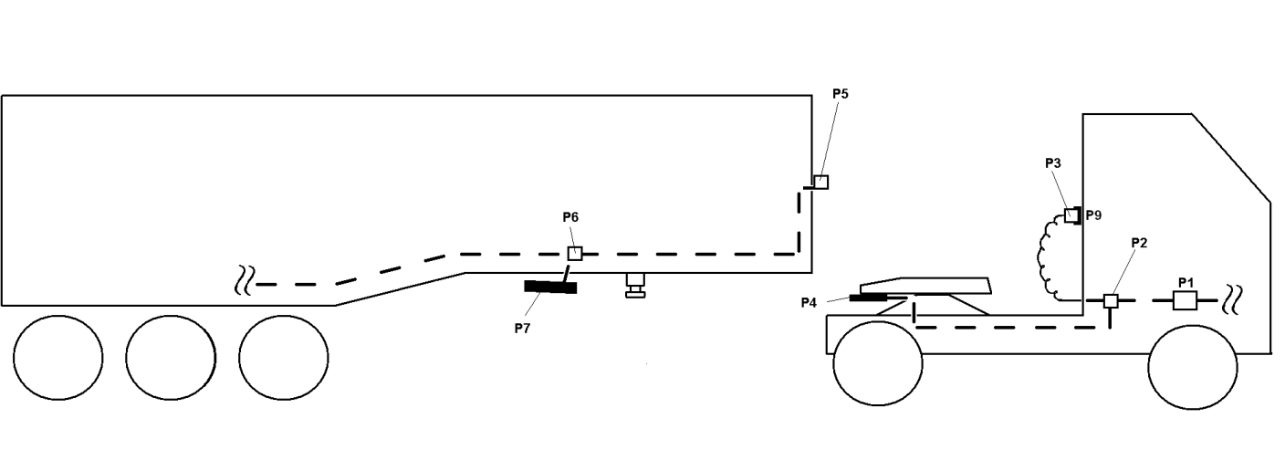
Figure E: Pneumatic connection Tractor and Trailer via ACV
Automated connection mode: No coiled cables connected, Connection between tractor and trailer when P4 and P7 are connected (i.e. when fifth wheel coupled)

Manual mode A (only the tractor equipped with automated connection)
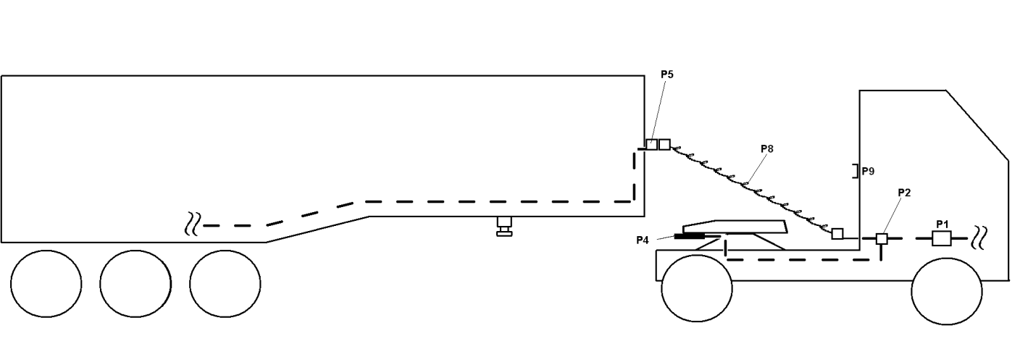
Figure F: Pneumatic connection Tractor and Trailer via coiled tube
Coiled tubes connected, Line P2 to P6 is not in use

Manual mode B (only the semi-trailer equipped with automated connection)
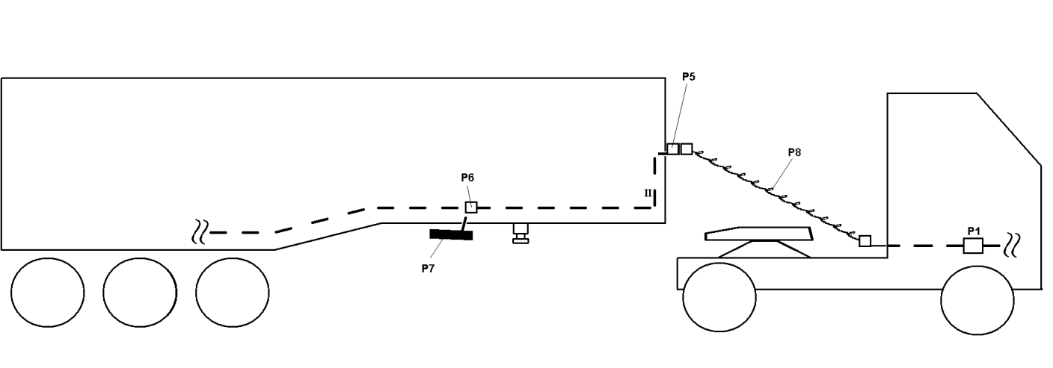
Figure G: Pneumatic connection Tractor and Trailer via coiled tube
Coiled tubes connected, Line P2 to P6 is not in use

B. JUSTIFICATION

Introduction:

The connection of a trailer to a towing vehicle is a hazardous process in involving a person (usually the driver) in the manual connection of air pipes and electrical wiring, in addition to the mechanical connection. Automated coupling systems are designed to reduce/remove this risk. For the optimal control of the braking of towing vehicle and trailer combinations the electrical interface is specified as an ISO 7638 connector with the interchange of electronic information conforming to ISO 11992. However, the ISO 7638 connector is not an optimal design for an automated connection and, therefore, it is necessary to amend the electrical control line requirements to allow alternative means of making the electrical connection between towing vehicle and trailer.

The objective of this proposed amendment is, therefore, to allow automated coupling systems while retaining all the requirements related to the use of the ISO 7638 connector and ISO 11992 for data transfer.

Additional requirements specific to an automated coupling system are contained in a new Annex 22.

2.39 and 2.40
The definitions “brake electric/electronic interface” and “automated connector” are added to ensure a clear understanding of what is meant by automated coupling systems within the terms of this regulation.

Additional requirements specific to an automated coupling system are contained in a new Annex 22.

Paragraph 5.1.3.6.:

For clarity the existing paragraph is sub-divided into 3 parts – a, b and c. The parts “b” and “c” are without change. Part “a” is re-structured so that the existing requirements are retained without change in “i” and the requirements for an automated coupling system, as an alternative, are specified in “ii”.

The requirements in “ii” with regard to the minimum number of pins and the ability to transfer data as per ISO 11992 are identical to “i”. Reference to the new Annex 22 is made with regard to additional specific requirements for an automated coupling system.

By making this amendment and a similar one in the “vehicles of category O” section, and by making reference to the new Annex 22, the number of changes in the regulation text is minimised.

The actual physical layout of the automated connector with regard to the electrical pins and the air connections, together with any alignment structures for the 2 halves of the connector, is not specified. At this stage of the development process it is not deemed appropriate to specify such an interface as it could be design restrictive, although at a later stage it may be appropriate to introduce an ISO standard.

The use of parts a, b and c, and i and ii means that it is not necessary to re-number a significant number of existing paragraphs.

5.1.3.8. and 5.1.3.9.
The current text of paragraph 5.1.3.8. has been divided into two parts with the second part being given the number 5.1.3.9. without a change in content. For clarification the term “articulated vehicle combinations” has been replaced by “tractor and semi-trailer combinations”.

Paragraph 5.1.3.9. is expanded to cover the case of automated connectors not requiring the flexible hoses or cables as used in non-automated systems.

5.2.1.23 and 5.2.2.17
The automated connector is added as an alternative to the ISO 7638 connector together with a reference to the corresponding requirements in the new Annex 22. The requirements are stipulated in Annex 22 to avoid too much new text in the main body of the regulation.

Annex 6
Paragraph 2.5.
As the automated connector does not have any flexible hoses or cables in spite of being sometimes installed on a semi-trailer tractor, a clarification of the application of the measurement method is needed.

The clarification also includes a statement about which vehicle should have the extra added volume.

Paragraph 3.3.3.
The amendment does not change the content of the existing paragraph but clarifies the method of carrying out the test.

Annex 22

Paragraph 2.1
The paragraph ensures that the electrical capability and functionality of the automated connector is the same as the current ISO 7638 electrical connector.

To ensure that the same provisions apply for ACV regarding data communication and power supply two new sub-paragraphs were added.

Paragraph 2.2
For automated coupling systems for tractors and semi-trailers, the allocation of data communication cable lengths defined in ISO 11992-1 is not appropriate. The total length of 40m specified in ISO 11992-1 has been retained to ensure the same quality of data transmission. The coiled cable length of 7m has been divided on the basis of 6m on the tractor and 1m on the semi-trailer. This provides the necessary additional cable on both vehicles required for the automated connector.

In all other cases, semi-trailer non-automated, full trailer in both automated and non-automated modes, centre axle trailer in both automated and non-automated modes, the requirements of ISO 11992-1 apply.

Paragraph 2.3
This paragraph was added to ensure that we have a point to point system without branches.

Paragraph 2.4 ,2.5 and 2.6
Paragraph 2.4 ensures that the air, electrical power and electronic signals are properly connected. This would mean that pin 5 is checked as described in 5.2.1.29.5.

The compatibility matrix below shows different connector configurations. The matrix shows where the warning system of paragraph 2.4 is applicable.

Tractor/truck | trailer | consequence | remarks
ACV | ACV | Good connection possible via ACV
 | Non-ACV | No connection possible or according the appendix to the Annex | Driver may have the idea that connections will be made automatically  Driver should be warned.
 | Different ACV-system | No connection possible | Comparable to a situation where the trailer coupling is different.  Driver should be warned.
 | Different other connectors (air, lights) and trailer coupling | Air; trailer wheel no release the brakes automatically  Lights; no special consequences  Trailer coupling; not possible to couple the trailer | Driver may have the idea that connections will be made automatically.  Driver should be warned.
Non- ACV | ACV | No connection possible or according the appendix to the Annex | Driver is used to connect the connectors by hand and will see what the problem is.
 | Non-ACV | Good connection possible via ISO 7638 | Currently the normal situation
 | Different ACV-system | No connection possible or according the appendix to the Annex | Same situation as with “ACV”. Driver is used to connect the connectors by hand and will see what the problem is.
 | Different other connectors (air, lights) and trailer coupling | Air; no automatic release of the trailer brakes.  Lights; no special consequences  Trailer coupling; not possible to couple the trailer | Driver is used to connect the connectors by hand and will see what the problem is.

Warning modes described in the matrix below show that automated connectors have a driver warning with at least an equivalent safety level as we have today.

Warning Modes
System Component xxxxxxxxxxxxxConfiguration x  Failure | Automatic |  | Manual
 | FACS | AVC | Pneumatic | Brake Electric ISO7638 | Mechanic Coupling
Mechanical connection error (R55) | Remote indication R55 (Optical) | Same as today, Driver check | ---- | ---- | Driver Check
Pneumatic connection error (P) | Trailer brakes applied (Haptic) *** | Trailer brakes applied (Haptic) *** | Trailer brakes applied Driver action (Haptic) ** | ---- | ----
Brake Electric connection error (E) | At least:  Optical indication according to §5.2.1.29.5 (Pin 5) | At least:  Optical indication according to §5.2.1.29.5 (Pin 5) | ---- | Driver Action (Optical), according to R13 §52.1.29.5  (Pin 5)* | ----
* Optical driver warning in cab at "Ignition ON"
** Only an action regarding "Control line", Possibly also a Check in the case of the "supply line" (Dependent on initial pressure in the Trailer)
***In case of FACS/ACV the P&E connectors are integrated in a single unit. Hence designs exist that provides both the P and the E sets of warnings.

Paragraph 2.5 was added to ensure that the technical service and type approval authority are provided with an information document outlining the functionality and any limitations in use with regard to compatibility.
Paragraph 2.6 was added to ensure that the driver is provided with information regarding possible incompatibilities and their consequences.

Justification for the pictures

Picture examples are provided to improve the understanding of the requirements without being design restrictive.
Only tractor and semi-trailer combinations are shown as mixed-mode operation on these vehicles is envisaged today.

The ISO 7638:2003 connector may be used for 5 pin or 7 pin applications, as appropriate.
The conductor cross sections specified in ISO 7638:2003 for the trailer may be reduced if the trailer is installed with its own independent fuse. The rating of the fuse shall be such that the ³ In the case of a trailer equipped with both an ISO 7638 connector and automated connector, the marking shall show that the ISO 7638 connector should not be connected when an automated connector is in use.

