EPPR OBD2
CLEPA comment on para. 5.3.17.1.1

1. IMMA proposal for including a kill switch,
as in “OBD2CG-05-03 (IMMA)” on “5. General requirements”, para. 5.3.17.1.1., cell S138

<Proposal>
Autonomous engine restarts commanded by the engine control system following an engine stall or an engine restart after operation of the kill switch may be considered a new driving cycle or a continuation of the existing driving cycle.
<Justification>
Unlike four wheelers, MC is able to shutdown engine by engin kill switch. Requirements on engin shutdown by engine kill switch is necessary, and IMMA propose to add requirements.

2. CLEPA noted the document in which OICA is explaining the motivation
for introducing autonomous engine restarts:

GRPE-2015-05

Proposal ; see page 7 section 3.10 :

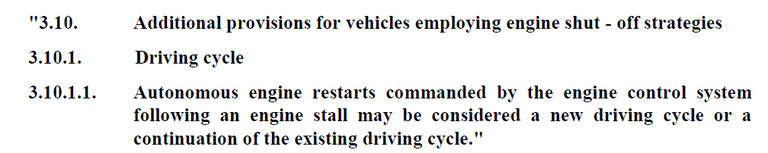

Justification, see page 10 section F :




