- Suggestion of connectors requirements
However, connectors (including the vehicle inlet) are allowed to be separated without the use of tools, if they meet one or more of the following requirements:
(a)They comply with 5.1.1.1.1. and 5.1.1.1.2. when separated, or
(b) They are provided with a locking mechanism (at least two distinct actions are needed to separate the connector from its mating component). Additionally, other components, not being part of the connector, shall be removable only with the use of tools in order to be able to separate the connector, or
(c) The voltage of the live parts becomes equal or below 60V DC or equal or below 30V AC (rms) within 1s after the connector is separated.
5.1.1.1.1. For high voltage live parts inside the passenger compartment or luggage compartment, the protection degree IPXXD shall be provided.
5.1.1.1.2. For high voltage live parts in areas other than the passenger compartment or luggage compartment, the protection degree IPXXB shall be provided.
MOD
However, connectors comply with 5.1.1.1.1.and 5.1.1.1.2 when they are connected. They (including the vehicle inlet) are allowed to be separated without the use of tools, if they meet one or more of the following requirements:
(a) They comply with 5.1.1.1.2 when separated and outside the passenger cabin and the passenger cabin , or
(b) They are provided with a locking mechanism (at least two distinct actions are needed to separate the connector from its mating component). Additionally, other components, not being part of the connector, shall be removable only with the use of tools in order to be able to separate the connector, or
(c) The voltage of the live parts becomes equal or below 60V DC or equal or below 30V AC (rms) within 1s after the connector is separated.
5.1.1.1.1. For high voltage live parts inside the passenger compartment or luggage compartment, the protection degree IPXXD shall be provided.
5.1.1.1.2. For high voltage live parts in areas other than the passenger compartment or luggage compartment, the protection degree IPXXB shall be provided.

- Suggestion of low electrical energy requirements
Low electrical energy
The total energy (TE) [of capacitors connected to] the high voltage buses shall be less than 0.2 J when measured and calculated in accordance with formula (a) of paragraph 6.1.6.2.3.
Alternatively, the total energy (TE) may be calculated by the measured voltage Vb of the high voltage bus and the capacitance of the X-capacitors (Cx) specified by the manufacturer according to formula (b) of paragraph 6.1.6.2.3.
The energy stored in the Y-capacitors (TEy1, TEy2) shall also be less than 0.2 J. This shall be calculated by measuring the voltages V1 and V2 of the high voltage buses and the electrical chassis, and the capacitance of the Y-capacitors specified by the manufacturer according to formula (c) of paragraph 6.1.6.2.3.
Low electical energy for Y-capacitors is necessary requirements in nornal use.
MOD
Capacitive coupling shall meet at least one of the following requirements:
- In the class B voltage circuit, the energy stored at its maximum working voltage of all the capacitance between any class B voltage live parts and electrical chassis, shall not be more than 0.2J. 0.2J is the requirement for the maximum electric power stored in the y-capacitor of the positive side or the negative side in the class B voltage circuit. In addition, if class B voltage circuits are isolated from each other, then 0.2J is the requirement for individual isolated circuits. This shall be calculated by measuring the voltages V1 and V2 of the high voltage buses and the electrical chassis, and the capacitance of the Y-capacitors specified by the manufacturer according to formula (c) of paragraph 6.1.6.2.3.
- The class B voltage circuit shall have at least two insulation layers, barriers or enclosures, or placed inside or behind the enclosures, which shall be able to withstand the pressures no less than 10 kPa without significant plastic deformation.

- Suggestion of isolation resistance test procedure
MOD
6.1.1.2.2. Measurement method using the vehicle’s own REESS as DC voltage source
6.1.1.2.2.1. Test vehicle conditions
The high voltage-bus is energized by the vehicle’s own REESS and/or energy conversion system and the voltage level of the REESS and/or energy conversion system throughout the test shall be at least the nominal operating voltage as specified by the vehicle manufacturer.
6.1.1.2.2.2. Measurement instrument
The voltmeter used in this test shall measure DC values and has an internal resistance of at least 10 MΩ.
6.1.1.2.2.3. Measurement method
6.1.1.2.2.3.1. First step
- The voltage is measured as shown in Figure 1 and the high voltage bus voltage (Vb) is recorded. Vb shall be equal to or greater than the nominal operating voltage of the REESS and/or energy conversion system as specified by the vehicle manufacturer.
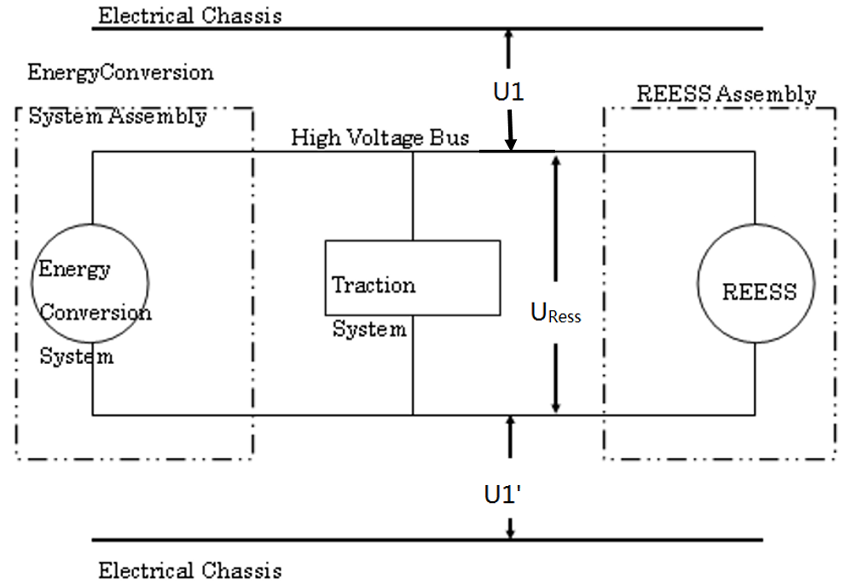
Figure 1 Measurement of U1, U1’ and U_{Ress}
6.1.1.2.2.3.2. Second step
Measure the voltages between two terminals of REESS and the electrical chassis simultaneously using two voltmeters with the same internal resistance, as shown in figure 1.record the higher value for U1, and the lower one for U1’;
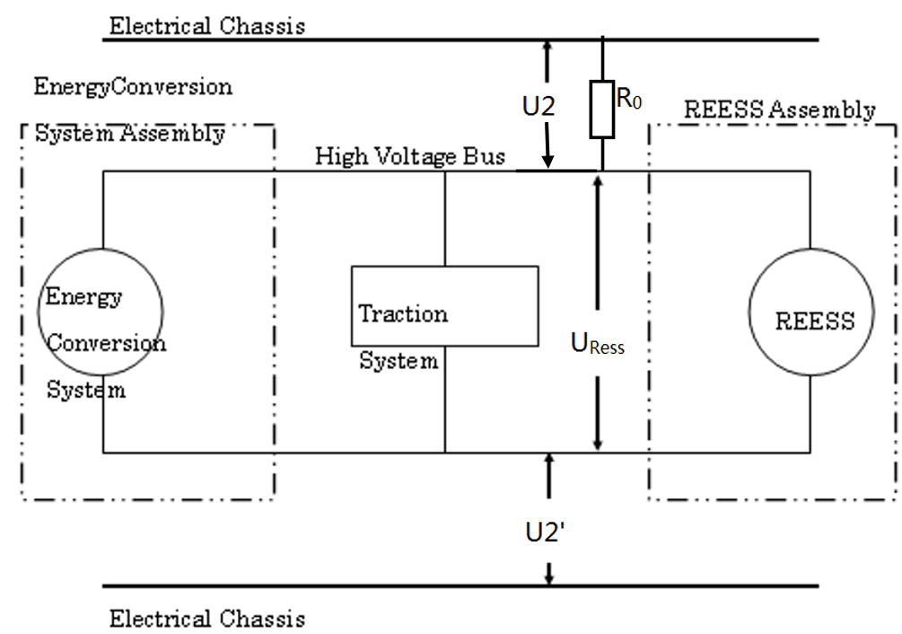
Figure 2 Measurement of U2 and U2’

6.1.1.2.2.3.3. Third step
A standard known resistance (Ro) is inserted between the U1 side of the high voltage bus and the electrical chassis. With Ro installed, the voltages between two terminals of REESS and the electrical chassis are measured using two voltmeters with the same internal resistance. The voltages are recorded U2 and U2’ as figure2 showing
The electrical isolation (Ri) is calculated according to the following formula:
$R_{i}=\frac{1}{\frac{1}{R_{0}\left(\frac{U_{2}^{、}}{U_{2}}-\frac{U_{1}^{、}}{U_{1}}\right)}-\frac{1}{r}}$ (1)
The resulting Ri, which is the electrical isolation resistance value (in Ω), is divided by the working voltage of the high voltage bus in volt (V):
R (Ω / V)= Ri (Ω) / Working voltage (V)

- Suggestion of Confirmation method for functions of on-board isolation resistance monitoring system
MOD

The on-board isolation resistance monitoring system specified in
paragraph 5.1.1.2.4.3. for fuel cell vehicles and that specified in paragraph 5.1.1.3.4 for protection against water effects shall be tested using the following procedure.
(a)Measure U1 and U1’ as 6.1.1.2.2.3.2. record the lower one as U1’
(b) Determine the isolation resistance, Ri, of the electric power train with the electrical isolation monitoring system using the procedure outlined paragraph 6.1.1.
(c) If the minimum isolation resistance value required in accordance with paragraphs 5.1.1.2.4.1. or 5.1.1.2.4.2. is 100 Ω/V ,insert a resistor with resistance Ro between the U1’ side terminal of the electric power train and the electrical chassis. The magnitude of the resistor, Ro, shall be such that:
1/(1/(95xV) – 1/Ri) ≤ Ro < 1/(1/(100xV) – 1/Ri)
where V is the working voltage of the electric power train.
(d) If the minimum isolation resistance value required in accordance with paragraphs 5.1.1.2.4.1. or 5.1.1.2.4.2. is 500 Ω/V, insert a resistor with resistance Ro between the U1’ side terminal of the electric power train and the electrical chassis. The magnitude of the resistor, Ro, shall be such that:
1/(1/(475xV) – 1/Ri) ≤ Ro < 1/(1/(500xV) – 1/Ri)
where V is the working voltage of the electric power train.

