Meeting notes of the 1st meeting of the COP TF
Author: Iddo Riemersma
Date: 16 November 2018 (version 3 of minutes: 29 November 2018)

Meeting agenda

- Opening
- Background and scope
- Objectives of the COP TF
- Comparison table: discuss the main elements of CoP line by line
- CoP data: how can this be made available
- Timeline – next meetings
Participants are listed in the table at the end of this document.

Meeting notes

Opening
Iddo Riemersma welcomed the participants, and explained he will act as chair of the COP TF at the request of the EC. Bart Thedinga will represent the EC, since Alessandro Marotta will move to the JRC.

Background and scope
Under the Transposition project, which is covered in a dedicated TF, the goal is to develop a harmonized UN Regulation for WLTP, based upon existing GTRs. This UNR WLTP will initially cover only some elements of the existing Regulations 83 and 101.
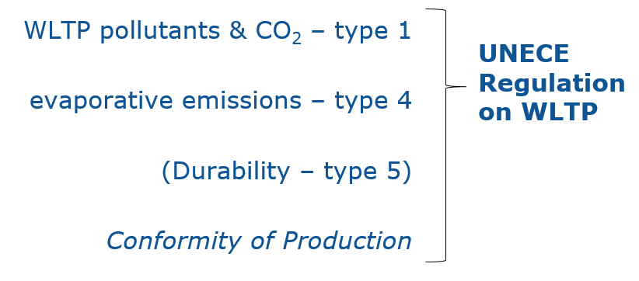
In parallel a new series of amendments to R 83 (=08 series of amendments) is foreseen in which all the other elements of the EU emission type approval procedure will be included and for the type 1 and type 4 requirements reference will be made to the new WLTP Regulation.
GTR 15 which describes the Worldwide harmonized Light vehicles Test Procedure and GTR 19 on the EVAPorative emission test procedure for the WLTP are to be transposed.
The primary task of this TF COP is to agree on the COP provisions, which are essential content for every UN Regulation, per the 1958 agreement. Durability is deemed not to be the main focus and may be discussed at a later time. Since the COP provisions in R83 and R101 are NEDC based it is not appropriate to simple carry these over. The European emissions type-approval Regulation 2017/1151 introduced COP provisions which are WLTP based.
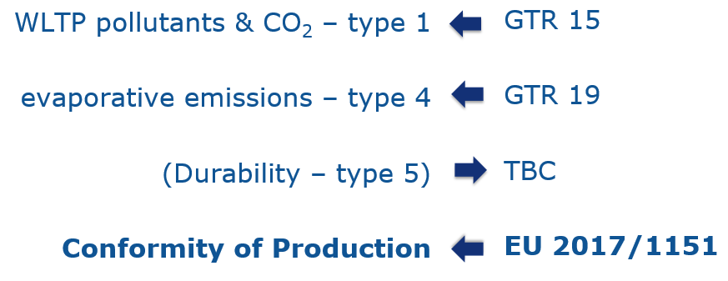
Europe has gone through a process in order to determine COP provisions adapted to the WLTP, although these provisions for CO₂ are deemed unsuitable by some stakeholders. For a proper analysis of the alleged issues, the EU considers it necessary to have COP test result data (see paragraph on COP data below).

Objectives of the TF
The objective of this COP-TF is to decide and agree on the COP requirements for a UN Regulation on WLTP. Ideally an informal document is drafted for the GRPE, on which we can build upon.

Comparison table
A table was circulated in advance of the meeting which compares the main elements of the COP provisions in UN R83 /R101, in Regulation (EU) 2017/1151 and in Japanese legislation. This will be used as a basis for the discussions in the Taskforce. Japan provided an update of document WLTP-24-12e_Appendix01_JPN COP on the COP in Japan. Iddo asked team Japan to check the table and complement it with any missing information and the new information from the updated document. Nick-san agreed to do this.
In this meeting we briefly touched on all items listed in the table, to get a feel on which element can be harmonized, and where more discussions are needed. The outcomes of this first round will be included in a revised version of the table.
Other remarks that were made during the meeting:
Bill Coleman would like to know if the COP TF resides under the 58 or the 98 Agreement. The COP is a necessary element for transposing the WLTP GTR into a UN WLTP Regulation, therefore this taskforce acts under the 58 Agreement. This concept however needs to be confirmed by IWG WLTP as India (not a CP to the 58 Agreement) expressed interest in developing harmonized CoP arrangements.
Nick Ichikawa-san asked which TAA would be responsible for checking the COP for an approval under level 1a or 1b. Conclusion is that the same TAA that granted the type approval should also check the COP and this would also apply to level 2 approvals.
There was a discussion on the test vehicle selection. The table shows that the TAA selects the vehicle at random from the production, but according to industry that is only the case when the COP audits show that the process is unsatisfactory or when the TAA conducts the CoP test themselves. This will be investigated in more detail.

COP data
There are objections from the European car industry to the current evaluation statistics applied in Regulation (EU) 2017/1151 to the CO2 COP. The EC is willing to look into this, but considers data is needed to evaluate possible adaptations. According to industry, it is legally not possible to share data because of anti-trust legislation. They propose to use ‘synthetic’ data. Biagio said that this introduces constraints, because the actual variance in the data would be necessary for a proper evaluation of alternative statistic formulas. An alternative suggestion is to ask COP data from the TAA’s. Arjan and Elodie will check if there is a possibility to go via this route, and will come back to the group. Bill recalled that data was shared during a WLTP meeting in Paris in 2015, where NEDC data was shown and analysed according to EU-WLTP. He will send the presentation to Iddo. Other alternatives were to supply NEDC data or maybe normalized data, Bill will ask if these data can be made available. Bart made a suggestion to send data requests to the members of the TAA Expert group and/or TCMV, if this would be considered an appropriate route.

Timeline and next meeting
On 23 November 2018 there will be a meeting of the Transposition TF in Paris, where the subject of COP may be touched upon as well.
Ideally an informal document would be drafted before the GRPE meeting in January, and according to Rob Gardner the working document for the transposition should be finished in week 6 or 7 (2019).
Given the large number of issues that need to be discussed in detail, the group expressed preference for a face-to-face meeting by end of November or beginning of December. Iddo will inform if that is possible for team Japan, maybe just after the RDE meeting in Brussels on 29 November. If a face-to-face meeting is not possible, a Webex meeting will be organized in the week of 3-7 December.

Action list
Item | Name | Action
1-1 | Nick Ichikawa | Check the table and complement it with any missing information and the new information from the updated document
1-2 | Iddo Riemersma | Modify table according to outcome discussions and distribute
1-3 | Arjan Dijkhuizen | Check the possibility to deliver COP data through RDW
1-4 | Elodie Collot | Check the possibility to deliver COP data through UTAC
1-5 | Bill Coleman | Send presentation shown in the Paris meeting
1-6 | Iddo Riemersma | Check with Team Japan if it is possible to have a face-to-face meeting

Participant list
Name | Organisation | Present at this meeting
William Coleman | VW/ACEA | Y
Jürgen Leu | Opel/ACEA | Y
Franco Guazzotti | Iveco/ACEA | Y
Shumpei Miyazaki | MLIT/JASIC | Y
Nick Ichikawa | Toyota/JASIC | Y
Mayumi Morimoto | Honda/JASIC | Y
Arjan Dijkhuizen | Netherlands/RDW | Y
Franjo Akmadza | Hyundai/KAMA | N
Elodie Collot | France/UTAC | Y
Norbert Ligterink | Netherlands/TNO | Y
Alessandro Marotta | EC | N
Bart Thedinga | EC | Y
Rob Gardner | TRL/EC | Y
Biaggio Ciuffo | JRC/EC | Y
Penny Dilara | EC | Y
Iddo Riemersma | Sidekick/EC | Y

