Draft Meeting Minutes of the 17th Meeting of the Informal Working Group on
Electrical Vehicle Safety - Global Technical Regulation
(EVS-GTR)
Location: Southfield, MI, USA
Date: January 23-24, 2019
Chair: Mr. Nha Nguyen (USA) - Absent
Vice Chair (Acting Chair): Mr. Aleksander Lazarevic (EC)
Vice Chair: Dr. Wang Fang (China) on behalf of Ms. Chen Chunmei
Secretary: Dr. Kenichiroh KOSHIKA (Japan)
Participants: Canada, China, India, Japan, Korea, the European Commission, OICA, Test houses and laboratories-- total about 40 participants.

- Welcome
- Due to the US government shutdown, the chair of the group, Mr. Nha Nguyen, was unable to attend the meeting and the vice-chair, Mr. Aleksander Lazarevic, acted as the chair for this session.
- Alliance members welcomed the participants.

2. Approvals
- Agenda (EVS17-A03 [0118]) was approved.
- On draft minutes of 16thmeeting (EVS17-A07), some corrections were introduced. The group approved the minutes with these corrections.
- Action items (EVS16A12 [0909])
- NHTSA update about the laser methodology postponed.
- ISO work update will be provided during the meeting.
- Feedbacks on the TP whitepaper were received from several members, which will be addressed during this session.
- For high voltage issues, an exchange of emails between China and OICA took place prior to the meeting and the status report will be provided by China.

3. Reports of UN Activities
- 176th WP29 held in November 2018; it was reported that the representative of the US reported the status of the group activities during the WP29 meeting.
- 64th GRSP held in December 2018; No specific question was asked on the EVS activities during GRSP meeting. OICA asked whether it has been reported to GRSP that the issue of inductive charging would no longer be addressed by IWG if, Due to absence of the chair of GRSP/EVS-IWG, this question remains to be confirmed later. [Action: Chair]

4. Update on ongoing and planned research and rulemaking activities
- Update from Contracting Parties
  - US
- No representatives participated.
  - China
- TBT notification will be probably introduced in April 2019 regarding the 3 GB standards related to EVS-GTR work. OICA asked whether GB/T on BMS will become mandatory of not. CATARC replied that the standard will be finalized in March, the responsible government office will decide whehter to introduce the standard as mandatory.
  - Korea
- The representative was not present for this part of the meeting.
  - Canada
- No update on rule making.
  - EC
- The process of transposing GTR No.20 into UNRs is ongoing together with Japan and OICA, where a dedicated meeting will be held on the 25thJanuary. The provisional target timing for submitting the drafts is at May 2019 GRSP session.
  - Japan
- Japan is proceeding with the transposition of GTR 20 to UNRs together with EC and OICA.

- SAE presentation on their standard development regarding battery and EV safety (EVS17-D02, EVS17-D03)
- SAE presented their standardization activities in the area of EV and battery safety.
- SAE has been published several recommended practices related to first and second responders for electric vehicles.
- The standards related to charging are being continuously updated.
- More details on battery safety standards were presented by the committee chair. J2464 and J2929 are the key publications on the battery safety.
- J2464 is published as a recommended practise serving as a guidance for test procedures but no pass-fail criteria is provided in this document. SAE is working on the second revision to be released in this year.
- J2929 on the other hand includes safety criteria and will be updated in this year. At SAE “single cell failure” is being discussed to distinguish from internal shorts.
- "J2929 on the other hand includes safety criteria and will be updated in the future. At SAE “single cell failure” is being discussed to distinguish from internal shorts.”

- Technical information from each countries and Industry (OICA) about the (10) items for phase 2
5.1 Thermal propagation and methods of initiation in battery system
  - OICA (EVS17-E1TP-0100, EVS17-E1TP-0200, EVS17-E1TP-0300)
- Alliance and ACEA presented their research/data on field incidents with respect to the thermal events of electric vehicles. So far, both of them confirmed there is no conclusive evidence that the incidents where t thermal propagation occurred were solely due to internal short circuit.
- Canada asked if there is a possibility that thermal propagation was caused by internal short circuit. ACEA responded that there might be a possibility, but detailed investigation was needed to identify the root cause. Besides that possibility, the number of cases is not significant despite the increase of EVs in the market.
- OICA commented that the documentation approach will facilitate the detailed investigation in the future.
- China concurred that the quality management could lead to good field results, however,. China prefers to address unknown safety issues and continue the research. OICA commented that to have correct answer, it is necessary to understand the exact cause. If the root cause is in quality management, we should look at that.

  - Canada (EVS17-E1TP-0500 )
- Canada provide an update on their work on thermal propagation test procedure. Canada also asserted that test method equivalency probably does not exist.
- OICA requested clarification on cell selection criteria/priorities. Cell selection procedure needs to be further developed.
- OICA pointed that monitoring the battery system while vehicle is not in active driving mode (or when the battery system does not have any electrical activity) may entail additional development cost. .
- Japan commented that the heat generation of internal short circuit and heat induced by the initiation method might be different. Canada mentioned that TR response can be more easily simulated than ISC responses.
- JRC asked how TRIM method can be implemented in the regulatory procedure considering protected IP. Capability of the TRIM method (e.g. heating power) can be specified independent of the used heating device, but additional parameters need to be determined for regulatory purpose.
- For testing, cooling systems need to be included and thus vehicle level testing will be necessary. Body structure will not be significant for the protection measure. Canada noted that pack level test can be a pre-qualification but not final qualification for ensuring the safety of vehicle occupants.

  - European Commission (EVS17-E1TP-0600)
- JRC reported the progress of their research. JRC investigated the feasibility of inductive heating where thermal runaway could be initiated. As this is still feasibility study, only cell level tests were conducted and it is not known if it can be applied at pack level. Inductive heating still offers significant room for optimisation if used as initiation method. JRC emphasized that the area affected by an initiation method should be considered for method selection. A smaller affected area could be more representative of an internal short circuit than a large affected area.
- JRC confirmed that manipulation of a pack would be required for applying inductive heating as initiation method.

  - China (EVS17-E1TP-0700)
- China presented a new self-heating method (based on 3 samples). A recent trend of battery cell technology to increase energy density renders the issue of battery safety even more sensitive, with the foil materials getting thinner and with the nickel content becoming higher.
- Following the question from OICA, China checked the data and found that there was a mistake in slide 15. The standard deviation coefficient of trigger temperature of ‘21700-4.5Ah-16.20Wh’ at 80W should be 0.02. So 80W is the selected heating power. The photo taken after the tests is shown below.
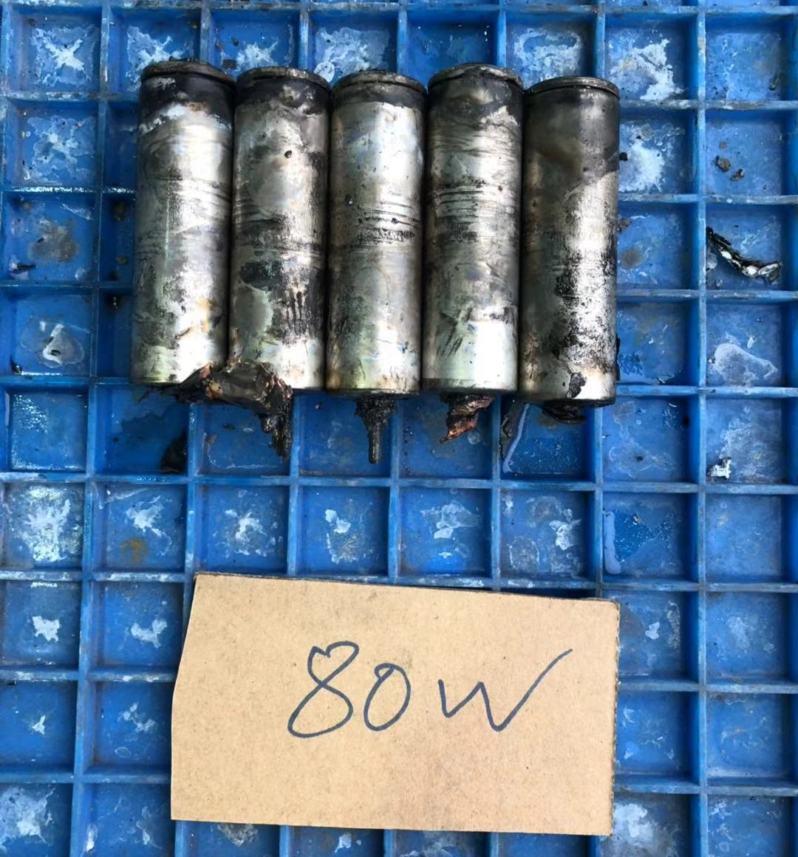
The photos after tests
- Canada commented that the repeatability might be caused by the installation of the heater rather than the power, while also a heating area should also be considered. China admitted that such complex parameters need to be analysed further.
- OICA asked how many vehicles in use correspond to the 34 cases of thermal propagation. China will investigate these numbers. OICA requested China to investigate how many quality management systems used by 8 China’s major manufacturers are ISO based.
- OICA noted that China is introducing a stricter requirement compared to GTR. The escape time requirement in the GTR phase 1 is not simply 5 minutes but “allow egress or 5 minutes.”
- JRC asked about the rationale for the heater selection rule, including dimensions and the level of severity.. OICA also asked what “continuous current interrupter” means.
- OICA also requested a clarification about the situation of parallel connection of cells (e.g. 4P connection). China responded that in such a case, parallel connection could be considered as one larger cell. OICA noted that in this case the energy of 4 cells will be applied to one cell. Canada commented that in case of pack level tests a greater number of cells could be electrically connected.

  - Japan (EVS17-E1TP-0800)
- Japan provided an updaten on the progress of Japanese research, where the initiation procedure to simulate manufacturing failure needs to be developed.
- Acting Chair questioned whether the research on the existing initiation methods that have proven to a lot of challenges is justifiable. On the other hand, the account should be taken of the time required to develop new test procedure vis-a-vis the IWG mandate.
- OICA commented that the detection and intervention technologies should not be bypassed by the test procedure. Canada noted that current GTR text does not allow alternative technologies/exemptions to be considered and this should be addressed further.

  - OICA (EVS17-E1TP-0300)
- ACEA conducted feasibility study of ultrasonic heating as non-invasive initiation method. It concluded that ultrasonic heating will not have a potential for further research since the invasiveness of this initiation method is much higher than expected. The wave guide requires metallic straight route to the target cell outside of the pack through an additional hole made on the casing.
- China requested to provide more details of the study if the certain experiments were conducted. OICA commented that this is only feasibility study and no experiment was conducted.

  - ISO update (EVS17-E1TP-0400)
- Dr. Ahlberg Tidblad, as ISO liaison officer, provided an update of ISO related activities.
- Each member is to draft a candidate test procedure by the next meeting scheduled in March. The most mature procedures will be considered for in ISO 6479-1 amend 1.
- In parallel, the draft standard/guideline for a documented approach is also under development.
- Acting chair commented that “most mature” may not necessarily mean most appropriate, but coordination between standardization bodies and regulatory bodies will be important.
- OICA commented that ISO development may not be suitable for regulatory purposes.
- JRC asked what the target of this standardization activity is and whether the outcome of the study of a documented approach could be shared in this group. The level of details of the initiation method should be sufficient so that the leader can conduct the test. Information could be shared if it is agreed by the respective ISO group.
- Japan asked what phenomenon should be simulated. ISO is also separated in the opinion in that regards.

  - White paper (EVS17-HACT-0400)
- Summary of inputs prepared by NHTSA is reviewed.
- Canada commented that question B.1 (What are we trying to simulate?) should be discussed further. JRC commented that a severity of events is not easy to determine.
- China considers that if 100% proof of no occurrence of thermal runaway, we should set the initiation of a single cell thermal runaway as the starting point. Canada also supported this approach, while cell level measures should also be assessed. JRC considers that local damage of cell will be closer to the relevant situation.
- Japan considers that the severity of the initiation should be relevant to that of contamination caused by manufacturing failure. JRC asked how it can be worked out.
- OICA commented that cell internal short are a family of events from hardly detectable one to a hypothetical thermal runaway and the distribution of occurrence should also be considered. Thermal runaway is really a special case that merely occurs in the field. OICA considers that the measures provided in the GTR phase 1 is a reasonable approach. The regulatory measure should consider the exposure ratio. Thermal runaway propagation is a really difficult test to establish while the need for regulatory interventionwill be always questionable given the lack of field evidence.
- Acting Chair commented that current GTR provides sufficient requirements but the technical service may experience difficulties in assessing the compliance. Another question is whether component level assessment can be introduced in this requirement.
- OICA commented that documentation approach is also implemented for electronic stability control or other regulations, even for self-certification scheme. ISO is trying to establish guidance for manufacturers and technical services.
- Canada wishes to see the actual example of documentation approach.
- SGS-TÜV commented that documentation approach will require the skill of technical services which might be different from an entity to an entity. Providing a test procedure could be alternative to the case where the documentation approach could not be accepted by a technical service. OICA added that the knowledge of documented approach will grow over the next years.
- China commented that in China, “documentation only” is not acceptable and third party testing is required. EV market will rapidly grow and safety issues should be treated seriously.
- Japan incident ratio itself may not be a reason not to require the thermal runaway and we may need a qualification method to ensure the safety.
- OICA commented that specific thermal propagation test may not contribute towards improving the safety as there are various phenomena of the internal short.
- Acting Chair commented that if documentation approach cannot be understood by technical service, there should be an alternative approach available, such as testing.
- Japan commented that research body should agree on the target phenomenon to be simulated. OICA commented that even in the manufacturing defects, there are several variations that may result in different phenomena. If the test is to focus on a limited condition, optimization to such specific situation may be taken and other safety features may be disregarded.
- Canada commented that simulating internal short circuit itself is not realistic and therefore simulating thermal runaway is a more pragmatic approach.
- Acting Chair asked what additional benefits could be provided by the new test procedure. As it was not possible to conclude the discussion on how to determine the severity of a thermal event and regarding the localization of failure the Acting Chair proposed to continue discussion during the next session.

5.2 Flammability, toxicity and corrosiveness of vented gas
  - China (EVS17-E2TG-0100)
- China introduced the study on this topic. The research is conducted along with the research of thermal propagation test.
- OICA asked if China intends to require a gas-tight battery pack since such a design may lead to the other hazards caused by the high internal pressure. Management of gases rather than elimination of the gas will be correct direction.
- OICA commented that Part 1 of GTR 20 does not provide any such requirement.
- OICA noted that in some countries, e.g. Sweden., research and training of first and second responders are already provided in order to prevent dangerous situation.
- OICA asked if China intends to develop proposal for in-use and/or post-crash scenarios. OICA clarified that for in-use requirement, there are already criteria in GTR phase 1．
- JRC noted that it is still working on this topic and the progress will be reported at the next meeting.
- Japan commented that if a certain requirement is considered, a clarification of the situation should be given (e.g. is it about the occupant’ safety or something else).

5.3 Water immersion test
  - China (EVS17-E3WI-0100)
- China introduced the table summarizing the views presented so far.
- Japan requested to clarify the assumed conditions for such requirements.
- OICA commented that if the group uses this matrix for further discussion, all should fill out the boxes. Acting Chair invited China to distribute the table to IWG members so that each party can provide the views by the next meeting. [Action item]

  - Korea (EVS17-E3WI-0200)
- Korea shared their experience by presenting two failure cases in the REESS immersion tests it conducted.
- JRC asked what scenario is looked at. In the first example the fire in the water will release less smokes. Korea considers fire and explosion will have higher risks.
- Japan considers that whole submersion of vehicle will not be a relevant scenario for this regulation.
- China commented that there will be two scenario; (a) drive through water which is not too deep where the water does not come into the cabin but battery pack may be fully or partly immerged, (b) treatment of the vehicle after immersion.
- Canada commented that these scenarios will not be the case to be considered for GTR as the risk is not EV specific and not normal in-use conditions.
- OICA commented that in case of post immersion, isolation resistance monitoring system will disable the system operation.
- Japan commented that the use of vehicle after immersion will be driver’s responsibility.
- China will investigate the difference between the ICE vehicles and EVs.
- Acting Chair mentioned it is necessary to confirm if these specific conditions are within the group’s mandate. This will be checked by co-sponsors. Also he noted that GTR 20 Part 1 required warning in case of thermal events.

5.4 REESS vibration profile
  - China (EVS17-E4VP-0100)
- China presented their research status.
- OICA asked the packs tested are already on the market or not. CATARC commented that REESS will not be brought to the market as it does not meet the draft GB standards.
- OICA noted that the intent of GTR/UNR vibration test is for safety purpose and not for durability purpose. China considers that UN38.3 is not for vehicle use but for transportation.
- OICA commented that the current test equipment will not allow heavy battery pack to vibrate at 200Hz.
- OICA commented that the most of manufacturers use vehicle specific profiles and there is no market problem with respect to the vibration reported. What will be the benefit in changing the test procedure?
- China considers the existing profile of EVS-GTR should be improved.
- SGS-TÜV mentioned that the profile developed for UNR100 was a kind of compromise and did not fully assess the market situation. It is also true that it is not possible to test heavy battery at high frequency. Considering the fact that the most of manufacturers are using vehicle specific profile, the regulation should provide a minimum profile in case where a manufacturer cannot provide the profile.
- China believes that random profile is better representation of the market. OICA commented that a 3-dimensional vibration tester is the state of art test procedure represents a more realistic situation.
- China suggested that we should first conclude whether we should change the profile or stay with current profile. Canada commented that vibration test will be still considered as durability.
- OICA commented that if we develop R100 now, vibration will not be included as it will not be safety requirement but it is difficult to remove existing requirements.
- Acting Chair suggested to see if any of the type approved vehicles on the market based on the current profile caused any safety problem or not. If there is no evidence of the market problem, then we should consider removing the vibration requirement from the regulation. If China can provide the field data showing that vibration caused safety problem, we can consider certain modifications to the existing profile.
- China considers that the profile developed in China is more scientifically reasonable and should be included in GTR. It is not intended to strengthen the requirement but correct to proper problem. In GTR we could keep manufacture’s choice of their own test profiles and at the meantime improve the existing test method should be researched and discussed.
- Acting Chair noted that for legislative procedure, impact assessment is required for changing the existing requirement. If there is no practical problem (i.e. data showing the vehicles approved under current profile causing safety critical problems with the proposed profile), it will be difficult to propose any changes to the existing requirments..

5.5 Protection during AC and DC charging and feeding process
- The discussion on this topic was postponed to the later session.

5.6Long-term fire resistance test
- The presentation was cancelled.

5.7Other issues
  - High voltage safety (EVS17-E7OI-0100)
- HV connector requirement, China agrees there is no need to modify current requirement.
- Low energy requirement, China believes that this requirement is equally important as the isolation resistance.
- I
China proposed a new isolation resistance measurement procedure that has been proved by derivation of equation and test experience. This test method is easy to handle and keep high accuracy, it will be an alternative test method to the existing procedure. Details could be discussed.

- China think there is mistake in isolation resistance monitoring procedure in existing GTR20 which will get the wrong test result. China give the modification proposal.
- OICA suggested to organize a side meeting among experts at the margins of the next IWG meeting.

5.8 Post-crash REESS safety assessment and stabilization procedures
- No discussion held on this topic.

5.9REESS rotation tests
- No discussion held on this topic.

5.10 Light electric vehicles (e.g. categories L6 and L7, low speed vehicles)
- No discussion held on this topic.

5.11 Overcurrent requirements + tests (component based)
- No discussion held on this topic.

6. Confirmation of the IWG meeting rules for a smooth operation in phase 2
- Secretary reminded the participants about the meeting rules in particular in view of a decreasing “submission rate before deadline” . (EVS17-A12)

7. Wrap up of the meeting Actions items and future meetings
7.1Action Items
ACTION ITEMS(EVS17-A10)

17th Meeting of EVS-GTR Informal Working Group (Detroit)
 | Action Items | Responsibility | Due | Status
 | Research information:  NHTSA Laser methodology  ISO update Thermal propagation | US  Annika | Ongoing  Next MTG
 | All members to provide information to water immersion white paper “EVS17-E3WI-0100”. | ALL  - China  - EC  -Japan  -US  -Canada  -Korea  -OICA | 05/12/19 | 05/12/19 is four weeks before the IWG-MTG
 | China to compile the water immersion white paper based on the action item 2.  (China is in charge of the water immersion white paper) | China | 05/26/19 | 05/26/19 is two weeks before the IWG-MTG
 | Group to continue discussion on the thermal propagation white paper during the next MTG. |  | Next MTG
 | China to provide additional evidence for the suitability of the new vibration profile | China | 05/26/19
 | Experts to provide scientific evidence based feedback about the China’s presentation on vibration | - EC  -Japan  -US  -Canada  -Korea  -OICA | 05/12/19
 | Chair reports on GRSP discussion on inductive charging status. | Chair | Next MTG

7.2 Future meetings
- Next meeting will be three days in Tokyo, Japan on June11-13, 2019 with CP meeting on Jun 10.
- Side meeting for transposition to UNR will be held on June 14.

- The 19th meeting will be held in Europe and the timing will be decided depending on the progress at the next meeting.

7.3 Closing
- IWG acknowledged and appreciated the support of the USCAR and the Alliance of Automobile Manufacturers
- Acting Chair and China thanked to the Secretary for all the support during the meeting as well as to all the participants for their active participation and closed the meeting.

