Submitted by CLEPA
Informal – document ACSF-22-02

22 ACSF IWG meeting 9-11 April 2019

Meeting Venue ACSF meeting
FEBIAC
Boulevard de la Woluwe 46 - 1200 Bruxelles - Tél. : +32 (0) 2 778 64 00
MAP is HERE

From Brussels city centre to FEBIAC
- By metro: ca. 25min travel
take metro 1 direction STOKKEL, stop at ROODEBEEK, go to exit n1, take tram 8 and leave at the second stop (VOOT), FEBIAC is the big building just in front
Brussels public transports website STIB is HERE, network map is HERE

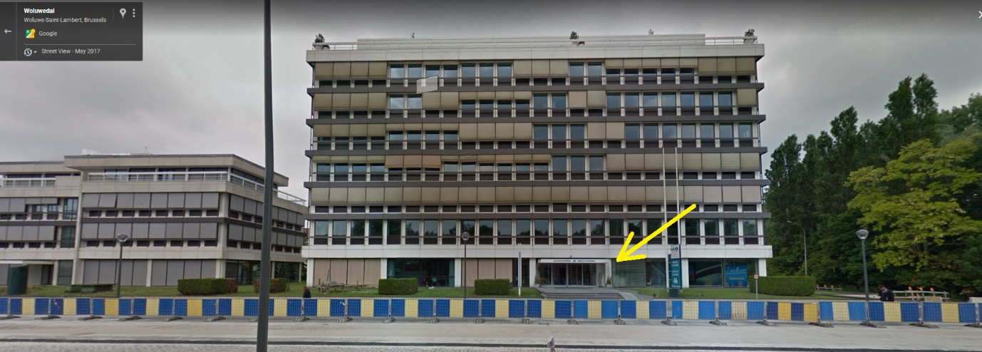

From Brussels Airport Zaventem to FEBIAC
- By taxi: ca. 25 min travel, ca. 30€ cost
Depending from peak hour it may be difficult to get a taxi
Uber is convenient, pick up point is at level 4 and level 5 inside the car parking P1

- By train / metro: ca. 1h15min travel, ca. 10€
take train to Brussels-Central (the train station is inside the airport at level -1, it is recommended to purchase the train tickets in advance online at SNCB) from Brussels Central take metro 1 direction STOKKEL, stop at ROODEBEEK and take tram 8 and leave at the second stop (VOOT), FEBIAC is the big building just in front
Brussels public transports website STIB is HERE, network map is HERE

From Brussels Airport Zaventem to Brussels city centre
- By train / metro: ca. 40min travel, 9€ cost
take train to Brussels-Central (the train station is inside the airport at level -1, it is recommended to purchase the train tickets in advance online at SNCB )
Usually trains stop also at Brussels NORD and Brussels MIDI.
Brussels public transports website STIB is HERE, network map is HERE

- By taxi: ca. 35 min travel, ca. 40€ cost
Depending from peak hour it may be difficult to get a taxi
Uber is more convenient, pick up point is at level 4 and level 5 inside the car parking P1

22ACSF HOTEL list Brussels

Any hotel near the metro system is suitable, better on the east side of town (Loi, Schuman, Merode, Montgomery)

THON HOTELS

NOVOTEL

NOVOTEL gare MIDI

ACCOR HOTELS

Hotels near CLEPA office

Hotel Eurostars Montgomery
Avenue de Tervuren 134, 1150 Bruxelles, Belgique
www.eurostarsmontgomery.com

BEST WESTERN PLUS Park Hotel Brussels
Avenue de l'Yser 21, 1040 Etterbeek, Belgique
www.parkhotelbrussels.be

Hotel Sofitel
Place Jourdan 1, 1040 Bruxelles
https://www.accorhotels.com/gb/hotel-5282-sofitel-brussels-europe/index.shtml#origin=accorhotels

Hotel Plasky
Avenue Eugène Plasky 212, 1030 Brussels
http://hotel-plasky.brussels-hotels.net/en/

