SLR-31-03

GTB input to SLR
for UN Regulation No. 48 – Headlamp levelling

During the 81st GRE session a proposal relating to headlamp levelling was discussed (document GRE/2019/3). It was mainly based on the results of the GRE IWG VGL.
GRE discussed and agreed, in principle, on a modification of the dipped beam levelling limits (the so-called “red box” proposed in document GRE-81-21). However, some aspects were not discussed in deep and the examination of this proposal will continue in the frame of GRE IWG SLR.
For Illustration:
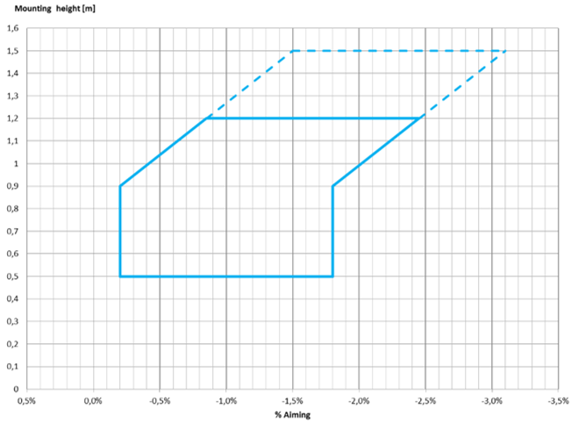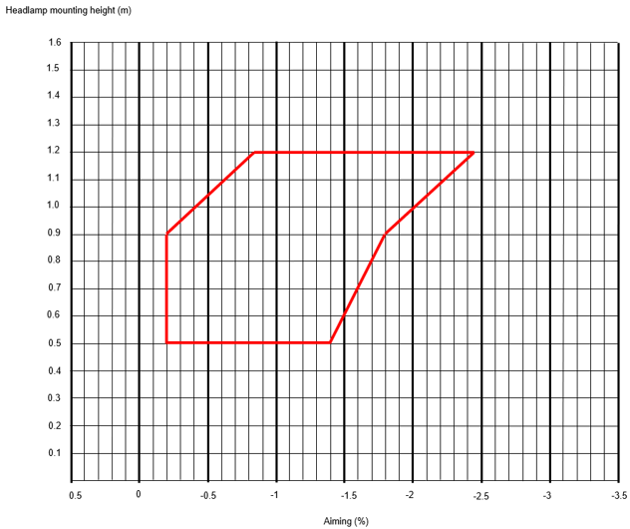
GRE/2019/3 GRE-81-21

GTB wishes to request clarifications about the following points:
- are the present minimum and maximum levelling limits of the “red box” intended to include the CoP tolerance, or the CoP tolerance will be added to these limits? It must be noted that the restriction of the levelling range, from the “blue box” to the “red box”, does not allow for inclusion of the CoP tolerances (due to technical limitations). It could be possible only if the limits are enlarged again by a 0.3 % for the maximum allowed inclination. Please note that the inclusion of the CoP limits will maintain the improvement produced by the VGL proposal, ensuring for the whole vehicles’ production (so in the real life) the respect of the levelling limits.
- is the initial aiming value still to be chosen in the full levelling range (in relation to the headlamp height of installation), or the intention exists to limit the choice of the initial aiming value in a restricted range or above a certain levelling limit? Please note that the very narrow levelling range of the “red box” (as it was for the “blue box”) ensures adequate headlamp performances for both illumination distance and disturbance reduction in all the allowed levelling conditions, so any restriction for the initial aiming is not necessary.
Based on the above specific issues, the general input could then consider the headlamp levelling problem with a wider attitude, taking into account all its aspects and not only the mere levelling limits. Good references are the whole results of the VGL works and the GTB/OICA study and proposal, presented some time ago in GRE and still not correctly considered by the Experts of GRE.
+++++++++++++++

