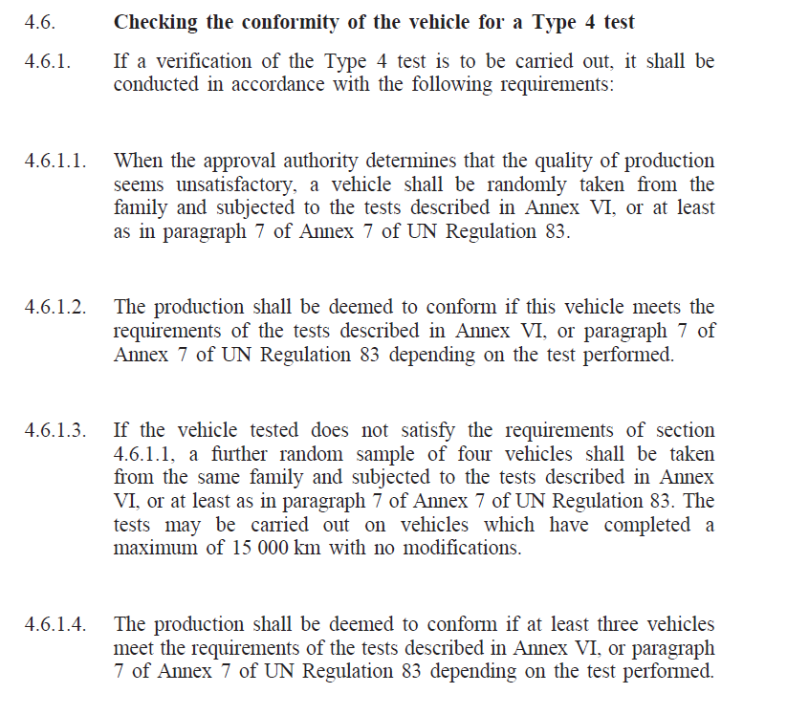

12/7/2019 Draft proposal for a revised EVAP COP procedure

4.6. Checking the conformity of the vehicle for a Type 4 test

4.6.1. Once per year a vehicle shall be randomly taken from the family and subjected to the three tests described in paragraph 7 of Annex 7 of UN Regulation 83 (i.e. the test for leakage, the test for venting and the purge test).

4.6.1.1. The production shall be deemed to conform if this vehicle meets the requirements of the tests described in paragraph 7 of Annex 7 of UN Regulation 83.

4.6.1.2. If the vehicle tested does not satisfy the requirements of section 4.6.1.1, a further random sample shall be taken from the same family and subjected to the tests described in Annex VI. The tests may be carried out on vehicles which have completed a maximum of 15 000 km with no modifications.

4.6.1.3. If the vehicle tested does not satisfy the requirements of Annex VI, a further random sample of four vehicles shall be taken from the same family and subjected to the tests described in Annex VI. The tests may be carried out on vehicles which have completed a maximum of 15 000 km with no modifications.

4.6.1.4. The production shall be deemed to conform if at least three vehicles meet the requirements of the tests described in Annex VI.

Regulation No 83 Supplement 7 to the 07 series of amendments
Date of entry into force: 29 December 2018

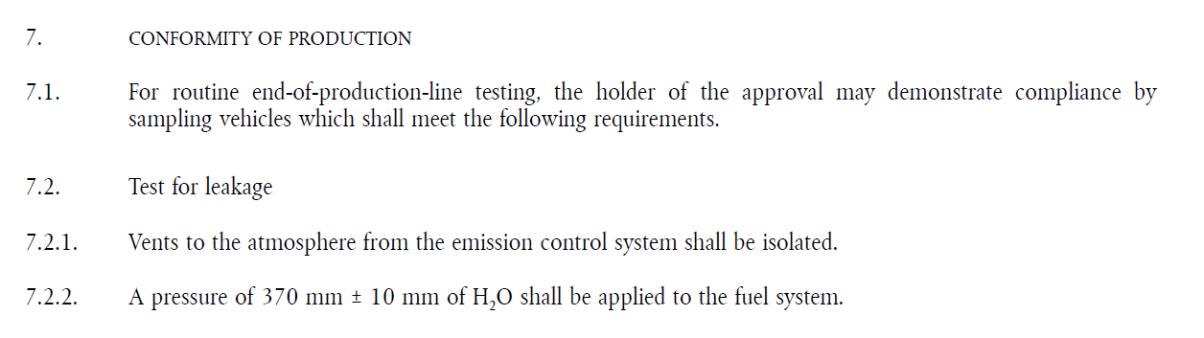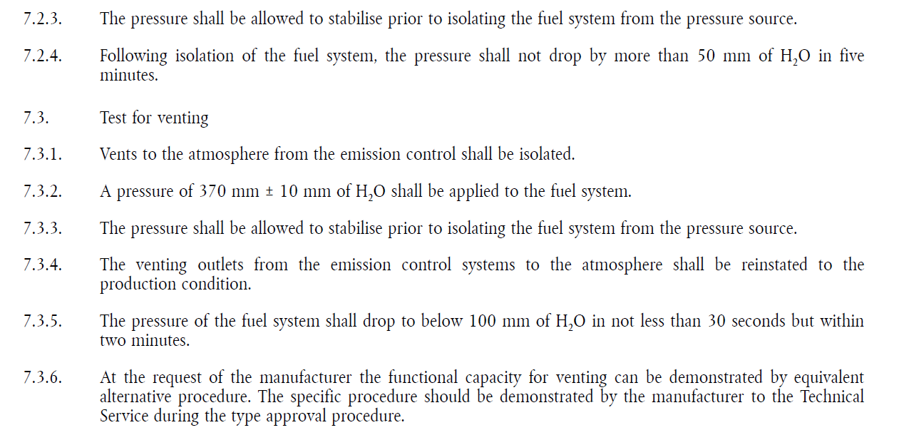
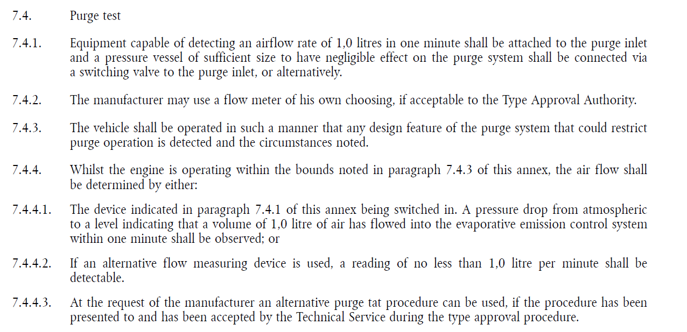

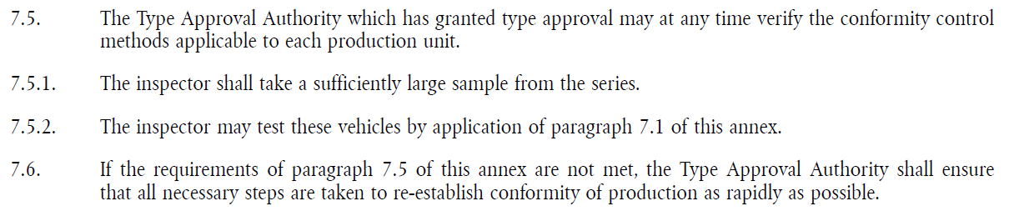

i.e. the EVAP family <TBD>

