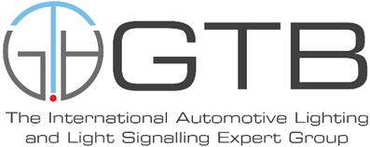
SLR-33-02

Proposal for an amendment to
UN Regulation No. 148 (Light Signalling Devices)

I. Proposal:
Paragraph 5.6.1., amend to read:
“5.6.1. Luminous intensity:
The light emitted by each of the two samples supplied shall meet the requirements in Table 8 where the minimum luminous intensities shall be fulfilled:
(a) In the case of direction indicators of categories 1, 1a, 1b, 2a, 2b, 11, 11a, 11b, 11c and 12 in the reference axis; or
(b) in the case of direction indicators of categories 5 and 6 in direction A according to Annex 2.
Table 8: Luminous intensities for direction indicator lamps
 | Minimum luminous intensity in HV (values in cd) | Maximum luminous intensity in any direction when used as (values in cd)
 |  | A single lamp | A lamp marked "D" (paragraph 3.3.2.5.2.)
1 | 175 | 1200 1000 | 600 500
1a | 250 | 1200 | 600
1b | 400 | 1200 | 600
2a (steady) | 50 | 500 | 250
2b (variable) | 50 | 1000 | 500
5 | 0.6 | 280 | 140
6 | 50 | 280 | 140
11 | 90 | 1200 1000 | N.A.
11a | 175 | 1200 1000 | N.A.
11b | 250 | 1200 | N.A.
11c | 400 | 1200 | N.A.
12 | 50 | 500 | N.A.
“

II. Justification:
- Regulation No. 48 and Regulation No. 53 prescribe the use of specific categories of front direction indicators in relation to their distance from the dipped beam headlamp or front fog lamp. However, the text is such that the higher categories, like 1a, 1b, 11b and 11c are allowed to be used also at any distance greater than the minimum prescribed for each of them.
- As a consequence of the above-mentioned amendment, there is no reason to require a lower maximum value for the category 1 or category 11 and 11a front direction indicators than that of the other categories. Therefore, it is proposed to align the maximum luminous intensity value of category 1 to that of categories 1a and 1b and those of categories 11 and 11a to those of 11b and 11c.

