Annex X
Submitted by FR and GER
Submitted by the EC
Test Specifications for Automated Lane Keeping Systems (ALKS)
1. General
This annex defines tests with the purpose to verify the technical requirements on Automated Lane Keeping Systems (ALKS).
Pass- and Fail-Criteria for tests are derived solely from the technical requirements in section 2 of the regulation. These requirements are worded in a way that they allow the derivation of pass-fail-criteria not only for a given set of test parameters, but for any combination of parameters in which the system is designed to work (e.g. operating speed range, operating lateral acceleration range, curvature range as contained in the operational design domain).
The test specifications in this document are meant to be a minimum set of tests, the technical service authorities may perform any other test within the operational design domain and may then compare the measured results against the requirements (concrete: expected test outcome).
The process for a technical service to perform approval tests shall fulfill the following points :
- Imposed scenarios : each scenario of the current annex shall be tested
- Imposed parameters sets : for each scenario of the previous point and for each target (if applicable), a minimum of two parameter sets in accordance with the specified parameters and corresponding to each intended situation (regular maneuver, emergency maneuver, not avoidable) shall be tested (if applicable).
- Random scenarios and parameters : in addition to the previous point, a minimum of [10] additional tests shall be performed with different parameters sets or scenarios not already covered in this annex.
- Critical scenarios and parameters : included into the minimum of [10] tests from the previous random scenarios and parameters, the technical service can defined specific scenarios or parameters tests in order to adapt it to the dedicated system to be approved.
While all defined test cases can be conducted with state of the art equipment such as surrogate targets and moving platforms, some extreme test parameters might require the use of real vehicles (preferably in a driverless test setup to not endanger the staff carrying out the tests).

2. Definitions
For the purposes of this annex,
2.1. “Time to Collision" (TTC) : means the value of time obtained by dividing the longitudinal distance (in the direction of travel of the subject vehicle) between the subject vehicle and the target by the longitudinal relative speed of the subject vehicle and the target, at any instant in time
2.2. “Offset” means the distance between the vehicle’s and the respective target’s longitudinal median plane in driving direction, measured on the ground, normalized by the half the vehicle width excluding devices for indirect vision and corrected by adding 50 %.
2.3. “Pedestrian Target” : means a soft target that represents a pedestrian
2.4. “Vehicle Target” : means a target that represents a vehicle
2.6. “Powered Two-Wheeler Target” : means a combination of a motorcycle and motorcyclist, a test device according to ISO [CD] 19206-5. The reference point for the location of the motorcycle shall be the most backward point on the centreline of the motorcycle
2.7 “v_{max}” The maximum speed the automated lane keeping system is able to operate with.
2.8. “Road user” is any vehicle including Two-Wheelers which are permitted to use the road the ALKS is able to operate on.

3. Test Area
3.1. Except otherwise noted, all tests shall be carried out on a road that is recognized and classified as an authorised road by the ALKS.
3.2. Except otherwise noted, tests should be carried out on a clearly marked lane that conforms to the requirements from section XXX and the operational design domain of the vehicle. In the case of lane positioning tests in section X, X, X, the marked lane shall have a width of no less than 3.5 m between the lane markings.
3.3. Except otherwise noted, the test surface shall provide a friction that is not lower than the friction which is specified in the operational design domain.
3.4. The lane shall have a sufficient long straight section (curvature 0 1/m) and a curved section with a curvature not higher than the curvature specified in the operational design domain.

4. Functional Tests
The functional or dysfunctional requirements must be tested by the technical service.
The verifications can be done by simple observations (test ok or not ok), or by test with single measurements based on the associated requirements.
The following requirements shall be verified by physical evaluations during the approval process :
Paragraphs | Topic
6.2.1 | Dedicated means to activate and deactivate
6.2.2. | Default status of new engine start/run
6.2.3a | System active if driver is in driver seat & belt is fastened
6.2.3b | System active if driver is available
6.2.3c | System active if no failure
6.2.3d | System active if DSSAD is operational
6.2.4a | Same dedicated means to activate and deactivate manually
6.2.4b | Means of desactiving protected against unintentional action
6.2.4c | At time of desactivation driver must be in lateral control
6.2.5.1 | Desactivation by input to driving controls
6.2.5.2 | Desactivation during an ongoing transition demand
6.2.5.4 | Desactivation in case of severe failure
6.1.2. | Driver presence
6.1.3.1. | Criteria for deeming driver availability
6.3.1.1. | Driver attentiveness
6.1.4. | Other activities than driving task

5. Tests for the dynamic driving function
The tests specified in this section are meant to be the minimum set of tests required for type approval. If this is deemed justified, the technical service or the relevant authorities may perform additional tests with other parameters as long as the parameters are included in the operational design domain of the vehicle, except where it is clearly noted.
Pass-fail-criteria for these additional tests shall be calculated using the performance requirements in the referenced paragraphs. This also includes performing tests at different environmental or friction conditions that are contained in the operational design domain.
The manufacturer shall demonstrate through appropriate documentation that these conditions are fulfilled throughout the ALKS operation range and all ODD. This may be achieved on the basis of appropriate documentation appended to the test report.
5.1. Overriding test
The vehicle shall be driven in a curved lane at the constant speed v_{max} with the aim to approach the maximum lateral acceleration as specified by the manufacturer with the automated lane keeping function activated and the vehicle driver having the hands and feet off the vehicle controls.
The driver shall then apply a force on the concerned driving control(s) (steering, accelerator and/or barking depending on the system definition) to override the automated lane keeping function and leave the lane. The force applied by the driver on the driving control, synchronized to the status of the automated lane keeping function, shall be recorded.
The overriding test is passed if the requirements from paragraph 6.2.5.1. above are fulfilled.
5.2. Lane keeping functionality tests
5.2.1. Lane keeping and stability test
The vehicle shall be driven in a lane at the constant speed v_{max} with the automated lane keeping function activated and the vehicle driver having the hands and feet off the vehicle controls for a time of not less than [5] minutes. The lane shall have curved and straight sections with the aim to approach the maximum lateral acceleration of the automated lane keeping function.
The test is passed if the vehicle’s lane position fulfils the requirements of paragraph 5.2.1. above, especially if no parts of the vehicle, including it’s devices for indirect vision, pass the outside edge of the lane markings, and if no noticeable oscillation of the lateral position is present. [This can be determined e.g. by checking if a dedicated peak in the frequency range from [0.1] to [5] Hz for any given window of [10] seconds of the power spectral density diagram of the lateral position or lateral acceleration is observed.]
5.2.2. Test for object avoidance in the lane
An object with a size small enough for the vehicle to pass without leaving the lane but large enough to assume damage to the vehicle shall be positioned in the lane, such as an object of a size of [118 x 78 x 80 cm].
The vehicle shall be driven in a lane at the constant speed v_{max} with the automated lane keeping function activated and the vehicle driver having the hands and feet off the vehicle controls, towards the object. There shall be no other vehicles in adjacent lanes.
The test is passed if the requirements from paragraph 5.2.1.., 5.2.2. and 5.2.5.1.. are fulfilled, especially if no collision between vehicle and object occurs.
The test shall be carried out on straight as well as curved sections of the track, with the curved sections chosen in a way to reach the maximum lateral acceleration as specified by the manufacturer.
5.2.3. False reaction test
An object with a size too small to assume damage to the vehicle but with a size large enough to be detectable by the vehicle’s sensors shall be positioned in the lane, such as an object of a size of [200 x 80 x 0.03 m].
The vehicle shall be driven in a lane at the constant speed v_{max} with the automated lane keeping function activated and the vehicle driver having the hands and feet off the vehicle controls, towards the object. There shall be no other vehicles in adjacent lanes.
The test is passed if no noticeable intervention of the automated lane keeping system occurs.
The test shall be carried out on straight as well as curved sections of the track, with the curved sections chosen in a way to reach the maximum lateral acceleration as specified by the manufacturer.
5.3. Interaction with a preceding vehicle
5.3.1. Following distance test
The vehicle shall be driven in a lane with varying curvatures as specified in the operational design domain, with the automated lane keeping function activated and the vehicle driver having the hands and feet off the vehicle controls, and with a preceding target, for at least [3] minutes per parameter combination.
The preceding target shall have the characteristics as defined below and shall be driven at the constant speeds and with offsets as defined below, as well as with a realistic speed profile, including accelerations, decelerations and full stops.with a deceleration level below [2] m/s² for a time longer than [3] minutes.
This speed profile shall selected from the [WLTP reference database*], according to the following algorithm:
- Filtering the database of short trips according to defined parameter values (v_{max} between [50] and [60] km/h, a_{max} [2] m/s², a_{min} [-2] m/s²)
- Performing a weighted random selection of the short trip from the filtered list, according to a weighting function [v_{average} x a_{positive, average}], normalised by the sum of all the values, so that the total probability is 1.
- If the selected short trip has a duration below [3] minutes, more short trips shall be added until the total cycle duration reaches the minimum prescribed value.

At least [two] combination of the following characteristics shall be performed for each target:
- Constant speed: 10 km/h, v_{max}, 0.5 x v_{max}, speed profile
- Target characteristics: Vehicle, Powered Two-Wheeler,
- Offset: 50%, 25%, 75%
The test is passed if the requirements of paragraph 5.2.3.3. above are fulfilled at all times.
5.3.2. Following stability test
The vehicle shall be driven with v_{max} in a straight lane with the automated lane keeping function activated and the vehicle driver having the hands and feet off the vehicle controls, and with a preceding vehicle.
The preceding vehicle shall perform a swerving motion with an amplitude of [10°] heading angle and a peak yaw rate of [1°/s] for not less than [1] minute.
The test is passed if the vehicle’s lane position fulfils the requirements of paragraph 5.2.1. above, especially if no parts of the vehicle, including it’s devices for indirect vision, pass the outside edge of the lane markings, and if no noticeable oscillation of the lateral position is present. [This can be determined e.g. by checking if a dedicated peak in the frequency range from [0.1] to [5] Hz for any given window of [10] seconds of the power spectral density diagram of the lateral position or lateral acceleration is observed.]
5.3.3. Preceding vehicle severe braking test
The vehicle shall be driven in a lane with varying curvatures as specified in the operational design domain, with the automated lane keeping function activated and the vehicle driver having the hands and feet off the vehicle controls, and with a preceding target, for at least [1] minute. The preceding target shall be driven at the constant speeds and with offsets as defined below, as well as with a realistic speed profile, including accelerations, decelerations and full stops. At time t₀ the preceding target will perform a deceleration manoeuvre with a mean fully developed deceleration of 6 m/s² until standstill.
The speed profile and the time at which the deceleration starts shall be selected according to the following algorithm:
  - Selection of the speed profile as described in 5.3.1.
  - Weighted random selection of the time of start of deceleration t₀ (which defines also the corresponding lead vehicle speed and acceleration v₀ and a₀) from the selected speed profile, according to a weighting function [v x (1 + abs(a)], normalised by the sum of all the values, so that the total probability is 1.

- At least [two] combination of the following characteristics shall be performed for each target:Constant speed: 10 km/h, v_{max}, 0.5 x v_{max}, , speed profile
- Target characteristics: Vehicle, Powered Two-Wheeler,
- Offset: 25%, 50%, 75%
The test is passed if the requirements of paragraph 5.2.5.1. above are fulfilled at all times.
5.4. Interaction with road users and objects in the lane
5.4.1. Stationary road user or blocked lane test
A stationary target with the characteristics as specified below and with an offset specified below shall be positioned in a lane with the curvature as specified below.
The vehicle shall be driven with v_{max} in the lane with the automated lane keeping function activated and the vehicle driver having the hands and feet off the vehicle controls, without any preceding vehicles or vehicles in the adjacent lanes, and with an initial time to collision with respect to the road user of not less than [10] seconds.
- At least [two] combination of the following characteristics shall be performed for each target:Curvature: 0 1/m, curvature to achieve the maximum lateral acceleration or maximum curvature, whichever is lower,
- Target characteristics: Vehicle, Powered Two-Wheeler, blocked lane
- Offset: 25%, 50%, 75% (25% and 75% not for blocked lane).
The test is passed if the requirements of paragraph 5.2..4.1. above are fulfilled (especially: collision avoidance without emergency manoeuvre).
5.4.2. Large obstacle test
An obstacle with a size so as to assume severe damage to the vehicle, such as a vehicle parked orthogonal to the direction of traffic shall be positioned in a lane with the curvature as specified below.
The vehicle shall be driven with v_{max} in the lane with the automated lane keeping function activated and the vehicle driver having the hands and feet off the vehicle controls, without any preceding vehicles or vehicles in the adjacent lanes, and with an initial time to collision with respect to the road user of not less than [10] seconds.
At least [two]combinations of the following characteristic shall be performed:
- Curvature: 0 1/m, curvature to achieve the maximum lateral acceleration or maximum curvature, whichever is lower.
The test is passed if the requirements of paragraph 5.2..5.1. above are fulfilled (especially: collision avoidance, emergency manoeuvre permitted).
[5.4.3. Crossing pedestrian test
A pedestrian test in a straight and curved lane shall be carried out according to Regulation (UN) Nr. 152-01, paragraph 5.2.2.4., where the vehicle shall be driven with v_{max} in the lane with the automated lane keeping function activated and the vehicle driver having the hands and feet off the vehicle controls.
The test is passed if the requirements from paragraph 5.2..5.3. above are fulfilled.]
[5.4.4. Pedestrian crossing in slow traffic
A pedestrian test in a straight and curved lane shall be carried out according to Regulation (UN) Nr. 152-01, paragraph 5.2.2.4., where the vehicle shall be driven in the lane preceding for another vehicle that come to a stop and then starts to move from 0 to 10kph with an acceleration not over 2m/s² with the automated lane keeping function activated and the vehicle driver having the hands and feet off the vehicle controls. At the moment that the preceding vehicle strats to move, the pedestrian start to cross the lane with the exception that the pedestrian shall be an adult pedestrian
The test is passed if the requirements from paragraph 5.2..5.3. above are fulfilled.]
5.5. Interaction with vehicles intruding into the lane
5.5.1. Cut-In Tests
The vehicle and a target vehicle shall be travelling parallel and in the same direction, both on individual marked lanes and with their individual longitudinal speeds as shown in the figure below, in stationary conditions for at least [10] seconds.
The offset between lane centre and longitudinal axis of the vehicle shall be chosen by the ALKS, the target shall be travelling initially with an offset to the vehicle’s lane centre equal to the lane width as shown in the table below.
The vehicle shall be driven with the speed as shown in the following table, in the lane with the automated lane keeping function activated and the vehicle driver having the hands and feet off the vehicle controls.
When the longitudinal distance between the vehicles has reached a distance corresponding to the Time-To-Collision value as shown in the table below, the target shall perform a lane change, the desired trajectory for the target being composed of two segments of equal duration with the same constant lateral acceleration demand, but opposed signs. The total lane change distance shall be the initial offset between the target’s longitudinal axis and the vehicle lane’s centre plane.
Resulting from the defined manoeuvre, the target shall enter the vehicle’s lane at the time t_{tC,Intrusion}.
During the test, all movement variables shall be recorded, and the value for t_{tC,intrusion} shall be calculated.

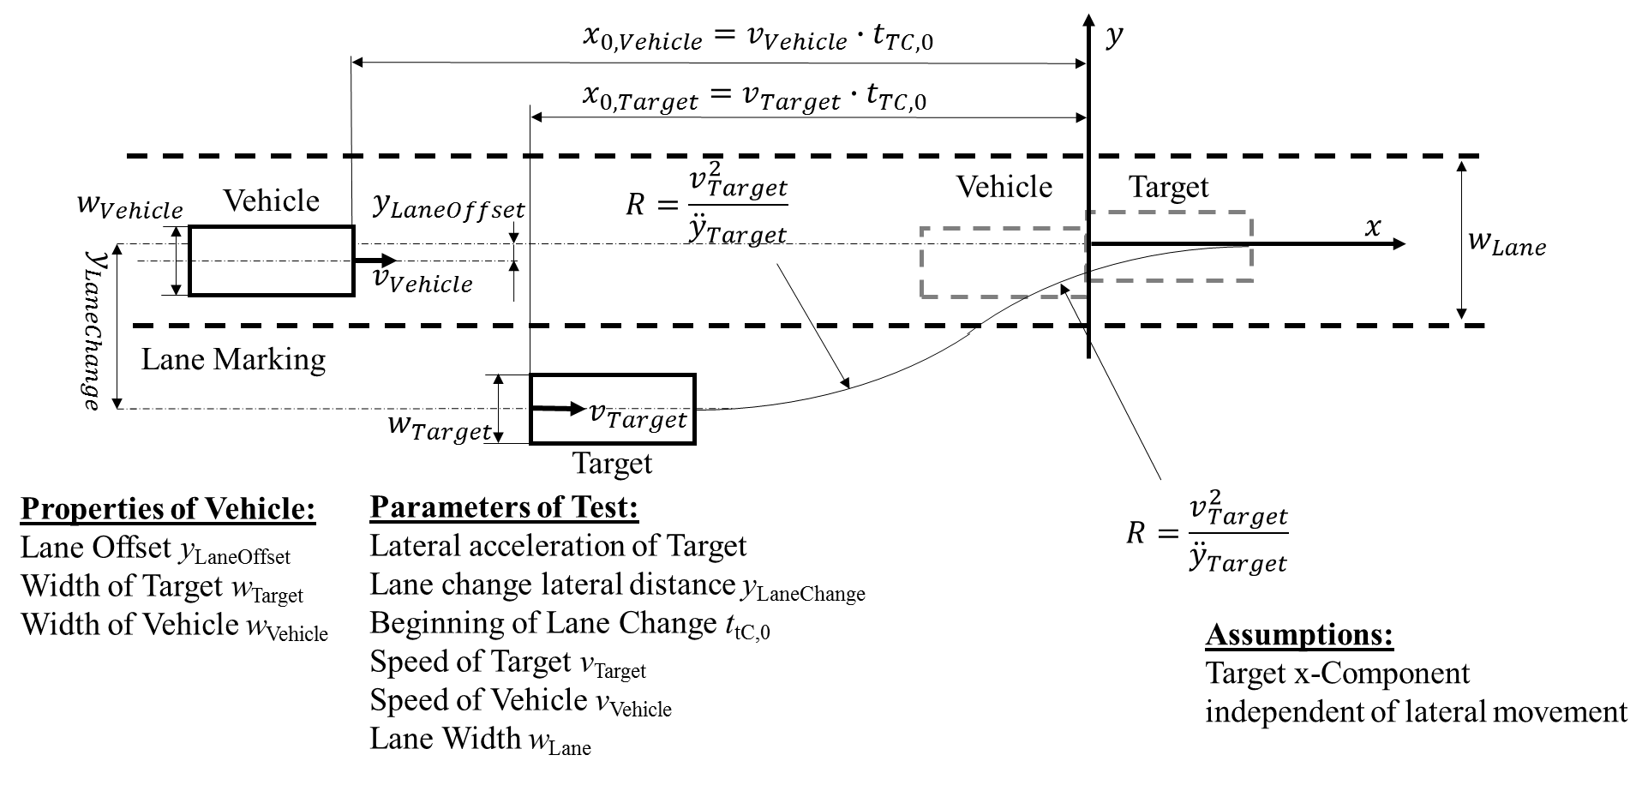
Tests shall be performed according to the parameters as shown in the table below. Each test is passed when the requirements of paragraph 5.2.4.2. and 5.2.5.2. (avoidance as function of t_{tC,intrusion}) are fulfilled.
The tests shall all be performed with a vehicle target and a powered two-wheeler target. Additionally the tests may be performed on a curved track with any curvature as specified in the operational design domain.
Test Case | 1 | 2 | 3 | 4 | 5
v_{Vehicle} [km/h] | 50 | 60 | 60 | 30 | 45
v_{Target} [km/h] | 10 | 50 | 10 | 15 | 40
Lateral acceleration of target [m/s²] | 0,5 | 1,5 | 3 | 3 | 1
Lane Width [m] | 3,5 | 3,5 | 3,5 | 3,5 | 3,5
t_{tC,0} [s] | 3 | 2,5 | 2,6 | 2,5 | 1,5

5.5.2. Cut-Out Tests
The vehicle and a preceding target vehicle shall be travelling in the same lane with the speed of the target vehicle v_{Target} with a maximum of v_{max}, in stationary conditions for at least [10] seconds. The vehicle shall be driven with the automated lane keeping function activated and the vehicle driver having the hands and feet off the vehicle controls.
The offset between lane centre and longitudinal axis of the vehicle as well as the distance between vehicle and target shall be chosen by the ALKS.
A second target object as specified in the table below shall be positioned in the lane sufficiently ahead and being approached by the target vehicle.
When the longitudinal distance between the target vehicle and the second, stationary target has reached a distance corresponding to a time-to-collision value as specified below, the target shall perform a lane change, the desired trajectory for the target being composed of two segments of equal duration with the same constant lateral acceleration demand, but opposed signs, chosen in a way to fulfil the Time-To-Collision value and so as to have no collision between the target vehicle and the second, stationary target. The total lane change distance shall be the initial offset between the target’s longitudinal axis and the vehicle lane’s centre plane.
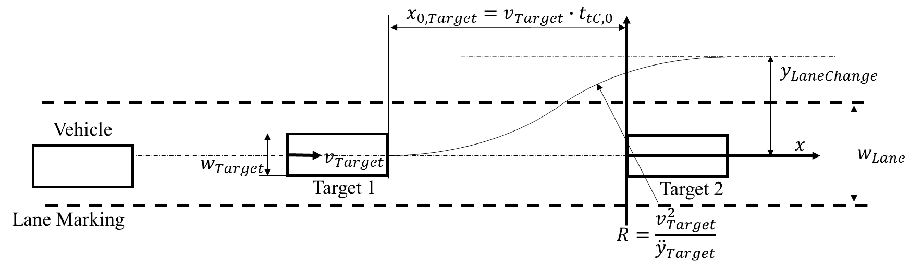
At least [two] combination of the following characteristics shall be performed for each target:
- Speeds: 10 km/h, 0.5 x v_{max}, v_{max},
- TTCs: 1.5 s, 2 s , 3 s,
- Peak lateral acceleration of 1 , 2, 3 m/s².

The test is passed if the requirements from paragraph 5.2.5.1. are fulfilled (especially there shall be no collision between vehicle and the second, stationary target).

