SLR-35-10/Rev.1

Proposal to correct Annex 24 of UN Regulation No. 150 (RRD)

Annex 24
Examples of approval marks

Figure A 24-I

Marking examples for single devices
Note: The above approval number must be placed close to, but in any position in relation to, the circle surrounding the letter "E". The digits constituting the approval number must face the same way as the "E". The group of symbols indicating the class must be diametrically opposite the approval number. The Type Approval Authorities shall avoid using approval numbers IA, IB, IIIA, IIIB and IVA which might be confused with the class symbols IA, IB, IIIA, IIIB and IVA.
These sketches show various possible arrangements and are given as examples only.
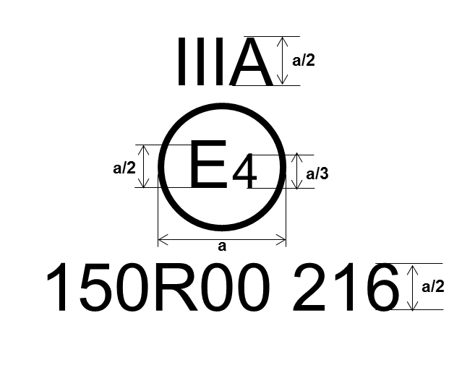 | Model A:  This The above approval mark affixed to a retro-reflective device shows that the type of device concerned has been approved in the Netherlands (E 4) under approval number 150R00-02216. The approval number shows that approval was granted in accordance with the requirements of theis Regulation as modified by the original 02 series of amendments.  For a = see Table 1
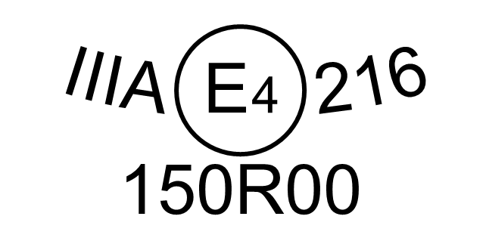 | Model B:  Same device as Model A, different arrangement.
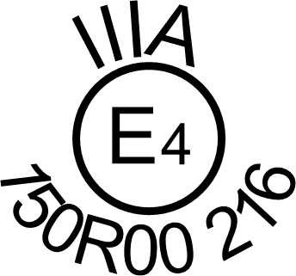 | Model C:  Same device as Model A, different arrangement.
a = see Table 2

Figure A24-II

Simplified marking examples for grouped, combined or reciprocally incorporated devices
Note: The three two examples of approval marks, models D and E and F, represent three possible variants of the marking of a lighting device when two or more lamps are part of the same unit of grouped, combined or reciprocally incorporated lamps.
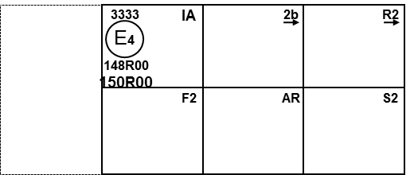 | Model D:
 | Model E:

Figure A24-III

Arrangement example of the approval mark for retro-reflective marking material
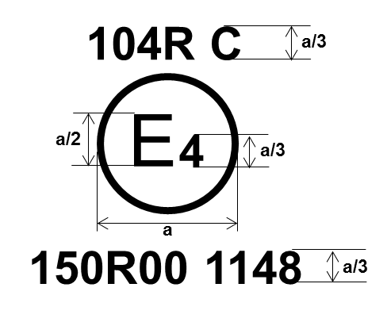
For a = see Table 1

Figure A24-IV

Arrangement of the approval mark for rear marking plates and SMV
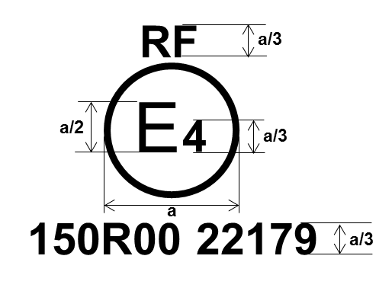
For a = see Table 1

Figure A24-V

Arrangement of the approval mark for advance warning triangle
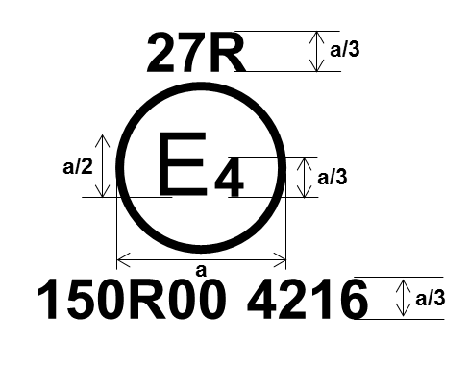
For a = see Table 1

