Submitted by leader of SG1a | Document: VMAD-05-03
Proposal for traffic disturbance test scenarios for ALKS

Annex X

Traffic disturbance test scenarios for ALKS

1. Introduction
--Why--
Validation and Verification of ADS (automated driving systems) safety requires a combination of processes and tools able to assess how the different elements of the complete system contribute to the safety of its operations in real world conditions. Traffic disturbance test scenarios define one set of test scenarios, reflecting boundary conditions which is to comply with all relevant traffic rules in the country of operation and is appropriate in the current situation in executing the dynamic driving task, and not to cause any collision which is rationally foreseeable and preventable as defined in paragraph 2.3.3 and paragraph 2.3.4 ., in which the vehicle’s operations are tested before its introduction in the market.

--What--
When validating overall performance of ADS, it is necessary to confirm that ADS shall not cause any traffic accidents resulting in injury or death that are rationally foreseeable and preventable under traffic conditions in the real world.
Rationally foreseeable scenarios are those logically derived from empirical traffic monitoring data.
As a first step, boundary conditions to divide rationally foreseeable scenarios for traffic disturbance testing into preventable and unpreventable scenarios are defined based on state of the art technologies and should be at least at the level of skilled human driver level without any human errors supported by state-of-the-art vehicle driver assistant technologies. With preventable scenario's, we mean the range of scenario's where the validation should prove that automation does not result in an accident which would have been prevented by an skilled human driver.
Besides, this common understanding as the first step for boundary condition for ADS is favorable to be harmonized internationally.

--How--
Traffic disturbance test scenarios check the safety of the intended functionality and are used for simulation and test-track validation/verification, but not for real-road testing.
Traffic disturbance test scenarios deal with the safety validation of ADS functions on judgement and manoeuvre, given that ADS function on perception and vehicle dynamic performance are working as designed for. Therefore, it is necessary to check system function on perception (whether or not surrounding vehicles within the range of defined parameters can be detected) and vehicle dynamic performance separately.
Traffic disturbance test scenarios are logically derived by combining a number of relevant properties, taken from disjunct layers describing the scenario space systematically.
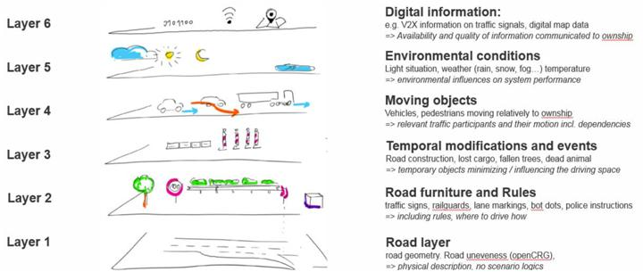
Disjunct layers used to logically derive concrete scenarios

2. Traffic disturbance test scenarios
The traffic disturbance test scenarios applicable to ALKS only include the Main roadway as the Road geometry (Layer 1), only lane keep as the Ego vehicle behavior, and the cut in, cut out and deceleration as the other vehicle‘s manoeuvre (Layer 4).
2.1. Other Vehicle’s Manoeuvre
Cut in | 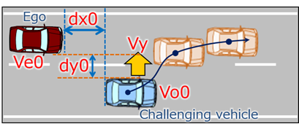
Cut out | 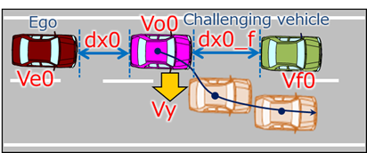
Deceleration | 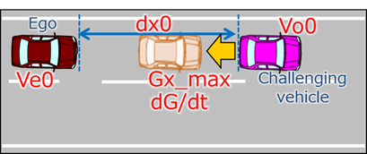

2.2. Parameter:
Initial condition | Initial velocity | Ve0 = Ego vehicle
 |  | Vo0 = Leading vehicle in lane or in adjacent lane
 |  | Vf0 = Vehicle in front of leading vehicle in lane
 | Initial distance | dx0 = Distance in Longitudinal direction between ego and leading vehicle in lane or in adjacent lane
 |  | dy0 = Inside Lateral distance between outside edge line of ego vehicle in parallel to the vehicle's median longitudinal plane within lanes and outside edge line of another vehicle in parallel to the vehicle's median longitudinal plane in adjacent lines.
 |  | dx0_f = Distance in longitudinal direction between front end of leading vehicle and rear end of vehicle in front of leading vehicle
Vehicle motion | Lateral motion | Vy = Lateral velocity
 | Deceleration | Gx_max = Maximum deceleration G
 |  | dG/dt = Deceleration rate

2.3. Driver model
In low-speed ALKS scenario, the avoidance capability required for the driver model is braking control only. This driver model is separated into the following three segments: “Risk perceive situation”, “Delay in time”, and “Deceleration degree and Max. G-force

Driver basic model for Cut in / Cut out / Deceleration
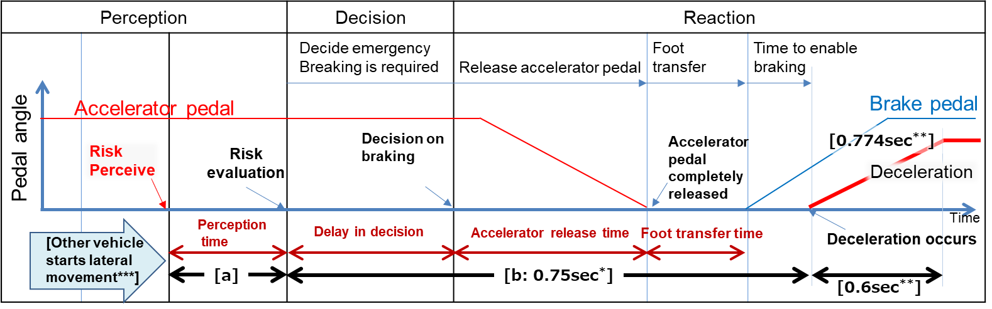
Note: [a] depend on each scenario
_________________________________________________________________
[*/ = 0.75sec is a common data in Japan.
**/ = 0.6sec and 0.774G are a data from experiments of NHTSA and Japan. (Coefficient of road friction is 0.6.)
***/= Timing of other vehicles start moving from lane keep to cut-in (or cut-out). It is indicated by lateral movement distance.]

-For Cut in scenario:
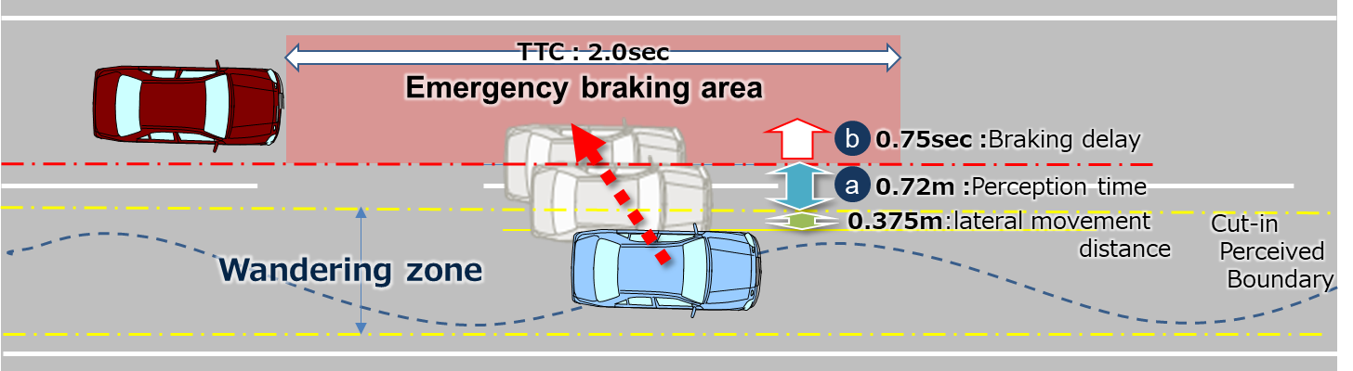
[0.375m] is lateral movement distance of side vehicle when it starts lateral movement.
The Cut-in perceived boundary is defined by the distribution of lateral movement distance of side vehicles (without lane change).
[a] is perception time. Risk perceived position of side vehicle is determined by lateral movement speed of it. [a] from the following formula;
[a:0.72m] = (Max lateral movement speed: 1.8m/s) x (Risk evaluation delay time: 0.4sec)
Max lateral movement speed is real world data in Japan.
Risk evaluation delay time is driving simulator data in Japan.
It specified [2sec*] as the maximum Time To Collision (TTC) to define the danger perception area in longitudinal direction.
[*/=TTC 2.0sec is based on the UNR guidelines on warning signals.]

-For Cut out scenario:
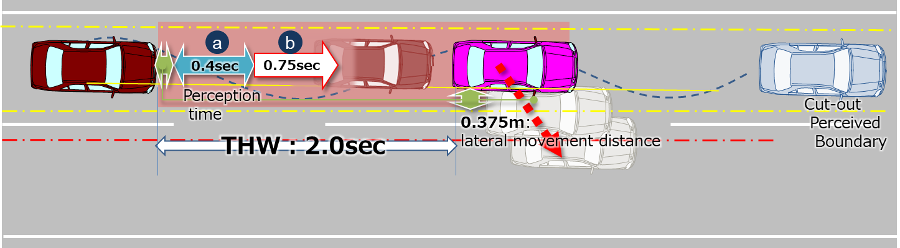
[0.375m] is lateral movement distance of leading vehicle when it starts lateral movement.
This parameter is skilled human driver that assumes a critical situation when leading vehicle moves [0.375m].
[a:0.4sec] is perception time (= delay in risk evaluation). Risk perceived position of side vehicle is determined by lateral movement speed of it.
It specified [2sec**] as the maximum Time Head Way (THW) to define the danger perception area in longitudinal direction.
[**/=THW 2.0sec is according to other countries’ regulations and guidelines.]

-For Deceleration scenario:
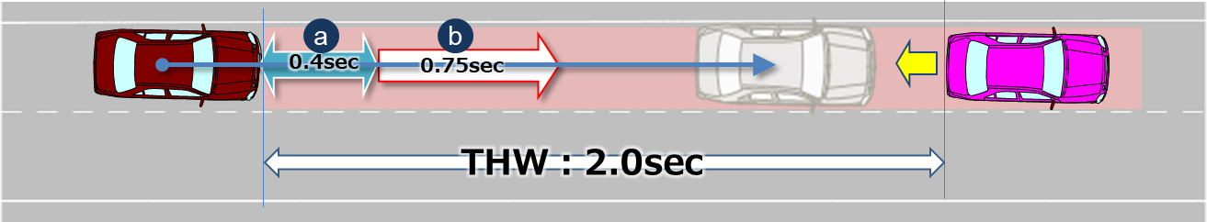
[a:0.4sec] is delay in perception (= Risk evaluation delay time). Risk perceived timing of leading vehicle is determined by deceleration rate of it.

2.4 Data sheet
Data sheet for checking if ADS avoid collision within any combination of each parameter within the vehicle speed which ALKS is enable to work.

2.4.1 Cut in
(Data sheets image)
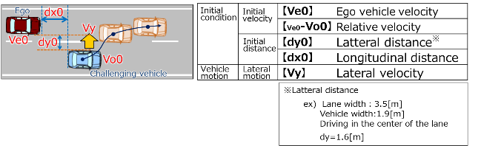
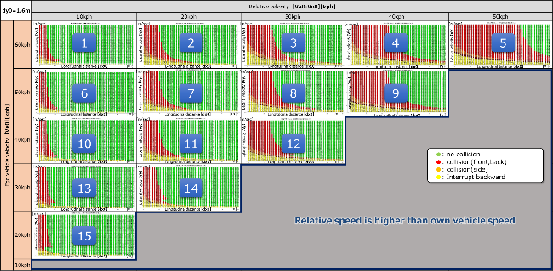

Ve0：60[kph]
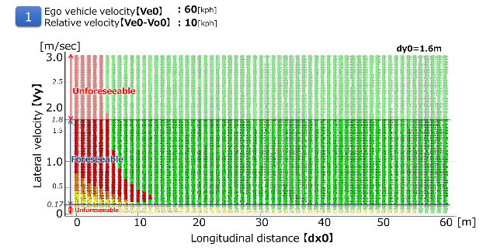

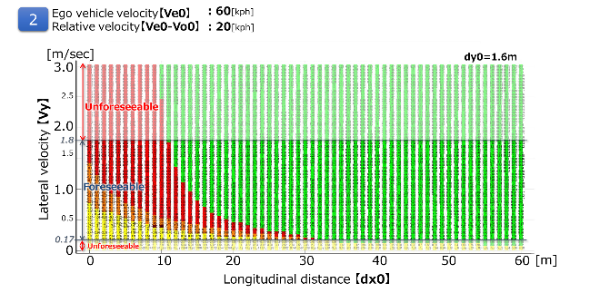
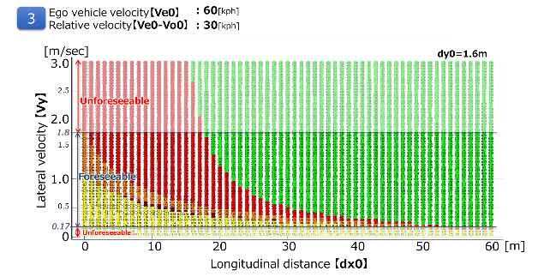

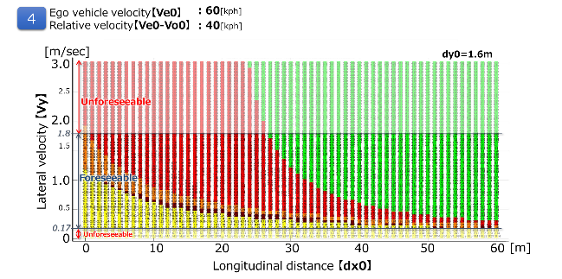

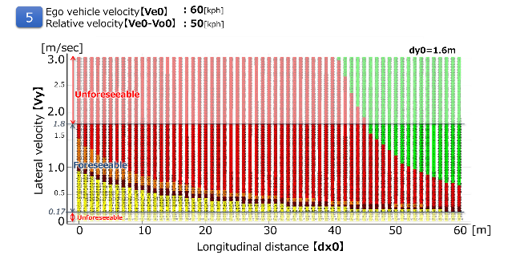

Ve0：50[kph]
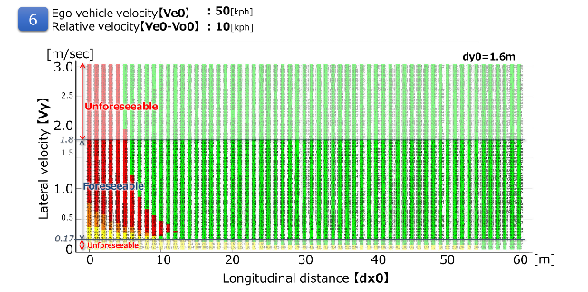

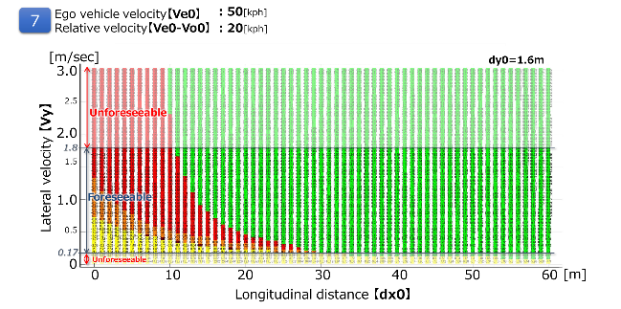

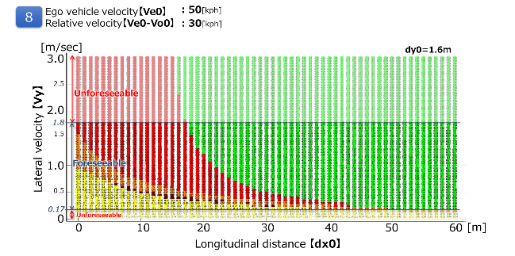

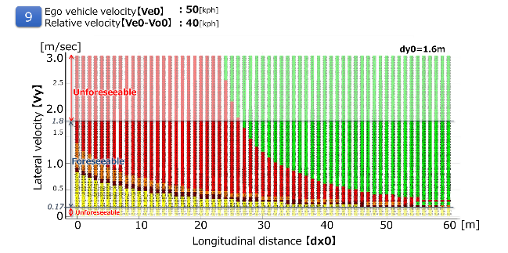

Ve0：40[kph]
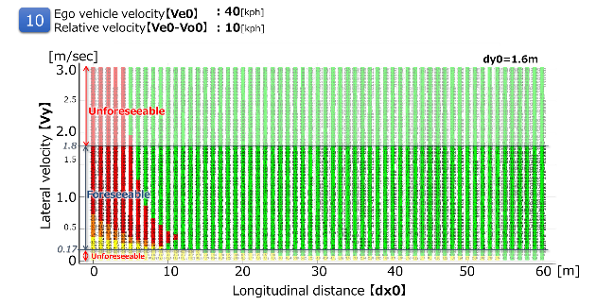

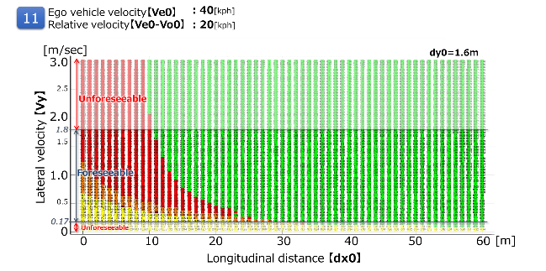

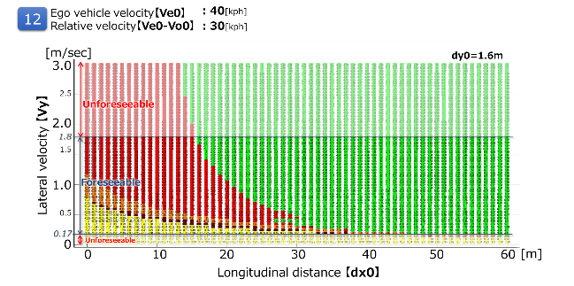

Ve0：30[kph]
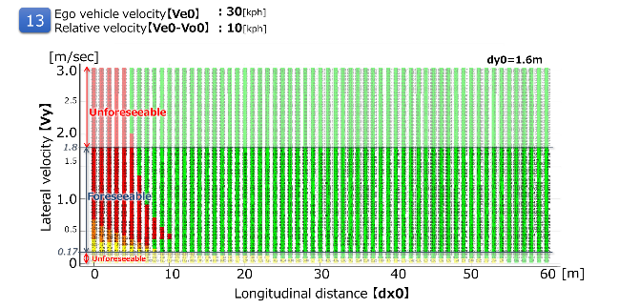

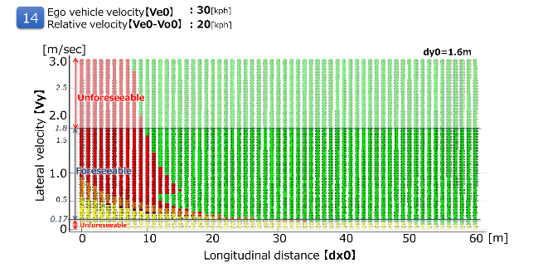

Ve0：20[kph]
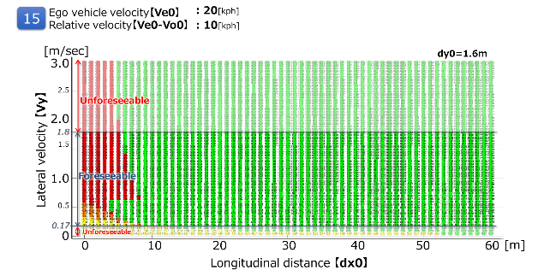

2.4.2 Cut out
It is possible to avoid all the deceleration (stop) vehicles ahead of the preceding vehicle cut-out in the following running condition at THW 2.0 sec.
(Data sheets image)
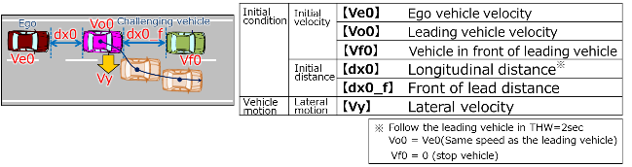
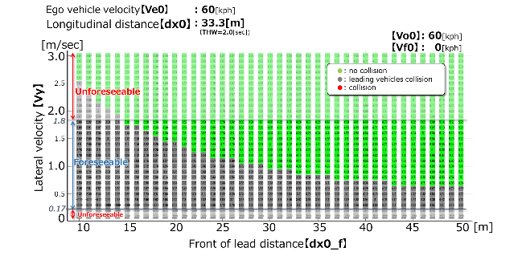
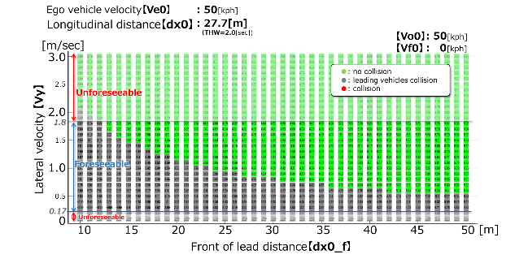
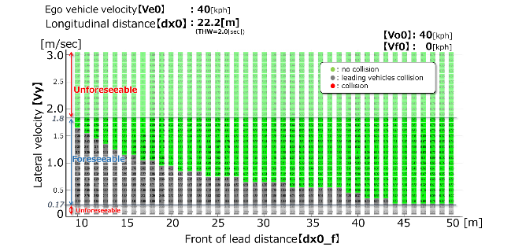
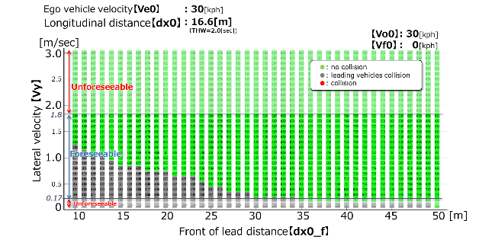
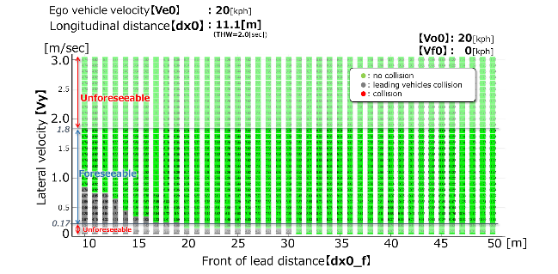
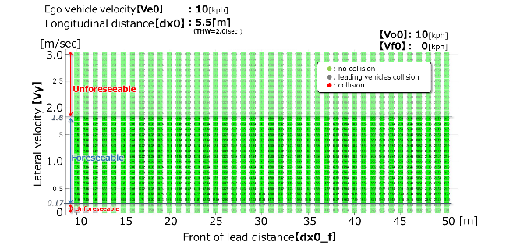

2.4.3 Deceleration
It is possible to avoid sudden deceleration of -1.0G or less in the follow-up driving situation at THW 2.0sec.
(Data sheet image)
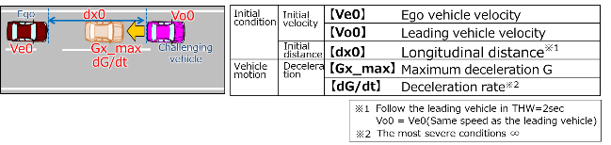
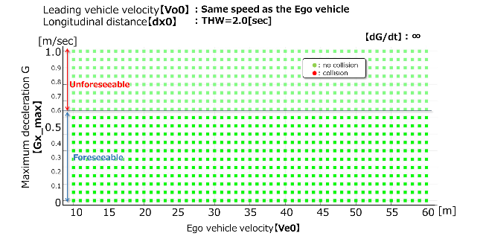
TBD

