Sub-Annex 1
Pure electric and hybrid electric vehicles
1. General requirements

Unless stated otherwise, all requirements in this sub-annex shall apply to vehicles with and without driver-selectable modes. Unless explicitly stated otherwise in this sub-annex, all of the requirements and procedures specified in Annex 6 and Annex 7 shall continue to apply for NOVC-HEVs, OVC-HEVs and PEVs.
1.1. Units, accuracy and resolution of electric parameters
Units, accuracy and resolution of measurements shall be as shown in paragraph 1.1. of annex 8.
[Table A8/1 Reserved]

[Table A8/2 Reserved]
1.2. Emission and fuel consumption testing
Parameters, units and accuracy of measurements shall be the same as those required for pure ICE vehicles.
1.3. Rounding of test results
1.3.1. Unless intermediate rounding is required, intermediate steps in the calculations shall not be rounded.
1.3.2. In the case of OVC-HEVs and NOVC-HEVs, the final criteria emission results shall be rounded according to paragraph 1.3.2. of Annex 7.,
1.3.3. For information not related to standards, good engineering judgement shall be used.
1.3.4. Rounding of range, CO₂, energy consumption and fuel consumption results is described in the calculation tables of annex 8.
1.4. Vehicle classification
All OVC-HEVs, NOVC-HEVs and PEVs shall be classified as Class 3 vehicles. The applicable test cycle for the Type 6 test procedure shall be determined according to paragraph 1.4.2. of this sub-annex based on the corresponding reference test cycle as described in paragraph 1.4.1. of this sub-annex.
1.4.1. Reference test cycle
1.4.1.1. The Class 3 reference test cycles are specified in paragraph 3.3. of Annex 1.
1.4.1.2. For PEVs, the downscaling procedure, according to paragraphs 8.2.3. and 8.3. of Annex 1, [may] be applied on the test cycles according to paragraph 3.3. of Annex 1 by replacing the rated power with maximum net power according to UN Regulation No. 85. In such a case, the downscaled cycle is the reference test cycle.
1.4.2. Applicable test cycle
1.4.2.1. Applicable WLTP test cycle
The reference test cycle according to paragraph 1.4.1. of sub-this annex shall be the applicable WLTP test cycle (WLTC) for the Type 6 test procedure.
In the case that paragraph 9. of Annex 1 is applied based on the reference test cycle as described in paragraph 1.4.1. of this sub-annex, this modified test cycle shall be the applicable WLTP test cycle (WLTC) for the Type 6 test procedure.

1.5. OVC-HEVs, NOVC-HEVs and PEVs with manual transmissions
The vehicles shall be driven according to the technical gear shift indicator, if available, or according to instructions incorporated in the manufacturer's handbook.
2. Run-in of test vehicle
The vehicle tested according to this sub-annex shall be presented in good technical condition and shall be run-in in accordance with the manufacturer’s recommendations. In the case that the REESSs are operated above the normal operating temperature range, the operator shall follow the procedure recommended by the vehicle manufacturer in order to keep the temperature of the REESS in its normal operating range. The manufacturer shall provide evidence that the thermal management system of the REESS is neither disabled nor reduced.
2.1. OVC-HEVs and NOVC-HEVs shall have been run-in according to the requirements of paragraph 2.3.3. of Annex 6.

2.2. PEVs shall have been run-in at least 300 km or one full charge distance, whichever is longer.
2.3. All REESS having no influence on CO₂ mass emissions shall be excluded from monitoring
3. Test procedure
3.1. General requirements
3.1.1. For all OVC-HEVs, NOVC-HEVs and PEVs, the following shall apply where applicable:
3.1.1.1. Vehicles shall be tested according to the applicable test cycles described in paragraph 1.4.2. of Annex 8.
3.1.1.2. If the vehicle cannot follow the applicable test cycle within the speed trace tolerances according to paragraph 2.6.8.3.1.2. of Annex 6, the accelerator control shall, unless stated otherwise, be fully activated until the required speed trace is reached again.
3.1.1.3. The powertrain start procedure shall be initiated by means of the devices provided for this purpose according to the manufacturer's instructions.
3.1.1.4. For OVC-HEVs, NOVC-HEVs and PEVs, exhaust emissions sampling and measurement of electric energy consumption shall begin for each applicable test cycle before or at the initiation of the vehicle start procedure and end at the conclusion of each applicable test cycle.
3.1.1.5. For OVC-HEVs and NOVC-HEVs, gaseous emission compounds, shall be analysed for each individual test phase. It is permitted to omit the phase analysis for phases where no combustion engine operates.
3.1.1.6. If applicable, particle number shall be analysed for each individual phase and particulate matter emission shall be analysed for each applicable test cycle.
3.1.2. Forced cooling as described in paragraph 2.6.6.4. of Annex 13 shall apply only for the charge-sustaining Type 1 test for OVC-HEVs according to paragraph 3.2. of this sub-annex and for testing NOVC-HEVs according to paragraph 3.3. of this sub-annex.
3.1.3. The requirements of paragraphs 2.2.2.1.2. and 2.2.2.1.3. of Annex 6 are exempted when testing was conducted according to (PEV test procedure) and.
3.2. OVC-HEVs
3.2.1. Vehicles shall be tested under charge-depleting operating condition (CD condition), and charge-sustaining operating condition (CS condition)
3.2.2. Vehicles may be tested according to six possible test sequences:
3.2.2.1. Option 1: charge-depleting Type 6 test with no subsequent charge-sustaining test.
3.2.2.2. Option 2: charge-sustaining Type 6 test with no subsequent charge-depleting test.
3.2.2.3. Option 3: charge-depleting Type 6 test with a subsequent charge-sustaining Type 6 test.
3.2.2.4. Option 4: charge-sustaining Type 6 test with a subsequent charge-depleting Type 6 test.
3.2.2.5. Option 5: charge-sustaining Type 6 test with a subsequent charge-sustaining Type 6 test.
3.2.2.6. Option 6: charge-depleting Type 6 test with a subsequent charge-depleting Type 6 test.

Figure A8/1

Possible test sequences in the case of OVC-HEV testing
Option 1
CD
Set SoC
Prec-Soak (CD)
P/C - Max. 1 WLTC
Break-off
Test-Soak
Charging
E_{AC}
CD Type 6 test
Option 3
CD + CS
Set SoC
Prec-Soak (CD)
P/C - Max. 1 WLTC
Break-off
Test-Soak
Charging
E_{AC}
CD Type 6 test
Prec-Soak (CS)
P/C - Max. 1 WLTC
Break-off
Option 4
CS + CD
Set SoC
[ Prec-Soak
(CS) ]
P/C - Max. 1 WLTC
Break-off
Test-Soak
CS Type 6 test
Test-Soak
Charging
E_{AC}
CD Type 6 test
Option 2
CS
Set SoC
[ Prec-Soak (CS) ]
P/C - Max. 1 WLTC
Break-off
Test-Soak
CS Type 6 test
Option 5
CS + CS
Set SoC
[ Prec-Soak
(CS) ]
P/C - Max. 1 WLTC
Break-off
Test-Soak
CS Type 6 test
Test-Soak
CS Type 6 test
Test-Soak
CS Type 6 test
Option 6
CD + CD
Set SoC
Prec-Soak (CD)
P/C - Max. 1 WLTC
Break-off
Test-Soak
Charging
E_{AC}
CD Type 6 test
Prec-Soak (CD)
P/C - Max. 1 WLTC
Break-off
Test-Soak
Charging
E_{AC}
CD Type 6 test

3.2.3. The driver-selectable mode shall be set as described in the following test sequences (Option 1 to Option 6).
3.2.4. Charge-depleting Type 6 test with no subsequent charge-sustaining test (Option 1)

The test sequence according to Option 1, described in paragraphs 3.2.4.1. to 3.2.4.7. inclusive of this sub-annex, as well as the corresponding REESS state of charge profile, are shown in Figure S-A1.App1/1 in Appendix 1 to this sub-annex.
3.2.4.1. Vehicle preparation, preconditioning and soaking procedure
The vehicle shall be prepared, preconditioned and soaked according to paragraph 2. of Appendix 2 to this sub-annex.
3.2.4.2. Test conditions
3.2.4.2.1. The test shall be carried out with a fully charged REESS according to the charging requirements as described in paragraph 5 of Appendix 2 to this sub-annex and with the vehicle operated in charge-depleting operating condition as defined in paragraph 3.3.5. of this Regulation.
3.2.4.2.2. Selection of a driver-selectable mode
For vehicles equipped with a driver-selectable mode, the mode for the charge-depleting Type 6 test shall be selected according to paragraph 2. of Appendix 6 to Annex 8.
[Placeholder: HVAC system settings Low Temp Presentation Rev7: setting as defined in optional Annex]
3.2.4.3. Charge-depleting Type 6 test procedure
3.2.4.3.1. The charge-depleting Type 6 test procedure shall start within [1] hour after completion of battery charge and shall consist of a number of consecutive cycles, [each followed by a soak period of no more than 30 minutes] until charge-sustaining operating condition is achieved.
As a manufacturer option, it is allowed to expand [1] hour requirement.
[3.2.4.3.2. During soaking between individual applicable test cycles, the powertrain shall be deactivated and the REESS shall not be recharged from an external electric energy source. The instrumentation for measuring the electric current of all REESSs and for determining the electric voltage of all REESSs according to Appendix 3 of Annex 8 shall not be turned off between test cycle phases. In the case of ampere-hour meter measurement, the integration shall remain active throughout the entire test until the test is concluded.
Restarting after soak, the vehicle shall be operated in the driver-selectable mode according to paragraph 3.2.4.2.2. of this sub-annex.]
3.2.4.3.3. In deviation from paragraph 5.3.1. of Annex 5 and additional to paragraph 5.3.1.2. of Annex 5, analysers may be calibrated and zero- checked before and after the charge-depleting Type 6 test.
3.2.4.4. End of the charge-depleting Type 6 test
The end of the charge-depleting Type 6 test is considered to have been reached when the break-off criterion according to paragraph 3.2.4.5. of this sub-annex is reached for the first time. The number of applicable WLTP test cycles up to and including the one where the break-off criterion was reached for the first time is set to n+1.
The applicable WLTP test cycle n is defined as the transition cycle.
The applicable WLTP test cycle n+1 is defined to be the confirmation cycle.
For vehicles without a charge-sustaining capability over the complete applicable WLTP test cycle, the end of the charge-depleting Type 6 test is reached by an indication on a standard on-board instrument panel to stop the vehicle, or when the vehicle deviates from the prescribed speed trace tolerance for 4 consecutive seconds or more. The accelerator control shall be deactivated and the vehicle shall be braked to standstill within 60 seconds.
3.2.4.5. Break-off criterion
3.2.4.5.1. Whether the break-off criterion has been reached for each driven applicable WLTP test cycle shall be evaluated.
3.2.4.5.2. The break-off criterion for the charge-depleting Type 6 test is reached when the relative electric energy change REEC_{i}, as calculated using the following equation, is less than [0.06].
$${REEC}_{i} =\frac{\left|{∆E}_{REESS,i}\right|}{E_{cycle}×\frac{1}{3600}}$$
where:
${REEC}_{i}$ is the relative electric energy change of the applicable test cycle considered i of the charge-depleting Type 6 test;
${∆E}_{REESS,i}$ is the change of electric energy of all REESSs for the considered charge-depleting Type 6 test cycle i calculated according to paragraph 4.3. of Annex 8, Wh;
[$E_{cycle}$ is the cycle energy demand of the considered applicable WLTP test cycle calculated according to paragraph 5. of Annex 7, Ws;]
i is the index number for the considered applicable WLTP test cycle;
$\frac{1}{3600}$ is a conversion factor to Wh for the cycle energy demand.
3.2.4.6. Each individual applicable WLTP test cycle within the charge-depleting Type 6 test shall fulfil the applicable criteria emission limits according to paragraph 1.2. of Annex 6.
3.2.5. Charge-sustaining Type 6 test with no subsequent charge-depleting test (Option 2)

The test sequence according to Option 2, as described in paragraphs 3.2.5.1. to 3.2.5.3.3. inclusive of this sub-annex, as well as the corresponding REESS state of charge profile, are shown in Figure S-A1.App1/2 in Appendix 1 to this sub-annex.
3.2.5.1. Vehicle preparation, preconditioning and soaking procedure
The vehicle shall be prepared, preconditioned and soaked according to the procedures in paragraph 2. of Appendix 2 to this sub-annex.

3.2.5.2. Test conditions
3.2.5.2.1. Tests shall be carried out with the vehicle operated in charge-sustaining operating condition as defined in paragraph 3.3.6. of this Regulation.
3.2.5.2.2. Selection of a driver-selectable mode
For vehicles equipped with a driver-selectable mode, the mode for the charge-sustaining Type 6 test shall be selected according to paragraph 3. of Appendix 6 to Annex 8.
[Placeholder: HVAC system settings Low Temp Presentation Rev7: setting as defined in optional Annex]
3.2.5.3. Charge-sustaining Type 6 test procedure
3.2.5.3.1. Vehicles shall be tested according to the Type 6 test procedures described in optional Annex 13.
3.2.5.3.2. If required, CO₂ mass emission shall be corrected applying the correction coefficient K_{CO2} obtained for the Type 1 test according to paragraph 2.3.4. of Appendix 2 to Annex 8.
3.2.5.3.3. The test according to paragraph 3.2.5.3.1. of this sub-annex shall fulfil the applicable criteria emission limits according to paragraph 1.2. of Annex 6.
3.2.6. Charge-depleting Type 6 test with a subsequent charge-sustaining test (Option 3)

The test sequence according to Option 3, as described in paragraphs 3.2.6.1. to 3.2.6.3. inclusive of this sub-annex, as well as the corresponding REESS state of charge profile, are shown in Figure S-A1.App1/3 in Appendix 1 to this sub-annex.
3.2.6.1. For the charge-depleting Type 6 test, the procedure described in paragraphs 3.2.4. of this sub-annex shall be followed.
3.2.6.2. Subsequently, the procedure for the charge-sustaining Type 6 test described in paragraphs 3.2.5. of this sub-annex shall be followed. Paragraph 2.1. of Appendix 2 to this sub-annex shall not apply.
3.2.7. Charge-sustaining Type 6 test with a subsequent charge-depleting test (Option 4)

The test sequence according to Option 4, described in paragraphs 3.2.7.1. and 3.2.7.2. of this annex, as well as the corresponding REESS state of charge profile, are shown in Figure S-A1.App1/4 of Appendix 1 to this sub-annex.
3.2.7.1. For the charge-sustaining Type 6 test, the procedure described in paragraphs 3.2.5. of this sub-annex shall be followed.
3.2.7.2. Subsequently, the procedure for the charge-depleting Type 6 test described in paragraphs 3.2.4. of this sub-annex shall be followed. Paragraph 2.1. of Appendix 2 to this sub-annex shall not apply.
3.2.8. Charge-sustaining Type 6 test with a subsequent charge-sustaining test (Option 5)

The test sequence according to Option 5, described in paragraphs 3.2.8.1. and 3.2.8.2. of this annex, as well as the corresponding REESS state of charge profile, are shown in Figure S-A1.App1/5 of Appendix 1 to this sub-annex.
3.2.8.1. For the first charge-sustaining Type 6 test, the procedure described in paragraphs 3.2.5. of this sub-annex shall be followed.
3.2.8.2. Subsequently, the procedure for the charge-sustaining Type 6 test described in paragraphs 3.2.5. of this sub-annex shall be followed. Paragraphs 2.1. to 2.5. inclusive of Appendix 2 to this sub-annex shall not apply.
3.2.9. Charge-depleting test with a subsequent charge-depleting test (Option 6)

The test sequence according to Option 6, described in paragraphs 3.2.9.1. and 3.2.9.2. of this annex, as well as the corresponding REESS state of charge profile, are shown in Figure S-A1.App1/6 of Appendix 1 to this sub-annex.
3.2.9.1. For the first charge-depleting test, the procedure described in paragraphs 3.2.4. of this sub-annex, shall be followed.
3.2.9.2. Subsequently, the procedure for the charge-depleting test described in paragraphs 3.2.4. of this sub-annex shall be followed. Paragraph 2.1. of Appendix 2 to this sub-annex shall not apply.

3.3. NOVC-HEVs
The test sequence described in paragraphs 3.3.1. to 3.3.3. inclusive of this sub-annex, as well as the corresponding REESS state of charge profile, are shown in Figure S-A1.App1/7 of Appendix 1 to this sub-annex.
3.3.1. Vehicle preparation, preconditioning and soaking procedure
The vehicle shall be prepared, preconditioned and soaked according to the procedures in paragraph paragraphs 4 of Appendix 2 to this sub-annex.
3.3.2. Test conditions
3.3.2.1. Vehicles shall be tested under charge-sustaining operating condition as defined in paragraph 3.3.6. of this Regulation.
3.3.2.2. Selection of a driver-selectable mode
For vehicles equipped with a driver-selectable mode, the mode for the charge-sustaining Type 6 test shall be selected according to paragraph 3. of Appendix 6 to Annex 8.
[Placeholder: HVAC system settings Low Temp Presentation Rev7: setting as defined in optional Annex]
3.3.3. Type 6 test procedure
3.3.3.1. Vehicles shall be tested according to the Type 6 test procedure described in optional Annex 13.
3.3.3.2. If required, CO₂ mass emission shall be corrected applying the correction coefficient K_{CO2} obtained for the Type 1 test according to paragraph 2.3.4. of Appendix 2 to annex 8.
3.3.3.3. The charge-sustaining Type 6 test shall fulfil the applicable criteria emission limits according to paragraph 1.2. of Annex 6.
3.4. PEVs

The test sequence for the PEV Type 6 test procedure, as described in paragraphs 3.4.1., 3.4.2. and 3.4.3. of this annex as well as the corresponding REESS state of charge profile, are shown in Figure [A8.App1/7] in [Appendix 1 to this annex].

3.4.1.. Vehicle preparation, preconditioning and soaking procedure
The vehicle shall be prepared, preconditioned and soaked according to the procedures in paragraph 3. of Appendix 2 to this sub-annex.
3.4.2. Test conditions
3.4.2.1. The test shall be carried out with a fully charged REESS according to the charging requirements as described in paragraph 5 of Appendix 2 to this sub-annex and with the vehicle operated in charge-depleting operating condition as defined in paragraph 3.3.5. of this Regulation.
3.4.2.2. Selection of a driver-selectable mode
For vehicles equipped with a driver-selectable mode, the mode for the test shall be selected according to paragraph 4. of Appendix 3 to this sub-annex.
[Placeholder: HVAC system settings Low Temp Presentation Rev7: setting as defined in optional Annex]

3.4.3. PEV Type 6 Test Procedure
3.4.3.1. REESS current and voltage measurement
From the beginning of the test until the break-off criterion is reached, the electric current of all REESSs and the electric voltage of all REESSs shall be determined according to Appendix 3 of Annex 8.
3.4.3.2. Break-off criterion
The break-off criterion is reached when the vehicle exceeds the prescribed speed trace tolerance as specified in paragraph 2.6.8.3. of Annex 6 for 4 consecutive seconds or more in the second constant speed segment CSS. The accelerator control shall be deactivated. The vehicle shall be braked to a standstill within 60 seconds.

3.4.3.3. Speed trace
The PEV Type 6 test procedure consists of one dynamic segment (DS), followed by one constant speed segment (CSS) as shown in Figure Ax/1.

Figure Ax/1
PEV Type 6 test procedure speed trace
The dynamic segment DS is used to calculate the energy consumption of t, the applicable WLTP city cycle and the applicable WLTP test cycle.
3.4.3.3.1. Dynamic segment
The dynamic segment consists of (3) applicable WLTP test cycles (WLTC) in accordance with paragraph 1.4.2.1. of Annex 8.
3.4.3.3.2. Constant speed segment
The the constant speed shall be same speed as that of Type 1 test according to paragraph 3.4.4.2.1.2. of annex 8..
The acceleration to the constant speed level shall be smooth and accomplished within 1 minute after completion of the dynamic segments and, in the case of a break according to paragraph 3.4.4.2.1.3. of annex 8, after initiating the powertrain start procedure.
[ The constant speed segment shall be excluded for the children vehicles in an UBE family ]

4. Calculations for hybrid electric and pure electric vehicles.
[4.1. Parameters for NOVC-HEVs, OVC-HEVs, and PEVs
4.1.1. Parameter for NOVC-HEVs and OVC-HEVs
Required parameter for NOVC-HEVs, OVC-HEVs are indicated in the Table AX/3. Calculations of the required parameters shall be performed according to the references as stated in Table S-A1/1 and according to specific provisions in paragraph 4.1.1.1 to 4.1.1.3..
4.1.1.1 Correction coefficients (K_{CO2}) obtained for the Type 1 test according to paragraph 2.3.4. of Appendix 2 to Annex 8 shall be used.
4.1.1.2. By calculating M_{CO2,weighted}, M_{CO2,CD,declared} shall be replaced by M_{CO2,CD} according to Annex 8, Table A8/8, step 13 and M_{CO2,CS,declared}, shall be replaced by M_{CO2,CS} according to Annex 8, Table A8/5, step 6 in the calculation scheme.
4.1.1.3. By calculating EAER, M_{CO2,CD,declared} shall be replaced by M_{CO2,CD,ave} according to Annex 8, Table A8/8, step 13 and M_{CO2,CS,declared} shall be replaced by M_{CO2,CS} according to Annex 8, Table A8/5, step 6 in the calculation scheme.
4.1.2. Parameter for PEVs
Required parameter for PEVs are indicated in the Table AX/3.
Calculations of the required parameters shall be performed according to the references stated in Table S-A1/1.

Table S-A1/1
Required parameters for NOVC-HEV, OVC-HEV and PEV on the Type 6 test.

 | Gaseous compounds (M),  particulate matter (PM),  particle number (PN) | CO₂ | Fuel efficiency (FE) | Electric energy consumption  (EC) | Electric ranges
NOVC-HEV | Mi, CS  (For 4 Phases:  Calculated according to Annex 8, Table A8/5, step 6  For 3 Phases:  Calculated according to Annex 8, Table A8/5, step 5)  PNCS  (calculated according to paragraph 4 of Annex 7)  PM CS  (calculated according to paragraph 3.4 of Annex 7) | [$M_{CO2,CS}$  (Calculated according to Annex 8, Table A8/5, step 6)] | NA | NA | NA
OVC-HEV | [M_{i,weighted}  (For 4 Phases:  Calculated according to Annex 8, Table A8/9, step 2)]  M_{i,CD,c} (for each CD cycle)  (For 4 Phases:  Calculated according to Annex 8, Table A8/8, step 6  For 3 Phases:  Not step available yet)  M_{i,CS}(For 4 Phases:  Calculated according to Annex 8, table A8/5, step 6  For 3 Phases:  Calculated according to Annex 8, Table A8/5, step 5)  [PN_{weighted}]  [For 4 Phases:  Calculated according to Annex 8, Table A8/9, step 2]  PN_{CD,C} (for each CD cycle)  (For 4 Phases:  Calculated according to Annex 8, Table A8/8, step 6  PN_{CS}(calculated according to paragraph 4 of Annex 7)  [PM_{weighted}]  For 4 Phases:  Calculated according to Annex 8, Table A8/9, step 2  PM_{CD,c} (for each CD cycle)  (For 4 Phases:  Calculated according to Annex 8, Table A8/8, step 6  For 3 Phases:  Not step available yet)  PM_{CS}  (calculated according to paragraph 3.4 of Annex 7) | [$M_{CO2,CS}$  (Calculated according to Annex 8, Table A8/5, step 6)  MCO2,CD  (Calculated according to Annex 8, Table A8/8, step 13)  MCO2, weighted]  (Calculated according to Annex 8, Table A8/9, step 8) |  | EC  Calculated according to Annex 8, Table A8/9, step 7)  [EC_{p}]  Calculated according to Annex 8, Table A8/9, step 7)  [$\text{EC}$_{DC}]  ? | [AER]  (calculated according to paragraph 4.4.1.1. of Annex 8)  EAER  Calculated according to Annex 8, Table A8/9, step 8)
PEV | NA | NA | NA | EC  (Calculated according to Table S-A/2, step 5)  EC_{p}  (Calculated according to Table S-A/2, step 5) | PER  (Calculated according to Table S-A/2, step 4)  [PER_{city}]  (Calculated according to Table S-A/2, step 4)

]

4.2. Determination of the pure electric ranges when the PEV Type 6 test procedure is applied
4.2.1. The pure electric range for the applicable WLTP test cycle PER for PEVs shall be calculated from the PEV Type 6 test as described in paragraph 3.4.3. of this sub- annex using the following equations:
$${PER}_{WLTC}=\frac{UBE}{{EC}_{DC,WLTC}}$$
where:
PER_{WLTC} is the pure electric range at low temperature for the applicable WLTC test cycle for PEVs, km;
UBE is the usable REESS energy at low temperature determined from the beginning of the PEV Type 6 test procedure until the break-off criterion as defined in paragraph 3.4.3.2. of this sub-annex is reached, Wh;
EC_{DC,WLTC} is the weighted electric energy consumption at low temperature for the applicable WLTP test cycle of DS of the PEV Type 6 test procedure Type 6 test, Wh/km;
and

$$UBE={∆E}_{REESS,{WLTC}_{1}}+{∆E}_{REESS,{WLTC}_{2}}+{∆E}_{REESS,{WLTC}_{3}}+{∆E}_{REESS,CSS}$$

where:
is the electric energy change of all REESSs during WLTC₁ of the PEV Type 6 test procedure, Wh;
is the electric energy change of all REESSs during WLTC₂ of the PEV Type 6 test procedure, Wh;
is the electric energy change of all REESSs during WLTC₃ of the PEV Type 6 test procedure, Wh;
is the electric energy change of all REESSs during CSS of the PEV Type 6 test procedure, Wh;
and
$${EC}_{DC,WLTC}= \sum_{j=1}^{3}{{EC}_{DC,WLTC, j}} x K_{WLTC, j}$$
where:
is the electric energy consumption for the applicable WLTP test cycle of the PEV Type 6 test procedure according to paragraph 4.3 of Annex 8, Wh/km;
is the weighting factor for the applicable WLTP test cycle of DS of the PEV Type 6 test procedure;
and:
$$K_{WLTC,1}=\frac{{∆E}_{REESS,WLTC,1}}{UBE} ; K_{WLTC,2}=\frac{{∆E}_{REESS,WLTC,2}}{UBE}$$

where:
KWLTC,1 is the weighting factor for the applicable 1st WLTP test cycle of DS of the PEV Type 6 test procedure;
KWLTC,2 is the weighting factor for the applicable 2nd WLTP test cycle of DS of the PEV Type 6 test procedure;
KWLTC,3 is the weighting factor for the applicable 3rd WLTP test cycle of DS of the PEV Type 6 test procedure;

is the electric energy change of all REESSs during the applicable 1st WLTP test cycle of the PEV Type 6 test procedure, Wh.
is the electric energy change of all REESSs during the applicable 2nd WLTP test cycle of the PEV Type 6 test procedure, Wh.
4.2.2. Pure Electric Range city (PER_{city}) (if applicable)
The pure electric range for the applicable WLTP city test cycle PER_{city} for PEVs shall be calculated from the PEV Type 6 test procedure as described in paragraph 3.4.3. of this sub-annex using the following equations:
$${PER}_{city}=\frac{UBE}{{EC}_{DC,city}}$$
where:
PERcity is the pure electric range for the applicable WLTP city test cycle for PEVs, km;
$UBE$ is the usable REESS energy according to paragraph 4.2.1. of this sub-annex, Wh;
${EC}_{DC,city}$ is the weighted electric energy consumption for the applicable WLTP city test cycle of DS of the PEV Type 6 test procedure, Wh/km;
and
$${EC}_{DC,city}= \sum_{j=1}^{3}{{EC}_{DC,city, j}} x K_{city, j}$$
where:
${EC}_{DC,city,j}$ is the electric energy consumption for the applicable WLTP city test cycle where the first applicable WLTP city test cycle of DS is indicated as j = 1, the second applicable WLTP city test cycle of DS is indicated as j = 2, the third applicable WLTP city test cycle of DS is indicated as j = 3 of the PEV Type 6 test procedure according to paragraph 4.3. of annex 8, Wh/km;
$K_{city,j}$ $K_{city,j}$ is the weighting factor for the applicable WLTP city test cycle where the first applicable WLTP city test cycle of DS is indicated as j = 1, the second applicable WLTP city test cycle of DS is indicated as j = 2, the third applicable WLTP city test cycle of DS is indicated as j = 3
and
$$K_{city,1}= \frac{∆E_{REESS,city,1}}{UBE}, K_{city,2}= \frac{∆E_{REESS,city,2}}{UBE},$$
$$K_{city,3}=1-K_{city,1}-K_{city,2}$$
where:
Kcity,1 is the weighting factor for the first applicable WLTP city test cycle of DS of the PEV Type 6 test procedure;
Kcity,2 is the weighting factor for the second applicable WLTP city test cycle of DS of the PEV Type 6 test procedure;
Kcity,3 i is the weighting factor for the third applicable WLTP city test cycle of DS of the PEV Type 6 test procedure;
${∆E}_{REESS,city,1}$ is the energy change of all REESSs during the first applicable WLTP city test cycle of DS of the PEV Type 6 test procedure, Wh.
$∆E_{REESS,city,2}$ is the energy change of all REESSs during the second applicable WLTP city test cycle of DS of the PEV Type 6 test procedure, Wh.

4.2.3. Phase-specific pure electric-range (PER_{p}) (if applicable)
The phase-specific pure electric-range for the applicable WLTP test cycle PER_{p} for PEVs shall be calculated from the PEV Type 6 test procedure as described in paragraph 3.4.3. of this sub-annex using the following equations:
PERp=UBEECDC,p
where:
UBE is the usable REESS energy according to paragraph 4.2.1. of this sub-annex, Wh;
ECDC,p is the electric energy consumption for the considered phase p determined from completely driven phases p of DS of the PEV Type 6 test procedure, Wh/km;
and
ECDC,p= j=13ECDC,p, j x Kp, j
where:
ECDC,p,j is the j^{th} electric energy consumption for the considered phase p of the consecutive cycle where the first driven phase of DS is indicated as j = 1, the second driven phase of DS is indicated as j = 2, the third driven phase of DS is indicated as j = 3 of the PEV Type 6 test procedure according to paragraph 4.3. of annex 8, Wh/km;
Kp,j is the j^{th} weighting factor for the considered phase p of the consecutive cycle where the first driven phase of DS is indicated as j = 1, the second driven phase of DS is indicated as j = 2, the third driven phase of DS is indicated as j = 3
and
Kp,1= ∆EREESS,p,1UBE, Kp,2= ∆EREESS,p,2UBE,
Kp,3=1-Kp,1-Kp,2
where:
Kp,1 is the weighting factor for the first driven phase p of DS of the PEV Type 6 test procedure;
Kp,2 is the weighting factor for the second driven phase p of DS of the PEV Type 6 test procedure;
Kp,3 i is the weighting factor for the third driven phase p of DS of the PEV Type 6 test procedure;
∆EREESS,p,1 is the energy change of all REESSs during the first driven phase p of DS of the PEV Type 6 test procedure, Wh.
∆EREESS,p,2 is the energy change of all REESSs during the second driven phase p of DS of the PEV Type 6 test procedure, Wh.

[ 4.2.4. PER calculation : for children vehicles ]

4.3. Determination of the electric energy consumption when the PEV Type 6 test procedure is applied
4.3.1. The electric energy consumption determined in this paragraph shall be calculated only if the vehicle was able to follow the applicable test cycle within the speed trace tolerances according to paragraph 2.6.8.3.1.2. of Annex 6 during the entire considered period.
4.3.2. Electric energy consumption determination of the applicable WLTP test cycle
The electric energy consumption of the applicable WLTP test cycle based on the recharged electric energy from the mains and the pure electric range shall be calculated using the following equation:
ECWLTC = EACPERWLTC
where:
ECWLTC is the electric energy consumption of the applicable WLTP test cycle based on the recharged electric energy from the mains and the pure electric range for the applicable WLTP test cycle, Wh/km;
EAC is the recharged electric energy from the mains according to paragraph 3.6.4. of Appendix 2 for a Type 6 test, Wh;
PERWLTC is the pure electric range for the applicable WLTP test cycle as calculated according to paragraph 4.2.1., km.
4.3.3. Electric energy consumption determination of the applicable WLTP city test cycle (if applicable)
The electric energy consumption of the applicable WLTP city test cycle based on the recharged electric energy from the mains and the pure electric range for the applicable WLTP city test cycle shall be calculated using the following equation:
ECcity = EACPERcity
where:
ECcity is the electric energy consumption of the applicable WLTP city test cycle based on the recharged electric energy from the mains and the pure electric range for the applicable WLTP city test cycle, Wh/km;
EAC is the recharged electric energy from the mains according to paragraph 3.6.4. of Appendix 2 for a Type 6 test, Wh;
PERcity is the pure electric range for the applicable WLTP city test cycle as calculated according to paragraph 4.2.2., km.
4.3.4. Electric energy consumption determination of the phase-specific values
The electric energy consumption of each individual phase based on the recharged electric energy from the mains and the phase-specific pure electric range shall be calculated using the following equation:
ECp = EACPERp
where:
ECp is the electric energy consumption of each individual phase p based on the recharged electric energy from the mains and the phase-specific pure electric range, Wh/km
EAC is the recharged electric energy from the mains according to paragraph 3.6.4. of appendix 2, Wh;
PERp is the phase-specific pure electric range as calculated according to paragraph 4.2.3., km

[ 4.3.5. EC calculation for children vehicles ]

4.4. Stepwise procedure for calculating the final test results of PEVs in case of the PEV Type 6 test procedure
For the purpose of this table, the following nomenclature within the questions and results is used:
j index for the considered period.

[For results after 4 phases;
The considered periods shall be the low phase, medium phase, high phase, extra high phase, the applicable WLTP city test cycle and the applicable WLTP test cycle.
For results after 3 phases;
The considered periods shall be the low phase, medium phase, high phase and the applicable WLTP test cycle.]

Table S-A1/2
Calculation of final PEV values determined by application the PEV Type 6 test procedure
Step no. | Source | Input | Process | Output
1 | Annex x | Test results | Results measured according to Appendix 3 to this annex, and pre-calculated according to paragraph 4.3. of Annex 8.  Usable battery energy according to paragraph 4.2.1. of this annex.  Recharged electric energy according to 3.6.4. of Appendix 2.  Output is available for each test.  E_{AC} shall be rounded according to paragraph 7 of this UN GTR to the first place of decimal. | ΔE_{REESS,j,} Wh;  d_{j,} km;  UBE, Wh;  E_{AC}, Wh.
2 | Output step 1 | ΔE_{REESS,j,} Wh;  UBE, Wh. | Calculation of weighting factors according to paragraph 4.2.1., 4.2.2. and 4.2.3. of this annex.  Output is available for each test. | K_{WLTC,1}  K_{WLTC,2}  K_{WLTC,3}  K_{city,1}  K_{city,2}  K_{city,3}  K_{p,1}  K_{p,2}  K_{p,3}
3 | Output step 1  Output step 2 | ΔE_{REESS,j,} Wh;  d_{j,} km;  UBE, Wh.  All weighting tors | Calculation of electric energy consumption at the REESSs according to paragraph 4.2.1., 4.2.2. and 4.2.3. of this sub-annex  Output is available for each test. | EC_{DC,WLTC,} Wh/km;  EC_{DC,city}, Wh/km;  EC_{DC,p,} Wh/km;
4 | Output step 1  Output step 3 | UBE, Wh;  EC_{DC,WLTC,} Wh/km;  EC_{DC,city,} Wh/km;  EC_{DC,p,} Wh/km; | Calculation of pure electric range according to paragraph 4.2.1., 4.2.2. and 4.2.3. of this sub-annex.  Output is available for each test. | PER_{WLTC,} km;  PER_{city,} km;  PER_{p,} km;
5 | Output step 1  Output step 4 | E_{AC,} Wh;  PER_{WLTC,} km;  PER_{city,} km;  PER_{p,} km; | Calculation of electric energy consumption at the mains according to paragraphs 4.3.1., 4.3.2. and 4.3.3. of this sub-annex. | EC_{WLTC,} Wh/km;  EC_{city,} Wh/km;  EC_{p,} Wh/km;
6 | Output step 4  Output step 5  Output step 3 | PER_{WLTC,} km;  PER_{city,} km;  EC_{WLTC,} Wh/km;  EC_{city,} Wh/km; | Averaging of tests for all input values.  Declaration of PER_{WLTC,dec} and EC_{WLTC,dec} based on PER_{WLTC,ave} and EC_{WLTC,ave}.  Alignment of PER in case of city, based on the ratio between PER_{WLTC,dec} and PER_{WLTC,ave}:  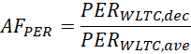  Alignment of EC in case of city, based on the ratio between EC_{WLTC,dec} and EC_{WLTC,ave:}  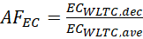 | PER_{WLTC,dec}, km;  PER_{WLTC,ave,} km;  PERcity,ave, km;  EC_{WLTC,dec,} Wh/km;  EC_{WLTC,ave,} Wh/km;  EC_{city,ave,}Wh/km;

[PLACEHOLDER]
[
x.x.x. PER
x.x.x. PER ratio calculation
The pure electric range ratio can be established for vehicle configurations that have not tested Type 6. The worst case vehicle configuration generating the PER ratio shall meet requirements defined in paragraphs 2.5 and 3.4.1.2 of Annex 8.
The pure electric range ratio, PER_{_R}, shall be calculated as follows:
PER_{_R} = PER _{-7°C} /PER _{23°}
where
PER _{-7°C} is the electric range of the worst case vehicle over the complete WLTC cycle at -7°C, as defined in paragraph 3.4.1.2 of Annex 8
PER _{23°C} is the electric range of the worst case vehicle over the complete WLTC cycle at 23°C, as defined in paragraph 3.4.1.2 of Annex 8
Both PER_{23C°} and PER_{-7°C} shall be measured on the same test vehicle.
The PER_{_R} shall be included in all relevant test reports and shall be rounded to 4 points of decimal.

x.x.x. EC ratio calculation
The pure electric consumption ratio can be established for vehicle configurations that have not tested Type 6. The worst case vehicle configuration generating the electric consumption ratio shall meet requirements defined in paragraphs 2.5 and 3.4.1.2 of Annex 8.
The pure electric consumption ratio, EC_{_R}, shall be calculated as follows:
EC_{_R} = EC _{-7°C} /EC _{23°}
where
EC_{23°C} is the weighted electric energy consumption over the applicable WLTC cycle at 23°C
EC_{-7°C} is the weighted electric energy consumption over the applicable WLTC cycle at -7°C
Both EC_{23C°} and EC_{-7°C} shall be measured on the same test vehicle.
The EC_{_R} shall be included in all relevant test reports and shall be rounded to 4 points of decimal.

x.x.x. PER and EC low temp ratio application on vehicles in a low temp family
The applicable PER and EC values for each pure electric vehicle utilizing the pure electric range ratio and pure electric consumption ratio for Type 6 shall be calculated using the following equations:
PER _{-7°C} = PER _{23°C} × PER_{_R}
EC_{-7°C} = EC_{23°C} × EC_{_R}
where
PER_{23°C} is the electric range over the complete WLTC cycle at 23°C of the applicable vehicle utilizing PER_{_R}
EC_{23°C} is the weighted electric energy consumption over the applicable WLTC cycle at 23°C of the applicable vehicle utilizing EC_{_R}
PER_{_R} is the pure electric range ratio, defined in 4.8.1
EC_{_R} is the pure electric consumption ratio, defined in 4.8.2]
x.x.x. OVC-HEV
x.x.x. [value] ratio calculation
(…)
x.x.x. [value] low temp ratio application on vehicles in a low temp family
(…)

]

[
Sub-Annex 1 B8 - Appendix 1
REESS state of charge profile
1. Test sequences and REESS profiles: OVC-HEVs, charge-depleting and charge-sustaining test
1.1. Test sequence OVC-HEVs according to Option 1
Charge-depleting Type 6 test with no subsequent charge-sustaining test (Figure S-A.App1/1)

Figure S-A.App1/1

OVC-HEVs, charge-depleting Type 6 test
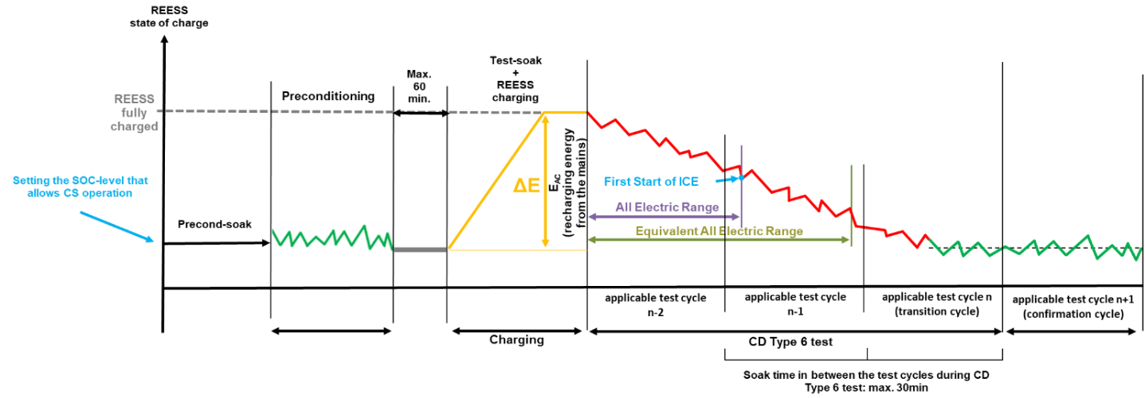

1.2. Test sequence OVC-HEVs according to Option 2
Charge-sustaining Type 6 test with no subsequent charge-depleting test (Figure S-A.App1/2).

Figure S-A.App1/2

OVC-HEVs, charge-sustaining Type 6 test
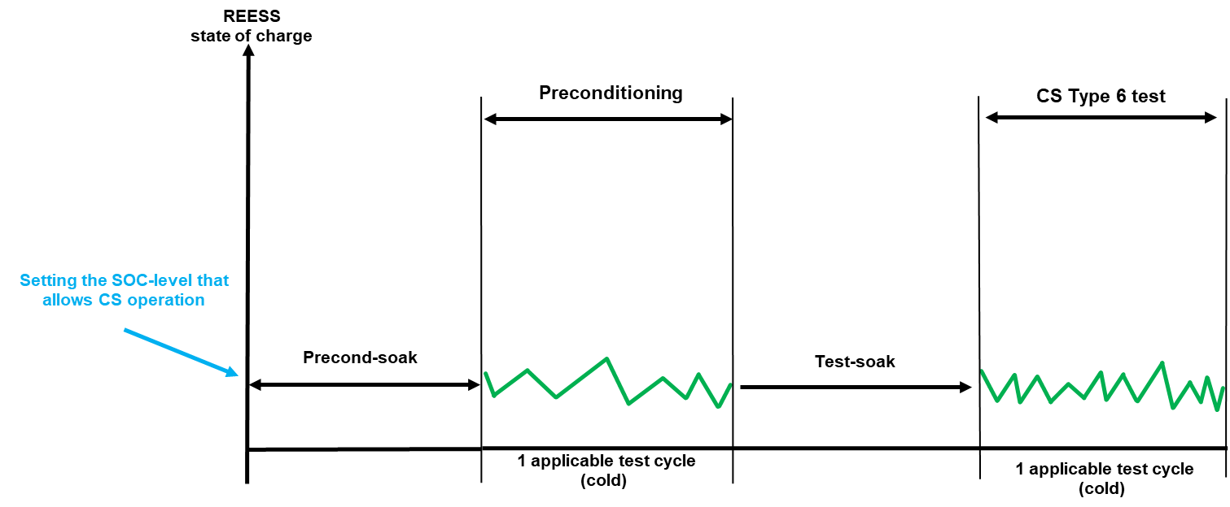

1.3. Test sequence OVC-HEVs according to Option 3
Charge-depleting Type 6 test with subsequent charge-sustaining test (Figure S-A.App1/3).

Figure S-A.App1/3

OVC-HEVs, charge-depleting Type 6 test with subsequent charge-sustaining test
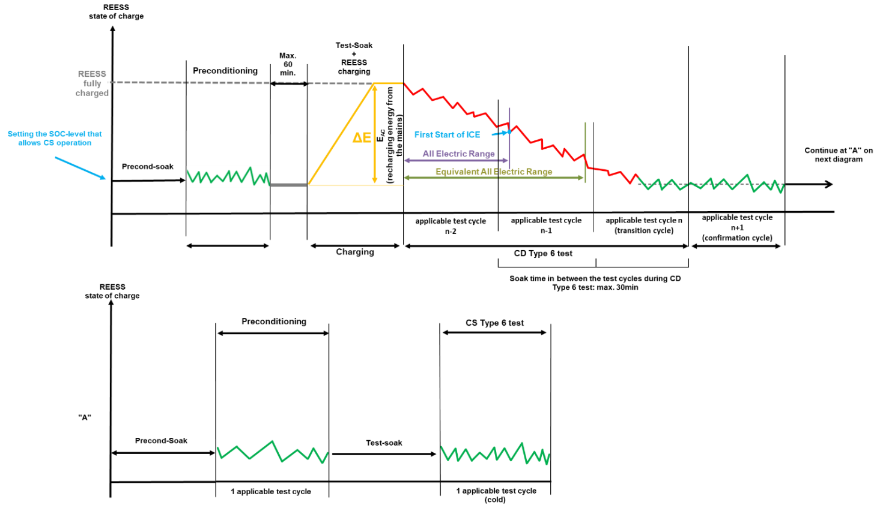
1.4. Test sequence OVC-HEVs according to Option 4
Charge-sustaining Type 6 test with subsequent charge-depleting test (Figure S-A.App1/4)
Figure S-A.App1/4
OVC-HEVs, charge-sustaining Type 6 test with subsequent charge-depleting test
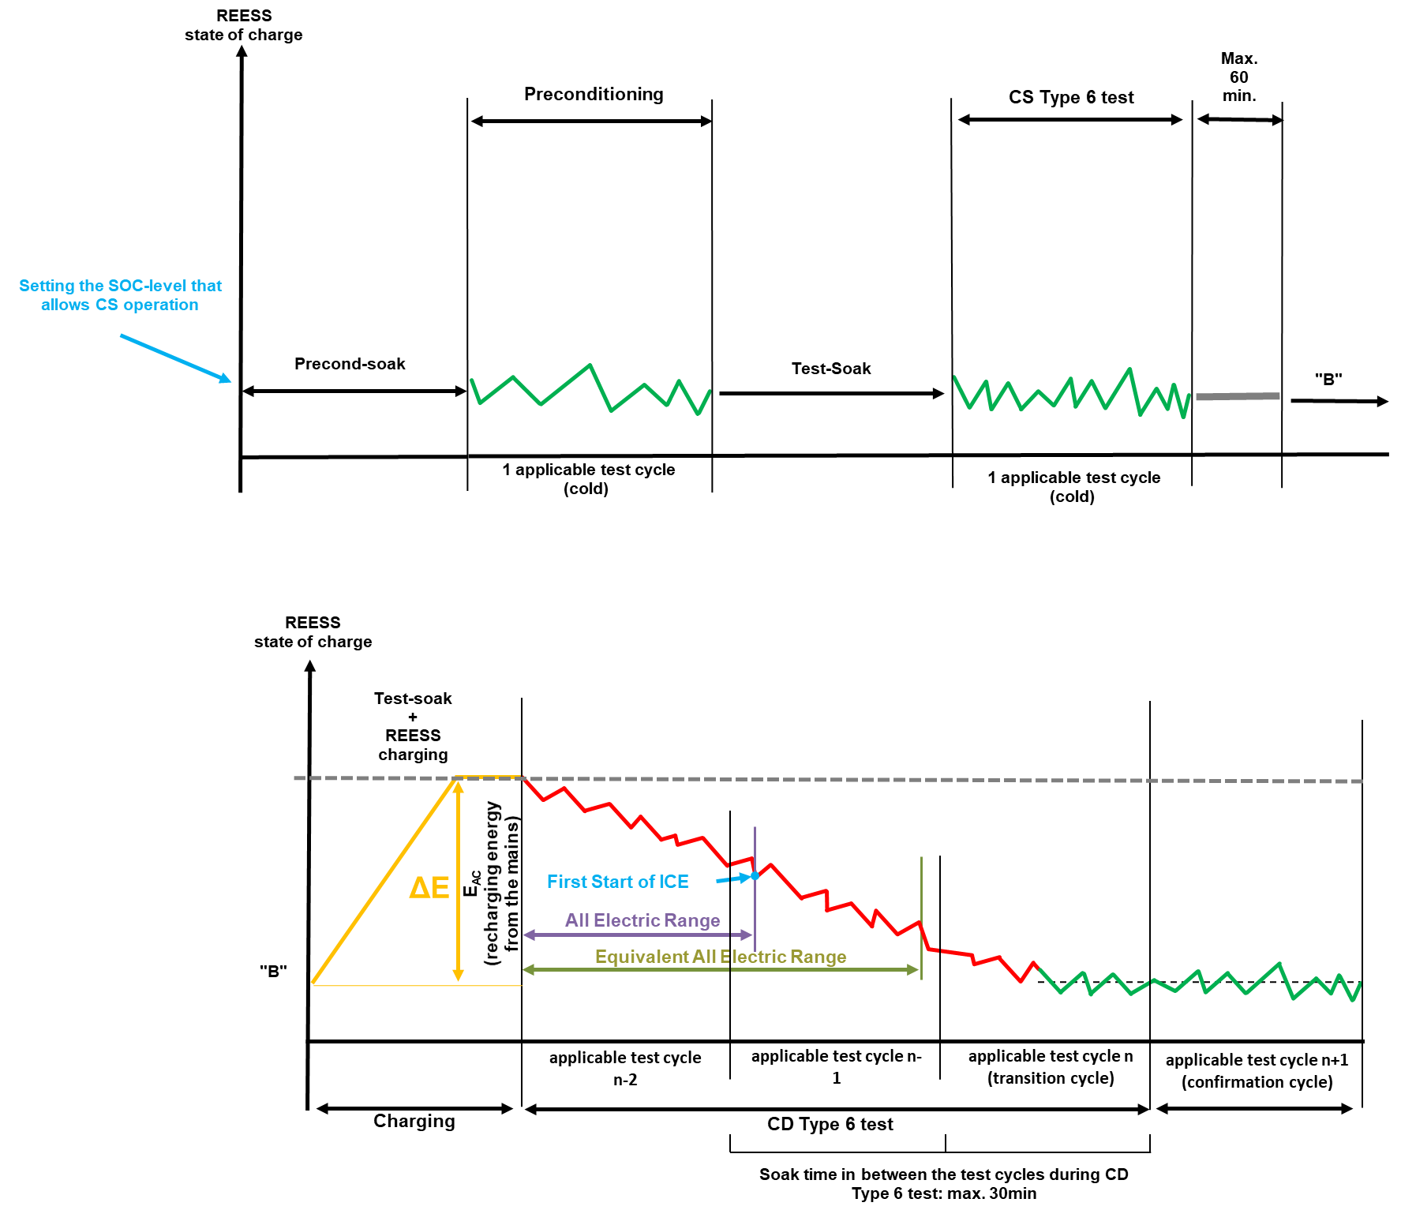

1.5. Test sequence OVC-HEVs according to Option 5
Charge-sustaining Type 6 test with subsequent charge- sustaining test (Figure S-A.App1/5)

Figure S-A.App1/5
OVC-HEVs, charge-sustaining Type 6 test with subsequent charge-sustaining test

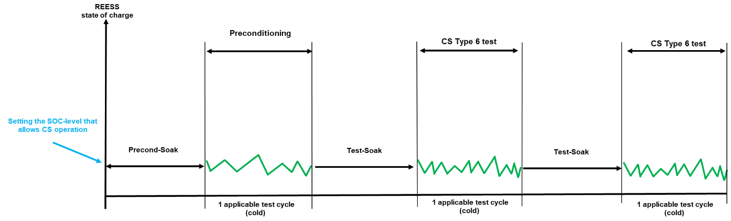

1.6. Test sequence OVC-HEVs according to Option 6
Charge-depleting Type 6 test with subsequent charge-depleting test (Figure S-A.App1/6)

Figure S-A.App1/6
OVC-HEVs, charge-depleting Type 6 test with subsequent charge-depleting test
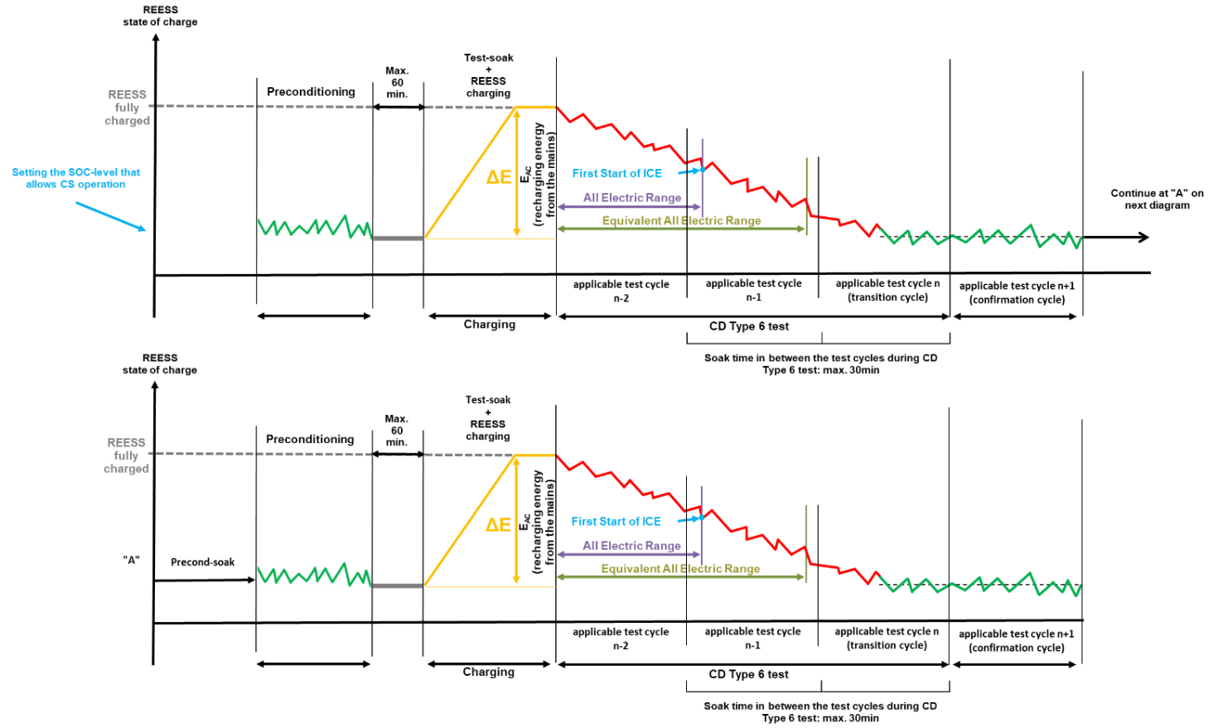
2. Test sequence NOVC-HEVs
Charge-sustaining Type 6 test (Figure S-A.App1/7)

Figure S-A.App1/7

NOVC-HEVs charge-sustaining Type 6 test
3. Test sequences PEV

3.1. PEV Type 6 test procedure (Figure S-A.App1/8)

Figure S-A.App1/8
PEV Type 6 test sequence
]

Sub-Annex 1 8 - Appendix 2
Vehicle preparation, preconditioning and soaking procedure of OVC-HEVs, NOVC-HEVs and PEVs for Type 6 testing
1. This appendix describes the test procedure for REESS and combustion engine preconditioning in preparation for:
(a) Electric range, charge-depleting and charge-sustaining measurements when testing OVC-HEVs; and
(b) Electric range measurements as well as electric energy consumption measurements when testing PEVs.
2. OVC-HEV preparation, preconditioning and soaking
2.1. Vehicle preparation procedure
The state of charge of the REESS shall be set according to the manufacturer’s recommendation.
[The setting of the state of charge of the REESS may be performed at unrestricted conditions].

[Placeholder: HVAC system settings Low Temp Presentation Rev7: up to driver]
2.2. Soak before preconditioning (precond-soak)
2.2.1. Soaking of the vehicle before preconditioning shall be performed according to paragraph 2.6.3.4. of the optional Annex 13.
2.2.1.1. [OVC-HEVs tested under charge-sustaining conditions shall be kept in an area with ambient conditions as specified in paragraph 2.6.1.2. of this annex for a minimum of 6 hours and a maximum of [36] hours before preconditioning. [This time shall be referred as t_{precond-soak} and shall be recorded]
2.2.1.2. OVC-HEVs tested under charge-depleting conditions shall be kept in an area with ambient conditions as specified in paragraph 2.6.1.2. of this annex for a minimum of 9 hours and a maximum of 36 hours before preconditioning. [This time shall be referred as t_{precond-soak-CD} and shall be recorded].
2.2.2. The soak shall be performed without using a cooling fan and with all body parts positioned as intended under normal parking operation.
2.2.3. The REESS shall not be charged during the soak period.
[Placeholder: HVAC system settings Low Temp Presentation Rev7: up to OEM]

2.3. Transfer from soak to preconditioning
In case that the vehicle is exposed to a temperature higher than -4°C, the transfer between the soak area and the test cell shall be undertaken as quickly as possible, without any unjustified delay and for no longer than [20] minutes.

2.4. Preconditioning
2.4.1. At the start of the preconditioning test, the test cell shall have a temperature set point of -7 °C and the tolerance of the actual value shall be within ±3 °C. [The engine oil temperature and coolant temperature, if any, shall be within ± 2 °C of the set point -7°C.] During preconditioning, the tolerance of the actual value shall be within ± 5°C
2.4.2. The vehicle shall be driven over one applicable WLTP test cycle under charge-sustaining operating condition. During this preconditioning cycle, the charging balance of the REESS shall be determined. [At the end of preconditioning, the REEC_{i} value defined in paragraph 3.2.4.5.2. of Annex 8 shall be below 0.06. This criteria applies to only discharge side.]

[Placeholder: HVAC system settings Low Temp Presentation Rev7: up to the driver]
2.5. Transfer from preconditioning to soak
Paragraph 2.3. of this appendix shall be applied.
2.6. Soak after preconditioning and before test (test-soak)
2.6.1. After preconditioning and before testing, vehicles shall be kept in a soak area with the ambient conditions described in paragraph 2.6.1.2. of Annex 13.
2.6.2 Soaking when the test procedure starts with a charge-sustaining test.
2.6.2.1 Soaking of the vehicle shall be performed according to paragraph 2.6.6. of the optional Annex 13 for a minimum of 12 hours and a maximum of 36 hours.
2.6.2.2. Forced cooling down shall not be applied to vehicles preconditioned for the Type 6 test.
2.6.2.3. The vehicle shall not be connected to the grid during the soak period.
2.6.3. Soaking when the test procedure starts with a charge-depleting test.
2.6.3.1. Soaking of the vehicle shall be performed according to paragraph 2.6.6.4. of the optional Annex 13 for a minimum of 12 hours and a maximum of 36 hours.
2.6.3.2. Forced cooling down shall not be applied to vehicles preconditioned for the Type 6 test.
2.6.3.3. The vehicle shall be connected to the grid at the start of this soak and shall be disconnected from the grid at the end of this soak.
[During soak, the REESS shall be charged using the normal charging procedure as defined in paragraph 5 of this appendix.
Soak shall continue until the end-of-charge criterion, as defined in paragraph 5.2. of this appendix is reached. The soak time shall be reported.]
2.6.3.4. Measuring the recharged electric energy
The energy measurement equipment, placed between the vehicle charger and the mains, shall measure the recharged electric energy E_{AC} delivered from the mains, as well as its duration. Electric energy measurement may be stopped when the end-of-charge criterion as defined in paragraph 5.2. of Appendix 2 to this sub-annex is reached.
[Placeholder: HVAC system settings Low Temp Presentation Rev7: no operation]
2.7. Transfer from soak to Type 6 Testing
2.7.1. Transfer when the test procedure starts with a charge-sustaining test
[The transfer from the soak area to the test cell shall be undertaken as quickly as possible, without any unjustified delay.
During the transfer, a stabilized vehicle shall not receive any unjustified exposures to temperatures outside the temperature tolerance 7±3°C. If that is unavoidable, the vehicle shall be stabilised before the start of the test procedure by holding it at an ambient temperature of - 7°C ± 3°C for at least six times as long as the vehicle was exposed to temperatures outside the temperature tolerance.]
2.7.2. Transfer when the test procedure starts with a charge-depleting test
During the transfer, a stabilized vehicle shall not receive any unjustified exposures to temperatures outside the temperature tolerance 7±3°C.
[The transfer from the soak area to the test cell shall be undertaken as quickly as possible, without any unjustified delay with a maximum of 1 hour between charge completion and start of the test procedure.
At the option of the manufacturer, the criterion of maximum 1 hour can be omitted. In that case it and if the vehicle has received exposures to temperatures outside the temperature tolerance of 7±3°C, the vehicle shall be stabilised before the start of the test procedure by holding it at an ambient temperature of -7°C±3°C for at least six times as long as the vehicle was exposed to temperatures outside the temperature tolerance.]

3. PEV preparation, preconditioning and soaking
3.1 Vehicle preparation procedure
Paragraph 2.1. of this appendix shall be applied.

[Placeholder: HVAC system settings Low Temp Presentation Rev7: up to the driver]

3.2 Soak before Preconditioning (precond-soak)
3.2.1 Soaking of the vehicle before preconditioning shall be performed according to paragraph 2.6.6.4. of the optional Annex 13.
3.2.2. The vehicle shall soak for a minimum of 9 hours and maximum 36 hours.. [This time shall be referred as t_{precond-soak-PEV} and shall be recorded]

3.2.2 The soak shall be performed without using a cooling fan and with all body parts positioned as intended under normal parking operation.
3.2.3. The REESS shall not be charged during the soak period.

[Placeholder: HVAC system settings Low Temp Presentation Rev7: up to the OEM]
[The heating and cooling system shall not be manually activated during the soak period/Thermal comfort preconditioning function, if available, shall not be activated during this soak].

3.3. Transfer from Soak to Preconditioning
Paragraph 2.3. of this appendix shall be applied.
3.4 Preconditioning
3.4.1 At the start of the preconditioning test, the test cell shall have a temperature set point of -7 °C and the tolerance of the actual value shall be within ±3 °C. During preconditioning, the tolerance of the actual value shall be within [± 5°C]

3.4.2. The PEV shall be discharged at the constant speed used during the Type 1 test until the break-off criterion is reached as specified in paragraph 3.4.4.2.3 of Annex 8. Cumulative distance driven should not exceed [50] km before the break-off criterion is reached.
[Breaks for the driver and/or operator are not permitted during preconditioning].
[If the cumulative distance exceeds [50] km, the accelerator control shall be deactivated, and the vehicle shall be braked to a standstill within 60 seconds. The vehicle shall exit the test cell and the state of charge of the REESS shall be set as per paragraph 3.1 following by soaking as per paragraph 3.2 of this annex]

[Placeholder: HVAC system settings Low Temp Presentation Rev7: up to the driver]
[The use of cabin heating or cooling is permitted during the discharging of the REESS at the manufacturer’s recommended setting. ]

3.5. Transfer from preconditioning to soak
Paragraph 2.3. of this appendix shall be applied.
3.6. Soak After Preconditioning and Before Test (test-soak)
3.6.1 After the vehicle has completed preconditioning and is placed in the soak area at the temperature of -7°C (± 3°C), the vehicle shall soak for a minimum of [12] hours and maximum 36 hours. [This time shall be referred as t_{soak-PEV} and shall be recorded]
3.6.2 The soak shall be performed without using a cooling fan and with all body parts positioned as intended under normal parking operation.
3.6.3. The vehicle shall be connected to the grid at the start of the soak and shall be disconnected from the grid at the end of the soak.
[During soak, the REESS shall be charged using the normal charging procedure as defined in paragraph 5 of this appendix.
Soak shall continue until the end-of-charge criterion, as defined in paragraph 5.2. of this appendix is reached. The soak time shall be reported.]
3.6.4. The energy measurement equipment, placed between the vehicle charger and the mains, shall measure the recharged electric energy E_{AC} delivered from the mains as well as its duration.
[Placeholder: HVAC system settings: Low Temp Presentation Rev7: no operation]
[Manual setting of the heating or cooling system is not permitted during the soak period.]
[The heating and cooling system shall not be manually activated during the soak period].

3.7. Transfer from soak to Type 6 Testing
Paragraph 2.7.2. of this appendix shall be applied.

4. NOVC-HEV preparation, preconditioning and soaking
[4.1. Vehicle preparation procedure
Paragraph 2.1. of this appendix shall be applied.
[4.2. Soak before preconditioning (precond-soak)
4.2.1. Soaking of the vehicle before preconditioning shall be performed according to paragraph 2.6.5.1.3. of the optional Annex 13.
4.2.2. [NOVC-HEVs shall be kept in an area with ambient conditions as specified in paragraph XX of this Annex for a minimum of 6 hours and a maximum of [36] hours before preconditioning. [This time shall be referred as t_{precond-soak} and shall be recorded]
4.2.3. The soak shall be performed without using a cooling fan and with all body parts positioned as intended under normal parking operation.]
[Placeholder: HVAC system settings Low Temp Presentation Rev7: up to the OEM]
[The heating and cooling system shall not be manually activated during the soak period/Thermal comfort preconditioning function, if available, shall not be activated during this soak].

4.3. Transfer from soak to preconditioning
Paragraph 2.3. of this appendix shall be applied..
4.4. Preconditioning
4.4.1. The vehicle shall be driven over one applicable WLTP test cycle under charge-sustaining operating condition.
4.4.2. At the start of the preconditioning test, the test cell shall have a temperature set point of -7 °C and the tolerance of the actual value shall be within ±3 °C. [The engine oil temperature and coolant temperature, if any, shall be within ± 2 °C of the set point -7°C]. During preconditioning, the tolerance of the actual value shall be within ± 5°C.
[Placeholder: HVAC system settings Low Temp Presentation Rev7: up to the driver]
[The use of cabin heating or cooling is permitted during the discharging of the REESS at the manufacturer’s recommended setting. ]
4.5. Transfer from preconditioning to soak
Paragraph 2.3. of this appendix shall be applied.
4.6. Soak after preconditioning and before test (test-soak)
4.6.1. After preconditioning and before testing, vehicles shall be kept in a soak area with the ambient conditions described in paragraph 2.6.1.2. of Annex 13.
4.6.2. Soaking of the vehicle shall be performed according to paragraph 2.6.6. of the optional Annex 13 for a minimum of 12 hours and a maximum of 36 hours.
4.6.3. Forced cooling down shall not be applied to vehicles preconditioned for the Type 6 test.

[Placeholder: HVAC system settings: Low Temp Presentation Rev7: no operation]
[Manual setting of the heating or cooling system is not permitted during the soak period.]
[The heating and cooling system shall not be manually activated during the soak period].

4.7. Transfer from soak to Type 6 Testing
Paragraph 2.7.1. of this appendix shall be applied.

5. Application of a normal charge
Normal charging is the transfer of electricity to an electrified vehicle with a power of less than or equal to 22 kW.
Where there are several possible methods to perform a normal AC charge (e.g. cable, induction, etc.), the charging procedure via cable shall be used.
Where there are several AC charging power levels available, the highest normal charging power shall be used. An AC charging power lower than the highest normal AC charging power may be selected if recommended by the manufacturer and by approval of the responsible authority.
5.1. The REESS shall be charged at an ambient temperature as specified in paragraph 2.6.1.2. of optional Annex 13 with the on-board charger if fitted.
The vehicle shall be connected to the mains within 60 minutes after the preconditioning. [For vehicles with time of day delayed charging, shall enter the soak area and shall be connected to the mains without unjustified delay. The delayed charging setting must only occur once and may not be modified further during the soak period.] The REESS is fully charged when the end-of-charge criterion, as defined in paragraph 5.2. of this appendix, is reached.
In the following cases, a charger recommended by the manufacturer and using the charging pattern prescribed for normal charging shall be used if:
(a) No on-board charger is fitted, or
(b) The charging time exceeds the soaking time defined in paragraph 2.6.6.4. of Annex 13.
The procedures in this paragraph exclude all types of special charges that could be automatically or manually initiated, e.g. equalization charges or servicing charges. The manufacturer shall declare that, during the test, a special charge procedure has not occurred.
5.2. End-of-charge criterion
The end-of-charge criterion is reached when the on-board or external instruments indicate that the REESS is fully charged. . If When the charging is performed during soaking and finished before the minimum required soaking time as defined in paragraph 2.6.6.4. of Annex 13, the vehicle shall stay connected to the grid at least until the minimum required soaking time is reached. At the request of the manufacturer, the soak time may be extended to up to 36 hours.

