Explanation

This draft is based on the ‘UNR WLTP Series 1’ as this contains the latest amendment

* Colour codes

**Grey**: Same as the 23°C test

**Black**: Parts of the draft concerned by the modifications but not yet modified

**Violet**: Additional text or modifications or deletion

* Status: As of 04/02/2020

|  |  |  |
| --- | --- | --- |
| **Topics** | **Discussion status** | **Drafting status** |
| 1. Family criteria | Not yet started | 1st draft idea with [] |
| 2. Test vehicle selection | Not yet started | 1st draft idea with [] |
| 3. Test procedure | Under discussion | 1st draft ready with [] |
| 4. Multiplication factor instead of interpolation | Concluded (multiplication factor) | 1st draft ready with [] |
| 5. Post processing | Under discussion | Not yet started |

SPACE HOLDER for PEV

UBE Family criteria

x.x.x. [Only vehicles which are identical with respect to all the following characteristics are permitted to be part of the same low temperature UBE Family:

(a) Pre-heating of the REESS (option, default or not available)

(b) The vehicles shall have a variation in battery capacity of no more than [X] per cent of the vehicle with the lowest capacity;]

Vehicle selection for PEV

x.x.x.x. [Determining the worst case PER ratio in the case of the PEV Type 6 ~~Type 6 PEV consecutive or shortened cycle~~ test procedure

Within a given roadload family, select the Type 6 vehicle test data corresponding to the vehicle with the smallest REESS, largest cabin size (by volume) and least number of powered axles. If multiple cabin heater types exist for this vehicle configuration, select the highest energy consumption heating device within this vehicle’s subgroup. If optional features exist for cabin thermal conditioning or REESS conditioning, select the vehicle configuration without this option (if possible). The PER ratio is applicable to all vehicles within the roadload family, and only the selected vehicle must perform Type 6 testing.

As an alternative, the PER ratio may be further sub-divided by REESS capacity within a roadload family. Within this configuration, select the vehicle of equivalent REESS capacity with the largest cabin size. If multiple cabin heater types exist for this vehicle configuration, select the highest energy consumption heating device within this vehicle’s subgroup. If optional features exist for cabin thermal conditioning or REESS conditioning, select the vehicle configuration without this option (if possible). The PER ratio is applicable to vehicles within the roadload family of equivalent REESS capacity, and only the selected vehicle must perform Type 6 testing.

Annex B8

Annex B8

Pure electric~~,~~ and hybrid electric ~~and compressed hydrogen fuel cell hybrid~~ vehicles

1. General requirements

In the case of testing NOVC-HEVs~~,~~ and OVC-HEVs ~~and NOVC-FCHVs~~, Appendix 2 and Appendix 3 to this annex shall replace ~~Appendix 2 to Annex B6~~.

Unless stated otherwise, all requirements in this annex shall apply to vehicles with and without driver-selectable modes. Unless explicitly stated otherwise in this annex, all of the requirements and procedures specified in Annex B6 and Annex B7 shall continue to apply for NOVC-HEVs, OVC-HEVs, ~~NOVC-FCHVs~~ and PEVs.

1.1. Units, accuracy and resolution of electric parameters

Units, accuracy and resolution of measurements shall be as shown in Table ~~A8~~/1.

Table ~~A8~~/1

**Parameters, units, accuracy and resolution of measurements**

| *Parameter* | *Units* | *Accuracy* | *Resolution* |
| --- | --- | --- | --- |
| Electrical energy (a) | Wh | ±1 per cent | 0.001 kWh(b) |
| Electrical current | A | ±0.3 per cent FSD or  ±1 per cent of reading (c,d) | 0.1 A |
| Electric voltage | V | ±0.3 per cent FSD or  ±1 per cent of reading (c) | 0.1 V |
| (a) Equipment: static meter for active energy.  (b) AC watt-hour meter, Class 1 according to IEC 62053-21 or equivalent.  (c) Whichever is greater.  (d) Current integration frequency 20 Hz or more. | | | |

[Table A8/2 Reserved]

1.2. Emission and fuel consumption testing

Parameters, units and accuracy of measurements shall be the same as those required for pure ICE vehicles.

1.3. Rounding of test results

1.3.1. Unless intermediate rounding is required, intermediate steps in the calculations shall not be rounded.

1.3.2. In the case of OVC-HEVs ~~and NOVC-HEVs~~, the final criteria emission results shall be rounded according to paragraph 1.3.2. of Annex B7, ~~the NOx correction factor KH shall be rounded according to paragraph 1.3.3. of Annex B7~~, and the dilution factor DF shall be rounded according to paragraph 1.3.4. of Annex B7,

1.3.3. For information not related to standards, good engineering judgement shall be used.

1.3.4. Rounding of range, CO2, energy consumption and fuel consumption results is described in the calculation tables of this annex.

1.4. Vehicle classification

All OVC-HEVs, NOVC-HEVs~~,~~ and PEVs ~~and NOVC-FCHVs~~ shall be classified as Class 3 vehicles. The applicable test cycle for the Type 6 test procedure shall be determined according to paragraph 1.4.2. of this annex based on the corresponding reference test cycle as described in paragraph 1.4.1. of this annex.

1.4.1. Reference test cycle

1.4.1.1. The Class 3 reference test cycles are specified in paragraph 3.3. of Annex B1.

1.4.1.2. For PEVs, the downscaling procedure, according to paragraphs 8.2.3. and 8.3. of Annex B1, may be applied on the test cycles according to paragraph 3.3. of Annex B1 by replacing the rated power with maximum net power according to UN Regulation No. 85. In such a case, the downscaled cycle is the reference test cycle.

1.4.2. Applicable test cycle

1.4.2.1. Applicable WLTP test cycle

The reference test cycle according to paragraph 1.4.1. of this annex shall be the applicable WLTP test cycle (WLTC) for the Type 6 test procedure.

In the case that paragraph 9. of Annex B1 is applied based on the reference test cycle as described in paragraph 1.4.1. of this annex, this modified test cycle shall be the applicable WLTP test cycle (WLTC) for the Type 6 test procedure.

1.4.2.2.

Applicable WLTP city test cycle

The Class 3 WLTP city test cycle (WLTCcity) is specified in paragraph 3.5. of Annex B1.

1.5. OVC-HEVs, NOVC-HEVs,~~NOVC-FCHVs~~ and PEVs with manual transmissions

The vehicles shall be driven according to the technical gear shift indicator, if available, or according to instructions incorporated in the manufacturer's handbook.

2. Run-in of test vehicle

The vehicle tested according to this annex shall be presented in good technical condition and shall be run-in in accordance with the manufacturer’s recommendations. In the case that the REESSs are operated above the normal operating temperature range, the operator shall follow the procedure recommended by the vehicle manufacturer in order to keep the temperature of the REESS in its normal operating range. The manufacturer shall provide evidence that the thermal management system of the REESS is neither disabled nor reduced.

2.1. OVC-HEVs and NOVC-HEVs shall have been run-in according to the requirements of paragraph 2.3.3. of Annex B6.

2.2. ~~NOVC-FCHVs shall have been run-in at least 300 km with their fuel cell and REESS installed~~.

2.3. PEVs shall have been run-in at least 300 km or one full charge distance, whichever is longer.

2.4. All REESS having no influence on CO2 mass emissions ~~or H~~~~2~~ ~~consumption~~ shall be excluded from monitoring

3. Test procedure

3.1. General requirements

3.1.1. For all OVC-HEVs, NOVC-HEVs~~,~~ and PEVs ~~and NOVC-FCHVs~~, the following shall apply where applicable:

3.1.1.1. Vehicles shall be tested according to the applicable test cycles described in paragraph 1.4.2. of this annex.

3.1.1.2. If the vehicle cannot follow the applicable test cycle within the speed trace tolerances according to paragraph 2.6.8.3.1.2. of Annex B6, the accelerator control shall, unless stated otherwise, be fully activated until the required speed trace is reached again.

3.1.1.3. The powertrain start procedure shall be initiated by means of the devices provided for this purpose according to the manufacturer's instructions.

3.1.1.4. For OVC-HEVs, NOVC-HEVs, ~~NOVC-FCHVs~~ and PEVs, exhaust emissions sampling and measurement of electric energy consumption shall begin for each applicable test cycle before or at the initiation of the vehicle start procedure and end at the conclusion of each applicable test cycle.

3.1.1.5. For OVC-HEVs and NOVC-HEVs, gaseous emission compounds, shall be analysed for each individual test phase. It is permitted to omit the phase analysis for phases where no combustion engine operates.

3.1.1.6. If applicable, particle number shall be analysed for each individual phase and particulate matter emission shall be analysed for each applicable test cycle.

3.1.2. ~~Forced cooling as described in paragraph 2.7.2. of Annex B6 shall apply only for the charge-sustaining Type 1 test for OVC-HEVs according to paragraph 3.2. of this annex and for testing NOVC-HEVs according to paragraph 3.3. of this annex.~~

3.1.3. The requirements of paragraphs 2.2.2.1.2. and 2.2.2.1.3. of Annex B6 are exempted when testing was conducted according to (PEV test procedure) ~~and (FCHV test procedure)~~.

3.2. OVC-HEVs

3.2.1. Vehicles shall be tested under charge-depleting operating condition (CD condition), and charge-sustaining operating condition (CS condition)

3.2.2. Vehicles may be tested according to four possible test sequences:

3.2.2.1. Option 1: charge-depleting Type 6 test with no subsequent charge-sustaining ~~Type 1~~ test.

3.2.2.2. Option 2: charge-sustaining Type 6 test with no subsequent charge-depleting ~~Type 1~~ test.

3.2.2.3. Option 3: charge-depleting Type 6 test with a subsequent charge-sustaining Type 6 test.

3.2.2.4. Option 4: charge-sustaining Type 6 test with a subsequent charge-depleting Type 6 test.

# Figure A~~8~~/1

# **Possible test sequences in the case of OVC-HEV testing**

Option 1

CD

Set SoC to Max. 1 WLTC

Soak-1

P/C - Max. 1 WLTC

REEC < 4%

Soak-2

Charging

EAC

CD Type 6 test

Option 3

CD + CS

Set SoC to Max. 1 WLTC

Soak-1

P/C - Max. 1 WLTC

REEC < 4%

Soak-2

Charging

EAC

CD Type 6 test

Soak-3

CS Type 6 test

Option 4

CS + CD

Set SoC to Max. 1 WLTC

Soak-1

P/C - Max. 1 WLTC

REEC < 4%

Soak-3

CS Type 6 test

Soak-2

Charging

EAC

CD Type 6 test

Option 2

CS

Set SoC to Max. 1 WLTC

Soak-1

P/C - Max. 1 WLTC

REEC < 4%

Soak-3

CS Type 6 test

3.2.3. The driver-selectable mode shall be set as described in the following test sequences (Option 1 to Option 4).

3.2.4. Charge-depleting Type 6 test with no subsequent charge-sustaining ~~Type 1~~ test (Option 1)

# The test sequence according to Option 1, described in paragraphs 3.2.4.1. to 3.2.4.7. inclusive of this annex, as well as the corresponding REESS state of charge profile, are shown in Figure ~~A8~~.App1/1 in Appendix 1 to this optional annex.

3.2.4.1. Preconditioning

The vehicle shall be prepared according to the procedures in paragraphs ~~2.2.~~ 2.1., 2.2. and 2.4. of Appendix 4 to this optional annex.

3.2.4.2. Test conditions

3.2.4.2.1. The test shall be carried out with a fully charged REESS according to the charging requirements as described in paragraph ~~2.2.3~~. 2.4.2. of Appendix 4 to this annex and with the vehicle operated in charge-depleting operating condition as defined in paragraph 3.3.5. of this Regulation.

3.2.4.2.2. Selection of a driver-selectable mode

For vehicles equipped with a driver-selectable mode, the mode for the charge-depleting Type 6 test shall be selected according to paragraph 2. of Appendix 6 to ~~this~~ annex B8.

3.2.4.3. Charge-depleting Type 6 test procedure

3.2.4.3.1. The charge-depleting Type 6 test procedure shall consist of a number of consecutive cycles, each followed by a soak period of no more than 30 minutes until charge-sustaining operating condition is achieved.

3.2.4.3.2. During soaking between individual applicable test cycles, the powertrain shall be deactivated and the REESS shall not be recharged from an external electric energy source. The instrumentation for measuring the electric current of all REESSs and for determining the electric voltage of all REESSs according to Appendix 3 of ~~this~~ annex B8 shall not be turned off between test cycle phases. In the case of ampere-hour meter measurement, the integration shall remain active throughout the entire test until the test is concluded.

Restarting after soak, the vehicle shall be operated in the driver-selectable mode according to paragraph 3.2.4.2.2. of this annex.

3.2.4.3.3. In deviation from paragraph 5.3.1. of Annex B5 and additional to paragraph 5.3.1.2. of Annex B5, analysers may be calibrated and zero- checked before and after the charge-depleting Type 6 test.

3.2.4.4. End of the charge-depleting Type 6 test

The end of the charge-depleting Type 6 test is considered to have been reached when the break-off criterion according to paragraph 3.2.4.5. of ~~this~~ annex B8 is reached for the first time. The number of applicable WLTP test cycles up to and including the one where the break-off criterion was reached for the first time is set to n+1.

The applicable WLTP test cycle n is defined as the transition cycle.

The applicable WLTP test cycle n+1 is defined to be the confirmation cycle.

For vehicles without a charge-sustaining capability over the complete applicable WLTP test cycle, the end of the charge-depleting Type 6 test is reached by an indication on a standard on-board instrument panel to stop the vehicle, or when the vehicle deviates from the prescribed speed trace tolerance for 4 consecutive seconds or more. The accelerator control shall be deactivated and the vehicle shall be braked to standstill within 60 seconds.

3.2.4.5. Break-off criterion

3.2.4.5.1. Whether the break-off criterion has been reached for each driven applicable WLTP test cycle shall be evaluated.

3.2.4.5.2. The break-off criterion for the charge-depleting Type 6 test is reached when the relative electric energy change REECi, as calculated using the following equation, is less than 0.04.

where:

is the relative electric energy change of the applicable test cycle considered i of the charge-depleting Type 6 test;

is the change of electric energy of all REESSs for the considered charge-depleting Type 6 test cycle i calculated according to paragraph 4.3. of this annex, Wh;

is the cycle energy demand of the considered applicable WLTP test cycle calculated according to paragraph 5. of Annex B7, Ws;

i is the index number for the considered applicable WLTP test cycle;

is a conversion factor to Wh for the cycle energy demand.

3.2.4.6. REESS charging and measuring the recharged electric energy

3.2.4.6.1. The vehicle shall be connected to the mains within ~~120 minutes after the applicable WLTP test cycle n+1~~ 30 minutes after the precondition where the applicable WLTP test cycle in which the break-off criterion for the charge-depleting Type 6 test is reached for the first time.

The REESS is fully charged when the end-of-charge criterion, as defined in paragraph ~~2.2.3.2.~~ 2.4.2.2. of Appendix 4 to this optional annex, is reached.

3.2.4.6.2. The electric energy measurement equipment, placed between the vehicle charger and the mains, shall measure the recharged electric energy EAC delivered from the mains, as well as its duration. Electric energy measurement may be stopped when the end-of-charge criterion, as defined in paragraph ~~2.2.3.2.~~ 2.4.2.2. of Appendix 4 to this annex, is reached.

3.2.4.7. Each individual applicable WLTP test cycle within the charge-depleting Type 6 test shall fulfil the applicable criteria emission limits according to paragraph 1.2. of AnnexB6.

3.2.5. Charge-sustaining Type 6 test with no subsequent charge-depleting ~~Type 1~~ test (Option 2)

# The test sequence according to Option 2, as described in paragraphs 3.2.5.1. to 3.2.5.3.3. inclusive of this optional annex, as well as the corresponding REESS state of charge profile, are shown in Figure ~~A8~~.App1/2 in Appendix 1 to this annex.

3.2.5.1. Preconditioning and soaking

The vehicle shall be prepared according to the procedures in paragraph paragraphs ~~2.2.~~ 2.1. to 2.3.1 inclusive ~~2.1.~~ of Appendix 4 to this optional annex.

3.2.5.2. Test conditions

3.2.5.2.1. Tests shall be carried out with the vehicle operated in charge-sustaining operating condition as defined in paragraph 3.3.6. of this Regulation.

3.2.5.2.2. Selection of a driver-selectable mode

For vehicles equipped with a driver-selectable mode, the mode for the charge-sustaining Type 6 test shall be selected according to paragraph 3. of Appendix 6 to this optional annex.

3.2.5.3. Type 6 test procedure

3.2.5.3.1. Vehicles shall be tested according to the Type 6 test procedures described in optional Annex XX ~~B6~~.

3.2.5.3.2. If required, ~~CO~~~~2~~ ~~mass emission shall be corrected according to Appendix 2 to this annex~~. CO2 mass emission shall be corrected using Type 1 correction factor.

3.2.5.3.3. The test according to paragraph 3.2.5.3.1. of this annex shall fulfil the applicable criteria emission limits according to paragraph 1.2. of Annex B6.

3.2.6. Charge-depleting Type 6 test with a subsequent charge-sustaining ~~Type 1~~ test (Option 3)

# The test sequence according to Option 3, as described in paragraphs 3.2.6.1. to 3.2.6.3. inclusive of this optional annex, as well as the corresponding REESS state of charge profile, are shown in Figure ~~A8~~.App1/3 in Appendix 1 to this annex.

3.2.6.1. For the charge-depleting Type 6 test, the procedure described in paragraphs 3.2.4.1. to 3.2.4.5. inclusive as well as paragraph 3.2.4.7. of this annex shall be followed.

3.2.6.2. Subsequently, the procedure for the charge-sustaining Type 6 test described in paragraphs 3.2.5.1. to 3.2.5.3. inclusive of this annex shall be followed. Paragraphs ~~2.1.1. and 2.1.2.~~ 2.1 to 2.2.1. inclusive of Appendix 4 to this optional annex shall not apply.

3.2.6.3. REESS charging and measuring the recharged electric energy

3.2.6.3.1. The vehicle shall be connected to the mains within ~~120 minutes after the conclusion of the charge-sustaining Type 1 test~~ 30 minutes after the precondition where the applicable WLTP test cycle in which the break-off criterion is reached for the first time.

The REESS is fully charged when the end-of-charge criterion as defined in paragraph ~~2.2.3.2.~~ 2.4.2.2. of Appendix 4 to this annex is reached.

3.2.6.3.2. The energy measurement equipment, placed between the vehicle charger and the mains, shall measure the recharged electric energy EAC delivered from the mains, as well as its duration. Electric energy measurement may be stopped when the end-of-charge criterion as defined in paragraph ~~2.2.3.2.~~ 2.4.2.2. of Appendix 4 to this optional annex is reached.

3.2.7. Charge-sustaining Type 6 test with a subsequent charge-depleting ~~Type 1~~ test (Option 4)

# The test sequence according to Option 4, described in paragraphs 3.2.7.1. and 3.2.7.2. of this annex, as well as the corresponding REESS state of charge profile, are shown in Figure ~~A8~~.App1/4 of Appendix 1 to this annex.

3.2.7.1. For the charge-sustaining Type 6 test, the procedure described in paragraphs 3.2.5.1. to 3.2.5.3. inclusive of this annex, as well as paragraph 3.2.6.3.1. of this annex, shall be followed.

3.2.7.2. Subsequently, the procedure for the charge-depleting Type 6 test described in paragraphs 3.2.4.2. to 3.2.4.7. inclusive of this annex shall be followed. Paragraphs ~~2.1.1. and 2.1.2.~~ 2.1 to 2.2.1. inclusive of Appendix 4 to this optional annex shall not apply.

3.3. NOVC-HEVs

The test sequence described in paragraphs 3.3.1. to 3.3.3. inclusive of this annex, as well as the corresponding REESS state of charge profile, are shown in Figure ~~A8~~.App1/5 of Appendix 1 to this annex.

3.3.1. Preconditioning and soaking

3.3.1.1. Vehicles shall be preconditioned according to paragraph ~~2.6. of Annex B6~~ x.x of the optional Annex XX.

In addition to the requirements of paragraph ~~2.6. of Annex B6~~ x.x of the optional Annex XX, the level of the state of charge of the traction REESS for the charge-sustaining test may be set according to the manufacturer’s recommendation before preconditioning in order to achieve a test under charge-sustaining operating condition.

3.3.1.2. Vehicles shall be soaked according to paragraph ~~2.7. of Annex B6~~ x.x of the optional Annex XX.

3.3.2. Test conditions

3.3.2.1. Vehicles shall be tested under charge-sustaining operating condition as defined in paragraph 3.3.6. of this Regulation.

3.3.2.2. Selection of a driver-selectable mode

For vehicles equipped with a driver-selectable mode, the mode for the charge-sustaining Type 6 test shall be selected according to paragraph 3. of Appendix 6 to this annex.

3.3.3. Type 6 test procedure

3.3.3.1. Vehicles shall be tested according to the Type 6 test procedure described in optional Annex XX ~~B6~~.

3.3.3.2. If required, ~~the CO~~~~2~~ ~~mass emission shall be corrected according to Appendix 2 to this annex~~ CO2 mass emission shall be corrected using Type 1 correction factor..

3.3.3.3. The charge-sustaining Type 6 test shall fulfil the applicable criteria emission limits according to paragraph 1.2. of Annex B6.

3.4. PEVs

3.4.1. General requirements

The test procedure to determine the pure electric range and electric energy consumption shall be selected according to the estimated pure electric range at low temperature (PER~~LT~~) of the test vehicle from Table A8/3. In the case that the interpolation method is applied, the applicable test procedure shall be selected according to the PER~~LT~~ of vehicle **[L]** within the specific interpolation family.

Table A8/3

**Procedures to determine pure electric range and electric energy consumption**

|  |  |  |
| --- | --- | --- |
| *Applicable test cycle* | *The estimated PER* ~~LT~~ *is…* | *Applicable test procedure* |
| Test cycle according to paragraph 1.4.2.1. of this annex including the extra high phase. | …less than the length of 3 applicable WLTP test cycles. | ~~Consecutive cycle [Type 6] test procedure (according to paragraph 3.4.4.1. of this annex).~~  PEV ~~Shortened~~ **[Type 6]** test procedure (according to paragraph 3.4.4.3. of this annex). |
| … equal to or greater than the length of 3 applicable WLTP test cycles. | PEV ~~Shortened~~ **[Type 6]** test procedure (according to paragraph 3.4.4.3. of this annex). |
| Test cycle according to paragraph 1.4.2.1. of this annex excluding the extra high phase. | …less than the length of 4 applicable WLTP test cycles. | ~~Consecutive cycle [Type 6] test procedure (according to paragraph 3.4.4.1. of this annex).~~  PEV ~~Shortened~~ **[Type 6]** test procedure (according to paragraph 3.4.4.3. of this annex). |
| …equal to or greater than the length of 4 applicable WLTP test cycles. | PEV ~~Shortened~~ **[Type 6]** test procedure (according to paragraph 3.4.4.3. of this annex). |
| City cycle according to paragraph 1.4.2.2. of this annex. | …not available over the applicable WLTP test cycle. | ~~Consecutive cycle [Type 6] test procedure (according to paragraph 3.4.4.1. of this annex).~~  PEV ~~Shortened~~ **[Type 6]** test procedure (according to paragraph 3.4.4.3. of this annex). |

The manufacturer shall give evidence to the responsible authority concerning the estimated pure electric range (PER~~LT~~) prior to the test. In the case that the interpolation method is applied, the applicable test procedure shall be determined based on the estimated PER~~LT~~ of vehicle **[L]** of the interpolation family. The PER~~LT~~ determined by the applied test procedure shall confirm that the correct test procedure was applied.

~~The test sequence for the consecutive cycle Type 6 test procedure, as described in paragraphs 3.4.2., 3.4.3. and 3.4.4.1. of this annex, as well as the corresponding REESS state of charge profile, are shown in Figure [~~**~~A8.App1/8]~~** ~~of~~ **~~[Appendix 1 to this annex].~~**

The test sequence for the PEV ~~shortened~~ Type 6 test procedure, as described in paragraphs 3.4.2., 3.4.3. and 3.4.4.2. of this annex as well as the corresponding REESS state of charge profile, are shown in Figure [**A8.App1/9**] in **[Appendix 1 to this annex].**

3.4.2. Preconditioning

The vehicle shall be prepared according to the procedures in paragraph 3. of Appendix 4 to this annex.

3.4.3. Selection of a driver-selectable mode

For vehicles equipped with a driver-selectable mode, the mode for the test shall be selected according to paragraph 4. of Appendix 3 to this Annex.

**PLACE HOLDER**

**[3.4.3’. ~~Heating device setting during test~~**

**~~[~~**~~During the test, operate the vehicle's interior climate control system with the heat on and set to primarily defrost the front window (only if vehicle does not have cabin humidity detection). Turn air conditioning off. You may not use any supplemental auxiliary heat during this testing. You may set the heater to any temperature and fan setting during vehicle preconditioning.~~

~~(1) Manual control. Unless you rely on automatic control as specified in paragraph (2) of this section, take the following steps to control heater settings:~~

~~(i) Set the climate control system as follows before [the first acceleration (t = 20 s)], or before starting the vehicle if the climate control system allows it:~~

~~(A) Temperature. Set controls to maximum heat. For automatic control systems running in manual mode, set the heater control to XX °C or higher.~~

~~(B) Fan speed. Set the fan speed to full off or the lowest available speed if a full off position is not available.~~

~~(C) Airflow direction. Direct airflow to the front window (window defrost mode) if vehicle does not have cabin humidity detection.~~

~~(D) Air source. If independently controllable, set the system to draw in outside air.~~

~~(ii) At the XX idle of the test cycle, which occurs XX seconds after the start of the test, set the fan speed to maximum. Complete by XX seconds after the start of the test. Leave temperature and air source settings unchanged.~~

~~(iii) At the XX idle of the test interval, which occurs at the deceleration to zero km per hour XX seconds after the start of the test, set the fan speed to the lowest setting that maintains air flow. Complete these changes by XX seconds after the start of the test. [You may use different vent and fan speed settings for the remainder of the test.] Leave the temperature and air source settings unchanged.~~

~~(2) Automatic control. For vehicles with automatic control systems running in automatic mode, set the temperature to XX °C and the air flow control to the front window defrost mode for the whole test if the vehicle does not have cabin humidity detection. If the vehicle has cabin humidity detection, set the air flow control to automatic control. Recirculation may be used only if automatically enabled by the automatic control.~~

~~(3) Multiple-zone systems. For vehicles that have separate driver and passenger controls and/or separate front and rear controls, the 2~~~~nd~~ ~~and 3~~~~rd~~ ~~row (if applicable) outlet(s) shall be closed and the controls in the off position. Passenger controls in the front shall be equivalent to driver controls. The front exhaust outlet(s) is/are set to the maximum and the outlet(s) direction is adjusted to the middle.~~**~~]~~**

3.4.4.3.  **PEV Type 6 Test Procedure**

~~3.4.4.3.1. Speed trace and breaks~~

~~The test shall be performed by driving consecutive applicable test cycles until the break-off criterion according to paragraph 3.4.4.1.3. of this Annex is reached. Breaks for the driver and/or operator are permitted only between test cycles and with a maximum total break time of 10 minutes for Type 1 tests and [10 minutes] for Type 6 tests. During the break, the powertrain and cabin heater (if applicable) shall be switched off.~~

3.4.4.3.2. REESS current and voltage measurement

From the beginning of the test until the break-off criterion is reached, the electric current of all REESSs and the electric voltage of all REESSs shall be determined according to Appendix 3 to Annex B8.

3.4.4.3.3. Break-off criterion

The break-off criterion is reached when the vehicle exceeds the prescribed speed trace tolerance as specified in paragraph 2.6.8.3. of Annex 6 for 4 consecutive seconds or more in the ~~second~~ constant speed segment CSS. The accelerator control shall be deactivated. The vehicle shall be braked to a standstill within 60 seconds.

3.4.4.4 Speed trace

The PEV Type 6 test procedure consists of one dynamic segment (DS), followed by one constant speed segment (CSS) as shown in Figure Ax/1.

Figure Ax/1

PEV Type 6 test procedure speed trace

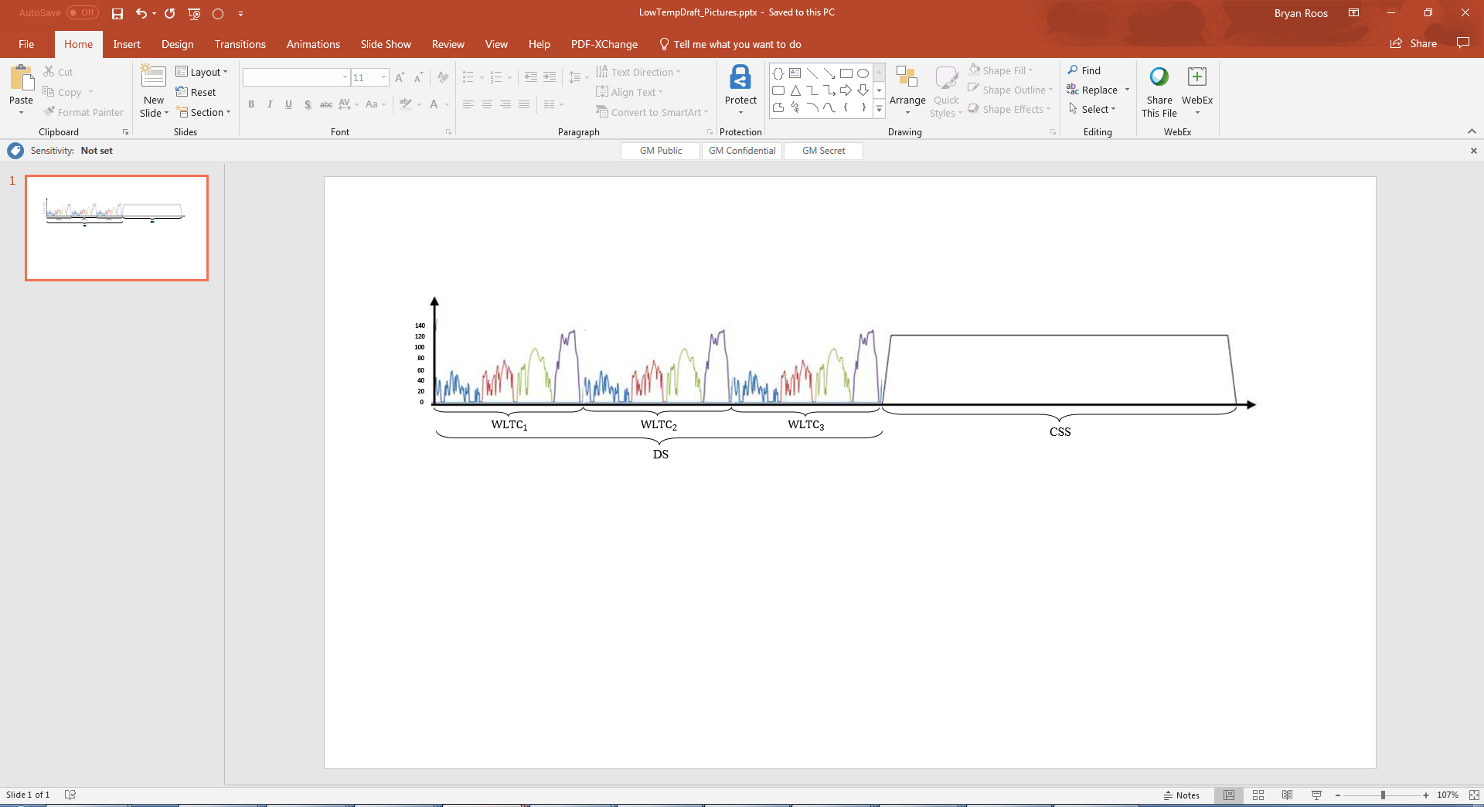

The dynamic segment DS is used to calculate the energy consumption of ~~the phase considered,~~ the applicable WLTP city cycle and the applicable WLTP test cycle.

3.4.4.4.1.1. Dynamic segment

The dynamic segment consists of (3) applicable WLTP test cycles (WLTC) in accordance with paragraph 1.4.2.1. of Annex 8.

3.4.4.4.1.2. Constant speed segment

~~If the interpolation method is applied, the same constant speed shall be applied within the interpolation family.~~

(a) Speed specification

The minimum speed of the constant speed segments shall be 100 km/h. At the request of manufacturer and with approval of the approval authority, a higher constant speed in the constant speed segments may be selected.

The acceleration to the constant speed level shall be smooth and accomplished within 1 minute after completion of the dynamic segments and, in the case of a break according to Table Ax/1, after initiating the powertrain start procedure.

If the maximum speed of the vehicle is lower than the required minimum speed for the constant speed segments according to the speed specification of this paragraph, the required speed in the constant speed segments shall be equal to the maximum speed of the vehicle.

(b) Distance determination of CSS

The length  of constant speed segment CSS may be calculated using the following equation:



where:

dCSS is the length of constant speed segment CSS, km;

PER is the estimated pure electric range of the considered PEV at low temperature, km;

dWLTC  is the length of the applicable WLTC cycle, km

3.4.4.4.1.3. Breaks

Breaks for the driver and/or operator are permitted only in the constant speed segments as prescribed in Table Ax/1.

Table Ax/1

Breaks for the driver and/or test operator

| *Distance driven in constant speed segment CSS (km)* | *Maximum total break (min)* |
| --- | --- |
| Up to 100 | 10 |
| Up to 150 | 20 |
| Up to 200 | 30 |
| Up to 300 | 60 |
| More than 300 | Shall be based on the manufacturer’s recommendation |
| *Note:* During a break, the powertrain shall be switched off. | |

~~3.4.4.3. REESS charging and measuring the recharged electric energy~~

~~3.4.4.3.1. After coming to a standstill according to paragraph 3.4.4.1.3. of this annex for the consecutive cycle Type 1 test procedure and in paragraph 3.4.4.2.3. of this annex for the shortened Type 1 test procedure, the vehicle shall be connected to the mains within 120 minutes.~~

~~The REESS is fully charged when the end-of-charge criterion, as defined in paragraph 2.2.3.2. of Appendix 4 to this annex, is reached.~~

~~3.4.4.3.2. The energy measurement equipment, placed between the vehicle charger and the mains, shall measure the recharged electric energy E~~~~AC~~ ~~delivered from the mains as well as its duration. Electric energy measurement may be stopped when the end-of-charge criterion, as defined in paragraph 2.2.3.2. of Appendix 4 to this annex, is reached.~~

~~3.5. NOVC-FCHVs~~

~~The test sequence, described in paragraphs 3.5.1. to 3.5.3. inclusive of this annex, as well as the corresponding REESS state of charge profile, is shown in Figure A8.App1/5 in Appendix 1 to this annex.~~

~~3.5.1. Preconditioning and soaking~~

~~Vehicles shall be conditioned and soaked according to paragraph 3.3.1. of this annex.~~

~~3.5.2. Test conditions~~

~~3.5.2.1. Vehicles shall be tested under charge-sustaining operating conditions as defined in paragraph 3.3.6. of this Regulation.~~

~~3.5.2.2. Selection of a driver-selectable mode~~

~~For vehicles equipped with a driver-selectable mode, the mode for the charge-sustaining Type 1 test shall be selected according to paragraph 3. of Appendix 6 to this annex.~~

~~3.5.3. Type 1 test procedure~~

~~3.5.3.1. Vehicles shall be tested according to the Type 1 test procedure described in Annex B6 and fuel consumption calculated according to Appendix 7 to this annex.~~

~~3.5.3.2. If required, fuel consumption shall be corrected according to Appendix 2 to this annex.~~

4. Calculations for hybrid electric and pure electric vehicles ~~and compressed hydrogen fuel cell vehicles~~

4.1. Calculations of gaseous emission compounds, particulate matter emission and particle number emission

4.1.1. Charge-sustaining mass emission of gaseous emission compounds, particulate matter emission and particle number emission for OVC-HEVs and NOVC-HEVs

The charge-sustaining particulate matter emission shall be calculated according to paragraph 3.3. of Annex B7.

The charge-sustaining particle number emission shall be calculated according to paragraph 4. of Annex B7.

4.1.1.1. Stepwise procedure for calculating the final test results of the charge-sustaining ~~Type 1~~ test for NOVC-HEVs and OVC-HEVs

The results shall be calculated in the order described in Table A8/5. All applicable results in the column "Output" shall be recorded. The column "Process" describes the paragraphs to be used for calculation or contains additional calculations.

For the purpose of this table, the following nomenclature within the equations and results is used:

complete applicable test cycle (to be calculated both for results after 3-phases and for results after 4-phases);

every applicable cycle phase, for the purpose of EAERcity calculation (as applicable), p shall represent the city driving cycle;

applicable criteria emission component (except CO2);

CS charge-sustaining;

CO2 CO2 mass emission.

Table A8/5

**Calculation of final charge-sustaining gaseous emission and fuel efficiency values (FE applicable for results after 3 phases only)**

POST PROCESSING TABLE

4.1.1.2. In the case that the correction according to paragraph 1.1.4. of Appendix 2 to this annex was not applied, the following charge-sustaining CO2 mass emission shall be used:

where:

is the charge-sustaining CO2 mass emission of the charge-sustaining ~~Type 1~~ test according to Table A8/5, step No. 3, g/km;

is the non-balanced charge-sustaining CO2 mass emission of the charge-sustaining ~~Type 1~~ test, not corrected for the energy balance, determined according to Table A8/5, step No. 2, g/km.

4.1.1.3. If the correction of the charge-sustaining CO2 mass emission is required according to paragraph 1.1.3. of Appendix 2 to this annex or in the case that the correction according to paragraph 1.1.4. of Appendix 2 to this annex was applied, the CO2 mass emission correction coefficient shall be determined according to paragraph 2. of Appendix 2 to this annex. The corrected charge-sustaining CO2 mass emission shall be determined using the following equation:

where:

is the charge-sustaining CO2 mass emission of the charge-sustaining ~~Type 1~~ test according to Table A8/5, step No. 3, g/km;

is the non-balanced CO2 mass emission of the charge-sustaining ~~Type 1~~ test, not corrected for the energy balance, determined according to Table A8/5, step No. 2, g/km;

is the electric energy consumption of the charge-sustaining ~~Type 1~~ test according to paragraph 4.3. of this annex, Wh/km;

is the CO2 mass emission correction coefficient according to paragraph 2.3.2. of Appendix 2 to this annex, (g/km)/(Wh/km).

4.1.1.4. In the case that phase-specific CO2 mass emission correction coefficients have not been determined, the phase-specific CO2 mass emission shall be calculated using the following equation:

where:

is the charge-sustaining CO2 mass emission of phase p of the charge-sustaining ~~Type 1~~ test according to Table A8/5, step No. 3, g/km;

is the non-balanced CO2 mass emission of phase p of the charge-sustaining ~~Type 1~~ test, not corrected for the energy balance, determined according to Table A8/5, step No. 1, g/km;

is the electric energy consumption of phase p of the charge-sustaining ~~Type 1~~ test according to paragraph 4.3. of this annex, Wh/km;

is the CO2 mass emission correction coefficient according to paragraph 2.3.2. of Appendix 2 to this annex, (g/km)/(Wh/km).

4.1.1.5. In the case that phase-specific CO2 mass emission correction coefficients have been determined, the phase-specific CO2 mass emission shall be calculated using the following equation:

where:

is the charge-sustaining CO2 mass emission of phase p of the charge-sustaining ~~Type 1~~ test according to Table A8/5, step No. 3, g/km;

is the non-balanced CO2 mass emission of phase p of the charge-sustaining ~~Type 1~~ test, not corrected for the energy balance, determined according to Table A8/5, step No. 1, g/km;

is the electric energy consumption of phase p of the charge-sustaining ~~Type 1~~ test, determined according to paragraph 4.3. of this annex, Wh/km;

s the CO2 mass emission correction coefficient according to paragraph 2.3.2.2. of Appendix 2 to this annex, (g/km)/(Wh/km);

is the index of the individual phase within the applicable WLTP test cycle.

4.1.2. Charge-depleting CO2 mass emission for OVC-HEVs

For 4-phase WLTP test

The utility factor-weighted charge-depleting CO2 mass emission MCO2,CD shall be calculated using the following equation:

For 3-phase WLTP test

The charge-depleting CO2 mass emission MCO2,CD shall be calculated using the following equation:

where:

is the utility factor-weighted charge-depleting CO2 mass emission, g/km;

is the CO2 mass emission determined according to paragraph 3.2.1. of Annex B7 of phase j of the charge-depleting ~~Type 1~~ test, g/km;

is the utility factor of phase j according to Appendix 5 to this annex;

is the index number of the considered phase;

is the number of phases driven up to the end of the transition cycle according to paragraph 3.2.4.4. of this annex.

In the case that the interpolation method is applied, k shall be the number of phases driven up to the end of the transition cycle of vehicle L,

If the transition cycle number driven by vehicle H, , and, if applicable, by an individual vehicle within the vehicle interpolation family, , is lower than the transition cycle number driven by vehicle L, , the confirmation cycle of vehicle H and, if applicable, an individual vehicle shall be included in the calculation. The CO2 mass emission of each phase of the confirmation cycle shall be subsequently corrected to an electric energy consumption of zero by using the CO2 correction coefficient according to Appendix 2 to this annex.

4.1.3. This paragraph is applicable for 4-phase WLTP test only:

Utility factor-weighted mass emissions of gaseous compounds, particulate matter emission and particle number emission for OVC-HEVs

4.1.3.1. The utility factor-weighted mass emission of gaseous compounds

where:

is the utility factor-weighted mass emission compound i, g/km;

is the index of the considered gaseous emission compound (except CO2);

is the utility factor of phase j according to Appendix 5 to this annex;

is the mass emission of the gaseous emission compound i determined according to paragraph 3.2.1. of Annex B7 of phase j of the charge-depleting ~~Type 1~~ test, g/km;

is the charge-sustaining mass emission of gaseous emission compound i for the charge-sustaining ~~Type 1~~ test according to Table A8/5, step No. 6, g/km;

is the index number of the considered phase;

is the number of phases driven until the end of the transition cycle according to paragraph 3.2.4.4. of this annex.

For calculating the utility-factor weighted CO2 mass emission the following equation shall be used:

where:

is the utility-factor weighted charge-depleting CO2 mass emission, g/km.

is the declared charge-depleting CO2 mass emission according to Table A8/8, step no. 14, g/km.

is the declared charge-sustaining CO2 mass emission according to Table A8/5, step no. 7, g/km.

is the average of the sum of utility factors of each charge-depleting test.

j is the index number of the considered phase;

k is the number of phases driven until the end of the transition cycle according to paragraph 3.2.4.4. of this annex.

In the case that the interpolation method is applied for CO2, k shall be the number of phases driven up to the end of the transition cycle of vehicle L for the application of both equations of this paragraph.

If the transition cycle number driven by vehicle H, , and, if applicable, by an individual vehicle within the vehicle interpolation family is lower than the transition cycle number driven by vehicle L, , the confirmation cycle of vehicle H and, if applicable, an individual vehicle shall be included in the calculation. The CO2 mass emission of each phase of the confirmation cycle shall then be corrected to an electric energy consumption of zero ) by using the CO2 correction coefficient according to Appendix 2 to this annex.

4.1.3.2. The utility factor-weighted particle number emission shall be calculated using the following equation:

where:

is the utility factor-weighted particle number emission, particles per kilometre;

is the utility factor of phase j according to Appendix 5 to this annex;

is the particle number emission during phase j determined according to paragraph 4. of Annex B7 for the charge-depleting ~~Type 1~~ test, particles per kilometre;

is the particle number emission determined according to paragraph 4.1.1. of this annex for the charge-sustaining ~~Type 1~~ test, particles per kilometre;

is the index number of the considered phase;

is the number of phases driven until the end of transition cycle n according to paragraph 3.2.4.4. of this annex.

4.1.3.3. The utility factor-weighted particulate matter emission shall be calculated using the following equation:

where:

is the utility factor-weighted particulate matter emission, mg/km;

is the utility factor of cycle c according to Appendix 5 to this annex;

is the charge-depleting particulate matter emission during cycle c determined according to paragraph 3.3. of Annex B7 for the charge-depleting ~~Type 1~~ test, mg/km;

is the particulate matter emission of the charge-sustaining ~~Type 1~~ test according to paragraph 4.1.1. of this annex, mg/km;

is the index number of the cycle considered;

is the number of applicable WLTP test cycles driven until the end of the transition cycle n according to paragraph 3.2.4.4. of this annex.

4.2. Calculation of fuel consumption and fuel efficiency

4.2.1. Charge-sustaining fuel consumption and fuel efficiency for OVC-HEVs and NOVC-HEVs ~~and NOVC-FCHVs~~

4.2.1.1. The charge-sustaining fuel consumption and fuel efficiency for OVC-HEVs and NOVC-HEVs shall be calculated stepwise according to Table A8/6.

Table A8/6

**Calculation of final charge-sustaining fuel consumption and fuel efficiency for OVC-HEVs, NOVC-HEVs (FE applicable for results after 3 phases only)**

POST PROCESSING TABLE

~~4.2.1.2. Charge-sustaining fuel consumption and fuel efficiencyfor NOVC-FCHVs~~

~~4.2.1.2.1. Stepwise procedure for calculating the final test fuel consumption and fuel efficiency results of the charge-sustaining Type 1 test for NOVC-FCHVs~~

~~The results shall be calculated in the order described in Table A8/7. All applicable results in the column "Output" shall be recorded. The column "Process" describes the paragraphs to be used for calculation or contains additional calculations.~~

~~For the purpose of this table, the following nomenclature within the equations and results is used:~~

~~complete applicable test cycle;~~

~~every applicable cycle phase; [for the purpose of EAER~~~~city~~ ~~calculation (as applicable), p shall represent the city driving cycle;]~~

~~CS charge-sustaining~~

~~Table A8/7~~

**~~Calculation of final charge-sustaining fuel consumption for NOVC-FCHVs~~** **~~(FE applicable for results after 3 phases only)~~**

~~For results after 4-phases all the calculations in this table shall be for the complete cycle~~

~~For the 3-phase WLTP all the calculations in this table shall be for the 3-phase cycle and also for individual phases;~~

|  |  |  |  |  |
| --- | --- | --- | --- | --- |
| *~~Step No.~~* | *~~Source~~* | *~~Input~~* | *~~Process~~* | *~~Output~~* |
| ~~1~~ | ~~Appendix 7 to this annex.~~ | ~~Non-balanced charge-sustaining fuel consumption~~  ~~FC~~~~CS,nb,~~ ~~kg/100km~~ | ~~Charge-sustaining fuel consumption FC~~~~CS,c,1~~ ~~according to paragraph 2.2.6. of Appendix 7 to this annex.~~  ~~The calculation of fuel consumption shall be performed separately for the applicable cycle and its phases.~~  ~~For that purpose, the applicable phase or cycle FC values shall be used;~~  ~~Phase-specific values according to paragraph 2.2.7. of Appendix 7 to this annex).~~ | ~~, kg/100 km; , kg/100 km.~~ |
| ~~2~~ | ~~Output step 1~~ | ~~, kg/100 km; , kg/100 km.~~ | ~~REESS electric energy change correction.~~  ~~Paragraphs 4.2.1.2.2. to 4.2.1.2.5. (where applicable) inclusive of this annex.~~ | ~~, kg/100 km;~~  ~~For results after 3 phases~~  ~~, kg/100 km;~~ |
| ~~3~~  ~~Result of a single test.~~ | ~~Output step 2~~ | ~~, kg/100 km; , kg/100 km.~~ | ~~For results after 3 phases~~  ~~Conversion of fuel consumption FC into fuel efficiency FE~~ | ~~, kg/100 km; , kg/100 km. , km/kg. , km/kg.~~ |
| ~~4~~ | ~~Output step 3~~ | ~~For every test: , kg/100 km; , kg/100 km. , km/kg. , km/kg.~~ | ~~Averaging of tests and declared value according to paragraphs 1.2. to 1.2.3. inclusive of Annex B6.~~ | ~~, kg/100 km; , kg/100 km. , km/kg. , km/kg.~~ |
| ~~5~~  ~~Interpolation family result.~~  ~~If the interpolation method is not applied, step No. 6 is not required and the output of this step is the final result.~~  ~~results of a Type 1 test for a test vehicle.~~ | ~~Output step 4~~ | ~~, kg/100 km; , kg/100 km; , kg/100 km.~~  ~~, km/kg. , km/kg; , km/ kg.~~ | ~~Alignment of phase values. Paragraph 1.2.4. of Annex B6,~~  ~~and:~~  ~~FC and FE values shall be rounded according to paragraph 6.1.8. of this Regulation to the second place of decimal.~~  ~~In the case that the interpolation method is not applied, final rounding shall be applied according to paragraph 6.1.8. of this Regulation to the first place of decimal.~~ | ~~, kg/100 km; , kg/100 km FE~~~~CS,p,5~~~~, km/kg. FE~~~~CS,c,5~~~~, km/kg.~~ |
| ~~6~~  ~~Result of an individual vehicle.~~  ~~Final FC result.~~ | ~~Output step 5~~ | ~~, kg/100 km;~~ | ~~Fuel consumption calculation according to paragraph 4.5.5.1.3. of this annex for individual vehicles in an interpolation family.~~  ~~Final rounding of individual vehicle values shall be performed according to paragraph 6.1.8. of this Regulation.~~  ~~FC values shall be rounded to the first place of decimal.~~  ~~Output is available for each individual vehicle.~~ | ~~, kg/100 km;~~ |

~~4.2.1.2.2. In the case that the correction according to paragraph 1.1.4. of Appendix 2 to this annex was not applied, the following charge-sustaining fuel consumption shall be used:~~

~~where:~~

~~is the charge-sustaining fuel consumption of the charge-sustaining Type 1 test according to Table A8/7, step No. 2, kg/100 km;~~

~~is the non-balanced charge-sustaining fuel consumption of the charge-sustaining Type 1 test, not corrected for the energy balance, according to Table A8/7, step No. 1, kg/100 km.~~

~~4.2.1.2.3. If the correction of the fuel consumption is required according to paragraph 1.1.3. of Appendix 2 to this annex or in the case that the correction according to paragraph 1.1.4. of Appendix 2 to this annex was applied, the fuel consumption correction coefficient shall be determined according to paragraph 2. of Appendix 2 to this annex. The corrected charge-sustaining fuel consumption shall be determined using the following equation:~~

~~where:~~

~~is the charge-sustaining fuel consumption of the charge-sustaining Type 1 test according to Table A8/7, step No. 2, kg/100 km;~~

~~is the non-balanced fuel consumption of the charge-sustaining Type 1 test, not corrected for the energy balance, according to Table A8/7, step No. 1, kg/100 km;~~

~~is the electric energy consumption of the charge-sustaining Type 1 test according to paragraph 4.3. of this annex, Wh/km;~~

~~is the fuel consumption correction coefficient according to paragraph 2.3.1. of Appendix 2 to this annex, (kg/100 km)/(Wh/km).~~

~~4.2.1.2.4. In the case that phase-specific fuel consumption correction coefficients have not been determined, the phase-specific fuel consumption shall be calculated using the following equation:~~

~~where:~~

~~is the charge-sustaining fuel consumption of phase p of the charge-sustaining Type 1 test according to Table A8/7, step No. 2, kg/100 km;~~

~~is the non-balanced fuel consumption of phase p of the charge-sustaining Type 1 test, not corrected for the energy balance, according to Table A8/7, step No. 1, kg/100 km;~~

~~is the electric energy consumption of phase p of the charge-sustaining Type 1 test, determined according to paragraph 4.3. of this annex, Wh/km;~~

~~is the fuel consumption correction coefficient according to paragraph 2.3.1. of Appendix 2 to this annex, (kg/100 km)/(Wh/km);~~

~~is the index of the individual phase within the applicable WLTP test cycle.~~

~~4.2.1.2.5.~~

~~In the case that phase-specific fuel consumption correction coefficients have been determined, the phase-specific fuel consumption shall be calculated using the following equation:~~

~~where:~~

~~is the charge-sustaining fuel consumption of phase p of the charge-sustaining Type 1 test according to Table A8/7, step No. 2, kg/100 km;~~

~~is the non-balanced fuel consumption of phase p of the charge-sustaining Type 1 test, not corrected for the energy balance, according to Table A8/7, step No. 1, kg/100 km;~~

~~is the electric energy consumption of phase p of the charge-sustaining Type 1 test, determined according to paragraph 4.3. of this annex, Wh/km;~~

~~is the fuel consumption correction coefficient for the correction of the phase p according to paragraph 2.3.1.2. of Appendix 2 to this annex, (kg/100 km)/(Wh/km);~~

~~is the index of the individual phase within the applicable WLTP test cycle.~~

4.2.2. The charge-depleting fuel consumption for OVC-HEVs

For 4-phase WLTP test:

The utility factor-weighted charge-depleting fuel consumption shall be calculated using the following equation:

where:

is the utility factor weighted charge-depleting fuel consumption, l/100 km;

is the fuel consumption for phase j of the charge-depleting ~~Type 1~~ test, determined according to paragraph 6. of Annex B7, l/100 km;

is the utility factor of phase j according to Appendix 5 to this annex;

is the index number for the considered phase;

is the number of phases driven up to the end of the transition cycle according to paragraph 3.2.4.4. of this annex.

In the case that the interpolation method is applied, k shall be the number of phases driven up to the end of the transition cycle of vehicle L

If the transition cycle number driven by vehicle H, , and, if applicable, by an individual vehicle within the vehicle interpolation family, , is lower than the transition cycle number driven by vehicle L the confirmation cycle of vehicle H and, if applicable, an individual vehicle shall be included in the calculation. The fuel consumption of each phase of the confirmation cycle shall be calculated according to paragraph 6. of Annex B7 with the criteria emission over the complete confirmation cycle and the applicable CO2 phase value which shall be corrected to an electric energy consumption of zero, , by using the CO2 mass correction coefficient (KCO2) according to Appendix 2 to this annex.

For 3-phase WLTP test

The charge-depleting fuel efficiency shall be calculated using the following equation:

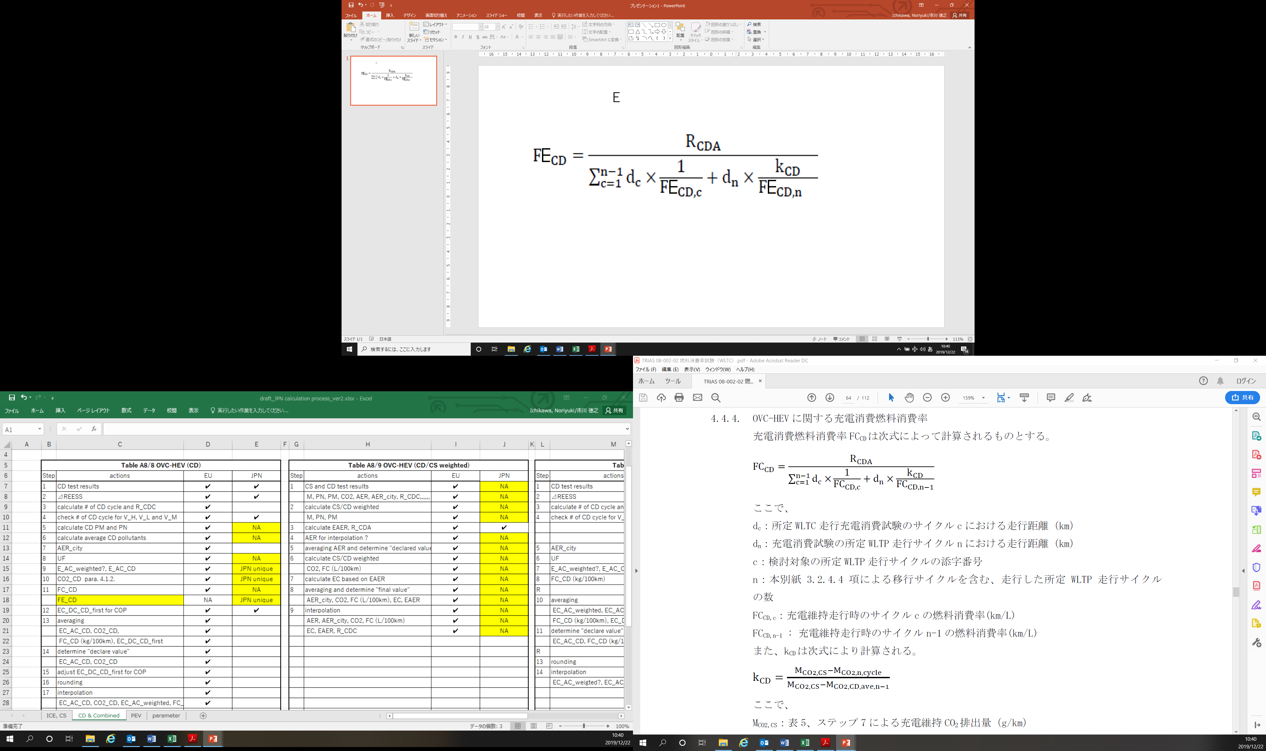where:

is the charge-depleting fuel efficiency, km/l;

actual charge-depleting range defined in paragraph 4.4.5. of this Annex, km;

is the fuel efficiency for cycle c of the charge-depleting ~~Type 1~~ test, determined according to paragraph 6. of Annex B7, km/l;

is the index number for the considered cycle;

n is the number of applicable WLTP test cycles driven up to the end of the transition cycle according to paragraph 3.2.4.4. of this annex

is the distance driven in the applicable WLTP test cycle c of the charge-depleting ~~Type 1~~ test, km;

is the distance driven in the applicable WLTP test cycle n of the charge-depleting ~~Type 1~~ test, km;

4.2.3. This paragraph is applicable only for 4-phase WLTP test

Utility factor-weighted fuel consumption for OVC-HEVs

The utility factor-weighted fuel consumption for OVC-HEVs from the charge-depleting and charge-sustaining ~~Type 1~~ test shall be calculated using the following equation:

where:

is the utility factor-weighted fuel consumption, l/100 km;

is the utility factor of phase jaccording to Appendix 5 to this annex;

is the fuel consumption of phase j of the charge-depleting ~~Type 1~~ test, determined according to paragraph 6. of Annex B7, l/100 km;

is the declared charge-depleting CO2 mass emission according to Table A8/8, step no. 14, g/km;

is the average charge-depleting CO2 mass emission according to Table A8/8, step no. 13, g/km;

is the fuel consumption determined according to Table A8/6, step No. 1, l/100 km;

is the index number for the considered phase;

is the number of phases driven up to the end of the transition cycle according to paragraph 3.2.4.4. of this annex.

In the case that the interpolation method is applied, k shall be the number of phases driven up to the end of the transition cycle of vehicle L

If the transition cycle number driven by vehicle H, , and, if applicable, by an individual vehicle within the vehicle interpolation family is lower than the transition cycle number driven by vehicle L, , the confirmation cycle of vehicle H and, if applicable, an individual vehicle shall be included in the calculation.

The fuel consumption of each phase of the confirmation cycle shall be calculated according to paragraph 6. of Annex B7 with the criteria emission over the complete confirmation cycle and the applicable CO2 phase value which shall be corrected to an electric energy consumption of zero  by using the CO2 mass correction coefficient (KCO2) according to Appendix 2 to this annex.

4.3. Calculation of electric energy consumption

For the determination of the electric energy consumption based on the current and voltage determined according to Appendix 3 to this annex, the following equations shall be used:

where:

is the electric energy consumption over the considered period j based on the REESS depletion, Wh/km;

is the electric energy change of all REESSs during the considered period j, Wh;

is the distance driven in the considered period j, km;

and

where:

is the electric energy change of REESS i during the considered period j, Wh;

and

where:

is the voltage of REESS i during the considered period j determined according to Appendix 3 to this annex, V;

is the time at the beginning of the considered period j, s;

is the time at the end of the considered period j, s;

is the electric current of REESS i during the considered period j determined according to Appendix 3 to this annex, A;

is the index number of the considered REESS;

is the total number of REESS;

is the index for the considered period, where a period can be any combination of phases or cycles;

is the conversion factor from Ws to Wh.

4.3.1. This paragraph is applicable only for 4-phase WLTP test

Utility factor-weighted charge-depleting electric energy consumption based on the recharged electric energy from the mains for OVC-HEVs

The utility factor-weighted charge-depleting electric energy consumption based on the recharged electric energy from the mains shall be calculated using the following equation:

where:

is the utility factor-weighted charge-depleting electric energy consumption based on the recharged electric energy from the mains, Wh/km;

is the utility factor of phase j according to Appendix 5 to this annex;

is the electric energy consumption based on the recharged electric energy from the mains of phase j, Wh/km;

and

where:

is the electric energy consumption based on the REESS depletion of phase j of the charge-depleting ~~Type 1~~ test according to paragraph 4.3. of this annex, Wh/km;

is the recharged electric energy from the mains determined according to paragraph 3.2.4.6. of this annex, Wh;

is the electric energy change of all REESSs of phase j according to paragraph 4.3. of this annex, Wh;

is the index number for the considered phase;

is the number of phases driven up to the end of the transition cycle according to paragraph 3.2.4.4. of this annex.

In the case that the interpolation method is applied, k is the number of phases driven up to the end of the transition cycle of L,nveh_L.

4.3.2. This paragraph is applicable for 4-phase WLTP test only:

Utility factor-weighted electric energy consumption based on the recharged electric energy from the mains for OVC-HEVs

The utility factor-weighted electric energy consumption based on the recharged electric energy from the mains shall be calculated using the following equation:

where:

is the utility factor-weighted electric energy consumption based on the recharged electric energy from the mains, Wh/km;

is the utility factor of phase j according to Appendix 5 to this annex;

is the declared charge-depleting electric energy consumption based on the recharged electric energy from the mains for OVC-HEVs according to Table A8/8, step 14, Wh/km;

is the index number for the considered phase;

is the number of phases driven up to the end of the transition cycle according to paragraph 3.2.4.4. of this annex.

In the case that the interpolation method is applied, k is the number of phases driven up to the end of the transition cycle of vehicle L, nveh_L.

4.3.3. Electric energy consumption for OVC-HEVs

4.3.3.1. Determination of cycle-specific electric energy consumption

The electric energy consumption based on the recharged electric energy from the mains and the equivalent all-electric range shall be calculated using the following equation:

where:

is the electric energy consumption of the applicable WLTP test cycle based on the recharged electric energy from the mains and the equivalent all-electric range, Wh/km;

is the recharged electric energy from the mains according to paragraph 3.2.4.6. of this annex, Wh;

is the equivalent all-electric range for OVC-HEVs according to paragraph 4.4.4.1. of this annex, km.

4.3.3.2. Determination of phase-specific electric energy consumption

The phase-specific electric energy consumption based on the recharged electric energy from the mains and the phase-specific equivalent all-electric range shall be calculated using the following equation:

where:

is the phase-specific electric energy consumption based on the recharged electric energy from the mains and the equivalent all-electric range, Wh/km;

is the recharged electric energy from the mains according to paragraph 3.2.4.6. of this annex, Wh;

is the phase-specific equivalent all-electric range according to paragraph 4.4.4.2. of this annex, km.

4.3.4. Electric energy consumption of PEVs

4.3.4.1. The electric energy consumption determined in this paragraph shall be calculated only if the vehicle was able to follow the applicable test cycle within the speed trace tolerances according to paragraph 2.6.8.3.1.2. of Annex B6 during the entire considered period.

4.3.4.2. Electric energy consumption determination of the applicable WLTP test cycle

The electric energy consumption of the applicable WLTP test cycle based on the recharged electric energy from the mains and the pure electric range shall be calculated using the following equation:

where:

is the electric energy consumption of the applicable WLTP test cycle based on the recharged electric energy from the mains and the pure electric range for the applicable WLTP test cycle, Wh/km;

is the recharged electric energy from the mains according to paragraph 3.1.5 of Appendix 4 for a Type 6 test, Wh;

is the pure electric range for the applicable WLTP test cycle as calculated according to paragraph 4.4.2.3.1. ~~or paragraph 4.4.2.2.1.~~ of this annex, depending on the PEV test procedure used, km.

4.3.4.3. Electric energy consumption determination of the applicable WLTP city test cycle (if applicable)

The electric energy consumption of the applicable WLTP city test cycle based on the recharged electric energy from the mains and the pure electric range for the applicable WLTP city test cycle shall be calculated using the following equation:

where:

is the electric energy consumption of the applicable WLTP city test cycle based on the recharged electric energy from the mains and the pure electric range for the applicable WLTP city test cycle, Wh/km;

is the recharged electric energy from the mains according to paragraph 3.1.5 of Appendix 4 for a Type 6 test, Wh;

is the pure electric range for the applicable WLTP city test cycle as calculated according to paragraph 4.4.2.3.2. ~~or paragraph 4.4.2.2.2.~~ of this annex, depending on the PEV test procedure used, km.

~~4.3.4.4. Electric energy consumption determination of the phase-specific values~~

~~The electric energy consumption of each individual phase based on the recharged electric energy from the mains and the phase-specific pure electric range shall be calculated using the following equation:~~

~~where:~~

~~is the electric energy consumption of each individual phase p based on the recharged electric energy from the mains and the phase-specific pure electric range, Wh/km~~

~~is the recharged electric energy from the mains according to paragraph 3.4.4.3. of this annex, Wh;~~

~~is the phase-specific pure electric range as calculated according to paragraph 4.4.2.1.3. or paragraph 4.4.2.2.3. of this annex, depending on the PEV test procedure used, km.~~

4.4. Calculation of electric ranges

4.4.1. All-electric ranges AER and for OVC-HEVs

4.4.1.1. All-electric range AER

The all-electric range AER for OVC-HEVs shall be determined from the charge-depleting ~~Type 1~~ test described in paragraph 3.2.4.3. of this annex as part of the Option 1 test sequence and is referenced in paragraph 3.2.6.1. of this annex as part of the Option 3 test sequence by driving the applicable WLTP test cycle according to paragraph 1.4.2.1. of this annex. The AER is defined as the distance driven from the beginning of the charge-depleting ~~Type 1~~ test to the point in time where the combustion engine starts consuming fuel.

4.4.1.2. All-electric range city (if applicable)

4.4.1.2.1. The all-electric range city for OVC-HEVs shall be determined from the charge-depleting ~~Type 1~~ test described in paragraph 3.2.4.1., 3.2.4.2. and 3.2.4.3. of this annex as part of the Option 1 test sequence by driving the applicable WLTP city test cycle according to paragraph 1.4.2.2. of this annex. The is defined as the distance driven from the beginning of the charge-depleting ~~Type 1~~ test to the point in time where the combustion engine starts consuming fuel.

The point in time where the combustion engine starts consuming fuel shall be considered as the break-off criterion and shall replace the break-off criterion described in paragraph 3.2.4.4.

4.4.1.2.2. As an alternative to paragraph 4.4.1.2.1. of this annex, the all-electric range city may be determined from the charge-depleting ~~Type 1~~ test described in paragraph 3.2.4.3. of this annex by driving the applicable WLTP test cycles according to paragraph 1.4.2.1. of this annex. In that case, the charge-depleting ~~Type 1~~ test by driving the applicable WLTP city test cycle shall be omitted and the all-electric range city shall be calculated using the following equation:

where:

AERcity is the all-electric range city, km;

is the usable REESS energy determined from the beginning of the charge-depleting ~~Type 1~~test described in paragraph 3.2.4.3. of this annex by driving applicable WLTP test cycles until the point in time when the combustion engine starts consuming fuel, Wh;

is the weighted electric energy consumption of the pure electrically driven applicable WLTP city test cycles of the charge-depleting ~~Type 1~~test described in paragraph 3.2.4.3. of this annex by driving applicable WLTP test cycle(s), Wh/km;

and

where:

is the electric energy change of all REESSs during phase j, Wh;

is the index number of the considered phase;

k+1 is the number of the phases driven from the beginning of the test until the point in time when the combustion engine starts consuming fuel;

and

where:

is the electric energy consumption for the jth pure electrically driven WLTP city test cycle of the charge-depleting ~~Type 1~~test according to paragraph 3.2.4.3. of this annex by driving applicable WLTP test cycles, Wh/km;

is the weighting factor for the jth pure electrically driven applicable WLTP city test cycle of the charge-depleting ~~Type 1~~ test according to paragraph 3.2.4.3. of this annex by driving applicable WLTP test cycles;

is the index number of the pure electrically driven applicable WLTP city test cycle considered;

is the number of pure electrically driven applicable WLTP city test cycles;

and

where:

is the electric energy change of all REESSs during the first applicable WLTP city test cycle of the charge-depleting ~~Type 1~~ test, Wh;

and

for .

4.4.2.3. Determination of the pure electric ranges when the PEV Type 6 test procedure is applied

4.4.2.3.1. The pure electric range for the applicable WLTP test cycle PER for PEVs shall be calculated from the PEV Type 6 test as described in paragraph 3.4.4.4. of this annex using the following equations:

where:

PERWLTC is the pure electric range at low temperature for the applicable WLTC test cycle for PEVs, km;

UBE  is the usable REESS energy at low temperature determined from the beginning of the PEV Type 6 test procedure until the break-off criterion as defined in paragraph 3.4.4.3.3. of this annex is reached, Wh;

ECDC,WLTC  is the weighted electric energy consumption at low temperature for the applicable WLTP test cycle of DS ~~DS~~~~1~~ ~~and DS~~~~2~~ of the PEV Type 6 test procedure Type 6 test, Wh/km;

and

where:

 is the electric energy change of all REESSs during WLTC1 of the PEV Type 6 test procedure, Wh;

 is the electric energy change of all REESSs during WLTC2 of the PEV Type 6 test procedure, Wh;

 is the electric energy change of all REESSs during WLTC3 of the PEV Type 6 test procedure, Wh;

 is the electric energy change of all REESSs during CSS of the PEV Type 6 test procedure, Wh;

and

where:

 is the electric energy consumption for the applicable WLTP test cycle of the PEV Type 6 test procedure according to paragraph 4.3 of this Annex x, Wh/km;

 is the weighting factor for the applicable WLTP test cycle of DS of the PEV Type 6 test procedure;

and:



where:

 is the weighting factor for the applicable WLTP test cycle of DS of the PEV Type 6 test procedure;

 is the electric energy change of all REESSs during the applicable 1st WLTP test cycle of the PEV Type 6 test procedure, Wh.

 is the electric energy change of all REESSs during the applicable 2nd WLTP test cycle of the PEV Type 6 test procedure, Wh.

~~[Electric consumption for alternate short Type 6 is calculated per 4.3.4.2 in this Annex.]~~

4.4.2.1.2. Pure Electric Range city (PERcity) (if applicable)

The pure electric range for the applicable WLTP city test cycle PERcity for PEVs shall be calculated from the PEV Type 6 test procedure as described in paragraph 4.4.2.3.1 of this annex using the following equations:

where:

PERcity is the pure electric range for the applicable WLTP city test cycle for PEVs, km;

is the usable REESS energy according to paragraph 4.4.2.3.1. of this annex, Wh;

is the weighted electric energy consumption for the applicable WLTP city test cycle of DS of the PEV Type 6 test procedure, Wh/km;

and

where:

is the electric energy consumption for the applicable WLTP city test cycle where the first applicable WLTP city test cycle of DSis indicated asj = 1, the second applicable WLTP city test cycle of DS is indicated as j = 2, ~~the first applicable WLTP city test cycle of DS~~~~2~~ ~~is indicated as j = 3 and the second applicable WLTP city test cycle of DS~~~~2~~ ~~is indicated as j = 4~~ the third applicable WLTP city test cycle of DS is indicated as j = 3 of the PEV Type 6 test procedure according to paragraph 4.3. of this annex, Wh/km;

is the weighting factor for the applicable WLTP city test cycle where the first applicable WLTP city test cycle of DSis indicated as j = 1, the second applicable WLTP city test cycle of DS is indicated as j = 2, ~~the first applicable WLTP city test cycle of DS~~~~2~~ ~~is indicated as j = 3 and the second applicable WLTP city test cycle of DS~~~~2~~ ~~is indicated as~~~~j = 4~~, the third applicable WLTP city test cycle of DS is indicated as j = 3

and

where:

is the energy change of all REESSs during the first applicable WLTP city test cycle of DS of the PEV Type 6 test procedure, Wh.

is the energy change of all REESSs during the second applicable WLTP city test cycle of DS of the PEV Type 6 test procedure, Wh.

~~4.4.2.1.3. The phase-specific pure electric range PER~~~~p~~ ~~for PEVs shall be calculated from the Type 1 test as described in paragraph 3.4.4.2. of this annex by using the following equations:~~

~~where:~~

~~PER~~~~p~~ ~~is the phase-specific pure electric range for PEVs, km;~~

~~is the usable REESS energy according to paragraph 4.4.2.1.1. of this annex, Wh;~~

~~is the weighted electric energy consumption for each individual phase of DS~~~~1~~ ~~and DS~~~~2~~ ~~of the shortened Type 1 test procedure, Wh/km;~~

~~In the case that phase p = low and phase p = medium, the following equations shall be used:~~

~~where:~~

~~is the electric energy consumption for phase p where the first phase p of DS~~~~1~~ ~~is indicated as j = 1, the second phase p of DS~~~~1~~ ~~is indicated as j = 2, the first phase p of DS~~~~2~~ ~~is indicated as j = 3 and the second phase p of DS~~~~2~~ ~~is indicated as j = 4 of the shortened Type 1 test procedure according to paragraph 4.3. of this annex, Wh/km;~~

~~is the weighting factor for phase p where the first phase p of DS~~~~1~~ ~~is indicated as j = 1, the second phase p of DS~~~~1~~ ~~is indicated as j = 2, the first phase p of DS~~~~2~~ ~~is indicated as j = 3, and the second phase p of DS~~~~2~~ ~~is indicated as j = 4 of the shortened Type 1 test procedure;~~

~~and~~

~~where:~~

~~is the energy change of all REESSs during the first phase p of DS~~~~1~~ ~~of the shortened Type 1 test procedure, Wh.~~

~~In the case that phase p = high and phase p = extra high, the following equations shall be used:~~

~~where:~~

~~is the electric energy consumption for phase p of DS~~~~j~~ ~~of the shortened Type 1 test procedure according to paragraph 4.3. of this annex, Wh/km;~~

~~is the weighting factor for phase p of DS~~~~j~~ ~~of the shortened Type 1 test procedure~~

~~and~~

~~where:~~

~~is the electric energy change of all REESSs during the first phase p of DS~~~~1~~ ~~of the shortened Type 1 test procedure, Wh.~~

~~4.4.2.2. Determination of the pure electric ranges when the consecutive cycle Type 6 test procedure is applied~~

~~4.4.2.2.1. The pure electric range for the applicable WLTP test cycle PER~~~~WLTP~~ ~~for PEVs shall be calculated from the Type 1 test as described in paragraph 3.4.4.1. of this annex using the following equations:~~

~~where:~~

~~is the usable REESS energy determined from the beginning of the consecutive cycle Type 6 test procedure until the break-off criterion according to paragraph 3.4.4.1.3. of this annex is reached, Wh;~~

~~is the electric energy consumption for the applicable WLTP test cycle determined from completely driven applicable WLTP test cycles of the consecutive cycle Type 6 test procedure, Wh/km;~~

~~and~~

~~where:~~

~~is the electric energy change of all REESSs during phase j of the consecutive cycle Type 1 test procedure, Wh;~~

~~is the index number of the phase;~~

~~is the number of phases driven from the beginning up to and including the phase where the break-off criterion is reached;~~

~~and:~~

~~where:~~

~~is the electric energy consumption for the applicable WLTP test cycle j of the consecutive cycle Type 6 test procedure according to paragraph 4.3. of this annex, Wh/km;~~

~~is the weighting factor for the applicable WLTP test cycle j of the consecutive cycle Type 6 test procedure;~~

~~is the index number of the applicable WLTP test cycle;~~

~~is the whole number of complete applicable WLTP test cycles driven;~~

~~and~~

~~where:~~

~~is the electric energy change of all REESSs during the first applicable WLTP test cycle of the consecutive Type 6 test cycle procedure, Wh.~~

~~4.4.2.2.2. Pure Electric Range city (PER~~~~city~~~~) (if applicable)~~

~~The pure electric range for the WLTP city test cycle PER~~~~city~~ ~~for PEVs shall be calculated from the Type 1 test as described in paragraph 3.4.4.1. of this annex using the following equations:~~

~~where:~~

~~PER~~~~city~~ ~~is the pure electric range for the WLTP city test cycle for PEVs, km;~~

~~is the usable REESS energy according to paragraph 4.4.2.2.1. of this annex, Wh;~~

~~is the electric energy consumption for the applicable WLTP city test cycle determined from completely driven applicable WLTP city test cycles of the consecutive cycle Type 6 test procedure, Wh/km;~~

~~and~~

~~where:~~

~~is the electric energy consumption for the applicable WLTP city test cycle j of the consecutive cycle Type 6 test procedure according to paragraph 4.3. of this annex, Wh/km;~~

~~is the weighting factor for the applicable WLTP city test cycle j of the consecutive cycle Type 6 test procedure;~~

~~is the index number of the applicable WLTP city test cycle;~~

~~is the whole number of complete applicable WLTP city test cycles driven;~~

~~and~~

~~where:~~

~~is the electric energy change of all REESSs during the first applicable WLTP city test cycle of the consecutive cycle Type 6 test procedure, Wh.~~

~~4.4.2.2.3. The phase-specific pure electric range PER~~~~p~~ ~~for PEVs shall be calculated from the Type 1 test as described in paragraph 3.4.4.1. of this annex using the following equations:~~

~~where:~~

~~PER~~~~p~~ ~~is the phase-specific pure electric range for PEVs, km;~~

~~is the usable REESS energy according to paragraph 4.4.2.2.1. of this annex, Wh;~~

~~is the electric energy consumption for the considered phase p determined from completely driven phases p of the consecutive cycle Type 1 test procedure, Wh/km;~~

~~and~~

~~where:~~

~~is the j~~~~th~~ ~~electric energy consumption for the considered phase p of the consecutive cycle Type 1 test procedure according to paragraph 4.3. of this annex, Wh/km;~~

~~is the j~~~~th~~ ~~weighting factor for the considered phase p of the consecutive cycle Type 1 test procedure;~~

~~is the index number of the considered phase p;~~

~~is the whole number of complete WLTC phases p driven;~~

~~and~~

~~where:~~

~~is the electric energy change of all REESSs during the first driven phase p during the consecutive cycle Type 1 test procedure, Wh.~~

4.4.3. Charge-depleting cycle range for OVC-HEVs

The charge-depleting cycle range RCDC shall be determined from the charge-depleting ~~Type 1~~ test described in paragraph 3.2.4.3. of this annex as part of the Option 1 test sequence and is referenced in paragraph 3.2.6.1. of this annex as part of the Option 3 test sequence. The is the distance driven from the beginning of the charge-depleting ~~Type 1~~ test to the end of the transition cycle according to paragraph 3.2.4.4. of this annex.

4.4.4. Equivalent all-electric range for OVC-HEVs

4.4.4.1. Determination of cycle-specific equivalent all-electric range

The cycle-specific equivalent all-electric range shall be calculated using the following equation:

where:

is the cycle-specific equivalent all-electric range, km;

is the declared charge-sustaining CO2 mass emission according to Table A8/5, step No. 7, g/km;

is the arithmetic average charge-depleting CO2 mass emission according to the equation below, g/km;

is the declared charge-depleting CO2 mass emission according to Table A8/8, step no. 14, g/km;

is the average charge-depleting CO2 mass emission according to Table A8/8, step no. 13, g/km;

is the charge-depleting cycle range according to paragraph 4.4.2. of this annex, km;

and

where:

is the arithmetic average charge-depleting CO2 mass emission, g/km. In the case of more than one charge-depleting test, the additional average of each test shall be calculated;

is the CO2 mass emission determined according to paragraph 3.2.1. of Annex B7 of phase j of the charge-depleting ~~Type 1~~ test, g/km;

is the distance driven in phase j of the charge-depleting ~~Type 1~~ test, km;

is the index number of the considered phase;

is the number of phases driven up to the end of the transition cycle n according to paragraph 3.2.4.4. of this annex.

4.4.4.2. Determination of the phase-specific equivalent all-electric range

The phase-specific equivalent all-electric range shall be calculated using the following equation:

where:

is the phase-specific equivalent all-electric range for the considered phase p, km;

is the phase-specific CO2 mass emission from the charge-sustaining ~~Type 1~~ test for the considered phase p according to Table A8/5, step No. 7, g/km;

is the declared charge-depleting CO2 mass emission according to Table A8/8, step no. 14, g/km;

is the average charge-depleting CO2 mass emission according to Table A8/8, step no. 13, g/km;

are the electric energy changes of all REESSs during the considered phase j, Wh. In the case of more than one charge-depleting test, the additional average of each test shall be calculated;

is the electric energy consumption over the considered phase p based on the REESS depletion, Wh/km;

is the index number of the considered phase;

k is the number of phases driven up to the end of the transition cycle n according to paragraph 3.2.4.4 of this annex;

and

where:

is the arithmetic average charge-depleting CO2 mass emission for the considered phase p, g/km. In the case of more than one charge-depleting test, the additional average of each test shall be calculated;

is the CO2 mass emission determined according to paragraph 3.2.1. of Annex B7 of phase p in cycle c of the charge-depleting ~~Type 1~~ test, g/km;

is the distance driven in the considered phase p of cycle c of the charge-depleting ~~Type 1~~ test, km;

is the index number of the considered applicable WLTP test cycle;

is the index of the individual phase within the applicable WLTP test cycle;

is the number of applicable WLTP test cycles driven up to the end of the transition cycle n according to paragraph 3.2.4.4. of this annex;

and:

where:

is the electric energy consumption of the considered phase p based on the REESS depletion of the charge-depleting ~~Type 1~~ test, Wh/km. In the case of more than one charge-depleting test, the additional average of each test shall be calculated;

is the electric energy consumption of the considered phase p of cycle c based on the REESS depletion of the charge-depleting ~~Type 1~~ test according to paragraph 4.3. of this annex, Wh/km;

is the distance driven in the considered phase p of cycle c of the charge-depleting ~~Type 1~~ test, km;

is the index number of the considered applicable WLTP test cycle;

is the index of the individual phase within the applicable WLTP test cycle;

is the number of applicable WLTP test cycles driven up to the end of the transition cycle n according to paragraph 3.2.4.4. of this annex.

For the 4-phase WLTP;The considered phase shall be the low phase, medium phase, high phase, extra high phase, and the city driving cycle.

For the 3-phase WLTP;The considered phase shall be the low phase, medium phase and high phase.

4.4.5. Actual charge-depleting range for OVC-HEVs

The actual charge-depleting range shall be calculated using the following equation:

where:

is the actual charge-depleting range, km;

is the charge-sustaining CO2 mass emission according to Table A8/5, step No. 7, g/km;

is the CO2 mass emission of the applicable WLTP test cycle n of the charge-depleting ~~Type 1~~ test, g/km;

is the arithmetic average CO2 mass emission of the charge-depleting ~~Type 1~~ test from the beginning up to and including the applicable WLTP test cycle   
(n-1), g/km;

is the distance driven in the applicable WLTP test cycle c of the charge-depleting ~~Type 1~~ test, km;

is the distance driven in the applicable WLTP test cycle n of the charge-depleting ~~Type 1~~ test, km;

is the index number of the considered applicable WLTP test cycle;

is the number of applicable WLTP test cycles driven including the transition cycle according to paragraph 3.2.4.4. of this annex;

and:

where:

is the arithmetic average CO2 mass emission of the charge-depleting ~~Type 1~~ test from the beginning up to and including the applicable WLTP test cycle (n-1), g/km;

is the CO2 mass emission determined according to paragraph 3.2.1. of Annex B7 of the applicable WLTP test cycle c of the charge-depleting ~~Type 1~~ test, g/km;

is the distance driven in the applicable WLTP test cycle c of the charge-depleting ~~Type 1~~ test, km;

is the index number of the considered applicable WLTP test cycle;

is the number of applicable WLTP test cycles driven including the transition cycle according to paragraph 3.2.4.4. of this annex.

~~4.5. Interpolation of individual vehicle values~~

~~4.5.1.1. Interpolation range for NOVC- HEVs and OVC-HEVs~~

~~4.5.1.1.1. The interpolation method shall only be used if the difference in charge-sustaining CO~~~~2~~ ~~over the applicable cycle resulting from step 8 of Table A8/5 in Annex B8 between test vehicles L and H is between a minimum of 5 g/km and a maximum defined in paragraph 4.5.1.1.2. of this annex.~~

~~4.5.1.1.2. The maximum difference in charge-sustaining CO~~~~2~~ ~~allowed over the applicable cycle resulting from the calculation of the charge-sustaining CO~~~~2~~ ~~mass emission M~~~~CO2,CS~~ ~~from step 8 in Table A8/5 of Annex B8 between test vehicles L and H shall be 20 per cent of the charge-sustaining CO~~~~2~~ ~~emissions from vehicle H plus 5 g/km, but shall be at least 15 g/km and not exceed 20 g/km. See Figure A8/3. This restriction does not apply for the application of a road load matrix family or when the calculation of the road load of vehicles L and H is based on the default road load.~~

~~Figure A8/3~~

**~~Interpolation range between vehicle H and vehicle L applied to EVs~~**

~~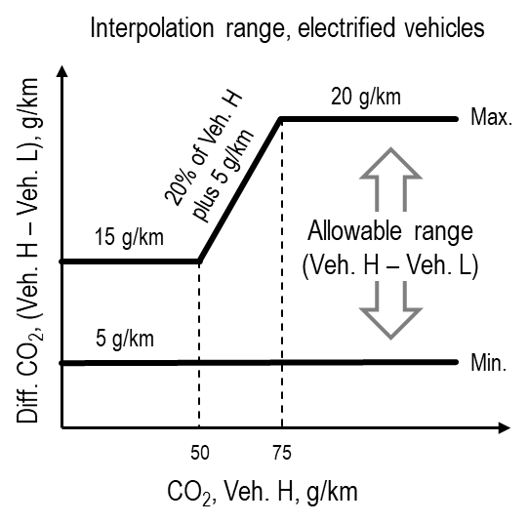~~

~~4.5.1.1.3. The allowed interpolation range defined in paragraph 4.5.1.1.2. of this annex may be increased by 10 g/km charge-sustaining CO~~~~2~~ ~~if a vehicle M is tested within that family and the conditions according to paragraph 4.5.1.1.5. of this annex are fulfilled. This increase is allowed only once within an interpolation family. See Figure A8/4.~~

~~Figure A8/4~~

**~~Interpolation range for EVs with vehicle M~~**

~~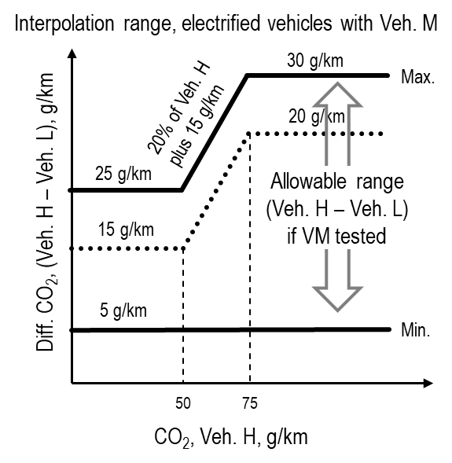~~

~~4.5.1.1.4. At the request of the manufacturer and with approval of the responsible authority, the application of the interpolation method on individual vehicle values within a family may be extended if the maximum extrapolation of an individual vehicle (Step 9 in Table A8/5) is not more than 3 g/km above the charge-sustaining CO~~~~2~~ ~~mass emission of vehicle H (Step 8 in Table A8/5) and/or is not more than 3 g/km below the charge-sustaining CO~~~~2~~ ~~mass emission of vehicle L (Step 8 in Table A8/5). This extrapolation is valid only within the absolute boundaries of the interpolation range specified in this paragraph.~~

~~For the application of a road load matrix family, or when the calculation of the road load of vehicles L and H is based on the default road load, extrapolation is not permitted.~~

~~4.5.1.1.5. Vehicle M~~

~~Vehicle M is a vehicle within the interpolation family between vehicles L and H with a cycle energy demand which is preferably closest to the average of vehicles L and H.~~

~~The limits of the selection of vehicle M (see Figure A8/5) are such that neither the difference in CO~~~~2~~ ~~mass emission between vehicles H and M nor the difference in charge-sustaining CO~~~~2~~ ~~mass emission between vehicles M and L is higher than the allowed charge-sustaining CO~~~~2~~ ~~range according to paragraph 4.5.1.1.2. of this annex. The defined road load coefficients and the defined test mass shall be recorded.~~

~~Figure A8/5~~

**~~Limits for the selection of vehicle M~~**

~~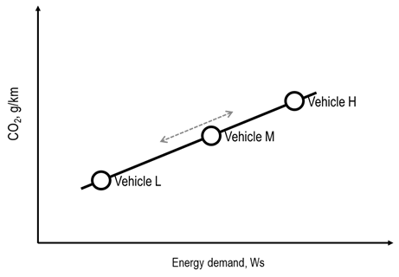~~

~~The linearity of charge-sustaining CO~~~~2~~ ~~mass emission for vehicle M shall be verified against the linearly interpolated charge-sustaining CO~~~~2~~ ~~mass emission between vehicle L and H over the applicable cycle by using the corrected measured values referring to step 6 M~~~~CO2,CS,c,6~~ ~~of Table A8/5 of this annex.~~

~~The linearity criterion for vehicle M shall be considered fulfilled if the charge-sustaining CO~~~~2~~ ~~mass emission of vehicle M over the applicable WLTC minus the charge-sustaining CO~~~~2~~ ~~mass emission derived by interpolation is less than 2 g/km or 3 per cent of the interpolated value, whichever value is less, but at least 1 g/km. See Figure A8/6.~~

~~Figure A8/6~~

**~~Linearity criterion for vehicle M~~**

~~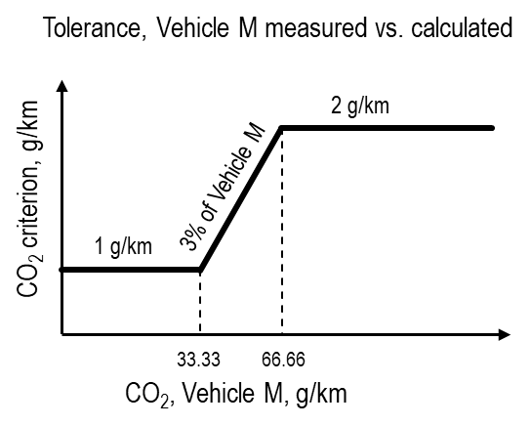~~

~~If the linearity criterion is fulfilled, the interpolation method shall be applicable for all individual vehicle values between vehicles L and H within the interpolation family.~~

~~If the linearity criterion is not fulfilled, the interpolation family shall be split into two sub-families for vehicles with a cycle energy demand between vehicles L and M, and vehicles with a cycle energy demand between vehicles M and H. In such a case, the final values of e.g. the charge-sustaining CO~~~~2~~ ~~mass emissions of vehicle M shall be determined according to the same process as for vehicles L or H. See Table A8/5, Table A8/6, Table A8/8 and Table A8/9.~~

~~For vehicles with a cycle energy demand between that of vehicles L and M, each parameter of vehicle H necessary for the application of the interpolation method on individual OVC-HEV and NOVC-HEV values, shall be substituted by the corresponding parameter of vehicle M.~~

~~For vehicles with a cycle energy demand between that of vehicles M and H, each parameter of vehicle L that is necessary for the application of the interpolation method on individual OVC-HEV and NOVC-HEV values shall be substituted by the corresponding parameter of vehicle M.~~

~~4.5.2. Calculation of energy demand per period~~

~~The energy demand and distance driven per period p applicable for individual vehicles in the interpolation family shall be calculated according to the procedure in paragraph 5. of Annex B7, for the sets k of road load coefficients and masses according to paragraph 3.2.3.2.3. of Annex B7.~~

~~4.5.3. Calculation of the interpolation coefficient for individual vehicles~~

~~The interpolation coefficient per period shall be calculated for each considered period p using the following equation:~~

~~where:~~

~~is the interpolation coefficient for the considered individual vehicle for period p;~~

~~is the energy demand for the considered period for vehicle L according to paragraph 5. of Annex B7, Ws;~~

~~is the energy demand for the considered period for vehicle H according to paragraph 5. of Annex B7, Ws;~~

~~is the energy demand for the considered period for the individual vehicle according to paragraph 5. of Annex B7, Ws;~~

~~is the index of the individual period within the applicable test cycle.~~

~~In the case that the considered period p is the applicable WLTP test cycle, is named .~~

~~4.5.4. This paragraph is applicable only for 4-phase WLTP test~~

~~Interpolation of the CO~~~~2~~ ~~mass emission for individual vehicles~~

~~4.5.4.1. Individual charge-sustaining CO~~~~2~~ ~~mass emission for OVC-HEVs and NOVC-HEVs~~

~~The charge-sustaining CO~~~~2~~ ~~mass emission for an individual vehicle shall be calculated using the following equation:~~

~~where:~~

~~is the charge-sustaining CO~~~~2~~ ~~mass emission for an individual vehicle of the considered period p according to Table A8/5, step No. 9, g/km;~~

~~is the charge-sustaining CO~~~~2~~ ~~mass emission for vehicle L of the considered period p according to Table A8/5, step No. 8, g/km;~~

~~is the charge-sustaining CO~~~~2~~ ~~mass emission for vehicle H of the considered period p according to Table A8/5, step No. 8, g/km;~~

~~is the interpolation coefficient for the considered individual vehicle for period p;~~

~~is the index of the individual period within the applicable WLTP test cycle.~~

~~The considered periods shall be the low phase, medium phase, high phase, extra high phase and the applicable WLTP test cycle.~~

~~4.5.4.2. Individual utility factor-weighted charge-depleting CO~~~~2~~ ~~mass emission for OVC-HEVs~~

~~The utility factor-weighted charge-depleting CO~~~~2~~ ~~mass emission for an individual vehicle shall be calculated using the following equation:~~

~~where:~~

~~is the utility factor-weighted charge-depleting CO~~~~2~~ ~~mass emission for an individual vehicle, g/km;~~

~~is the utility factor-weighted charge-depleting CO~~~~2~~ ~~mass emission for vehicle L, g/km;~~

~~is the utility factor-weighted charge-depleting CO~~~~2~~ ~~mass emission for vehicle H, g/km;~~

~~is the interpolation coefficient for the considered individual vehicle for the applicable WLTP test cycle.~~

~~4.5.4.3. Individual utility factor-weighted CO~~~~2~~ ~~mass emission for OVC-HEVs~~

~~The utility factor-weighted CO~~~~2~~ ~~mass emission for an individual vehicle shall be calculated using the following equation:~~

~~where:~~

~~is the utility factor-weighted CO~~~~2~~ ~~mass emission for an individual vehicle, g/km;~~

~~is the utility factor-weighted CO~~~~2~~ ~~mass emission for vehicle L, g/km;~~

~~is the utility factor-weighted CO~~~~2~~ ~~mass emission for vehicle H, g/km~~**~~;~~**

~~is the interpolation coefficient for the considered individual vehicle for the applicable WLTP test cycle.~~

~~4.5.5. Interpolation of the fuel consumption and fuel efficiency for individual vehicles~~

~~4.5.5.1. Individual charge-sustaining fuel consumption and fuel efficiency for OVC-HEVs and NOVC-HEVs~~

~~4.5.5.1.1. This paragraph is applicable only for 4-phase WLTP test~~

~~Individual charge-sustaining fuel consumption for OVC-HEVs and NOVC-HEVs~~

~~The charge-sustaining fuel consumption for an individual vehicle shall be calculated using the following equation:~~

~~where:~~

~~is the charge-sustaining fuel consumption for an individual vehicle of the considered period p according to Table A8/6, step No. 3, l/100 km;~~

~~is the charge-sustaining fuel consumption for vehicle L of the considered period p according to Table A8/6, step No. 2, l/100 km;~~

~~is the charge-sustaining fuel consumption for vehicle H of the considered period p according to Table A8/6, step No. 2, l/100 km;~~

~~is the interpolation coefficient for the considered individual vehicle for period p;~~

~~is the index of the individual period within the applicable WLTP test cycle.~~

~~The considered periods shall be the low phase, medium phase, high phase, extra high phase, and the applicable WLTP test cycle.~~

~~4.5.5.1.2. This paragraph is only applicable for the 3-phase WLTP:~~

~~Individual charge-sustaining fuel efficiency for OVC-HEVs and NOVC-HEVs~~

~~The charge-sustaining fuel efficiency for an individual vehicle shall be calculated using the following equation:~~

~~where:~~

~~is the charge-sustaining fuel consumption for an individual vehicle of the considered period p according to Table A8/6, step No. 3, km/l;~~

~~is the charge-sustaining fuel consumption for vehicle L of the considered period p according to Table A8/6, step No. 2, km/l;~~

~~is the charge-sustaining fuel consumption for vehicle H of the considered period p according to Table A8/6, step No. 2, km/l;~~

~~is the interpolation coefficient for the considered individual vehicle for period p;~~

~~is the index of the individual period within the applicable WLTP test cycle.~~

~~The considered periods shall be the low phase, medium phase, high phase and the applicable WLTP test cycle. 4.5.5.2. Individual charge depleting fuel consumption for OVC-HEVs~~

~~For 4-phase WLTP test~~

~~The utility factor-weighted charge-depleting fuel consumption for an individual vehicle shall be calculated using the following equation:~~

~~where:~~

~~is the utility factor-weighted charge-depleting fuel consumption for an individual vehicle, l/100 km;~~

~~is the utility factor-weighted charge-depleting fuel consumption for vehicle L, l/100 km;~~

~~is the utility factor-weighted charge-depleting fuel consumption for vehicle H, l/100 km;~~

~~is the interpolation coefficient for the considered individual vehicle for the applicable WLTP test cycle.~~

~~For 3-phase WLTP test~~

~~The charge-depleting fuel efficiency for an individual vehicle shall be calculated using the following equation:~~

~~where:~~

~~is the charge-depleting fuel efficiency for an individual vehicle, km/l;~~

~~is the charge-depleting fuel efficiency for vehicle L, km/l;~~

~~is the charge-depleting fuel efficiency for vehicle H, km/l;~~

~~is the interpolation coefficient for the considered individual vehicle for the applicable WLTP test cycle.~~

~~4.5.5.3. This paragraph is applicable only for 4-phase WLTP test~~

~~Individual utility factor-weighted fuel consumption for OVC-HEVs~~

~~The utility factor-weighted fuel consumption for an individual vehicle shall be calculated using the following equation:~~

~~where:~~

~~is the utility factor-weighted fuel consumption for an individual vehicle, l/100 km;~~

~~is the utility factor-weighted fuel consumption for vehicle L, l/100 km;~~

~~is the utility factor-weighted fuel consumption for vehicle H, l/100 km;~~

~~is the interpolation coefficient for the considered individual vehicle for the applicable WLTP test cycle.~~

~~4.5.6. Interpolation of electric energy consumption for individual vehicles~~

~~4.5.6.1. This paragraph is applicable only for 4-phase WLTP test~~

~~Individual utility factor-weighted charge-depleting electric energy consumption based on the recharged electric energy from the mains for OVC-HEVs~~

~~The utility factor-weighted charge-depleting electric energy consumption based on the recharged electric energy from for an individual vehicle shall be calculated using the following equation:~~

~~where:~~

~~is the utility factor-weighted charge-depleting electric energy consumption based on the recharged electric energy from the mains for an individual vehicle, Wh/km;~~

~~is the utility factor-weighted charge-depleting electric energy consumption based on the recharged electric energy from the mains for vehicle L, Wh/km;~~

~~is the utility factor-weighted charge-depleting electric energy consumption based on the recharged electric energy from the mains for vehicle H, Wh/km;~~

~~is the interpolation coefficient for the considered individual vehicle for the applicable WLTP test cycle.~~

~~4.5.6.2. This paragraph is applicable only for 4-phase WLTP test~~

~~Individual utility factor-weighted electric energy consumption based on the recharged electric energy from the mains for OVC-HEVs~~

~~The utility factor-weighted electric energy consumption based on the recharged electric energy from the mains for an individual vehicle shall be calculated using the following equation:~~

~~where:~~

~~is the utility factor weighted electric energy consumption based on the recharged electric energy from the mains for an individual vehicle, Wh/km;~~

~~is the utility factor weighted electric energy consumption based on the recharged electric energy from the mains for vehicle L, Wh/km;~~

~~is the utility factor weighted electric energy consumption based on the recharged electric energy from the mains for vehicle H, Wh/km;~~

~~is the interpolation coefficient for the considered individual vehicle for the applicable WLTP test cycle.~~

~~4.5.6.3. Individual electric energy consumption for OVC-HEVs and PEVs~~

~~The electric energy consumption for an individual vehicle according to paragraph 4.3.3. of this annex in the case of OVC-HEVs and according to paragraph 4.3.4. of this annex in the case of PEVs shall be calculated using the following equation:~~

~~where:~~

~~is the electric energy consumption for an individual vehicle for the considered period p, Wh/km;~~

~~is the electric energy consumption for vehicle L for the considered period p, Wh/km;~~

~~is the electric energy consumption for vehicle H for the considered period p, Wh/km;~~

~~is the interpolation coefficient for the considered individual vehicle for period p;~~

~~is the index of the individual period within the applicable test cycle.~~

~~For the 4-phase WLTP;~~

~~The considered periods shall be the low phase, medium phase, high phase, extra high phase, the applicable WLTP city test cycle and the applicable WLTP test cycle.~~

~~For the 3-phase WLTP ;~~

~~The considered periods shall be the low phase, medium phase, high phase and the applicable WLTP test cycle.~~

~~4.5.7. Interpolation of electric ranges for individual vehicles~~

~~4.5.7.1. Individual all-electric range for OVC-HEVs~~

~~If the following criterion~~

~~where:~~

~~is the all-electric range of vehicle L for the applicable WLTP test cycle, km;~~

~~is the all-electric range of vehicle H for the applicable WLTP test cycle, km;~~

~~is the actual charge-depleting range of vehicle L, km;~~

~~is the actual charge-depleting range of vehicle H, km;~~

~~is fulfilled, the all-electric range for an individual vehicle shall be calculated using the following equation:~~

~~where:~~

~~is the all-electric range for an individual vehicle for the considered period p, km;~~

~~is the all-electric range for vehicle L for the considered period p, km;~~

~~is the all-electric range for vehicle H for the considered period p, km;~~

~~is the interpolation coefficient for the considered individual vehicle for period p;~~

~~is the index of the individual period within the applicable test cycle.~~

~~For the 4-phase WLTP; The considered periods shall be the applicable WLTP city test cycle and the applicable WLTP test cycle.~~

~~For the 3-phase WLTP;The considered periods shall be the applicable WLTP test cycle.~~

~~If the criterion defined in this paragraph is not fulfilled, the AER determined for vehicle H is applicable to all vehicles within the interpolation family.~~

~~4.5.7.2. Individual pure electric range for PEVs~~

~~The pure electric range for an individual vehicle shall be calculated using the following equation:~~

~~where:~~

~~is the pure electric range for an individual vehicle for the considered period p, km;~~

~~is the pure electric range for vehicle L for the considered period p, km;~~

~~is the pure electric range for vehicle H for the considered period p, km;~~

~~is the interpolation coefficient for the considered individual vehicle for period p;~~

~~is the index of the individual period within the applicable test cycle.~~

~~For the 4-phase WLTP only;~~

~~The considered periods shall be the low phase, medium phase, high phase, extra high phase, the applicable WLTP city test cycle and the applicable WLTP test cycle.~~

~~For the 3-phase WLTP only;~~

~~The considered periods shall be the applicable WLTP test cycle.~~

~~4.5.7.3. Individual equivalent all-electric range for OVC-HEVs~~

~~The equivalent all-electric range for an individual vehicle shall be calculated using the following equation:~~

~~where:~~

~~is the equivalent all-electric range for an individual vehicle for the considered period p, km;~~

~~is the equivalent all-electric range for vehicle L for the considered period p, km;~~

~~is the equivalent all-electric range for vehicle H for the considered period p, km;~~

~~is the interpolation coefficient for the considered individual vehicle for period p;~~

~~is the index of the individual period within the applicable test cycle.~~

~~For the 4-phase WLTP;~~

~~The considered periods shall be the low phase, medium phase, high phase, extra high phase, the applicable WLTP city test cycle and the applicable WLTP test cycle.~~

~~For the 3-phase WLTP only;~~

~~The considered periods shall be the applicable WLTP test cycle.~~

~~4.5.8. Adjustment of values~~

~~The individual EAER value determined in accordance with paragraph 4.5.7.3. of this annex may be decreased by the OEM. In such cases:~~

~~The EAER phase values shall be decreased by the ratio of the decreased EAER value divided by the calculated EAER value. This shall not compensate for technical elements that would effectively require a vehicle to be excluded from the interpolation family.~~

4.6. Stepwise procedure for calculating the final test results of OVC-HEVs

In addition to the stepwise procedure for calculating the final charge-sustaining test results for gaseous emission compounds according to paragraph 4.1.1.1. of this annex and for fuel consumption and fuel efficiency according to paragraph 4.2.1.1. of this annex, paragraphs 4.6.1. and 4.6.2. of this annex describe the stepwise calculation of the final charge-depleting as well as the final charge-sustaining and charge-depleting weighted test results.

4.6.1. Stepwise procedure for calculating the final test results of the charge-depleting ~~Type 1~~ test for OVC-HEVs

The results shall be calculated in the order described in Table A8/8. All applicable results in the column "Output" shall be recorded. The column "Process" describes the paragraphs to be used for calculation or contains additional calculations.

For the purpose of Table A8/8, the following nomenclature within the equations and results is used:

c complete applicable test cycle;

p every applicable cycle phase; for the purpose of the city test cycle calculation (as applicable), p shall represent the city driving cycle;

i applicable criteria emission component;

CS charge-sustaining;

CO2 CO2 mass emission.

Table A8/8

**Calculation of final charge-depleting values (FE applicable for results after 3 phases only)**

POST PROCESSING TABLE

4.6.2. Stepwise procedure for calculating the final charge-sustaining and charge-depleting weighted test results of the ~~Type 1~~ test for OVC-HEVs

The results shall be calculated in the order described in Table A8/9. All applicable results in the column "Output" shall be recorded. The column "Process" describes the paragraphs to be used for calculation or contains additional calculations.

For the purpose of this table, the following nomenclature within the equations and results is used:

considered period is the complete applicable test cycle;

every applicable cycle phase; for the purpose of EAERcity calculation (as applicable), p shall represent the city driving cycle;

applicable criteria emission component (except for CO2);

j index for the considered period;

CS charge-sustaining;

CD charge-depleting;

CO2 CO2 mass emission;

REESS Rechargeable Electric Energy Storage System.

Table A8/9

**Calculation of final charge-depleting and charge-sustaining weighted values (FE applicable for results after 3 phases only)**

POST PROCESSING TABLE

4.7. Stepwise procedure for calculating the final test results of PEVs

The results shall be calculated ~~in the order described in Table A8/10 of the consecutive cycle procedure and~~ in the order described in Table Ax/2 in the case of the PEV Type 6 ~~shortened~~ test procedure. All applicable results in the column "Output" shall be recorded. The column "Process" describes the paragraphs to be used for calculation or contains additional calculations.

~~4.7.1. Stepwise procedure for calculating the final test results of PEVs in case of the consecutive cycles procedure~~

~~For the purpose of this table, the following nomenclature within the questions and results is used:~~

~~j index for the considered period.~~

~~Table A8/10~~

**~~Calculation of final PEV values determined by application of the consecutive cycle~~** ~~Type 1~~ **~~procedure~~**

~~For results after 4 phases;~~

~~The considered periods shall be the low phase, medium phase, high phase, extra high phase, the applicable WLTP city test cycle and the applicable WLTP test cycle.~~

~~For results after 3 phases;~~

~~The considered periods shall be the low phase, medium phase, high phase and the applicable WLTP test cycle.~~

~~POST PROCESSING TABLE~~

4.7.2. Stepwise procedure for calculating the final test results of PEVs in case of the PEV Type 6 ~~shortened~~ test procedure

For the purpose of this table, the following nomenclature within the questions and results is used:

j index for the considered period.

Table A8/11

**Calculation of final PEV values determined by application the PEV Type 6** ~~shortened~~~~Type 1~~ **test procedure**

For results after 4 phases;

The considered periods shall be the ~~low phase, medium phase, high phase, extra high phase,~~ the applicable WLTP city test cycle and the applicable WLTP test cycle.

For results after 3 phases;

The considered periods shall be ~~the low phase, medium phase, high phase and~~ the applicable WLTP test cycle.

Table Ax/2

**Calculation of final PEV values determined by application the PEV Type 6 test procedure**

| *Step no.* | *Source* | *Input* | *Process* | *Output* |
| --- | --- | --- | --- | --- |
| 1 | Annex x | Test results | Results measured according to Appendix 3 to this annex, and pre-calculated according to paragraph 4.3. of this annex.  Usable battery energy according to paragraph 4.4.2.3.1. of this annex.  Recharged electric energy according to 3.1.5. of Appendix 4.  Output is available for each test.  EAC shall be rounded according to paragraph 6.1.8. of this Regulation to the first place of decimal.  ~~In the case that the interpolation method is applied, the output is available for vehicle H and vehicle L.~~ | ΔEREESS,j, Wh;  dj, km;  UBE, Wh;  EAC, Wh. |
| 2 | Output step 1 | ΔEREESS,j, Wh;  UBE, Wh. | Calculation of weighting factors according to paragraph 4.4.2.3.1. of this annex..  Output is available for each test.  ~~In the case that the interpolation method is applied, the output is available for vehicle H and vehicle L.~~ | KWLTC,1  KWLTC,2  KWLTC,3  Kcity,1  Kcity,2  Kcity,3 |
| 3 | Output step 1  Output step 2 | ΔEREESS,j, Wh;  dj, km;  UBE, Wh.  All weighting tors | Calculation of electric energy consumption at the REESSs according to paragraph 4.4.2.3.1. of this annex  Output is available for each test.  ~~In the case that the interpolation method is applied, the output is available for vehicle H and vehicle L.~~ | ECDC,WLTC, Wh/km;  ECDC,city, Wh/km; |
| 4 | Output step 1  Output step 3 | UBE, Wh;  ECDC,WLTC, Wh/km;  ECDC,city, Wh/km; | Calculation of pure electric range according to paragraph 4.4.2.3.1. of this annex.  Output is available for each test. | PERWLTC, km;  PERcity, km; |
| 5 | Output step 1  Output step 4 | EAC, Wh;  PERWLTC, km;  PERcity, km; | Calculation of electric energy consumption at the mains according to paragraph 4.3.4. of this annex. | ECWLTC, Wh/km;  ECcity, Wh/km; |
| 6 | Output step 4  Output step 5  Output step 3 | PERWLTC, km;  PERcity, km;  ECWLTC, Wh/km;  ECcity, Wh/km; | Averaging of tests for all input values.  Declaration of PERWLTC,dec and ECWLTC,dec based on PERWLTC,ave and ECWLTC,ave.  Alignment of PER in case of city, based on the ratio between PERWLTC,dec and PERWLTC,ave:    Alignment of EC in case of city, based on the ratio between ECWLTC,dec and ECWLTC,ave: | PERWLTC,dec, km;  PERWLTC,ave, km;  PERcity,ave, km;  ECWLTC,dec, Wh/km;  ECWLTC,ave, Wh/km;  ECcity,ave,Wh/km; |

4.8. [PER Ratio

4.8.1 The pure electric range ratio can be established for vehicle configurations that have not tested Type 6. The worst case vehicle configuration generating the PER ratio shall meet requirements defined in paragraphs 2.5 and 3.4.1.2 of annex B8.

The pure electric range ratio, PER_R, shall be calculated as follows:

PER_R = PER -7°C /PER 23°

where

PER -7°C is the electric range of the worst case vehicle over the complete WLTC cycle at -7°C, as defined in paragraph 3.4.1.2 of annex B8

PER 23°C is the electric range of the worst case vehicle over the complete WLTC cycle at 23°C, as defined in paragraph 3.4.1.2 of annex B8

Both PER23C° and PER-7°C shall be measured on the same test vehicle.

The PER_R shall be included in all relevant test reports and shall be rounded to 4 points of decimal.

4.8.2 The pure electric consumption ratio can be established for vehicle configurations that have not tested Type 6. The worst case vehicle configuration generating the electric consumption ratio shall meet requirements defined in paragraphs 2.5 and 3.4.1.2 of annex B8.

The pure electric consumption ratio, EC_R, shall be calculated as follows:

EC_R = EC -7°C /EC 23°

where

EC23°C is the weighted electric energy consumption over the applicable WLTC cycle at 23°C

EC-7°C is the weighted electric energy consumption over the applicable WLTC cycle at -7°C

Both EC23C° and EC-7°C shall be measured on the same test vehicle.

The EC_R shall be included in all relevant test reports and shall be rounded to 4 points of decimal.

4.8.3 The applicable PER and EC values for each pure electric vehicle utilizing the pure electric range ratio and pure electric consumption ratio for Type 6 shall be calculated using the following equations:

PER -7°C = PER 23°C × PER_R

EC-7°C = EC23°C × EC_R

where

PER 23°C is the electric range over the complete WLTC cycle at 23°C of the applicable vehicle utilizing PER_R

EC23°C is the weighted electric energy consumption over the applicable WLTC cycle at 23°C of the applicable vehicle utilizing EC_R

PER_R is the pure electric range ratio, defined in 4.8.1

EC_R is the pure electric consumption ratio, defined in 4.8.2]

Annex ~~B8~~ - Appendix 1

**REESS state of charge profile**

1. Test sequences and REESS profiles: OVC-HEVs, charge-depleting and charge-sustaining test

1.1. Test sequence OVC-HEVs according to Option 1

Charge-depleting Type 6 test with no subsequent charge-sustaining ~~Type 1~~ test (Figure ~~A8~~.App1/1)

# Figure ~~A8~~.App1/1

# **OVC-HEVs, charge-depleting Type 6 test**

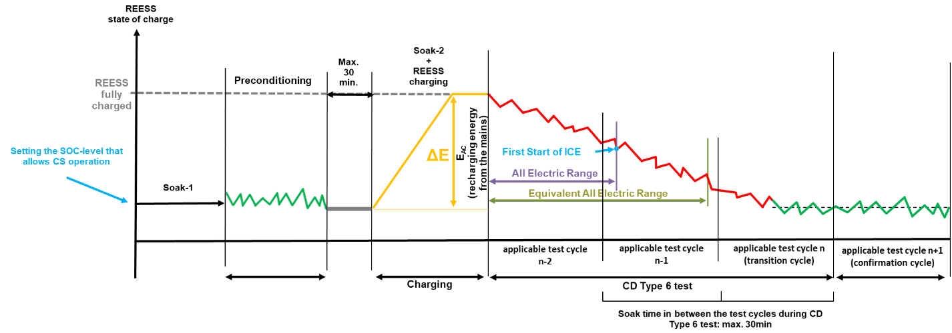

1.2. Test sequence OVC-HEVs according to Option 2

Charge-sustaining Type 6 test with no subsequent charge-depleting ~~Type 1~~ test (Figure ~~A8~~.App1/2).

# Figure ~~A8~~.App1/2

# **OVC-HEVs, charge-sustaining Type 6 test**

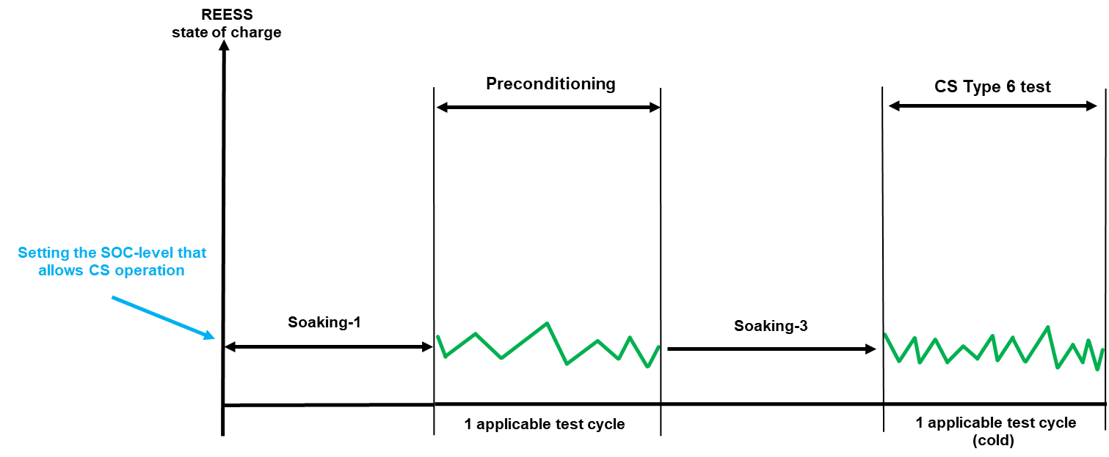

1.3. Test sequence OVC-HEVs according to Option 3

Charge-depleting Type 6 test with subsequent charge-sustaining ~~Type 1~~ test (Figure ~~A8~~.App1/3).

# Figure ~~A8.~~App1/3

# OVC-HEVs, charge-depleting Type 6 test with subsequent charge-sustaining ~~Type 1~~ test

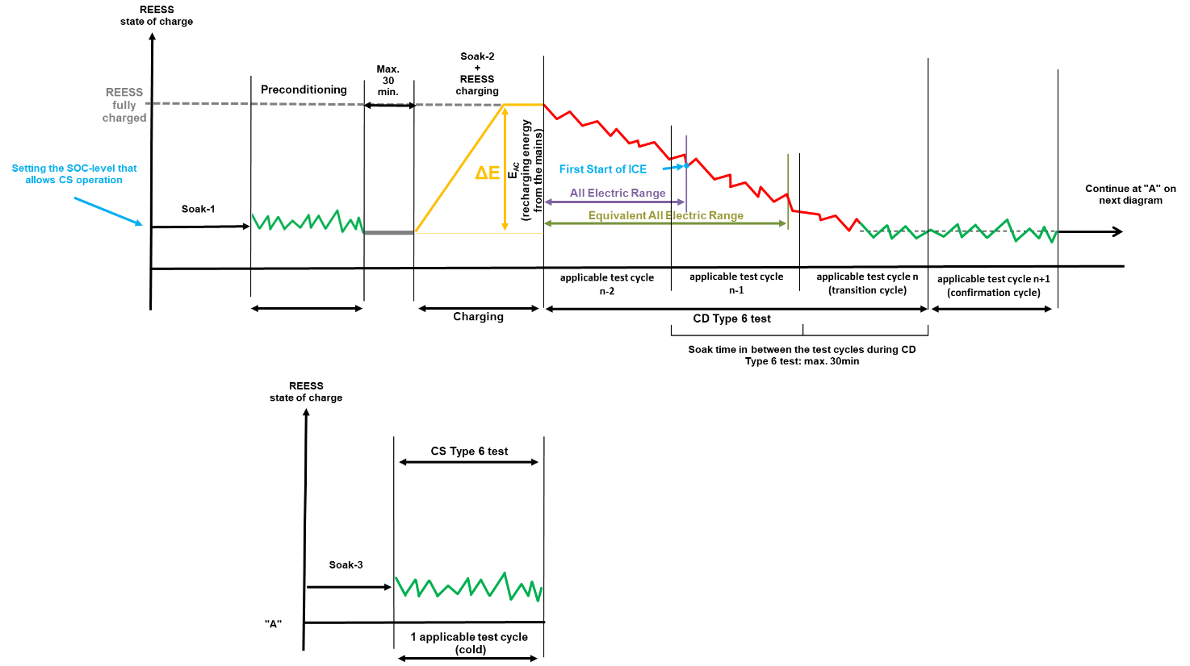

1.4. Test sequence OVC-HEVs according to Option 4

Charge-sustaining Type 6 test with subsequent charge-depleting ~~Type 1~~ test (Figure ~~A8~~.App1/4)

Figure ~~A8~~.App1/4

**OVC-HEVs, charge-sustaining Type 6 test with subsequent charge-depleting ~~Type 1~~ test**

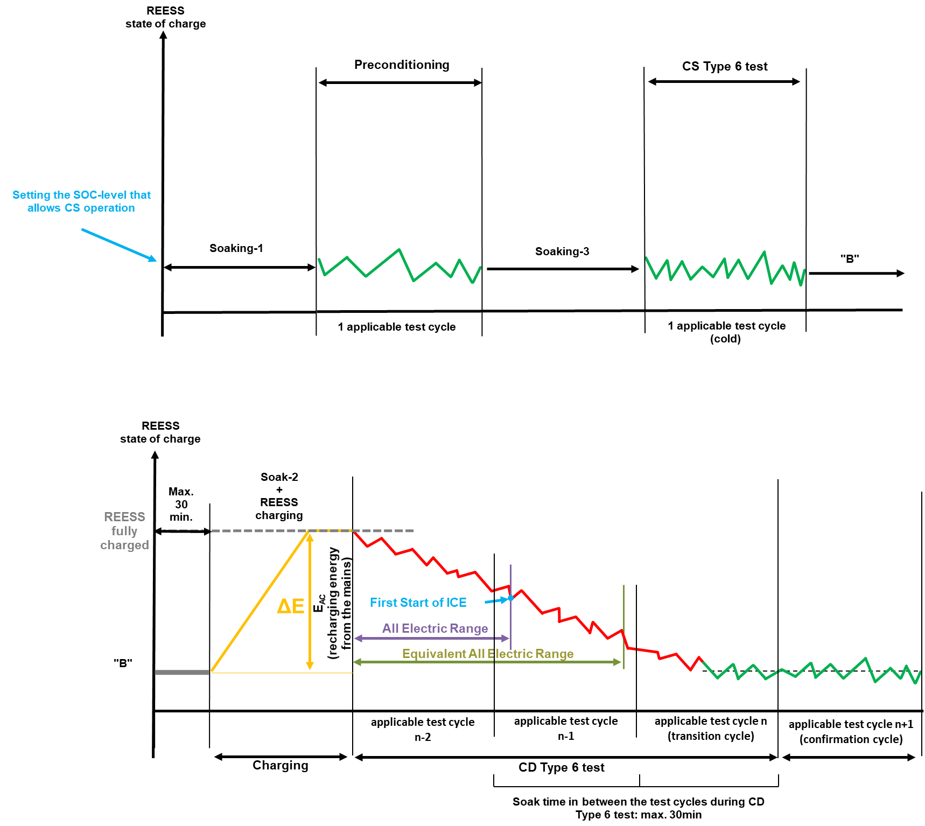

2. Test sequence NOVC-HEVs ~~and NOVC-FCHVs~~

Charge-sustaining Type 6 test (Figure ~~A8~~.App1/5)

# Figure ~~A8~~.App1/5

# **NOVC-HEVs ~~and NOVC-FCHVs~~, charge-sustaining Type 6 test**



3. Test sequences PEV

~~3.1. Consecutive cycles procedure (Figure A8.App1/6)~~

# ~~Figure A8.App1/6~~

# **~~Consecutive cycles Type 6 test sequence PEV~~**

3.2. PEV Type 6 ~~Shortened~~ test procedure (Figure ~~A8~~.App1/7)

# Figure ~~A8~~.App1/7

**~~Shortened test procedure~~ PEV Type 6 test sequence ~~for PEVs~~**

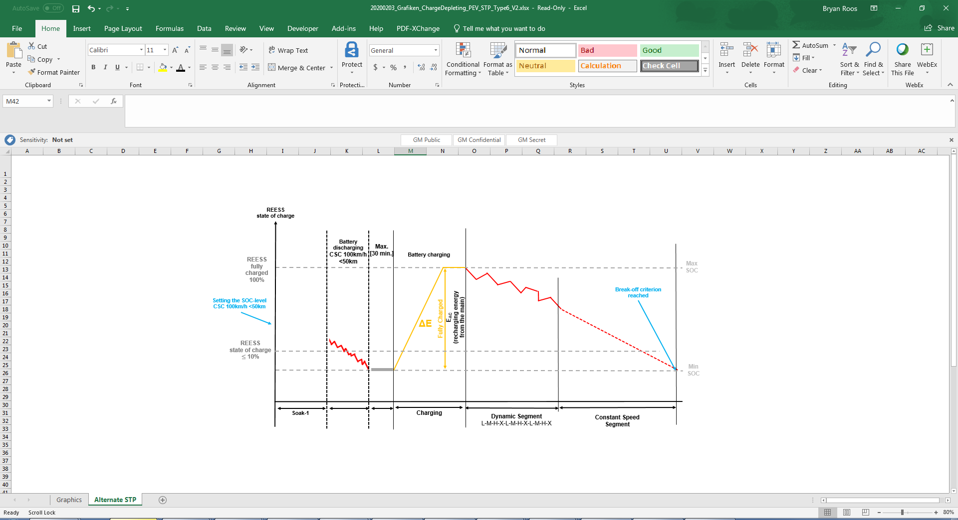

Annex B8 - Appendix 2

REESS energy change-based correction procedure

This Appendix describes the procedure to correct the charge-sustaining Type 1 test CO2 mass emission for NOVC-HEVs and OVC-HEVs, and the fuel consumption for NOVC-FCHVs as a function of the electric energy change of all REESSs.

1. General requirements

1.1. Applicability of this appendix

1.1.1. The correction shall be applied on the phase-specific fuel consumptions for NOVC-FCHVs and on the phase-specific CO2 mass emissions for NOVC-HEVs and OVC-HEVs of the charge-sustaining Type 1 test.

1.1.2. The application of the correction over the total cycle on the fuel consumption for NOVC-FCHVs, on the CO2 mass emission for NOVC-HEVs and OVC-HEVs is based on the charge-sustaining REESS energy change of the charge-sustaining Type 1 test and the correction criterion c.

For the calculation of , paragraph 4.3. of this annex shall be used. The considered period j used in paragraph 4.3. of this annex is defined by the charge-sustaining Type 1 test. The correction criterion c shall be determined according to paragraph 1.2. of this Appendix.

1.1.3. The correction over the total cycle shall be applied on the fuel consumption for NOVC-FCHVs, the CO2 mass emission for NOVC-HEVs and OVC-HEVs if is negative which corresponds to REESS discharging and the correction criterion c calculated in paragraph 1.2. of this appendix is greater than the applicable threshold according to Table A8.App2/1.

1.1.4. The correction over the total cycle may be omitted on the fuel consumption for NOVC-FCHVs, the CO2 mass emission for NOVC-HEVs and OVC-HEVs and uncorrected values may be used if:

(a) is positive which corresponds to REESS charging and the correction criterion c calculated in paragraph 1.2. of this appendix is greater than the applicable threshold according to Table A8.App2/1;

(b) The correction criterion c calculated in paragraph 1.2. of this appendix is smaller than the applicable threshold according to Table A8.App2/1;

(c) The manufacturer can prove to the responsible authority by measurement that there is no relation between and charge-sustaining CO2 mass emission and and fuel consumption respectively.

1.2. The correction criterion c is the ratio between the absolute value of the REESS electric energy change and the fuel energy and shall be calculated as follows:

where:

is the charge-sustaining REESS energy change according to paragraph 1.1.2. of this appendix, Wh;

is the charge-sustaining energy content of the consumed fuel according to paragraph 1.2.1. of this appendix in the case of NOVC-HEVs and OVC-HEVs, and according to paragraph 1.2.2. of this appendix in the case of NOVC-FCHVs, Wh.

1.2.1. Charge-sustaining fuel energy for NOVC-HEVs and OVC-HEVs

The charge-sustaining energy content of the consumed fuel for NOVC-HEVs and OVC-HEVs shall be calculated using the following equation:

where:

is the charge-sustaining energy content of the consumed fuel of the applicable WLTP test cycle of the charge-sustaining Type 1 test, Wh;

is the heating value according to Table A6.App2/1, kWh/l;

is the non-balanced charge-sustaining fuel consumption of the charge-sustaining Type 1 test, not corrected for the energy balance, determined according to paragraph 6. of Annex B7, using the gaseous emission compound values according to Table A8/5, step No. 2, l/100 km;

is the distance driven over the corresponding applicable WLTP test cycle, km;

conversion factor to Wh.

1.2.2. Charge-sustaining fuel energy for NOVC-FCHVs

The charge-sustaining energy content of the consumed fuel for NOVC-FCHVs shall be calculated using the following equation:

where:

is the charge-sustaining energy content of the consumed fuel of the applicable WLTP test cycle of the charge-sustaining Type 1 test, Wh;

is the lower heating value of hydrogen, MJ/kg;

is the non-balanced charge-sustaining fuel consumption of the charge-sustaining Type 1 test, not corrected for the energy balance, determined according to Table A8/7, step No. 1, kg/100 km;

is the distance driven over the corresponding applicable WLTP test cycle, km;

conversion factor to Wh.

Table A8.App2/1

**RCB correction criteria thresholds**

| *Applicable Type 1 test cycle* | *Low + Medium* | *Low + Medium +*  *High* | *Low + Medium +*  *High + Extra High* |
| --- | --- | --- | --- |
| Thresholds for correction criterion c | 0.015 | 0.01 | 0.005 |

2. Calculation of correction coefficients

2.1. The CO2 mass emission correction coefficient KCO2, the fuel consumption correction coefficients Kfuel,FCHV, as well as, if required by the manufacturer, the phase-specific correction coefficients KCO2,p and Kfuel,FCHV,p shall be developed based on the applicable charge-sustaining Type 1 test cycles.

In the case that vehicle H was tested for the development of the correction coefficient for CO2 mass emission for NOVC-HEVs and OVC-HEVs, the coefficient may be applied to vehicles that fulfil the same interpolation family criteria.

2.2. The correction coefficients shall be determined from a set of charge-sustaining Type 1 tests according to paragraph 3. of this appendix. The number of tests performed by the manufacturer shall be equal to or greater than five.

The manufacturer may request to set the state of charge of the REESS prior to the test according to the manufacturer’s recommendation and as described in paragraph 3. of this appendix. This practice shall only be used for the purpose of achieving a charge-sustaining Type 1 test with opposite sign of the and with approval of the responsible authority.

The set of measurements shall fulfil the following criteria:

(a) The set shall contain at least one test with and at least one test with . is the sum of electric energy changes of all REESSs of test n calculated according to paragraph 4.3. of this annex.

(b) The difference in between the test with the highest negative electric energy change and the test with the highest positive electric energy change shall be greater than or equal to 5 g/km. This criterion shall not be applied for the determination of Kfuel,FCHV.

In the case of the determination of KCO2, the required number of tests may be reduced to three tests if all of the following criteria are fulfilled in addition to (a) and (b):

(c) The difference in between any two adjacent measurements, related to the electric energy change during the test, shall be less than or equal to 10 g/km.

(d) In addition to (b), the test with the highest negative electric energy change and the test with the highest positive electric energy change shall not be within the region that is defined by:

,

where:

is the energy content of the consumed fuel calculated according to paragraph 1.2. of this appendix, Wh.

(e) The difference in between the test with the highest negative electric energy change and the mid-point, and the difference in between the mid-point and the test with the highest positive electric energy change shall be similar and preferably be within the range defined by (d). If this requirement is not feasible, the responsible authority shall decide if a retest is necessary.

The correction coefficients determined by the manufacturer shall be reviewed and approved by the responsible authority prior to its application.

If the set of at least five tests does not fulfil criterion (a) or criterion (b) or both, the manufacturer shall provide evidence to the responsible authority as to why the vehicle is not capable of meeting either or both criteria. If the responsible authority is not satisfied with the evidence, it may require additional tests to be performed. If the criteria after additional tests are still not fulfilled, the responsible authority shall determine a conservative correction coefficient, based on the measurements.

2.3. Calculation of correction coefficients and

2.3.1. Determination of the fuel consumption correction coefficient

For NOVC-FCHVs, the fuel consumption correction coefficient , determined by driving a set of charge-sustaining Type 1 tests, is defined using the following equation:

where:

is the fuel consumption correction coefficient, (kg/100 km)/(Wh/km);

is the charge-sustaining electric energy consumption of test n based on the REESS depletion according to the equation below, Wh/km

is the mean charge-sustaining electric energy consumption of tests based on the REESS depletion according to the equation below, Wh/km;

is the charge-sustaining fuel consumption of test n, not corrected for the energy balance, according to Table A8/7, step No. 1, kg/100 km;

is the arithmetic average of the charge-sustaining fuel consumption of tests based on the fuel consumption, not corrected for the energy balance, according to the equation below, kg/100 km;

is the index number of the considered test;

is the total number of tests;

and:

and:

and:

where:

is the charge-sustaining REESS electric energy change of test n according to paragraph 1.1.2. of this appendix, Wh;

is the distance driven over the corresponding charge-sustaining Type 1 test n, km.

The fuel consumption correction coefficient shall be rounded according to paragraph 6.1.8. of this Regulation to four significant figures. The statistical significance of the fuel consumption correction coefficient shall be evaluated by the responsible authority.

2.3.1.1. It is permitted to apply the fuel consumption correction coefficient that was developed from tests over the whole applicable WLTP test cycle for the correction of each individual phase.

2.3.1.2. Additional to the requirements of paragraph 2.2. of this appendix, at the manufacturer’s request and upon approval of the responsible authority, separate fuel consumption correction coefficients for each individual phase may be developed. In this case, the same criteria as described in paragraph 2.2. of this appendix shall be fulfilled in each individual phase and the procedure described in paragraph 2.3.1. of this appendix shall be applied for each individual phase to determine each phase specific correction coefficient.

2.3.2. Determination of CO2 mass emission correction coefficient KCO2

For OVC-HEVs and NOVC-HEVs, the CO2 mass emission correction coefficient , determined by driving a set of charge-sustaining Type 1 tests, is defined by the following equation:

where:

is the CO2 mass emission correction coefficient, (g/km)/(Wh/km);

is the charge-sustaining electric energy consumption of test n based on the REESS depletion according to paragraph 2.3.1. of this appendix, Wh/km;

is the arithmetic average of the charge-sustaining electric energy consumption of tests based on the REESS depletion according to paragraph 2.3.1. of this appendix, Wh/km;

is the charge-sustaining CO2 mass emission of test n, not corrected for the energy balance, calculated according Table A8/5, step No. 2, g/km;

is the arithmetic average of the charge-sustaining CO2 mass emission of tests based on the CO2 mass emission, not corrected for the energy balance, according to the equation below, g/km;

is the index number of the considered test;

is the total number of tests;

and:

The CO2 mass emission correction coefficient shall be rounded according to paragraph 6.1.8. of this Regulation to four significant figures. The statistical significance of the CO2 mass emission correction coefficient shall be evaluated by the responsible authority.

2.3.2.1. It is permitted to apply the CO2 mass emission correction coefficient developed from tests over the whole applicable WLTP test cycle for the correction of each individual phase.

2.3.2.2. Additional to the requirements of paragraph 2.2. of this appendix, at the request of the manufacturer and upon approval of the responsible authority, separate CO2 mass emission correction coefficients for each individual phase may be developed. In this case, the same criteria as described in paragraph 2.2. of this appendix shall be fulfilled in each individual phase and the procedure described in paragraph 2.3.2. of this appendix shall be applied for each individual phase to determine phase-specific correction coefficients.

3. Test procedure for the determination of the correction coefficients

3.1. OVC-HEVs

For OVC-HEVs, one of the following test sequences according to Figure A8.App2/1 shall be used to measure all values that are necessary for the determination of the correction coefficients according to paragraph 2. of this appendix.

Figure A8.App2/1

**OVC-HEV test sequences**



3.1.1. Option 1 test sequence

3.1.1.1. Preconditioning and soaking

Preconditioning and soaking shall be conducted according to paragraph 2.1. of Appendix 4 to this annex.

3.1.1.2. REESS adjustment

Prior to the test procedure according to paragraph 3.1.1.3. of this appendix, the manufacturer may adjust the REESS. The manufacturer shall provide evidence that the requirements for the beginning of the test according to paragraph 3.1.1.3. of this appendix are fulfilled.

3.1.1.3. Test procedure

3.1.1.3.1. The driver-selectable mode for the applicable WLTP test cycle shall be selected according to paragraph 3. of Appendix 6 to this annex.

3.1.1.3.2. For testing, the applicable WLTP test cycle according to paragraph 1.4.2. of this annex shall be driven.

3.1.1.3.3. Unless stated otherwise in this appendix, the vehicle shall be tested according to the Type 1 test procedure described in Annex B6.

3.1.1.3.4. To obtain a set of applicable WLTP test cycles required for the determination of the correction coefficients, the test may be followed by a number of consecutive sequences required according to paragraph 2.2. of this appendix consisting of paragraph 3.1.1.1. to paragraph 3.1.1.3. inclusive of this appendix.

3.1.2. Option 2 test sequence

3.1.2.1. Preconditioning

The test vehicle shall be preconditioned according to paragraph 2.1.1. or paragraph 2.1.2. of Appendix 4 to this annex.

3.1.2.2. REESS adjustment

After preconditioning, soaking according to paragraph 2.1.3. of Appendix 4 to this annex shall be omitted and a break, during which the REESS is permitted to be adjusted, shall be set to a maximum duration of 60 minutes. A similar break shall be applied in advance of each test. Immediately after the end of this break, the requirements of paragraph 3.1.2.3. of this appendix shall be applied.

Upon request of the manufacturer, an additional warm-up procedure may be conducted in advance of the REESS adjustment to ensure similar starting conditions for the correction coefficient determination. If the manufacturer requests this additional warm-up procedure, the identical warm-up procedure shall be applied repeatedly within the test sequence.

3.1.2.3. Test procedure

3.1.2.3.1. The driver-selectable mode for the applicable WLTP test cycle shall be selected according to paragraph 3. of Appendix 6 to this annex.

3.1.2.3.2. For testing, the applicable WLTP test cycle according to paragraph 1.4.2. of this annex shall be driven.

3.1.2.3.3. Unless stated otherwise in this appendix, the vehicle shall be tested according to the Type 1 test procedure described in Annex B6.

3.1.2.3.4. To obtain a set of applicable WLTP test cycles that are required for the determination of the correction coefficients, the test may be followed by a number of consecutive sequences required according to paragraph 2.2. of this appendix consisting of paragraphs 3.1.2.2. and 3.1.2.3. of this appendix.

3.2. NOVC-HEVs and NOVC-FCHVs

For NOVC-HEVs and NOVC-FCHVs, one of the following test sequences according to Figure A8.App2/2 shall be used to measure all values that are necessary for the determination of the correction coefficients according to paragraph 2. of this appendix.

Figure A8.App2/2

**NOVC-HEV and NOVC-FCHV test sequences**

Option 1 test sequence

(paragraph 3.2.1. of this appendix)

Option 2 test sequence

(paragraph 3.2.2. of this appendix)

Preconditioning

Applicable WLTP test cycle

REESS adjustment within a similar break of max. 60min

Optional:

Additional warm up procedure

Preconditioning and soaking

Applicable WLTP test cycle

REESS adjustment

3.2.1. Option 1 test sequence

3.2.1.1. Preconditioning and soaking

The test vehicle shall be preconditioned and soaked according to paragraph 3.3.1. of this annex.

3.2.1.2. REESS adjustment

Prior to the test procedure, according to paragraph 3.2.1.3. of this appendix, the manufacturer may adjust the REESS. The manufacturer shall provide evidence that the requirements for the beginning of the test according to paragraph 3.2.1.3. of this appendix are fulfilled.

3.2.1.3. Test procedure

3.2.1.3.1. The driver-selectable mode shall be selected according to paragraph 3. of Appendix 6 to this annex.

3.2.1.3.2. For testing, the applicable WLTP test cycle according to paragraph 1.4.2. of this annex shall be driven.

3.2.1.3.3. Unless stated otherwise in this appendix, the vehicle shall be tested according to the charge-sustaining Type 1 test procedure described in Annex B6.

3.2.1.3.4. To obtain a set of applicable WLTP test cycles that are required for the determination of the correction coefficients, the test can be followed by a number of consecutive sequences required according to paragraph 2.2. of this appendix consisting of paragraph 3.2.1.1. to paragraph 3.2.1.3. inclusive of this appendix.

3.2.2. Option 2 test sequence

3.2.2.1. Preconditioning

The test vehicle shall be preconditioned according to paragraph 3.3.1.1. of this annex.

3.2.2.2. REESS adjustment

After preconditioning, the soaking according to paragraph 3.3.1.2. of this annex shall be omitted and a break, during which the REESS is permitted to be adjusted, shall be set to a maximum duration of 60 minutes. A similar break shall be applied in advance of each test. Immediately after the end of this break, the requirements of paragraph 3.2.2.3. of this appendix shall be applied.

Upon request of the manufacturer, an additional warm-up procedure may be conducted in advance of the REESS adjustment to ensure similar starting conditions for the correction coefficient determination. If the manufacturer requests this additional warm-up procedure, the identical warm-up procedure shall be applied repeatedly within the test sequence.

3.2.2.3. Test procedure

3.2.2.3.1. The driver-selectable mode for the applicable WLTP test cycle shall be selected according to paragraph 3. of Appendix 6 to this annex.

3.2.2.3.2. For testing, the applicable WLTP test cycle according to paragraph 1.4.2. of this annex shall be driven.

3.2.2.3.3. Unless stated otherwise in this appendix, the vehicle shall be tested according to the Type 1 test procedure described in Annex B6.

3.2.2.3.4. To get a set of applicable WLTP test cycles that are required for the determination of the correction coefficients, the test can be followed by a number of consecutive sequences required according to paragraph 2.2. of this appendix consisting of paragraphs 3.2.2.2. and 3.2.2.3. of this appendix.

Annex B8 - Appendix 3

Determination of REESS current and REESS voltage for NOVC-HEVs, OVC-HEVs and PEVs ~~and NOVC-FCHVs~~

1. Introduction

1.1. This appendix defines the method and required instrumentation to determine the REESS current and the REESS voltage of NOVC-HEVs, OVC-HEVs, PEVs and NOVC-FCHVs.

1.2. Measurement of REESS current and REESS voltage shall start at the same time as the test starts and shall end immediately after the vehicle has finished the test.

1.3. The REESS current and the REESS voltage of each phase shall be determined.

1.4. A list of the instrumentation used by the manufacturer to measure REESS voltage and current (including instrument manufacturer, model number, serial number, last calibration dates (where applicable)) during:

(a) The Type 1 test according to paragraph 3 of this annex;

(b) The procedure to determine the correction coefficients according to Appendix 2 of this annex (where applicable);

(c) For the 4-phase WLTP only;

The Ambient Temperature Correction Test (ATCT) as specified in Annex B6a

shall be provided to the responsible authority.

2. REESS current

REESS depletion is considered as a negative current.

2.1. External REESS current measurement

2.1.1. The REESS current(s) shall be measured during the tests using a clamp-on or closed type current transducer. The current measurement system shall fulfil the requirements specified in Table A8/1 of this annex. The current transducer(s) shall be capable of handling the peak currents at engine starts and temperature conditions at the point of measurement.

In order to have an accurate measurement, zero adjustment and degaussing shall be performed before the test according to the instrument manufacturer's instructions.

2.1.2. Current transducers shall be fitted to any of the REESS on one of the cables connected directly to the REESS and shall include the total REESS current.

In case of shielded wires, appropriate methods shall be applied in accordance with the responsible authority.

In order to easily measure the REESS current using external measuring equipment, the manufacturer should provide appropriate, safe and accessible connection points in the vehicle. If that is not feasible, the manufacturer is obliged to support the responsible authority in connecting a current transducer to one of the cables directly connected to the REESS in the manner described above in this paragraph.

2.1.3. The current transducer output shall be sampled with a minimum frequency of 20 Hz. The measured current shall be integrated over time, yielding the measured value of Q, expressed in ampere-hours Ah. The integration may be done in the current measurement system.

2.2. Vehicle on-board REESS current data

As an alternative to paragraph 2.1. of this appendix, the manufacturer may use on-board REESS current measurement data. The accuracy of these data shall be demonstrated to the responsible authority.

3. REESS voltage

3.1. External REESS voltage measurement

During the tests described in paragraph 3. of this annex, the REESS voltage shall be measured with the equipment and accuracy requirements specified in paragraph 1.1. of this annex. To measure the REESS voltage using external measuring equipment, the manufacturers shall support the responsible authority by providing REESS voltage measurement points and safety instructions.

3.2. Nominal REESS voltage

For NOVC-HEVs, NOVC-FCHVs and OVC-HEVs, instead of using the measured REESS voltage according to paragraph 3.1. of this appendix, the nominal voltage of the REESS determined according to IEC 60050-482 may be used.

3.3. Vehicle on-board REESS voltage data

As an alternative to paragraphs 3.1. and 3.2. of this appendix, the manufacturer may use the on-board voltage measurement data. The accuracy of these data shall be demonstrated to the responsible authority.

3.4. Restrictions in the application of instantaneous voltage

In the following situations, the application of the instantaneous voltage according to paragraphs 3.1. and 3.3. of this appendix is prohibited and the nominal REESS voltage determined according to the standard referenced in paragraph 3.2. of this appendix shall be used:

(a) During the development of the REESS energy change-based correction factor defined in Appendix 2 to this annex;

(b) For the calculation of charge-sustaining CO2 mass emission for OVC-HEVs and NOVC-HEVs as described in paragraphs 4.1.1.3. to 4.1.1.5. inclusive of this annex;

(c) For the calculation of charge-sustaining fuel consumption for NOVC-FCHVs as described in paragraphs 4.2.1.2.3. to 4.2.1.2.5. inclusive of this annex.

Annex B8 - Appendix 4

Preconditioning, soaking and REESS charging conditions of PEVs and OVC-HEVs

1. This appendix describes the test procedure for REESS and combustion engine preconditioning in preparation for:

(a) Electric range, charge-depleting and charge-sustaining measurements when testing OVC-HEVs; and

(b) Electric range measurements as well as electric energy consumption measurements when testing PEVs.

2. OVC-HEV preconditioning and soaking

~~2.1. Preconditioning and soaking when the test procedure starts with a charge-sustaining test~~

~~2.1.1. For preconditioning the combustion engine, the vehicle shall be driven over at least one applicable WLTP test cycle. During each driven preconditioning cycle, the charging balance of the REESS shall be determined. The preconditioning shall be stopped at the end of the applicable WLTP test cycle during which the break-off criterion is fulfilled according to paragraph 3.2.4.5. of this annex.~~

~~2.1.2. As an alternative to paragraph 2.1.1. of this appendix, at the request of the manufacturer and upon approval of the responsible authority, the state of charge of the REESS for the charge-sustaining Type 1 test may be set according to the manufacturer’s recommendation in order to achieve a test under charge-sustaining operating condition.~~

~~In such a case, a preconditioning procedure, such as that applicable to pure ICE vehicles as described in paragraph 2.6. of Annex B6, shall be applied.~~

~~2.1.3. Soaking of the vehicle shall be performed according to paragraph 2.7. of Annex B6.~~

~~2.2. Preconditioning and soaking when the test procedure starts with a charge-depleting test~~

~~2.2.1. OVC-HEVs shall be driven over at least one applicable WLTP test cycle. During each driven preconditioning cycle, the charging balance of the REESS shall be determined. The preconditioning shall be stopped at the end of the applicable WLTP test cycle during which the break-off criterion is fulfilled according to paragraph 3.2.4.5. of this annex.~~

~~2.2.2. Soaking of the vehicle shall be performed according to paragraph 2.7. of Annex B6. Forced cooling down shall not be applied to vehicles preconditioned for the Type 1 test. During soak, the REESS shall be charged using the normal charging procedure as defined in paragraph 2.2.3. of this appendix.~~

2.1. REESS SoC set point for OVC-HEV before charge-depleting and charge-sustaining Type 6 tests and [stabilization] soaking

2.1.1. The state of charge of the REESS for the charge-depleting and charge-sustaining Type 6 tests shall be set according to the manufacturer’s recommendation in order to achieve one test under charge-sustaining operating condition with a maximum of one applicable WLTP test cycle at -7⁰C. [The setting of the state of charge of the REESS shall be performed at an ambient temperature of 23⁰C or lower].

2.1.2. Soaking

2.1.2.1. Soaking of the vehicle shall be performed according to paragraph 2.7. of the optional Annex X for a minimum of 9 hours. The soak time shall be recorded.

2.2. Precondition

2.2.1. During preconditioning, the test cell temperature shall be -7 °C ±5 °C. The engine oil temperature and coolant temperature, if any, shall be within ± 3 °C of the set point, -7 °C.

For preconditioning the combustion engine, the vehicle shall be driven under charge-sustaining operating condition. During the driven preconditioning cycle, the charging balance of the REESS shall be determined. At the end of the preconditioning the break-off criterion shall be fulfilled according to paragraph 3.2.4.5. of annex B8.

2.3. Soaking when the test procedure starts with a charge-sustaining test.

2.3.1. Soaking of the vehicle shall be performed according to paragraph 2.7. of the optional Annex X. Forced cooling down shall not be applied to vehicles preconditioned for the Type 6 test.

2.4. Soaking when the test procedure starts with a charge-depleting test.

2.4.1. Soaking of the vehicle shall be performed according to paragraph 2.7. of the optional Annex X for a minimum of 12 hours and a maximum of 18 hours. Soak shall continue until the end-of-charge criterion, as defined in paragraph 2.4.2.2. of this appendix is reached. The soak time shall be reported. Forced cooling down shall not be applied to vehicles preconditioned for the Type 6 test. During soak, the REESS shall be charged using the normal charging procedure as defined in paragraph 2.4.2. of this appendix.

~~2.2.3.~~ 2.4.2. Application of a normal charge

Normal charging is the transfer of electricity to an electrified vehicle with a power of less than or equal to 22 kW.

Where there are several possible methods to perform a normal AC charge (e.g. cable, induction, etc.), the charging procedure via cable shall be used.

Where there are several AC charging power levels available, the highest normal charging power shall be used. An AC charging power lower than the highest normal AC charging power may be selected if recommended by the manufacturer and by approval of the responsible authority.

~~2.2.3.1.~~ 2.4.2. The REESS shall be charged at an ambient temperature as specified in paragraph 2.2.2.2. of optional Annex X ~~B6~~ with the on-board charger if fitted.

The vehicle shall be connected to the mains within 30 minutes after the precondition where the applicable WLTP test cycle in which the break-off criterion is reached for the first time. The REESS is fully charged when the end-of-charge criterion, as defined in paragraph 2.4.2.2. of this appendix, is reached.

In the following cases, a charger recommended by the manufacturer and using the charging pattern prescribed for normal charging shall be used if:

(a) No on-board charger is fitted, or

(b) The charging time exceeds the soaking time defined in paragraph 2.7. of Annex B6.

The procedures in this paragraph exclude all types of special charges that could be automatically or manually initiated, e.g. equalization charges or servicing charges. The manufacturer shall declare that, during the test, a special charge procedure has not occurred.

~~2.2.3.2.~~2.4.2.2.End-of-charge criterion

The end-of-charge criterion is reached when the on-board or external instruments indicate that the REESS is fully charged. . ~~If~~ When the charging is performed during soaking and finished before the minimum required soaking time as defined in paragraph ~~2.7. of Annex B6~~ 2.4. of this appendix, the vehicle shall stay connected to the grid at least until the minimum required soaking time is reached.

3. PEV preconditioning

~~3.1 Initial charging of the REESS~~

~~At the request of the manufacturer, charging may be undertaken at 23 °C if paragraph 3.1.2 is applicable. Initial charging of the REESS should occur only if the vehicle’s REESS is below [X%] state of charge. The battery charging shall not exceed [X%] state of charge upon completion and a charge termination point below [X%] state of charge can be recommended by the manufacturer. On-board supplemental heating or cooling devices automatically present during charging while connected to the mains shall reflect normal operation and the windows and doors of the vehicle shall remain closed.~~

~~3.1.1. Application of a normal charge~~

~~The REESS shall be charged according to paragraph 2.2.3.1. of Appendix 4 to Annex 8. The REESS shall be charged without measurement of energy delivered from the mains.~~

~~3.1.2 Discharging the REESS at~~ ~~23 °C Ambient~~

~~At the request of the manufacturer, the PEV shall be discharged at 23 °C ambient at a speed of [100 km/h] for a maximum of [50] km, and in accordance with paragraph 3. of Appendix 4 to Annex 8. After the discharging cycle, the vehicle shall transfer from the [23°C] test cell to the soak area at the temperature of -7°C within [X] minutes. For vehicles that do not require charging per the guidelines in 3.1, paragraphs 3.1.1 and 3.1.2 may be omitted and the vehicle shall be placed in soak area at the temperature of T~~~~low~~ ~~directly.~~

3.1.3 Soak at -7°C Before Discharging

After the vehicle is placed in the soak area at the temperature of -7°C, the vehicle shall soak for a minimum of [9] hours. The REESS shall not be charged during the soak period.

3.1.4 Discharging the REESS at -7°C

After the soak, the vehicle shall be transferred from the soak area to the test cell within [20] minutes. The vehicle shall then be prepared for dynamometer testing within [20] minutes of entering the test cell. The PEV shall be discharged at -7°C at a speed of [100 km/h] until the RESSS reaches the break-off criterion as specified in paragraph 3.4.4.2.3 of Annex 8. Cumulative distance driven should not exceed [50] km before the break-off criterion is reached. Breaks for the driver and/or operator are not permitted during the discharging of the REESS at -7°C.

If the cumulative distance exceeds [50] km, the vehicle shall be braked to a standstill within 60 seconds. The vehicle shall exit the test cell and be placed on charge without measurement of energy delivered from the mains. The battery charging shall not exceed [X%] state of charge upon completion and a charge termination point below [X%] state of charge can be recommended by the manufacturer. ~~The REESS is fully charged when the end-of-charge criterion, as defined in paragraph 2.2.3.2 of Appendix 4, Annex 8 is reached.~~

3.1.5 Soak Before Type 6 Testing

After discharging and before Type 6 testing, vehicles shall be transferred within [20] minutes to a soak area with the ambient conditions -7°C described in paragraph XX of this Annex.

From the end of discharging until the soaking at -7°C, the vehicle shall not be exposed to a different temperature than -7°C for longer than [10 minutes].

The vehicle shall be kept in the soak area such that the soaking time ~~(tsoak_LT)~~ from the end of the discharge test to the beginning of the Type 6 test is equal to a minimum soaking time of [12] hours. ~~and a maximum of~~ At the request of the manufacturer, soaking time may be extended up to a maximum [36] hours. The soak shall be performed without using a cooling fan and with all body parts positioned as intended under normal parking operation.

Within [10] minutes of entering the soak area ~~completion of~~ ~~3.1.4~~, the vehicle shall be charged and the electric energy consumption from the charging supply ~~shall be recorded if the vehicle plans to use thermal conditioning during the soak or prior to the drive cycle. If no thermal conditioning is used, the vehicle shall be charged within [X] minutes of completion of 3.1.4 and the electric energy consumption from the charging supply shall be~~ ~~excluded and measured at the end of the applicable test cycle~~ shall be measured and conclude ~~according to paragraph 2.4.4.2 of this annex~~ within [1] hour prior to paragraph 3.1.6 of this annex.

The energy measurement equipment, placed between the vehicle charger and the mains, shall measure the recharged electric energy EAC delivered from the mains as well as its duration.

If thermal conditioning is used, the vehicle shall remain connected to the mains and the recharged electric energy EAC shall be recorded until the vehicle is transferred to the test cell for the Type 6 test. Auxiliary heating or cooling devices automatically present during charging or after charge complete while connected to the mains shall reflect normal operation and the windows and doors of the vehicle shall remain closed.

3.1.6 Transition period before Type 6 Testing (PEV)

Vehicle transfer from the soak area to the test cell shall be as short as possible and not exceed [20] minutes.

~~For vehicles that use cabin conditioning:~~

~~The Type 6 test shall begin within a maximum of [40] minutes after unplugged from the mains in the soak area. Fully prepare the dynamometer site to begin the applicable test cycle within [X] minutes of installation of the vehicle onto the dynamometer. During this time, cabin conditioning shall remain off. After the dynamometer site is prepared and ready for test, plug the vehicle into the mains, begin recording charging energy from the mains and begin cabin conditioning of the vehicle for a maximum of [X] minutes using on-board controls, phone applications, or other means accepted by the technical authority. Terminate the charging and energy recording from the mains and begin the applicable test cycle immediately following the cabin conditioning, minimizing heat loss to the dynamometer cell room. Record the charge energy from the mains used during the cabin conditioning period.~~

~~For vehicles that do not use cabin conditioning:~~

~~The Type 6 test shall begin within a maximum of [X] minutes after unplugged from the mains in the soak area.~~ Fully prepare the dynamometer site to begin the applicable test cycle within [20] minutes of installation of the vehicle onto the dynamometer. Do not plug in the vehicle into the mains for charging during dynamometer site preparation. ~~Begin the applicable cycle within [X] minutes of dynamometer site preparation completion.~~

Annex B8 - Appendix 5

Utility factors (UF) for OVC-HEVs

1. Each Contracting Party may develop its own UFs.

2. The methodology recommended for the determination of a UF curve based on driving statistics is described in SAE J2841 (Sept. 2010, Issued 2009-03, Revised 2010-09).

3. For the calculation of a fractional utility factor UFj for the weighting of period j, the following equation shall be applied by using the coefficients from Table A8.App5/1.

where:

UFj utility factor for period j;

dj measured distance driven at the end of period j, km;

Ci ith coefficient (see Table A8.App5/1);

dn normalized distance (see Table A8.App5/1), km;

k number of terms and coefficients in the exponent;

j number of period considered;

i number of considered term/coefficient;

sum of calculated utility factors up to period (j-1).

Table A8.App5/1

**Parameters for the determination of fractional UFs (as applicable)**

|  |  |
| --- | --- |
| *Parameter* | *For the 4-phase WLTP only* |
| dn | 800 km |
| C1 | 26.25 |
| C2 | -38.94 |
| C3 | -631.05 |
| C4 | 5964.83 |
| C5 | -25095 |
| C6 | 60380.2 |
| C7 | -87517 |
| C8 | 75513.8 |
| C9 | -35749 |
| C10 | 7154.94 |

Annex B8 - Appendix 6

Selection of driver-selectable modes

1. General requirement

1.1. The manufacturer shall select the driver-selectable mode for the Type 1 test procedure according to paragraphs 2. to 4. inclusive of this appendix which enables the vehicle to follow the considered test cycle within the speed trace tolerances according to paragraph 2.6.8.3.1.2. of Annex B6. This shall apply to all vehicle systems with driver-selectable modes including those not solely specific to the transmission.

1.2. The manufacturer shall provide evidence to the responsible authority concerning:

(a) The availability of a predominant mode under the considered conditions;

(b) The maximum speed of the considered vehicle;

and if required:

(c) The best and worst case mode identified by the evidence on the fuel consumption and, if applicable, on the CO2 mass emission/fuel consumption in all modes. See paragraph 2.6.6.3. of Annex B6;

(d) The highest electric energy consuming mode;

(e) The cycle energy demand (according to paragraph 5 of Annex B7 where the target speed is replaced by the actual speed).

1.3. On the basis of technical evidence provided by the manufacturer and with the agreement of the responsible authority, the dedicated driver-selectable modes, such as "mountain mode" or "maintenance mode" which are not intended for normal daily operation but only for special limited purposes, shall not be considered. All remaining modes used for forward driving shall be considered and the criteria emissions limits shall be fulfilled in all these modes under charge-depleting and charge-sustaining operating condition.

2. OVC-HEVs equipped with a driver-selectable mode under charge-depleting operating condition

For vehicles equipped with a driver-selectable mode, the mode for the charge-depleting Type 1 test shall be selected according to the following conditions.

# The flow chart in Figure A8.App6/1 illustrates the mode selection according to this paragraph.

2.1. If there is a predominant mode that enables the vehicle to follow the reference test cycle under charge-depleting operating condition, this mode shall be selected.

2.2. If there is no predominant mode or if there is a predominant mode but this mode does not enable the vehicle to follow the reference test cycle under charge-depleting operating condition, the mode for the test shall be selected according to the following conditions:

(a) If there is only one mode which allows the vehicle to follow the reference test cycle under charge-depleting operating conditions, this mode shall be selected;

(b) If several modes are capable of following the reference test cycleunder charge-depleting operating conditions and none of those modes is a configurable start mode, the worst case mode for electric energy consumption of those modes shall be selected;

(c) If several modes are capable of following the reference test cycleunder charge-depleting operating conditions and at least two of those modes are a configurable start mode, the worst case mode for electric energy consumption shall be selected from these configurable start modes.

2.3. If there is no mode according to paragraph 2.1. and paragraph 2.2. of this appendix that enables the vehicle to follow the reference test cycle, the reference test cycle shall be modified according to paragraph 9 of Annex B1:

(a) If there is a predominant mode which allows the vehicle to follow the modified reference test cycle under charge-depleting operating conditions, this mode shall be selected.

(b) If there is no predominant mode but other modes which allow the vehicle to follow the modified reference test cycle under charge-depleting operating condition, the worst case mode for electric energy consumption of those modes shall be selected. In the case that at least two or more configurable start modes, the worst case mode for electric energy consumption shall be selected from these configurable start modes;

(c) If there is no mode which allows the vehicle to follow the modified reference test cycle under charge-depleting operating condition, the mode or modes with the highest cycle energy demand shall be identified and the worst case mode for electric energy consumption shall be selected.

# Figure A8.App6/1a and Figure A8.App6/1b

# **Selection of driver-selectable mode for OVC-HEVs under charge-depleting operating condition**

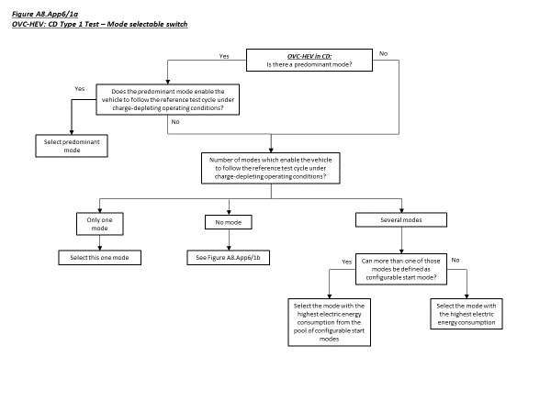

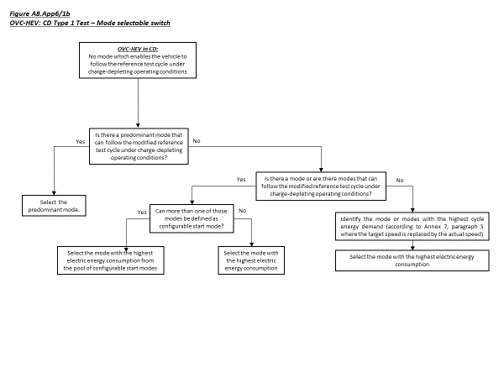

3. OVC-HEVs, NOVC-HEVs and NOVC-FCHVs equipped with a driver- selectable mode under charge-sustaining operating condition

For vehicles equipped with a driver-selectable mode, the mode for the charge-sustaining Type 1 test shall be selected according to the following conditions.

# The flow chart in Figure A8.App6/2 illustrates the mode selection according to this paragraph.

3.1. If there is a predominant mode that enables the vehicle to follow the reference test cycle under charge-sustaining operating condition, this mode shall be selected.

3.2. If there is no predominant mode or if there is a predominant mode but this mode does not enable the vehicle to follow the reference test cycle under charge-sustaining operating condition, the mode for the test shall be selected according to the following conditions:

(a) If there is only one mode which allows the vehicle to follow the reference test cycle under charge-sustaining operating conditions, this mode shall be selected;

(b) If several modes are capable of following the reference test cycleunder charge-sustaining operating conditions and none of those modes is a configurable start mode, the worst case mode for CO2 emissions and fuel consumption shall be selected;

(c) If several modes are capable of following the reference test cycleunder charge-sustaining operating conditions and at least two or more of those modes are a configurable start mode, the worst case mode for CO2 emissions and fuel consumption shall be selected.

3.3. If there is no mode according to paragraph 3.1. and paragraph 3.2. of this appendix that enables the vehicle to follow the reference test cycle, the reference test cycle shall be modified according to paragraph 9. of Annex B1:

(a) If there is a predominant mode which allows the vehicle to follow the modified reference test cycle under charge-sustaining operating condition, this mode shall be selected.

(b) If there is no predominant mode but other modes which allow the vehicle to follow the modified reference test cycle under charge-sustaining operating condition, the worst case mode for CO2 emissions and fuel consumption of these modes shall be selected.

(c) If there is no mode which allows the vehicle to follow the modified reference test cycle under charge-sustaining operating condition, the mode or modes with the highest cycle energy demand shall be identified and the worst case mode for CO2 emissions and fuel consumption of those modes shall be selected. In the case that at least two or more of these modes are a configurable start mode, the worst case mode for CO2 emissions and fuel consumption shall be selected from these modes.

# Figure A8.App6/2a and Figure A8.App6/2b

# **Selection of a driver-selectable mode for OVC-HEVs, NOVC-HEVs ~~and NOVC- FCHVs~~ under charge-sustaining operating condition**

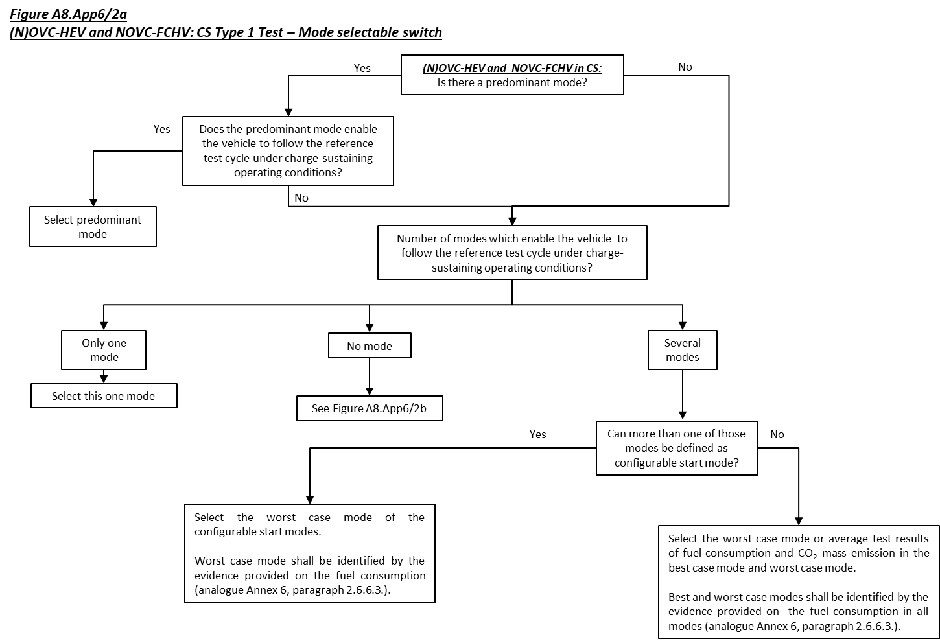

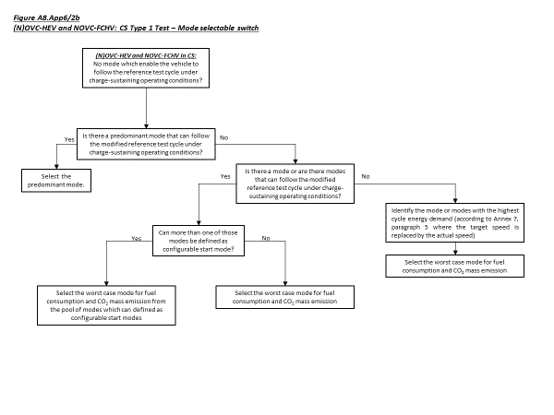

4. PEVs equipped with a driver-selectable mode

For vehicles equipped with a driver-selectable mode, the mode for the test shall be selected according to the following conditions.

# The flow chart in Figure A8.App6/3 illustrates the mode selection according to this paragraph.

4.1. If there is a predominant mode that enables the vehicle to follow the reference test cycle, this mode shall be selected.

4.2. If there is no predominant mode or if there is a predominant mode but this mode does not enable the vehicle to follow the reference test cycle,the mode for the test shall be selected according to the following conditions:

(a) If there is only one mode which allows the vehicle to follow the reference test cycle, this mode shall be selected;

(b) If several modes are capable of following the reference test cycle and none of those modes is a configurable start mode, the worst-case mode for electric energy consumption of those modes shall be selected;

(c) If several modes are capable of following the reference test cycleand at least two of those modes are a configurable start mode, the worst-case mode for electric energy consumptionshall be selected from these configurable start modes.

4.3. If there is no mode according to paragraph 4.1. and paragraph 4.2. of this appendix that enables the vehicle to follow the reference test cycle, the reference test cycle shall be modified according to paragraph 9. of Annex B1. The resulting test cycle shall be named as the applicable WLTP test cycle:

(a) If there is a predominant mode which allows the vehicle to follow the modified reference test cycle, this mode shall be selected;

(b) If there is no predominant mode but other modes which allow the vehicle to follow the modified reference test cycle, worst case mode for electric energy consumption of those modes shall be selected. In the case that at least two or more configurable start modes, the worst case mode for electric energy consumption shall be selected from these configurable start modes;

(c) If there is no mode which allows the vehicle to follow the modified reference test cycle, the mode or modes with the highest cycle energy demand shall be identified and the worst case mode for electric energy consumption shall be selected.

# Figure A8.App6/3a and Figure A8.App6/3b

# **Selection of the driver-selectable mode for PEVs**

