|  |  |  |  |
| --- | --- | --- | --- |
|  | United Nations | ECE/TRANS/WP.29/GRSG/2020/XX  VRU-Proxi-13-06 | |
| _unlogo | **Economic and Social Council** | | Distr.: General  x  Original: English |

**Economic Commission for Europe**

Inland Transport Committee

**World Forum for Harmonization of Vehicle Regulations**

**Working Party on General Safety Provisions**

**118th session**

Geneva, X X 2020

Item X of the provisional agenda

Proposal for a new UN Regulation on uniform provisions concerning the approval of motor vehicles with regard to the Moving Off Information System for the Detection of Pedestrians and Cyclists

**Submitted by the Informal Working Group on Awareness of Vulnerable Road Users proximity in low speed manoeuvres**

The text reproduced below was prepared by the Informal Working Group (IWG) on Awareness of Vulnerable Road Users proximity in low speed manoeuvres (VRU-Proxi) to establish a new UN Regulation on Moving Off Information Systems (MOIS) intended to be fitted to heavy vehicles to protect vulnerable road users. It provides the state of play of the discussions held by the informal working group throughout 2019. It aims at providing the experts of Working Party on General Safety Provisions (GRSG) the opportunity to react, comment and contribute to work performed by the informal working group in advance of the 118th session of GRSG.

**Green: OICA-CLEPA proposals or comments (28th January 2020) -OICA-CLEPA review still under progress**

**OICA-CLEPA proposals support requirements that would take into account the specificities of different categories of vehicles.**

I. Proposal

UN Regulation No. [XXX]

**Uniform provisions concerning the approval of motor vehicles with regard to the Moving Off Information System for the Detection of Pedestrians and Cyclists**

1. Scope

1.1. This Regulation applies to the approval of vehicles of categories M2, M3, N2 and N3 with regard to an onboard system to detect and inform the driver of the presence of pedestrians and cyclists in close-proximity to the front of the vehicle and, if necessary, warn the driver of a potential collision.

1.2. The requirements of this Regulation are so worded as to apply to vehicles which are developed for right-hand traffic. In vehicles that are developed for left-hand traffic, these requirements shall be applied by inverting the criteria, when appropriate.

2. Definitions

For the purposes of this Regulation:

2.1. *"Moving Off Information System (MOIS)"* means a system to detect and inform the driver of the presence of pedestrians and cyclists in close-proximity to the front of the vehicle ~~and, if necessary, warn the driver of a potential collision.~~

OICA 21/01/2020: pure information signal as a minimum as reaction time is short and the speed is very low (even information signal is not relevant as explained by AEB experts). Warning, up to manufacturer strategy

2.2. *"Approval of a vehicle type"* means the full procedure whereby a Contracting Party to the Agreement certifies that a vehicle type meets the technical requirements of this Regulation;

2.3. *"Vehicle type with regard to its Moving Off Information System"* means a category of vehicles which do not differ in such essential respects as:

(a) The manufacturer's trade name or mark;

(b) Vehicle features which significantly influence the performances of the Moving Off Information System;

(c) The type and design of the Moving Off Information System.

2.4. *"Reaction time"* means the time between when the information signal is provided and a driver reaction has occurred, which shall be taken as 1.4 seconds.

2.5. *"Ocular reference point"* means the middle point between two points 65 mm apart and 635 mm vertically above the reference point which is specified in Annex 1 of ECE/TRANS/WP.29/78/Rev.6[[1]](#footnote-2) on the driver's seat. The straight line joining the two points runs perpendicular to the vertical longitudinal median plane of the vehicle. The centre of the segment joining the two points is in a vertical longitudinal plane which shall pass through the centre of the driver's designated seating position, as specified by the vehicle manufacturer.

2.6. *"Collision point"* means the position where the trajectory of any vehicle **front** point would intersect with any pedestrian or cyclist point should a moving off manoeuvre or moving ahead manoeuvre be performed by the vehicle.

OICA 21/01/2020: clarification

2.7. *"Last Point of Information (LPI)"* means the point at which the information signal shall have been given. It is the point preceding the expected motion of a vehicle towards a pedestrian or cyclist in moving off or moving straight ahead situations where a collision could occur**, taking into account a reaction time of 1.4s** .

OICA 22/01/2020: 1.4 s in the definition.

2.8. *"Vehicle front"* The plane perpendicular to the median longitudinal plane of the vehicle and touching its foremost point, disregarding the projection of devices for indirect vision **and part of the vehicle which is more than 2.0 m above the ground**

OICA 28/01/2020: in line BSIS last updates and nearside and offside planes definitions

2.9. *"Nearside"* means the right side of the vehicle for right-hand traffic.

2.10. *"Nearside Plane"* The plane parallel to the median longitudinal plane of the vehicle and touching its most outboard point in the nearside direction, **in front of the drivers R points,** **below 2 m height and** disregarding the projection of devices for indirect vision.

OICA 21/01/2020: clarification of the nearside plane

2.11. *"Offside"* means the left side of the vehicle for right-hand traffic

2.12. *"Offside Plane"* The plane parallel to the median longitudinal plane of the vehicle and touching its most outboard point in the offside direction, **in front of the drivers R points,** **below 2 m height and** the projection of devices for indirect vision.

OICA 21/01/2020: clarification of the offside plane

2.13. *"Information signal"* means a signal emitted by the MOIS with the purpose of informing the vehicle driver about a pedestrian or cyclist in close-proximity to the front of the vehicle.

2.14. *"Collision warning signal"* means a signal emitted by the MOIS with the purpose of warning the vehicle driver when the MOIS has detec**t**ed a potential frontal collision with a pedestrian or cyclist in close-proximity to the front of the vehicle.

OICA 28/01/2020: correction

2.15. *"Subject vehicle"* means the vehicle being tested

2.16. *"Vehicle trajectory"* means the connection of all positions where the vehicle front has been or will be during the test runs.

2.17. *"Soft target"* means a target that will suffer minimum damage and cause minimum damage to the subject vehicle in the event of a collision.

OICA – 20/01/2020: comment - more details about dimensions (height, width) is required for a better understanding

2.18. "*Pedestrian test target*" means an adult or child sized pedestrian simulated by a soft target device specified according to ISO 19206-2:2018. The reference point for the location of the pedestrian shall be at a point at the intersect between the H-point and the centreline of the test target.

OICA – 21/01/2020: comment: where is that reference point located?

ISO should be made available to GRSG.

2.19. "*Cyclist test target*" means a combination of an adult ~~[or child]~~ sized cyclist and bicycle simulated by a soft target device specified according to [ISO 19206-4:2020]. The reference point for the location of the cyclist test target shall be the centre of the bottom bracket on the centreline of the bicycle.

OICA – 21/01/2020: we propose to delete the requirements related to child cyclist as no standard available.

2.20. "*Common space*" means an area on which two or more information functions (e.g. symbols) may be displayed, but not simultaneously

2.21. "*Forward separation*" means the distance in the forward direction between the vehicle front end and the reference point of the soft target.

2.22. *"Vehicle master control switch"* means the device by which the vehicle's on-board electronics system is brought, from being switched off, as in the case where a vehicle is parked without the driver being present, to a normal operation mode.

OICA 21/01/2020: New definitions below

2.23 “Potential moving off manoeuvre” means the vehicle being in an operation mode with the parking brakes released and the mode of operation of the vehicle such, that at the release of the service brake the vehicle will start moving forward.

2.24 “Low-speed travelling straight ahead manoeuvre” means the vehicle being in an operation mode, moving forward [at speeds below 10 km/h].

First proposal that will be updated. We present just an intention. We may think about a distance moved as a starting point to define the beginning of the low speed….

2.25 “Maximum Forward Separation Distance” means the forward separation in vehicle front where the MOIS system is at minimum required to provide an information signal.

2.26 “Vehicle Width” means the distance between nearside plane and offside plane.

OICA – 21/01/2020:

[Definitions:

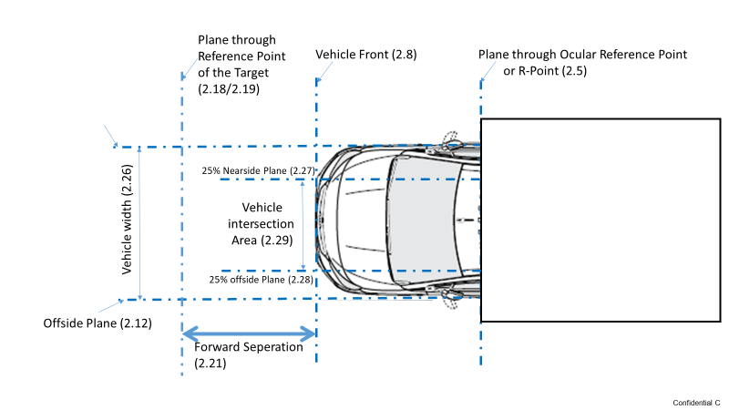]

2.27 "25% Nearside Plane" means the plane parallel to the median longitudinal plane of the vehicle and 25% of the vehicle width inside from the nearside plane towards the median longitudinal plane.

2.28 "25% Offside Plane" means the plane parallel to the median longitudinal plane of the vehicle and 25% of the vehicle width inside from the offside plane towards the median longitudinal plane.

2.29 "Vehicle Intersection Area" means the area between the 25% nearside plane and the 25% offside plane in front of the vehicle.

2.30 VRU means an adult or a child pedestrian or an adult cyclist

3. Application for approval

3.1. The application for approval of a vehicle type with regard to the Moving Off Information Systems (MOIS) shall be submitted by the vehicle manufacturer or by their authorized representative.

3.2. It shall be accompanied by the documents mentioned below in triplicate and include the following particular:

3.2.1. A description of the vehicle type with regard to the items mentioned in paragraph 5., together with dimensional drawings and the documentation as referred to in paragraph 6.1. The numbers and/or symbols identifying the vehicle type shall be specified.

3.3. A vehicle representative of the vehicle type to be approved shall be submitted to the Technical Service conducting the approval tests.

4. Approval

4.1. If the vehicle type submitted for approval pursuant to this Regulation meets the requirements of paragraph 5. below, approval of that vehicle type shall be granted.

4.2. The conformity of the requirements in paragraph 5. shall be verified with the test procedure as defined in paragraph 6., ~~however its operation shall not be limited to these test conditions.~~

OICA – 21/01/2020: It is not clearly defined here. And the test cases are the worst cases. So no need to add other test cases. We propose too to delete some paragraphs in 6.5.3, 6.6.3, 6.7.3 related to the other cases

4.3. An approval number shall be assigned to each vehicle type approved; its first two digits (00 for this Regulation in its initial form) shall indicate the series of amendments incorporating the most recent major technical amendments made to this Regulation at the time of issue of the approval. The same Contracting Party shall not assign the same number to the same vehicle type equipped with another type of MOIS, or to another vehicle type.

4.4. Notice of approval or of refusal or withdrawal of approval pursuant to this Regulation shall be communicated to the Parties to the Agreement applying this Regulation by means of a form conforming to the model in Annex 1 and photographs and/or plans supplied by the applicant being in a format not exceeding A4 (210 x 297 mm), or folded to that format, and on an appropriate scale.

4.5. There shall be affixed, conspicuously and in a readily accessible place specified on the approval form, to every vehicle conforming to a vehicle type approved under this Regulation, an international approval mark conforming to the model described in Annex 2, consisting of either:

4.5.1. A circle surrounding the letter "E" followed by:

(a) the distinguishing number of the country which has granted approval;[[2]](#footnote-3)and

(b) the number of this Regulation, followed by the letter "R", a dash and the approval number to the right of the circle prescribed in this paragraph;

[or

4.5.2. An oval surrounding the letters "UI" followed by the Unique Identifier.]

4.6. If the vehicle conforms to a vehicle type approved under one or more other UN Regulations annexed to the Agreement, in the country which has granted approval under this Regulation, the symbol prescribed in paragraph 4.5. above need not be repeated. In such a case, the UN Regulation and approval numbers and the additional symbols shall be placed in vertical columns to the right of the symbol prescribed in paragraph 4.5. above.

4.7. The approval mark shall be clearly legible and be indelible.

4.8. The approval mark shall be placed close to or on the vehicle data plate.

5. Specifications

5.1. General requirements

5.1.1. Any vehicle fitted with a MOIS complying with the definition of paragraph 2.3. above shall meet the requirements contained in paragraphs 5.2. to 5.6. of this Regulation.

5.1.2. The effectiveness of the MOIS shall not be adversely affected by magnetic or electrical fields. This shall be demonstrated by compliance with the technical requirements and transitional provisions of UN Regulation No. 10, 05 series of amendments or any later series of amendments.

5.2. Performance requirements

5.2.1. The MOIS shall inform the driver about pedestrians and cyclists in close-proximity to the vehicle front that might be endangered during a potential moving off or low-speed travelling straight ahead manoeuvre. ~~This information shall be provided to the driver, taking in to account a reaction time of 1.4 seconds, so that the vehicle may be prevented by the driver from interacting with the trajectory of the pedestrian or cyclist.~~

**The maximum forward separation distance shall be the distance between vehicle front and the intersection of a plane through the drivers ocular reference points tangential to the vehicle front body and a plane 0.9 m** **above ground surface or at the choice of the vehicle manufacturer 3.7 m .**

OICA– 21/01/2020: Head of the child pedestrian dummy can be seen

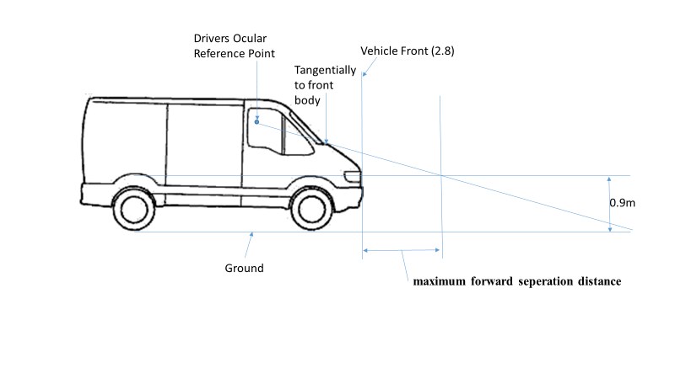

5.2.3. The MOIS shall at least operate **during a potential moving off or low-speed travelling straight ahead manoeuvre** ~~standstill and for all forward vehicle speeds to 10 km/h~~, for ambient light conditions above **1000** ~~15~~ Lux.

OICA 21/01/2020: Moved to that part of the regulation (§ number to be changed), including references to the definitions and ambient light threshold in line with AEB (1000 for car and 2000 for VRU).

5.2.1.1 The information signal shall be **given to the driver and** maintained only for as long as the conditions specified in paragraphs 5.2.1.2. and 5.2.1.3. are fulfilled. ~~The deactivation of the information signal as a result of the subject vehicle turning away from the pedestrian or cyclist trajectory is not allowed as long as the collision remains possible, in case the driver would steer back towards the pedestrian or cyclist trajectory.~~

OICA – 22/01/2020: taken from BSIS. Not relevant for MOIS. We propose to delete the turning requirement

5.2.1.2. ~~When the vehicle is~~~~stationary, the MOIS shall give an information signal at the last point of information (LPI) for adult and child pedestrians and cyclists moving at speeds of between 3 km/h and 5 km/h, when travelling from the nearside and offside of the vehicle in a direction perpendicular to the vehicle longitudinal median plane, at a forward separation of between 0.8 0.6 metres for an adult (0.5 metres for a child)~~**~~.~~** ~~and 3.7 metres and that could result in a collision with the vehicle front at an impact position of no further than 25% of the vehicle width from the vehicle side relevant to the direction from which the test target is travelling.~~

**When the vehicle is in a potential moving off manoeuvre, the MOIS shall give an information signal, if there is any VRU in a zone in front of the vehicle, which is limited as follows:**

**(a) To the sides by the offside plane and a parallel plane through the last point of information (LPI) for VRU moving at speeds of between 3 km/h and 5 km/h perpendicular to the vehicle longitudinal median plane measured from the 25% nearside plane on the nearside and**

**(b) to the front by a forward separation of 0.8 meters and the maximum forward separation distance (see Appendix 1 Figure 1).**

OICA 22/01/2020: Should not be symmetric as offside, you have a better view, the VRU would have already crossed one road lane

Reference to Test cases (§) to be added for clarification

Instead of the LPI on the nearside, we would also support a maximum nearside lateral separation distance with the same idea as for the maximum forward separation (Head of the child pedestrian dummy can be seen) => proposal under construction.

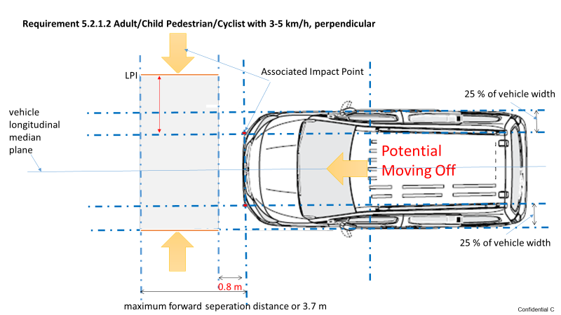

5.2.1.3 The MOIS shall also give a**n** ~~continuous~~ information signal **during Low-speed travelling straight ahead manoeuvre and potential moving off manoeuvre** ~~at all operational speeds~~ **for a stationary or a moving (up to 5 km/h) VRU** ~~adult and child pedestrians and cyclists~~ located within an area bounded by the subject vehicle width and a forward separation of between 0.**8**~~6~~ metres ~~for an adult (0.5 metres for a child)~~ and ~~3.7 metres~~ **the** **maximum forward separation distance.**

OICA 20/01/2020: Reference to Test cases (§) to be added for clarification

Is this 0 to 5 km/h for or is this 3 to 5 km/h ? What are all operational speeds? Vehicle speed

Fast VRU that touches this area aren’t a threat especially to limited acceleration capability of M2/N2/M3/N3 vehicles. Therefore information is not necessary in this case.

TF VRU-Proxi 21/01/2020: proposal shared with TRL

[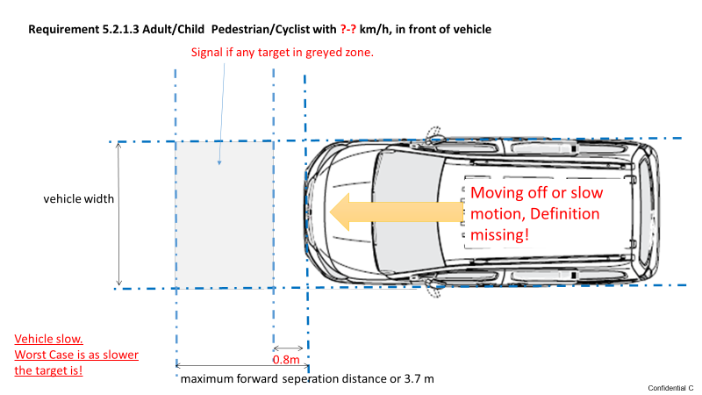]

5.2.1.4. The information signal shall meet the requirements of paragraph 5.3.

~~5.2.2 The MOIS shall warn the driver when the risk of a collision increases.~~

~~The collision warning signal shall meet the requirements of paragraph 5.4. It may be deactivated manually. In the case of a manual deactivation, it shall be reactivated upon each activation of the vehicle master control switch.~~

OICA 20/01/2020: we propose to move 5.2.2 to 5.4 in order to have the collision warning requirements in the same section (see 5.4 proposals)

~~5.2.3. The MOIS shall at least operate standstill and for all forward vehicle speeds to 10 km/h, for ambient light conditions above 15 Lux.~~

OICA 21/01/2020: we propose to move 5.2.2 around section 5.2.1

5.2.4. ~~The vehicle manufacturer shall ensure that the number of false reactions due to the detection of pedestrians and cyclists not at risk and static objects such as cones, traffic signs, hedges and parked cars are minimised. This shall be tested in accordance with the provisions of paragraph 6.8. (false information signal test).~~

**The vehicle manufacturer shall ensure that the number of false-positive warnings due to the detection of static non-VRU objects such as cones, traffic signs, hedges and parked cars shall be minimized. However, it may give an information signal when a collision is imminent.**

OICA 28/01/2020: taken from BSIS. We can not predict, nor measure if a pedestrian or a cyclist is at risk.

5.2.5. **Deactivation**

The MOIS shall automatically deactivate if it cannot operate properly due to its sensor devices becoming contaminated by ice, snow, mud, dirt or similar material or due to ambient light conditions below that specified in paragraph 5.2.3. **The MOIS shall automatically reactivate when the contamination is no longer present and the normal function of the sensors is verified. This shall be tested in accordance with the provisions of paragraph 6.10. (automatic deactivation test).** ~~Automatic deactivation shall be indicated by the failure warning signal specified in paragraph 5.5.2. The MOIS shall automatically reactivate when the contamination is no longer present and the normal function of the sensors is verified. This shall be tested in accordance with the provisions of paragraph 6.10. (automatic deactivation test).~~

OICA 20/01/2020: 5.2.5 is split in 2 (deactivation and signal). Failure warning signal requirements are moved to section 5.5 (to make the requirements clear)

~~5.2.6. The MOIS also shall provide the driver with a failure warning signal when there is a failure that prevents the requirements of this Regulation from being met. The failure warning signal shall be as specified in paragraph 5.5.1. This shall be tested in accordance with the provisions of paragraph 6.9. (failure detection test).~~

OICA 20/01/2020: Failure warning signal requirements are moved to section 5.5 (to make the requirements clear)

~~[5.2.7. The manufacturer shall demonstrate, to the satisfaction of the Technical Service and Type Approval Authority, through the use of documentation, simulation or any other means, that the MOIS is performing as specified also for smaller bicycles and smaller bicyclists, differing by not more than 36 per cent from the values detailed in ISO 19206-4:2018.]~~

OICA 20/01/2020: No smaller bicycle and bicyclist standards, so we propose to delete that requirement

5.3. Information signal

5.3.1. The MOIS information signal referred to in paragraph 5.2.1. above shall be an optical information signal that is noticeable and easily verifiable by the driver from the driver's seat. This information signal shall be visible by daylight and at night.

~~5.3.2. The device emitting the information signal shall be forward of a plane located at the ocular reference point and perpendicular to the vehicle longitudinal median plane and above a plane located at the ocular reference point and angled 30° downward from the vehicle horizontal plane.~~

OICA: This requirement conflicts with UN R125, not allowing information in the windscreen above the 9 ° line !!!

5.4. Collision warning signal

The MOIS shall warn the driver when the risk of a collision **is imminent** ~~increases~~.

~~The collision warning signal shall meet the requirements of paragraph 5.4.~~ ~~It~~ **The Collision warning signal** may be deactivated manually. In the case of a manual deactivation, it shall be reactivated upon each activation of the vehicle master control switch.

OICA 21/01/2020: See previous 5.2.2

5.4.1. The warning signal ~~referred to in paragraph 5.2.2. above~~ shall be provided by the means of a combination of at least two modes selected from the optical signal, acoustic signal or haptic signal.

Where the warning signal is provided by using an optical mode, this shall be a signal differing in activation strategy from the information signal specified in paragraph 5.3.

OICA 21/01/2020: no reference needed as 5.2.2 is moved in 5.4

5.4.2. The warning signal shall be easily understandable for the driver to relate the warning signal to the potential collision. In case the warning signal is an optical signal this signal shall also be visible by daylight and at night.

5.4.3. The warning signal shall be activated at the earliest point in time where the system detects a potential collision, e.g. by the moving off from rest towards a pedestrian or cyclist, by the evaluating of the distance between or trajectory intersection of the vehicle and pedestrian or cyclist. The warning strategy shall be explained in the information referred to in paragraph 6.1.

The Technical Service shall verify the operation of the system according to the strategy.

5.5. Failure warning signals

**Failure warning signal shall be provided to the driver at Automatic deactivation or mal-function of the MOIS** ~~shall be indicated by the failure warning signal specified in paragraph 5.5.2.~~ ~~The MOIS shall automatically reactivate when the contamination is no longer present and the normal function of the sensors is verified. This shall be tested in accordance with the provisions of paragraph 6.10. (automatic deactivation test).~~

**It shall remain active as long as the MOIS is unavailable.**

OICA 20/01/2020: see previous §5.2.5 and 5.2.6

OICA 20/01/2020: HMI may be really complex with all the new systems. We may think about HMI harmonization

5.5.1. The failure warning signal referred to in paragraph 5.2.6. above shall be a**n** ~~yellow~~ optical signal and shall be other than or clearly distinguishable from the information signal. The failure warning signal shall be visible by daylight and night and shall be easily verifiable by the driver from the driver's seat.

OICA 20/01/2020: Why yellow?

Requires 3 different optical signals constant yellow for failure, different for information and also different to warning signal

A text as failure signal should also be possible. Probably not in yellow.

~~5.5.2. The failure warning signal referred to in paragraph 5.2.5. shall be an optical signal and shall indicate that the MOIS is temporarily not available. It shall remain active as long as the MOIS is unavailable. The failure warning signal specified in paragraph 5.5.1. above may be used for this purpose.~~

OICA 20/01/2020: delete. See first 5.5 proposal

5.5.3. The MOIS failure warning signal~~s~~ shall be activated with the activation of the vehicle master control switch. This requirement does not apply to **failure** ~~collision~~ warning signals shown in a common space.

OICA 22/01/2020: just to show that the failure warning signal works. We mix 5.5.3 and 5.6 to make the regulation easy to read.

5.6. Provisions for Periodic Technical Inspection

5.6.1. At a Periodic Technical Inspection, it shall be possible to confirm the correct operational status of the MOIS by a visible observation of the failure warning signal status.

In case of the failure warning signal being in a common space, the common space must be observed to be functional prior to the failure warning signal status check.

6. Test procedure

6.1. The manufacturer shall provide a documentation package which gives access to the basic design of the system and, if applicable, the means by which it is linked to other vehicle systems. The function of the system including its sensing and warning strategy shall be explained and the documentation shall describe how the operational status of the system is checked, whether there is an influence on other vehicle systems, and the method(s) used in establishing the situations which will result in a failure warning signal being displayed. The documentation package shall give sufficient information for the Type Approval Authority to identify the vehicle type and to aid decision-making on the selection of worst-case conditions.

6.2. Test conditions

6.2.1. The test shall be performed on a flat**,** dryasphalt or a concrete surface.

6.2.2. The ambient temperature shall be between 0° C and 45° C.

6.2.3. The test shall be performed under visibility conditions that allow the target to be observed throughout the test and that allows safe driving at the required test speeds.

6.2.4. Natural ambient illumination shall be homogeneous in the test area and in excess of 2000 lux. It should be ensured that testing is not performed whilst driving towards, or away from, the sun at a low angle.

6.3. Vehicle conditions

6.3.1. Test weight

~~The vehicle may be tested at any condition of load, the distribution of the mass among the axles shall be stated by the vehicle manufacturer without exceeding any of the maximum permissible mass for each axle. No alteration shall be made once the test procedure has begun. The vehicle manufacturer shall demonstrate through the use of documentation that the system works at all conditions of load.~~

**The vehicle shall be tested in a condition of load to be agreed between the manufacturer and the Technical Service. No alteration shall be made once the test procedure has begun.**

OICA 29/01/2020: taken from UN-R131 (to do the test procedures at the same time)

~~6.3.2. The vehicle shall be tested at the tyre pressures for normal running conditions~~.

OICA 28/01/2020:

We propose to delete 6.3.2 as it is not requested even in other regulations (such as UN-R131 – AEBS Heavy vehicles, 152 – AEBS M1, N1)

6.3.3. In the case where the MOIS is equipped with a user-adjustable information timing, the test as specified in paragraphs 6.5. and 6.6.below shall be performed for each test case with the information threshold set at the settings that generate the information signal closest to the collision point, i.e. worst-case setting. No alteration shall be made once the test run has started.

6.4. Verification of signals test

6.4.1. With the vehicle stationary check that the optical failure warning signals comply with the requirements of paragraph 5.5. above.

6.4.2.  ~~With the vehicle stationary, activate the information and collision warning signals and verify that the signals comply with the requirements specified in paragraphs 5.3. and 5.4.~~

OICA 28/01/2020: 6.4.2 aim is to check if MOIS is activated. So, if there is no deactivation signal or failure warning signal, that would mean that MOIS is activated => so we can delete 6.4.2

During all the test cases, we will check the information (for both vehicle manoeuvres) and collision warning signals (when the vehicle is in low-speed travelling straight ahead manoeuvre)

As a comment in the original 6.4.2 requirement, collision warning is possible when the vehicle is moving

6.5. Static Crossing Tests

6.5.1. The subject vehicle shall remain ~~stationary~~ **in potential moving off maneuver** with the MOIS active and the test area marked out as shown in Figure 1 in Appendix 1. The relevant test target (*T*) shall be manoeuvred such that it moves on a trajectory perpendicular to the longitudinal median plane of the subject vehicle at the test case distance (*dTC*) away from the vehicle front and from the relevant crossing direction (*c*) (Table 1 in Appendix 1). The test target shall be accelerated such that it reaches the test target speed (*v*) at a distance of no closer than 15 metres from the plane relating to the subject vehicle side nearest the crossing direction. The test case speed shall be maintained until the plane relating to the opposite subject vehicle side is cleared by a distance of no less than 5 metres.

OICA 20/01/2020: proposal to be in line with new definitions

6.5.2. The Technical Service shall verify the activation of the MOIS information signal before the test target (*T*) reaches a distance corresponding to the last point of information (*dLPI*) in Table 1 of Appendix 1, and the MOIS information signal remains on until the test target passes the plane relating to the opposite vehicle side (*s2*). The collision warning signal shall not be activated.

6.5.3. Repeat paragraphs 6.5.1. to 6.5.2. for ~~all~~ **two** test cases shown in Table 1 of Appendix 1 to this Regulation **at the selection of the technical service**.

~~The Technical Service~~ **~~may~~** ~~shall perform at least one other test case by selecting a combination of any test target defined in this Regulation and the test target speeds, test target travel directions, forward separation distances and impact positions from the ranges defined in paragraph 5.2.1.2.~~

OICA 28/01/2020: to be in line with our previous proposal, we should delete the paragraph 2 of 6.5.3.

20 test cases (+ false information tests) in the current proposal, we may definitively reduce that number

6.6. Longitudinal Stopping for Moving Off Cyclist Tests

6.6.1. The cyclist test target (*T*) shall be located within the test area marked out as shown in Figure 2 in Appendix 1. The cyclist test target shall be positioned at the relevant test target starting point (*pcyc*) in Table 2 of Appendix 1 and face in the direction of travel and parallel to the longitudinal median plane of the subject vehicle. The subject vehicle shall be accelerated in a straight line to a constant speed of 10 ± 0.5 km/h, before entering the stopping corridor. The subject vehicle shall maintain a constant speed until the vehicle front passes the braking point (*pbrake*) shown in Figure 2 in Appendix 1, before braking to a stop such that the vehicle front is positioned at the stopping point (*pstop*).

6.6.2. After a delay of no less than 10 seconds from the point at which the subject vehicle is considered to have stopped, the test target shall then be accelerated in a straight line on a trajectory parallel to the longitudinal median plane of the vehicle to a constant speed of ~~10 ± 0.5 km/h~~ **10 -0,5km/h** within a distance of 5 metres. The cyclist shall continue at this constant speed for no less than 3 seconds, before being brought to a stop. While accelerating and travelling at a constant speed in a straight line, the lateral tolerance of the test target motion shall not exceed ~~± 0.5 metres~~ **+/- 0.05m**.

OICA 28/01/2020:

10 ± 0.5 km/h is in conflict with the requirement which is up to 10 kph (5.2.3)

Lateral tolerance proposal to be in line with NCAP measure

6.6.2 needed as no requirement in section 5 in line with 6.6.2?

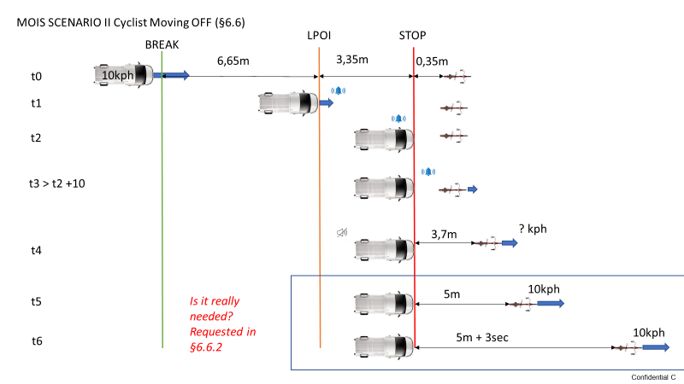

6.6.3. The Technical Service shall verify the activation of the MOIS information signal before the subject vehicle reaches a distance from the stopping point (*pstop*) corresponding to the last point of information (*dLPI*) in Table 2 of Appendix 1, and the MOIS information signal remains on until the test target passes a distance from the vehicle front relating to the maximum detection distance of 3.7 metres in Figure 2 in Appendix 1. The collision warning signal may be activated with the information signal, as appropriate.

6.6.4. Repeat paragraphs 6.6.1. to 6.6.3. for ~~all~~ **two** test cases shown in Table 2 of Appendix 1 to this Regulation **at the selection of the Technical Service**.

~~The Technical Service~~ **~~may~~** ~~shall perform at least one other test case by selecting a combination of cyclist test target and cyclist starting points from the ranges defined in paragraph 5.2.1.3. of this Regulation.~~

OICA 28/01/2020: to be in line with our previous proposal, we should delete the paragraph 2 of 6.6.4.

20 test cases (+ false information tests) in the current proposal, we may definitively reduce that number

6.7 Longitudinal Moving Off with Cyclist Tests

6.7.1. The cyclist test target (*T*) shall be located within the test area marked out as shown in Figure 2 of Appendix 1. The cyclist test target shall be positioned at the relevant test target starting point (*pcyc*) in Table 2 of Appendix 1 and face in the direction of travel and parallel to the longitudinal median plane of the subject vehicle. The subject vehicle shall be accelerated in a straight line to a constant speed of ~~10 ± 0.5 km/h~~ **10 -0,5km/h**, before entering the stopping corridor. The subject vehicle shall maintain a constant speed until the vehicle front passes the braking point (*pbrake*) shown in Table 2 of Appendix 1, before braking to a stop such that the vehicle front is positioned at the stopping point (*pstop*).

OICA 28/01/2020:

10 ± 0.5 km/h is in conflict with the requirement which is up to 10 kph (5.2.3)

6.7.2. After a delay of no less than 10 seconds from the point at which the subject vehicle is considered to have stopped, the test target and subject vehicle shall be accelerated at the same time and in a straight line, on a trajectory parallel to the longitudinal median plane of the subject vehicle, to a constant speed of ~~10 ± 0.5 km/h~~ **10 -0,5km/h** in a distance of no greater than 5 metres. The lateral tolerance of the subject vehicle and test target motion shall not exceed ~~± 0.5 metres~~ **+/- 0.05m**. The subject vehicle and test target shall maintain this constant speed until a total travel distance of no less than 15 metres from the stopping point (*dtravel*) is traversed by the subject vehicle. The separation distance (*dsep*) between the vehicle front and test target shall be maintained to a tolerance of ~~± 0.5 metres~~ **+/- 0.05m**.

OICA 28/01/2020 :

10 ± 0.5 km/h is in conflict with the requirement which is up to 10 kph

Lateral tolerance proposal to be in line with NCAP measure (5.2.3)

Dsep: 0.5 m may conflict with the minimum distance required

Dtravel and Desp are not defined (to be added in Appendix 1?)

Vehicle and Bicycle acceleration are different. Is it an issue for the testing procedure as it is written?

6.7.3. The Technical Service shall verify the activation of the MOIS information signal before the subject vehicle reaches a distance from the stopping point (*pstop*) corresponding to the last point of information (*dLPI*) in Table 2 of Appendix 1, and that the MOIS information signal remains on until the subject vehicle passes the total travel distance from the stopping point (*dtravel*). The collision warning signal may be activated with the information signal, as appropriate.

6.7.4. Repeat paragraphs 6.7.1. to 6.7.3. for ~~all~~ **two** test cases shown in Table 2 of Appendix 1 to this Regulation **at the selection of the Technical Service.**

~~The Technical Service~~ **~~may~~** ~~shall perform at least one other test case by selecting a combination of cyclist test target and cyclist positions from those defined in paragraph 5.2.1.3. of this Regulation.~~

OICA 28/01/2020: OICA 28/01/2020: to be in line with our previous proposal, we should delete the paragraph 2 of 6.6.4.

20 test cases (+ false information tests) in the current proposal, we may definitively reduce that number

OICA 28/01/2020: we propose to delete the whole section 6.8, to be in line with BSIS. We are not able to predict. We can minimize but not avoid 100% false positive or false negative.

More technology neutral.

And less tests to be done

~~6.8 False information signal test~~

~~6.8.1. Pedestrian and environmental clutter false information signal test~~

~~6.8.1.1. The adult pedestrian test target shall be positioned so as to face in a direction perpendicular to the longitudinal median plane of the subject vehicle and at a lateral distance (~~*~~d~~~~lat~~*~~) of 1.0 ± 0.25 metres outboard from either the nearside or offside planes of the subject vehicle trajectory, as selected by the Technical Service.~~

~~6.8.1.2. Position a local traffic sign, corresponding to sign C14 as defined in the Vienna convention on road signs and signals[[3]](#footnote-4) (speed limit 50 km/h) or a local sign that is closest in meaning to this, on a pole 3.0 ± 0.5 metres before the pedestrian test target and at a lateral distance of 1.0 ± 0.25 metres outboard from either the nearside or offside planes of the subject vehicle trajectory, as selected by the Technical Service. The lowest point of the local traffic sign shall be located at 2 m above the test track surface.~~

~~6.8.1.3. Position a stationary vehicle, of Category M1 AA saloon, so as to face in a direction that is parallel to the longitudinal median plane, and in the direction of travel, of the subject vehicle. The front of the vehicle shall be positioned 4.0 ± 0.5 metres before the pedestrian test target and the side of the vehicle shall be positioned at a lateral distance (~~*~~d~~~~lat~~*~~) of 1.0 ± 0.25 metres outboard from either the nearside or offside planes of the subject vehicle trajectory, as selected by the Technical Service.~~

~~6.8.1.4. The subject vehicle shall travel in a straight line for a distance of at least 60 metres at a constant speed, selected from between 5 km/h and 10 km/h with a tolerance of ± 0.5 km/h, to pass the stationary vehicle, traffic sign and test target at the defined lateral distance (~~*~~d~~~~lat~~*~~).~~

~~During the test there shall be no adjustment of any subject vehicle control other than slight steering adjustments to counteract any drifting.~~

~~6.8.1.5. The MOIS shall not provide an information signal or collision warning signal at any point during testing.~~

~~6.8.2. Cyclist false [information and] collision warning signal test~~

~~6.8.2.1. The adult cyclist test target shall be positioned so as to face in a direction that is parallel to the longitudinal median plane of the subject vehicle and at a lateral distance (~~*~~d~~~~lat~~*~~) of 1.0 ± 0.25 metres outboard from either the nearside or offside planes of the subject vehicle trajectory, as selected by the Technical Service.~~

~~6.8.2.2. The subject vehicle shall travel in a straight line for a distance of at least 60 metres at a constant speed of 10 ± 0.5 km/h. As the subject vehicle reaches a forward separation distance of 5 m from the adult cyclist test target, the test target shall be accelerated in a straight line on a trajectory parallel to the longitudinal median plane of the subject vehicle to a constant speed, selected from between 3 km/h and 5 km/h with a tolerance of ± 0.5 km/h, and within a distance of 2 metres. The constant speeds of the adult cyclist test target and that of the subject vehicle shall be maintained until the subject vehicle passes the test target at the defined lateral distance (~~*~~d~~~~lat~~*~~).~~

~~During the test there shall be no adjustment of any subject vehicle control other than slight steering adjustments to counteract any drifting.~~

~~6.8.2.3. The MOIS shall not provide [an information signal or] collision warning signal at any point during testing.~~

6.9. Failuredetection test

6.9.1. Simulate a MOIS failure, for example by disconnecting the power source to any MOIS component or disconnecting any electrical connection between the MOIS components. The electrical connections for the failure warning signal of paragraph 5.5.1. above shall not be disconnected when simulating a MOIS failure.

6.9.2. The failure warning signal specified in paragraphs 5.2.6. and 5.5.1. shall be activated and remain activated while the vehicle is being driven and shall be reactivated upon each activation of the vehicle master control switch, as long as the simulated failure exists.

6.10. Automatic deactivation test

6.10.1. With the MOIS system active, contaminate any of the MOIS sensing devices completely with a substance comparable to snow, ice or mud (e.g. based on water). The MOIS shall automatically deactivate, indicating this condition as specified in paragraph 5.5.2.

6.10.2. Remove any contamination from the MOIS sensing devices completely and perform a reactivation of the vehicle master control switch. The MOIS shall automatically reactivate after a driving time not exceeding 60 seconds.

OICA 28/01/2020: taken from BSIS. Not in AEBS regulation.

What does activation mean (It is working well?)

7. Modification of vehicle type and extension of approval

7.1. Every modification of the vehicle type as defined in paragraph 2.3. of this Regulation shall be notified to the Type Approval Authority which approved the vehicle type. The Type Approval Authority may then either:

7.1.1. Consider that the modifications made do not have an adverse effect on the conditions of the granting of the approval and grant an extension of approval;

7.1.2. Consider that the modifications made affect the conditions of the granting of the approval and require further tests or additional checks before granting an extension of approval.

7.2. Confirmation or refusal of approval, specifying the alterations, shall be communicated by the procedure specified in paragraph 4.4. above to the Contracting Parties to the Agreement applying this Regulation.

7.3. The Type Approval Authority shall inform the other Contracting Parties of the extension by means of the communication form which appears in Annex 1 to this Regulation. It shall assign a serial number to each extension, to be known as the extension number.

8. Conformity of production

8.1. Procedures for the conformity of production shall conform to the general provisions defined in Article 2 and Schedule 1 to the 1958 Agreement (E/ECE/TRANS/505/Rev.3) and meet the following requirements:

8.2. A vehicle approved pursuant to this Regulation shall be so manufactured as to conform to the type approved by meeting the requirements of paragraph 5. above;

8.3. The Type Approval Authority which has granted the approval may at any time verify the conformity of control methods applicable to each production unit. The normal frequency of such inspections shall be once every two years.

9. Penalties for non‑conformity of production

9.1. The approval granted in respect of a vehicle type pursuant to this Regulation may be withdrawn if the requirements laid down in paragraph 8. above are not complied with.

9.2. If a Contracting Party withdraws an approval it had previously granted, it shall forthwith so notify the other Contracting Parties applying this Regulation by sending them a communication form conforming to the model in Annex 1 to this Regulation.

10. Production definitively discontinued

If the holder of the approval completely ceases to manufacture a type of vehicle approved in accordance with this Regulation, they shall so inform the Type Approval Authority which granted the approval, which in turn shall forthwith inform the other Contracting Parties to the Agreement applying this Regulation by means of a communication form conforming to the model in Annex 1 to this Regulation.

11. Names and addresses of the Technical Services responsible for conducting approval tests and of Type Approval Authorities

The Contracting Parties to the Agreement applying this Regulation shall communicate to the United Nations Secretariat the names and addresses of the Technical Services responsible for conducting approval tests and of the Type Approval Authorities which grant approval and to which forms certifying approval or extension or refusal or withdrawal of approval are to be sent.

**Appendix 1**

Figure 1

**Set Up for Static Crossing Tests**

Stationary Left Hand Drive Vehicle

Vehicle front

Offside plane

Nearside plane

25% width from offside

25% width from nearside

Offside LPI plane

Nearside LPI plane

*d25%*

*d25%*

*dw*

*dLPI*

*dLPI*

5 m

15 m

5 m

15 m

*dTC* = 0.5±0.1 m

*dTC* = 0.6±0.1 m

*dTC* = 3.7±0.1 m

Where the following definitions apply:

*dw* vehicle width

*d25%* a distance relating to 25% of the vehicle width

*dLPI* the distance between 25% of the vehicle width and the last point of information (LPI)

*dTC* the test case distance

**dFS Maximum forward separation distance as defined in section 5.2.1**

Table 1

**Test Cases for Static Crossing Tests**

|  |  |  |  |  |  |
| --- | --- | --- | --- | --- | --- |
| Test Case | Test Target (T) | Test Case Distance (dTC) /m | Crossing Direction (c) | Test Target Speed (v) /km/h | Distance to Last Point of Information (*dLPI*) /m |
| 1 | Child Pedestrian | 0. ~~5~~**8**±0.1 | Nearside | 3 | 1.2 |
| 2 | Adult Pedestrian | ~~3.7±~~ **dFS -**0.1 | Nearside | 3 | 1.2 |
| 3 | Adult Cyclist | 0.~~6~~**8**±0.1 | Offside | 3 | 1.2 |
| ~~4~~ | ~~Child Cyclist~~ | ~~3.7±0.1~~ | ~~Offside~~ | ~~3~~ | ~~1.2~~ |
| ~~5~~ | ~~Child Cyclist~~ | ~~0. 5~~**8**~~±0.1~~ | ~~Nearside~~ | ~~5~~ | ~~2.0~~ **~~1.9~~** |
| 6 | Adult Cyclist | ~~3.7±~~ **dFS -**0.1 | Nearside | 5 | **1.9** |
| 7 | Adult Pedestrian | 0. ~~6~~**8**±0.1 | Offside | 5 | **1.9** |
| 8 | Child Pedestrian | ~~3.7±~~ **dFS -**0.1 | Offside | 5 | **1.9** |

OICA 28/01/2020: 1.9 is equivalent to 1.4s at 5 kph

Figure 2

**Set Up for Longitudinal Cyclist Tests**

Subject Vehicle

*pstop*

*d50%*

1.75±0.1 m

3.5±0.1 m

Stopping corridor

1.25±0.1 m

*d50%*

*dLPI*

10±0.2 m

15±0.2 m

4.6±0.1 m

*pcyc*

*px*

*py*

Stopping corridor

*pbrake*

Where the following definitions apply:

*d50%* a distance relating to 50% of the vehicle width

*pbrake* the vehicle braking point

*pstop* the vehicle stopping point

*dLPI* the distance between the last point of information (LPI) line and the vehicle stopping point

*pcyc* the cyclist test target starting point, taken from the cyclist test target reference point

*px* the distance between the vehicle front and cyclist test target starting point

*py* the distance between the vehicle longitudinal median plane and cyclist test target starting point, with the

nearside of the vehicle being the positive direction

**dFS Maximum forward separation distance as defined in section 5.2.1**

Table 2

**Test Cases for Longitudinal Cyclist Tests**

|  |  |  |  |  |
| --- | --- | --- | --- | --- |
| Test Case | Test Target (T) | Distance to Forward Cyclist Start Point (px) /m | Distance to Lateral Cyclist Start Point (py) /m | Distance to Last Point of Information (*dLPI*) /m |
| ~~1~~ | ~~Child Cyclist~~ | ~~0.35±0.1~~ | ~~+d~~~~50%~~ ~~±0.1~~ | ~~3.35±0.1~~ |
| 2 | Adult Cyclist | 0.35±0.1 | 0.0±0.1 | 3.35±0.1 |
| ~~3~~ | ~~Child Cyclist~~ | ~~0.35±0.1~~ | ~~-d~~~~50%~~ ~~±0.1~~ | ~~3.35±0.1~~ |
| 4 | Adult Cyclist | ~~3.7±~~ **dFS -**0.1 | +d50% ±0.1 | 0.0±0.1 |
| ~~5~~ | ~~Child Cyclist~~ | ~~3.7±0.1~~ | ~~0.0±0.1~~ | ~~0.0±0.1~~ |
| 6 | Adult Cyclist | ~~3.7±~~ **dFS -**0.1 | -d50% ±0.1 | 0.0±0.1 |

OICA: to be updated considering the maximum forward separation distance (dfs) and the minimum forward separation defined in 5.2.1.2 (0.8 m)

**Annex 1**

**Communication**

(Maximum format: A4 (210 x 297 mm)

|  |  |
| --- | --- |
|  | issued by: (Name of administration)  ......................................  ......................................  ...................................... |

[[4]](#footnote-5)Concerning: [[5]](#footnote-6) Approval granted

Approval extended

Approval refused

Approval withdrawn

Production definitively discontinued

of a type of vehicle with regard to the Moving Off Information System (MOIS) pursuant to UN Regulation No. [XXX]

Approval No.:

1. Trademark:

2. Type and trade name(s):

3. Name and address of manufacturer:

4. If applicable, name and address of manufacturer's representative:

5. Brief description of vehicle:

6. Date of submission of vehicle for approval:

7. Technical Service performing the approval tests:

8. Date of report issued by that Service:

9. Number of report issued by that Service:

10. Reason(s) for extension (if applicable) :

11. Approval with regard to the MOIS is granted/refused:2

12. Place:

13. Date:

14. Signature:

15. Annexed to this communication are the following documents, bearing the approval number indicated above:

16. Any remarks:



**Annex 2**

**Arrangements of approval marks**

(see paragraphs 4.5. to [4.5.2.] of this Regulation)



XXXR - 00185

a = 8 mm min

The above approval mark affixed to a vehicle shows that the vehicle type concerned has been approved in Belgium (E6) with regard to the Moving Off Information System (MOIS) pursuant to UN Regulation No. [XXX]. The first two digits of the approval number indicate that the approval was granted in accordance with the requirements of UN Regulation No. [XXX] in its original form.

UI

a/3

270650

a/2

2a/3

a ≥ 8 mm

a

The above Unique Identifier shows that the type concerned has been approved and that the relevant information on that type-approval can be accessed on the UN secure internet database by using 270650 as Unique Identifier. Any leading zeroes in the Unique Identifier may be omitted in the approval marking.

II. Justification

1. Low-speed moving off from rest and travelling straight ahead manoeuvres that involve collisions between heavy vehicles and pedestrians and cyclists usually have serious consequences for these particularly vulnerable road users (VRUs). In the past, VRU safety was raised by increasing the number of mirrors to provide better visibility of the area in front of the vehicle. Since collisions with these characteristics still occur and advanced driver assistance systems have been introduced in a lot of vehicle segments, it is obvious to use such assistance systems for avoiding accidents between heavy vehicles and VRUs.

2. Theoretical considerations show that the criticality of traffic situations that involve heavy vehicles and VRUs can be significant due to the misunderstandings of the situation by the vehicle operators. In some cases, the increase in situation criticality can occur so suddenly that high-urgency warnings, intended to generate a driver reaction to the situation, cannot be activated early enough for the driver to react in time. In general, driver reactions to any information (high/low urgency signals) can be expected only after a certain reaction time. This response time, particularly during close-proximity manoeuvres, is much longer than the time required to avoid the accident in many situations **–** the accident cannot be avoided despite the warning.

3. High-urgency warnings during a driving situation are only justified should the probability for an accident be high **–** otherwise vehicle drivers tend to ignore the system alerts. Should lower urgency information signals be activated sufficiently early, however, it may help the driver rather than annoy them. It is assumed to be possible to design a human-machine interface (HMI) for moving-off driver assistance systems in a way that it does not annoy drivers when the information is not needed, for instance by requiring the use of a less intrusive signal mode.

4. Therefore, this UN Regulation asks for the early activation of a proximity information signal in case pedestrians or cyclists might be entering a critical area in front of the vehicle, should the heavy vehicle either move off from rest in a straight line or be travelling straight ahead at low-speeds. This signal shall only be deactivated automatically in case of system failure or contamination of the sensors. Although manual deactivation shall not be possible, manual suppression of any audible signals shall be possible.

5. Furthermore, this UN Regulation asks for an additional signal, which shall be given when the collision becomes unavoidable, e.g. when the vehicle accelerates from rest and the pedestrian or cyclist is located directly in front of the vehicle. The activation and deactivation strategy for this collision warning signal may be determined by the manufacturer; however, it shall be deactivated together with the proximity information signal in case of system failure or sensor contamination.

6. This UN Regulation defines a test procedure based on heavy vehicles that are stationary, moving-off from rest and moving ahead at low-speeds in a straight line for speeds of 10 km/h or less. Collision analysis data shows that the provision of information and warnings during these vehicle manoeuvres is appropriate since the information signal needs to be present sufficiently early to alert the driver of pedestrians and cyclists in close-proximity to the front end of the vehicle

1. See Annex 1 to the Consolidated Resolution on the Construction of Vehicles (R.E.3), document ECE/TRANS/WP.29/78/Rev.6 - www.unece.org/trans/main/wp29/wp29wgs/wp29gen/wp29resolutions.html [↑](#footnote-ref-2)
2. The distinguishing numbers of the Contracting Parties to the 1958 Agreement are reproduced in Annex 3 to the Consolidated Resolution on the Construction of Vehicles (R.E.3), document ECE/TRANS/WP.29/78/Rev.6 - www.unece.org/trans/main/wp29/wp29wgs/wp29gen/wp29resolutions.html [↑](#footnote-ref-3)
3. See ECE/TRANS/196, para. 91 on the Convention on Road Signs and Signals of 1968 European Agreement Supplementing the Convention and Protocol on Road Markings, Additional to the European Agreement. [↑](#footnote-ref-4)
4. Distinguishing number of the country which has granted/extended/refused/withdrawn an approval (see approval provisions in this Regulation). [↑](#footnote-ref-5)
5. Strike out what does not apply. [↑](#footnote-ref-6)