Appendix 5

*Assessment of overall trip dynamics using the moving averaging window method*

1. INTRODUCTION

The Moving Averaging Window method is used to assess the overall trip dynamics. The test is divided in sub-sections (windows) and the subsequent analysis aims at determining whether the trip is valid for RDE purposes. The ‘normality’ of the windows is assessed by comparing their CO2 distance-specific emissions with a reference curve obtained from the vehicle CO2 emissions measured in accordance with the applicable type approval cycle.

2. SYMBOLS, PARAMETERS AND UNITS

Index (i) refers to the time step.

Index (j) refers to the window.

Index (k) refers to the category (t=total, u=low speed average speed class, r=medium speed average speed class, m=high speed average speed class) or to the CO2 characteristic curve (cc).

- coefficients of the CO2 characteristic curve

- coefficients of the CO2 characteristic curve

- CO2 mass, [g]

- CO2 mass in window j, [g]

- total time in step i, [s]

- duration of a test, [s]

- actual vehicle speed in time step i, [km/h]

- average vehicle speed in window j, [km/h]

- upper tolerance for the vehicle CO2 characteristic curve, [%]

- lower tolerance for the vehicle CO2 characteristic curve, [%]

3. MOVING AVERAGING WINDOWS

3.1. Definition of averaging windows

The instantaneous CO2 emissions calculated according to Appendix 4 shall be integrated using a moving averaging window method, based on an appropriate reference CO2 mass. The reference CO2 mass shall be defined by each Contracting Party.

The moving window calculations are conducted with a time increment Δ*t* corresponding to the data sampling frequency. These sub-sets used to calculate the vehicle on-road CO2 emissions and its average speed are referred to as ‘averaging windows’ in the following sections. The calculation described in the present point shall be run from the first data point (forward).

The following data shall not be considered for the calculation of the CO2 mass, the distance and the vehicle average speed in each averaging window:

1. The periodic verification of the instruments and/or after the zero drift verifications;
2. Vehicle ground speed < 1 km/h;

The calculation shall start from test start.

The mass emissions shall be determined by integrating the instantaneous emissions in g/s as specified in Appendix 4 to this Annex.

*Figure 1*

*Vehicle speed versus time - Vehicle averaged emissions versus time, starting from the first averaging window*

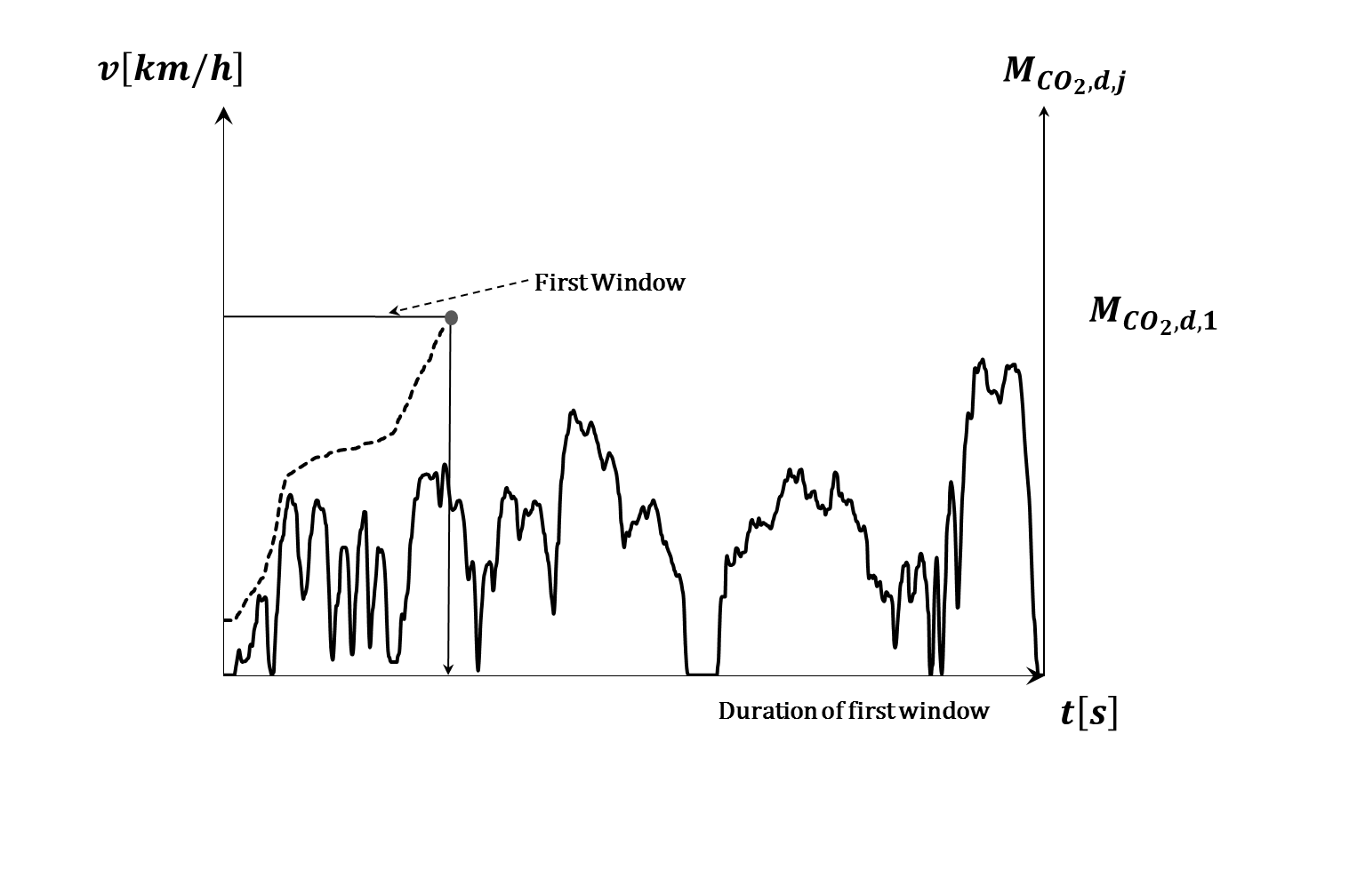

*Figure 2*

*Definition of CO2 mass based on averaging windows*

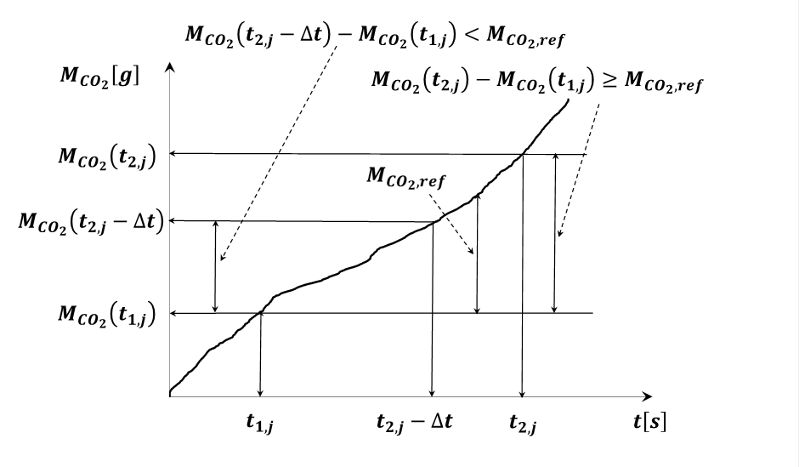

The duration of the jth averaging window is determined by:

Where:

is the CO2 mass measured between the test start and time , [g];

is the reference CO2 mass

shall be selected such as:

where is the data sampling period.

The CO2 masses in the windows are calculated by integrating the instantaneous emissions calculated as specified in Appendix 4.

**Examples of applications by contracting parties**

|  |  |
| --- | --- |
| **Contracting party using** | **Reference CO2 mass** |
| WLTP 3 and 4 phases | Half of the CO2 mass emitted during the applicable WLTP cycle  Half of the CO2 mass emitted by OVC-HEV vehicles in Charge Sustaining mode WLTP cycle |
| MIDC | Total CO2 mass emitted over the MIDC cycle  Total CO2 mass emitted by OVC-HEV vehicles in Charge Sustaining mode in MIDC cycle |

3.2. Calculation of window characteristics

The following shall be calculated for each window determined in accordance with point 3.1.,

1. The distance-specific CO2 emissions ;
2. The average vehicle speed

4. EVALUATION OF WINDOWS

4.1. Introduction

The windows are assessed by comparing their CO2 distance-specific emissions with a curve obtained from the vehicle CO2 emissions measured in accordance with the applicable type approval cycle. For that purpose, the windows are classified in urban, rural and motorway average speed classes.

4.2. CO2 characteristic curve reference points

The distance-specific CO2 emissions to be considered in this paragraph for the definition of the characteristic curve shall be obtained from the tests conducted on the vehicle using the applicable type approval cycle(s).

For OVC-HEV vehicles, the values shall be obtained from the applicable type approval cycle conducted using the Charge Sustaining mode.

The reference points *P*1,*P*2 and *P*3 required to define the vehicle CO2 characteristic curve are as follows:

4.2.1. *Point P1 - Low speed point*

The co-ordinates for *P1* are the following:.

is the average speed for the type approval cycle (or cycle phases) **selected as representative for urban operation** by the contracting party, [km/h]

are the distance-specific vehicle CO2 emissions of the type approval cycle or cycle phases **selected as representative for urban operation** by the contracting party [g/km]

4.2.2. *Point P2 - Medium speed point*

The co-ordinates for *P2* are the following:.

is the average speed of the type approval cycle (or cycle phases) **selected as representative for rural operation** by the contracting party, [km/h]

are the distance-specific vehicle CO2 emissions of the type approval cycle or cycle phases **selected as representative for rural operation** by the contracting party [g/km]

4.2.3. *Point P3 - High speed point*

The co-ordinates for *P3* are the following:.

is the average speed of the type approval cycle (or cycle phases) **selected as representative for motorway/expressway operation** by the contracting party, in [km/h]

are the distance-specific vehicle CO2 emissions of the type approval cycle or cycle phases **selected as representative for motorway/expressway operation** by the contracting party, expressed in [g/km]

**Examples of applications by contracting parties**

|  |  |
| --- | --- |
| **Contracting party using** | **Points for the CO2 characteristic curve** |
| WLTP 4 phases | (Average S*peed of the Low Speed phase of the WLTP cycle)*  = Vehicle CO2 emissions over the Low Speed phase of the WLTP cycle [g/km]  (Average S*peed of the High Speed phase of the WLTP cycle)*  = Vehicle CO2 emissions over the High Speed phase of the WLTP cycle [g/km]  (Average S*peed of the Extra High Speed phase of the WLTP cycle)*  = Vehicle CO2 emissions over the Extra High Speed phase of the WLTP cycle [g/km] |
| WLTP 3 phases | (Average S*peed of the Low Speed phase of the WLTP cycle)*  = Vehicle CO2 emissions over the Low Speed phase of the WLTP cycle [g/km]  (Average S*peed of the High Speed phase of the WLTP cycle)*  = Vehicle CO2 emissions over the High Speed phase of the WLTP cycle [g/km] |
| MIDC | Adjustments factors:  = 1,10 for M vehicles  = 1,05 for N1, M and N1 low powered vehicles  (Average S*peed of the phase 1 of the MIDC cycle)*  = x Vehicle CO2 emissions over the phase 1 of the MIDC cycle [g/km]  (Average S*peed of the phase 2 of the MIDC cycle)*  = x Vehicle CO2 emissions over the phase 2 of the MIDC cycle [g/km] |

4.3.1 CO2 characteristic curve definition

Using the reference points defined in section 4.2, the characteristic curve CO2 emissions are calculated as a function of the average speed using two linear sections (*P*1, *P*2) and (*P*2, *P*3). The section (*P*2, *P*3) is limited to 145 km/h on the vehicle speed axis. The characteristic curve is defined by equations as follows:

For the section (:

For the section (:

*Figure 3*

*Vehicle CO2 characteristic curve and tolerances for ICE and NOVC-HEV vehicles (Illustrated for the case )*

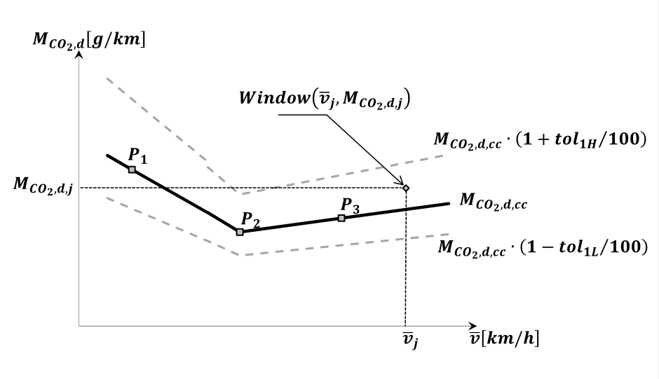

*Figure 4:*

*Vehicle CO2 characteristic curve and tolerances for OVC-HEV vehicles (Illustrated for the case )*

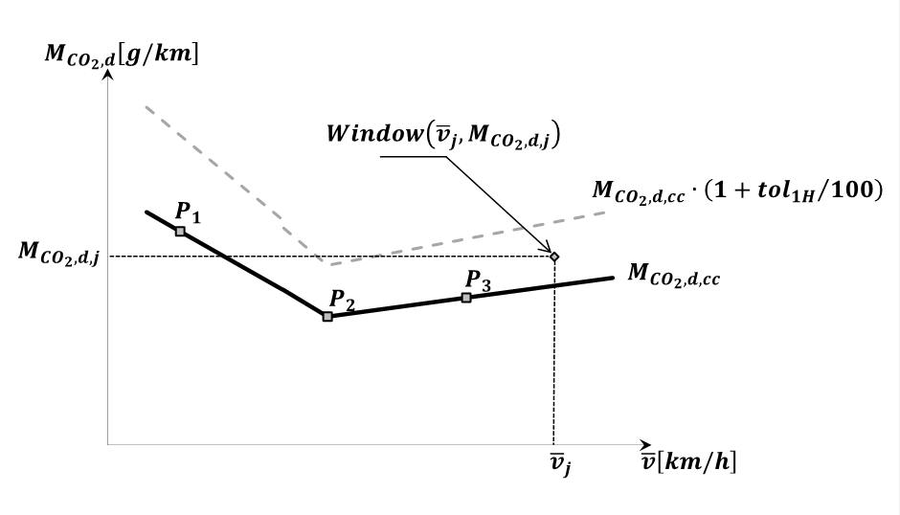

4.4.1. Classifying windows in Low, medium and high average speed classes

The moving averaging windows shall be classified into the low, medium and high average speed classes selected by the contracting parties.

**Examples of applications by contracting parties**

|  |  |
| --- | --- |
| **Contracting party using** | **Average speed ranges for window classification**  **(** being the **window average speed)** |
| WLTP 4 phases | Low speed: 0<≤45 km/h  Medium speed: 45<≤80 km/h  High speed: 80<km/h  N2 category vehicles that are equipped in accordance with Directive 92/6/EEC with a device limiting vehicle speed to 90 km/h, motorway windows are characterised by average vehicle speeds greater than or equal to 70 km/h and lower than 90 km/h |
| WLTP 3 phases | Low speed: 0<≤50 km/h  High speed: 50<≤100 km/h km/h |
| MIDC | *M1 and N1 vehicles:*  Low speed: 0<≤35 km/h  Medium speed: 35<≤55 km/h  High speed: 55< km/h  *M1 and N1 – Low Powered Vehicles:*  Low speed: 0<≤35 km/h  Medium speed: 35< |

*Figure 5*

*Vehicle CO2 characteristic curve: low, medium and high average speed definitions* *(Illustrated for WLTP 4 phases ICE and NOVC-HEV vehicles) except N2 category vehicles that are equipped in accordance with Directive 92/6/EEC with a device limiting vehicle speed to 90 km/h)*

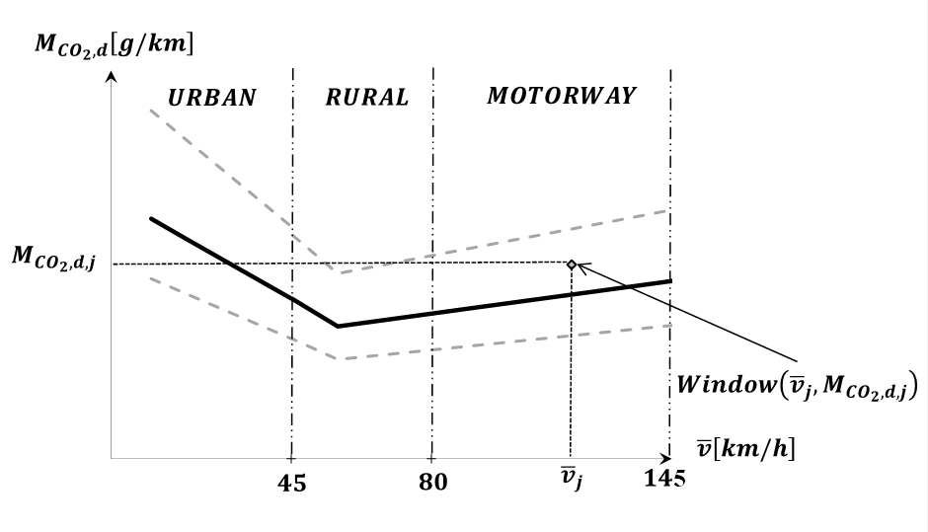

*Figure 6.*

*Vehicle CO2 characteristic curve: low, medium and high average speed definitions (Illustrated for OVC-HEV vehicles) WLTP 4 phases, except N2 category vehicles that are equipped in accordance with Directive 92/6/EEC with a device limiting vehicle speed to 90 km/h)*

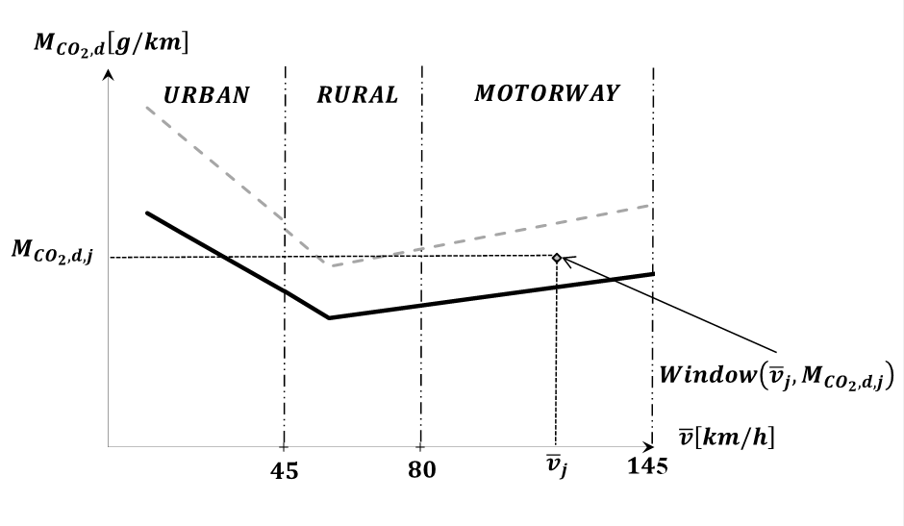

*Figure 5-2*

*Vehicle CO2 characteristic curve: low and high average speed definitions* *(Illustrated for ICE and NOVC-HEV vehicles)*

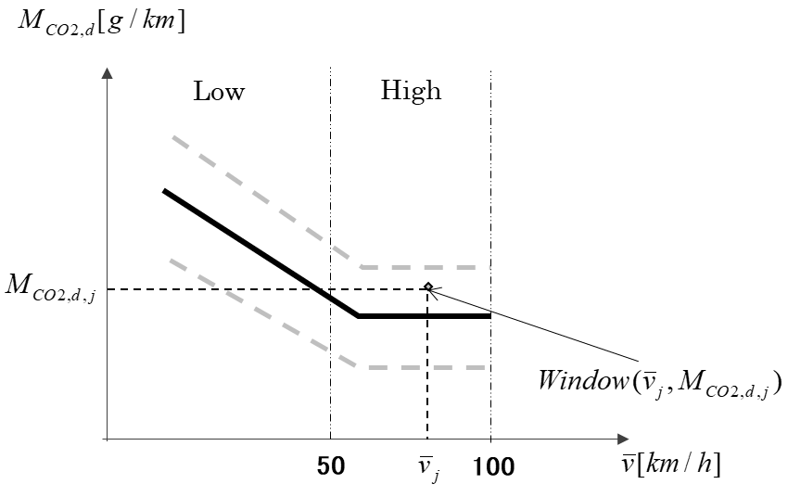

*Figure 6-2.*

*Vehicle CO2 characteristic curve: low and high average speed definitions (Illustrated for OVC-HEV vehicles)*

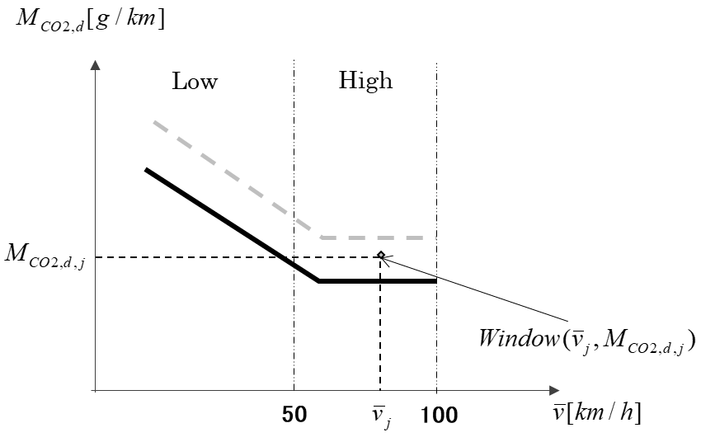

4.5.1. Assessment of trip validity

The test is valid when at least 50% of the windows in the low, medium and high (medium and high, when applicable) speed classesare within the tolerances and .

To reflect the driving behaviour in a region, the tolerances are selected by the contracting party.

For NOVC-HEVs and OVC-HEVs, if the minimum requirement of 50 % between and is not met, the upper positive tolerance  may be increased by steps of 1 % until the 50 % target is reached. When using this mechanism, the value of shall never exceed 50 %.

**Examples of applications by contracting parties**

|  |  |
| --- | --- |
| **Contracting party using** | **Tolerances** |
| WLTP 3 and 4 phases | for low speed windows  for medium and high speed windows  for all windows  OVC-HEV vehicles: for all windows |
| MIDC | for all windows  for all windows  OVC-HEV vehicles? |

Appendix 6

*Calculation of the final RDE emissions results*

1. **Symbols, Parameters and Units**

Index (k) refers to the category (t=total, u=urban, cu=phases of the type approval cycle corresponding to the urban operation)

is the distance share of usage of the internal combustion engine for an OVC-HEV over the RDE trip

is the distance driven [km], with the internal combustion engine on for an OVC-HEV over the RDE trip

is the distance driven [km], with the internal combustion engine off for an OVC-HEV over the RDE trip

is the final RDE distance-specific mass of gaseous criteria emissions [mg/km] or particle number [#/km]

is the distance-specific mass of gaseous criteria emission [mg/km] or particle number [#/km] emissions, emitted over the complete RDE trip and prior to any correction in accordance with this Appendix

is the distance-specific mass of CO2 [g/km], emitted over the RDE trip

is the distance-specific mass of CO2 [g/km], emitted over the applicable type approval cycle

is the distance-specific mass of CO2 [g/km], emitted over the applicable type approval cycle for an OVC-HEV vehicle tested on its charge sustaining mode

ratio between the CO2 emissions measured during the RDE test and the applicable type approval tests

is the result evaluation factor calculated for the RDE trip

is the first parameter of the function used to calculate the result evaluation factor

is the second parameter of the function used to calculate the result evaluation factor

1. **Calculation of the Final RDE emissions results**
   1. **Introduction**

The trip validity shall be verified in accordance with point 9.2. of this GTR. Contracting parties may decide that attenuation of the RDE results is required in order to account for extreme RDE trips.

India shall follow RDE Package 3 post-processing method for final emissions calculation.

For the valid trips, the final RDE results are calculated as follows for vehicles with ICE, NOVC-HEV and OVC-HEV.

For the complete RDE trip and for the urban part of the RDE trip (k=t=total, k=u=urban):

The values of the parameter and of the function used to calculate the result evaluation factor need to be assessed by each CP.

The RDE result evaluation factors (k=t=total, k=u=urban) shall be obtained using the functions laid down in point 2.2. for vehicles with ICE and NOVC-HEV, and in point 2.3. for OVC-HEV. A graphical illustration of the method is provided in Figure App 6.1 below, while the mathematical formulas are found in Table App 6.1:

Figure App 6.1: Function to calculate the result evaluation factor



Table App 6.1 Result evaluation factors calculation

|  |  |  |
| --- | --- | --- |
| When: | Then the Result evaluation factor is: | Where: |
|  |  |  |
|  |  |  |
|  |  |  |

**Example of application by a contracting party**

|  |  |
| --- | --- |
| **Contracting party using** | **Values for the RF function** |
| WLTP 3 and 4 phases | and |

* 1. **RDE result evaluation factor for vehicles with ICE and NOVC-HEV**

The value of the RDE result evaluation factor depends on the ratio between the distance specific CO2 emissions measured during the RDE test and the distance-specific CO2 emitted by the vehicle over the applicable type approval test. For the urban emissions, the relevant phases of the applicable type approval test shall be considered.

**Example of application by a contracting party**

|  |  |
| --- | --- |
| **Contracting party using** | **Reference laboratory cycles or cycle phases to be considered to obtain** |
| WLTP 3 and 4 phases | *Total emissions:*  - All vehicles: whole applicable WLTP driving cycle  *Urban emissions:*  - ICE vehicles : WLTP Low and the Medium speed phases  - For NOVC-HEVs the whole applicable WLTP driving cycle |

* 1. **RDE result evaluation factor for OVC-HEV**

The value of the RDE result evaluation factor depends on the ratio between the distance-specific CO2 emissions measured during the RDE test and the distance-specific CO2 emitted by the vehicle over the applicable type approval test. The ratio is corrected by a ratio reflecting the respective usage of the internal combustion engine during the RDE trip and on the applicable type approval test, to be conducted using the charge sustaining mode.

For either the urban or the total driving (k=t=total, k=u=urban):

where is the ratio of the distance driven either in urban or total trip (k=t=total, k=u=urban) with the combustion engine on divided by the total urban or total trip distance:

With determination of combustion engine operation in accordance with Appendix 4 Paragraph 5.

* 1. **Account for the margin of uncertainty of PEMS instruments in the final RDE values.**

In those CPs where the emission limits are set based on laboratory tests, the extra uncertainty of the measurements by PEMS compared to laboratory measurements needs to be taken into account for the final calculation of the results that will be used for proving compliance with emission limits.

*As an example for application in CPs applying the WLTP:*

The emissions resulting from the operations described in the previous paragraphs shall be divided by a conformity factor defined as 1+margin pollutant., where margin of pollutant is a measure of the uncertainty of the PEMS measurements compared to the ones performed in the laboratory.

The *margin* for each pollutant is specified as follows:

|  |  |  |  |  |  |
| --- | --- | --- | --- | --- | --- |
| Pollutant | Mass of oxides of nitrogen (NOx) | Number of particles (PN) | Mass of carbon monoxide (CO)[1] | Mass of total hydrocarbons (THC) | Combined mass of total hydrocarbons and oxides of nitrogen (THC + NOx) |
| *marginpollutant* | 0,43 | 0,5 | *unspecified* | *unspecified* | *unspecified* |

Appendix 7a

*Assessment of excess or absence of trip dynamics*

1. INTRODUCTION

The RDE trip dynamics shall be representative of typical in-use driving. This Appendix describes the calculation procedures to assess the trip dynamics by determining the excess or absence of dynamics during an RDE Trip.

2. SYMBOLS, PARAMETERS AND UNITS

|  |  |  |  |  |  |
| --- | --- | --- | --- | --- | --- |
|  | |  | |  | |
|  | |  | |  | |
|  | |  | |  | |
|  | |  | |  | |
|  | |  | |  | |
|  | |  | |  | |
| *a* | | — | | acceleration [m/s2] | |
| *ai* | | — | | acceleration in time step i [m/s2] | |
| *apos* | | — | | positive acceleration greater than 0,1 m/s2 [m/s2] | |
| *apos,i,k* | | — | | positive acceleration greater than 0,1 m/s2 in time step i considering the urban, rural and motorway shares [m/s2] | |
| *ares* | | — | | acceleration resolution [m/s2] | |
| *di* | | — | | distance covered in time step i [m] | |
| *di,k* | | — | | distance covered in time step i considering the urban, rural and motorway shares [m] | |
| Index (i) | | — | | discrete time step | |
| Index (j) | | — | | discrete time step of positive acceleration datasets | |
| Index (k) | | — | | refers to the respective category (t=total, u=urban, r=rural, m=motorway) | |
| Mk | | — | | number of samples for motorway shares with positive acceleration greater than 0,1 m/s2 | |
| *N*k | — | | total number of samples for the motorway and the complete trip | |
| *RPAk* | — | | relative positive acceleration for motorway shares [m/s2 or kWs/(kg*km)] | |
| *tk* | — | | duration of the motorway shares and the complete trip [s] | |
|  | |  | |  | |
| *ν* | | — | | vehicle speed | |
| *νi* | | — | | actual vehicle speed in time step i | |
| *νi,k* | | — | | actual vehicle speed in time step i considering the urban, rural and motorway shares | |
|  | | — | | actual vehicle speed per acceleration in time step *i* [m2/s3 or W/kg] | |
|  | | — | | actual vehicle speed per positive acceleration greater than 0,1 m/s2 in time step *j* considering the urban, rural and motorway shares [m2/s3 or W/kg]. | |
|  | | — | | 95th percentile of the product of vehicle speed per positive acceleration greater than 0,1 m/s2 for the urban, rural and motorway shares [m2/s3 or W/kg] | |
| νk | | — | | average vehicle speed for urban, rural and motorway shares | |

3. TRIP INDICATORS

3.1. Calculations

3.1.1. *Data pre-processing*

Dynamic parameters like acceleration, or RPA shall be determined with a speed signal of an accuracy of 0,1 % for all speed values above 3 km/h and a sampling frequency of 1 Hz. This accuracy requirement is generally fulfilled by distance calibrated signals obtained from a wheel (rotational) speed sensor. Otherwise, acceleration shall be determined with an accuracy of 0,01 m/s2 and a sampling frequency of 1 Hz. In this case the separate speed signal, in , shall have an accuracy of at least 0,1 km/h. The correct speed trace builds the basis for further calculations and binning as described in paragraph 3.1.2 and 3.1.3.

3.1.2. *Calculation of distance, acceleration and*

The following calculations shall be performed over the whole time based speed trace (1 Hz resolution) from second 1 to second *tt* (last second).

The distance increment per data sample shall be calculated as follows:

where:

|  |  |  |
| --- | --- | --- |
| di |  | is the distance covered in time step *i* [m] |
| *ν*i |  | is the actual vehicle speed in time step *i* [m/h] |
| *N*t |  | is the total number of samples |

The acceleration shall be calculated as follows:

where:

|  |  |  |
| --- | --- | --- |
| *ai* |  | is the acceleration in time step i [m/s2]. For *i* = 1:vi-1 =0, for *i* =Nt: *vi+1* = 0. |

The product of vehicle speed per acceleration shall be calculated as follows:

where:

|  |  |  |
| --- | --- | --- |
|  |  | is the product of the actual vehicle speed per acceleration in time step *i* [m2/s3 or W/kg]. |

3.1.3.1. *Binning of the results in speed bins*

After the calculation of *ai* and , the values *vi*, *di*, *ai* and shall be ranked in ascending order of the vehicle speed.

All datasets shall be binned into the urban, rural and motorway/expressway speed bins according to the speed boundaries chosen by the contracting party. Special provisions may be applied for light commercial vehicles.

For each speed bin the average vehicle speed () shall be calculated as follows:

where:

In each speed bin, there shall be a minimum number of datasets with acceleration values *ai* 0,1 m/s. The minimum number of datasets may be specified by the contracting party but shall not be lower than 100.

|  |  |  |
| --- | --- | --- |
| Nk |  | is the total number of samples of the urban, rural, and motorway shares. |

**Example of applications by a contracting parties**

|  |  |
| --- | --- |
| **Contracting party using** | **Speed boundaries to bin the dataset into low, medium and high speed driving bins** |
| WLTP 4 phases | *Speed bin boundaries:*  Urban: 1< ≤60 km/h  Rural: 60< ≤90 km/h  Motorway: 90< km/h  For N2 category vehicles that are equipped with a device limiting vehicle speed to 90 km/h, all datasets with ≤ 60 km/h belong to the “urban” speed bin, all datasets with 60 km/h < ≤ 80 km/h belong to the “rural” speed bin and all datasets with > 80 km/h belong to the “motorway” speed bin.  *Minimum number of datasets Nk per speed bin:*  Urban and rural: 150  Motorway: 100 |
| WLTP 3 phases | Add appropriate bins |
| MIDC | *Speed bin boundaries - M category vehicles:*  Urban: 1<≤45 km/h  Rural: 45<≤65 km/h  Motorway: 65< km/h  *Speed bin boundaries - N1 category vehicles:*  Urban: 1<≤40 km/h  Rural: 40<≤60 km/h  Motorway: 60< km/h  *Minimum number of datasets Nk per speed bin:*  Urban and rural: 150  Motorway: 100 |

3.1.4.1. *Calculation of per speed bin*

The 95th percentile of the values shall be calculated as follows:

The values in each speed bin shall be ranked in ascending order for all datasets with *ai,k* (0,1 > m/s2) (≥ 0,1 m/s2) and the total number of these samples *Mk* shall be determined.

Percentile values are then assigned to values with *ai,k* ≥ 0,1 m/s2 as follows:

The lowest value gets the percentile 1/*Mk*, the second lowest 2/*Mk*, the third lowest 3/*Mk* and the highest value (Mk/Mk = 100 %.)

is the value, with j/Mk = 95 %). If j/Mk = 95 % cannot be met, shall be calculated by linear interpolation between consecutive samples *j* and *j+1* with *j/Mk* < 95 % and (*j+1*)/Mk > 95%.

3.1.4.2. *Calculation of per speed bin*

The relative positive acceleration per speed bin shall be calculated as follows:

where:

|  |  |  |
| --- | --- | --- |
| RPAk |  | is the relative positive acceleration for urban, rural and motorway/expressway shares in [m/s2 or kWs/(kg*km)] |
| Δt |  | is a time difference equal to 1 second |
| Mk |  | is the sample number for urban, rural and motorway/expressway shares with positive acceleration |
| Nk |  | is the total sample number for urban, rural and motorway/expressway speed bins |

4. ASSESSMENT OF TRIP VALIDITY

The trip validity shall be checked against the following criteria selected by Contracting Parties in order to reflect typical driving in their region, in order to avoid too aggressive or too mild driving during an RDE test.

4.1.1. Assessment of per speed bin (with v in [km/h])

For each speed bin, the point () shall be below the applicable limit curve as defined by the Contracting Party.

**Example of applications by contracting parties**

|  |  |
| --- | --- |
| **Contracting party using** | **Conditions to be fulfilled for the limit curves** |
| WLTP 3 and 4 phases | Trip invalid if and  Trip invalid if and  Upon the request of the manufacturer, and only for those N1 or N2 vehicles where the vehicle power-to-test mass ratio is less than or equal to 44 W/kg then:  Trip invalid if and  Trip invalid if and  is fulfilled, the trip is invalid.  To calculate the power-to-test mass ratio, the following values shall be used:  - the mass which corresponds to the RDE test mass of the vehicle (kg);  - the maximum rated engine power as declared by the manufacturer (W). |
| MIDC | *M category vehicles:*  Trip invalid if and  Trip invalid if and  *N1 category vehicles:*  Trip invalid if and  Trip invalid if and  M1/M2/N1 low powered category of vehicles:  If > (0.0142 ⋅ + 4.6214) is fulfilled, the trip is invalid." |

4.1.2. Assessment of RPA per speed bin

For each speed bin (urban, rural and motorway), the point () shall be above the applicable limit curve as defined by the Contracting Party.

**Example of applications by contracting parties**

|  |  |
| --- | --- |
| **Contracting party using** | **Conditions to be fulfilled for the limit curves** |
| WLTP 3 and 4 phases | Trip invalid if and  Trip invalid if and |
| MIDC | *M category vehicles:*  Trip invalid if and  Trip invalid if and  *N1 category vehicles:*  M1/M2/N1 low powered category of vehicles:  If ≤ 54.76 km/h and  RPA < (-0.0022 x Vmean + 0.1271) is fulfilled, the trip is invalid.  If > 54.76 km/h and  RPA < 0.0066 is fulfilled, the trip is invalid." |

1.