Informal Document: EPPR-04-01e
(4th EPPR Session – October 8 - 9, 2013)

INVITATION TO THE 4th SESSION OF THE GRPE INFORMAL GROUP ON Environmental and Propulsion Performance Requirements of L-category vehicles (EPPR)

You are kindly invited to the 4th informal group session on Environmental and Propulsion Performance Requirements of L-category vehicles (EPPR) which will take place in India:

Time:
October 8, 2013: 10:00 – 17:00
October 9, 2013: 09:00 – 16:00

Venue:
ARAI (The Automotive Research Association of India),
Registered Office: Survey No. 102, Vetal Hill, Off Paud Road,
Kothrud, Pune - 411 038, Maharashtra, India
Tel Nos: +91-20-3023 1101 / 30231102
Mobile No: + 91 99754 92660 (Mr. A.R. Karale, Director’s Office)

Recommendations regarding the travel arrangements, hotels etc. is given on next page.
Agenda and meeting documents will be up-loaded to the informal group webpage prior to the meeting as they become available.

If you do intend on participating, please inform to the chair Petter Åsman (petter.asman@trafikverket.se) and secretary Thomas Vercammen (thomas.vercammen@honda-eu.com).

Remote participation may be offered in case you cannot attend the meeting. Please inform the chair and secretary in order to prepare for practical arrangements.

ARAI Map:

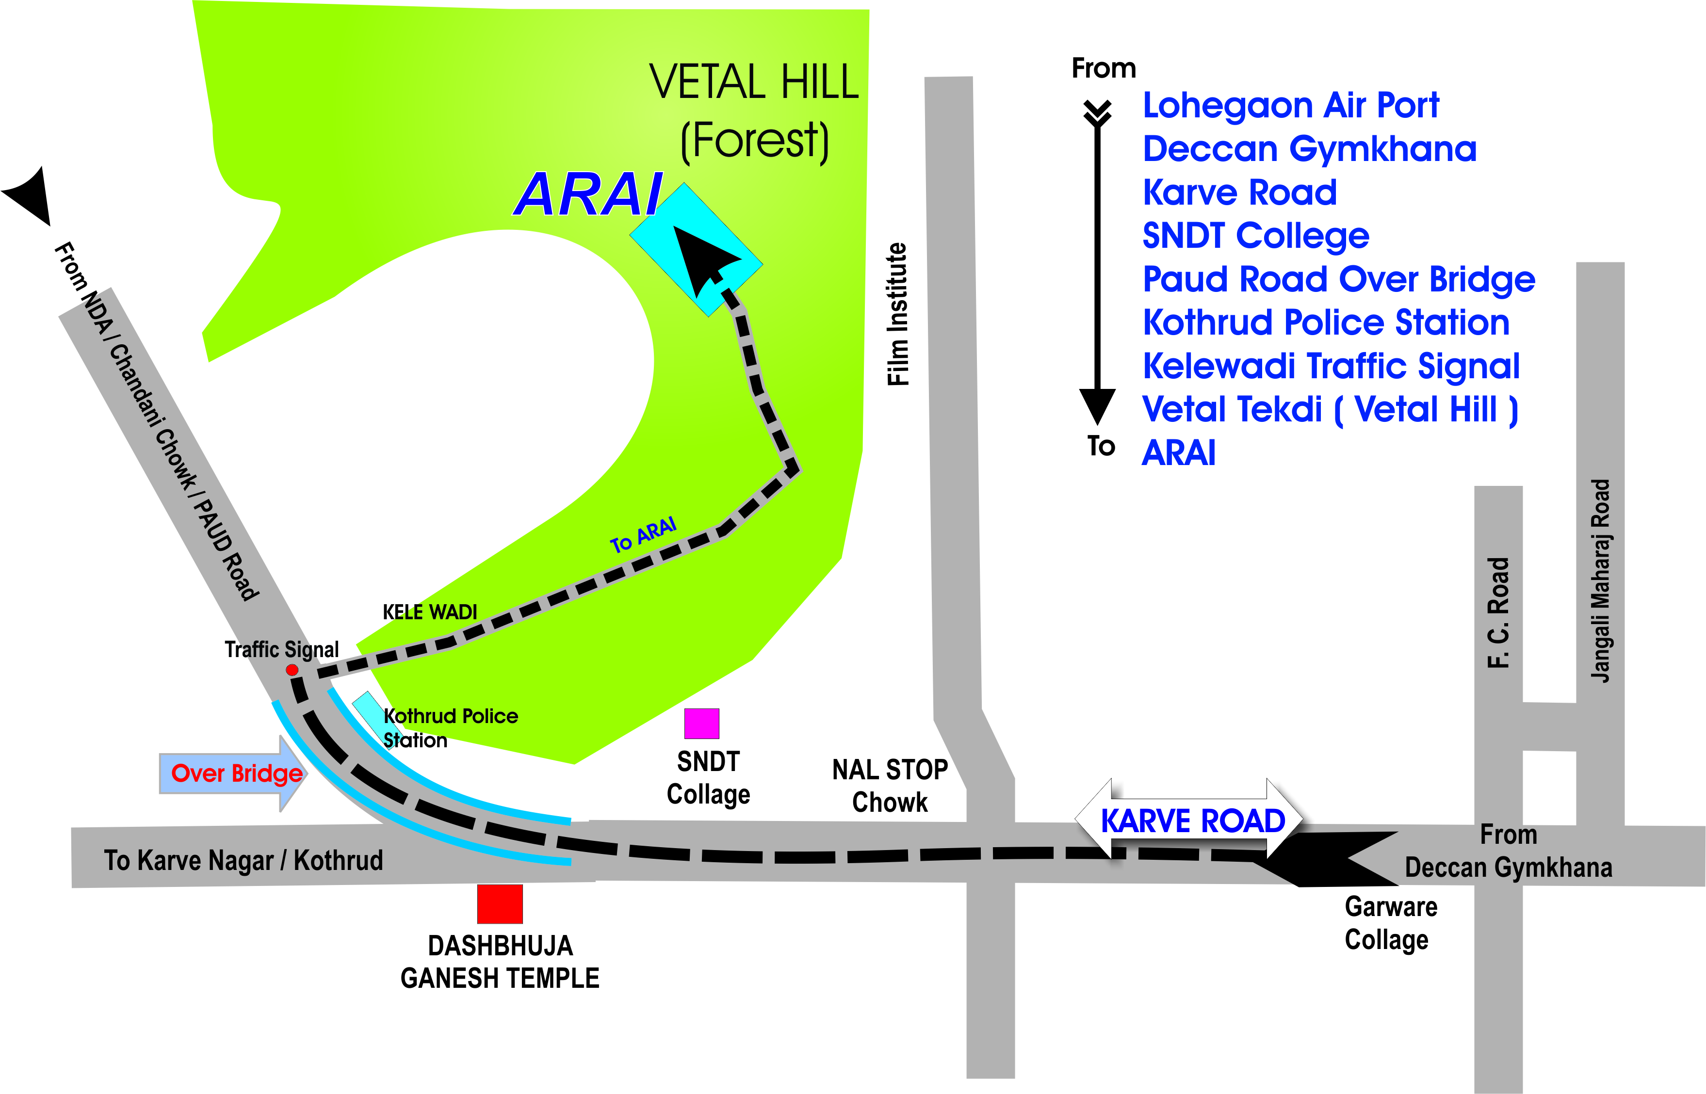

ARAI (The Automotive Research Association of India),
Survey No. 102, Vetal Hill, Off Paud Road, Kothrud, Pune - 411 038, Maharashtra, India

Nearest Airport to ARAI -: Lohegaon airport, Pune
Approximate distance from Lohegaon airport, Pune to ARAI, Pune-: 18 kms.
Approximate distance from CST Mumbai airport to ARAI, Pune -: 170 kms.

Hotel Recommendations:

Sr.no. | Hotel Name, Address, Telephone No | Approximate Tariff incl. Taxes (in Euro)
1 | JW Marriot,  Senapati Bapat Road,  Pune, 411053, India,  Tel: +91 20 6683 3333,  Fax: +91 20 2563 6363 | 145
2 | Le Meridian,  Raja Bahadur Mill Road Pune, 411001,  Tel: +91 20 26050505,  Fax: +91 20 26050506 | 100
3 | Hyatt Regency,  Weikfield IT Park, Nagar Road, Pune 411014  Tel: +91 20 6645 1234  Fax: +91 20 6645 1235 | 120
4 | Royal Orchid Central,  Marisoft Annexe, Kalyani Nagar, Pune 411 014,  Tel: +91 20 4000 3000,  Fax: +91 20 4000 3111 | 85
5 | Hotel Pride,  5 University Road, Shivajinagar, Pune - 411005,  Tel: +91 20 25534567, 25530444  Fax. +91 20 2553 3228 | 90
6 | Hotel President,  34/11, Erandwane, Behind Kohinoor Mangal Karyalaya, Prabhat Road, Pune 411004,  Tel: +91 20 30255555  Fax: +91 20 25438633 | 60

